**CSCB58 Final Project**

**Diffuse-It! Manual**

This project simulates a game of Keep Talking and Nobody Explodes on the DE2 board. The purpose of this game is for a team of players to solve a series of puzzles within a set amount of time. If they fail to complete all puzzles within the time limit the bomb will explode and they will lose.

The game requires interaction and teamwork between a minimum of two players, where one player will hold the bomb and the other player will hold the manual. Each player can see their particular artifact but not the other (i.e. the bomb player can only see the DE2 bomb and the manual player can only see the manual). By having the bomb player describe the boards settings and the manual player deciphering the board’s codes via the manual teams must work together and to complete each puzzle’s objectives before time expires.

The game has an option of five different playable puzzles where each simulation will contain a random set of three puzzles to be completed. Puzzle settings are randomized based on difficulty and a set of four internal states for each puzzle.

**How To Play!**

When Diffuse-It! is first run you will be presented with the main menu. You can tell if you are in the main menu by checking HEX7, which should display 0. Difficulty can be assigned using SW[1:0]. When you have selected your difficulty you can proceed to attempting to diffuse the bomb by pressing KEY[1]. When you believe you have successfully finished a puzzle you must press KEY[1] to continue.

If HEX7 reads 1, 3, and 5 you need to press KEY[1] to proceed to the next puzzle. If HEX7 reads 2, 4, 6 you are in Puzzle 1, Puzzle 2, or Puzzle 3 respectfully. If HEX7 is 7, you have won! If HEX7 is 8, you have lost. If you are in WIN or LOSS, to return to main menu turn all of SW[17:0] to 1 and press KEY[1].

**Game 1: Morse Code**

Before beginning the puzzle, make sure SW[16] is enabled in the case of difficulties easy and hard, and SW[12] in the case of difficulty medium.

Begin this puzzle by pressing KEY[2] to reveal a sequence of flashing LED(s). In morse code these flashes translate as follows: short blinks are dots and long blinks are dashes. Taking A to be 0,B to be 1, etc. indicate, in binary, on the switches which letter was flashing and then press KEY[0] to see if you were right. The switches are as follows:

* Switches 0-2 (for EASY)
* Switches 0-2 for the first letter, 15-17 for the second (for MEDIUM)
* Switches 0-4 for the first letter, 5-9 for the second (for HARD)

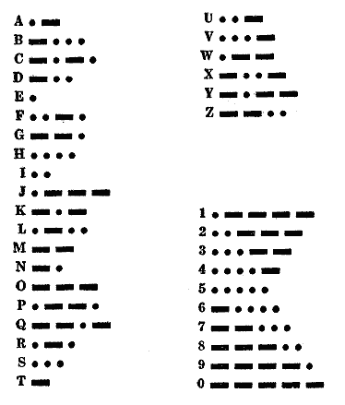

**Game 2: Maze**

Begin this puzzle by observing the green LEDS to determine the starting position in a virtual maze programmed into the bomb.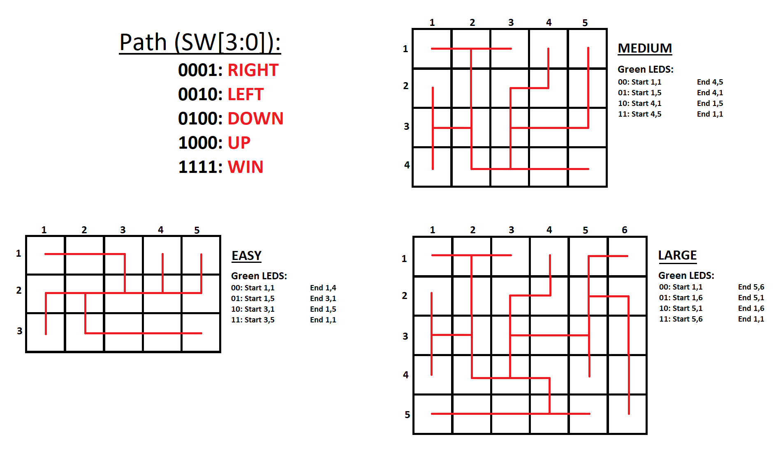

Your starting state is read as ‘row, column’. You must navigate the maze from your starting position to your ending position, using the red lines. If you attempt to move to another position that deviates from the red path, the bomb will explode on the following movement.

Form a “Path” that dictates which direction you wish to move in by forming the representative binary numbers using SW[7:4]. When you want to move in the direction specified by path, press KEY[3]. Be careful when pressing KEY[3], you know you will have moved when the value of LEDR[17:11] changes.

(*provided maze guide is horizontal for clarity, when reading, rotate so that the text is readable normally)*

**Game 3: Symbols**

An encrypted symbol will be shown on HEX0 which must be deciphered based on the manual. Players must enter the matching switch pattern in SW[17:0] based on the HEX pattern displayed. Press KEY[0] to submit. If correct, a new HEX symbol will appear to be completed again. Repeat this process until LED[6] is on. Click KEY[1] to return to a new puzzle.

|  |  |
| --- | --- |
| HEX0 | Solution |
| _  |  | | | 18'b10_0100_0110_1111_0000 |
| _  |_| | 18'b01_0110_0001_0100_1101 |
| |  _| | 18'b00_1100_0111_1010_1010 |
| | |  |_| | 18'b11_0110_0100_1100_1111 |
| _  |  _ | 18'b00_1000_0110_0001_0100 |
| _  _  _ | 18'b00_0111_1100_0001_0101 |
| _  |_| | 18'b01_1100_0100_1010_0110 |
| _  _  | | 18'b10_0110_0001_1100_0111 |

**Game 4: Lights**

The bomb will have a series of flashing lights and an encrypted code displayed on HEX’s 0, 1 and 2. Based on the HEX code, it can be solved which LED’s are relevant to the puzzle at hand. Players must match the green LED’s and red LED’s flashing at the same rate based on the HEX pattern. The number of matching LED’s must be entered in binary on the SW switches, using KEY[0] to submit.

Example: If counting the number of LEDR’s equal to LEDG[1] is 2 then answer becomes SW[17:0] = 18’b00_0000_0000_0010

|  |  |  |  |
| --- | --- | --- | --- |
| HEX2 | HEX1 | HEX0 | SOLUTION |
| _  |  | | | _ | _  |_| | Count the number of LEDR's flashing at the same pace as LEDG 1 |
| _  |  | | | |_  _| | _  |_|  | | | Count the number of LEDR's flashing at the same pace as LEDG 3 |
| |_|  _ | _  | |  | | | | |  |_| | Count the number of LEDR's flashing at the same pace as LEDG 5 |
| |_|  _ | _  |_  _| | _  |  _ | Count the number of LEDR's flashing at the same pace as LEDG 7 |