**Document**

**Team’s name：**

**QS Team**

**Student number：**

|  |  |
| --- | --- |
| **Name** | **Student Number** |
| **Gao Qian** | **2016014302** |
| **Zhu Didi** | **2016014400** |
| **Yu Zhongrui** | **2016014292** |

* **1.Description of the application**

**E commerce service enjoys great popularity in China.**

**Often we would spend too much time looking through the goods provided by online retailers yet still can’t make a good choice. That is not the purpose of some customers who choose to shop online because they want to have a satisfying shopping experience and save time.**

**So we develop a web application to get the information of goods from different e-commerce giants quickly and design a small game to help us make decisions in a short time.**

* **2.Diagram**

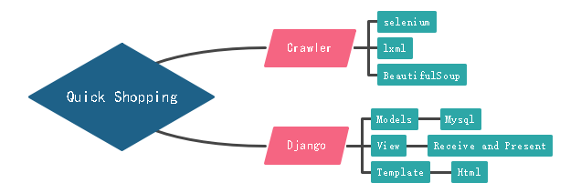

* **3.User Instructions**

**Function 1-----search:**

**For users, if you want to buy some things with reliable quality in a short time, all you need to do is just to input the name of the goods.**

**Then goods from different e commerce giants will be presented.**

**You can click the corresponding picture to see detailed information.**

**Function 2-----browsing with barrage**

**However, simply browsing the website can be boring and time wasting.**

**We develop a small scene with moving blocks on which attached goods’ information.**

**So you can click the responding button to look through all the goods with high attention because human eyes are more sensitive to moving objects.**

**Function 3-----Random**

**If at last you have no idea which to buy, you still have one more way ------random!**

**A small game with goods’ picture will randomly choose one goods, if you don’t want waste time any more,that’s it.**

* **4.** **Highlights and difficulties**

**To be consistent with the idea that sometimes we need a quick shopping, We provide a simple and beautifully designed interface for users to search.**

**One way to save time is to collect goods information from different e commerce giants so we don’t need to compare them in different websites or apps.**

**But, many Chinese e-commerce websites have special defence to prevent web crawler from collecting information. Traditional web crawlers are difficult to collect valid information.**

**Thankfully, python has a library called selenium which have the ability to simulate browsers’ actions and download effective information.**

**However, the price is time.**

**Traditional web crawlers get information from certain urls and their speed is satisfying while using selenium is a slow process.**

**So the strategy we use is to ‘crawl’ not that much information at first. But the web crawlers is still working in the back.Later, when the user want to look through more information, the corresponding data is already stored in the database and can be presented very fast.**

**During this part, we implement the multithreading technique to make it faster.**

* **5. Testing**

**(1)The search Page**

**We test many kinds of goods, such as “Kindle”,”Surface”,”Nike” and so on.The lists of goods will be showed within 5s as long as the Internet is in a good condition.**

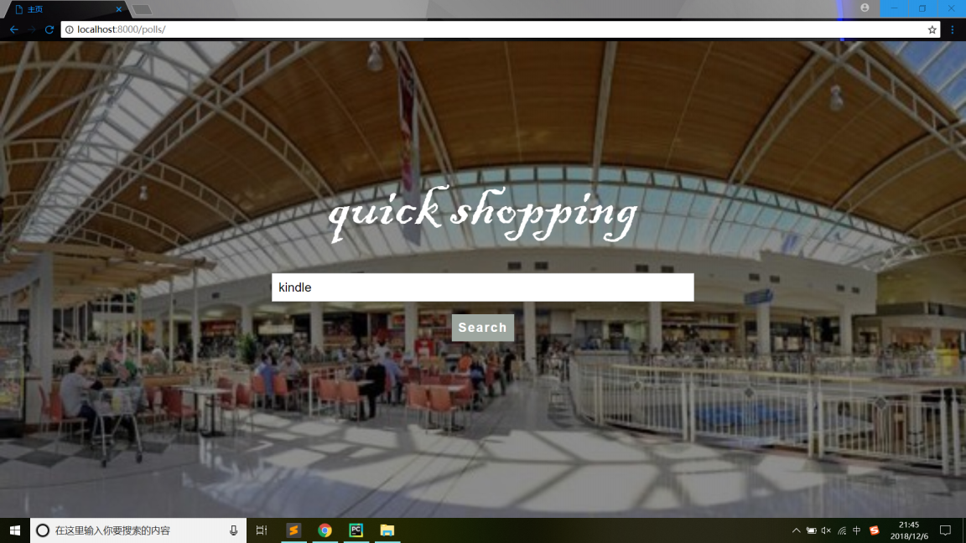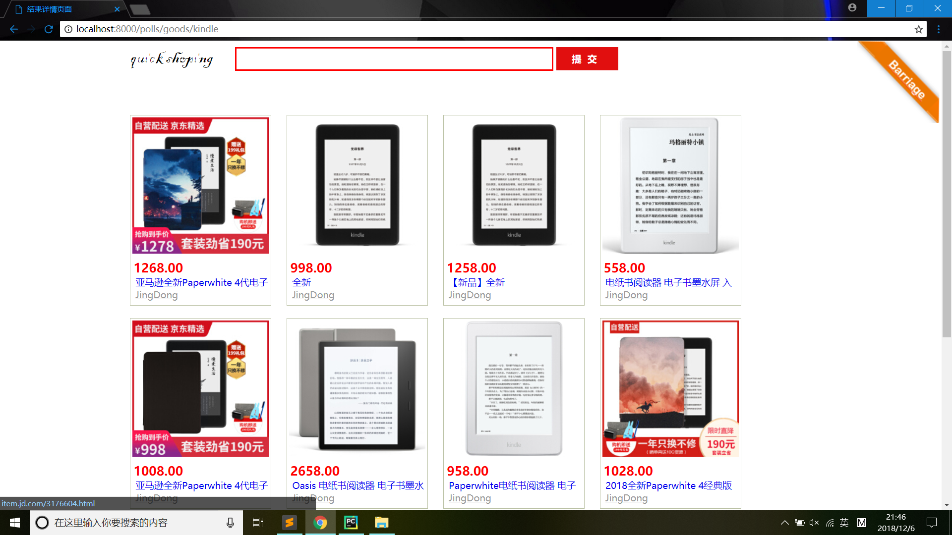

**(2)Barrage Page**

**When you click on the barrage that displays the product information, the barrage slides into the shopping cart.**

**If you click on the shopping cart, it will jump to the random selection page.**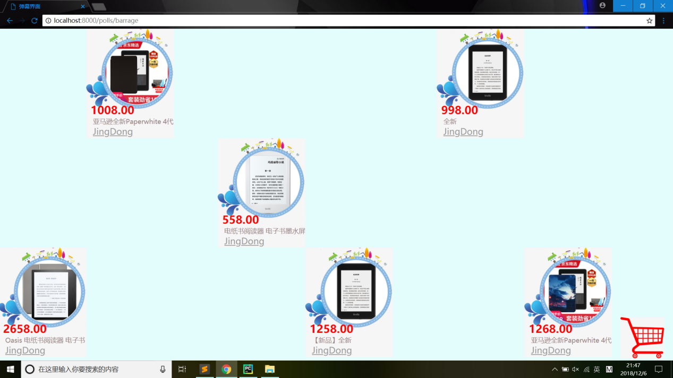

**(3)Random selection Page**

**Similar to the lottery, pulling the handle down, the interface will continuously display the goods in the shopping cart. Pulling the handle up , the interface will randomly display a certain item.**

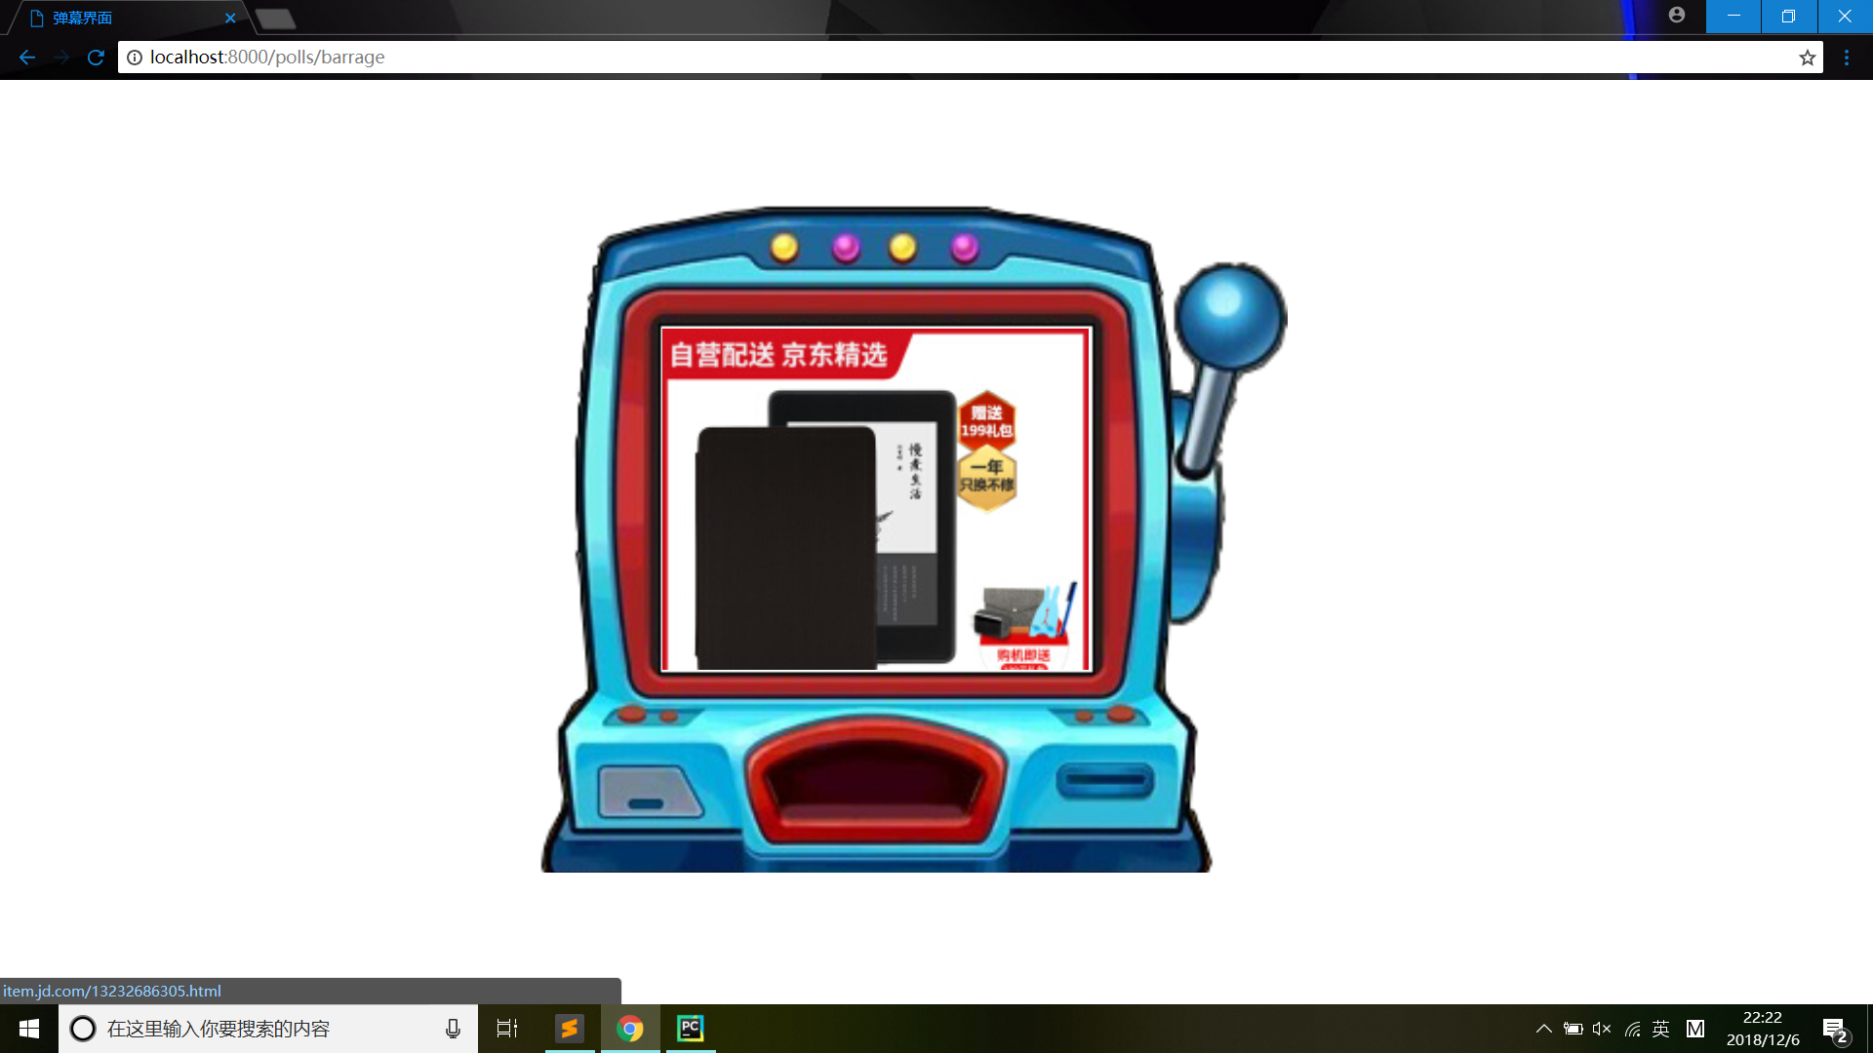

* **6. Suggested improvements**

1. **Improve the efficiency of web crawlers.**
2. **Add the function of Filter according to the price or comments.**
3. **Add more details to the animation**

* **7.Others（**extra credit**）**

**With the knowledge we learn in python:**

1. **We write efficient and valid web crawlers to get information from several e commerce giants.**
2. **In the process of using multiple web crawlers, we used the multithreading technique in Python and special strategy to minimize the time cost.**
3. **We develop a well-performed website with Django.**
4. **Beautifully designed and user-friendly interface.**
5. **Unique idea.We offer an** **unprecedented shopping idea - display goods. information in the form of a barrage and allow users to randomly select items like a lottery.**