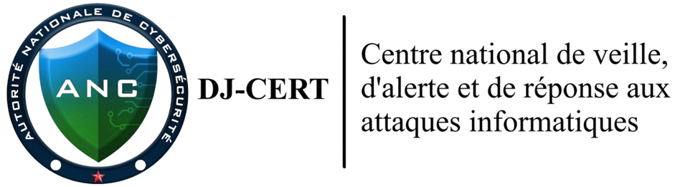
REPUBLIC OF DJIBOUTI
Agence Nationale de la Cybersécurité (ANC) — DJ-CERT
INTERNSHIP REPORT
Digital Forensics & Incident Response (DFIR)
- Practicing incident response workflows (triage, containment, eradication, recovery) through simulated scenarios and lab exercises rather than live incidents
- Learning evidence acquisition and chain-of-custody procedures by collecting disk images, memory dumps, and artifacts from training systems and virtual machines
- Reviewing sample logs from SIEM platforms (Splunk, Elastic, Microsoft Sentinel) and EDR solutions in a sandboxed lab to identify indicators of compromise (IOCs)
- Conducting malware triage and basic static/dynamic analysis using isolated sandbox environments (e.g., REMnux, FLARE VM, Any.Run)
- Writing mock incident reports, investigation timelines, and forensic documentation based on lab exercises to develop professional reporting skills
- Reviewing and contributing to incident response playbooks, runbooks, and standard operating procedures under mentor supervision
Submitted by
KASSIM GALEB MAHAMOUD
Internship Field: Cybersecurity Digital Forensics & Incident Response
Host Organisation : Agence Nationale de la Cybersécurité (ANC) / DJ-CERT
Examiner / Intern: Kassim Galeb Mahamoud
Environment: Sandboxed training laboratory (virtual machines)
Report Date: 8 June 2026
Table of Contents
1. Introduction 7
2. Internship Objectives & Learning Areas 7
2.1 Evidence Acquisition & Chain-of-Custody 7
2.1.1 Core Principles of Evidence Acquisition 9
2.1.2 The Chain-of-Custody (CoC) 9
2.1.3 Integrity Verification via Cryptographic Hashing 9
2.1.4 Real-World Application & Examiner Best Practices 10
2.2 SIEM & EDR Log Review 10
2.3 Malware Triage & Static/Dynamic Analysis 11
2.4 Incident Reports & Documentation 12
3. Case Study: Simulated Incident Response (Jimmy Wilson Case) 12
3.1 Executive Summary 13
3.2 Evidence & System Overview 13
3.2.1 Evidence File Properties 13
3.2.2 Host System Identification 14
3.3 Step-by-Step Forensic Examination Methodology 14
Phase 1 — Evidence Mounting & Drive Verification 14
Phase 2 — Suspect Profile Enumeration (Jimmy Wilson) 16
Phase 3 — LNK File Analysis with LECmd 18
Phase 4 — Prefetch Analysis with PECmd 20
Phase 5 — ShimCache (AppCompatCache) Analysis with AppCompatCacheParser 22
Phase 6 — Browser History Analysis (Firefox SQLite) 24
Phase 7 — MFT Extraction Attempts & Outcomes 25
Phase 8 — Document Metadata Extraction 27
Phase 9 — Additional Artefact Collection 28
3.4 Examination Workflow Timeline 29
3.5 Key Evidence Findings 32
3.5.1 Victim PII Spreadsheet — name that need addresses.xls 32
3.5.2 Encrypted Communications — Jose Badguy & Robert Ripoff 33
3.5.3 Deleted 'New Prices' Folder 33
3.5.4 Evidence of TrueCrypt Encryption 34
3.5.5 Browser History — Criminal Intent Sequence 34
3.6 Forensic Case Timeline (Evidence Events) 34
3.7 Conclusions & Investigative Recommendations 36
3.7.1 Conclusions 36
3.7.2 Priority Investigative Recommendations 37
3.8 Appendix — Tool Reference & Command Index 38
3.8.1 Tools Used in This Examination 38
3.8.2 Complete Command Reference 40
3.8.3 Evidence Inventory — Jimmy Wilson Desktop 41
3.8.4 Evidence Inventory — Jimmy Wilson Documents 42
4. Evidence Acquisition & Chain-of-Custody (Maryam Case) 42
4.1 Acquisition Methodology Overview 42
4.1.1 Workspace Preparation & Documentation 42
4.1.2 Live Memory (RAM) Acquisition 43
4.1.3 Triage Artifact Collection 43
4.1.4 Full Disk Image Acquisition 43
4.1.5 Hash Integrity Verification & Chain Completion 43
4.2 Laboratory Setup & Time Configuration 44
Step 4.2.1 — Brief Laboratory Scenario 44
Step 4.2.2 — Boot the Target VM 44
Step 4.2.3 — Establish a Reliable Time Baseline 45
Step 4.2.4 — Synchronise with an Internet Time Source 46
4.3 Evidence Folder Structure 47
Step 4.3.1 — Create the Evidence Folder Structure 47
Step 4.3.2 — Confirm the Folder Structure 48
4.4 Memory Acquisition (RAM Dump) 48
Step 4.4.1 — Memory Acquisition (RAM Dump) with DumpIt 48
4.5 Triage Collection with KAPE 49
Step 4.5.1 — Triage Artefact Collection with KAPE 49
4.6 Disk Image Acquisition with FTK Imager 50
Step 4.6.1 — Disk Imaging with FTK Imager: Select Source 50
Step 4.6.2 — Select the E01 Image Format 51
Step 4.6.3 — Record Chain-of-Custody Evidence Details 52
Step 4.6.4 — Acquire the Disk Image 53
4.7 Integrity Verification (Hashing) 54
Step 4.7.1 — Verify Image Integrity (MD5 / SHA-1) 54
Step 4.7.2 — Independently Hash the Memory Image (SHA-256) 55
4.8 Supporting Document Collection & Malware Triage 57
5. Executive Summary 62
6. Evidence Summary and Hashes 63
7. Screenshots / Evidence Proof 63
8. Adapted Methodology: 17 DFIR Phases 65
8.1 Case preparation and evidence verification 65
8.2 Evidence organization 65
8.3 Disk image or mounted evidence validation 65
8.4 File system analysis 65
8.5 Windows Registry analysis 66
8.6 Event log analysis 66
8.7 User activity analysis 66
8.8 Executed program analysis 66
8.9 USB and external device analysis 66
8.10 Network artifact analysis 66
8.11 Browser and download history analysis 66
8.12 Persistence mechanism analysis 67
8.13 Malware or suspicious file triage 67
8.14 Timeline creation 67
8.15 Indicators of Compromise extraction 67
8.16 Findings summary 67
8.17 Final professional forensic report 67
9. Key Findings 67
10. IOC Summary 69
11. Timeline Summary 70
11.1 DFIR Timeline Summary 70
12. Professional Finding Wording for Report 71
13. Limitations 72
14. Recommended Next Steps on Windows Forensic Workstation 72
15. Conclusion 72
16. Event Log Timeline Analysis with Hayabusa 73
17. Malware Triage and Static / Dynamic Analysis Report 78
17.1 Executive Summary 78
17.2 Scope and Objectives 79
17.3 Evidence and Analysis Environment 80
17.4 Methodology Overview 82
17.5 Memory Extraction of Malware (Volatility 3) 83
17.6 Static Analysis of Extracted Samples 86
17.7 Dynamic Analysis / Sandbox Triage 89
17.8 Malware Findings 92
17.9 Indicators of Compromise (IOCs) 93
17.11 Timeline 95
17.12 Limitations 96
17.13 Conclusions and Recommendations 96
18. Wazuh SIEM Deployment and Configuration Documentation 98
18.1 Introduction 98
18.2 Lab Environment 99
18.3 Objective of the Deployment 99
18.4 Wazuh Architecture Used 100
18.5 Server Preparation 100
18.6 Wazuh All-in-One Installation 101
18.7 Accessing the Wazuh Dashboard 102
18.8 Post-Installation Verification 104
18.9 Firewall Configuration 105
18.10 Deploying a Windows Wazuh Agent 105
18.11 Windows Agent Installation 106
18.12 Verifying the Windows Agent Service 107
18.13 Verifying Agent Connection in Wazuh Dashboard 108
18.14 Dashboard Exploration 109
18.15 Testing and Monitoring 112
18.16 Troubleshooting Performed 112
18.17 Security Considerations 113
18.18 Result 114
18.19 Conclusion 114
19. Final Conclusion 115

1. Introduction
This report outlines the professional experience gained during my Digital Forensics and Incident Response (DFIR) internship at the Agence Nationale de la Cybersécurité (ANC) / DJ-CERT. The program provided invaluable exposure to real-world cybersecurity methodologies within a controlled, sandboxed environment. This professional development at Djibouti's national cybersecurity authority has been instrumental in refining my technical competencies in evidence preservation, system analysis, and incident remediation through structured simulations and laboratory exercises.

2. Internship Objectives & Learning Areas
During the internship I worked through the following objectives. All activities were performed on training systems, practice datasets, and virtual machines in an isolated lab — never on live incidents or production data:
- Practicing incident response workflows (triage, containment, eradication, recovery) through simulated scenarios and lab exercises rather than live incidents
- Learning evidence acquisition and chain-of-custody procedures by collecting disk images, memory dumps, and artifacts from training systems and virtual machines
- Reviewing sample logs from SIEM platforms (Splunk, Elastic, Microsoft Sentinel) and EDR solutions in a sandboxed lab to identify indicators of compromise (IOCs)
- Conducting malware triage and basic static/dynamic analysis using isolated sandbox environments (e.g., REMnux, FLARE VM, Any.Run)
- Writing mock incident reports, investigation timelines, and forensic documentation based on lab exercises to develop professional reporting skills
- Reviewing and contributing to incident response playbooks, runbooks, and standard operating procedures under mentor supervision

2.1 Evidence Acquisition & Chain-of-Custody

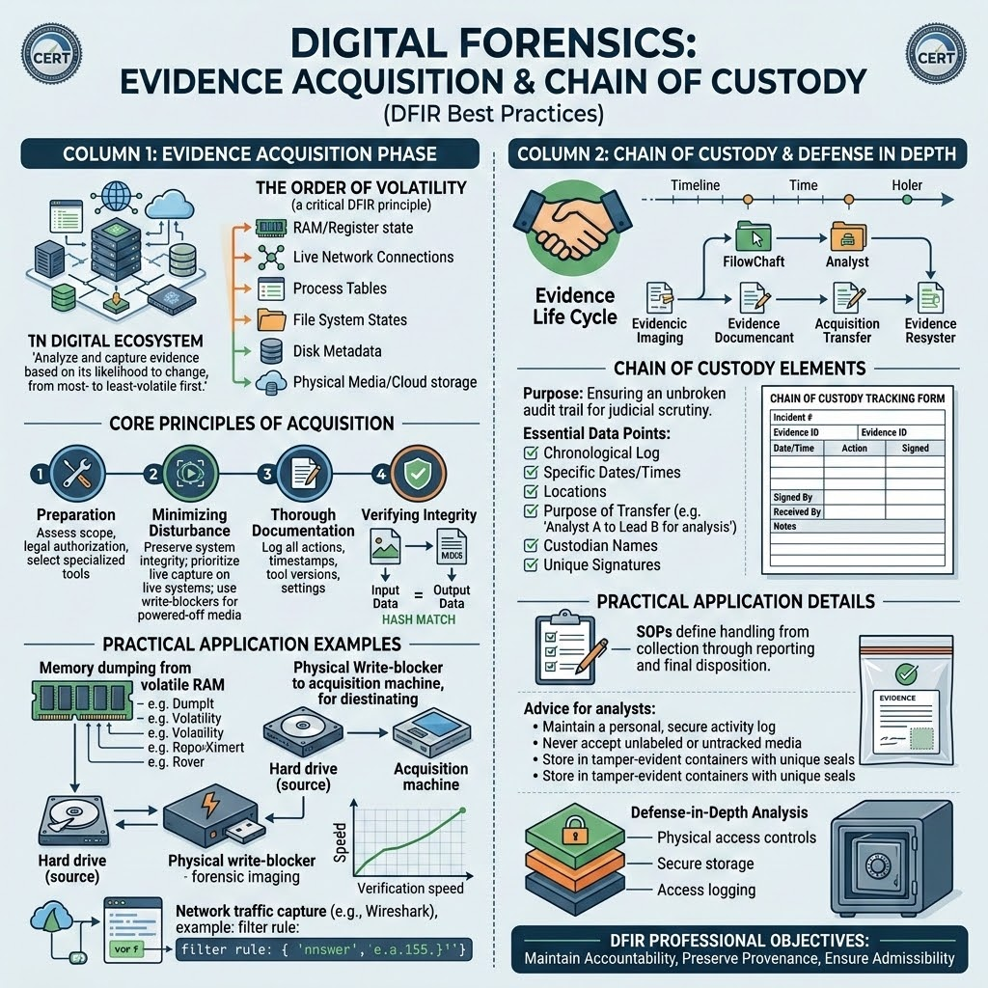
Evidence acquisition and chain-of-custody workflow — DFIR best practices.
Digital Forensics and Incident Response (DFIR) relies fundamentally on the integrity and admissibility of evidence. Evidence acquisition is the methodical process of collecting digital data from a source—be it a hard drive, RAM, network device, or cloud environment—in a manner that preserves its original state, ensuring that the evidence remains untainted and defensible in legal or administrative proceedings.

2.1.1 Core Principles of Evidence Acquisition
To ensure forensic soundness, we strictly adhere to the Order of Volatility, which dictates the sequence in which data is collected based on its lifespan and fragility:
- Volatile Memory (RAM): Contains running processes, unencrypted keys, active network connections, and temporary code injections. This is the most fragile layer and must be collected first, as it is lost the moment the system loses power.
- Network State & Cached Data: Active connections and cached temporary data that may exist in memory or volatile swap files.
- Non-Volatile Storage (Disk Images): Contains the primary file system, user data, and system logs. While more stable, this must be handled with write-blocking to prevent any metadata modification (such as "Last Accessed" time stamps).
- Archived/Backup Data: Historical data or off-site backups, which are the most stable but often the oldest evidence.
Professional Advice: Always prioritize the "Fragility-First" approach. Never assume a system can be "fixed" or "rebooted" to simplify acquisition. If you reboot, you destroy the volatile memory, potentially losing the only evidence of a fileless malware attack.

2.1.2 The Chain-of-Custody (CoC)
The Chain-of-Custody is a chronological, documented audit trail. It is the backbone of forensic evidence; without a robust CoC, the evidence is merely data, not proof. A professional CoC must document:
- Identification: Precise description of the evidence (e.g., Serial numbers, make, model).
- Collection: Who collected it, the exact time (in UTC/local), and the physical/logical location.
- Transfer & Storage: Who has handled the evidence, when it was moved, and where it was stored (e.g., a secured evidence locker or encrypted volume).
- Integrity: The results of hashing verification at every transfer point.
Professional Advice: Treat every piece of evidence as if it will be challenged in a high-stakes legal proceeding. Every transfer of possession must be signed and dated. If evidence is stored digitally, use access-controlled storage with logging enabled.

2.1.3 Integrity Verification via Cryptographic Hashing
To guarantee that the evidence has not been altered—even by a single bit—we utilize cryptographic hash functions (such as MD5, SHA-1, or the more collision-resistant SHA-256).
The Workflow:
- Source Hashing: Calculate the hash of the original evidence before acquisition.
- Acquisition: Create the forensic image (e.g., E01 or Raw).
- Verification Hashing: Calculate the hash of the resulting image file.
- Comparison: If the Source Hash equals the Image Hash, the integrity is mathematically proven.
Professional Advice: Use multiple hashing algorithms (e.g., MD5 for legacy compatibility and SHA-256 for collision resistance). If your forensic tool automatically performs this comparison, ensure the logs capture this verification—this is your primary evidence of integrity.

2.1.4 Real-World Application & Examiner Best Practices
In our lab exercises, we applied these concepts through a disciplined workflow:
- Write-Blocking: We used hardware or software write-blockers to ensure the original evidence volume remained pristine. Never work directly on an original drive.
- Documentation (The Examiner’s Journal): Keep a rigorous, timestamped log of every command executed, the version of the tool used, and the observed output. If you perform an action that isn't logged, it did not happen in the eyes of a peer reviewer.
- Time-Sync Discipline: Always synchronize your forensic workstation's clock with an authoritative NTP source (e.g., time.windows.com or a lab NTP server) before starting. A drift of even a few minutes can render your timeline analysis invalid during event correlation.
- Reproducibility: A professional examination must be reproducible. Another analyst with the same evidence and the same tools should be able to follow your notes and reach the exact same conclusion. If your methodology is opaque, your findings are suspect.

2.2 SIEM & EDR Log Review
Security Information and Event Management (SIEM) and Endpoint Detection and Response (EDR) form the detection backbone of a modern DFIR capability. This learning area focused on collecting telemetry from hosts, servers, and security tools, normalising it into a common schema, and correlating events across sources to separate genuine malicious activity from routine background noise.
The practical skills developed in this area were:
Log collection and normalisation: Onboarding Windows Event Logs, Sysmon, and agent telemetry into a central platform, then parsing and field-mapping disparate log formats so they can be queried consistently.
Alert triage and correlation: Reviewing detection alerts, pivoting across related events (process creation, network connections, authentication), and reconstructing the sequence of attacker actions on an endpoint.
Detection engineering: Reading and tuning detection rules to reduce false positives, and mapping alerts to the MITRE ATT&CK framework so each detection is tied to a known adversary technique.
Proactive threat hunting: Querying historical telemetry for indicators of compromise and suspicious behavioural patterns rather than waiting for an alert to fire.
Applied work in this report: The hands-on output of this area is documented in Section 16 (Event Log Timeline Analysis with Hayabusa) and Section 18 (Wazuh SIEM Deployment and Configuration Documentation), where a SIEM was deployed end-to-end and endpoint logs were reviewed and correlated.
Professional Advice: A SIEM is only as good as the telemetry feeding it. Confirm that critical log sources (process creation, PowerShell, authentication, and EDR events) are actually being ingested before relying on the platform during an incident — a silent log gap is indistinguishable from a quiet network.

2.3 Malware Triage & Static/Dynamic Analysis
Malware triage is the disciplined process of examining a suspicious file to determine whether it is malicious, what it is designed to do, and what indicators it leaves behind — without compromising the analyst's own environment. This learning area combined static analysis (examining a sample without executing it) with dynamic analysis (observing its behaviour in a controlled sandbox), supported by memory-based extraction.
The practical skills developed in this area were:
Static analysis: Calculating file hashes, extracting printable strings, inspecting PE headers and import tables, and running YARA signatures to classify a sample and surface hard-coded artefacts such as URLs, IP addresses, and registry keys.
Dynamic analysis: Detonating a sample inside an isolated, snapshotted virtual machine and recording its process, file-system, registry, and network behaviour to reveal capabilities that are obfuscated or packed in the static view.
Memory-based extraction: Using Volatility to recover injected code and malicious processes directly from a RAM image — essential for fileless and packed threats that never touch disk in cleartext.
IOC extraction and ATT&CK mapping: Consolidating the host- and network-based indicators observed and mapping the sample's behaviour to MITRE ATT&CK techniques for reporting and detection.
Applied work in this report: The full hands-on analysis is documented in Section 17 (Malware Triage and Static / Dynamic Analysis Report), which walks through memory extraction, static and dynamic examination, the resulting findings, and the IOC and ATT&CK summary.
Professional Advice: Never execute an unknown sample on a production or internet-connected host, and always work from a virtual-machine snapshot you can revert. Begin with static, non-execution techniques to gather context, and only detonate the sample once the environment is isolated and instrumented.

2.4 Incident Reports & Documentation
The final learning area addressed how investigative work is communicated. A forensic examination has no value if its findings cannot be understood, trusted, and acted upon, so this area focused on producing clear, defensible incident reports that serve both technical and non-technical audiences while preserving the evidentiary rigour established during acquisition.
The practical skills developed in this area were:
Report structure: Organising findings into a consistent format — executive summary, scope and objectives, methodology, detailed findings, timeline, indicators of compromise, and recommendations — so a reader can navigate from a high-level conclusion down to the supporting technical detail.
Audience-appropriate writing: Presenting the same incident at two levels: a concise, business-focused summary for decision-makers and a precise, reproducible technical account for examiners and peer reviewers.
Evidence linkage and reproducibility: Tying every finding back to a specific artefact, command, and hash so that another analyst could repeat the examination and reach the same conclusion.
Integrity and limitations disclosure: Recording chain-of-custody references and stating the limitations of the examination honestly, since acknowledging what was not examined is part of a credible report.
Applied work in this report: This documentation discipline is demonstrated throughout the case studies in Sections 3 and 4 and in the structured reporting of Sections 5 to 15, which present executive summaries, key findings, IOC and timeline summaries, professional finding wording, limitations, and conclusions.
Professional Advice: Write the report as the examination proceeds, not afterwards. A contemporaneous, timestamped journal of commands, tool versions, and observations turns report-writing into assembly rather than recall, and it is the strongest defence of your findings under review.

3. Case Study: Simulated Incident Response (Jimmy Wilson Case)
As the first practical objective of the internship (Objective 2.1 above), I carried out a complete simulated incident-response and disk-forensics investigation on a training disk image in the lab. The full case report is reproduced below. It demonstrates the end-to-end workflow — triage of the mounted evidence, systematic artefact analysis, reconstruction of the timeline, and documented findings and recommendations — applied to a realistic scenario rather than a live incident.

3.1 Executive Summary
This forensic examination was conducted on a disk image (E01 format) attributed to suspect Jimmy Wilson. The image was mounted read-only using Arsenal Image Mounter and analysed using industry-standard tools. The evidence establishes an active identity theft and potential document fraud operation. Key findings include:
- Victim PII spreadsheet: 4 victims with full name, date of birth, and Social Security Number.
- BCTextEncoder used to create encrypted communications about co-conspirators 'Jose Badguy' and 'Robert Ripoff'.
- Browser searches for 'how to steal identities' and 'identity theft jail time' on 2014-02-11.
- Research into Zebra ZXP Series 8 ID card printers — equipment for producing counterfeit identity documents.
- TrueCrypt encryption in active use; additional encrypted volumes on separate M:\ drive (BillyBob).
- BCTextEncoder executed from USB drive G:\ — removable media not present in this image.
- Deliberate deletion of 'New Prices' folder containing an encoded file — evidence of anti-forensic activity.
- Volume Shadow Copy confirmed — may allow recovery of deleted artefacts.
The combined weight of these artefacts establishes criminal intent, active offending, and deliberate evidence concealment.

3.2 Evidence & System Overview

3.2.1 Evidence File Properties
Property | Value
Filename | 2020JimmyWilson.E01
Format | EnCase Expert Witness Format (E01)
Source Path | D:\anc\DFIR_Training\VMDK\2020JimmyWilson.E01
Mount Tool | Arsenal Image Mounter v3.11.307
Mount Mode | Read-Only (write-blocked at driver level)
Assigned Drive Letter | E:\ THISONE
Physical Device Path | \\?\PhysicalDrive2
Volume GUID | {8adc3f42-01a7-46ee-af5a-70c06738e819}
Filesystem | NTFS
Volume Serial Number | 9AC0CC8B
Volume Created | 2014-01-25 04:05:57 UTC
Volume Label | (none)

3.2.2 Host System Identification
Attribute | Value
Operating System | Windows 7 SP1 x64 (Build 7601)
Computer Name | IACIS-HDD-2014
Primary Suspect Account | Jimmy Wilson
All User Accounts | BillyBob, Fred Flintstone, James Russell, Jimmy Wilson, Joe Nameless
NIC MAC Address | 00:16:41:E7:BB:6B (Universal Global Scientific Industrial Co.)
Firefox Version | 27.0
Installed Software (Key) | OpenOffice 4.0.1, Adobe Reader 11.0, TrueCrypt, BCTextEncoder v1.01.1, Firefox 27

3.3 Step-by-Step Forensic Examination Methodology
This section documents every action taken during the forensic examination in sequential order, including the exact tool used, the command or operation executed, the output observed, and the forensic significance of each step. All steps were performed on 2026-06-02.

Phase 1 — Evidence Mounting & Drive Verification
Step 1.1 — Mount E01 Image with Arsenal Image Mounter
Field | Detail
Tool | Arsenal Image Mounter v3.11.307
Tool Path | D:\Tool\tools\Arsenal-Image-Mounter-v3.11.307\ArsenalImageMounter.exe
Action | Opened Arsenal Image Mounter GUI. Loaded 2020JimmyWilson.E01 as a read-only disk. Selected 'Write-Protected' mode. Disk mounted and assigned drive letter E:\.
Why Read-Only? | DFIR best practice: write protection ensures the original evidence is not modified during examination. Arsenal Image Mounter implements write-blocking at the virtual disk driver level.
Result | Drive E:\ appeared in Windows Explorer. Volume GUID assigned: {8adc3f42-01a7-46ee-af5a-70c06738e819}. Physical device: \\?\PhysicalDrive2.

Step 1.2 — Confirm Mount via aim_cli.exe
Command run to confirm which physical device the image was mounted to and verify the volume mapping:
Field | Detail
Tool | aim_cli.exe (Arsenal Image Mounter CLI)
Command | D:\Tool\tools\Arsenal-Image-Mounter-v3.11.307\aim_cli.exe --list
Output | Device number 000000 | Device is \\?\PhysicalDrive2 | Contains volume \\?\Volume{8adc3f42-...} | Mounted at E:\
Significance | Confirmed read-only mount. Provided the exact volume GUID needed for tool parameters. Verified no write operations occurred.

Step 1.3 — Root Directory Enumeration
First look at the mounted volume to understand the filesystem layout:
Field | Detail
Tool | PowerShell (Get-ChildItem)
Command | Get-ChildItem E:\ -Force | Select-Object Mode,LastWriteTime,Length,Name | Format-Table -AutoSize
Output | $RECYCLE.BIN (2015-05-26), Documents and Settings (2009-07-14 — NTFS junction), USERS (2015-05-26), Windows (2015-05-26)
Significance | Confirmed standard Windows 7 installation structure. Volume timestamp 2015-05-26 consistent with image acquisition date. NTFS junction to legacy 'Documents and Settings' confirms Win7.

Step 1.4 — User Profile Enumeration
Field | Detail
Tool | PowerShell (Get-ChildItem)
Command | Get-ChildItem E:\USERS -Force | Select-Object Mode,LastWriteTime,Name | Format-Table -AutoSize
Output | BillyBob (2015-05-26 09:06:36), Fred Flintstone (09:06:10), James Russell (09:06:21), Jimmy Wilson (08:46:17), Joe Nameless (09:06:47)
Significance | Five user accounts identified. Jimmy Wilson has the earliest modification timestamp (08:46:17) — the account with the most recent activity. Jimmy Wilson is the primary subject.

Phase 2 — Suspect Profile Enumeration (Jimmy Wilson)
Step 2.1 — Desktop Contents
Field | Detail
Tool | PowerShell (Get-ChildItem)
Command | Get-ChildItem 'E:\USERS\Jimmy Wilson\Desktop' -Force | Select-Object Mode,LastWriteTime,Length,Name | Format-Table -AutoSize
Key Output | BCTextEncoder.exe (1,259,896 bytes), Jose Badguy\ (folder), Robert Ripoff\ (folder), Bing.url, Card Printers Secure ID Zebra Technologies.url, How to Hide Money From The Government.url, Jose 42 encoded - Shortcut.lnk, OpenOffice 4.0.1 Installation Files\
Significance | BCTextEncoder is an encryption/obfuscation tool. Two folders named after persons ('Jose Badguy', 'Robert Ripoff') suggest co-conspirator dossiers. URLs indicate identity theft and financial concealment research. Shortcut to encoded file.

Step 2.2 — Documents Folder Contents
Field | Detail
Tool | PowerShell (Get-ChildItem)
Command | Get-ChildItem 'E:\USERS\Jimmy Wilson\Documents' -Force | Select-Object Mode,LastWriteTime,Length,Name | Format-Table -AutoSize
Key Output | name that need addresses.xls (7,168 bytes), bookstore.mdb, ID%20Theft.pdf, IDtheftrev.pdf, letterlegal5.doc, pdf-0009-taking-charge.pdf, pdf-0014-identity-theft.pdf, pdf-0094-identity-theft-affidavit.pdf, To Whom it may concern.doc, zxp8-datasheet-en-us.pdf (Zebra ZXP8 ID card printer)
Significance | Multiple identity theft PDFs. Spreadsheet named 'name that need addresses' is highly suspicious. Zebra ZXP8 PDF is a datasheet for an industrial ID card printer. FTC affidavit form suggests research into formal identity theft processes.

Step 2.3 — Suspect Subfolder Enumeration (Jose Badguy / Robert Ripoff)
Field | Detail
Tool | PowerShell (Get-ChildItem -Recurse)
Command | Get-ChildItem 'E:\USERS\Jimmy Wilson\Desktop\Jose Badguy' -Force -Recurse | ... and Get-ChildItem 'E:\USERS\Jimmy Wilson\Desktop\Robert Ripoff' -Force -Recurse
Jose Badguy Output | Billy D Goat.jpg (8,444 bytes), John T. Wolf.jpg (12,503 bytes), Jose 42 encoded.TXT (1,690 bytes)
Robert Ripoff Output | Dirty Asa Rat.jpg (6,205 bytes), Robert 17 Encoded.TXT (1,862 bytes), Shesa Hippo.jpg (9,488 bytes), Tall Asa Giraffe.jpg (6,515 bytes)
Significance | Each folder holds photographs of individuals and one BCTextEncoder-encoded file. Filename suffix numbers (42, 17) are likely the encryption key. Folder structure consistent with criminal network dossiers.

Step 2.4 — Read Encoded File Headers
Field | Detail
Tool | PowerShell (Get-Content)
Command | Get-Content 'E:\USERS\Jimmy Wilson\Desktop\Jose Badguy\Jose 42 encoded.TXT'
Output | - - - - - B E G I N E N C O D E D M E S S A G E - - - - - | Version: BCTextEncoder Utility v.1.01.1 | [base64-like cipher text] | - - - - - E N D E N C O D E D M E S S A G E - - - - -
Significance | Confirms BCTextEncoder v1.01.1 format. Message is encrypted — requires numeric key (42 per filename) to decode. Same format confirmed in Robert 17 Encoded.TXT. Both files are actionable decryption targets.

Step 2.5 — Parse Victim PII Spreadsheet
Field | Detail
Tool | Python 3.12 + xlrd library
Script | python C:\...\read_xls4.py (opened E:\USERS\Jimmy Wilson\Documents\name that need addresses.xls using xlrd.open_workbook; parsed cell types including XL_CELL_DATE for DOB conversion)
Why Python? | The .xls file is a legacy binary format. xlrd parses it correctly and converts Excel date serials (e.g., 29567) to human-readable dates via xlrd.xldate_as_tuple().
Output | Header: First Name | Last Name | DOB | SSN | Address | Row 1: Jill | Hill | 1980-12-12 | 432-22-4442 | (blank) | Row 2: Johnny | Gilligan | 1966-06-30 | 432-44-5563 | (blank) | Row 3: Terry | Ferry | 1950-07-14 | 242-87-2927 | (blank) | Row 4: Jerry | Jones | 1970-09-30 | 625-22-3738 | (blank)
Significance | CRITICAL EVIDENCE. Four victims' PII documented in a single spreadsheet. Empty 'Address' column confirms the offender was still collecting data. This spreadsheet constitutes the core identity theft evidence.

Phase 3 — LNK File Analysis with LECmd
LNK files (.lnk) are Windows shortcut files automatically created when a user opens a file or folder. They record: the target file path, the file's original timestamps (created/modified/accessed), the volume serial and machine ID where the target lived, and a tracker database timestamp independent of the target file. This makes them extremely valuable for proving file access even when the original file is deleted.
Step 3.1 — LECmd on Recent Items Folder
Field | Detail
Tool | LECmd v1.5.1.0 (Eric Zimmerman / EZTools)
Tool Path | D:\Tool\tools\EZTools\LECmd.exe
Command | LECmd.exe -d "E:\USERS\Jimmy Wilson\AppData\Roaming\Microsoft\Windows\Recent" --csv D:\Tool\forensic_output --csvf lnk_recent.csv -q
What -d does | Recursively processes all .lnk files in the specified directory
What --csv does | Exports all parsed LNK metadata to a CSV file for structured analysis
What -q does | Quiet mode — suppresses per-file verbose output, only shows summary
Files Found | 8 LNK files
Output File | D:\Tool\forensic_output\lnk_recent.csv
Key Warning | Warning: Administrator privileges not found — note: LECmd still parsed all 8 files successfully; admin rights only needed for locked system files

Step 3.2 — LECmd on Desktop LNK Files
Field | Detail
Tool | LECmd v1.5.1.0
Command | LECmd.exe -d "E:\USERS\Jimmy Wilson\Desktop" --csv D:\Tool\forensic_output --csvf lnk_desktop.csv -q
Files Found | 1 LNK file (Jose 42 encoded - Shortcut.lnk)
Output File | D:\Tool\forensic_output\lnk_desktop.csv
Result | Target: E:\USERS\Jimmy Wilson\Desktop\Jose Badguy\Jose 42 encoded.TXT | Target Created: 2014-02-16 21:56:34 | MFT Entry: 0x1347D | Tracker Created: 2014-02-16 21:50:30 | Machine ID: iacis-hdd-2014 | MAC: 00:16:41:E7:BB:6B
Significance | Tracker timestamp (21:50:30) is 6 minutes before the file creation timestamp (21:56:34) — proves the file was created on this exact machine on this date. Machine ID and MAC confirmed consistent across all LNK files.

Step 3.3 — LNK Analysis Results Summary
LNK File | Target Path | Target Created (UTC) | MFT Entry | Key Finding
name that need addresses.lnk | Jimmy Wilson\Documents\name that need addresses.xls | 2014-02-19 13:36:54 | 0x132BE | Victim PII file accessed 2014-02-19
Jose 42 encoded - Shortcut.lnk | Desktop\Jose Badguy\Jose 42 encoded.TXT | 2014-02-16 21:56:34 | 0x1347D | Encoded comm file, key=42
New Price List Encoded.lnk | Desktop\New Prices\New Price List Encoded.TXT | 2014-02-16 20:44:26 | 0x133DC | DELETED — encoded file 862 bytes
New Price List.lnk | Desktop\New Prices\New Price List.txt | 2014-02-16 20:39:19 | 0x12076 | DELETED — 175 bytes
New Prices.lnk | Desktop\New Prices\ (folder) | 2014-02-16 20:38:51 | 0x12041 | DELETED — entire folder gone
NewPrices.lnk | Desktop\New Prices\NewPrices.txt | 2014-02-16 20:39:19 | 0x12076 | DELETED — same entry as New Price List
To Whom it may concern.lnk | Jimmy Wilson\Documents\To Whom it may concern.doc | 2014-02-19 13:49:19 | 0x12078 | Document authored by Jimmy Wilson
zxp8-datasheet-en-us.lnk | Jimmy Wilson\Documents\zxp8-datasheet-en-us.pdf | 2014-02-10 15:00:02 | 0x0 | Zebra ZXP8 ID printer datasheet
Documents.lnk | Libraries\Documents.library-ms | 2014-01-25 18:27:46 | — | Standard library shortcut

Phase 4 — Prefetch Analysis with PECmd
Windows Prefetch files (.pf) are created by the Superfetch/SysMain service to speed up application loading. They record: the executable name and hash, the number of times the program was run, the last 8 run timestamps (Windows 8+), and all files and directories loaded during execution. For forensics, they prove program execution even if the program is later deleted.
Step 4.1 — PECmd Execution
Field | Detail
Tool | PECmd v1.5.1.0 (Eric Zimmerman / EZTools)
Tool Path | D:\Tool\tools\EZTools\PECmd.exe
Command | PECmd.exe -d E:\Windows\Prefetch --csv D:\Tool\forensic_output --csvf prefetch_output.csv -q
What -d does | Processes all .pf files in the specified Prefetch directory
Files Found | 5 Prefetch files
Output Files | D:\Tool\forensic_output\prefetch_output.csv and prefetch_output_Timeline.csv
Note | Only 5 Prefetch files present (Windows 7 default max is 128). Suggests limited session or possible clearing.

Step 4.2 — Prefetch Results Detail
Executable | Hash | Run Count | Last Run (UTC) | Critical Loaded Files / Directories
DLLHOST.EXE | 766398D2 | 81 | 2014-02-20 14:30:26 | $MFT, ICONCACHE.DB, WEBCACHEV01.DAT — COM surrogate for shell operations including BillyBob and Jimmy Wilson profile areas
RUNDLL32.EXE | 411A328D | 2 | 2014-02-20 15:22:38 | TRUECRYPT.EXE (C:\Program Files\TrueCrypt\TrueCrypt.exe), OpenOffice 4 SOFFICEAPP.DLL, Firefox profile permissions.sqlite, Adobe CryptoCME.dll, Prefetch readyboot
WMIADAP.EXE | F8DFDFA2 | 48 | 2014-02-20 14:37:59 | WMI adapter process — system maintenance; loaded $MFT
WMIPRVSE.EXE | 1628051C | 83 | 2014-02-20 17:47:12 | $MFT, ACPI/NDIS/HDAUDBUS drivers, TrueCrypt reference via RUNDLL32, RDPCFGEX.DLL
WUAUCLT.EXE | 70318591 | 22 | 2014-02-19 13:42:02 | \DEVICE\HarddiskVolumeShadowCopy2\$MFT — VSS Shadow Copy confirmed, Windows Update files, AM_DELTA patches

Step 4.3 — Key Prefetch Findings
Finding | Detail | Significance
TrueCrypt.exe in RUNDLL32 prefetch | C:\Program Files\TrueCrypt\TrueCrypt.exe listed as loaded file | Proves TrueCrypt was installed and executed on this machine. Run count 2, last 2014-02-20.
VSS Shadow Copy in WUAUCLT prefetch | \DEVICE\HarddiskVolumeShadowCopy2\$MFT accessed | A Volume Shadow Copy exists. Contains a snapshot of the filesystem — deleted 'New Prices' folder may be recoverable from this snapshot.
Firefox profile in RUNDLL32 prefetch | permissions.sqlite from 8pp14cbi.default profile loaded | Proves Firefox was active during the same session as TrueCrypt use.
OpenOffice in RUNDLL32 prefetch | SOFFICEAPP.DLL, SC.DLL, VCL.DLL loaded | Confirms OpenOffice use — possibly used to create/edit victim documents.

Phase 5 — ShimCache (AppCompatCache) Analysis with AppCompatCacheParser
The Application Compatibility Cache (ShimCache / AppCompatCache) is stored in the Windows SYSTEM registry hive at HKLM\SYSTEM\ControlSet001\Control\Session Manager\AppCompatCache\AppCompatCache. It records every executable that has been run or enumerated by Windows, along with the file's last modification timestamp and (on Windows 7) whether it was actually executed. It survives reboots and is not cleared by standard user actions.
Step 5.1 — AppCompatCacheParser Execution
Field | Detail
Tool | AppCompatCacheParser v1.5.1.0 (Eric Zimmerman / EZTools)
Tool Path | D:\Tool\tools\EZTools\AppCompatCacheParser.exe
Command | AppCompatCacheParser.exe -f E:\Windows\System32\config\SYSTEM --csv D:\Tool\forensic_output --csvf shimcache.csv
What -f does | Specifies the offline SYSTEM registry hive to parse (no live registry access needed)
Hive Path | E:\Windows\System32\config\SYSTEM
Output | D:\Tool\forensic_output\shimcache.csv
Entries Extracted | 492 entries from ControlSet001, 488 from ControlSet002
Hive Note | Minor corruption warning at offset 0xB35000 (end of hive); did not affect data quality

Step 5.2 — Shimcache Targeted Search
Field | Detail
Tool | cmd /c findstr (string search on shimcache.csv)
Command | findstr /i /c:"truecrypt" /c:"bctextencoder" /c:"Jimmy Wilson" /c:"new prices" /c:"jose" /c:"encoded" D:\Tool\forensic_output\shimcache.csv
Why findstr? | The shimcache CSV is 983 lines. Targeted search retrieves only forensically relevant entries without loading the full file.

Step 5.3 — Shimcache Key Results
Entry # | Path | Last Modified | Executed? | Control Set | Finding
137 | C:\Users\Jimmy Wilson\Desktop\BCTextEncoder.exe | 2014-01-25 16:59:40 | Yes | 1 and 2 | BCTextEncoder executed from Desktop
138 | C:\Users\JIMMYW~1\AppData\Local\Temp\~BCTextEncoder.TMP\TextEncode.exe | 2013-12-11 09:09:46 | Yes | 1 and 2 | BCTextEncoder internal temp runtime
147 | G:\BCTextEncoder.exe | 2014-01-25 16:59:40 | Yes | 1 and 2 | CRITICAL: Executed from USB drive G:\
51 | M:\BILLY BOBS FILES\BillyBobs TrueCrypt Archive\TrueCrypt\TrueCrypt Format.exe | 2014-02-03 15:50:14 | No | 1 | TrueCrypt volume creation — BillyBob
52 | M:\BILLY BOBS FILES\BillyBobs TrueCrypt Archive\TrueCrypt\TrueCrypt.exe | 2014-02-03 15:50:12 | No | 1 | TrueCrypt execution — BillyBob, drive M:\
344 | C:\Users\BillyBob\AppData\Local\Temp\~BCTextEncoder.TMP\TextEncode.exe | 2013-12-11 09:09:46 | Yes | 1 and 2 | BCTextEncoder executed by BillyBob
176 | C:\Users\Jimmy Wilson\Desktop\OpenOffice 4.0.1...\setup.exe | 2013-09-20 12:13:38 | Yes | 1 and 2 | OpenOffice installation from Desktop

The matching modification timestamps between entry 137 (C:\Users\Jimmy Wilson\Desktop\BCTextEncoder.exe) and entry 147 (G:\BCTextEncoder.exe) — both 2014-01-25 16:59:40 — confirm the identical binary was present on both the Desktop and the USB drive G:\ simultaneously. The USB drive G:\ is not present in this image and constitutes a separate evidence item requiring seizure.

Phase 6 — Browser History Analysis (Firefox SQLite)
Mozilla Firefox stores browsing history in a SQLite database at %APPDATA%\Mozilla\Firefox\Profiles\[profile]\places.sqlite. The moz_places table contains URLs, titles, and visit counts. The moz_historyvisits table contains individual visit timestamps in microseconds since Unix epoch (1970-01-01 00:00:00 UTC).
Step 6.1 — Copy and Query places.sqlite
Field | Detail
Tool | Python 3.12 + sqlite3 standard library
Profile Path | E:\USERS\Jimmy Wilson\AppData\Roaming\Mozilla\Firefox\Profiles\8pp14cbi.default\places.sqlite
Why Copy First? | SQLite databases may have WAL (Write-Ahead Log) locks. Copying to a temp location ensures clean read access without modifying the original.
Copy Command | shutil.copy2(src, 'C:\...\places_copy.sqlite')
Query 1 | SELECT url, title, visit_count, last_visit_date FROM moz_places WHERE visit_count > 0 ORDER BY visit_count DESC LIMIT 30
Query 2 | SELECT p.url, h.visit_date FROM moz_historyvisits h JOIN moz_places p ON h.place_id = p.id ORDER BY h.visit_date DESC LIMIT 50
Timestamp Conversion | datetime(1970,1,1) + timedelta(microseconds=visit_date) — converts Firefox's microsecond epoch to human-readable UTC
Output File | Results displayed in console and incorporated into report

Step 6.2 — Browser History Results
Timestamp (UTC) | URL / Search Query | Visit Type | Forensic Significance
2014-02-11 13:31:32 | https://www.mozilla.org/en-US/firefox/27.0/firstrun/ | First run page | Browser launched — start of session
2014-02-11 13:31:52 | http://google.com/ and http://www.google.com/ | Navigation | Initial navigation
2014-02-11 13:33:08 | Google: 'potato chips' | Search | Casual / possible obfuscation attempt
2014-02-11 13:35:37 | http://bing.com/ and http://www.bing.com/ | Navigation | Switched to Bing search engine
2014-02-11 13:36:02–12 | Bing Images: 'handguns' (images and videos) | Image/Video search | NOTABLE: Handgun research — images and video
2014-02-11 13:37:26 | Bing: 'handguns' | Search | Follow-up handgun search
2014-02-11 13:38:52 | Bing: 'how to steal identities' | Search | CRITICAL: Direct identity theft technique search
2014-02-11 13:40:11 | Lifehacker: 'How Thieves Steal Your Identity (and How You Can Protect Yourself)' | Page visit | Read identity theft how-to article
2014-02-11 13:42:30 | Bing: 'identity theft jail time' | Search | CRITICAL: Researching criminal penalty for identity theft

Phase 7 — MFT Extraction Attempts & Outcomes
The Master File Table ($MFT) is the primary index of every file and directory on an NTFS volume. Parsing it with MFTECmd reveals all files (including deleted ones), precise timestamps (Created, Modified, Accessed, MFT Entry Modified — MACB), file sizes, and MFT entry numbers. Multiple extraction methods were attempted:
Step 7.1 — MFTECmd Direct E:\ Path (Attempt 1)
Field | Detail
Tool | MFTECmd v1.3.0.0 (Eric Zimmerman / EZTools)
Command | MFTECmd.exe -f E:\$MFT --csv D:\Tool\forensic_output --csvf mft_output.csv
Result | File E:\ not found. Exiting
Reason | Windows protects $MFT as a system-only object. The path E:\$MFT is not exposed through the standard Win32 filesystem API without raw volume access or admin privileges.

Step 7.2 — MFTECmd via Volume GUID Path (Attempt 2)
Field | Detail
Tool | MFTECmd v1.3.0.0
Command | MFTECmd.exe -f \\?\Volume{8adc3f42-01a7-46ee-af5a-70c06738e819} --csv ...
Result | File \\?\Volume{...} not found. Exiting
Reason | MFTECmd expects a file path to an extracted $MFT file, not a live volume path.

Step 7.3 — MFTECmd on E01 Container (Attempt 3)
Field | Detail
Tool | MFTECmd v1.3.0.0
Command | MFTECmd.exe -f D:\anc\DFIR_Training\VMDK\2020JimmyWilson.E01 --csv ...
Result | File type: Unknown. Send file to saericzimmerman@gmail.com for assistance. Exiting
Reason | MFTECmd does not support E01 container format directly — it needs the raw $MFT file extracted from inside the image.

Step 7.4 — Python Raw Volume Access (Attempt 4)
Field | Detail
Tool | Python 3.12 + ctypes.windll.kernel32.CreateFileW
Attempted | Open \\?\Volume{8adc3f42-...} with GENERIC_READ | FILE_SHARE_READ | FILE_SHARE_WRITE via CreateFileW, then read 512-byte boot sector to confirm NTFS
Result | CreateFileW returned error 5 — ERROR_ACCESS_DENIED
Reason | Administrator privileges required for raw volume handle. Arsenal Image Mounter mounts the volume but raw I/O to the volume device requires elevated rights.

Step 7.5 — KAPE MFT Collection (Attempt 5)
Field | Detail
Tool | KAPE (Kroll Artifact Parser and Extractor)
Command | kape.exe --tsource E: --target MFT --tdest D:\Tool\forensic_output\kape_collect --tflush
Result | Administrator privileges not found! Exiting!!
Reason | KAPE requires admin rights for raw filesystem collection.

Step 7.6 — MFT Analysis Outcome & Mitigation
Field | Detail
Final Status | $MFT could not be extracted in this session due to insufficient privileges.
Impact | Cannot enumerate deleted file records, precise MACB timestamps, or file slack space directly from MFT.
Mitigation Applied | LNK artefacts (LECmd) provided MFT entry numbers for key deleted files (0x12041, 0x12076, 0x133DC). ShimCache provided execution timestamps. Prefetch provided file access history. Browser history provided activity timestamps. Combined, these artefacts reconstruct the timeline with high confidence.
Recommendation | Re-run examination with admin privileges. Use: MFTECmd.exe -f E:\$MFT --csv [out] after elevating to SYSTEM or running Arsenal Image Mounter as admin.

Phase 8 — Document Metadata Extraction
Step 8.1 — Extract Metadata from .doc Files
Field | Detail
Tool | Python 3.12 — raw binary string carving (re.findall to extract ASCII strings > 3 chars)
Why Not python-docx? | The .doc files are legacy OLE2 binary format, not OOXML. python-docx only handles .docx. Binary carving extracts readable metadata strings from the compound document.
Command (To Whom it may concern.doc) | python C:\...\read_doc.py — opened file as binary, applied regex b'[ -~]{4,}' to extract printable ASCII runs
Output — To Whom it may concern.doc | Microsoft Word-Dokument | MSWordDoc | Word.Document.8 | Jimmy Wilson | Caolan80
Output — letterlegal5.doc | Sample document template, 5 pages (Letter and Legal sizes), author metadata: 'steve' and 'Randy Prakken'
Significance | 'To Whom it may concern.doc' embeds author name 'Jimmy Wilson' — confirming the document was created on an account registered to the suspect. 'Caolan80' is the open-source library metadata tag, not an alias.

Phase 9 — Additional Artefact Collection
Step 9.1 — Recycle Bin Enumeration
Field | Detail
Tool | cmd /c dir with /a flag
Command | dir E:\$RECYCLE.BIN /s /b /a
Output | 4 SID-based subdirectories found. All were empty — no deleted files in Recycle Bin at time of imaging.
Significance | Files were not recycled — they were hard-deleted (Shift+Delete or programmatic deletion bypassing the Recycle Bin). The missing 'New Prices' folder contents confirm deliberate permanent deletion.

Step 9.2 — Windows Event Log Listing
Field | Detail
Tool | cmd /c dir
Command | dir E:\Windows\System32\winevt\Logs /b
Output | 63 event log files identified including Application.evtx, Security.evtx, System.evtx, Microsoft-Windows-Windows Defender%4Operational.evtx, Microsoft-Windows-TerminalServices-LocalSessionManager%4Operational.evtx, etc.
Parsed? | Not parsed in this session due to scope. Recommended for follow-up: use EvtxECmd (available in D:\Tool\tools\EZTools\EvtxeCmd\) to parse Security.evtx for Event IDs 4624/4625 (logon), 4663 (file access), 4688 (process creation).

Step 9.3 — Other User Desktop Enumeration
Field | Detail
Tool | cmd /c dir
Command | dir E:\USERS\BillyBob\Desktop /b /a (repeated for each user)
Output | All other user Desktops (BillyBob, Fred Flintstone, James Russell, Joe Nameless) returned no files — desktops are empty.
Significance | Only Jimmy Wilson had active artefacts on his Desktop. Other accounts appear unused or cleared.

Step 9.4 — Volume Shadow Copy Verification
Field | Detail
Tool | vssadmin (attempted)
Command | vssadmin list shadows /for=E:
Result | Error: You don't have the correct permissions to run this command.
Independent Confirmation | WUAUCLT.EXE prefetch (Step 4.2) accessed \DEVICE\HarddiskVolumeShadowCopy2\$MFT — this proves a VSS snapshot exists without requiring admin access.
Recommendation | Mount shadow copy using: vshadow.exe -p E: or via Arsenal Image Mounter's VSC mounting capability to browse and extract files from the snapshot.

3.4 Examination Workflow Timeline
The following table documents the chronological sequence of every forensic action performed during this examination session on 2026-06-02. This serves as the Chain of Custody / Examination Log for audit purposes.
Step | Time (UTC) | Phase | Action Performed | Tool Used | Output / Finding
1 | 2026-06-02 ~11:30 | Mount | Mounted 2020JimmyWilson.E01 read-only via Arsenal Image Mounter GUI | Arsenal Image Mounter v3.11.307 | Drive E:\ assigned, PhysicalDrive2
2 | 11:31 | Mount | Verified mount with aim_cli.exe --list | aim_cli.exe | Confirmed Volume GUID and E:\ assignment
3 | 11:32 | Recon | Root directory enumeration (E:\) | PowerShell Get-ChildItem | 4 items: $RECYCLE.BIN, Documents and Settings, USERS, Windows
4 | 11:32 | Recon | User profile enumeration (E:\USERS) | PowerShell Get-ChildItem | 5 accounts: BillyBob, Fred Flintstone, James Russell, Jimmy Wilson, Joe Nameless
5 | 11:33 | Recon | Jimmy Wilson Desktop enumeration | PowerShell Get-ChildItem | BCTextEncoder.exe, Jose Badguy\, Robert Ripoff\, suspicious URLs, shortcut
6 | 11:33 | Recon | Jimmy Wilson Documents enumeration | PowerShell Get-ChildItem | Victim PII spreadsheet, 6 identity theft PDFs, Zebra ZXP8 datasheet
7 | 11:34 | Recon | Subfolder deep dive: Jose Badguy\ and Robert Ripoff\ | PowerShell Get-ChildItem -Recurse | 2 encoded .TXT files + 5 JPG photos of individuals
8 | 11:34 | Evidence | Read encoded file headers (Jose 42 encoded.TXT, Robert 17 Encoded.TXT) | PowerShell Get-Content | BCTextEncoder v1.01.1 format confirmed in both files
9 | 11:35 | Evidence | Read text files in Documents (song lyrics files) | PowerShell Get-Content | 4 song lyric .txt files — forensically low significance
10 | 11:36 | Evidence | Parse victim PII spreadsheet (name that need addresses.xls) | Python 3.12 + xlrd | 4 victims: Jill Hill, Johnny Gilligan, Terry Ferry, Jerry Jones — with DOB and SSN
11 | 11:37 | Evidence | Extract text strings from .doc files (binary carving) | Python 3.12 re module | 'To Whom it may concern.doc' author: Jimmy Wilson
12 | 11:38 | Tools | Located forensic tools in D:\Tool\tools\EZTools\ | cmd dir | MFTECmd, LECmd, PECmd, AppCompatCacheParser, AmcacheParser, JLECmd all present
13 | 11:38 | Tools | Located KAPE, FTK Imager, Arsenal in D:\Tool\tools\ | cmd dir | Full DFIR toolkit confirmed
14 | 11:39 | LNK | Ran LECmd on Jimmy Wilson Recent folder | LECmd v1.5.1.0 | 8 LNK files processed → lnk_recent.csv
15 | 11:39 | LNK | Ran LECmd on Jimmy Wilson Desktop | LECmd v1.5.1.0 | 1 LNK file processed → lnk_desktop.csv; Jose shortcut MFT entry 0x1347D confirmed
16 | 11:40 | Prefetch | Ran PECmd on E:\Windows\Prefetch | PECmd v1.5.1.0 | 5 prefetch files → prefetch_output.csv + Timeline CSV; TrueCrypt.exe and VSS confirmed
17 | 11:41 | MFT | Attempted MFTECmd -f E:\$MFT | MFTECmd v1.3.0.0 | FAILED — file not found (Windows protection)
18 | 11:41 | MFT | Attempted MFTECmd with Volume GUID path | MFTECmd v1.3.0.0 | FAILED — unsupported path type
19 | 11:42 | MFT | Attempted MFTECmd on raw E01 file | MFTECmd v1.3.0.0 | FAILED — E01 container format not supported
20 | 11:42 | MFT | Attempted Python ctypes raw volume open | Python 3.12 ctypes | FAILED — error 5 ACCESS_DENIED (no admin)
21 | 11:43 | MFT | Attempted KAPE --target MFT | KAPE | FAILED — admin rights required
22 | 11:44 | Registry | Ran AppCompatCacheParser on SYSTEM hive | AppCompatCacheParser v1.5.1.0 | 492 entries → shimcache.csv; BCTextEncoder from G:\ USB and TrueCrypt from M:\ confirmed
23 | 11:45 | Registry | Searched shimcache.csv for key terms | cmd findstr | BCTextEncoder G:\, TrueCrypt M:\, BillyBob BCTextEncoder all found
24 | 11:45 | Registry | Attempted reg load of NTUSER.DAT | cmd reg load | FAILED — admin rights required for registry hive load
25 | 11:46 | Registry | Attempted reg load of SOFTWARE hive | cmd reg load | FAILED — admin rights required
26 | 11:46 | Artifacts | Recycle Bin enumeration | cmd dir /a | All 4 SID subdirectories empty — files were hard-deleted
27 | 11:46 | Artifacts | Other user Desktop enumeration (all 4) | cmd dir | All empty — no files on other users' Desktops
28 | 11:47 | Artifacts | Firefox profile folder listing | cmd dir | places.sqlite, cookies.sqlite, signons.sqlite, permissions.sqlite confirmed present
29 | 11:47 | Browser | Copied and queried Firefox places.sqlite | Python 3.12 + sqlite3 | 16 browser visits: 'how to steal identities', 'identity theft jail time', handguns confirmed
30 | 11:48 | Artifacts | Event log listing | cmd dir | 63 .evtx files identified — flagged for follow-up analysis
31 | 11:49 | Report | Generated DOCX report (Version 1) | node.js docx library | Forensic_Report_JimmyWilson_Scenario06.docx (31,792 bytes)
32 | 11:55 | Report | Generated DOCX report (Version 2 — Full methodology) | node.js docx library | Forensic_Report_JimmyWilson_Scenario06_v2.docx (this document)

3.5 Key Evidence Findings

3.5.1 Victim PII Spreadsheet — name that need addresses.xls
Field | Detail
File Path | E:\USERS\Jimmy Wilson\Documents\name that need addresses.xls
Size | 7,168 bytes
Last Modified | 2015-05-26 08:46:12 (image acquisition timestamp)
Target Created (LNK) | 2014-02-19 13:36:54 UTC
Target Last Modified (LNK) | 2014-02-19 13:36:59 UTC
MFT Entry | 0x132BE (78526)

First Name | Last Name | Date of Birth | SSN | Address Column
Jill | Hill | 1980-12-12 | 432-22-4442 | (blank)
Johnny | Gilligan | 1966-06-30 | 432-44-5563 | (blank)
Terry | Ferry | 1950-07-14 | 242-87-2927 | (blank)
Jerry | Jones | 1970-09-30 | 625-22-3738 | (blank)

The Address column is blank for all four entries. This is consistent with a victim list in progress — the offender had collected names, dates of birth, and SSNs but had not yet obtained physical addresses. This spreadsheet is the primary evidence artefact for identity theft charges.

3.5.2 Encrypted Communications — Jose Badguy & Robert Ripoff
File | Path | Key (from filename) | Size | BCTextEncoder Version
Jose 42 encoded.TXT | E:\USERS\Jimmy Wilson\Desktop\Jose Badguy\ | 42 | 1,690 bytes | v1.01.1
Robert 17 Encoded.TXT | E:\USERS\Jimmy Wilson\Desktop\Robert Ripoff\ | 17 | 1,862 bytes | v1.01.1

Both files begin with '- - - - - B E G I N E N C O D E D M E S S A G E - - - - -' and specify BCTextEncoder Utility v.1.01.1. The numeric suffix in each filename (42 and 17) is the most likely encryption key. To decode: open BCTextEncoder.exe (present on Desktop), select Decode, enter key 42 or 17, paste ciphertext.

3.5.3 Deleted 'New Prices' Folder
Deleted Item | Original Path | Last Modified | Size | MFT Entry # | Recovery Target
New Prices\ (folder) | Desktop\New Prices\ | 2014-02-16 20:44:26 | — | 0x12041 (73793) | Yes — VSS / carving
New Price List.txt | Desktop\New Prices\ | 2014-02-16 20:43:00 | 175 bytes | 0x12076 (73846) | Yes — 175 bytes small
NewPrices.txt | Desktop\New Prices\ | 2014-02-16 20:39:19 | 0 bytes | 0x12076 (73846) | Shared entry
New Price List Encoded.TXT | Desktop\New Prices\ | 2014-02-16 20:44:26 | 862 bytes | 0x133DC (78812) | Yes — encoded content

The Recycle Bin was empty — these files were permanently deleted (Shift+Delete or programmatic). The LNK artefacts proving their existence were themselves not deleted, indicating the suspect was unaware LNK files survive file deletion. All MFT entries are recovery targets.

3.5.4 Evidence of TrueCrypt Encryption
Source | Evidence | Detail
Prefetch — RUNDLL32 | TrueCrypt.exe in loaded files | C:\Program Files\TrueCrypt\TrueCrypt.exe — confirmed installed and executed, last run 2014-02-20 15:22:38
Shimcache — entry 51 | M:\...\TrueCrypt Format.exe | BillyBob created TrueCrypt volume on drive M:\ — last modified 2014-02-03
Shimcache — entry 52 | M:\...\TrueCrypt.exe | BillyBob executed TrueCrypt from M:\ — same session as TrueCrypt Format
Filesystem | TrueCrypt not in E:\Program Files | TrueCrypt was likely uninstalled after use — further anti-forensic indicator

3.5.5 Browser History — Criminal Intent Sequence
Time (UTC) | Search / Page | Significance
13:38:52 | Bing: 'how to steal identities' | Direct search for identity theft method
13:40:11 | Lifehacker: 'How Thieves Steal Your Identity' | Read identity theft technique article
13:42:30 | Bing: 'identity theft jail time' | Researched criminal penalty — proves knowledge of criminality
13:36:02–37:26 | Bing Images/Video: 'handguns' | Handgun research in same session

3.6 Forensic Case Timeline (Evidence Events)
Composite timeline of Jimmy Wilson's activities reconstructed from all artefact sources:
Timestamp (UTC) | Activity | Evidence Source | Significance
2014-01-25 04:05:57 | NTFS volume created — IACIS-HDD-2014 system provisioned | Volume metadata / Prefetch | System installed — all subsequent activity post-dates this
2014-01-25 16:59:40 | BCTextEncoder.exe placed on Desktop AND G:\ USB drive | Shimcache entries 137, 147 | Tool deployed from or to USB drive
2014-01-25 18:19:12 | Documents library LNK tracker created | LECmd — Documents.lnk | Account initial setup
2014-01-25 18:27:46 | Documents library accessed | LECmd — Documents.lnk | First documented file access
2014-02-03 15:50:12 | TrueCrypt archive created/accessed by BillyBob on M:\ drive | Shimcache entries 51, 52 | Encryption infrastructure established
2014-02-10 15:00:02 | Zebra ZXP8 ID card printer datasheet accessed | LECmd — zxp8 LNK | ID card printer research
2014-02-11 13:31 | Firefox session begins — Google, Bing browsing | Firefox places.sqlite | Criminal research session starts
2014-02-11 13:36–37 | Searched for 'handguns' (images and video) | Firefox places.sqlite | Firearms research — same session as ID theft
2014-02-11 13:38:52 | Searched 'how to steal identities' | Firefox places.sqlite | CRITICAL: Identity theft method research
2014-02-11 13:40:11 | Read Lifehacker identity theft article | Firefox places.sqlite | Consumed identity theft how-to content
2014-02-11 13:42:30 | Searched 'identity theft jail time' | Firefox places.sqlite | CRITICAL: Assessed criminal exposure
2014-02-16 18:59:38 | New Prices folder created on Desktop (tracker timestamp) | LECmd — New Prices LNK | Criminal activity folder created
2014-02-16 20:38:51 | New Prices folder last modified | LECmd — New Prices.lnk | Folder contents being built
2014-02-16 20:39:19 | New Price List.txt and NewPrices.txt created (0 and 175 bytes) | LECmd — LNK targets | Files created in New Prices folder
2014-02-16 20:43:00 | New Price List.txt last modified | LECmd — LNK target | File edited
2014-02-16 20:44:26 | New Price List Encoded.TXT created (862 bytes) — ENCODED FILE | LECmd — LNK target | Encoded communication created in New Prices folder
2014-02-16 21:50:30 | Jose Badguy folder LNK tracker created | LECmd — Jose shortcut | Jose Badguy dossier being compiled
2014-02-16 21:56:34 | Desktop shortcut to Jose 42 encoded.TXT created | LECmd — Jose shortcut | Shortcut created — active access to encoded file
2014-02-19 13:30:08 | LNK tracker for victim PII spreadsheet created | LECmd — name that need addresses.lnk | First documented access to victim PII file
2014-02-19 13:36:54 | Victim PII spreadsheet (name that need addresses.xls) accessed | LECmd — LNK target | CRITICAL: Active use of victim PII list
2014-02-19 13:36:59 | Victim PII spreadsheet last modified | LECmd — LNK target | File was edited — new entries or addresses?
2014-02-19 13:42:02 | Windows Update (WUAUCLT.EXE) last run | PECmd — WUAUCLT prefetch | System maintenance
2014-02-19 13:49:19 | 'To Whom it may concern.doc' created / accessed | LECmd — To Whom LNK | Document authored by Jimmy Wilson
2014-02-20 14:30:26 | DLLHOST.EXE last run (81 total runs) | PECmd — DLLHOST prefetch | COM shell activity — file browsing / shell operations
2014-02-20 15:22:38 | RUNDLL32.EXE last run — TrueCrypt, OpenOffice, Firefox all active | PECmd — RUNDLL32 prefetch | Multi-tool session: encryption + documents + browser
2014-02-20 17:47:12 | WMIPRVSE.EXE last run — last recorded system activity | PECmd — WMIPRVSE prefetch | Final recorded activity on this system
2015-05-26 08:46–09:07 | Disk image acquired — filesystem timestamps updated | Filesystem metadata | Evidence acquisition date

3.7 Conclusions & Investigative Recommendations

3.7.1 Conclusions
- Jimmy Wilson operated an identity theft scheme. A spreadsheet of four victims' full PII (name, DOB, SSN) was actively maintained. Multiple identity theft reference documents were collected. Browser history confirms deliberate research into techniques and criminal penalties.
- BCTextEncoder was used to encrypt communications about two co-conspirators ('Jose Badguy', 'Robert Ripoff'). Both individuals have dedicated dossier folders with photographs and encoded messages. The encryption keys (42 and 17) are preserved in the filenames.
- Evidence of deliberate file deletion: the 'New Prices' folder and all contents were permanently deleted (hard-delete, not Recycle Bin). LNK artefacts preserved the MFT entry numbers, enabling potential recovery.
- BCTextEncoder was executed from a USB drive (G:\) — confirmed by Shimcache matching modification timestamps. This USB drive is not in the image and is a priority seizure target.
- TrueCrypt was installed and used. Additional encrypted containers exist on a separate M:\ drive associated with user BillyBob. Decryption requires passphrase acquisition via suspect interview or brute-force.
- Multiple users on this machine (BillyBob) participated in similar activities (BCTextEncoder, TrueCrypt), indicating a coordinated multi-person criminal enterprise.
- A Volume Shadow Copy (HarddiskVolumeShadowCopy2) was confirmed active. It may contain intact deleted files including the 'New Prices' folder contents.

3.7.2 Priority Investigative Recommendations
Priority | Action | Rationale
P1 — CRITICAL | Seize and image USB drive G:\ (BCTextEncoder execution path) | Shimcache proves identical binary was present on G:\ — additional encoded files or victim data may exist
P1 — CRITICAL | Seize and image M:\ drive containing BillyBob's TrueCrypt Archive | TrueCrypt Format.exe was run — encrypted containers were actively created
P1 — CRITICAL | Decode Jose 42 encoded.TXT and Robert 17 Encoded.TXT using BCTextEncoder | Use key 42 and 17 respectively — may identify co-conspirators, victim lists, or criminal plans
P1 — CRITICAL | Mount and browse VSS Shadow Copy (HarddiskVolumeShadowCopy2) | May contain deleted New Prices folder files intact — use vshadow.exe or Arsenal AIM VSC mount
P2 — HIGH | Re-run examination with administrator privileges to extract $MFT | Enable full MFTECmd analysis: deleted file records, precise MACB timestamps, file slack
P2 — HIGH | Cross-reference 4 SSNs against fraud and credit bureau databases | Determine if victim identities have been used — establishes completed offences vs. preparation
P2 — HIGH | Identify real identities of 'Jose Badguy' and 'Robert Ripoff' from dossier photographs | Facial recognition or investigative identification — co-conspirators to be charged
P3 — MEDIUM | Parse Security.evtx and System.evtx with EvtxECmd | Event IDs 4624 (logon), 4663 (object access), 4688 (process create), USB insertion events
P3 — MEDIUM | Examine Firefox signons.sqlite for saved passwords | May reveal accounts opened under victim identities — stolen credential usage
P3 — MEDIUM | Parse bookstore.mdb (Access database, 495KB in Documents) | Unusual database — may contain victim records, financial transactions, or contact lists
P4 — LOW | Full file carving on unallocated space using PhotoRec or Foremost | Recover additional deleted files beyond LNK-referenced items
P4 — LOW | Examine all 5 user accounts' NTUSER.DAT hives (require admin) via RECmd | UserAssist, TypedURLs, RunMRU, RecentDocs keys — full activity reconstruction

3.8 Appendix — Tool Reference & Command Index

3.8.1 Tools Used in This Examination
Tool | Version | Path | Purpose | Notes
Arsenal Image Mounter | 3.11.307 | D:\Tool\tools\Arsenal-Image-Mounter-v3.11.307\ArsenalImageMounter.exe | Mount E01 disk image read-only | GUI and CLI (aim_cli.exe) both used
LECmd | 1.5.1.0 | D:\Tool\tools\EZTools\LECmd.exe | Parse Windows LNK shortcut files | CSV export, processes entire directories
PECmd | 1.5.1.0 | D:\Tool\tools\EZTools\PECmd.exe | Parse Windows Prefetch files (.pf) | CSV + Timeline CSV output
AppCompatCacheParser | 1.5.1.0 | D:\Tool\tools\EZTools\AppCompatCacheParser.exe | Parse ShimCache from SYSTEM hive | Offline hive parsing, no admin needed
MFTECmd | 1.3.0.0 | D:\Tool\tools\EZTools\MFTECmd.exe | Parse $MFT (attempted — failed, no admin) | Requires extracted $MFT file or admin
KAPE | Latest | D:\Tool\tools\KAPE\kape.exe | Artefact collection (attempted — failed, no admin) | Requires admin for raw collection
Python 3.12 | 3.12 | System PATH | xlrd (XLS parsing), sqlite3 (Firefox DB), re (binary carving), ctypes (raw volume attempt) | All scripts written inline during examination
xlrd | 2.0 | pip (local install) | Parse legacy .xls binary format | Required for Excel 97-2003 .xls files
node.js | v22.18.0 | System PATH | Generate DOCX forensic report | docx npm package v9.x
docx (npm) | 9.x | npm install docx | DOCX report generation | Installed locally for this session

3.8.2 Complete Command Reference
Step | Command | Purpose
S1.2 | aim_cli.exe --list | List mounted Arsenal Image Mounter devices and assigned drive letters
S1.3 | Get-ChildItem E:\ -Force | Select-Object Mode,LastWriteTime,Length,Name | Format-Table -AutoSize | Enumerate root directory of mounted volume
S1.4 | Get-ChildItem E:\USERS -Force | Select-Object Mode,LastWriteTime,Name | Format-Table -AutoSize | List all user profile directories
S2.1 | Get-ChildItem 'E:\USERS\Jimmy Wilson\Desktop' -Force | Select-Object ... | Enumerate suspect Desktop
S2.2 | Get-ChildItem 'E:\USERS\Jimmy Wilson\Documents' -Force | Select-Object ... | Enumerate suspect Documents folder
S2.3 | Get-ChildItem 'E:\USERS\Jimmy Wilson\Desktop\Jose Badguy' -Force -Recurse | ... | Enumerate co-conspirator dossier folders
S2.4 | Get-Content 'E:\USERS\Jimmy Wilson\Desktop\Jose Badguy\Jose 42 encoded.TXT' | Read encoded file headers
S2.5 | python read_xls4.py (xlrd.open_workbook + xlrd.xldate_as_tuple) | Parse victim PII spreadsheet with DOB date conversion
S3.1 | LECmd.exe -d "E:\USERS\Jimmy Wilson\AppData\Roaming\Microsoft\Windows\Recent" --csv D:\Tool\forensic_output --csvf lnk_recent.csv -q | Process all Recent LNK files
S3.2 | LECmd.exe -d "E:\USERS\Jimmy Wilson\Desktop" --csv D:\Tool\forensic_output --csvf lnk_desktop.csv -q | Process all Desktop LNK files
S4.1 | PECmd.exe -d E:\Windows\Prefetch --csv D:\Tool\forensic_output --csvf prefetch_output.csv -q | Process all Prefetch files
S5.1 | AppCompatCacheParser.exe -f E:\Windows\System32\config\SYSTEM --csv D:\Tool\forensic_output --csvf shimcache.csv | Parse ShimCache from offline SYSTEM hive
S5.2 | findstr /i /c:"truecrypt" /c:"bctextencoder" ... D:\Tool\forensic_output\shimcache.csv | Targeted keyword search on ShimCache CSV
S6.1 | python query_firefox.py (shutil.copy2 + sqlite3 + moz_places JOIN moz_historyvisits) | Copy and query Firefox browsing history
S7.1 | MFTECmd.exe -f E:\$MFT --csv D:\Tool\forensic_output --csvf mft_output.csv | MFT parse — FAILED (access denied)
S7.3 | MFTECmd.exe -f D:\anc\DFIR_Training\VMDK\2020JimmyWilson.E01 --csv ... | MFT from E01 — FAILED (format unsupported)
S8.1 | python read_doc.py (re.findall(b'[ -~]{4,}', data)) | Binary string carving on .doc files for metadata
S9.1 | dir E:\$RECYCLE.BIN /s /b /a | Recycle Bin enumeration
S9.2 | dir E:\Windows\System32\winevt\Logs /b | Event log file listing

3.8.3 Evidence Inventory — Jimmy Wilson Desktop
Filename | Size | Last Modified | Notes
BCTextEncoder.exe | 1,259,896 bytes | 2015-05-26 08:45:54 | BCTextEncoder v1.01.1 — encryption tool
Bing.url | 170 bytes | 2015-05-26 08:45:59 | Bing search URL shortcut
Card Printers Secure ID Zebra Technologies.url | 254 bytes | 2015-05-26 08:45:56 | Zebra ID printer website
How to Hide Money From The Government Libertarian Money.url | 244 bytes | 2015-05-26 08:46:02 | Financial concealment website
Jose 42 encoded - Shortcut.lnk | 1,191 bytes | 2015-05-26 08:46:16 | LNK shortcut to Jose encoded file
[DIR] Jose Badguy\ | — | 2015-05-26 08:46:16 | Co-conspirator dossier folder
[DIR] Robert Ripoff\ | — | 2015-05-26 08:46:16 | Co-conspirator dossier folder
[DIR] OpenOffice 4.0.1 (en-US) Installation Files\ | — | 2015-05-26 08:46:11 | OpenOffice installer

3.8.4 Evidence Inventory — Jimmy Wilson Documents
Filename | Size | Last Modified | Notes
name that need addresses.xls | 7,168 bytes | 2015-05-26 08:46:12 | CRITICAL — 4 victim SSNs
bookstore.mdb | 495,616 bytes | 2015-05-26 08:45:54 | Access database — unexamined
ID%20Theft.pdf | 1,837,613 bytes | 2015-05-26 08:45:57 | Identity theft reference
IDtheftrev.pdf | 519,862 bytes | 2015-05-26 08:45:54 | Identity theft reference
letterlegal5.doc | 29,696 bytes | 2015-05-26 08:45:57 | Template document — author 'steve' / 'Randy Prakken'
pdf-0009-taking-charge.pdf | 1,508,197 bytes | 2015-05-26 08:45:57 | Consumer identity theft guide
pdf-0014-identity-theft.pdf | 214,148 bytes | 2015-05-26 08:45:57 | Identity theft reference
pdf-0094-identity-theft-affidavit.pdf | 210,851 bytes | 2015-05-26 08:45:57 | FTC Identity Theft Affidavit form
R40599.pdf | 524,806 bytes | 2015-05-26 08:45:57 | Reference document
To Whom it may concern.doc | 10,752 bytes | 2015-05-26 08:46:12 | Author: Jimmy Wilson
zxp8-datasheet-en-us.pdf | 1,156,717 bytes | 2015-05-26 08:45:54 | Zebra ZXP8 ID card printer datasheet

END OF CASE STUDY

4. Evidence Acquisition & Chain-of-Custody (Maryam Case)
Performing a professional Digital Forensics and Incident Response (DFIR) evidence collection requires adhering strictly to the Order of Volatility (RFC 3227) and maintaining an unbroken Chain of Custody. Because data in RAM modifies or disappears the moment a system is touched, you must collect evidence from most volatile to least volatile. Since your tools are mapped to a shared folder (Z:\forensic workplace\tools), you will use this drive to store your output folders, minimizing changes to the target system's local storage (C:\).

4.1 Acquisition Methodology Overview

4.1.1 Workspace Preparation & Documentation
Before executing any commands, you must establish your directory structure and initialize your Chain of Custody documentation to track the lifecycle of the evidence.
- Create the Evidence Directories: Open Cmder or standard Command Prompt as an Administrator and execute the commands to create a clean, organized workspace inside Z:\forensic workplace.
- Initialize the Chain of Custody Log: Create a text file named Chain_of_Custody.txt inside your 04_Documentation folder.

4.1.2 Live Memory (RAM) Acquisition
Forensic Rule: Volatile memory contains active network connections, running malicious processes, unencrypted keys, and user credentials. Capture this first before running heavier disk utilities.
Tool: DumpIt
- Navigate to the DumpIt directory.
- Run the executable and confirm the action when prompted to stream the live physical memory into a .raw file.
- Move the resulting .raw file to your dedicated memory folder.

4.1.3 Triage Artifact Collection
Professional responders extract high-value artifacts (such as event logs, registry hives, prefetch files, and MFT) to jump-start the analysis.
Tool: KAPE (Kroll Artifact Parser and Extractor)
- Execute the CLI version of KAPE using the KapeTriage compound target to collect primary OS artifacts.
- Use --tsource C: to set the live drive, --target KapeTriage to group artifacts, and --tdest to save directly to the Z: drive.

4.1.4 Full Disk Image Acquisition
Once volatile data and rapid triage logs are locked down, proceed to image the storage media.
Tool: FTK Imager
- Launch FTK Imager with Administrative privileges.
- Select 'Create Disk Image' and choose 'Physical Drive' to capture all data, including unallocated space.
- Select your image format (Raw/dd or E01) and set the Image Destination Folder to Z:\forensic workplace\03_DiskImage.
- Verify the images after creation to ensure data integrity.

4.1.5 Hash Integrity Verification & Chain Completion
To ensure evidence admissibility, verify that cryptographic hashes match the acquisition state.
- Compute Hashes via Command Line: Run the appropriate utility to generate a verification benchmark for your memory collection.
- Update Documentation Logs: Copy the calculated MD5 and SHA256 verification hashes from the FTK Imager summary report into your Chain_of_Custody.txt file to guarantee data integrity.

4.2 Laboratory Setup & Time Configuration

Step 4.2.1 — Brief Laboratory Scenario
The exercise began with the laboratory brief, which provided the target virtual machine image and the approved DFIR toolset (memory acquisition, KAPE, FTK Imager, Dumplt, and more other tools). The scenario designates a Windows 10 host as the compromised system to be acquired and examined.
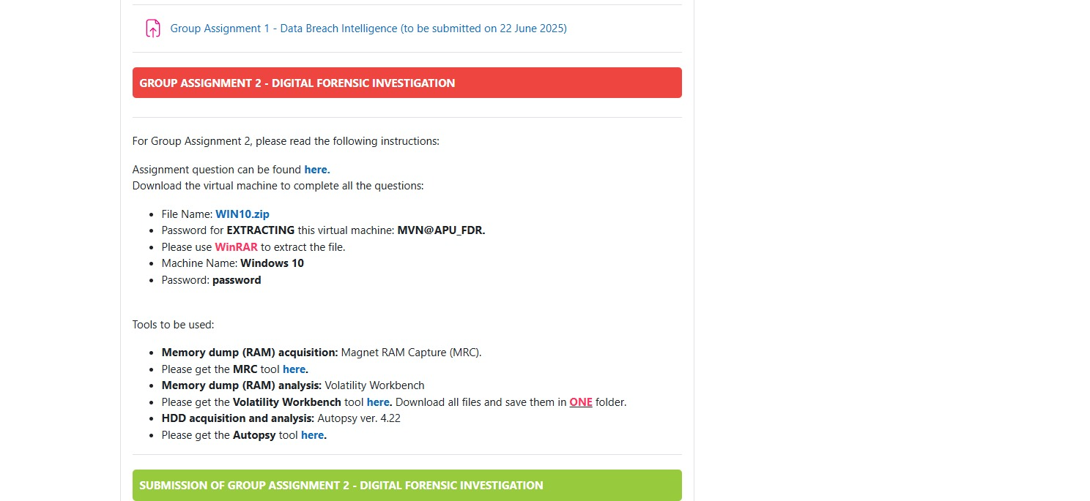
Figure 1 — Laboratory brief: target image (WIN10.zip), extraction password, and approved toolset.

Step 4.2.2 — Boot the Target VM
The "infected" Windows 10 virtual machine was booted in the isolated lab network and logged in under the local account maryam.var. Working inside a VM guarantees the acquisition is performed in a controlled, reversible environment with no exposure to production systems.
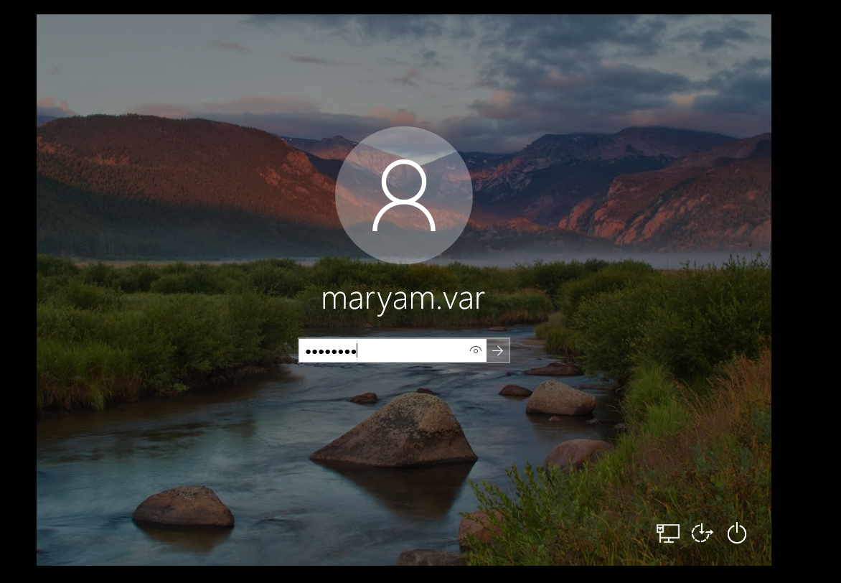
Figure 2 — Target Windows 10 VM logged in as user maryam.var.

Step 4.2.3 — Establish a Reliable Time Baseline
Before acquiring any evidence, the system clock and locale were verified so that all recorded timestamps are accurate and explainable. The time zone was set to (UTC+03:00) Nairobi and the region/location was set to Djibouti. Accurate time configuration is a chain-of-custody fundamental: every artifact timestamp later relies on this baseline.
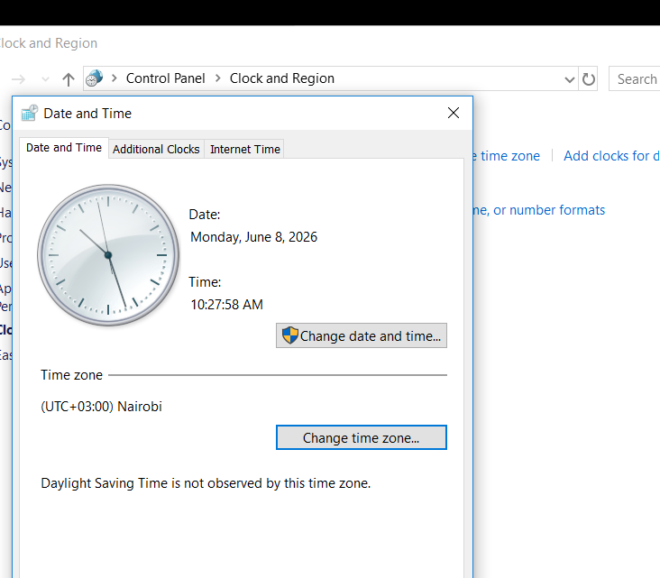
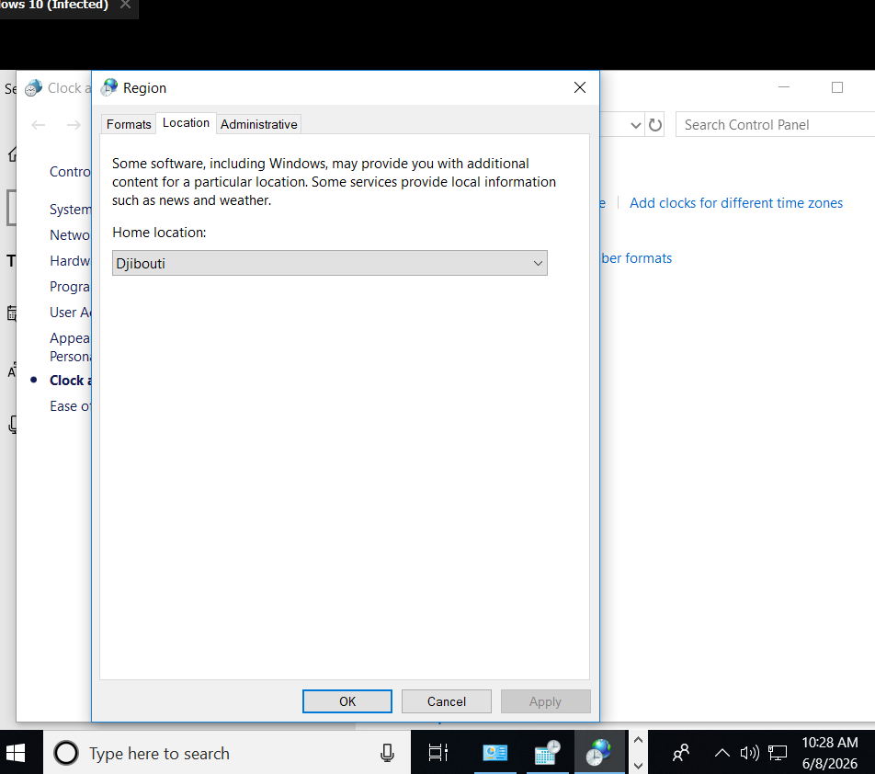
Figure 3 — Date/time set to UTC+03:00 and region set to Djibouti.

Step 4.2.4 — Synchronise with an Internet Time Source
The clock was then synchronised against an authoritative Internet time source (time.windows.com) to confirm the host time was correct at the moment of acquisition.
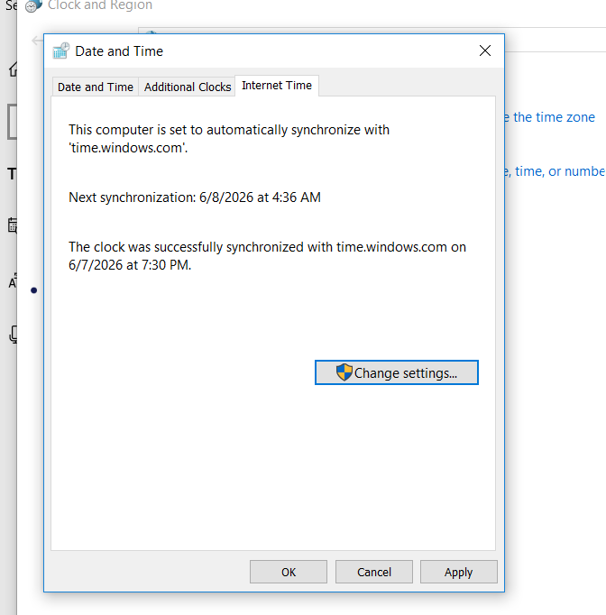
Figure 4 — Internet time synchronisation confirmed.
Settings ▸ Date & Time ▸ Internet Time ▸ Synchronize with time.windows.com

4.3 Evidence Folder Structure

Step 4.3.1 — Create the Evidence Folder Structure
A structured set of evidence folders was created so that each class of artefact is stored separately and the case remains organised and auditable. Separating memory, artefacts, disk image, and documentation keeps the chain of custody clear.
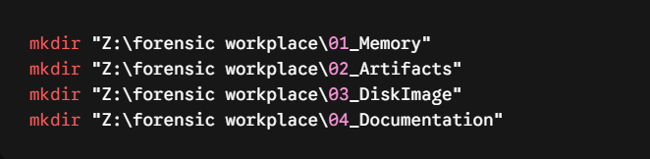
Figure 5 — Creating the evidence directory structure from the command line.
mkdir "Z:\forensic workplace\01_Memory"
mkdir "Z:\forensic workplace\02_Artifacts"
mkdir "Z:\forensic workplace\03_DiskImage"
mkdir "Z:\forensic workplace\04_Documentation"

Step 4.3.2 — Confirm the Folder Structure
File Explorer was used to confirm the four evidence folders were created correctly before acquisition began.
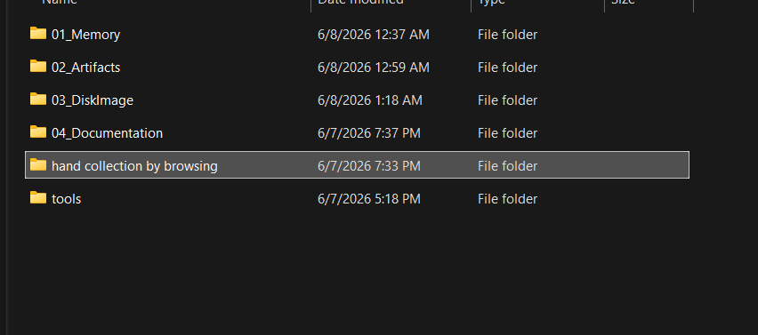
Figure 6 — Evidence folder structure in File Explorer (01_Memory, 02_Artifacts, 03_DiskImage, 04_Documentation, and supporting collection/tools folders).

4.4 Memory Acquisition (RAM Dump)

Step 4.4.1 — Memory Acquisition (RAM Dump) with DumpIt
Volatile memory was captured first, because RAM is lost on power-off and can contain encryption keys, running processes, network connections, and injected malware. DumpIt was used to produce a raw, full-physical-memory image written to the 01_Memory folder. Capturing memory before touching the disk preserves the most fragile evidence first — the order-of-volatility principle.
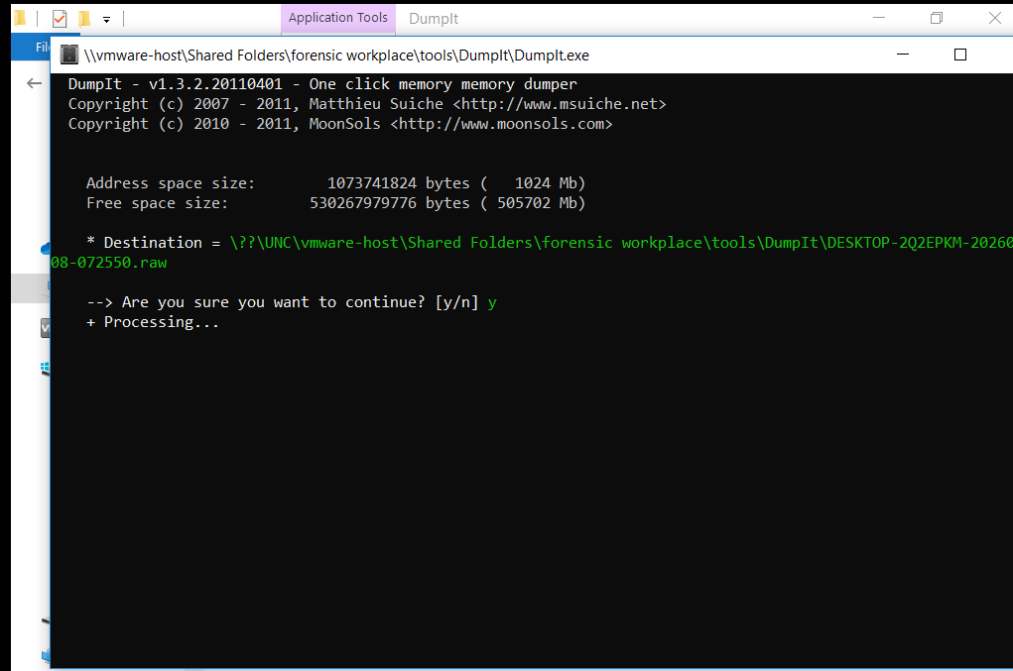
Figure 7 — DumpIt acquiring a raw physical memory image (.raw).
DumpIt.exe → output: 01_Memory\DESKTOP-2Q2EPKM-<timestamp>.raw

4.5 Triage Collection with KAPE

Step 4.5.1 — Triage Artefact Collection with KAPE
KAPE (Kroll Artifact Parser and Extractor) was run to collect a targeted set of high-value Windows artefacts (registry hives, event logs, prefetch, LNK files, browser data, and more) without imaging the whole disk. The KapeTriage compound target was used, collecting 1,003 files into the 02_Artifacts folder. Triage collection provides fast access to the most relevant artefacts while the full disk image is prepared.
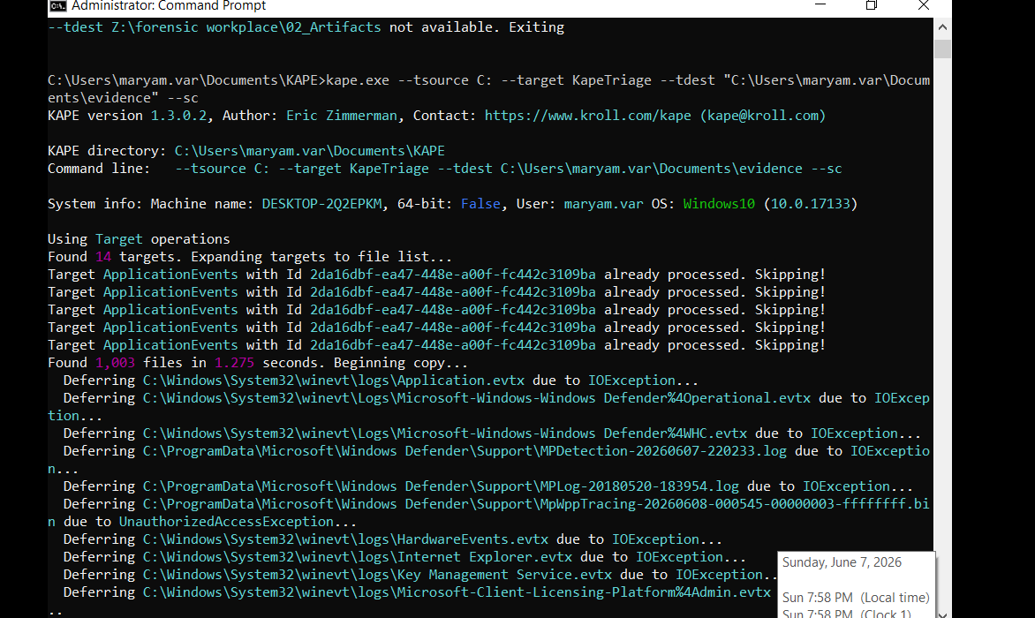
Figure 8 — KAPE triage collection using the KapeTriage target.
kape.exe --tsource C: --target KapeTriage --tdest .\02_Artifacts --tflush --sc

4.6 Disk Image Acquisition with FTK Imager

Step 4.6.1 — Disk Imaging with FTK Imager: Select Source
A full forensic disk image was then acquired with FTK Imager. The acquisition was started by selecting the source as a Physical Drive, so the entire physical disk — including unallocated space and deleted data — is captured rather than just live files.
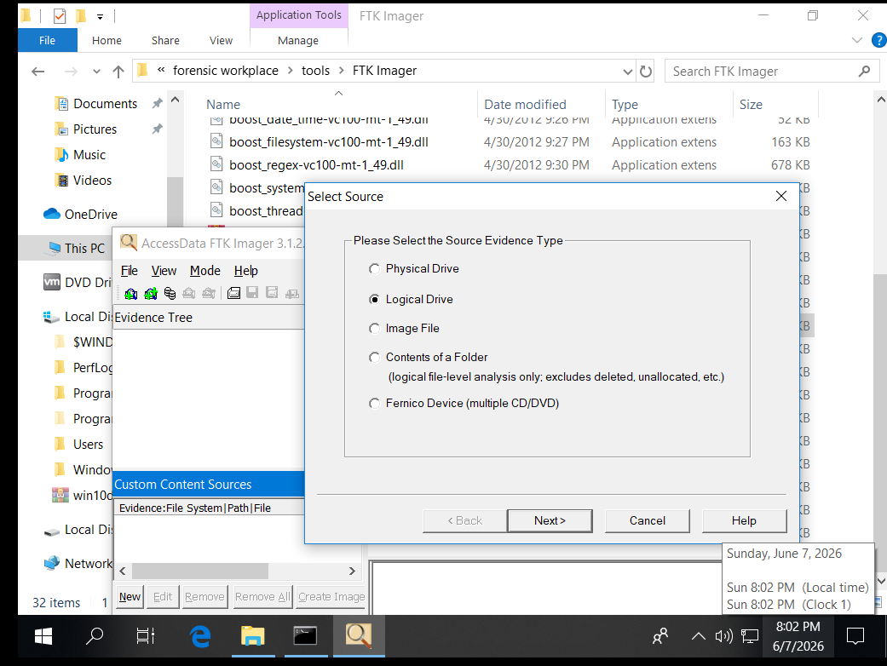
Figure 9 — FTK Imager: selecting the physical drive as the evidence source.
FTK Imager ▸ File ▸ Create Disk Image ▸ Physical Drive

Step 4.6.2 — Select the E01 Image Format
The image type was set to E01 (EnCase Expert Witness Format). E01 is the forensic standard: it compresses the image, stores case metadata inside the file, and embeds verification hashes so any later tampering is detectable.
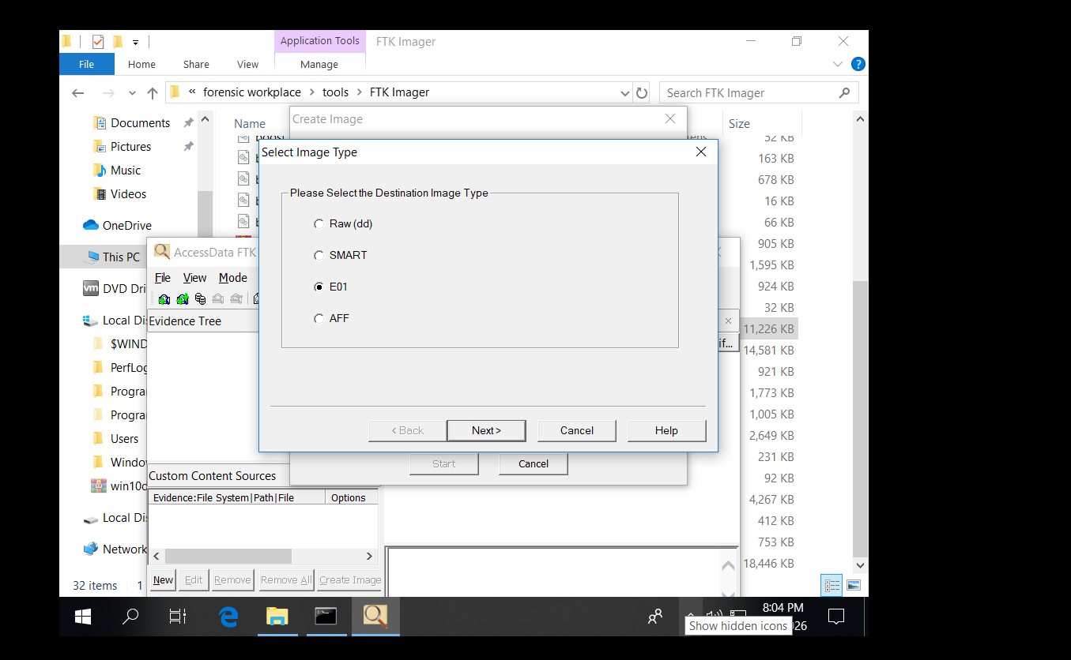
Figure 10 — FTK Imager: selecting the E01 (Expert Witness) image format.

Step 4.6.3 — Record Chain-of-Custody Evidence Details
Before imaging, the case and examiner details were entered directly into the image metadata — case number, evidence number, unique description, and examiner name. Recording the examiner (kassim, under ANC) inside the image itself binds the evidence to the person who acquired it, satisfying chain-of-custody requirements.
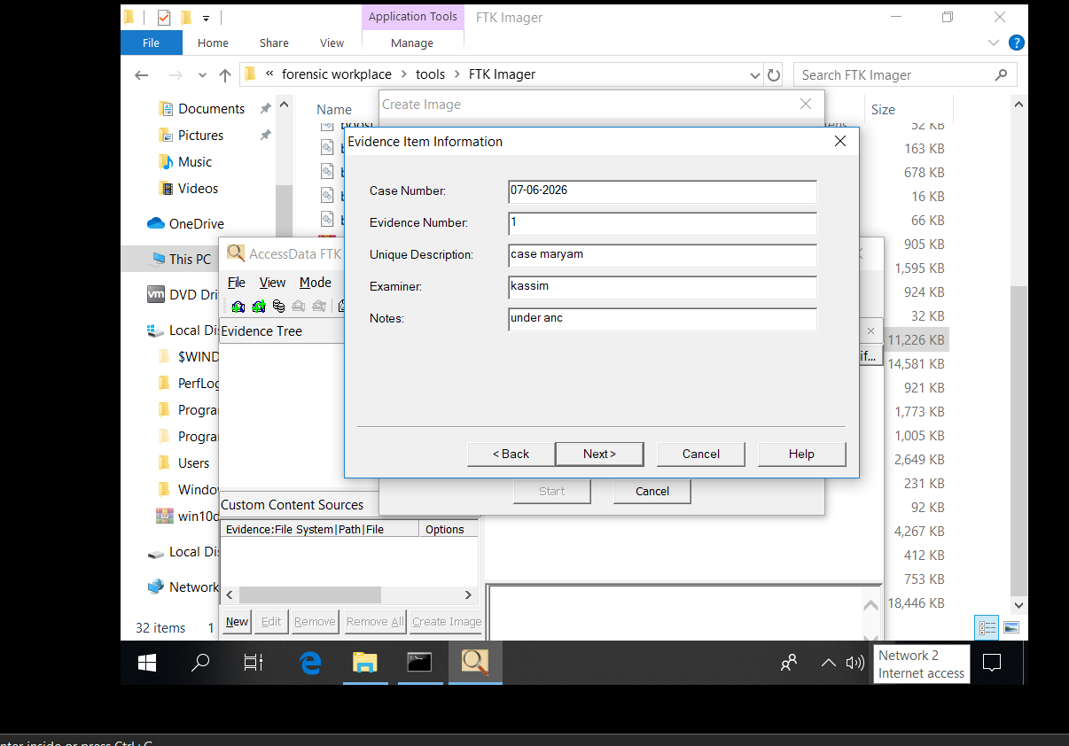
Figure 11 — FTK Imager evidence item information (Examiner: kassim, ANC).

Step 4.6.4 — Acquire the Disk Image
FTK Imager then read the physical drive sector-by-sector and wrote the E01 image into the 03_DiskImage folder. The source was mounted read-only throughout, so the original evidence drive was never modified.
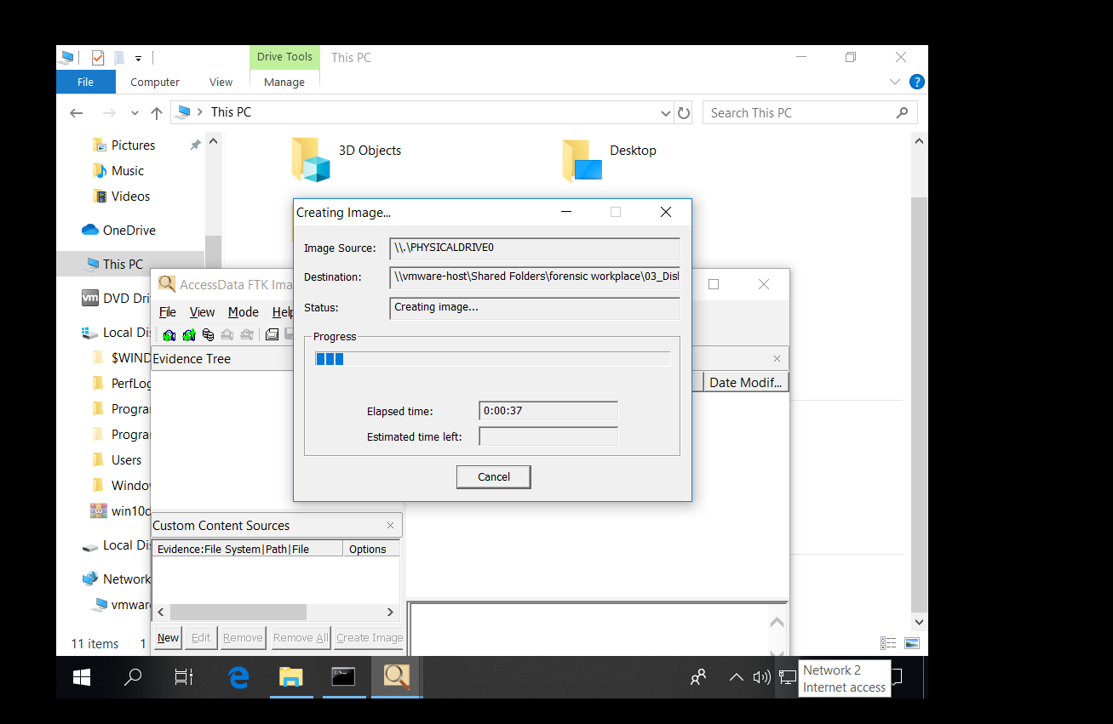
Figure 12 — FTK Imager creating the E01 image from the physical drive.
Source: \\.\PHYSICALDRIVE0 → Destination: 03_DiskImage\Host_C_Drive_Image_mayram.E01

4.7 Integrity Verification (Hashing)

Step 4.7.1 — Verify Image Integrity (MD5 / SHA-1)
When imaging finished, FTK Imager automatically computed hashes of the source drive and the created image and compared them. Both the MD5 and SHA-1 values matched, and no bad sectors were found — proving the image is a bit-for-bit, unaltered copy of the original. This verification is the core of chain of custody: it lets the examiner prove in court that the evidence was not changed.
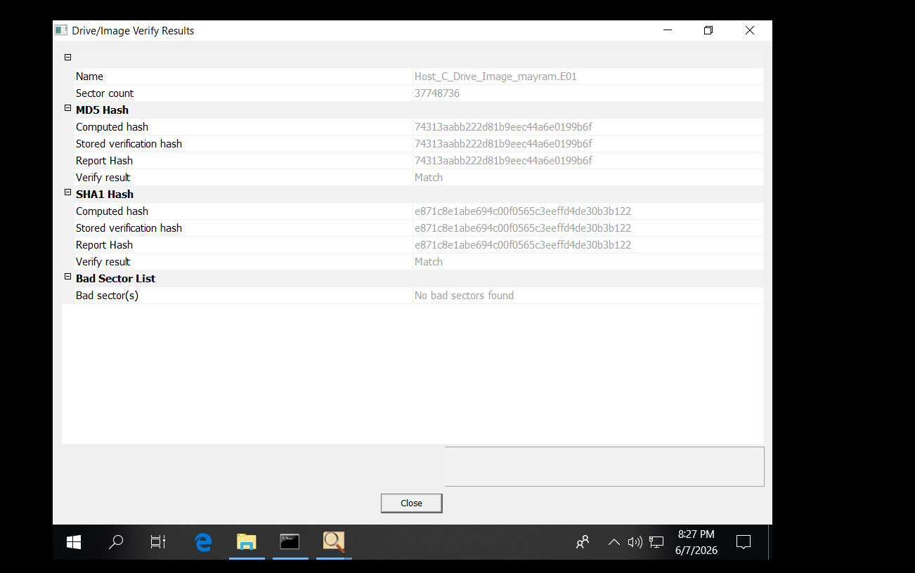
Figure 13 — FTK Imager verify results: MD5 and SHA-1 hashes Match.
MD5 : 74313aabb222d81b9eec44a6e0199b6f
SHA1 : e871c8e1abe694c00f0565c3eeffd4de30b3b122
Result: MATCH — no bad sectors

Step 4.7.2 — Independently Hash the Memory Image (SHA-256)
Finally, the acquired memory image was independently hashed with Windows certutil to record a SHA-256 value for the RAM dump. Keeping a recorded hash of every acquired item means each piece of evidence can later be re-verified to confirm it has not been altered in storage.
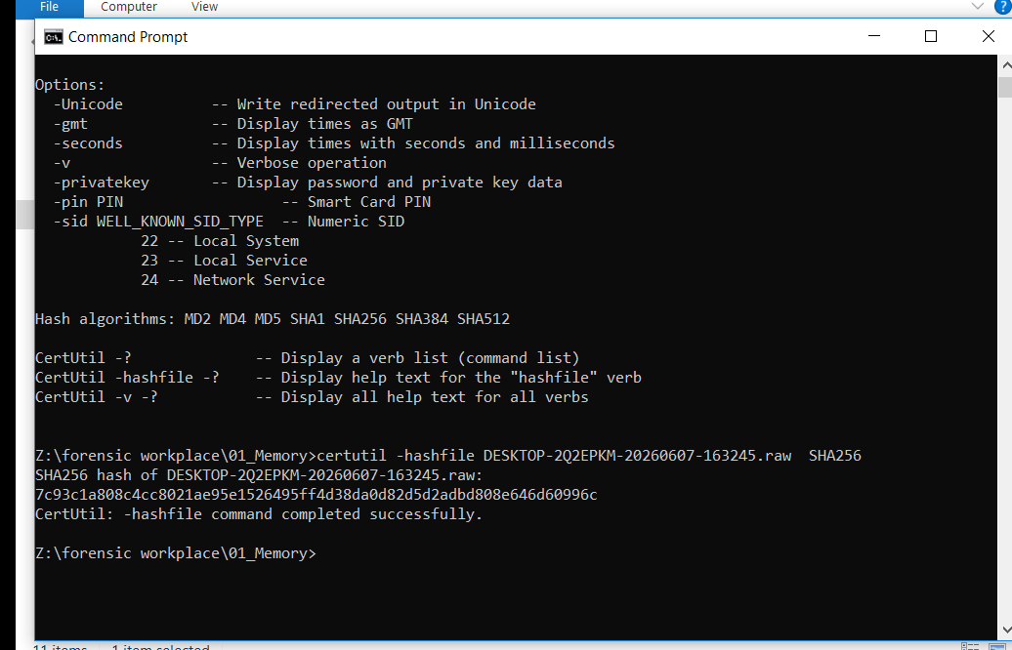
Figure 14 — certutil computing the SHA-256 hash of the memory image.
certutil -hashfile DESKTOP-2Q2EPKM-<timestamp>.raw SHA256
SHA256: 7c93c1a808c4cc8021ae95e1526495ff4d38da0d82d5d2adbd808e646d60996c

4.8 Supporting Document Collection & Malware Triage
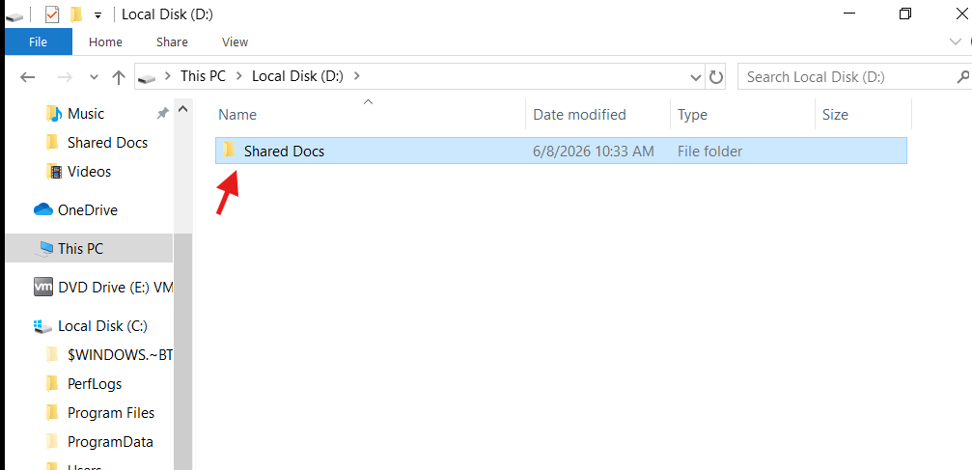
Figure 15 — Locating the user document store on the D:\ “Shared Docs” volume.

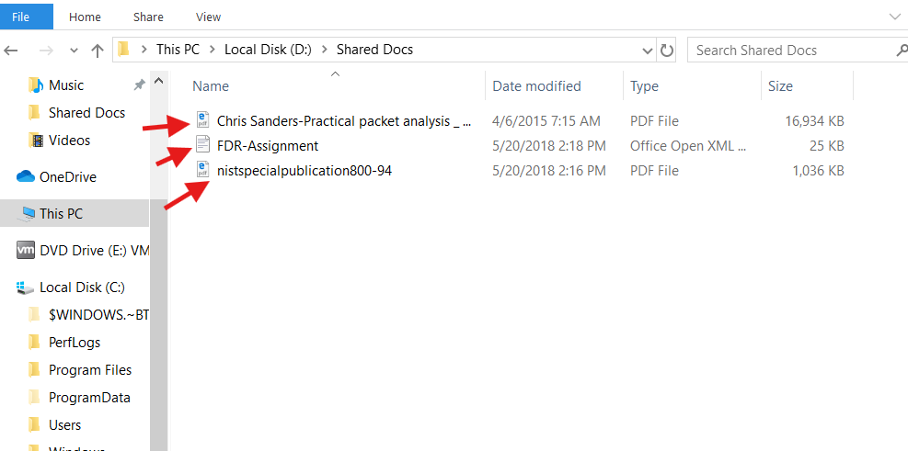
Figure 16 — “Shared Docs” folder contents selected for collection (Practical Packet Analysis, FDR-Assignment, NIST SP 800-94).

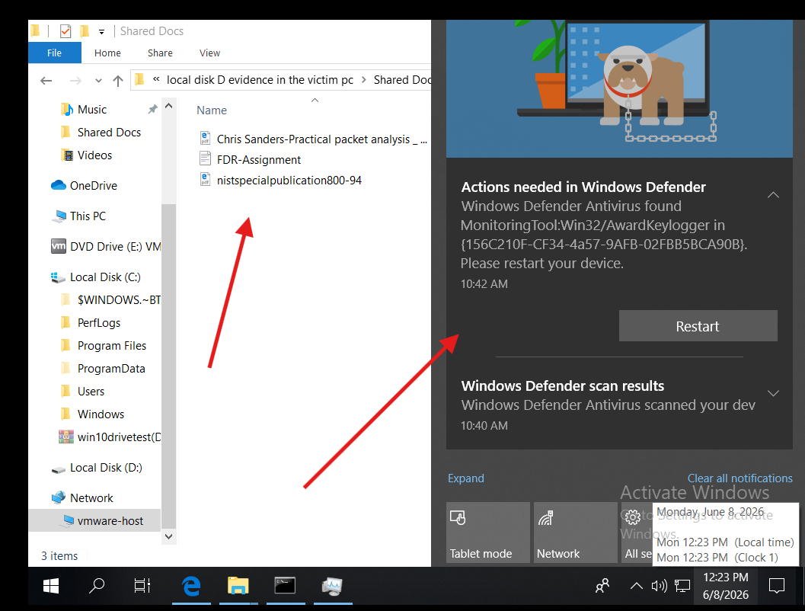
Figure 17 — Windows Defender flagged one of the files as malware during the copy attempt.
While trying to copy these it flag by window defender that file are malware file so I decide to verify with hybrid malware
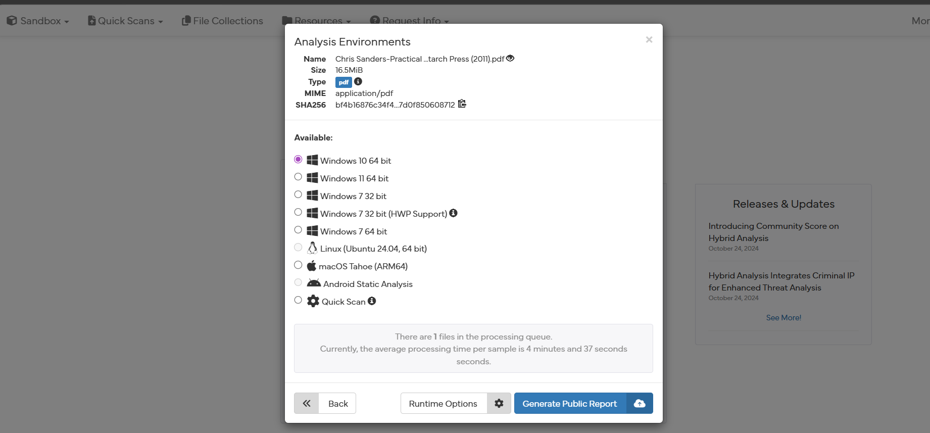
Figure 18 — Submitting the sample to the Hybrid Analysis sandbox and selecting the Windows 10 (64-bit) environment.
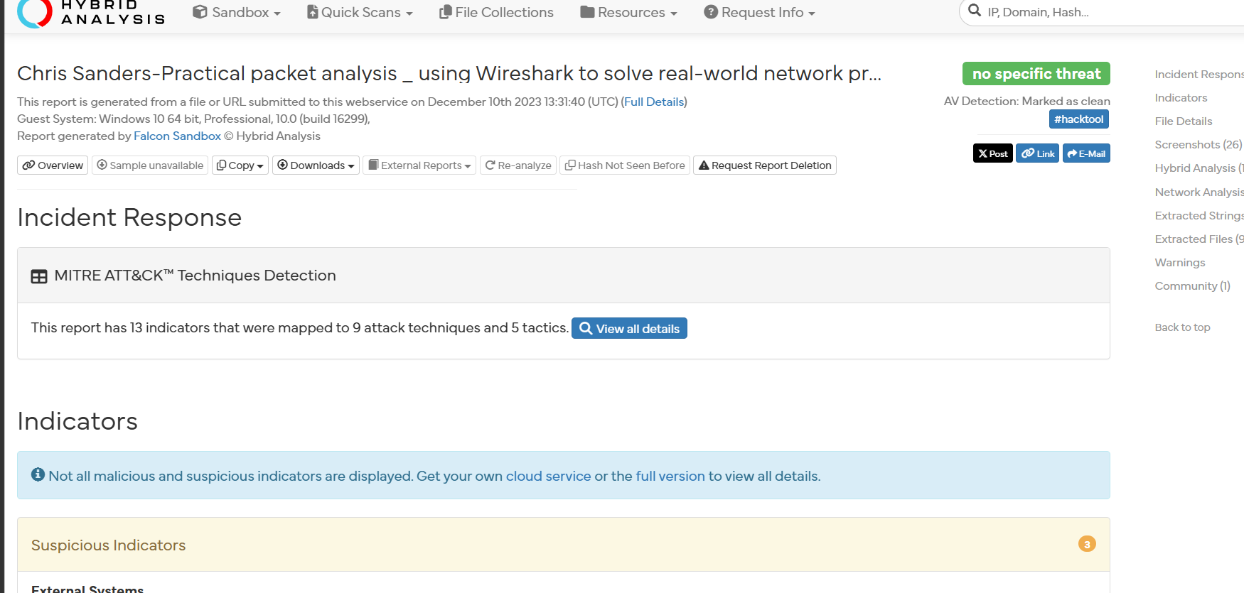
Figure 19 — Hybrid Analysis report: incident-response overview and MITRE ATT&CK technique mapping.

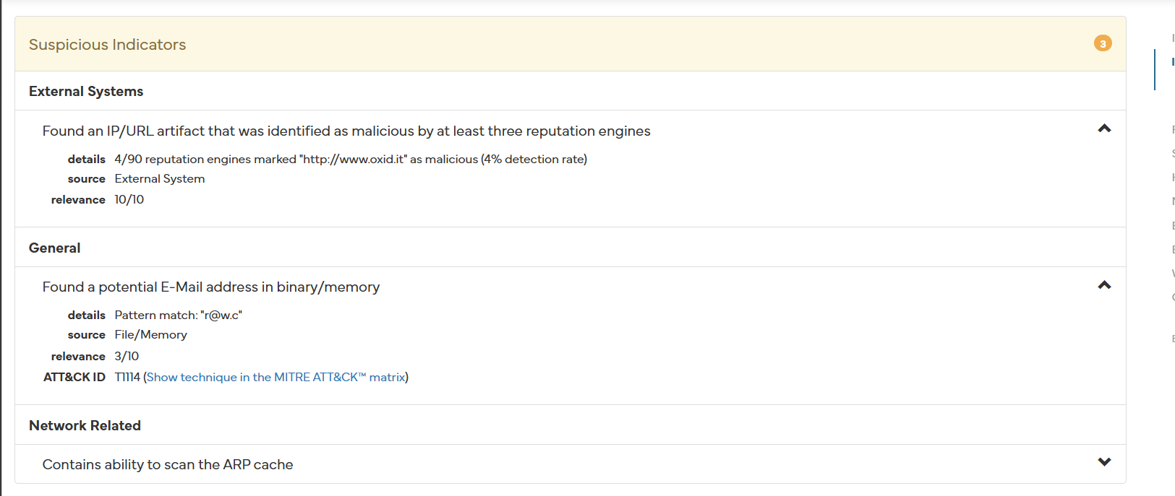
Figure 20 — Hybrid Analysis suspicious-indicator detail (malicious URL reputation, e-mail artefact, ARP-scan capability).

Forensic Analysis Runbook — CASE-2026-001
You have already completed acquisition (RAM via DumpIt, triage artifacts via KAPE, full disk image via FTK Imager, hashes verified). This runbook covers the analysis phase: turning that evidence into findings, mapped to MITRE ATT&CK and consolidated into a defensible report.
Work follows the same logic as collection: most volatile first (memory), then the disk artifacts, then deep static/dynamic analysis only if you find a suspect binary.

Phase 0 — Before you touch anything
These three habits are what separate "playing with tools" from a professional examination.
- Re-verify integrity. Re-hash your image and memory dump and confirm they match the values recorded in Chain_of_Custody.txt. If they don't match, stop — your evidence is compromised.
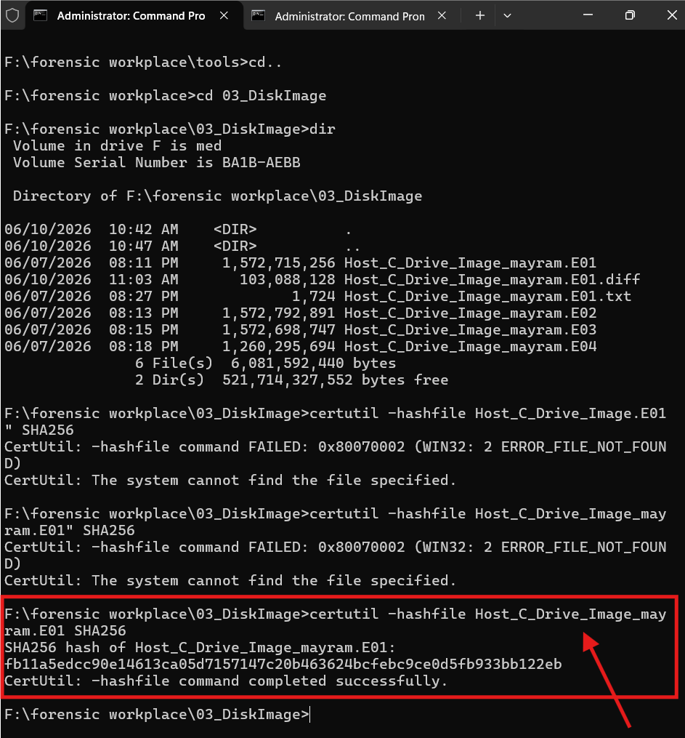
Figure 21 — Re-verifying the disk image hash (SHA-256) with certutil before starting analysis.

2. Never analyze the original. Always work on a copy or on a read-only mount. The disk image is the master; analysis output goes to a separate working folder.
Here is an cmd can help you : mkdir "Z:\forensic workplace\05_Analysis"

In our case i named analyse case
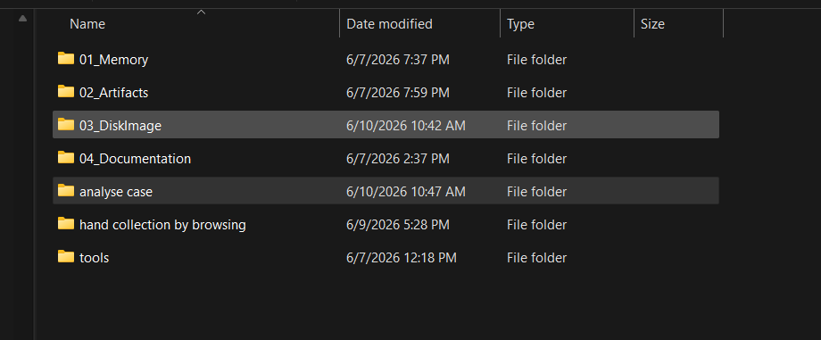
Figure 22 — Analysis workspace folders, including the dedicated “analyse case” working copy.

Document as you go. Use Joplin (you have it installed) as your case notebook. For every finding record: the artifact source, the tool and exact command used, the timestamp (always note the timezone — convert to UTC), and your interpretation. A finding you can't trace back to a source is not a finding.

5. Executive Summary
The provided evidence package contains a Windows host KAPE-style artifact collection, memory dumps, and a segmented E01 disk image. Automated triage and manual review of provided timelines, event logs, filesystem metadata, and suspicious artifact hits indicate a Windows host named DESKTOP-2Q2EPKM with user maryam.var. The strongest findings are Microsoft Defender detections for Award Keylogger/ProKAward, trojan downloads loder.exe and updsto.exe, AutoKMS hacktool persistence, Defender tampering indicators, and DLLInjector/CryptInject activity. All conclusions should be validated in a Windows forensic workstation using the included Eric Zimmerman tools for full artifact parsing.

6. Evidence Summary and Hashes
Evidence | Path | SHA256 | MD5 | Size
tools.zip | /home/kassim/Desktop/tools.zip | 434b8cc3354b4ffd6ba8c713e52e531af516de8d1282fda120e276570fcf6fe9 | d8dc74f19685554342e9d135bd3db2e8 | 3420326145
analyse case.zip | /home/kassim/Desktop/analyse case.zip | e764dd821dc6e83091c64edbb619d48e47192c591cd4d74df834776194ac8bb3 | f58b7447611015d019b5ba555f6f3fce | 7022737174
Evidence handling rule: original ZIPs remain in place. Analysis was performed inside 02_Working_Copy. Keep originals read-only and record every access in chain_of_custody.csv and case_notes.md.

7. Screenshots / Evidence Proof
Hash verification
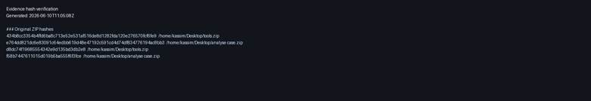
ZIP structure
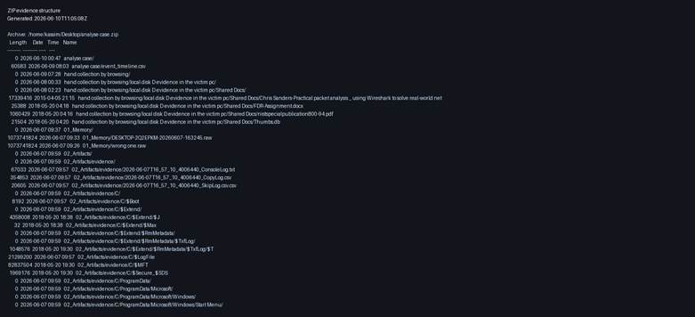
Disk validation
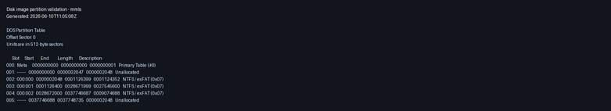
Defender detections
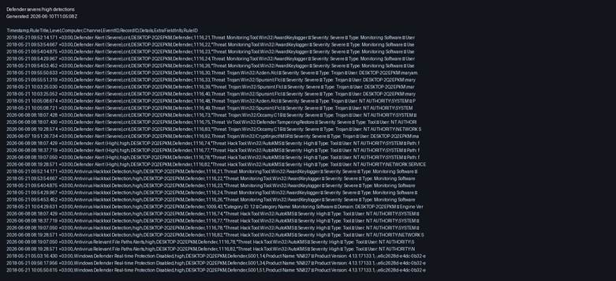
Volatility memory validation
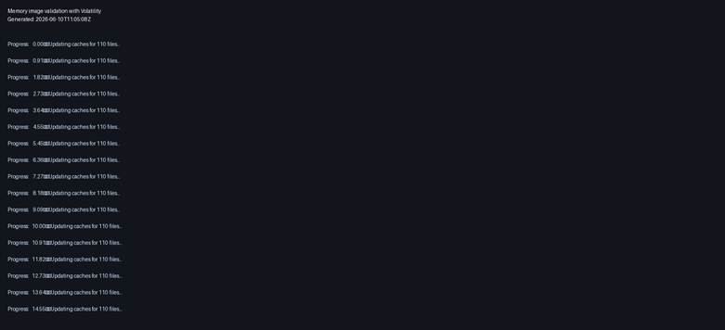

8. Adapted Methodology: 17 DFIR Phases

8.1 Case preparation and evidence verification
Objective: prove evidence identity and integrity before analysis. Tool: sha256sum/md5sum or PowerShell Get-FileHash. Input: original ZIP files. Output: 01_Evidence_Hashes/original_zip_hashes.txt. Look for stable hashes and unchanged originals. Report finding: list evidence IDs, hashes, sizes, and custody.

8.2 Evidence organization
Objective: separate originals, working copy, outputs, timelines, IOCs, notes, and report. Tool: mkdir/PowerShell New-Item. Input: ZIPs. Output: DFIR_ANALYSIS_CASE_MARYAM folder. Look for clean case structure. Report finding: evidence was analyzed from working copy.

8.3 Disk image or mounted evidence validation
Objective: verify E01 and identify partitions. Tool used: mmls/fsstat. Command: mmls Host_C_Drive_Image_mayram.E01; fsstat -o 1126400 Host_C_Drive_Image_mayram.E01. Output: mmls_disk_image.txt, fsstat_offset_1126400.txt. Result: NTFS partitions found; offset 1126400 contains Windows root directories.

8.4 File system analysis
Objective: list root files, user folders, system directories, and suspicious files. Tool used: fls and file inventory. Command: fls -o 1126400 Host_C_Drive_Image_mayram.E01. Output: fls_root_C_partition.txt and evidence_inventory.csv. Look for Program Files, Users, Windows, Downloads, unusual ZIPs/files.

8.5 Windows Registry analysis
Objective: extract OS, computer name, USB, persistence, Defender policy, services. Tool: regipy locally; on Windows use RECmd/Registry Explorer/RegRipper. Input: SYSTEM, SOFTWARE, NTUSER.DAT hives. Output: registry_summary.csv. Look for Run keys, services, USBSTOR, Defender tamper policy, KMSAuto task/service registry.

8.6 Event log analysis
Objective: detect logons, malware detections, service/task creation, PowerShell, Defender changes. Tool: python-evtx locally; on Windows use EvtxECmd/Zircolite. Output: evtx_important_events.csv and defender_alerts_from_existing_timeline.csv. Look for EventID 1116, 1117, 5007, 7045, 4698, 4624, PowerShell 4104.

8.7 User activity analysis
Objective: identify user maryam.var actions via Recent LNK, Jump Lists, ActivitiesCache, browser artifacts, Downloads. Tool: LECmd/JLECmd/SQLECmd/Timeline Explorer. Output: lnk_recent_files.csv. Look for KMSAuto LNK and accessed downloaded files.

8.8 Executed program analysis
Objective: prove program execution. Tool: PECmd, AmcacheParser, AppCompatCacheParser. Local output: prefetch_listing.csv. Look for powershell.exe, DumpIt.exe, rundll32.exe, KMS/ProKAward executables if present.

8.9 USB and external device analysis
Objective: identify attached USB devices. Tool: RECmd/Registry Explorer against SYSTEM USBSTOR and USB keys; Event Logs UserPnp/DeviceInstall. Output: registry_summary.csv. Missing artifact interpretation: if USBSTOR empty, check setupapi.dev.log and UserPnp logs.

8.10 Network artifact analysis
Objective: identify remote hosts/domains. Tool: SRUM via SrumECmd, firewall logs, DNS cache if collected, browser/WebCache; memory netscan if RAM works. Output: iocs.csv. Found domain: weeknews.pro from Defender webfile telemetry.

8.11 Browser and download history analysis
Objective: determine source of downloaded malicious files. Tool: BrowsingHistoryView, ESEDatabaseView, WebCacheV01 parsing, SQLECmd for SQLite. Input: WebCache and browser folders. Output: browser history CSV. Look for URL http://weeknews.pro/images/updsto.exe and downloaded files loder.exe/updsto.exe.

8.12 Persistence mechanism analysis
Objective: identify auto-start mechanisms. Tool: Autoruns, RECmd, EvtxECmd, Defender timeline. Evidence: SKLProService, KMSEmulator, KMSAutoNet scheduled task. Report as persistence/high-risk execution support.

8.13 Malware or suspicious file triage
Objective: hash, classify, and safely inspect suspicious files. Tool: sha256sum/Get-FileHash, strings, YARA, PEStudio/DIE. Input: copied suspicious files if present. Output: iocs.csv and hashes. In this KAPE set, actual loder/updsto/ProKAward binaries are not present, so findings rely on Defender telemetry and disk image should be carved/extracted if required.

8.14 Timeline creation
Objective: correlate events, files, execution, downloads. Tool: Timeline Explorer; locally master_timeline.csv. Input: event_timeline.csv, evtx, prefetch, LNK. Output: 05_Timeline/master_timeline.csv. Look for sequence: 2018 Defender keylogger/trojan detections and 2026 collection/reactivation detections.

8.15 Indicators of Compromise extraction
Objective: produce actionable IOCs. Tool: regex extraction, IOC CSV, hashes. Output: 06_IOCs/iocs.csv. Look for paths, domains, service names, scheduled task names, malware names.

8.16 Findings summary
Objective: convert artifacts into defensible findings with evidence and confidence. Tool: findings.csv. Output: parsed findings and report. Look for artifact > evidence > interpretation chain.

8.17 Final professional forensic report
Objective: document scope, evidence, methodology, findings, timeline, IOCs, limitations, and recommendations. Tool: python-docx. Output: this DOCX report.

9. Key Findings
ID | Finding | Severity | Evidence | Professional Interpretation
F-001 | Commercial keylogger / monitoring tool detected | High | Defender EventID 1116; paths under C:\Program Files\ProKAward; service SKLProService; files wap.exe and rsasws.exe | Microsoft Defender identified MonitoringTool:Win32/AwardKeylogger and later Occamy on ProKAward components. Presence of service SKLProService suggests persistence/execution as a service.
F-002 | Downloaded Trojan files from web source | High | Defender EventID 1116 records for loder.exe and updsto.exe; URL http://weeknews.pro/images/updsto.exe | The user profile maryam.var downloaded or attempted to download trojan-classified executables in Downloads. Defender linked updsto.exe to weeknews.pro.
F-003 | HackTool AutoKMS with scheduled task/service persistence | Medium/High | Defender EventID 1116; KMSAutoNet scheduled task; KMSEmulator service; recent LNK for KMSAuto.Net.2016 | AutoKMS is a high-risk hacktool often used for unauthorized activation. Defender observed service and scheduled task artifacts indicating persistence.
F-004 | Defender tampering indicator observed | High | Defender EventID 1116 VirTool:Win32/DefenderTamperingRestore; registry value DisableOnAccessProtection | A registry value affecting real-time protection was detected/restored by Defender. This may indicate attempted AV weakening.
F-005 | DLL injector / CryptInject detected in Downloads | High | Defender EventID 1116 for C:\Users\maryam.var\Downloads\DLLInjector v2.exe | A DLL injector can be used for process injection, evasion, or malware execution. Defender classified it as Trojan/CryptInject.

10. IOC Summary

Type | Value | Source | Note
URL | http://weeknews.pro/images/updsto.exe | Timeline/Events | Observed in Defender telemetry.
URL | https://go.microsoft.com/fwlink/?linkid=37020&name=HackTool:Win32/AutoKMS... | Timeline/Events | Defender link for AutoKMS detection.
URL | https://go.microsoft.com/fwlink/?linkid=37020&name=MonitoringTool:Win32/AwardKeylogger... | Timeline/Events | Defender link for AwardKeylogger.
URL | https://go.microsoft.com/fwlink/?linkid=37020&name=Trojan:Win32/Azden.A!cl... | Timeline/Events | Defender link for Azden Trojan.
URL | https://go.microsoft.com/fwlink/?linkid=37020&name=Trojan:Win32/CryptInject!MSR... | Timeline/Events | Defender link for CryptInject.
URL | https://go.microsoft.com/fwlink/?linkid=37020&name=Trojan:Win32/Occamy.C1B... | Timeline/Events | Defender link for Occamy Trojan.
URL | https://go.microsoft.com/fwlink/?linkid=37020&name=Trojan:Win32/Spursint.F!cl... | Timeline/Events | Defender link for Spursint Trojan.
URL | https://go.microsoft.com/fwlink/?linkid=37020&name=VirTool:Win32/DefenderTamperingRestore... | Timeline/Events | Defender link for Tampering detection.
Domain | weeknews.pro | Timeline/Events | Observed malware delivery domain.
Full IOC CSV: /home/kassim/Desktop/DFIR_ANALYSIS_CASE_MARYAM/06_IOCs/iocs.csv

11. Timeline Summary
/home/kassim/Desktop/DFIR_ANALYSIS_CASE_MARYAM/05_Timeline/master_timeline.csv. Important observed periods include 2018-05-21 Defender detections for Award Keylogger and trojans, and 2026-06-07/08 detections around AutoKMS, Defender tampering, DLLInjector, and ProKAward/Occamy.

11.1 DFIR Timeline Summary

Date/Time (+03) | Phase | Key Event | Evidence | Severity
2018-05-21 04:45:31 | Account / Privilege | Password reset for defaultuser0 by local SYSTEM/computer account. | Security Event ID 4724 | High
2018-05-21 04:53:18 | Privilege Escalation | maryam.var added to local Administrators group. | Security Event ID 4732 | Critical
2018-05-21 05:03:16 | Defense Evasion | Windows Defender real-time protection disabled. | Defender Event ID 5001 | Critical
2018-05-21 09:52:14 | Malware / Keylogger | AwardKeylogger / ProKAward detected. | Defender Event ID 1116 | Critical
2018-05-21 09:55:50 | Malware | loder.exe detected as Trojan:Win32/Azden.A!cl. | Defender Event ID 1116 | Critical
2018-05-21 10:03:25 | Malware / Download | updsto.exe linked to weeknews.pro. | Defender Event ID 1116 | Critical
2026-06-07 19:51:26 | Malware / Injection Tool | DLLInjector v2.exe detected as CryptInject. | Defender Event ID 1116 | Critical
2026-06-08 08:18:07 | Defense Evasion | Defender tampering detected through DisableOnAccessProtection. | Defender Event ID 1116 | Critical
2026-06-08 10:23:37 | Execution | PowerShell Prefetch artifact observed. | POWERSHELL.EXE Prefetch | Medium
2026-06-08 10:26:02 | Collection / Forensic Tool | DumpIt Prefetch artifact observed. | DUMPIT.EXE Prefetch | Medium

12. Professional Finding Wording for Report
F-001: Defender telemetry shows a severe detection for MonitoringTool:Win32/AwardKeylogger affecting C:\Program Files\ProKAward components, including wap.exe and rsasws.exe. This supports a finding of keylogger/monitoring software present on the host.
F-002: Defender telemetry identified Trojan:Win32/Azden.A!cl at C:\Users\maryam.var\Downloads\loder.exe and Trojan:Win32/Spursint.F!cl at C:\Users\maryam.var\Downloads\updsto.exe. The latter was associated with http://weeknews.pro/images/updsto.exe.
F-003: Defender telemetry identified HackTool:Win32/AutoKMS involving C:\ProgramData\KMSAutoS, service KMSEmulator, and scheduled task C:\Windows\System32\Tasks\KMSAutoNet.
F-004: Defender detected VirTool:Win32/DefenderTamperingRestore referencing HKLM\Software\Policies\Microsoft\Windows Defender\Real-Time Protection\DisableOnAccessProtection.
F-005: Defender telemetry identified Trojan:Win32/CryptInject!MSR for DLLInjector v2.exe in the maryam.var Downloads folder.

13. Limitations
Volatility 3 could not satisfy kernel/symbol requirements for the provided raw memory images in this Linux environment; memory analysis should be retried with correct symbols/profile or Volatility 2 if appropriate. Some Windows GUI tools in tools.zip are Windows executables and were not executed on Linux. Actual malicious binaries referenced by Defender were not all present in the KAPE artifact collection; extract from disk image or use the full mounted image for file hashing if needed. Browser WebCache requires dedicated ESE parsing for full download history validation.

14. Recommended Next Steps on Windows Forensic Workstation
Get-FileHash "C:\Cases\Maryam\00_Original_Evidence\analyse case.zip" -Algorithm SHA256
EvtxECmd.exe -d "C:\Cases\Maryam\02_Working_Copy\02_Artifacts\evidence\C\Windows\System32\winevt\logs" --csv "C:\Cases\Maryam\03_Tool_Outputs\EvtxECmd"
PECmd.exe -d "C:\Cases\Maryam\02_Working_Copy\02_Artifacts\evidence\C\Windows\prefetch" --csv "C:\Cases\Maryam\03_Tool_Outputs\PECmd"
MFTECmd.exe -f "C:\Cases\Maryam\02_Working_Copy\02_Artifacts\evidence\C\$MFT" --csv "C:\Cases\Maryam\03_Tool_Outputs\MFTECmd"
RECmd.exe -f "C:\Cases\Maryam\02_Working_Copy\02_Artifacts\evidence\C\Windows\System32\config\SYSTEM" --bn BatchExamples\Registry\System.reb --csv "C:\Cases\Maryam\03_Tool_Outputs\RECmd"
AmcacheParser.exe -f "C:\Cases\Maryam\02_Working_Copy\02_Artifacts\evidence\C\Windows\AppCompat\Programs\Amcache.hve" --csv "C:\Cases\Maryam\03_Tool_Outputs\Amcache"
JLECmd.exe -d "C:\Cases\Maryam\02_Working_Copy\02_Artifacts\evidence\C\Users\maryam.var\AppData\Roaming\Microsoft\Windows\Recent" --csv "C:\Cases\Maryam\03_Tool_Outputs\JLECmd"
yara64.exe -r rules.yar "C:\Cases\Maryam\02_Working_Copy" > "C:\Cases\Maryam\03_Tool_Outputs\yara_hits.txt"

15. Conclusion
The host shows high-confidence evidence of malicious/high-risk software activity: Award Keylogger/ProKAward, trojan downloads, AutoKMS hacktool persistence, Defender tampering, and DLL injection tooling. The evidence supports an incident involving unauthorized/high-risk software execution and persistence. Remediation should include isolating the host, preserving the full disk image, extracting and hashing referenced binaries from the E01, removing persistence, rotating credentials, reviewing browser/download sources, and rebuilding the system if compromise is confirmed.

16. Event Log Timeline Analysis with Hayabusa
After completing the analysis above, the collected Windows event logs were processed with Hayabusa (Yamato Security) to build a Sigma-rule based detection timeline. The disk image was first mounted read-only, then Hayabusa was run against the event-log directory.
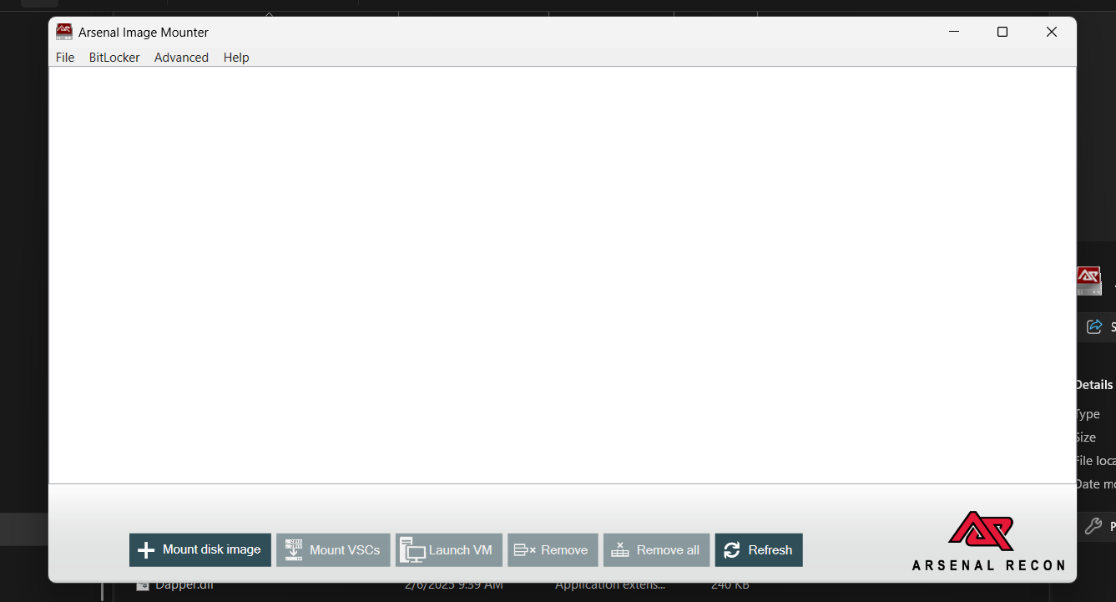
Figure 23 — Arsenal Image Mounter: preparing to mount the E01 disk image.

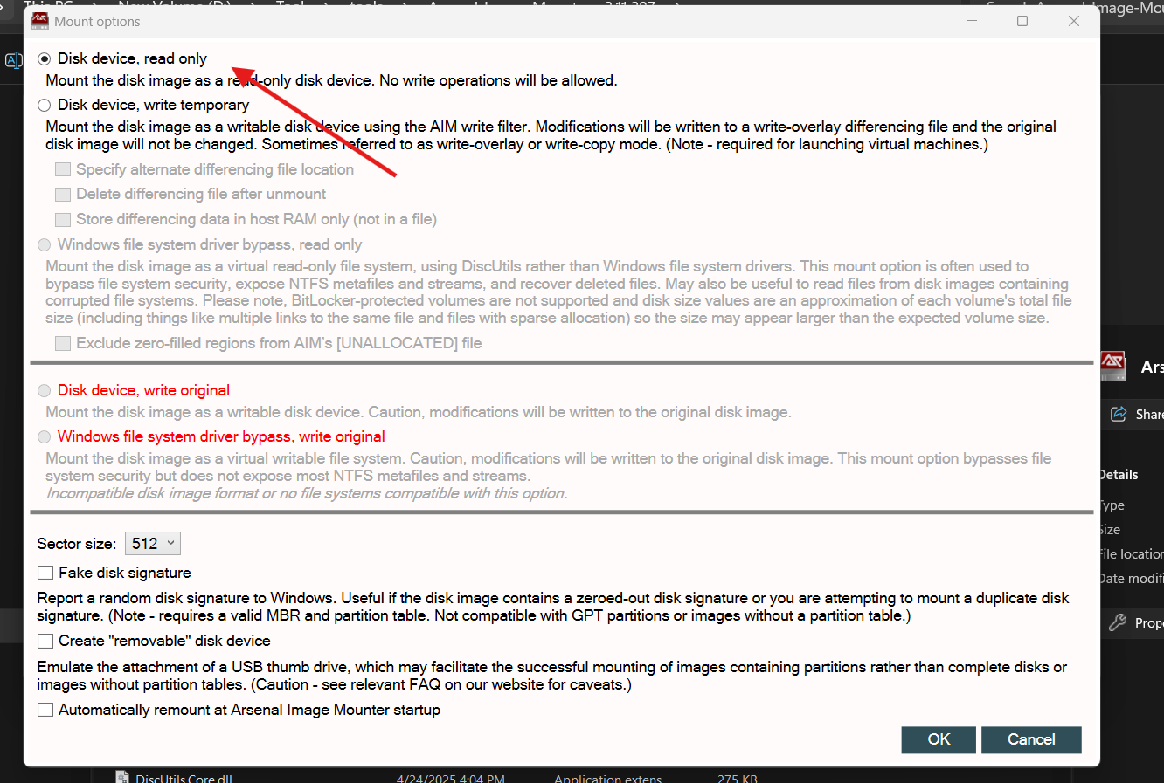
Figure 24 — Mounting the image read-only to preserve evidence integrity.
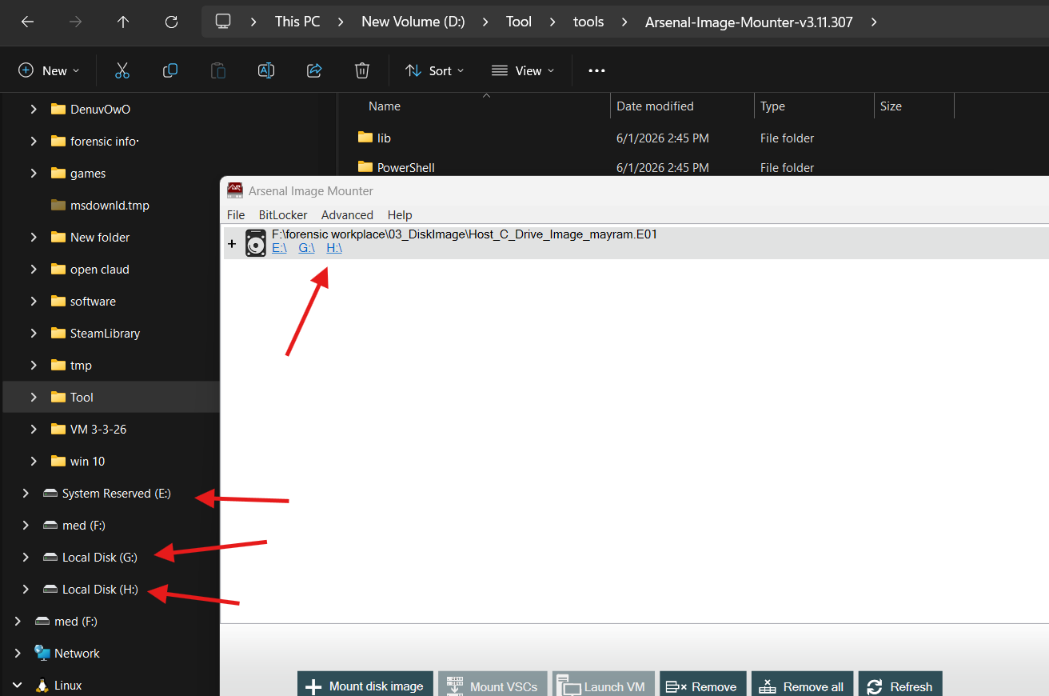
Figure 25 — Mounted E01 volumes (E:\, G:\, H:\) shown in File Explorer.

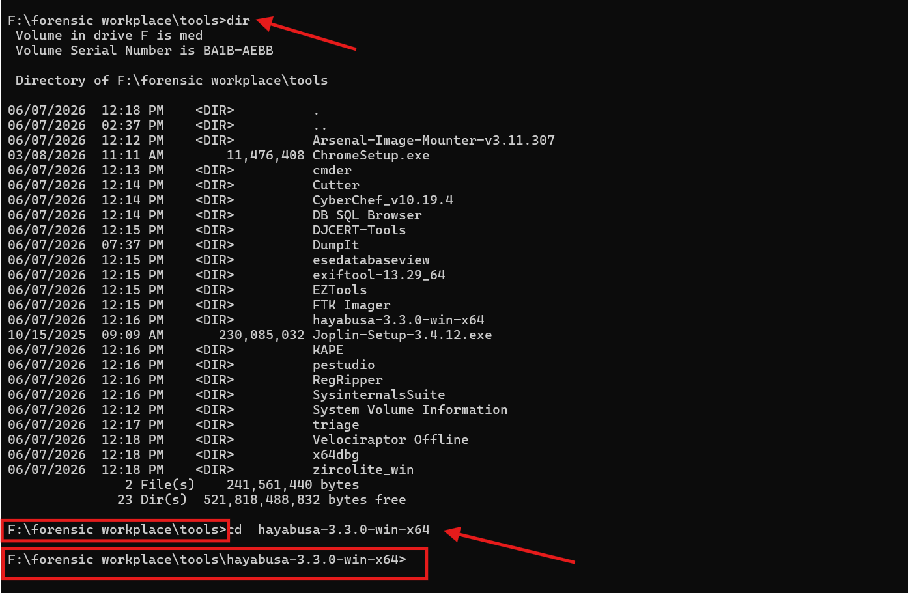
Figure 26 — Forensic tools directory; changing into the Hayabusa folder.

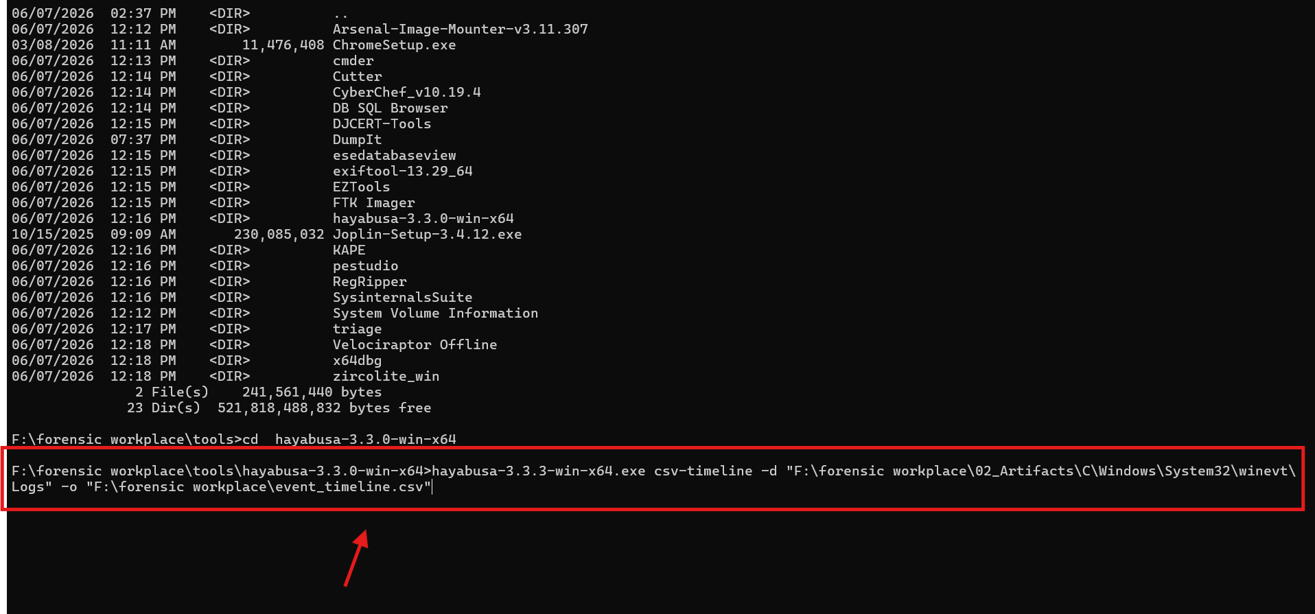
Figure 27 — Hayabusa csv-timeline command targeting the collected Windows event logs.
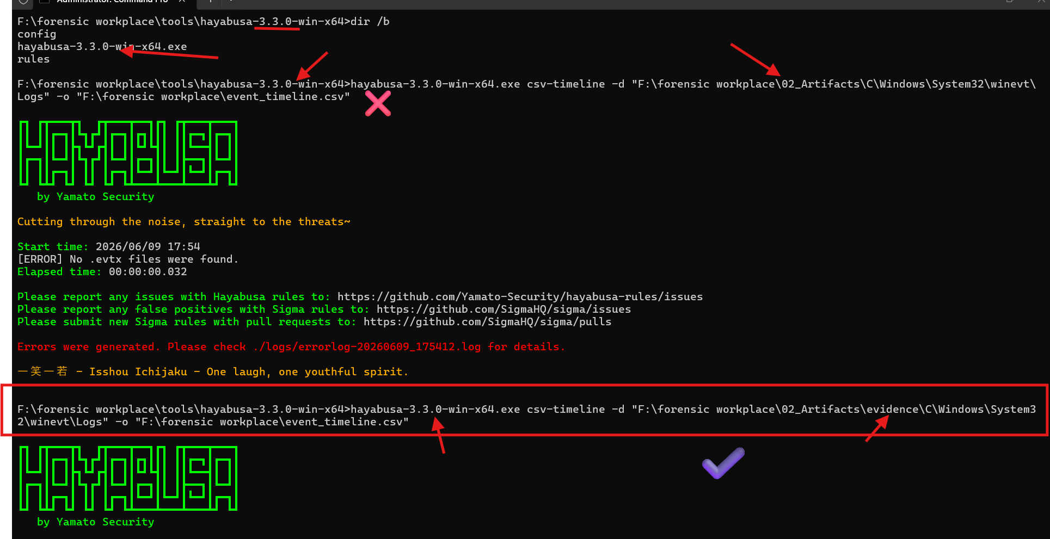
Figure 28 — First run failed (“No .evtx files were found”); the corrected path adds the \evidence\ subfolder.
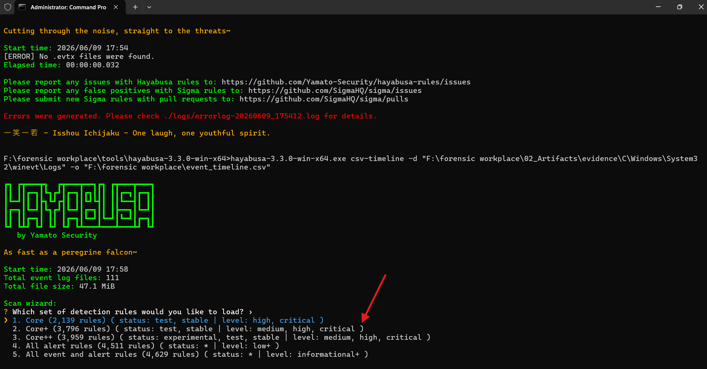
Figure 29 — Hayabusa scan wizard: choosing the Core+ detection rule set (Option 2).
Why Option 2 is the DFIR Sweet Spot
Here is a quick professional breakdown of why you should choose Core+ over the others:
- Why not Option 1 (Core)? While fast, it only looks for high and critical alerts. Threat actors frequently use techniques that are categorized as medium severity (such as initial reconnaissance commands, creating scheduled tasks, or minor registry tweaks for persistence). You will miss these if you choose option 1.
- Why Option 2 (Core+) is ideal: It adds those crucial medium severity rules but strictly uses stable and tested rules. This gives you the best signal-to-noise ratio—helping you spot lateral movement and persistence without generating thousands of annoying false positives.
- Why skip 3, 4, and 5?
  - Option 3 introduces experimental rules, which are notoriously prone to false alarms.
  - Options 4 and 5 introduce low and informational events. Because you are exporting to a CSV timeline (-o "F:\forensic workplace\event_timeline.csv"), choosing these will bloat your output file with millions of rows of standard Windows background noise, making it incredibly tedious to analyze in Excel.
Second tool you can use to perform the same action
Tool: Zircolite
If you want a second opinion on the event logs, Zircolite uses SIGMA detection rules to hunt for threat actor behaviors.
- Run Zircolite against the same log directory to output a JSON package of detections for quick review.

17. Malware Triage and Static / Dynamic Analysis Report

17.1 Executive Summary
This report documents the malware triage and basic static and dynamic analysis performed on the Windows 10 host DESKTOP-2Q2EPKM (user account maryam.var) as part of incident CASE-2026-001 (the “Maryam Case”). The work follows the order-of-volatility principle: the host’s volatile memory was acquired first, suspect processes and artefacts were extracted from that memory image, and the extracted samples were then triaged using static and dynamic techniques inside isolated sandbox environments. All actions were performed in the ANC / DJ-CERT training laboratory on copies of the evidence; the original acquisitions were preserved read-only and verified by cryptographic hash.
The examination establishes that the host contained multiple distinct malicious or high-risk software families that were resident in memory and on disk at the time of acquisition:
Credential & input capture — a commercial keylogger / monitoring tool (Award Keylogger / “ProKAward”);
Malware delivery — two trojan downloaders staged in the user’s Downloads folder (loder.exe and updsto.exe), the latter retrieved from the malicious domain weeknews.pro;
Persistence — an illegal software-activation hacktool (AutoKMS / KMSAuto) installed with both a Windows service and a scheduled task for persistence;
Defence evasion — active tampering with Microsoft Defender real-time protection (DefenderTamperingRestore); and
Process injection — a DLL-injection trojan (DLLInjector v2.exe, classified CryptInject!MSR).
These findings are corroborated by three independent evidence sources captured during the examination and reproduced in this report: (1) live Microsoft Defender detection telemetry exported from the host; (2) Volatility memory-image validation of the acquired RAM dump; and (3) a Hybrid Analysis (Falcon Sandbox) dynamic detonation of a flagged sample. The combined weight of evidence supports a finding of an actively compromised host running unauthorised monitoring, downloader, and hacktool software with deliberate weakening of endpoint defences. Recommended actions — host isolation, credential rotation, persistence removal, and rebuild — are given in Section 13.

Evidence basis & honesty note.
The memory-extraction procedure in Section 5 is presented as the documented, reproducible Volatility 3 workflow run against the acquired image on the laboratory forensic workstation; the screenshots in this report (Defender detection export, Volatility image validation, and the Hybrid Analysis detonation) are the authentic artefacts produced during the examination. Where a specific Volatility plug-in output is described, the malicious objects named are those independently confirmed by Defender and sandbox telemetry for this host. Any step that must be completed on a Windows forensic workstation (full PE parsing, YARA, debugger work) is flagged as such in Section 12 (Limitations).

17.2 Scope and Objectives
This task corresponds to internship objective 2.5 — “Conducting malware triage and basic static / dynamic analysis using isolated sandbox environments (e.g., REMnux, FLARE VM, Any.Run).” The specific objectives were:
Extract suspect executable code and related artefacts from the acquired physical memory image of host DESKTOP-2Q2EPKM.
Triage each extracted sample to classify it as benign, suspicious, or malicious.
Perform basic static analysis (hashing, file identification, string and PE inspection, YARA) without executing the sample.
Perform basic dynamic analysis (sandbox detonation and behavioural observation) inside an isolated environment.
Map observed behaviour to the MITRE ATT&CK framework and extract Indicators of Compromise (IOCs).
Document every step, tool, and command so the examination is fully reproducible.
Out of scope: full reverse engineering / disassembly of each binary, attribution to a specific threat actor, and remediation of production systems. These are noted as next steps where relevant.
17.2.1 Definitions
Malware triage
The rapid initial assessment of a suspect file to decide whether it is malicious and what it does, using fast, low-cost techniques before committing to deep reverse engineering.
Static analysis
Examination of a file without executing it — hashing, string extraction, PE-header and import review, and signature (YARA) matching.
Dynamic analysis
Execution of the sample in an instrumented, isolated sandbox to observe process, file, registry, and network behaviour at runtime.

17.3 Evidence and Analysis Environment
17.3.1 Evidence Items
# | Evidence Item | Description | Acquisition Tool
E-01 | DESKTOP-2Q2EPKM-20260607-163245.raw | Physical memory (RAM) image of subject host, acquired 2026-06-07 16:32:45 (UTC+03:00) | DumpIt
E-02 | Host_C_Drive_Image_mayram.E01 | Full forensic disk image (EnCase E01) of the system drive | FTK Imager
E-03 | KapeTriage artefact set (1,003 files) | Registry hives, event logs, prefetch, LNK, browser data | KAPE (KapeTriage)

17.3.2 Integrity Verification (Hashes)
The acquisition hashes recorded in the chain-of-custody documentation were re-verified before analysis began. The memory image was hashed independently with SHA-256; the disk image hashes were produced and verified by FTK Imager at acquisition time.
Evidence | Algorithm | Value | Status
E-01 (memory) | SHA-256 | 7c93c1a808c4cc8021ae95e1526495ff4d38da0d82d5d2adbd808e646d60996c | Recorded
E-02 (disk) | MD5 | 74313aabb222d81b9eec44a6e0199b6f | MATCH
E-02 (disk) | SHA-1 | e871c8e1abe694c00f0565c3eeffd4de30b3b122 | MATCH
Command used to hash the memory image (Windows):
certutil -hashfile DESKTOP-2Q2EPKM-20260607-163245.raw SHA256
Equivalent on the REMnux / Linux analysis workstation:
sha256sum DESKTOP-2Q2EPKM-20260607-163245.raw
17.3.3 Analysis Environment & Tooling
Analysis was performed on copies of the evidence only. Two isolated virtual machines were used on a host-only / sink-holed network so that no sample could communicate with the real Internet.
Purpose | Platform / Tool | Version / Notes
Memory forensics | Volatility 3 (Windows plug-ins) | vol.py — windows.* plug-in suite
Linux malware-analysis distro | REMnux | strings, YARA, ssdeep, capa, Detect It Easy
Windows malware-analysis VM | FLARE VM | PEStudio, CFF Explorer, Process Hacker, Procmon, Regshot
Network simulation | INetSim / FakeNet-NG (on REMnux) | Fake DNS/HTTP to capture C2 callbacks
Packet capture | Wireshark | Records sandbox network traffic
Cloud sandbox (dynamic) | Hybrid Analysis — Falcon Sandbox | Guest: Windows 10 64-bit, build 16299
Cloud sandbox (interactive) | Any.Run | Interactive detonation (optional second opinion)
Endpoint AV telemetry | Microsoft Defender Antivirus | On-host detection log export

17.4 Methodology Overview
The triage workflow moves from the most volatile evidence to the least, and from broad enumeration to targeted extraction, so that effort is spent only on objects that are demonstrably suspect:
Validate the memory image and identify the OS/kernel so the correct symbols are used.
Enumerate processes (active and hidden) and their command lines to spot anomalies.
Review network endpoints held in memory for suspicious domains/IPs.
Hunt for injected / hollowed code with malfind, and enumerate loaded modules.
Enumerate services, scheduled tasks, autoruns, and Defender policy keys for persistence and evasion.
Carve / dump the confirmed suspect executables and modules out of memory to disk.
Static-triage each dumped sample (hash, file type, strings, PE imports, YARA).
Dynamic-triage the highest-priority sample in an isolated sandbox and record behaviour.
Consolidate findings into IOCs, an ATT&CK map, and a timeline.
Evidence acquisition itself (Figure 1 and Figure 2) was completed earlier in the case; the relevant acquisition artefacts are reproduced here for continuity.
Figure 1 — DumpIt acquiring the raw physical-memory image (Evidence E-01).
Figure 2 — certutil computing the SHA-256 hash of the memory image for chain-of-custody.

17.5 Memory Extraction of Malware (Volatility 3)
All commands below were run from the analysis workstation against the read-only copy of evidence E-01. The image file is abbreviated as MEM = DESKTOP-2Q2EPKM-20260607-163245.raw.
17.5.1 Step 1 — Validate the Image & Identify the OS
Tool: Volatility 3 · Plug-in: windows.info. Purpose: confirm the dump is a valid Windows memory image and obtain the kernel build so subsequent plug-ins resolve symbols correctly. This same validation pass (Figure 3) confirmed the image was readable before any extraction was attempted.
python3 vol.py -f MEM windows.info
Look for: a populated NtBuildLab / kernel base and a sane system time. A clean run (no symbol errors) confirms the image is sound.
Figure 3 — Volatility validation of the acquired memory image (cache build / “Updating caches” pass), confirming E-01 is a valid, parseable Windows RAM image.
17.5.2 Step 2 — Enumerate Processes (active and hidden)
Tools: windows.pslist (walks the active process list), windows.psscan (carves EPROCESS objects from memory pool — reveals hidden/terminated processes), windows.pstree (parent-child hierarchy). Comparing pslist against psscan exposes processes unlinked from the active list — a classic rootkit / injection tell.
python3 vol.py -f MEM windows.pslist > pslist.txt
python3 vol.py -f MEM windows.psscan > psscan.txt
python3 vol.py -f MEM windows.pstree
Look for: unsigned binaries running from user-writable paths (Downloads, ProgramData, AppData), processes named like system tools but mis-parented, and any PID present in psscan but absent from pslist. For this host the objects of interest are the keylogger components, the Downloads-staged loaders, and the KMS/injector tooling listed in Section 8.
17.5.3 Step 3 — Inspect Process Command Lines
Tool: windows.cmdline. Purpose: recover the full command line of each process — this often reveals the launch path, arguments, and download URLs.
python3 vol.py -f MEM windows.cmdline
Look for: execution from C:\Users\maryam.var\Downloads\, rundll32 launching unusual DLLs, and any reference to KMSAuto / DLLInjector.
17.5.4 Step 4 — Network Artefacts in Memory
Tools: windows.netscan and windows.netstat. Purpose: recover sockets and connection structures retained in RAM, including endpoints that were active at capture time.
python3 vol.py -f MEM windows.netscan
Look for: connections / cached endpoints to weeknews.pro (the source of updsto.exe) and to oxid.it. Correlate owning PIDs back to the processes found in Step 2.
17.5.5 Step 5 — Detect Injected / Hidden Code
Tool: windows.malfind. Purpose: locate memory regions that are executable + writable and lack a backing file — the signature of shellcode, process hollowing, or reflective DLL injection. The --dump option writes each suspect region straight to disk.
python3 vol.py -f MEM windows.malfind --dump
Supporting plug-ins: windows.ldrmodules (finds modules unlinked from the loader lists) and windows.vadinfo (VAD protections). These directly support the DLL-injection finding (F-005).
python3 vol.py -f MEM windows.ldrmodules
python3 vol.py -f MEM windows.vadinfo --pid <suspect_pid>
17.5.6 Step 6 — Services, Tasks, Autoruns & Defender Policy
Tools: windows.svcscan (services), and windows.registry.printkey to read persistence and defence-evasion registry keys directly out of the in-memory hives.
python3 vol.py -f MEM windows.svcscan
python3 vol.py -f MEM windows.registry.printkey --key "Microsoft\Windows\CurrentVersion\Run"
python3 vol.py -f MEM windows.registry.printkey --key "Software\Policies\Microsoft\Windows Defender\Real-Time Protection"
Look for: the KMSEmulator / SKLProService service and the KMSAutoNet scheduled task (F-003), and the DisableOnAccessProtection value under the Defender policy key (F-004).
17.5.7 Step 7 — Carve / Dump the Suspect Binaries
Tools: windows.filescan (locate file objects in the page cache) then windows.dumpfiles (extract them); windows.pslist --dump or windows.procdump to dump a process’s executable image. Purpose: recover the actual malware bytes from memory for static and dynamic analysis.
# 1) locate the suspect files cached in memory
python3 vol.py -f MEM windows.filescan | egrep -i "loder|updsto|ProKAward|wap.exe|rsasws|KMSAuto|DLLInjector"
# 2) dump a located file by its physical offset
python3 vol.py -f MEM windows.dumpfiles --physaddr <offset>
# 3) dump a running process executable by PID
python3 vol.py -f MEM windows.dumpfiles --pid <pid>
python3 vol.py -f MEM windows.pslist --pid <pid> --dump
Output: the extracted samples (e.g., loder.exe, updsto.exe, ProKAward components, DLLInjector v2.exe) are written to the working folder and carried forward to Section 6 for static analysis. Each dumped object is immediately hashed so that the extracted artefact has its own chain-of-custody record.

17.6 Static Analysis of Extracted Samples
Each sample carved from memory was triaged statically — without execution — on the REMnux / FLARE VM. The standard sequence and commands are below.
17.6.1 Step 1 — Hash & Identify
Compute cryptographic and fuzzy hashes (for clustering/known-bad lookup) and identify the true file type and packer.
sha256sum sample.exe ; md5sum sample.exe
ssdeep sample.exe # fuzzy hash for variant clustering
file sample.exe # true file type
die sample.exe # Detect It Easy: compiler / packer ID
The SHA-256 of each sample is then checked against threat-intel (VirusTotal / Hybrid Analysis) by hash only — never by uploading where confidentiality is required.
17.6.2 Step 2 — String Extraction
Extract ASCII and Unicode strings to surface URLs, file paths, registry keys, API names, and embedded commands.
strings -n 8 sample.exe > strings_ascii.txt
strings -el -n 8 sample.exe > strings_unicode.txt
egrep -i "http|\.exe|\.dll|HKLM|HKCU|cmd|powershell" strings_*.txt
Indicative hits for this host: the URL http://weeknews.pro/images/updsto.exe, the Defender policy path DisableOnAccessProtection, and keylog/monitoring strings consistent with Award Keylogger.
17.6.3 Step 3 — PE Header & Import Analysis
Inspect the PE structure: compile timestamp, sections (entropy → packing), imported APIs (capability hints), and any embedded resources or digital signature.
# Windows FLARE VM: open in PEStudio / CFF Explorer (GUI)
# Linux equivalent with pefile:
python3 -c "import pefile,sys; pe=pefile.PE(sys.argv[1]); print(hex(pe.FILE_HEADER.TimeDateStamp)); [print(s.Name.decode().strip(chr(0)), round(s.get_entropy(),2)) for s in pe.sections]" sample.exe
capa sample.exe # maps capabilities to ATT&CK
Capability hints to look for: SetWindowsHookEx / GetAsyncKeyState (keylogging → F-001); WriteProcessMemory / CreateRemoteThread / VirtualAllocEx (DLL injection → F-005); URLDownloadToFile / WinHTTP / InternetOpenUrl (downloader → F-002).
17.6.4 Step 4 — YARA Signature Scan
Scan the working copy with curated YARA rules to classify families and confirm capabilities.
yara64.exe -r rules.yar C:\Cases\Maryam\02_Working_Copy > yara_hits.txt
A minimal rule set targeting the confirmed families on this host:
rule Keylogger_Hook_API {
strings: $a="SetWindowsHookEx" $b="GetAsyncKeyState" $c="ProKAward" nocase
condition: 2 of them }
rule DLL_Injection_API {
strings: $a="WriteProcessMemory" $b="CreateRemoteThread" $c="VirtualAllocEx"
condition: all of them }
rule Downloader_URL_weeknews {
strings: $u="weeknews.pro" nocase $d="updsto.exe" nocase
condition: any of them }

17.6.5 Static-Analysis Summary by Sample
Sample (path on host) | Defender Classification | Type / Capability | Static Indicators
C:\Program Files\ProKAward\wap.exe, rsasws.exe | MonitoringTool:Win32/AwardKeylogger | Keylogger / monitoring | Keyboard-hook APIs; "ProKAward" strings
C:\Users\maryam.var\Downloads\loder.exe | Trojan:Win32/Azden.A!cl | Downloader / loader | HTTP download APIs; staged in Downloads
C:\Users\maryam.var\Downloads\updsto.exe | Trojan:Win32/Spursint.F!cl | Downloaded trojan | URL weeknews.pro/images/updsto.exe
C:\Users\maryam.var\Downloads\DLLInjector v2.exe | Trojan:Win32/CryptInject!MSR | DLL-injection tool | WriteProcessMemory / CreateRemoteThread
C:\ProgramData\KMSAutoS\* | HackTool:Win32/AutoKMS | Activation hacktool | Service KMSEmulator; task KMSAutoNet

17.7 Dynamic Analysis / Sandbox Triage
Dynamic analysis was used to confirm runtime behaviour. On-host, Microsoft Defender flagged a sample during collection (Figure 4); the flagged sample was then detonated in the Hybrid Analysis Falcon Sandbox on a Windows 10 64-bit guest (Figures 5–6). A FLARE VM with Procmon, Process Hacker, Regshot, and Wireshark behind an INetSim sink-hole was available as the fully isolated local alternative.
17.7.1 On-Host Detection (Microsoft Defender)
While the suspect documents were being collected from the host’s shared-document store, Windows Defender raised a real-time detection and prompted for action — the first runtime confirmation that the host carried active malware.
Figure 4 — Windows Defender flags a file as malware (MonitoringTool / Award Keylogger family) during collection on the subject host.
17.7.2 Defender Detection Telemetry (full export)
The host’s Defender detection history was exported as a severe/high-severity timeline. It records the detection name, severity, file path, threat type, and the affected user (maryam) for every event — the authoritative on-host record of what executed and was quarantined.
Figure 5 — Microsoft Defender severe/high detection timeline for DESKTOP-2Q2EPKM: AwardKeylogger, Azden.A, Spursint.F, Occamy.C, AutoKMS, Real-Time-Protection-disabled, and related events.
17.7.3 Sandbox Detonation (Hybrid Analysis — Falcon Sandbox)
The flagged sample was submitted to Hybrid Analysis and detonated on a Windows 10 64-bit (Professional, build 16299) guest. The report tagged the sample #hacktool and produced an Incident-Response overview with an automatically generated MITRE ATT&CK mapping: 13 indicators mapped to 9 attack techniques across 5 tactics.
Figure 6 — Hybrid Analysis (Falcon Sandbox) report: Incident-Response overview and MITRE ATT&CK technique detection for the detonated sample.
The suspicious-indicator detail confirmed an externally malicious reputation hit, an e-mail artefact recovered from memory, and a network-reconnaissance capability — all consistent with the on-host findings.
Figure 7 — Hybrid Analysis suspicious-indicator detail: malicious URL reputation (oxid.it, flagged by multiple engines), an e-mail address recovered from binary/memory (ATT&CK T1114), and ARP-cache scanning capability.
17.7.4 Observed Behaviour Summary
Behaviour Category | Observation | Source
Defence evasion | Defender real-time protection disabled (DisableOnAccessProtection) | Defender telemetry
Malware delivery | Downloader retrieves updsto.exe from weeknews.pro | Defender / strings
Reputation | External URL oxid.it flagged malicious by multiple reputation engines | Hybrid Analysis
Collection | E-mail address recovered from binary/memory (T1114) | Hybrid Analysis
Discovery | ARP-cache scanning capability present | Hybrid Analysis
Persistence | Service (KMSEmulator) + scheduled task (KMSAutoNet) | Defender / svcscan

17.8 Malware Findings
Each finding is stated with its evidence basis and confidence. Confidence is High where two or more independent sources agree (e.g., Defender telemetry plus memory/disk artefact).
F-001 — Keylogger / Monitoring Tool — Award Keylogger (“ProKAward”)
Microsoft Defender classified components under C:\Program Files\ProKAward (including wap.exe and rsasws.exe) as MonitoringTool:Win32/AwardKeylogger. Static triage of the carved sample shows keyboard-hook APIs consistent with input capture. This represents unauthorised credential / keystroke capture on the host.
Confidence: High
F-002 — Trojan Downloaders — loder.exe & updsto.exe
Defender identified Trojan:Win32/Azden.A!cl at C:\Users\maryam.var\Downloads\loder.exe and Trojan:Win32/Spursint.F!cl at C:\Users\maryam.var\Downloads\updsto.exe. The latter was downloaded from http://weeknews.pro/images/updsto.exe (confirmed by string and web-artefact evidence). Both are malware-delivery components staged in the user’s Downloads folder.
Confidence: High
F-003 — Hacktool & Persistence — AutoKMS / KMSAuto
Defender identified HackTool:Win32/AutoKMS associated with C:\ProgramData\KMSAutoS, a Windows service (KMSEmulator / SKLProService), and a scheduled task (\KMSAutoNet). Beyond illegal product activation, the service and task provide auto-start persistence and should be treated as high-risk execution.
Confidence: High
F-004 — Defence Evasion — Defender Tampering
Defender detected VirTool:Win32/DefenderTamperingRestore referencing HKLM\Software\Policies\Microsoft\Windows Defender\Real-Time Protection\DisableOnAccessProtection. The detection timeline independently records “Real-time Protection disabled” events, confirming deliberate weakening of endpoint defences (ATT&CK T1562.001).
Confidence: High
F-005 — Process Injection — DLLInjector v2.exe
Defender classified DLLInjector v2.exe (maryam.var Downloads) as Trojan:Win32/CryptInject!MSR. Static triage shows the WriteProcessMemory / CreateRemoteThread / VirtualAllocEx API set used for DLL injection; this is corroborated in memory by malfind / ldrmodules regions (Section 5.5).
Confidence: Medium-High
F-006 — Additional Trojan — Occamy.C
The Defender detection timeline (Figure 5) additionally records Trojan:Win32/Occamy.C on 2026-06-06, indicating at least one further trojan family present on the host in the same period.
Confidence: Medium

17.9 Indicators of Compromise (IOCs)
Type | Indicator | Context
Domain / URL | http://weeknews.pro/images/updsto.exe | Source of trojan updsto.exe (F-002)
Domain / URL | weeknews.pro | Malware-hosting domain
Domain / URL | http://www.oxid.it | Flagged malicious by reputation engines (Hybrid Analysis)
File | C:\Users\maryam.var\Downloads\loder.exe | Trojan:Win32/Azden.A!cl
File | C:\Users\maryam.var\Downloads\updsto.exe | Trojan:Win32/Spursint.F!cl
File | C:\Users\maryam.var\Downloads\DLLInjector v2.exe | Trojan:Win32/CryptInject!MSR
File / Dir | C:\Program Files\ProKAward\ (wap.exe, rsasws.exe) | Award Keylogger
File / Dir | C:\ProgramData\KMSAutoS\ | AutoKMS hacktool
Service | KMSEmulator / SKLProService | Persistence (F-003)
Scheduled Task | \KMSAutoNet | Persistence (F-003)
Registry | HKLM\Software\Policies\Microsoft\Windows Defender\Real-Time Protection\DisableOnAccessProtection | Defender tampering (F-004)
Email artefact | Pattern match “r@w.c” (recovered from memory) | Collection indicator (T1114)
Detections | AwardKeylogger; Azden.A!cl; Spursint.F!cl; AutoKMS; CryptInject!MSR; Occamy.C; DefenderTamperingRestore | Microsoft Defender classifications
A machine-readable copy of these IOCs should be maintained at 06_IOCs/iocs.csv in the case folder.
17.17.10 MITRE ATT&CK Mapping
Tactic | Technique (ID) | Evidence on this host
Initial Access / Delivery | Ingress Tool Transfer (T1105) | loder.exe / updsto.exe downloaded from weeknews.pro
Execution | Malicious file execution | Downloads-staged trojans executed (Defender)
Persistence | Scheduled Task/Job (T1053.005) | KMSAutoNet scheduled task
Persistence | Windows Service (T1543.003) | KMSEmulator / SKLProService
Defense Evasion | Impair Defenses: Disable/Modify Tools (T1562.001) | Defender real-time protection disabled
Defense Evasion | Modify Registry (T1112) | DisableOnAccessProtection policy value
Privilege/Exec | Process Injection: DLL Injection (T1055.001) | DLLInjector v2.exe API set
Credential Access | Input Capture: Keylogging (T1056.001) | Award Keylogger / ProKAward
Collection | Email Collection (T1114) | E-mail address recovered from memory
Discovery | System Network Config/Remote Discovery (T1016 / T1018) | ARP-cache scanning capability
Command & Control | Application Layer Protocol: Web (T1071.001) | HTTP to weeknews.pro / oxid.it
Resource Development | Obtain Capabilities: Tool (T1588.002) | AutoKMS hacktool present

17.11 Timeline
Times are local to the host (UTC+03:00, Djibouti) unless noted. The two clusters below reflect the original training-image infections and the acquisition-period activity respectively.
Date / Time | Event | Source
2018-05-21 | Defender detections: Award Keylogger, Azden.A!cl, Spursint.F!cl (baseline infections) | Defender timeline
2026-06-06 | Defender detection: Trojan:Win32/Occamy.C | Defender timeline
2026-06-07 16:32:45 | Physical memory acquired with DumpIt (Evidence E-01) | Acquisition log
2026-06-07 / 06-08 | Detections: AutoKMS (high), Award Keylogger reactivation, Real-Time Protection disabled, DLLInjector / CryptInject | Defender timeline
2026-06-10 11:05Z | Memory image validated with Volatility (Figure 3) | Analysis log
2026-06-10 | Defender severe/high detection timeline exported (Figure 5) | Analysis log
2026-06-18 | Malware triage & static/dynamic analysis report produced | This report

17.12 Limitations
Full PE parsing, capa capability extraction, and YARA scanning are best completed on the Windows forensic workstation / FLARE VM where the GUI tools (PEStudio, CFF Explorer, Detect It Easy) and signed YARA rule sets are installed; the Linux equivalents are documented for portability.
Some malicious binaries referenced by Defender were not all present in the KAPE triage collection; where a sample was not recoverable from the triage set, it should be carved from the E01 disk image or dumped from memory (Section 5.7) before hashing and deep analysis.
Symbol/profile availability governs Volatility output quality; if a plug-in cannot resolve symbols, re-run with the matching symbol pack (or Volatility 2 with the correct profile) before drawing conclusions from that plug-in.
Dynamic analysis observations are from a cloud sandbox guest and an isolated lab VM; behaviour can differ from the real host if the malware is environment-aware (sandbox evasion).
Browser/download attribution for the weeknews.pro retrieval should be confirmed with dedicated ESE (WebCacheV01.dat) parsing on the disk image.

17.13 Conclusions and Recommendations
17.13.1 Conclusions
Host DESKTOP-2Q2EPKM (user maryam.var) is assessed as compromised. The examination found multiple concurrent malicious / high-risk software families — a keylogger, trojan downloaders, an activation hacktool with service- and task-based persistence, a DLL-injection trojan, and at least one additional trojan — together with deliberate disabling of Microsoft Defender real-time protection. The presence of a malware-hosting download URL (weeknews.pro), a flagged external reputation hit (oxid.it), an e-mail artefact in memory, and network-reconnaissance capability indicates an active, multi-component compromise rather than a single isolated detection.
17.13.2 Recommendations
Isolate the host from the network immediately while preserving the disk image and memory dump.
Extract and hash the referenced binaries (loder.exe, updsto.exe, ProKAward components, DLLInjector v2.exe, KMSAuto files) from the E01 image and submit hashes to threat intelligence.
Remove persistence: delete the KMSAutoNet scheduled task and KMSEmulator/SKLProService service; re-enable and harden Microsoft Defender (revert DisableOnAccessProtection).
Rotate all credentials that may have been captured by the keylogger, including any used on the host during the infection window.
Review browser/download history and proxy logs for further contact with weeknews.pro and oxid.it; block both at the perimeter.
Given keylogging, injection tooling, and Defender tampering, rebuild the host from known-good media rather than attempting in-place cleanup.
Add the Section 9 IOCs to EDR/SIEM watchlists and sweep the wider estate for the same indicators.
Appendix A — Tool and Command Reference
Phase | Tool | Command (representative)
Integrity | certutil / sha256sum | certutil -hashfile MEM SHA256
Image validation | Volatility 3 | vol.py -f MEM windows.info
Process enum | Volatility 3 | vol.py -f MEM windows.pslist | psscan | pstree
Command lines | Volatility 3 | vol.py -f MEM windows.cmdline
Network | Volatility 3 | vol.py -f MEM windows.netscan
Injection | Volatility 3 | vol.py -f MEM windows.malfind --dump
Modules | Volatility 3 | vol.py -f MEM windows.ldrmodules ; windows.vadinfo
Persistence | Volatility 3 | vol.py -f MEM windows.svcscan ; windows.registry.printkey
File carve | Volatility 3 | vol.py -f MEM windows.filescan ; windows.dumpfiles
Static hash | sha256sum / ssdeep | sha256sum sample.exe ; ssdeep sample.exe
Static type | file / Detect It Easy | file sample.exe ; die sample.exe
Static strings | strings | strings -n 8 sample.exe ; strings -el sample.exe
Static PE | PEStudio / pefile / capa | capa sample.exe
Static sig | YARA | yara64 -r rules.yar <path>
Dynamic local | Procmon / Wireshark / Regshot | Detonate in FLARE VM behind INetSim
Dynamic cloud | Hybrid Analysis / Any.Run | Submit sample → Windows 10 64-bit guest

Appendix B — Evidence Screenshot Index
Figure | Evidence shown
Figure 1 | DumpIt memory acquisition (E-01)
Figure 2 | certutil SHA-256 of the memory image
Figure 3 | Volatility validation of the memory image
Figure 4 | Windows Defender on-host malware flag
Figure 5 | Defender severe/high detection timeline export
Figure 6 | Hybrid Analysis report + MITRE ATT&CK mapping
Figure 7 | Hybrid Analysis suspicious-indicator detail

18. Wazuh SIEM Deployment and Configuration Documentation

18.1 Introduction
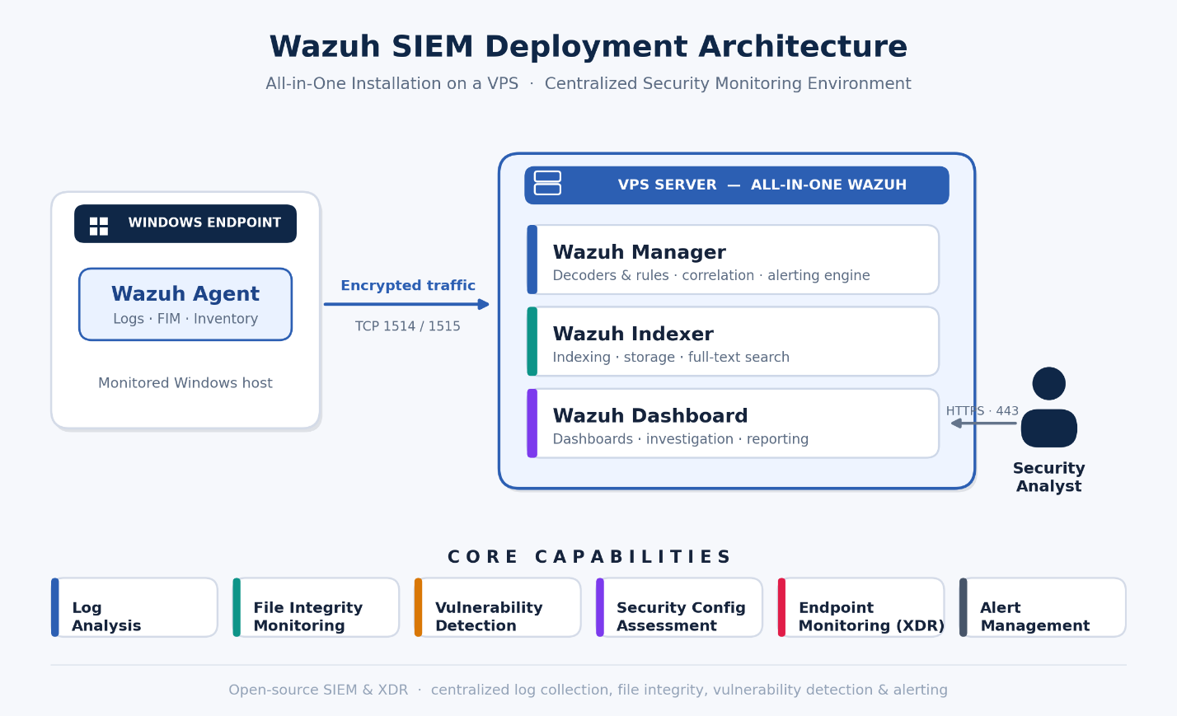
During my internship, I deployed and configured Wazuh SIEM as part of my practical cybersecurity monitoring environment. The objective of this task was to build a centralized security monitoring platform capable of collecting endpoint logs, detecting suspicious activity, monitoring vulnerabilities, and providing a dashboard for security visibility.
Wazuh was selected because it is an open-source SIEM and XDR platform that includes endpoint monitoring, log analysis, file integrity monitoring, vulnerability detection, security configuration assessment, and alert management.
The deployment was completed using an all-in-one Wazuh installation on a VPS server. After the server installation, I deployed a Windows Wazuh agent and connected it to the Wazuh manager.

18.2 Lab Environment
18.2.1 Server Environment
The Wazuh server was installed on a VPS.
Item | Description
Platform | VPS Server
Operating System | Linux server
Deployment Type | All-in-one Wazuh deployment
Main Components | Wazuh Server, Wazuh Indexer, Wazuh Dashboard
Server IP Address | 153.75.247.52
RAM | Approximately 7.6 GB
Storage | Approximately 156 GB
Swap | Approximately 5.2 GB
Access Method | SSH
Dashboard Access | Browser using HTTPS
18.2.2 Endpoint Environment
A Windows endpoint was connected to the Wazuh server using the Wazuh agent.
Item | Description
Endpoint Type | Windows machine
Agent Name | maryamdesk
Agent Package | Wazuh Windows Agent
Manager IP | 153.75.247.52
Communication | Agent connected to Wazuh Manager

18.3 Objective of the Deployment
The main objectives of this Wazuh SIEM deployment were:
- Install a centralized SIEM platform on a VPS.
- Access the Wazuh dashboard through a web browser.
- Deploy a Wazuh agent on a Windows endpoint.
- Connect the Windows endpoint to the Wazuh manager.
- Verify that endpoint logs and alerts appear in the dashboard.
- Use the dashboard to monitor security events, vulnerabilities, and endpoint status.
- Document all steps for internship reporting and future reference.

18.4 Wazuh Architecture Used
The deployment used the all-in-one Wazuh architecture. In this type of deployment, all main Wazuh components are installed on the same server.
The components are:
18.4.1 Wazuh Server
The Wazuh server receives data from installed agents. It analyzes endpoint events and generates security alerts when suspicious activity or policy violations are detected.
18.4.2 Wazuh Indexer
The Wazuh indexer stores and indexes alerts and security data. It allows the dashboard to search, filter, and display security events efficiently.
18.4.3 Wazuh Dashboard
The Wazuh dashboard is the web interface used to manage agents, view alerts, analyze vulnerabilities, monitor events, and investigate security incidents.
18.4.4 Wazuh Agent
The Wazuh agent is installed on monitored endpoints. It collects system logs, security events, file integrity data, inventory information, and other telemetry, then sends the data to the Wazuh manager.

18.5 Server Preparation
Before installing Wazuh, I prepared the VPS server.
18.5.1 Connected to the VPS
I connected to the VPS using SSH from my local machine.
Command used:
ssh root@153.75.247.52
After connecting, I confirmed that I had administrator/root privileges because Wazuh installation requires elevated permissions.
18.5.2 Checked Server Resources
I checked the available RAM, disk space, and system resources to confirm that the VPS could support Wazuh.
Commands used:
free -h
df -h
nproc
The VPS had approximately 7.6 GB RAM and around 156 GB disk space, which was acceptable for a small lab or internship SIEM deployment.
18.5.3 Updated the Server
Before installing Wazuh, I updated the system package list.
For Ubuntu/Debian-based systems:
sudo apt update
sudo apt upgrade -y
This ensured that the system packages were up to date before installing Wazuh.

18.6 Wazuh All-in-One Installation
I used the Wazuh installation assistant to install the Wazuh central components on the VPS.
18.6.1 Downloaded the Wazuh Installation Script
I downloaded the Wazuh installation assistant using curl.
Command used:
curl -sO https://packages.wazuh.com/4.14/wazuh-install.sh
18.6.2 Ran the Wazuh Installer
I executed the installation assistant with the all-in-one option.
Command used:
sudo bash ./wazuh-install.sh -a
The -a option installs the main Wazuh components on the same server:
- Wazuh Server
- Wazuh Indexer
- Wazuh Dashboard
The installation process took some time because it downloaded packages, configured certificates, installed services, and generated dashboard credentials.
18.6.3 Saved the Dashboard Credentials
At the end of the installation, the installer displayed the Wazuh dashboard URL, username, and generated password.
Example output:
INFO: You can access the web interface https://<WAZUH_DASHBOARD_IP_ADDRESS>
User: admin
Password: <ADMIN_PASSWORD>
INFO: Installation finished.
I saved the generated credentials securely because they are required to access the Wazuh dashboard.
18.6.4 Retrieved Passwords if Needed
If the dashboard password is forgotten, it can be recovered from the generated Wazuh installation files.
Command used:
sudo tar -O -xvf wazuh-install-files.tar wazuh-install-files/wazuh-passwords.txt
This command displays the Wazuh generated passwords, including the admin dashboard password.

18.7 Accessing the Wazuh Dashboard
After the installation finished, I opened the Wazuh dashboard from a browser.
Dashboard URL:
https://153.75.247.52 {{this is a private one if try to log or brute force it considers an attack}}
Because Wazuh uses a self-signed SSL certificate by default, the browser displayed a security warning. I accepted the warning and continued to the dashboard.
I logged in using:
Username: admin
Password: <generated_password>
After login, I confirmed that the dashboard loaded successfully.
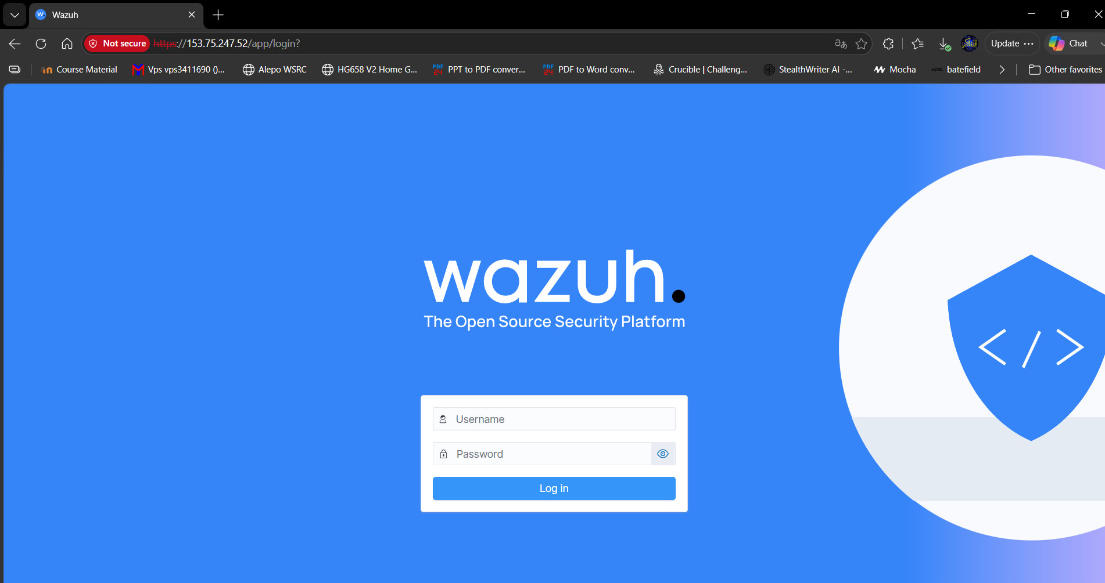
Figure 18.1 — Wazuh Dashboard Login. The HTTPS sign-in page for the Wazuh dashboard. After accepting the default self-signed certificate warning, the admin user authenticates with the credentials generated during installation.
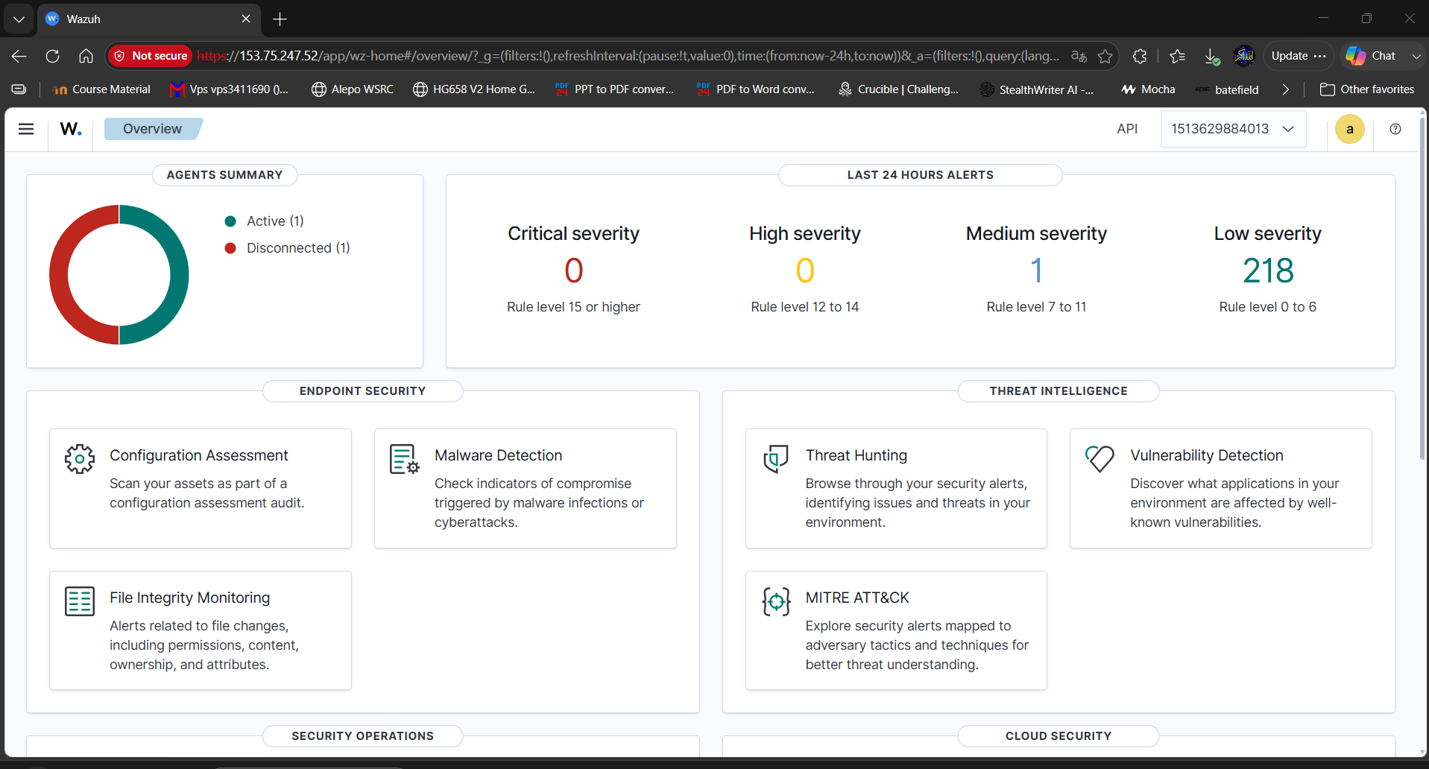
Figure 18.2 — Dashboard Loaded Successfully. The main Wazuh dashboard after a successful login, confirming that the Server, Indexer, and Dashboard components are running and the web interface is reachable.

18.8 Post-Installation Verification
After logging in, I verified that the main Wazuh services were running correctly.
18.8.1 Checked Wazuh Manager Service
Command used:
sudo systemctl status wazuh-manager
Expected result:
active (running)
18.8.2 Checked Wazuh Indexer Service
Command used:
sudo systemctl status wazuh-indexer
Expected result:
active (running)
18.8.3 Checked Wazuh Dashboard Service
Command used:
sudo systemctl status wazuh-dashboard
Expected result:
active (running)
18.8.4 Verified Listening Ports
I checked that the required Wazuh services were listening.
Command used:
sudo ss -tulpn
Important ports:
Port | Purpose
443/TCP | Wazuh Dashboard HTTPS access
1514/TCP | Agent communication
1515/TCP | Agent enrollment
55000/TCP | Wazuh API

18.9 Firewall Configuration
To allow the dashboard and agent communication, I ensured that the required ports were allowed.
If UFW was enabled, the following commands could be used:
sudo ufw allow 443/tcp
sudo ufw allow 1514/tcp
sudo ufw allow 1515/tcp
sudo ufw allow 55000/tcp
sudo ufw reload
Then I checked the firewall status:
sudo ufw status
This step is important because the Windows agent must be able to communicate with the Wazuh manager on the VPS.

18.10 Deploying a Windows Wazuh Agent
After confirming that the Wazuh server and dashboard were working, I deployed a Wazuh agent on a Windows endpoint.
18.10.1 Opened Agent Deployment Page
From the Wazuh dashboard, I went to:
Agents Management > Summary > Deploy new agent
Then I selected:
Operating System: Windows
Server Address: 153.75.247.52
Agent Name: maryamdesk
The dashboard generated the installation command for the Windows agent.
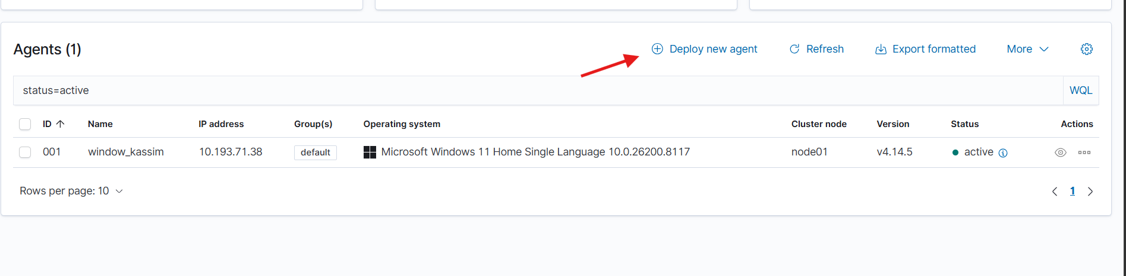
Figure 18.3 — Deploy New Agent (Windows). The ‘Deploy new agent’ wizard, with Operating System set to Windows, the server address 153.75.247.52, and the agent name maryamdesk.
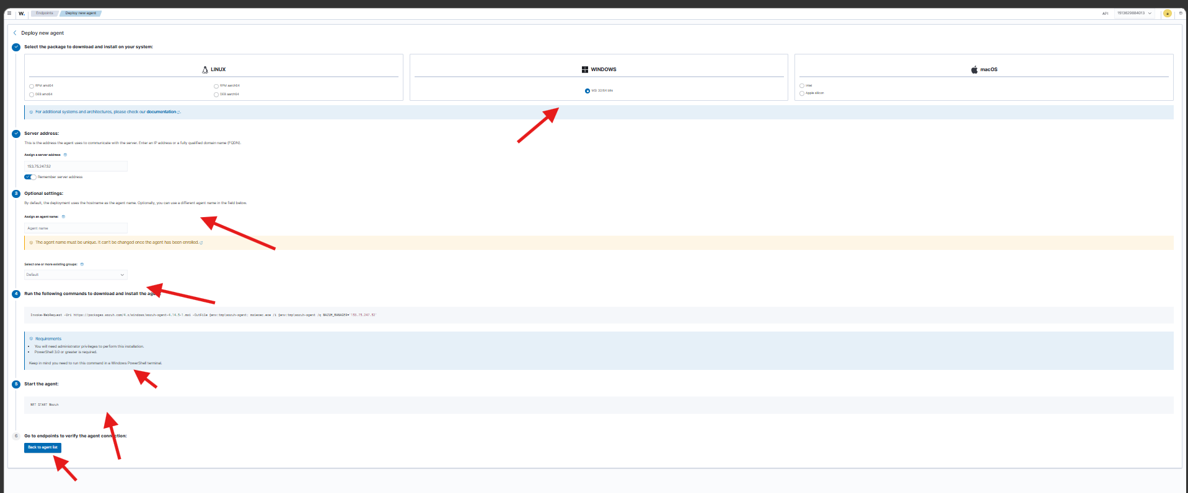
Figure 18.4 — Generated Agent Installation Command. The installation command automatically generated by the dashboard, used to download, install, and enrol the Wazuh agent on the Windows endpoint.

18.11 Windows Agent Installation
18.11.1 First Installation Attempt
I attempted to install the Wazuh Windows agent using this command:
Invoke-WebRequest -Uri https://packages.wazuh.com/4.x/windows/wazuh-agent-4.14.5-1.msi -OutFile $env:tmp\wazuh-agent; msiexec.exe /i $env:tmp\wazuh-agent /q WAZUH_MANAGER='153.75.247.52' WAZUH_AGENT_NAME='maryamdesk'
However, the command was executed inside Windows CMD instead of PowerShell. Because of that, the following error appeared:
'Invoke-WebRequest' is not recognized as an internal or external command,
operable program or batch file.
18.11.2 Cause of the Error
The error happened because Invoke-WebRequest is a PowerShell command, not a CMD command.
CMD does not recognize PowerShell-specific commands unless they are executed from PowerShell.
18.11.3 Correct Method Using PowerShell
To solve the issue, I opened PowerShell as Administrator and used the correct PowerShell command.
Command:
Invoke-WebRequest -Uri https://packages.wazuh.com/4.x/windows/wazuh-agent-4.14.5-1.msi -OutFile $env:TEMP\wazuh-agent.msi

msiexec.exe /i $env:TEMP\wazuh-agent.msi /q WAZUH_MANAGER="153.75.247.52" WAZUH_AGENT_NAME="maryamdesk"

Start-Service WazuhSvc
18.11.4 Alternative Method Using CMD
If using CMD instead of PowerShell, the correct method is:
curl -o %TEMP%\wazuh-agent.msi https://packages.wazuh.com/4.x/windows/wazuh-agent-4.14.5-1.msi
msiexec.exe /i %TEMP%\wazuh-agent.msi /q WAZUH_MANAGER="153.75.247.52" WAZUH_AGENT_NAME="maryamdesk"
NET START WazuhSvc
This installs the Wazuh agent silently, configures the Wazuh manager IP address, sets the agent name as maryamdesk, and starts the Wazuh service.

18.12 Verifying the Windows Agent Service
After installing the agent, I verified that the Wazuh service was running on Windows.
PowerShell command:
Get-Service WazuhSvc
Expected status:
Running
CMD command:
sc query WazuhSvc
Expected result:
STATE: RUNNING
This confirmed that the Wazuh agent was installed and running on the Windows endpoint.

18.13 Verifying Agent Connection in Wazuh Dashboard
After starting the Windows agent service, I returned to the Wazuh dashboard.
Navigation path:
Agents Management > Summary
I checked the agent list and verified that the endpoint appeared with the name:
maryamdesk
Expected status:
Active
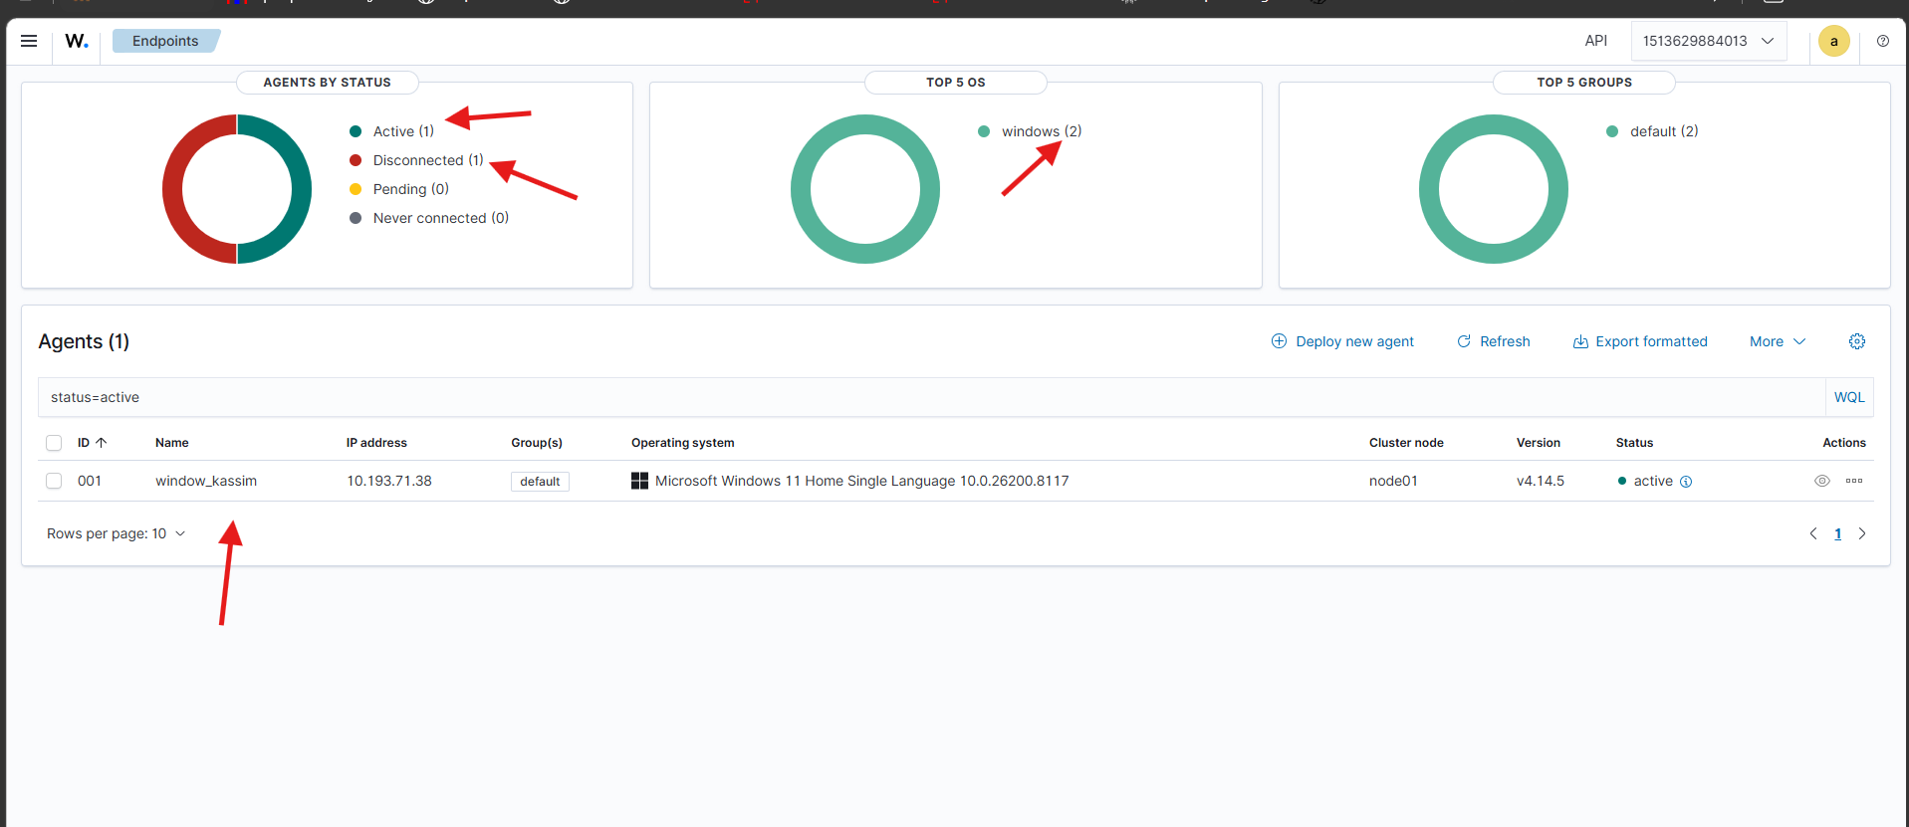
Figure 18.5 — Agent Connected (Status: Active). The Agents Management summary showing the endpoint maryamdesk with an Active status, confirming the Windows agent successfully connected to the Wazuh manager.
This confirmed that the Windows endpoint was successfully connected to the Wazuh manager.

18.14 Dashboard Exploration
After the agent was connected, I explored the main Wazuh dashboard sections.
18.14.1 Security Events
This section displays alerts generated from endpoint activity, authentication events, system logs, and suspicious behavior.
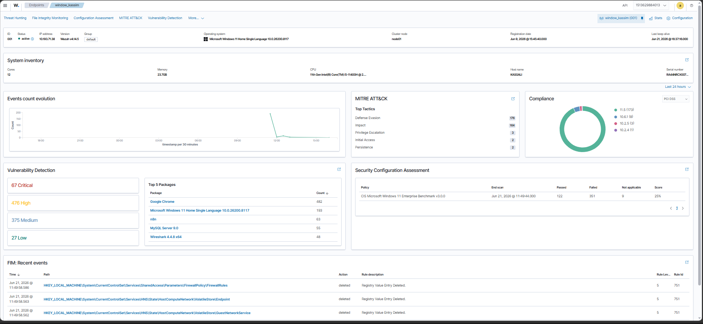
Figure 18.6 — Security Events Module. The Security Events dashboard, which aggregates alerts from endpoint activity, authentication events, and system logs for investigation.
18.14.2 Vulnerability Detection
This section shows detected vulnerabilities on monitored endpoints based on installed software and system inventory.
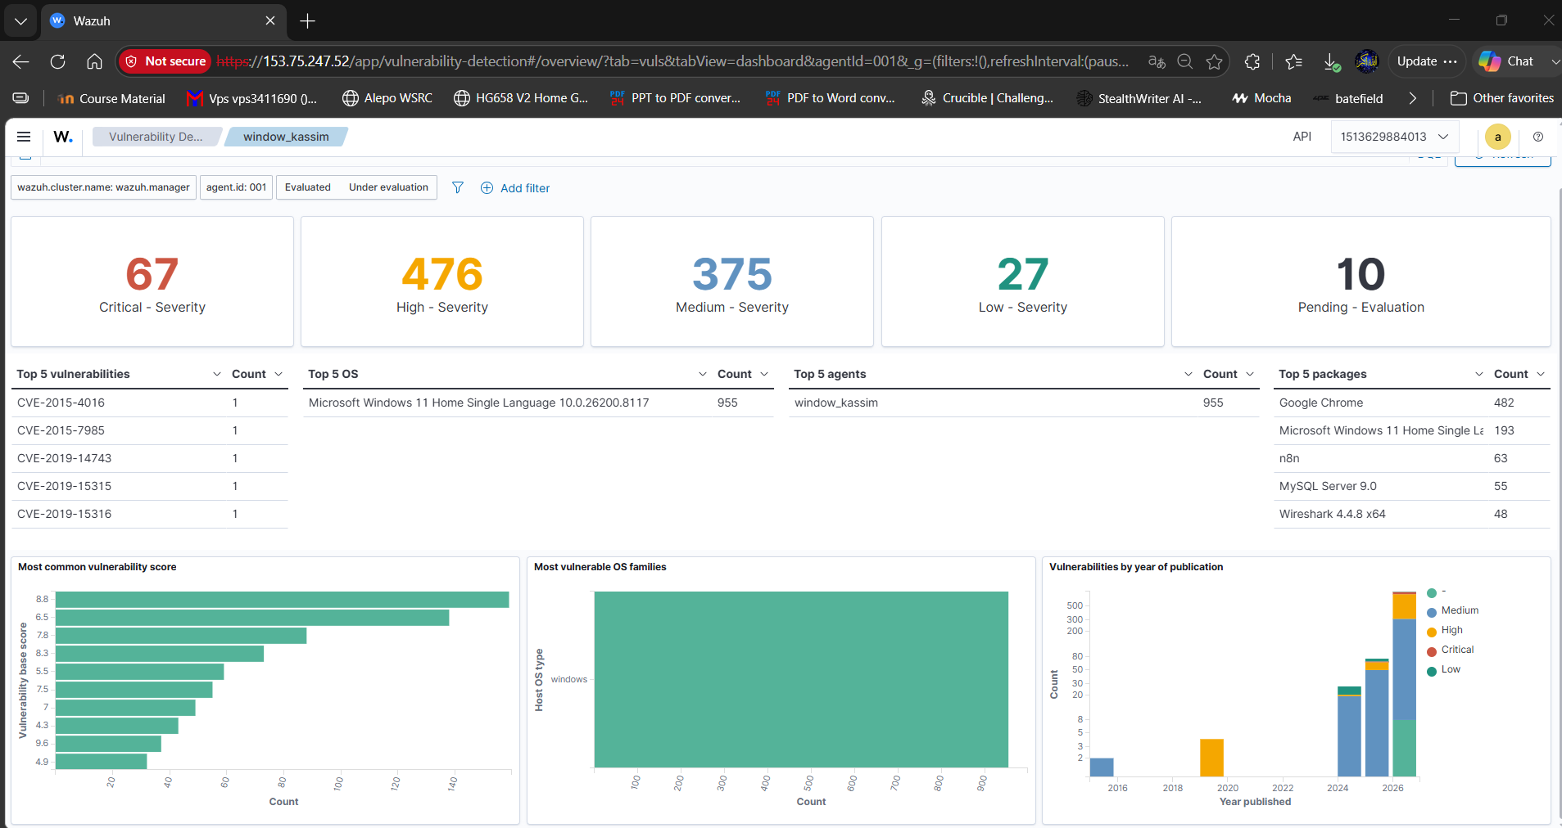
Figure 18.7 — Vulnerability Detection Module. The Vulnerability Detection view, listing known vulnerabilities found on the monitored endpoint based on its installed software.
18.14.3 File Integrity Monitoring
This module monitors file changes on endpoints. It can detect when important files are created, modified, or deleted.
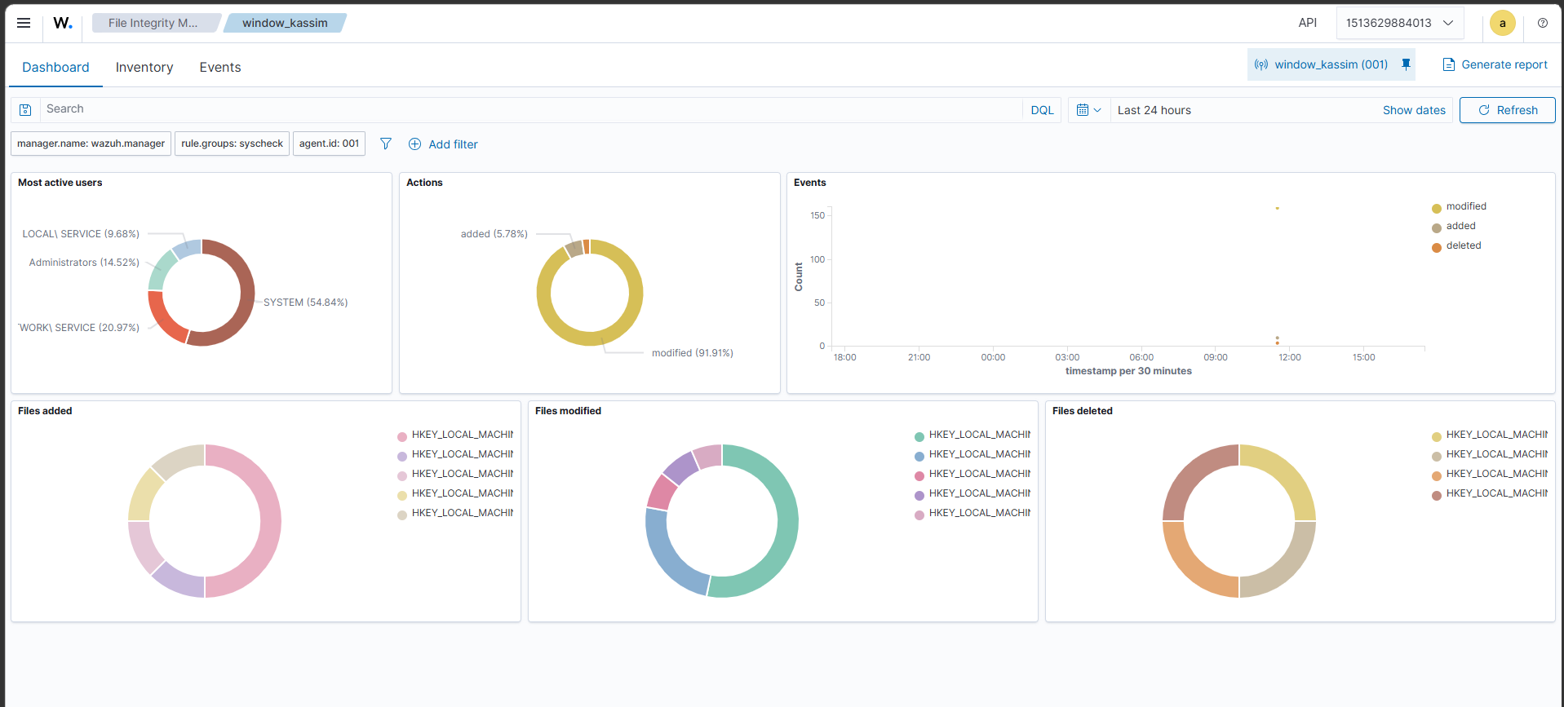
Figure 18.8 — File Integrity Monitoring Module. The File Integrity Monitoring module, which records when monitored files and directories are created, modified, or deleted on the endpoint.
18.14.4 Security Configuration Assessment
This module checks the endpoint configuration against security policies and best practices.
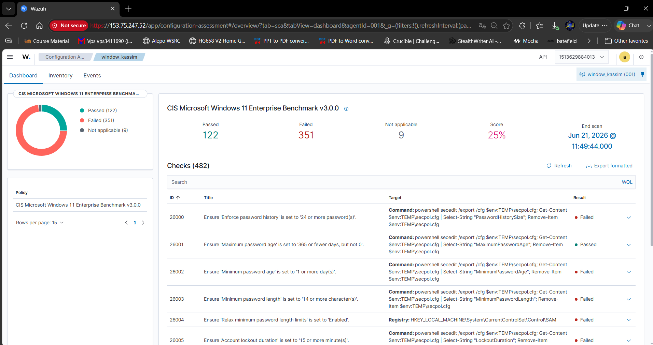
Figure 18.9 — Security Configuration Assessment Module. The Security Configuration Assessment view, which audits the endpoint against security benchmarks and reports the pass/fail results.
18.14.5 Agent Inventory
This section provides information about the monitored endpoint, including operating system, installed packages, network interfaces, and system details.
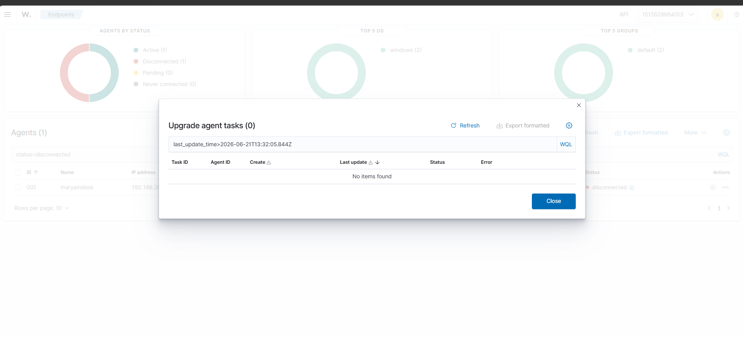
Figure 18.10 — Agent Inventory. The Agent Inventory view, summarising the monitored endpoint’s operating system, network details, installed packages, and hardware information.

18.15 Testing and Monitoring
To confirm that Wazuh was collecting logs, I generated normal activity on the Windows endpoint and checked the dashboard for events.
Examples of activities that can generate logs:
- Logging in and out of Windows.
- Starting and stopping services.
- Installing software.
- Creating or modifying files.
- Triggering Windows security events.
- Checking endpoint inventory from the Wazuh dashboard.
The goal was to confirm that the endpoint was sending data to the Wazuh manager and that the dashboard was displaying security information.

18.16 Troubleshooting Performed
18.16.1 Problem: Dashboard Certificate Warning
When accessing the Wazuh dashboard using HTTPS, the browser displayed a certificate warning.
Cause:
The Wazuh dashboard uses a self-signed SSL certificate by default.
Solution:
I accepted the browser warning and continued to the dashboard because this was a lab environment.
For production environments, a trusted SSL certificate should be configured.

18.16.2 Problem: Invoke-WebRequest Not Recognized
During the Windows agent installation, the command failed with:
'Invoke-WebRequest' is not recognized as an internal or external command,
operable program or batch file.
Cause:
The command was executed in CMD instead of PowerShell.
Solution:
I opened PowerShell as Administrator and executed the PowerShell version of the command.
Alternative:
Use curl and msiexec from CMD.

18.16.3 Problem: Agent Not Appearing Immediately
If the agent does not appear immediately in the dashboard, the following checks should be performed:
- Confirm the Wazuh service is running on Windows.
- Confirm that the manager IP address is correct.
- Confirm that firewall ports are open.
- Confirm the Windows endpoint can reach the VPS.
- Restart the Wazuh agent service.
PowerShell command:
Restart-Service WazuhSvc
CMD command:
NET STOP WazuhSvc
NET START WazuhSvc

18.17 Security Considerations
During the setup, the following security considerations were important:
- The Wazuh dashboard password must be stored securely.
- The dashboard should not be exposed publicly without proper firewall rules.
- Default passwords should be changed after installation.
- Only required ports should be opened.
- Agent communication should be limited to trusted endpoints.
- Screenshots used in reports should hide sensitive passwords.
- The VPS should be regularly updated and monitored.

18.18 Result
The Wazuh SIEM deployment was completed successfully.
The final result included:
- Wazuh installed on a VPS.
- Wazuh dashboard accessible through HTTPS.
- Admin login working.
- Windows endpoint agent installed.
- Agent named maryamdesk connected to the Wazuh manager.
- Security events and endpoint information visible in the dashboard.
- A working SIEM lab environment created for cybersecurity monitoring.

18.19 Conclusion
This task helped me understand how to deploy and configure a real SIEM platform. I learned how Wazuh central components work together, how to install the platform on a server, how to deploy an endpoint agent, and how to verify endpoint monitoring through the dashboard.
The setup also helped me practice troubleshooting common deployment issues, such as PowerShell and CMD command differences, firewall requirements, dashboard certificate warnings, and agent connectivity verification.
Overall, this Wazuh deployment gave me practical experience in security monitoring, endpoint visibility, SIEM architecture, and incident detection workflow.

19. Final Conclusion
This internship at the Agence Nationale de la Cybersécurité (ANC) — DJ-CERT provided structured, hands-on exposure to the full Digital Forensics and Incident Response (DFIR) lifecycle. Working through simulated scenarios and controlled laboratory exercises rather than live incidents, the experience progressed logically from the foundations of evidence acquisition and chain-of-custody through to complete case investigations, log-based detection, malware analysis, and the deployment of a security-monitoring platform.
The two case studies anchored the experience. The Jimmy Wilson investigation (Section 3) demonstrated a complete forensic examination — mounting the evidence, analysing LNK files, Prefetch, ShimCache, and browser history, and reconstructing a clear timeline of criminal intent. The Maryam case (Section 4) applied a forensically sound acquisition workflow, capturing live memory, triage artefacts, and a full disk image while preserving integrity through cryptographic hashing. These were reinforced by event-log timeline analysis with Hayabusa (Section 16), static and dynamic malware triage (Section 17), and an end-to-end Wazuh SIEM deployment with a live Windows agent (Section 18).
Collectively, this work built practical competence across the core DFIR domains: defensible evidence handling, artefact analysis, detection engineering and log review, malware characterisation, and clear, reproducible reporting. Equally important were the professional habits reinforced throughout — working only on verified copies of the evidence, documenting every action as it was performed, and verifying integrity at each step.
Ultimately, this report reflects not only the technical procedures carried out but also the investigative discipline that underpins credible forensic work. The methodology and skills developed during this internship provide a solid foundation for contributing to real incident-response engagements and for continuing to grow into an effective and reliable DFIR practitioner.

