Cash Plus, Safety Plus? Intimate Partner Violence and Productive Inclusion in Mauritania

Descriptive statistics

IBRAHIM KASSOUM Habibou

25 March 2025

# Summary

**Key Takeaways**:

* Around 54 percent of the women who participated in the evaluation gave their consent for the IPV module.
* Reasons for non-consent to the IPV module appear balanced between the different intervention groups with no significant differences.
* Overall, beneficiaries of the productive inclusion program present higher rates of IPV than recipients of the Tekavoul program.
* The most common type of violence is the partner controlling behavior, affecting over half of the women in the entire sample. The variation between groups is small.
* Interestingly, intervention groups generally show slightly higher IPV rates than control groups, which could indicate:
  + Increased awareness and comfort in reporting among intervention group participants.
  + Potential backlash effects from economic or social interventions.
* The psychosocial package presents the highest rate of sexual IPV, while economic IPV is more common among recipients of the capital and full packages.
* The variables that will be considered in the heterogeneity analysis are:
  + The sex of the household head
  + The beneficiary relationship to the household head
  + Household head literacy
  + Beneficiary literacy
  + Household head number of years of education (the median value as the threshold)
  + Beneficiary number of years of education (the median value as the threshold)
  + Beneficiary share of savings owned by their partner (the median value as the threshold)
  + Control over earnings index (the median value as the threshold)
  + Control over household resources index (the median value as the threshold)
  + Intra-household dynamics index (the median value as the threshold)
  + Beneficiary’s share of total revenue (the median value as the threshold)
  + Age gap between the household head and the beneficiary (the median value as the threshold)
* Enumerators fixed effects (FE) will be included in all regressions since there is variation in the number of surveyed individuals across treatment group.

# Consent for the IPV module balance

The following table presents the balance test for the IPV (Intimate Partner Violence) module from the second follow-up survey. Understanding this balance is important because it helps determine whether the sample remains properly randomized. Any imbalance could potentially affect the results, which is particularly important since IPV is the main outcome measure in this analysis.

* Out of the total sample size of 2,561 individuals, 54% (1,371 respondents) participated in the IPV module. This indicates that just over half of the sample provided consent, which is a common challenge in sensitive data collection.
* A notable proportion (28 percent) of non-participants were over the age of 50 and 9 percent of them are widow hence less exposed to the IPV.
* The remaining 9 percent of the women did not respond due to various reasons, including household refusal, absence during the survey period, or the respondent no longer residing in the household.
* *There are 15 women in the cash assignment group that are above 50 and included in the tekavoul program impact evaluation and answered to the IPV module*
* *27 women in the cash assignment group are aged above 50*.

|  | **N = 2,561***1* |
| --- | --- |
| **Status of consent to the IPV module** |  |
| La répondante clef a participé | 1,371 (54%) |
| Autre (preciser) | 101 (3.9%) |
| La répondante clef est agé de plus de 50 ans | 725 (28%) |
| La répondante clef est veuve | 222 (8.7%) |
| La répondante clef n'est pas disponible pendant toute la période de l'enquête | 125 (4.9%) |
| La répondante clef n'habite pas dans le ménage. | 6 (0.2%) |
| ménage non-trouvé | 6 (0.2%) |
| Refus du ménage | 5 (0.2%) |
| *1*n (%) | |

In the following, I performed balance checks on the variable consent to the IPV module by type of treatment. Overall, non-response is balanced between treatment groups.

## Tekavoul program

| **Table : Balance Table** | | | |
| --- | --- | --- | --- |
| Variable | **Control**  N = 531 | **Cash Assignment**  N = 971 | (1)-(2) |
| La répondante clef a participé | 0.46(0.50) | 0.43(0.50) | -0.143 |
| La répondante clef est agé de plus de 50 ans | 0.35(0.48) | 0.40(0.49) | 0.182* |
| Autre (preciser) | 0.05(0.21) | 0.05(0.21) | 0.068 |
| La répondante clef est veuve | 0.08(0.27) | 0.07(0.26) | 0.051 |
| La répondante clef n'est pas disponible pendant toute la période de l'enquête | 0.05(0.22) | 0.04(0.20) | -0.19 |
| Refus du ménage | 0.00(0.06) | 0.00(0.03) | -1.458 |
| ménage non-trouvé | 0.01(0.09) | 0.00(0.03) | -1.718** |
| La répondante clef n'habite pas dans le ménage. | 0.00(0.00) | 0.00(0.06) | 13.159*** |
| N cluster | 43 | 43 |  |
| N strata | 10 | 10 |  |
| Notes: Standard errors for all tests are clustered at the Social Promotion Space level. Fixed effects using randomization strata are included in all estimation regressions. *** p < 0.01, ** p < 0.05, * p < 0.1. | | | |

## Productive inclusion program

| **Table : Balance Table** | | | | | | | | | | | | |
| --- | --- | --- | --- | --- | --- | --- | --- | --- | --- | --- | --- | --- |
| Variable | **Control**  N = 571 | **Capital**  N = 357 | **Psychosocial**  N = 399 | **Full**  N = 303 | (1)-(2) | (1)-(3) | (1)-(4) | (2)-(3) | (2)-(4) | (3)-(4) | Joint F-test   P-value | Pooled F-test   P-value |
| La répondante clef a participé | 0.70(0.46) | 0.67(0.47) | 0.66(0.47) | 0.67(0.47) | 0.149 | 0.16 | 0.142 | 0.019 | -0.023 | -0.036 | 0.012 | -0.157 |
| La répondante clef est agé de plus de 50 ans | 0.15(0.35) | 0.13(0.34) | 0.15(0.36) | 0.14(0.34) | 0.1 | -0.024 | 0.097 | -0.132 | 0.003 | 0.126 | 0.166 | -0.049 |
| Autre (preciser) | 0.03(0.17) | 0.02(0.15) | 0.04(0.20) | 0.03(0.17) | 0.269 | -0.288 | -0.057 | -0.582 | -0.334 | 0.221 | 0.514 | 0.058 |
| La répondante clef est veuve | 0.06(0.24) | 0.10(0.29) | 0.10(0.30) | 0.12(0.32) | -0.423 | -0.483 | -0.694* | -0.06 | -0.233 | -0.162 | 0.182 | 0.544* |
| La répondante clef n'est pas disponible pendant toute la période de l'enquête | 0.05(0.23) | 0.08(0.27) | 0.04(0.20) | 0.04(0.19) | -0.408 | 0.242 | 0.419 | 0.65* | 0.817** | 0.154 | 2.531* | -0.023 |
| Refus du ménage | 0.00(0.04) | 0.00(0.05) | 0.00(0.00) | 0.00(0.06) | -0.507 | 12.033*** | -0.648 | 13.7*** | -0.168 | -13.783*** | 0.982 | 0.112 |
| ménage non-trouvé | 0.00(0.00) | 0.00(0.00) | 0.00(0.05) | 0.00(0.00) | -0.027 | -12.96*** | -0.004 | -13.468*** | 0.022 | 13.324*** | 0.501 | 11.969*** |
| La répondante clef n'habite pas dans le ménage. | 0.01(0.07) | 0.00(0.00) | 0.00(0.05) | 0.01(0.08) | 14.201*** | 0.86 | -0.225 | -13.439*** | -13.686*** | -0.945 | 1.555 | -0.652 |
| N cluster | 43 | 24 | 27 | 24 |  |  |  |  |  |  |  |  |
| N strata | 10 | 12 | 13 | 13 |  |  |  |  |  |  |  |  |
| Notes: Standard errors for all tests are clustered at the Social Promotion Space level. Fixed effects using randomization strata are included in all estimation regressions. The joint F-test shows the p-value from a test of equality of treatment arms. While the pooled F-test shows the p-value from a test of pooled treatment (i.e., a regression with a dummy for any treatment arm). *** p < 0.01, ** p < 0.05, * p < 0.1. | | | | | | | | | | | | |

# Descriptive Statistics

## IPV variables

The following tables primarily consider women who provided consent for the IPV module.  
The observed differences between this balance table and the attrition table in the following sections arise from the fact that some women did not provide consent for participation.

**Index construction**: See: <https://journals.plos.org/plosone/article?id=10.1371/journal.pone.0282339>

* A binary variable coded as 1 is created if a female beneficiary of the program responded affirmatively to any of the items related to IPV.
* Additionally, a continuous variable is constructed as the standardized average of the responses to each of these items that report the frequency of instances of each type of violence experienced in the past 12 months. This variable is measured on a 4-point Likert frequency scale (0 = Never, 1 = Once, 2 = Sometimes, 3 = Often). It is coded as “missing” only if all the items are missing. The range of the continuous variable is 0–3.

For all types of violence (except *controlling behavior*), the survey typically asks three sequential questions:

* Whether it has ever happened;
* Whether it happened in the past 12 months;
* For incidents in the past 12 months, the frequency (once, occasionally, or often)

### Partner’s controlling behavior

* Overall rates range between 51 percent and 56 percent across program groups.
* The control group rates are around 51 percent in the Productive Inclusion program, which is slightly lower than the intervention groups’ average for the same program (between 52 and 56 percent).
* In the Tekavoul program, the control group presents around 3 percentage points more controlling behavior than the intervention group.
* This type of IPV contains question on:
  + ipv1: Being jealous or angry if the wife speaks to other men,
  + ipv2: Accusing the wife of being unfaithful,
  + ipv3: Trying to prevent the wife from seeing family or friends,
  + ipv5: Insisting on knowing the wife’s whereabouts at all times,
  + ipv6: Expecting the wife to ask permission before seeking healthcare,
  + ipv7: Preventing the wife from working outside the home.

|  | Tekavoul | | | Productive inclusion | | | | | Productive inclusion (Pool) | | |
| --- | --- | --- | --- | --- | --- | --- | --- | --- | --- | --- | --- |
| Partner's controlling behavior | **Overall** N = 627 | **Control** N = 230 | **Cash Assignment** N = 397 | **Overall** N = 1,064 | **Control** N = 382 | **Capital** N = 232 | **Psychosocial** N = 251 | **Full** N = 199 | **Overall** N = 1,064 | **Control** N = 382 | **Pool** N = 682 |
| Binary for control IPV In the last 12 months | 51.28 | 53.28 | 50.13 | 53.53 | 51.05 | 55.60 | 56.40 | 52.28 | 53.53 | 51.05 | 54.93 |
| (Missing) | 1 | 1 | 0 | 3 | 0 | 0 | 1 | 2 | 3 | 0 | 3 |
| Control IPV intensity index z-score | -0.01 (1.01) | 0.00 (0.99) | -0.02 (1.01) | 0.01 (0.99) | -0.01 (1.02) | 0.01 (0.99) | 0.09 (1.02) | -0.04 (0.90) | 0.01 (0.99) | -0.01 (1.02) | 0.03 (0.97) |
| (Missing) | 1 | 1 | 0 | 3 | 0 | 0 | 1 | 2 | 3 | 0 | 3 |

### Emotional Violence

* Emotional IPV rates are considerably lower than controlling behaviors, ranging between 7 percent and 10 percent across groups.
* The Capital package presents slightly higher rates at 10.27 percent compared to the other interventions.
* Control groups show lower rates (around 7 percent) than intervention groups (8-10 percent).
* This type of IPV contains question on:
  + ipv8: Humiliating the wife in front of others,
  + ipv9: Threatening to hurt the wife or someone close to her,
  + ipv10: Insulting or belittling the wife,
  + ipv11: Deliberately scaring or intimidating the wife (through looks, shouting, breaking things).

|  | Tekavoul | | | Productive inclusion | | | | | Productive inclusion (Pool) | | |
| --- | --- | --- | --- | --- | --- | --- | --- | --- | --- | --- | --- |
| Emotional Violence | **Overall** N = 627 | **Control** N = 230 | **Cash Assignment** N = 397 | **Overall** N = 1,064 | **Control** N = 382 | **Capital** N = 232 | **Psychosocial** N = 251 | **Full** N = 199 | **Overall** N = 1,064 | **Control** N = 382 | **Pool** N = 682 |
| Binary for emo. IPV in the last 12 months | 7.50 | 7.34 | 7.59 | 8.50 | 7.88 | 10.27 | 9.09 | 6.84 | 8.50 | 7.88 | 8.84 |
| (Missing) | 27 | 12 | 15 | 40 | 14 | 8 | 9 | 9 | 40 | 14 | 26 |
| Emo. IPV intensity index z-score | -0.24 (0.28) | -0.25 (0.28) | -0.24 (0.28) | -0.23 (0.30) | -0.24 (0.29) | -0.21 (0.35) | -0.22 (0.30) | -0.25 (0.28) | -0.23 (0.30) | -0.24 (0.29) | -0.23 (0.31) |
| (Missing) | 27 | 12 | 15 | 40 | 14 | 8 | 9 | 9 | 40 | 14 | 26 |
| Emo. IPV severity index | 0.07 (0.28) | 0.05 (0.20) | 0.07 (0.31) | 0.07 (0.30) | 0.08 (0.32) | 0.09 (0.34) | 0.06 (0.24) | 0.07 (0.31) | 0.07 (0.30) | 0.08 (0.32) | 0.07 (0.30) |
| Emo. IPV severity index z-score | -0.02 (0.94) | -0.08 (0.68) | 0.01 (1.06) | 0.01 (1.03) | 0.02 (1.08) | 0.06 (1.14) | -0.03 (0.83) | -0.02 (1.04) | 0.01 (1.03) | 0.02 (1.08) | 0.00 (1.01) |

### Physical Violence

* The overall prevalence of physical violence ranges from about 0.99 percent in the Tekavoul program to 1.55 percent in the Productive Inclusion program.
* There appears to be slight variation between control groups (0.89 percent in Tekavoul control, 1.09 percent in productive inclusion control) and the beneficiaries of the two programs (1.05 percent in the beneficiaries of the cash assignment in the Tekavoul program, 1.80 percent for the beneficiary of the productive inclusion).
* Within the productive inclusion program, the psychosocial and the full intervention groups show the highest rates (around 2 percent).
* The physical IPV intensity and severity indices are very low across all groups, with minimal variation.
* This type of IPV contains questions on :
  + ipv12: slapping or throwing objects that could cause injury,
  + ipv13: Pushing, shoving, or pulling hair,
  + ipv14: Punching or hitting with objects that could cause injury,
  + ipv15: Kicking, dragging, or beating,
  + ipv16: Attempting to strangle or burn intentionally (not accidentally),
  + ipv17: Threatening or attacking with weapons (knife, gun, etc.).

|  | Tekavoul | | | Productive inclusion | | | | | Productive inclusion (Pool) | | |
| --- | --- | --- | --- | --- | --- | --- | --- | --- | --- | --- | --- |
| Physical Violence | **Overall** N = 627 | **Control** N = 230 | **Cash Assignment** N = 397 | **Overall** N = 1,064 | **Control** N = 382 | **Capital** N = 232 | **Psychosocial** N = 251 | **Full** N = 199 | **Overall** N = 1,064 | **Control** N = 382 | **Pool** N = 682 |
| Binary for phy. IPV in the last 12 months | 0.99 | 0.89 | 1.05 | 1.55 | 1.09 | 1.33 | 2.04 | 2.05 | 1.55 | 1.09 | 1.80 |
| (Missing) | 23 | 6 | 17 | 32 | 15 | 7 | 6 | 4 | 32 | 15 | 17 |
| Phy. IPV intensity index z-score | -0.14 (0.13) | -0.15 (0.10) | -0.14 (0.14) | -0.13 (0.18) | -0.14 (0.15) | -0.14 (0.16) | -0.12 (0.20) | -0.12 (0.25) | -0.13 (0.18) | -0.14 (0.15) | -0.13 (0.20) |
| (Missing) | 23 | 6 | 17 | 32 | 15 | 7 | 6 | 4 | 32 | 15 | 17 |
| Phy. IPV severity index | 0.00 (0.04) | 0.00 (0.04) | 0.00 (0.05) | 0.01 (0.10) | 0.00 (0.05) | 0.01 (0.08) | 0.01 (0.14) | 0.01 (0.12) | 0.01 (0.10) | 0.00 (0.05) | 0.01 (0.11) |
| Phy. IPV severity z-score | -0.05 (0.36) | -0.06 (0.33) | -0.05 (0.38) | -0.01 (0.80) | -0.05 (0.39) | -0.02 (0.66) | 0.03 (1.13) | 0.03 (0.99) | -0.01 (0.80) | -0.05 (0.39) | 0.01 (0.95) |

### Sexual Violence

* Sexual IPV prevalence ranges from 4.46 percent in Tekavoul to 7.47 percent in Productive Inclusion. There’s a more noticeable difference between control and intervention groups.
* The Psychosocial package recipient group shows the highest rate at 11.02 percent.
* The control groups consistently show lower rates than intervention groups.
* The severity indices for sexual violence are overall higher than those for physical violence.
* This type of IPV contains questions on:
  + ipv18: physically forcing sexual intercourse against the wife’s will
  + ipv19: having unwanted sexual intercourse due to fear of consequences
  + ipv20: forcing degrading or humiliating sexual acts

|  | Tekavoul | | | Productive inclusion | | | | | Productive inclusion (Pool) | | |
| --- | --- | --- | --- | --- | --- | --- | --- | --- | --- | --- | --- |
| Sexual violence | **Overall** N = 627 | **Control** N = 230 | **Cash Assignment** N = 397 | **Overall** N = 1,064 | **Control** N = 382 | **Capital** N = 232 | **Psychosocial** N = 251 | **Full** N = 199 | **Overall** N = 1,064 | **Control** N = 382 | **Pool** N = 682 |
| Binary for sex. IPV in the last 12 months | 4.46 | 3.56 | 5.00 | 7.47 | 5.18 | 7.73 | 11.02 | 7.18 | 7.47 | 5.18 | 8.76 |
| (Missing) | 22 | 5 | 17 | 46 | 15 | 12 | 15 | 4 | 46 | 15 | 31 |
| Sex. IPV intensity index z-score | -0.26 (0.26) | -0.27 (0.24) | -0.25 (0.27) | -0.22 (0.30) | -0.25 (0.27) | -0.22 (0.29) | -0.18 (0.34) | -0.22 (0.29) | -0.22 (0.30) | -0.25 (0.27) | -0.20 (0.31) |
| (Missing) | 22 | 5 | 17 | 46 | 15 | 12 | 15 | 4 | 46 | 15 | 31 |
| Sex. IPV severity index | 0.05 (0.24) | 0.05 (0.26) | 0.04 (0.23) | 0.08 (0.32) | 0.05 (0.24) | 0.08 (0.32) | 0.12 (0.40) | 0.07 (0.31) | 0.08 (0.32) | 0.05 (0.24) | 0.09 (0.35) |
| (Missing) | 1 | 0 | 1 | 2 | 1 | 0 | 1 | 0 | 2 | 1 | 1 |
| Sex. IPV severity Z-score | -0.08 (0.77) | -0.08 (0.83) | -0.08 (0.74) | 0.02 (1.00) | -0.08 (0.75) | 0.03 (1.03) | 0.16 (1.27) | 0.01 (0.99) | 0.02 (1.00) | -0.08 (0.75) | 0.07 (1.11) |
| (Missing) | 1 | 0 | 1 | 2 | 1 | 0 | 1 | 0 | 2 | 1 | 1 |

### Economic Violence

* Economic IPV rates fall between those of physical and sexual violence, with overall prevalence of 4.45 percent in Tekavoul and 6.73 percent in the Productive Inclusion program.
* Similar to the previous tables, intervention groups generally show higher reported rates compared to control groups:
  + In Tekavoul: control shows 3.17 percent while Cash Assignment shows 5.18 percent,
  + In productive inclusion: control shows 5.38 percent while intervention arms range from 5.37 percent to 8.76 percent.
* The Capital and Full intervention groups show the highest rates of economic IPV (8.76 percent and 8.72 percent respectively).
* Interestingly, the Psychosocial group, which had the highest sexual IPV rate, shows the lowest economic IPV rate among intervention groups (5.37 percent) with values similar to the recipients of the Tekavoul program (5.18 percent).
* This type of IPV contains questions on :
  + ipv22: taking money earned by the wife against her will,
  + ipv23: refusing to provide money for household necessities despite having funds available,
  + ipv24: forcing the wife to give all or part of her earnings to his family (in-laws).

|  | Tekavoul | | | Productive inclusion | | | | | Productive inclusion (Pool) | | |
| --- | --- | --- | --- | --- | --- | --- | --- | --- | --- | --- | --- |
| Economic violence | **Overall** N = 627 | **Control** N = 230 | **Cash Assignment** N = 397 | **Overall** N = 1,064 | **Control** N = 382 | **Capital** N = 232 | **Psychosocial** N = 251 | **Full** N = 199 | **Overall** N = 1,064 | **Control** N = 382 | **Pool** N = 682 |
| Binary for eco. IPV in the last 12 months | 4.45 | 3.17 | 5.18 | 6.73 | 5.38 | 8.76 | 5.37 | 8.72 | 6.73 | 5.38 | 7.49 |
| (Missing) | 20 | 9 | 11 | 38 | 10 | 15 | 9 | 4 | 38 | 10 | 28 |
| Eco. IPV intensity index z-score | -0.25 (0.21) | -0.27 (0.20) | -0.25 (0.22) | -0.23 (0.26) | -0.24 (0.23) | -0.20 (0.30) | -0.24 (0.24) | -0.21 (0.30) | -0.23 (0.26) | -0.24 (0.23) | -0.22 (0.28) |
| (Missing) | 20 | 9 | 11 | 38 | 10 | 15 | 9 | 4 | 38 | 10 | 28 |
| Eco. IPV severity index | 0.04 (0.19) | 0.02 (0.14) | 0.04 (0.21) | 0.06 (0.25) | 0.05 (0.22) | 0.07 (0.27) | 0.05 (0.23) | 0.08 (0.29) | 0.06 (0.25) | 0.05 (0.22) | 0.07 (0.26) |
| Eco. IPV severity z-score | -0.09 (0.77) | -0.15 (0.57) | -0.06 (0.86) | -0.01 (1.00) | -0.06 (0.88) | 0.06 (1.09) | -0.05 (0.91) | 0.06 (1.18) | -0.01 (1.00) | -0.06 (0.88) | 0.02 (1.06) |

### Other IPV index Violence

In this table we consider the emotional violence, the physical, sexual and economic violence.

|  | Tekavoul | | | Productive inclusion | | | | | Productive inclusion (Pool) | | |
| --- | --- | --- | --- | --- | --- | --- | --- | --- | --- | --- | --- |
| Other IPV index violence | **Overall** N = 627 | **Control** N = 230 | **Cash Assignment** N = 397 | **Overall** N = 1,064 | **Control** N = 382 | **Capital** N = 232 | **Psychosocial** N = 251 | **Full** N = 199 | **Overall** N = 1,064 | **Control** N = 382 | **Pool** N = 682 |
| Binary for at least one type of IPV incl. eco. in the last 12 months | 11.80 | 10.87 | 12.34 | 16.26 | 12.83 | 20.26 | 17.13 | 17.09 | 16.26 | 12.83 | 18.18 |
| Binary for at least one type of IPV | 10.10 | 9.61 | 10.38 | 13.08 | 10.76 | 15.09 | 15.54 | 12.06 | 13.08 | 10.76 | 14.37 |
| (Missing) | 3 | 1 | 2 | 1 | 1 | 0 | 0 | 0 | 1 | 1 | 0 |
| All IPV intensity index z-score | -0.09 (0.83) | -0.07 (0.91) | -0.10 (0.78) | 0.00 (0.98) | -0.09 (0.79) | 0.12 (1.15) | -0.04 (0.91) | 0.05 (1.15) | 0.00 (0.98) | -0.09 (0.79) | 0.04 (1.07) |

## Other household characteristics

### Household head is female

* 71 percent of female hh head live with there male partner in the same house.
* 12 percent of female hh head live are polygamous.

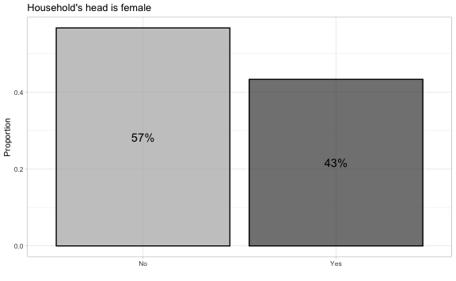

### Beneficiary relationship to household head

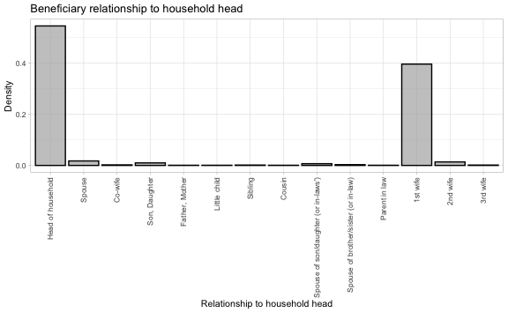

### Household head literacy

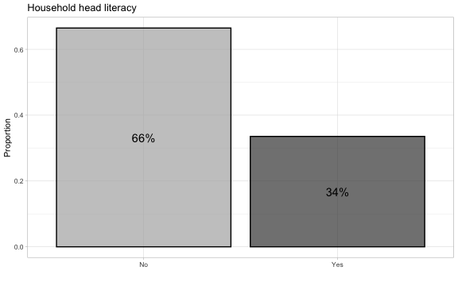

### Beneficiary literacy

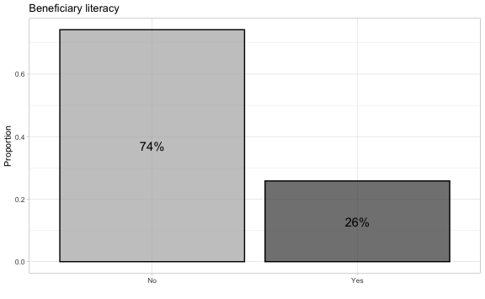

### Household head nbr. of years of education

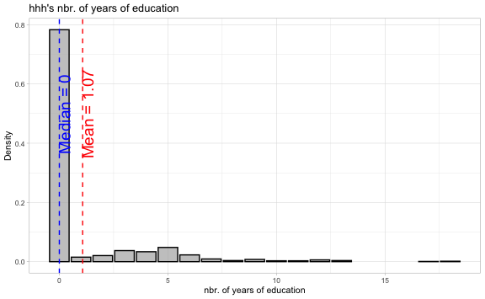

### Beneficiary nbr. of years of education

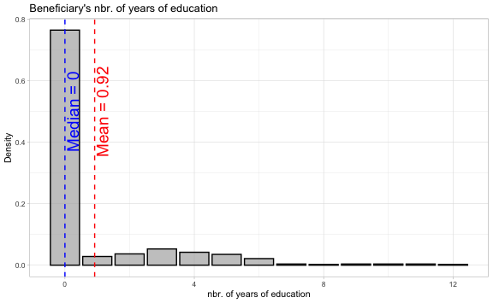

### Beneficiary is handicapped

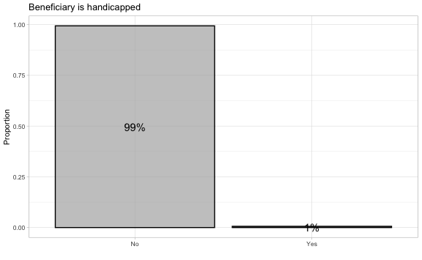

### Beneficiary is in a polygamous union

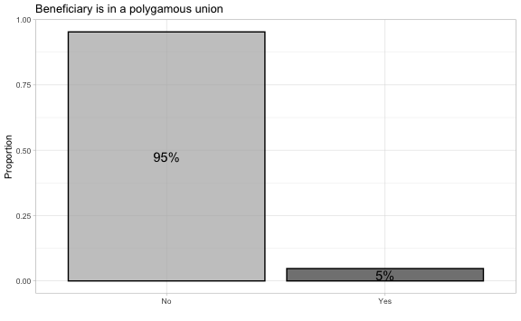

### Share of saving own by partner

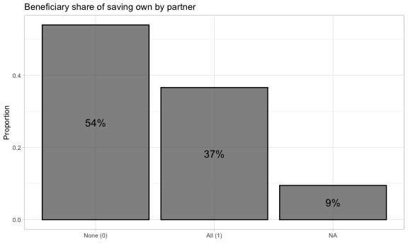

### Control over earnings

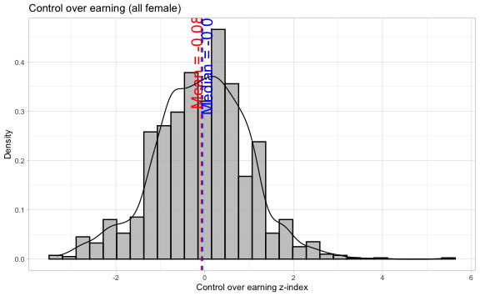

### Control over household resources

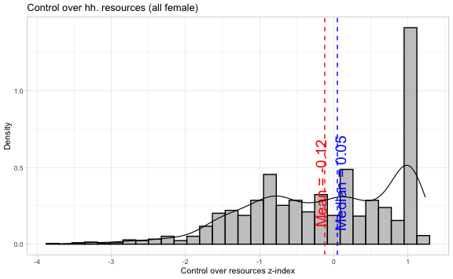

### Intra-household dynamics

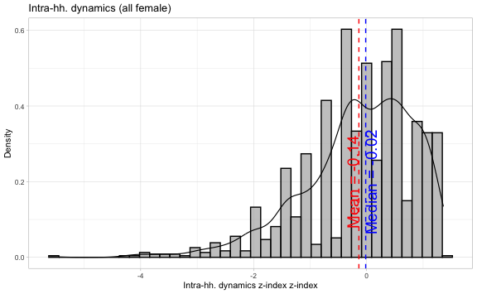

### Benef. share of total household revenues

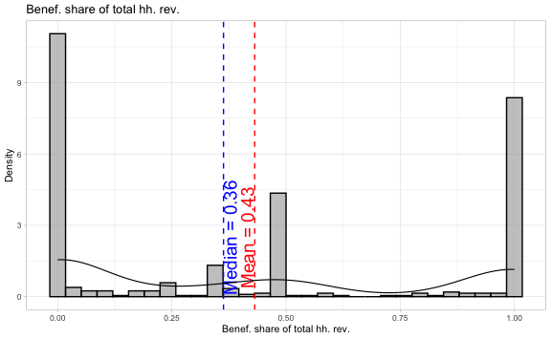

### Age distribution

Around 55 percent of the hhh are female benef.

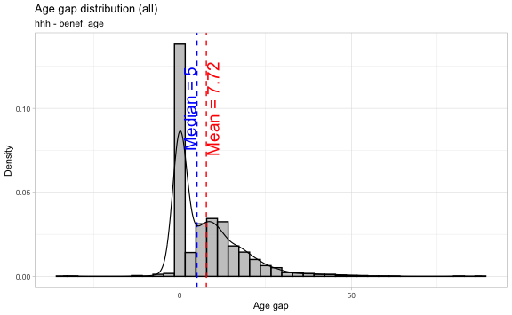

### Enumerator

#### All

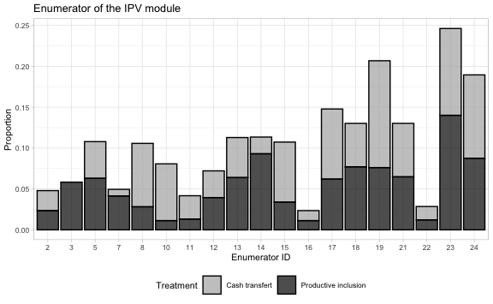

#### Tekavoul

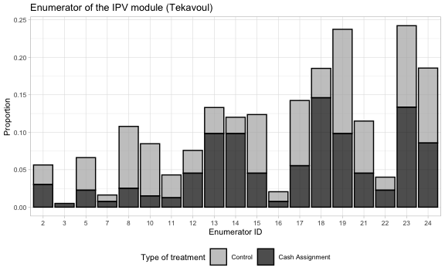

#### Productive inclusion

