Cash Plus, Safety Plus? Intimate Partner Violence and Productive Inclusion in Mauritania

Empirical strategy & Results

IBRAHIM KASSOUM Habibou

12 June 2025

# Some concerns

* Why Manuela use the baseline values of the control variables for the IPV instead of the followup-value for the control group (to prevent spill over effect ??)
* I remove the row with missing data in any of the IPV outcome variables.
* All variables can’t be used in the algorithm as some can explain the results just by pur chance. With all baseline variables t
* A Recursive Feature Elimination (RFE) is used to select features.
  + RFE is a feature selection technique that iteratively removes features based on their importance, aiming to find the optimal subset of features that provides the best model performance. It starts with a model trained on all features, then calculates feature importances, and removes the least important ones. This process is repeated until the desired number of features is reached or the model performance stops improving.
* I use Knn algorithm to impute missing values in the features of the training dataset. The same algorythm can be use to complete the for the prediction dataset (it is important so that we can adapt the number). The *mean* function is used as the aggregation
  + the Euclidean distance
  + 10 neigbor
* source: <https://livebook.datascienceheroes.com/selecting-best-variables.html#general_aspects_selecting_best_variables>

# Causal Forest for heterogeneity analysis of IPV

## Model estimation and Plot

## [1] "The estimated ATE is 0.03, the standard error is 0.05 and the pvalue is 0.56. The outcome is var is control_ipv_sev_12m and the treatment variable treatment_pool."

## [1] "The estimated ATE is -0.05, the standard error is 0.04 and the pvalue is 0.21. The outcome is var is control_ipv_sev_12m and the treatment variable treatment_csh_trnsfr."

## [1] "The estimated ATE is 0.05, the standard error is 0.06 and the pvalue is 0.44. The outcome is var is control_ipv_sev_12m and the treatment variable treatment_capital."

## [1] "The estimated ATE is -0.01, the standard error is 0.06 and the pvalue is 0.86. The outcome is var is control_ipv_sev_12m and the treatment variable treatment_psychosocial."

## [1] "The estimated ATE is 0.04, the standard error is 0.08 and the pvalue is 0.62. The outcome is var is control_ipv_sev_12m and the treatment variable treatment_full."

## [1] "The estimated ATE is 0, the standard error is 0.1 and the pvalue is 0.99. The outcome is var is control_ipv_sev_index and the treatment variable treatment_pool."

## [1] "The estimated ATE is 0.01, the standard error is 0.09 and the pvalue is 0.88. The outcome is var is control_ipv_sev_index and the treatment variable treatment_csh_trnsfr."

## [1] "The estimated ATE is 0.04, the standard error is 0.13 and the pvalue is 0.76. The outcome is var is control_ipv_sev_index and the treatment variable treatment_capital."

## [1] "The estimated ATE is -0.02, the standard error is 0.12 and the pvalue is 0.85. The outcome is var is control_ipv_sev_index and the treatment variable treatment_psychosocial."

## [1] "The estimated ATE is 0, the standard error is 0.13 and the pvalue is 0.98. The outcome is var is control_ipv_sev_index and the treatment variable treatment_full."

## [1] "The estimated ATE is 0.01, the standard error is 0.03 and the pvalue is 0.7. The outcome is var is emo_ipv_sev_12m and the treatment variable treatment_pool."

## [1] "The estimated ATE is 0.01, the standard error is 0.02 and the pvalue is 0.68. The outcome is var is emo_ipv_sev_12m and the treatment variable treatment_csh_trnsfr."

## [1] "The estimated ATE is 0.03, the standard error is 0.03 and the pvalue is 0.29. The outcome is var is emo_ipv_sev_12m and the treatment variable treatment_capital."

## [1] "The estimated ATE is 0, the standard error is 0.03 and the pvalue is 0.91. The outcome is var is emo_ipv_sev_12m and the treatment variable treatment_psychosocial."

## [1] "The estimated ATE is 0, the standard error is 0.04 and the pvalue is 0.99. The outcome is var is emo_ipv_sev_12m and the treatment variable treatment_full."

## [1] "The estimated ATE is -0.01, the standard error is 0.11 and the pvalue is 0.96. The outcome is var is emo_ipv_sev_index and the treatment variable treatment_pool."

## [1] "The estimated ATE is 0.19, the standard error is 0.11 and the pvalue is 0.07. The outcome is var is emo_ipv_sev_index and the treatment variable treatment_csh_trnsfr."

## [1] "The estimated ATE is 0.04, the standard error is 0.12 and the pvalue is 0.76. The outcome is var is emo_ipv_sev_index and the treatment variable treatment_capital."

## [1] "The estimated ATE is -0.07, the standard error is 0.1 and the pvalue is 0.53. The outcome is var is emo_ipv_sev_index and the treatment variable treatment_psychosocial."

## [1] "The estimated ATE is 0.01, the standard error is 0.13 and the pvalue is 0.94. The outcome is var is emo_ipv_sev_index and the treatment variable treatment_full."

## [1] "The estimated ATE is 0.01, the standard error is 0.01 and the pvalue is 0.44. The outcome is var is phy_ipv_sev_12m and the treatment variable treatment_pool."

## [1] "The estimated ATE is 0, the standard error is 0.01 and the pvalue is 0.87. The outcome is var is phy_ipv_sev_12m and the treatment variable treatment_csh_trnsfr."

## [1] "The estimated ATE is 0, the standard error is 0.01 and the pvalue is 0.93. The outcome is var is phy_ipv_sev_12m and the treatment variable treatment_capital."

## [1] "The estimated ATE is 0.01, the standard error is 0.01 and the pvalue is 0.53. The outcome is var is phy_ipv_sev_12m and the treatment variable treatment_psychosocial."

## [1] "The estimated ATE is 0.01, the standard error is 0.02 and the pvalue is 0.46. The outcome is var is phy_ipv_sev_12m and the treatment variable treatment_full."

## [1] "The estimated ATE is 0.15, the standard error is 0.11 and the pvalue is 0.18. The outcome is var is phy_ipv_sev_index and the treatment variable treatment_pool."

## [1] "The estimated ATE is 0, the standard error is 0.09 and the pvalue is 0.99. The outcome is var is phy_ipv_sev_index and the treatment variable treatment_csh_trnsfr."

## [1] "The estimated ATE is 0.08, the standard error is 0.09 and the pvalue is 0.38. The outcome is var is phy_ipv_sev_index and the treatment variable treatment_capital."

## [1] "The estimated ATE is 0.12, the standard error is 0.16 and the pvalue is 0.45. The outcome is var is phy_ipv_sev_index and the treatment variable treatment_psychosocial."

## [1] "The estimated ATE is 0.19, the standard error is 0.18 and the pvalue is 0.29. The outcome is var is phy_ipv_sev_index and the treatment variable treatment_full."

## [1] "The estimated ATE is 0.02, the standard error is 0.03 and the pvalue is 0.42. The outcome is var is sex_ipv_sev_12m and the treatment variable treatment_pool."

## [1] "The estimated ATE is 0.01, the standard error is 0.02 and the pvalue is 0.49. The outcome is var is sex_ipv_sev_12m and the treatment variable treatment_csh_trnsfr."

## [1] "The estimated ATE is 0.03, the standard error is 0.03 and the pvalue is 0.33. The outcome is var is sex_ipv_sev_12m and the treatment variable treatment_capital."

## [1] "The estimated ATE is 0.03, the standard error is 0.04 and the pvalue is 0.51. The outcome is var is sex_ipv_sev_12m and the treatment variable treatment_psychosocial."

## [1] "The estimated ATE is 0.01, the standard error is 0.04 and the pvalue is 0.69. The outcome is var is sex_ipv_sev_12m and the treatment variable treatment_full."

## [1] "The estimated ATE is 0.13, the standard error is 0.13 and the pvalue is 0.34. The outcome is var is sex_ipv_sev_index and the treatment variable treatment_pool."

## [1] "The estimated ATE is 0, the standard error is 0.07 and the pvalue is 0.98. The outcome is var is sex_ipv_sev_index and the treatment variable treatment_csh_trnsfr."

## [1] "The estimated ATE is 0.19, the standard error is 0.15 and the pvalue is 0.22. The outcome is var is sex_ipv_sev_index and the treatment variable treatment_capital."

## [1] "The estimated ATE is 0.2, the standard error is 0.25 and the pvalue is 0.42. The outcome is var is sex_ipv_sev_index and the treatment variable treatment_psychosocial."

## [1] "The estimated ATE is 0.08, the standard error is 0.16 and the pvalue is 0.61. The outcome is var is sex_ipv_sev_index and the treatment variable treatment_full."

## [1] "The estimated ATE is 0.02, the standard error is 0.03 and the pvalue is 0.4. The outcome is var is sex_phy_ipv_sev_12m and the treatment variable treatment_pool."

## [1] "The estimated ATE is 0.01, the standard error is 0.02 and the pvalue is 0.6. The outcome is var is sex_phy_ipv_sev_12m and the treatment variable treatment_csh_trnsfr."

## [1] "The estimated ATE is 0.04, the standard error is 0.04 and the pvalue is 0.23. The outcome is var is sex_phy_ipv_sev_12m and the treatment variable treatment_capital."

## [1] "The estimated ATE is 0.03, the standard error is 0.05 and the pvalue is 0.45. The outcome is var is sex_phy_ipv_sev_12m and the treatment variable treatment_psychosocial."

## [1] "The estimated ATE is 0.01, the standard error is 0.03 and the pvalue is 0.71. The outcome is var is sex_phy_ipv_sev_12m and the treatment variable treatment_full."

## [1] "The estimated ATE is 0.18, the standard error is 0.13 and the pvalue is 0.16. The outcome is var is sex_phy_ipv_sev_index and the treatment variable treatment_pool."

## [1] "The estimated ATE is 0.01, the standard error is 0.07 and the pvalue is 0.92. The outcome is var is sex_phy_ipv_sev_index and the treatment variable treatment_csh_trnsfr."

## [1] "The estimated ATE is 0.19, the standard error is 0.15 and the pvalue is 0.21. The outcome is var is sex_phy_ipv_sev_index and the treatment variable treatment_capital."

## [1] "The estimated ATE is 0.21, the standard error is 0.22 and the pvalue is 0.35. The outcome is var is sex_phy_ipv_sev_index and the treatment variable treatment_psychosocial."

## [1] "The estimated ATE is 0.14, the standard error is 0.16 and the pvalue is 0.39. The outcome is var is sex_phy_ipv_sev_index and the treatment variable treatment_full."

## [1] "The estimated ATE is 0.02, the standard error is 0.02 and the pvalue is 0.35. The outcome is var is eco_ipv_sev_12m and the treatment variable treatment_pool."

## [1] "The estimated ATE is 0.02, the standard error is 0.02 and the pvalue is 0.25. The outcome is var is eco_ipv_sev_12m and the treatment variable treatment_csh_trnsfr."

## [1] "The estimated ATE is 0.04, the standard error is 0.03 and the pvalue is 0.25. The outcome is var is eco_ipv_sev_12m and the treatment variable treatment_capital."

## [1] "The estimated ATE is 0, the standard error is 0.02 and the pvalue is 0.83. The outcome is var is eco_ipv_sev_12m and the treatment variable treatment_psychosocial."

## [1] "The estimated ATE is 0.03, the standard error is 0.03 and the pvalue is 0.26. The outcome is var is eco_ipv_sev_12m and the treatment variable treatment_full."

## [1] "The estimated ATE is 0.16, the standard error is 0.1 and the pvalue is 0.11. The outcome is var is eco_ipv_sev_index and the treatment variable treatment_pool."

## [1] "The estimated ATE is 0.14, the standard error is 0.1 and the pvalue is 0.14. The outcome is var is eco_ipv_sev_index and the treatment variable treatment_csh_trnsfr."

## [1] "The estimated ATE is 0.23, the standard error is 0.15 and the pvalue is 0.14. The outcome is var is eco_ipv_sev_index and the treatment variable treatment_capital."

## [1] "The estimated ATE is 0.04, the standard error is 0.1 and the pvalue is 0.66. The outcome is var is eco_ipv_sev_index and the treatment variable treatment_psychosocial."

## [1] "The estimated ATE is 0.21, the standard error is 0.16 and the pvalue is 0.19. The outcome is var is eco_ipv_sev_index and the treatment variable treatment_full."

## [1] "The estimated ATE is 0.05, the standard error is 0.04 and the pvalue is 0.22. The outcome is var is all_ipv_sev_12m and the treatment variable treatment_pool."

## [1] "The estimated ATE is 0.02, the standard error is 0.03 and the pvalue is 0.48. The outcome is var is all_ipv_sev_12m and the treatment variable treatment_csh_trnsfr."

## [1] "The estimated ATE is 0.08, the standard error is 0.05 and the pvalue is 0.08. The outcome is var is all_ipv_sev_12m and the treatment variable treatment_capital."

## [1] "The estimated ATE is 0.01, the standard error is 0.05 and the pvalue is 0.76. The outcome is var is all_ipv_sev_12m and the treatment variable treatment_psychosocial."

## [1] "The estimated ATE is 0.04, the standard error is 0.05 and the pvalue is 0.38. The outcome is var is all_ipv_sev_12m and the treatment variable treatment_full."

## [1] "The estimated ATE is 0.07, the standard error is 0.12 and the pvalue is 0.53. The outcome is var is all_ipv_sev_index and the treatment variable treatment_pool."

## [1] "The estimated ATE is 0.11, the standard error is 0.09 and the pvalue is 0.23. The outcome is var is all_ipv_sev_index and the treatment variable treatment_csh_trnsfr."

## [1] "The estimated ATE is 0.1, the standard error is 0.13 and the pvalue is 0.43. The outcome is var is all_ipv_sev_index and the treatment variable treatment_capital."

## [1] "The estimated ATE is 0.03, the standard error is 0.14 and the pvalue is 0.81. The outcome is var is all_ipv_sev_index and the treatment variable treatment_psychosocial."

## [1] "The estimated ATE is 0.08, the standard error is 0.15 and the pvalue is 0.58. The outcome is var is all_ipv_sev_index and the treatment variable treatment_full."

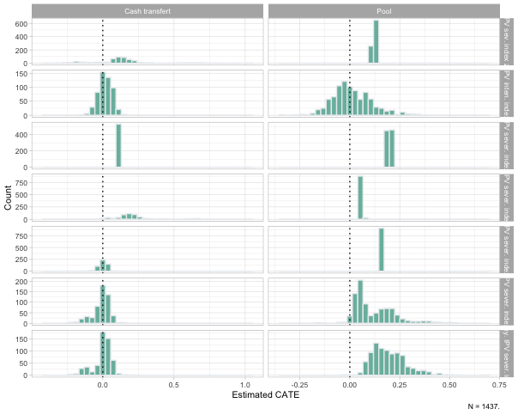

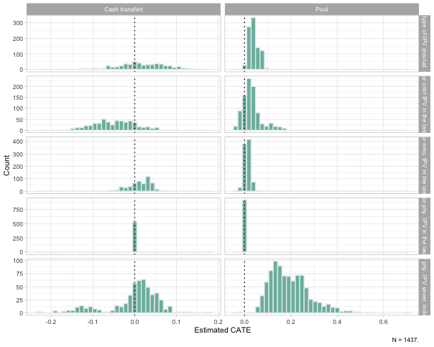

## Estimates

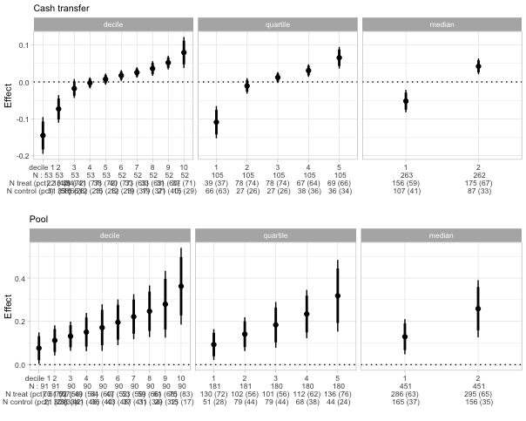

## Random forest for variable importance

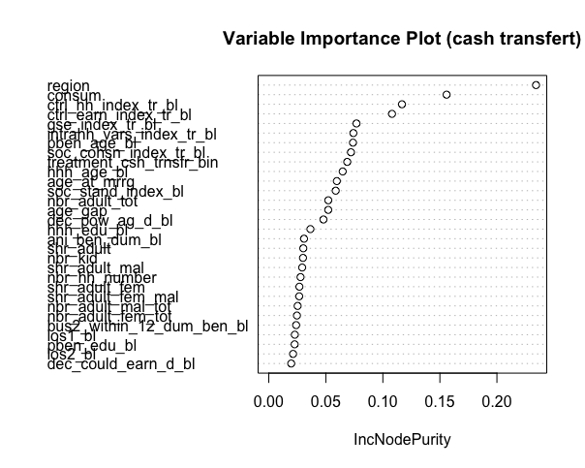

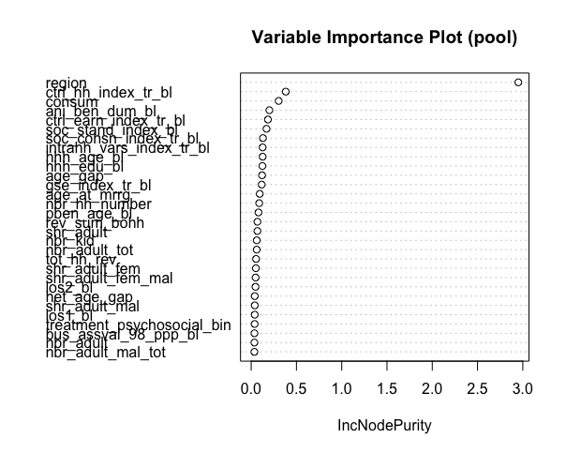

## Correlation between variables

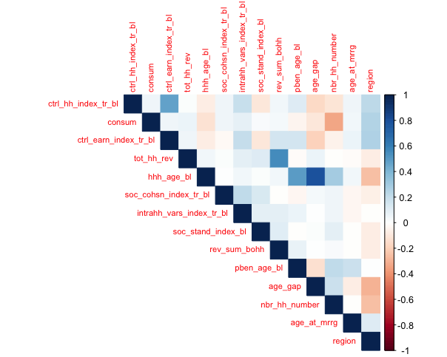

Adding theses variables in the baseline regression as control don’t have any effect on the estimates of the overall effect of the transfert on hh transfert

### Tekavoul

| **Table : Balance Table** | | | | | | | | |
| --- | --- | --- | --- | --- | --- | --- | --- | --- |
| Variable | **(1)   Control**  N = 194 | **(2)   Below Med.**  N = 156 | **(3)   Above Med.**  N = 175 | (1)-(2) | (1)-(3) | (3)-(2) | Joint F-test   P-value | Pooled F-test   P-value |
| Benef. of cash transfert only (0,1) | 0.00(0.00) | 1.00(0.00) | 1.00(0.00) | 0*** | 0*** |  |  | 0*** |
| Benef. of capital (0,1) | 0.00(0.00) | 0.00(0.00) | 0.00(0.00) |  |  |  |  |  |
| Benef. of psychosocial package (0,1) | 0.00(0.00) | 0.00(0.00) | 0.00(0.00) |  |  |  |  |  |
| Benef. of full package (0,1) | 0.00(0.00) | 0.00(0.00) | 0.00(0.00) |  |  |  |  |  |
| Benef. is HH head | 0.29(0.46) | 0.26(0.44) | 0.39(0.49) | 0.525 | 0.059* | 0.014** | 0.014** | 0.403 |
| Benef. is married (0,1) | 0.85(0.36) | 0.94(0.25) | 0.94(0.24) | 0.004*** | 0.002*** | 0.963 | 0.963 | 0.001*** |
| Benef. is handicapped | 0.01(0.07) | 0.01(0.11) | 0.00(0.00) | 0.417 | 0*** | 0*** | 0.156 | 0.894 |
| Female (hh. head) | 0.32(0.47) | 0.27(0.44) | 0.42(0.50) | 0.309 | 0.043** | 0.003*** | 0.003*** | 0.476 |
| Female (benef.) | 0.94(0.23) | 0.99(0.11) | 0.99(0.08) | 0.004*** | 0*** | 0.473 | 0.506 | 0*** |
| Polygamy (hh. head) | 0.10(0.30) | 0.10(0.30) | 0.06(0.23) | 0.887 | 0.13 | 0.118 | 0.131 | 0.455 |
| Polygamy (benef.) | 0.06(0.23) | 0.07(0.26) | 0.05(0.21) | 0.6 | 0.631 | 0.33 | 0.34 | 0.973 |
| Age (Hh. head) | 45.60(11.91) | 46.51(14.23) | 39.84(11.11) | 0.511 | 0*** | 0*** | 0*** | 0.031** |
| Age (benef.) | 35.24(11.38) | 36.24(9.47) | 33.17(8.26) | 0.382 | 0.052* | 0.002*** | 0.002*** | 0.525 |
| Age gap (hh. head - benef.) | 10.36(10.55) | 10.28(13.22) | 6.67(9.43) | 0.948 | 0*** | 0.001*** | 0.005*** | 0.07* |
| Age gap (hh. head - benef.) above med. (0,1) | 0.69(0.46) | 0.71(0.46) | 0.59(0.49) | 0.774 | 0.044** | 0.026** | 0.026** | 0.274 |
| Ben. age at marriage | 17.41(3.83) | 16.96(4.05) | 16.96(3.77) | 0.304 | 0.258 | 0.991 | 0.991 | 0.209 |
| Ben. married after 18 (0,1) | 0.60(0.49) | 0.48(0.49) | 0.52(0.50) | 0.027** | 0.123 | 0.489 | 0.489 | 0.029** |
| Nbr adults males (age 25-65) | 1.09(0.94) | 1.22(1.08) | 0.99(0.69) | 0.217 | 0.256 | 0.009*** | 0.027** | 0.886 |
| Nbr adults males (age 25-65) above med. (0,1) | 0.15(0.36) | 0.17(0.37) | 0.10(0.30) | 0.663 | 0.12 | 0.057* | 0.064* | 0.536 |
| Shr adults males (age 25-65) | 0.13(0.09) | 0.13(0.08) | 0.13(0.08) | 0.619 | 0.345 | 0.658 | 0.657 | 0.397 |
| Shr adults males (age 25-65) above med. (0,1) | 0.66(0.47) | 0.66(0.48) | 0.73(0.45) | 0.927 | 0.208 | 0.199 | 0.199 | 0.485 |
| Nbr males (age 15+) | 1.83(1.96) | 1.93(1.73) | 1.37(1.21) | 0.629 | 0.002*** | 0*** | 0.001*** | 0.201 |
| Nbr males (age 15+) above med. (0,1) | 0.40(0.49) | 0.49(0.50) | 0.26(0.44) | 0.115 | 0.004*** | 0*** | 0*** | 0.453 |
| Nbr adults females (age 25-65) | 1.32(0.97) | 1.41(1.26) | 1.10(0.75) | 0.45 | 0.01** | 0.002*** | 0.007*** | 0.408 |
| Nbr adults females (age 25-65) above med. (0,1) | 0.23(0.42) | 0.24(0.43) | 0.12(0.33) | 0.717 | 0.005*** | 0.003*** | 0.004*** | 0.191 |
| Shr adults females (age 25-65) | 0.16(0.10) | 0.15(0.08) | 0.15(0.09) | 0.485 | 0.283 | 0.702 | 0.699 | 0.31 |
| Shr adults females (age 25-65) above med. (0,1) | 0.25(0.44) | 0.28(0.45) | 0.24(0.43) | 0.541 | 0.782 | 0.386 | 0.386 | 0.856 |
| Nbr females (age 15+) | 2.13(1.86) | 2.29(2.02) | 1.57(1.07) | 0.432 | 0*** | 0*** | 0*** | 0.169 |
| Nbr females (age 15+) above med. (0,1) | 0.27(0.45) | 0.29(0.46) | 0.13(0.33) | 0.659 | 0*** | 0*** | 0*** | 0.085* |
| Shr females (age 15+) in adults | 0.57(0.19) | 0.55(0.18) | 0.57(0.19) | 0.173 | 0.796 | 0.284 | 0.297 | 0.377 |
| Shr females (age 15+) in adults above med. (0,1) | 0.29(0.46) | 0.29(0.46) | 0.27(0.44) | 0.983 | 0.594 | 0.597 | 0.597 | 0.757 |
| Shr of hh. without males (age 25-65) | 0.19(0.39) | 0.12(0.33) | 0.15(0.36) | 0.096* | 0.429 | 0.39 | 0.392 | 0.173 |
| Shr of hh. without males (age 15+) | 0.11(0.32) | 0.06(0.23) | 0.13(0.34) | 0.052* | 0.606 | 0.014** | 0.021** | 0.56 |
| Nbr adults tot (age 25-65) | 2.41(1.67) | 2.63(2.08) | 2.09(1.24) | 0.254 | 0.028** | 0.002*** | 0.005*** | 0.664 |
| Nbr adults tot (age 25-65) above med. (0,1) | 0.27(0.45) | 0.28(0.45) | 0.14(0.35) | 0.856 | 0.002*** | 0.001*** | 0.002*** | 0.101 |
| Shr adults tot (age 25-65) | 0.28(0.13) | 0.28(0.12) | 0.28(0.11) | 0.889 | 0.914 | 0.97 | 0.97 | 0.888 |
| Shr adults tot (age 25-65) above med. (0,1) | 0.50(0.50) | 0.47(0.50) | 0.51(0.50) | 0.555 | 0.871 | 0.462 | 0.462 | 0.817 |
| Nbr members (age 15+) in hh. | 3.96(3.45) | 4.22(3.44) | 2.94(2.06) | 0.479 | 0*** | 0*** | 0*** | 0.153 |
| Nbr members (age 15+) in hh. above med. (0,1) | 0.40(0.49) | 0.44(0.50) | 0.21(0.41) | 0.397 | 0*** | 0*** | 0*** | 0.07* |
| Nbr of elders (age 66+) | 0.17(0.42) | 0.17(0.43) | 0.06(0.23) | 0.948 | 0*** | 0*** | 0.003*** | 0.094* |
| Nbr of elders (age 66+) above med. (0,1) | 0.15(0.36) | 0.15(0.36) | 0.06(0.23) | 0.984 | 0.001*** | 0.002*** | 0.005*** | 0.09* |
| Shr of elders (age 66+) | 0.02(0.06) | 0.02(0.05) | 0.01(0.05) | 0.933 | 0.129 | 0.184 | 0.101 | 0.283 |
| Shr of elders (age 66+) above med. (0,1) | 0.15(0.36) | 0.15(0.36) | 0.06(0.23) | 0.984 | 0.001*** | 0.002*** | 0.005*** | 0.09* |
| Hh. has a kid (age 0-30 mnth) | 0.99(0.07) | 1.00(0.00) | 1.00(0.00) | 0*** | 0*** |  |  | 0*** |
| Nbr kid (age 0-30 mnth) | 6.92(5.04) | 7.57(5.42) | 6.23(3.65) | 0.275 | 0.092* | 0.004*** | 0.009*** | 0.898 |
| Nbr kid (age 0-30 mnth) above med. (0,1) | 0.59(0.49) | 0.64(0.48) | 0.55(0.50) | 0.311 | 0.453 | 0.087* | 0.087* | 0.92 |
| Nbr hh. members | 8.97(6.03) | 9.73(6.56) | 7.85(4.30) | 0.279 | 0.021** | 0.001*** | 0.002*** | 0.648 |
| Nbr hh. members above med. (0,1) | 0.56(0.50) | 0.62(0.49) | 0.42(0.50) | 0.272 | 0.011** | 0*** | 0*** | 0.344 |
| Education (years, HH head) | 1.31(2.89) | 1.30(2.88) | 0.90(2.18) | 0.98 | 0.109 | 0.135 | 0.155 | 0.38 |
| Education (years, benef.) | 1.01(2.19) | 0.74(1.67) | 0.67(1.61) | 0.185 | 0.085* | 0.704 | 0.702 | 0.088* |
| Primary education (0/1, H-hh. head) | 0.06(0.24) | 0.06(0.25) | 0.02(0.15) | 0.932 | 0.037** | 0.042** | 0.07* | 0.335 |
| Primary education (0/1, benef.) | 0.03(0.16) | 0.00(0.00) | 0.01(0.08) | 0*** | 0.044** | 0*** | 0.318 | 0.002*** |
| Literate (hh. head) | 0.29(0.45) | 0.32(0.47) | 0.33(0.47) | 0.525 | 0.381 | 0.833 | 0.833 | 0.371 |
| Literate (benef.) | 0.23(0.42) | 0.19(0.40) | 0.18(0.38) | 0.373 | 0.197 | 0.724 | 0.724 | 0.208 |
| Control over earnings | -0.18(1.00) | -0.23(1.21) | 0.03(1.00) | 0.686 | 0.063* | 0.043** | 0.036** | 0.385 |
| Control over hh. resources | -0.25(0.91) | -0.31(1.01) | 0.08(0.93) | 0.551 | 0.001*** | 0*** | 0*** | 0.099* |
| Intra hh. dynamics index | -0.13(1.02) | -0.10(0.91) | -0.09(1.05) | 0.809 | 0.749 | 0.929 | 0.929 | 0.742 |
| Self efficacy | 0.05(0.80) | 0.17(1.03) | 0.02(1.01) | 0.203 | 0.76 | 0.157 | 0.162 | 0.579 |
| Social cohesion and closeness to community | 0.10(1.01) | 0.30(1.01) | -0.13(0.94) | 0.056* | 0.025** | 0*** | 0*** | 0.818 |
| Social standing | -0.07(0.95) | -0.01(1.10) | -0.11(0.84) | 0.596 | 0.627 | 0.334 | 0.337 | 0.962 |
| Partner inclusiveness (1-4) | 3.34(0.75) | 3.32(0.67) | 3.42(0.68) | 0.85 | 0.268 | 0.199 | 0.195 | 0.577 |
| Community inclusiveness (1-4) | 2.60(0.87) | 2.63(0.85) | 2.47(0.81) | 0.694 | 0.159 | 0.081* | 0.08* | 0.537 |
| Ben. revenue tot. | 77.65(250.09) | 168.58(684.60) | 92.89(382.37) | 0.002*** | 0.627 | 0.093* | 0.222 | 0.037** |
| Household in Sélibaby (0,1) | 0.26(0.44) | 0.16(0.37) | 0.56(0.50) | 0.017** | 0*** | 0*** | 0*** | 0.009*** |
| Tot. hh. revenue | 172.45(714.60) | 224.18(899.59) | 261.10(889.68) | 0.546 | 0.298 | 0.713 | 0.708 | 0.309 |
| Consumption eq ppp | 3.29(1.63) | 3.12(1.85) | 2.88(1.47) | 0.363 | 0.009*** | 0.179 | 0.196 | 0.046** |
| Own earnings influence (0,1) | 0.80(0.40) | 0.81(0.39) | 0.89(0.31) | 0.727 | 0.012** | 0.044** | 0.049** | 0.113 |
| Can Decide to Earn Alone (0,1) | 0.79(0.41) | 0.81(0.39) | 0.90(0.30) | 0.641 | 0.005*** | 0.028** | 0.033** | 0.07* |
| Agriculture influence (0,1) | 0.70(0.46) | 0.79(0.41) | 0.81(0.40) | 0.062* | 0.019** | 0.698 | 0.698 | 0.016** |
| Livestock influence (0,1) | 0.43(0.50) | 0.53(0.50) | 0.49(0.50) | 0.054* | 0.269 | 0.401 | 0.401 | 0.08* |
| Off-farm business influence (0,1) | 0.65(0.48) | 0.65(0.48) | 0.64(0.48) | 0.89 | 0.772 | 0.888 | 0.888 | 0.799 |
| Daily spending influence (0,1) | 0.84(0.37) | 0.88(0.32) | 0.98(0.15) | 0.185 | 0*** | 0*** | 0.001*** | 0.001*** |
| Can Decide to Spend Alone (0,1) | 0.85(0.36) | 0.88(0.32) | 0.97(0.17) | 0.29 | 0*** | 0*** | 0.003*** | 0.003*** |
| Large purchases influence (0,1) | 0.83(0.38) | 0.87(0.34) | 0.95(0.21) | 0.279 | 0*** | 0.004*** | 0.008*** | 0.005*** |
| Can Decide to Spend Large Amounts Alone (0,1) | 0.84(0.37) | 0.86(0.35) | 0.95(0.22) | 0.633 | 0*** | 0.003*** | 0.006*** | 0.033** |
| Family planning influence (0,1) | 0.51(0.50) | 0.52(0.50) | 0.61(0.49) | 0.796 | 0.041** | 0.092* | 0.092* | 0.169 |
| Can Make Fertility Choices Alone (0,1) | 0.52(0.50) | 0.53(0.50) | 0.61(0.49) | 0.76 | 0.065* | 0.146 | 0.146 | 0.199 |
| Child education influence (0,1) | 0.79(0.41) | 0.87(0.34) | 0.85(0.36) | 0.049** | 0.2 | 0.496 | 0.497 | 0.07* |
| Wage earnings (yearly, USD) | 22.79(180.20) | 41.96(397.00) | 21.23(248.96) | 0.417 | 0.947 | 0.508 | 0.575 | 0.666 |
| Benef. controls crop revenue (0,1) | 0.02(0.14) | 0.04(0.21) | 0.06(0.23) | 0.184 | 0.045** | 0.61 | 0.612 | 0.036** |
| No. of beneficiary businesses | 0.12(0.34) | 0.13(0.37) | 0.08(0.31) | 0.804 | 0.277 | 0.206 | 0.205 | 0.618 |
| Beneficiary has a business (0,1) | 0.11(0.32) | 0.12(0.32) | 0.07(0.25) | 0.955 | 0.129 | 0.134 | 0.144 | 0.421 |
| No. of months benef worked last year | 0.65(2.25) | 0.94(2.89) | 0.48(1.98) | 0.303 | 0.426 | 0.074* | 0.099* | 0.848 |
| Entrepreneurial business types (yearly) | 0.11(0.32) | 0.12(0.32) | 0.07(0.25) | 0.955 | 0.129 | 0.134 | 0.144 | 0.421 |
| Beneficiary launched a business (0,1) | 0.04(0.19) | 0.02(0.14) | 0.02(0.15) | 0.33 | 0.463 | 0.818 | 0.819 | 0.355 |
| Business revenues (yearly, USD) | 37.29(173.09) | 94.46(552.93) | 53.66(288.39) | 0.005*** | 0.455 | 0.217 | 0.409 | 0.041** |
| Business profits (yearly, USD) | 11.21(60.61) | 36.00(175.56) | 19.58(119.23) | 0.005*** | 0.278 | 0.258 | 0.326 | 0.011** |
| Business asset value hh. (USD) | 17.48(102.68) | 8.76(48.01) | 9.10(45.86) | 0.14 | 0.133 | 0.948 | 0.948 | 0.115 |
| Business revenue (beneficiary, monthly, USD) | 4.76(22.50) | 9.74(49.66) | 6.13(34.10) | 0.059* | 0.626 | 0.365 | 0.446 | 0.163 |
| Benef. owns livestock (0,1) | 0.48(0.50) | 0.51(0.50) | 0.58(0.49) | 0.602 | 0.061* | 0.203 | 0.202 | 0.153 |
| Benef. traveled for work (0,1) | 0.04(0.19) | 0.03(0.18) | 0.03(0.18) | 0.845 | 0.93 | 0.91 | 0.91 | 0.874 |
| N cluster | 38 | 30 | 33 |  |  |  |  |  |
| N strata | 9 | 7 | 9 |  |  |  |  |  |
| Notes: Standard errors for all tests are clustered at the Social Promotion Space level level. Fixed effects using randomization strata are included in all estimation regressions. The joint F-test shows the p-value from a test of equality of treatment arms. While the pooled F-test shows the p-value from a test of pooled treatment (i.e., a regression with a dummy for any treatment arm). *** p < 0.01, ** p < 0.05, * p < 0.1. | | | | | | | | |

### Productive inclusion

| **Table : Balance Table** | | | | | | | | |
| --- | --- | --- | --- | --- | --- | --- | --- | --- |
| Variable | **(1)   Control**  N = 321 | **(2)   Below Med.**  N = 286 | **(3)   Above Med.**  N = 295 | (1)-(2) | (1)-(3) | (3)-(2) | Joint F-test   P-value | Pooled F-test   P-value |
| Benef. of cash transfert only (0,1) | 1.00(0.00) | 0.00(0.00) | 0.00(0.00) | 0*** | 0*** |  |  | 0*** |
| Benef. of capital (0,1) | 0.00(0.00) | 0.34(0.47) | 0.33(0.47) | 0*** | 0*** | 0.913 | 0.913 | 0*** |
| Benef. of psychosocial package (0,1) | 0.00(0.00) | 0.40(0.49) | 0.36(0.48) | 0*** | 0*** | 0.736 | 0.736 | 0*** |
| Benef. of full package (0,1) | 0.00(0.00) | 0.27(0.44) | 0.32(0.47) | 0*** | 0*** | 0.595 | 0.597 | 0*** |
| Benef. is HH head | 0.33(0.47) | 0.27(0.44) | 0.49(0.50) | 0.352 | 0.034** | 0*** | 0*** | 0.444 |
| Benef. is married (0,1) | 0.95(0.22) | 0.94(0.23) | 0.93(0.26) | 0.876 | 0.274 | 0.325 | 0.323 | 0.462 |
| Benef. is handicapped | 0.01(0.08) | 0.00(0.06) | 0.00(0.00) | 0.609 | 0*** | 0*** | 0.313 | 0.251 |
| Female (hh. head) | 0.35(0.48) | 0.28(0.45) | 0.49(0.50) | 0.33 | 0.065* | 0*** | 0*** | 0.546 |
| Female (benef.) | 0.99(0.10) | 1.00(0.06) | 0.98(0.15) | 0.307 | 0.125 | 0.003*** | 0.043** | 0.536 |
| Polygamy (hh. head) | 0.07(0.26) | 0.09(0.29) | 0.01(0.10) | 0.393 | 0*** | 0*** | 0*** | 0.366 |
| Polygamy (benef.) | 0.05(0.22) | 0.07(0.26) | 0.01(0.10) | 0.376 | 0*** | 0*** | 0*** | 0.538 |
| Age (Hh. head) | 42.31(12.52) | 43.20(10.81) | 40.11(10.54) | 0.526 | 0.078* | 0.002*** | 0.003*** | 0.593 |
| Age (benef.) | 33.66(6.94) | 33.96(7.08) | 34.17(6.95) | 0.661 | 0.392 | 0.738 | 0.737 | 0.464 |
| Age gap (hh. head - benef.) | 8.65(11.40) | 9.24(9.42) | 5.94(8.64) | 0.618 | 0.006*** | 0*** | 0*** | 0.29 |
| Age gap (hh. head - benef.) above med. (0,1) | 0.65(0.48) | 0.70(0.46) | 0.49(0.50) | 0.459 | 0.032** | 0*** | 0*** | 0.383 |
| Ben. age at marriage | 16.96(3.89) | 17.63(4.16) | 18.72(5.35) | 0.071* | 0*** | 0.026** | 0.037** | 0.001*** |
| Ben. married after 18 (0,1) | 1.37(0.49) | 1.41(0.48) | 1.54(0.50) | 0.409 | 0*** | 0.002*** | 0.003*** | 0.011** |
| Nbr adults males (age 25-65) | 1.08(0.87) | 1.08(0.84) | 0.78(0.50) | 0.993 | 0*** | 0*** | 0*** | 0.09* |
| Nbr adults males (age 25-65) above med. (0,1) | 0.12(0.33) | 0.12(0.32) | 0.03(0.17) | 0.878 | 0*** | 0*** | 0*** | 0.147 |
| Shr adults males (age 25-65) | 0.13(0.08) | 0.13(0.08) | 0.12(0.09) | 0.887 | 0.068* | 0.086* | 0.103 | 0.251 |
| Shr adults males (age 25-65) above med. (0,1) | 0.69(0.46) | 0.65(0.48) | 0.65(0.48) | 0.316 | 0.405 | 0.882 | 0.882 | 0.286 |
| Nbr males (age 15+) | 1.60(1.48) | 1.69(1.45) | 1.10(0.85) | 0.697 | 0*** | 0*** | 0*** | 0.239 |
| Nbr males (age 15+) above med. (0,1) | 0.36(0.48) | 0.39(0.49) | 0.22(0.42) | 0.587 | 0.004*** | 0*** | 0.001*** | 0.326 |
| Nbr adults females (age 25-65) | 1.23(1.01) | 1.23(0.98) | 1.00(0.39) | 0.979 | 0*** | 0*** | 0.012** | 0.288 |
| Nbr adults females (age 25-65) above med. (0,1) | 0.17(0.37) | 0.20(0.40) | 0.06(0.23) | 0.512 | 0.001*** | 0*** | 0*** | 0.387 |
| Shr adults females (age 25-65) | 0.15(0.08) | 0.14(0.07) | 0.15(0.07) | 0.156 | 0.965 | 0.11 | 0.111 | 0.467 |
| Shr adults females (age 25-65) above med. (0,1) | 0.26(0.44) | 0.21(0.41) | 0.26(0.44) | 0.248 | 0.818 | 0.156 | 0.156 | 0.626 |
| Nbr females (age 15+) | 1.87(1.61) | 2.07(1.97) | 1.47(0.86) | 0.416 | 0*** | 0*** | 0.003*** | 0.644 |
| Nbr females (age 15+) above med. (0,1) | 0.19(0.39) | 0.24(0.43) | 0.10(0.30) | 0.318 | 0.013** | 0*** | 0*** | 0.633 |
| Shr females (age 15+) in adults | 0.56(0.19) | 0.56(0.17) | 0.61(0.22) | 0.995 | 0.01** | 0.004*** | 0.008*** | 0.106 |
| Shr females (age 15+) in adults above med. (0,1) | 0.28(0.45) | 0.27(0.45) | 0.37(0.48) | 0.911 | 0.038** | 0.029** | 0.03** | 0.229 |
| Shr of hh. without males (age 25-65) | 0.14(0.35) | 0.14(0.34) | 0.25(0.44) | 0.91 | 0.008*** | 0.001*** | 0.003*** | 0.11 |
| Shr of hh. without males (age 15+) | 0.10(0.30) | 0.07(0.26) | 0.20(0.40) | 0.393 | 0.007*** | 0*** | 0*** | 0.184 |
| Nbr adults tot (age 25-65) | 2.31(1.67) | 2.31(1.65) | 1.78(0.66) | 0.991 | 0*** | 0*** | 0*** | 0.156 |
| Nbr adults tot (age 25-65) above med. (0,1) | 0.20(0.40) | 0.22(0.41) | 0.05(0.23) | 0.716 | 0*** | 0*** | 0*** | 0.202 |
| Shr adults tot (age 25-65) | 0.28(0.11) | 0.27(0.11) | 0.27(0.12) | 0.319 | 0.142 | 0.673 | 0.674 | 0.156 |
| Shr adults tot (age 25-65) above med. (0,1) | 0.48(0.50) | 0.45(0.50) | 0.42(0.49) | 0.432 | 0.12 | 0.522 | 0.522 | 0.186 |
| Nbr members (age 15+) in hh. | 3.47(2.82) | 3.76(3.13) | 2.57(1.34) | 0.529 | 0*** | 0*** | 0.001*** | 0.425 |
| Nbr members (age 15+) in hh. above med. (0,1) | 0.31(0.46) | 0.37(0.48) | 0.16(0.37) | 0.331 | 0.002*** | 0*** | 0*** | 0.492 |
| Nbr of elders (age 66+) | 0.09(0.31) | 0.11(0.35) | 0.06(0.25) | 0.677 | 0.134 | 0.043** | 0.112 | 0.705 |
| Nbr of elders (age 66+) above med. (0,1) | 0.09(0.28) | 0.09(0.29) | 0.05(0.23) | 0.807 | 0.13 | 0.071* | 0.103 | 0.582 |
| Shr of elders (age 66+) | 0.01(0.05) | 0.01(0.03) | 0.01(0.04) | 0.218 | 0.394 | 0.814 | 0.819 | 0.264 |
| Shr of elders (age 66+) above med. (0,1) | 0.09(0.28) | 0.09(0.29) | 0.05(0.23) | 0.807 | 0.13 | 0.071* | 0.103 | 0.582 |
| Hh. has a kid (age 0-30 mnth) | 1.00(0.00) | 1.00(0.00) | 1.00(0.06) |  | 0*** | 0*** | 0.294 | 0*** |
| Nbr kid (age 0-30 mnth) | 6.81(4.57) | 7.13(5.04) | 5.63(2.12) | 0.677 | 0*** | 0*** | 0.008*** | 0.487 |
| Nbr kid (age 0-30 mnth) above med. (0,1) | 0.59(0.49) | 0.57(0.50) | 0.50(0.50) | 0.694 | 0.05* | 0.13 | 0.127 | 0.221 |
| Nbr hh. members | 8.64(5.48) | 9.05(6.08) | 7.07(2.37) | 0.677 | 0*** | 0*** | 0.004*** | 0.446 |
| Nbr hh. members above med. (0,1) | 0.51(0.50) | 0.52(0.50) | 0.41(0.49) | 0.912 | 0.04** | 0.016** | 0.016** | 0.34 |
| Education (years, HH head) | 1.12(2.57) | 0.98(2.16) | 1.13(2.39) | 0.476 | 0.977 | 0.46 | 0.484 | 0.741 |
| Education (years, benef.) | 0.73(1.66) | 1.04(2.06) | 1.02(2.05) | 0.132 | 0.141 | 0.924 | 0.924 | 0.093* |
| Primary education (0/1, H-hh. head) | 0.04(0.20) | 0.03(0.17) | 0.03(0.16) | 0.441 | 0.265 | 0.772 | 0.775 | 0.277 |
| Primary education (0/1, benef.) | 0.00(0.06) | 0.02(0.15) | 0.02(0.14) | 0.001*** | 0.004*** | 0.71 | 0.715 | 0*** |
| Literate (hh. head) | 0.33(0.47) | 0.36(0.48) | 0.36(0.48) | 0.623 | 0.586 | 0.987 | 0.987 | 0.553 |
| Literate (benef.) | 0.19(0.39) | 0.28(0.45) | 0.29(0.46) | 0.058* | 0.007*** | 0.753 | 0.751 | 0.01** |
| Control over earnings | -0.08(1.10) | -0.31(1.13) | 0.05(1.03) | 0.044** | 0.314 | 0.001*** | 0.001*** | 0.665 |
| Control over hh. resources | -0.08(0.95) | -0.32(1.07) | -0.06(0.90) | 0.085* | 0.9 | 0.021** | 0.024** | 0.395 |
| Intra hh. dynamics index | -0.10(0.99) | -0.17(1.01) | -0.23(0.92) | 0.56 | 0.236 | 0.638 | 0.635 | 0.324 |
| Self efficacy | 0.10(1.01) | 0.24(0.93) | 0.31(0.81) | 0.204 | 0.071* | 0.506 | 0.501 | 0.09* |
| Social cohesion and closeness to community | 0.07(0.98) | 0.10(0.98) | 0.05(0.93) | 0.774 | 0.826 | 0.605 | 0.603 | 0.959 |
| Social standing | -0.07(0.96) | -0.02(0.95) | -0.16(0.75) | 0.663 | 0.302 | 0.15 | 0.145 | 0.763 |
| Partner inclusiveness (1-4) | 3.37(0.68) | 3.35(0.73) | 3.33(0.67) | 0.834 | 0.624 | 0.831 | 0.83 | 0.685 |
| Community inclusiveness (1-4) | 2.53(0.83) | 2.56(0.88) | 2.43(0.76) | 0.747 | 0.14 | 0.135 | 0.132 | 0.574 |
| Ben. revenue tot. | 132.13(554.56) | 176.58(623.71) | 97.70(337.03) | 0.498 | 0.397 | 0.023** | 0.081* | 0.933 |
| Household in Sélibaby (0,1) | 0.38(0.49) | 0.08(0.27) | 0.91(0.28) | 0*** | 0*** | 0*** | 0*** | 0.215 |
| Tot. hh. revenue | 251.05(906.05) | 318.91(933.81) | 217.11(686.51) | 0.498 | 0.666 | 0.228 | 0.282 | 0.839 |
| Consumption eq ppp | 3.00(1.65) | 3.05(1.64) | 3.23(1.42) | 0.814 | 0.181 | 0.298 | 0.271 | 0.405 |
| Own earnings influence (0,1) | 0.86(0.34) | 0.88(0.33) | 0.91(0.29) | 0.694 | 0.157 | 0.317 | 0.327 | 0.335 |
| Can Decide to Earn Alone (0,1) | 0.86(0.34) | 0.88(0.33) | 0.92(0.28) | 0.678 | 0.102 | 0.195 | 0.197 | 0.271 |
| Agriculture influence (0,1) | 0.80(0.40) | 0.78(0.42) | 0.78(0.42) | 0.516 | 0.604 | 0.936 | 0.936 | 0.489 |
| Livestock influence (0,1) | 0.51(0.50) | 0.37(0.48) | 0.58(0.49) | 0.004*** | 0.209 | 0*** | 0*** | 0.428 |
| Off-farm business influence (0,1) | 0.65(0.48) | 0.68(0.47) | 0.71(0.45) | 0.532 | 0.185 | 0.461 | 0.459 | 0.249 |
| Daily spending influence (0,1) | 0.94(0.24) | 0.94(0.24) | 0.98(0.13) | 0.992 | 0.004*** | 0.003*** | 0.02** | 0.272 |
| Can Decide to Spend Alone (0,1) | 0.93(0.25) | 0.94(0.24) | 0.98(0.13) | 0.926 | 0.001*** | 0.002*** | 0.03** | 0.217 |
| Large purchases influence (0,1) | 0.92(0.27) | 0.94(0.24) | 0.96(0.19) | 0.357 | 0.024** | 0.202 | 0.218 | 0.104 |
| Can Decide to Spend Large Amounts Alone (0,1) | 0.91(0.29) | 0.92(0.27) | 0.96(0.19) | 0.592 | 0.008*** | 0.034** | 0.043** | 0.111 |
| Family planning influence (0,1) | 0.58(0.49) | 0.58(0.49) | 0.61(0.49) | 0.986 | 0.589 | 0.634 | 0.634 | 0.749 |
| Can Make Fertility Choices Alone (0,1) | 0.59(0.49) | 0.59(0.49) | 0.61(0.49) | 0.925 | 0.583 | 0.686 | 0.686 | 0.71 |
| Child education influence (0,1) | 0.87(0.34) | 0.88(0.32) | 0.89(0.31) | 0.696 | 0.403 | 0.768 | 0.771 | 0.496 |
| Wage earnings (yearly, USD) | 31.97(331.85) | 9.59(89.42) | 0.00(0.00) | 0.003*** | 0*** | 0*** | 0.064* | 0*** |
| Benef. controls crop revenue (0,1) | 0.05(0.22) | 0.04(0.20) | 0.04(0.19) | 0.67 | 0.476 | 0.764 | 0.765 | 0.533 |
| No. of beneficiary businesses | 0.11(0.35) | 0.22(0.47) | 0.12(0.34) | 0.009*** | 0.657 | 0.012** | 0.021** | 0.065* |
| Beneficiary has a business (0,1) | 0.09(0.29) | 0.20(0.40) | 0.12(0.32) | 0.002*** | 0.418 | 0.034** | 0.037** | 0.02** |
| No. of months benef worked last year | 0.72(2.49) | 1.21(3.05) | 0.77(2.42) | 0.143 | 0.861 | 0.122 | 0.147 | 0.323 |
| Entrepreneurial business types (yearly) | 0.09(0.29) | 0.20(0.42) | 0.12(0.32) | 0.001*** | 0.418 | 0.021** | 0.029** | 0.015** |
| Beneficiary launched a business (0,1) | 0.02(0.15) | 0.07(0.25) | 0.05(0.22) | 0.002*** | 0.041** | 0.45 | 0.448 | 0.002*** |
| Business revenues (yearly, USD) | 75.16(439.97) | 138.74(612.93) | 79.52(326.20) | 0.341 | 0.93 | 0.086* | 0.179 | 0.533 |
| Business profits (yearly, USD) | 28.17(150.68) | 53.98(245.02) | 39.71(176.60) | 0.2 | 0.552 | 0.454 | 0.48 | 0.273 |
| Business asset value hh. (USD) | 9.22(47.51) | 6.17(24.49) | 11.57(80.96) | 0.22 | 0.631 | 0.037** | 0.283 | 0.937 |
| Business revenue (beneficiary, monthly, USD) | 8.08(42.76) | 12.94(56.86) | 9.81(38.34) | 0.394 | 0.728 | 0.416 | 0.472 | 0.495 |
| Benef. owns livestock (0,1) | 0.55(0.50) | 0.43(0.50) | 0.71(0.45) | 0.049** | 0.005*** | 0*** | 0*** | 0.726 |
| Benef. traveled for work (0,1) | 0.03(0.18) | 0.02(0.15) | 0.02(0.14) | 0.505 | 0.362 | 0.784 | 0.782 | 0.354 |
| N cluster | 38 | 46 | 46 |  |  |  |  |  |
| N strata | 10 | 10 | 11 |  |  |  |  |  |
| Notes: Standard errors for all tests are clustered at the Social Promotion Space level level. Fixed effects using randomization strata are included in all estimation regressions. The joint F-test shows the p-value from a test of equality of treatment arms. While the pooled F-test shows the p-value from a test of pooled treatment (i.e., a regression with a dummy for any treatment arm). *** p < 0.01, ** p < 0.05, * p < 0.1. | | | | | | | | |

### Other tables

## Estimates of treatment effect

### Controlling Behavior

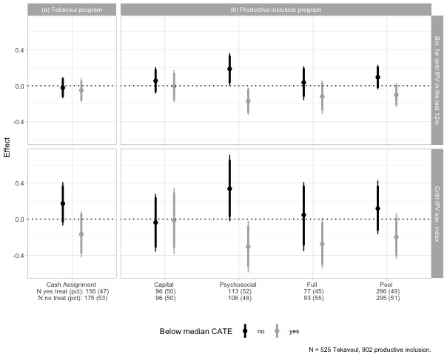

### Emotional Violence

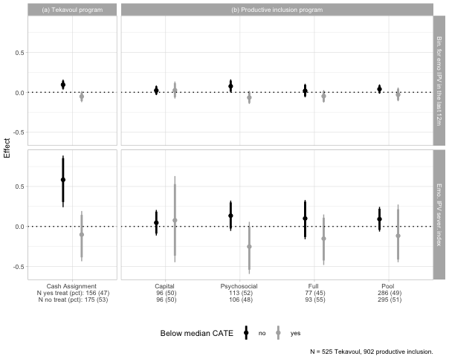

### Physical violence

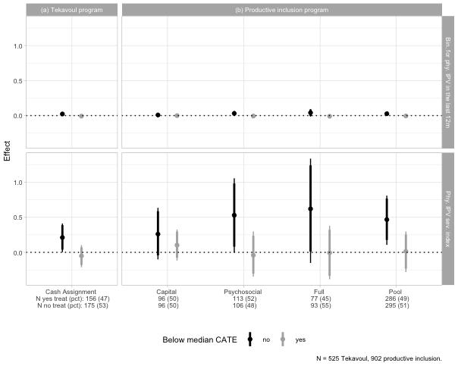

### Sexual Violence

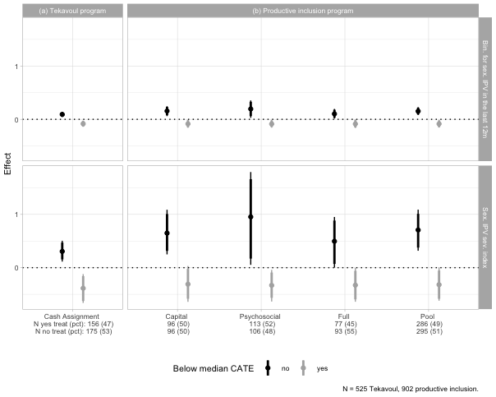

### Sexual and Physical violence

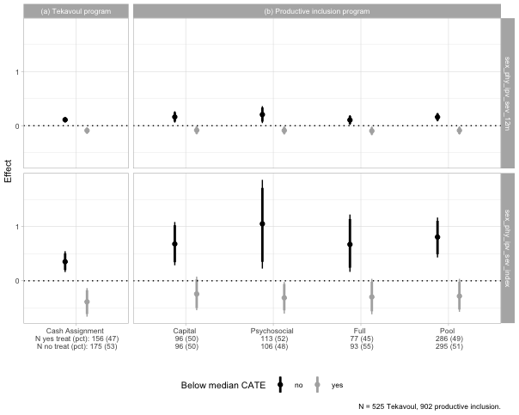

### Economic Violence

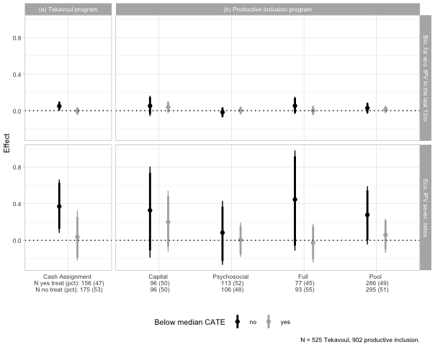

### Other types of violences

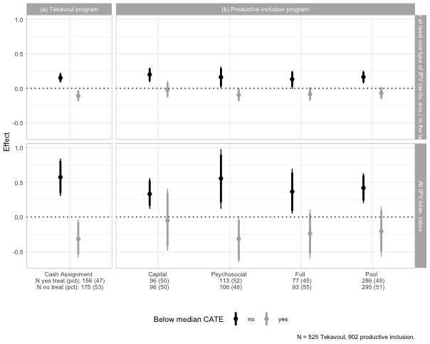

## Mechanism

### Economic Security & Emotional Well-being

Cash reduces poverty stress and improve emotional well-being. Impact: generally reduces IPV.

#### Household level

Decreasing household poverty and therefore poverty-related stress or improving emotional well-being Credit and savings variables at individual level - Tekavoul: * For the low group, the transfert increase financial security by increasing the total amoung borriwed and save by the household and beneficiary but it is inclear how if affect financial stress; * For high, it decrease non food consumption and business revenues (not sure about how to interpret)

* Productive inclusion
* For the low, the program decrease debt and increase saving and participation in tontine but this don’t affect household level consumption and food security
* high not effect

|  | (1) | (2) | (3) | (4) | (5) | (6) | (7) | (8) | (9) | (10) | (11) | (12) | (13) | (14) | (15) | (16) | (17) | (18) | (19) | (20) | (21) |
| --- | --- | --- | --- | --- | --- | --- | --- | --- | --- | --- | --- | --- | --- | --- | --- | --- | --- | --- | --- | --- | --- |
| **Outcome***1* | Gross consumption (daily, USD/capita) | Food consumption (daily, USD/adult eq.) | Non Food consumption (daily, USD/adult eq.) | Eating out expenditure (daily, USD/adult eq.) | Education expenditure (daily, USD/adult eq.) | Health expenditure (daily, USD/adult eq.) | Celebration expenditure (daily, USD/adult eq.) | Takes part in tontine/AVEC (0,1) | Total debt (yearly, USD) | Total borrowed (yearly, USD) | Household Gross transfers (yearly, USD) | Total savings (3 months, USD) | Food security (FIES) | Dietary diversity (FCS) | Total revenue (yearly, USD) | Business revenues (yearly, USD) | Wage earnings (yearly, USD) | Livestock revenue (yearly, USD) | Count of income sources (yearly) | No. of income sources (Household) | Wage types (Household) |
| Tekavoul |  |  |  |  |  |  |  |  |  |  |  |  |  |  |  |  |  |  |  |  |  |
| Control | — | — | — | — | — | — | — | — | — | — | — | — | — | — | — | — | — | — | — | — | — |
| Cash Assignment | 0.24 (0.350) | 0.21 (0.325) | 0.04 (0.048) | 0.00 (0.000) | 0.00 (0.002) | 0.00 (0.040) | 0.00 (0.026) | 0.06 (0.041) | 47.28 (36.9) | 57.53 (38.6) | 14.31 (72.4) | 4.17 (3.23) | 0.08 (0.429) | 1.34 (3.63) | 112.48 (95.4) | 40.67 (80.4) | -2.01 (3.70) | -16.02 (13.8) | 0.08 (0.119) | 0.07 (0.205) | 0.00 (0.007) |
| Estimated CATE (high)* Tekavoul |  |  |  |  |  |  |  |  |  |  |  |  |  |  |  |  |  |  |  |  |  |
| Estimated CATE (high)* Cash Assignment | -0.40 (0.435) | -0.11 (0.392) | -0.21** (0.076) | 0.00 (0.000) | 0.00 (0.003) | -0.04 (0.072) | -0.05 (0.036) | 0.05 (0.056) | 12.74 (39.7) | 13.00 (43.2) | -78.85 (88.2) | -4.34 (4.03) | -0.06 (0.568) | 4.79 (5.19) | -547.07 (284) | -527.41 (279) | -22.58 (25.3) | 13.00 (19.6) | -0.20 (0.173) | -0.24 (0.294) | -0.02 (0.021) |
| No. Obs. | 403 | 403 | 405 | 405 | 405 | 405 | 405 | 401 | 387 | 401 | 405 | 401 | 401 | 401 | 405 | 405 | 405 | 405 | 405 | 405 | 405 |
| R² | 0.089 | 0.086 | 0.132 |  | 0.081 | 0.025 | 0.055 | 0.052 | 0.054 | 0.073 | 0.021 | 0.079 | 0.091 | 0.045 | 0.129 | 0.106 | 0.035 | 0.040 | 0.116 | 0.082 | 0.027 |
| PI (Pool) |  |  |  |  |  |  |  |  |  |  |  |  |  |  |  |  |  |  |  |  |  |
| Control | — | — | — | — | — | — | — | — | — | — | — | — | — | — | — | — | — | — | — | — | — |
| Pool | -0.10 (0.332) | -0.36 (0.268) | 0.06 (0.060) | 0.00 (0.000) | 0.00 (0.002) | 0.12* (0.051) | 0.06* (0.026) | 0.44*** (0.069) | -51.14* (25.9) | -56.58* (27.1) | 28.82 (59.4) | 11.96*** (3.40) | 0.37 (0.306) | -0.53 (3.61) | 196.45 (119) | 167.82 (119) | 20.37 (15.2) | 6.87 (9.66) | 0.09 (0.120) | 0.14 (0.177) | 0.02* (0.009) |
| Estimated CATE (high)* Pool |  |  |  |  |  |  |  |  |  |  |  |  |  |  |  |  |  |  |  |  |  |
| Estimated CATE (high)* Pool | 0.16 (0.364) | 0.30 (0.295) | 0.08 (0.073) | 0.00 (0.000) | -0.01* (0.003) | -0.11 (0.071) | -0.08* (0.034) | -0.21* (0.097) | 1.66 (31.7) | 5.85 (34.3) | -19.57 (77.0) | -8.01 (4.94) | -0.21 (0.610) | 6.34 (4.65) | -336.69 (180) | -226.15 (176) | -4.08 (25.0) | -4.96 (17.7) | -0.12 (0.162) | -0.13 (0.274) | -0.02 (0.016) |
| No. Obs. | 669 | 669 | 687 | 687 | 687 | 687 | 687 | 684 | 663 | 684 | 687 | 684 | 684 | 684 | 687 | 687 | 687 | 687 | 687 | 687 | 687 |
| R² | 0.065 | 0.073 | 0.048 |  | 0.059 | 0.029 | 0.062 | 0.167 | 0.037 | 0.048 | 0.027 | 0.024 | 0.039 | 0.039 | 0.050 | 0.041 | 0.013 | 0.029 | 0.089 | 0.065 | 0.023 |
| Control mean @ follow up | 3.288 | 2.630 | 0.331 | 0 | 0.009 | 0.143 | 0.179 | 0.162 | 79.7 | 101.1 | 76.36 | 3.769 | 3.210 | 39.74 | 502 | 330.6 | 11.2 | 18.91 | 0.896 | 1.319 | 0.011 |
| Control SD @ follow up | 2.154 | 1.883 | 0.378 | 0 | 0.015 | 0.380 | 0.168 | 0.369 | 194.9 | 220.6 | 366.92 | 28.033 | 2.689 | 23.77 | 1210 | 1153.2 | 138.5 | 95.06 | 0.805 | 1.349 | 0.103 |
| Cash Assignment + Estimated CATE (high) * Cash Assignment | -0.160 | 0.096 | -0.172 | 0 | 0.001 | -0.041 | -0.045 | 0.109 | 60.0 | 70.5 | -64.54 | -0.164 | 0.018 | 6.14 | -435 | -486.7 | -24.6 | -3.03 | -0.128 | -0.169 | -0.017 |
| Pool + Estimated CATE (high) * Pool | 0.068 | -0.057 | 0.132 | 0 | -0.004 | 0.018 | -0.016 | 0.228 | -49.5 | -50.7 | 9.25 | 3.948 | 0.159 | 5.81 | -140 | -58.3 | 16.3 | 1.91 | -0.025 | 0.006 | -0.003 |
| *1*Notes: Results presented are OLS estimates that include controls for randomization strata (commune) and, where possible, baseline outcomes. We control for social promotion intervention. Enumerator fixed effects are included in all regression. We estimate the regressions for the productive beneficiaries aged 18-49 only. Robust standard errors are shown in parentheses, clustered at the village proxy level. *** p < 0.01, ** p < 0.05, * p < 0.1. | | | | | | | | | | | | | | | | | | | | | |
| Abbreviations: CI = Confidence Interval, SE = Standard Error | | | | | | | | | | | | | | | | | | | | | |

#### Ben level

For the higj h in tekavoul, the cash reduce business at both household driven by a reduction in beneficiary busoness evenue

|  | Total revenue (yearly, USD) |  | | Business revenues (yearly, USD) |  | | Wage earnings (yearly, USD) |  | | Livestock revenue (yearly, USD) |  | |
| --- | --- | --- | --- | --- | --- | --- | --- | --- | --- | --- | --- | --- |
| **Outcome***1* | hh. | ben. | prt. | hh. | ben. | prt. | hh. | ben. | prt. | hh. | ben. | prt. |
| Tekavoul |  |  |  |  |  |  |  |  |  |  |  |  |
| Control | — | — | — | — | — | — | — | — | — | — | — | — |
| Cash Assignment | 112.48 (95.4) | 46.93 (73.5) | 65.55 (59.4) | 40.67 (80.4) | 4.85 (66.7) | 35.82 (47.5) | -2.01 (3.70) | 0.00 (0.000) | -2.01 (3.70) | -16.02 (13.8) | -8.51 (6.25) | -7.51 (12.4) |
| Estimated CATE (high)* Tekavoul |  |  |  |  |  |  |  |  |  |  |  |  |
| Estimated CATE (high)* Cash Assignment | -547.07 (284) | -325.31 (249) | -221.76 (161) | -527.41 (279) | -300.23 (248) | -227.18 (147) | -22.58 (25.3) | 0.00 (0.000) | -22.58 (25.3) | 13.00 (19.6) | 15.07* (7.40) | -2.07 (17.6) |
| No. Obs. | 405 | 405 | 405 | 405 | 405 | 405 | 405 | 405 | 405 | 405 | 405 | 405 |
| R² | 0.129 | 0.059 | 0.109 | 0.106 | 0.059 | 0.090 | 0.035 |  | 0.035 | 0.040 | 0.067 | 0.035 |
| PI (Pool) |  |  |  |  |  |  |  |  |  |  |  |  |
| Control | — | — | — | — | — | — | — | — | — | — | — | — |
| Pool | 196.45 (119) | 265.85** (96.9) | -69.41 (65.3) | 167.82 (119) | 270.77** (96.9) | -102.95 (62.9) | 20.37 (15.2) | 1.92 (1.75) | 18.45 (15.1) | 6.87 (9.66) | 3.85 (6.50) | 3.02 (5.57) |
| Estimated CATE (high)* Pool |  |  |  |  |  |  |  |  |  |  |  |  |
| Estimated CATE (high)* Pool | -336.69 (180) | -270.26 (148) | -66.43 (99.6) | -226.15 (176) | -260.52 (147) | 34.37 (90.2) | -4.08 (25.0) | 4.65 (6.78) | -8.73 (24.1) | -4.96 (17.7) | -1.49 (8.23) | -3.46 (12.7) |
| No. Obs. | 687 | 687 | 687 | 687 | 687 | 687 | 687 | 687 | 687 | 687 | 687 | 687 |
| R² | 0.050 | 0.041 | 0.078 | 0.041 | 0.043 | 0.049 | 0.013 | 0.009 | 0.011 | 0.029 | 0.017 | 0.033 |
| Control mean @ follow up | 502 | 216.97 | 285 | 330.6 | 175.0 | 155.6 | 11.2 | 2.04 | 9.15 | 18.91 | 5.67 | 13.242 |
| Control SD @ follow up | 1210 | 971.08 | 695 | 1153.2 | 951.3 | 621.5 | 138.5 | 56.06 | 126.78 | 95.06 | 47.81 | 77.506 |
| Cash Assignment + Estimated CATE (high) * Cash Assignment | -435 | -278.38 | -156 | -486.7 | -295.4 | -191.4 | -24.6 | 0.00 | -24.59 | -3.03 | 6.56 | -9.584 |
| Pool + Estimated CATE (high) * Pool | -140 | -4.41 | -136 | -58.3 | 10.3 | -68.6 | 16.3 | 6.57 | 9.72 | 1.91 | 2.35 | -0.444 |
| *1*Notes: Results presented are OLS estimates that include controls for randomization strata (commune) and, where possible, baseline outcomes. We control for social promotion intervention. Enumerator fixed effects are included in all regression. We estimate the regressions for the productive beneficiaries aged 18-49 only. Robust standard errors are shown in parentheses, clustered at the village proxy level. *** p < 0.01, ** p < 0.05, * p < 0.1. | | | | | | | | | | | | |
| Abbreviations: CI = Confidence Interval, SE = Standard Error | | | | | | | | | | | | |

### Intra-household Conflict

#### Main indexes

|  | (1) | (2) | (3) |
| --- | --- | --- | --- |
| **Outcome***1* | Intra-household dynamics index | Violence perceptions index | Gender attitudes index |
| Tekavoul |  |  |  |
| Control | — | — | — |
| Cash Assignment | -0.05 (0.126) | 0.00 (0.151) | -0.08 (0.133) |
| Estimated CATE (high)* Tekavoul |  |  |  |
| Estimated CATE (high)* Cash Assignment | -0.07 (0.179) | -0.20 (0.207) | 0.15 (0.221) |
| No. Obs. | 401 | 401 | 401 |
| R² | 0.058 | 0.077 | 0.119 |
| PI (Pool) |  |  |  |
| Control | — | — | — |
| Pool | -0.16 (0.100) | 0.16 (0.129) | -0.09 (0.127) |
| Estimated CATE (high)* Pool |  |  |  |
| Estimated CATE (high)* Pool | -0.03 (0.138) | -0.19 (0.175) | -0.16 (0.246) |
| No. Obs. | 684 | 684 | 684 |
| R² | 0.043 | 0.026 | 0.036 |
| Control mean @ follow up | 0.119 | -0.021 | -0.008 |
| Control SD @ follow up | 0.835 | 0.941 | 0.980 |
| Cash Assignment + Estimated CATE (high) * Cash Assignment | -0.114 | -0.196 | 0.071 |
| Pool + Estimated CATE (high) * Pool | -0.186 | -0.031 | -0.245 |
| *1*Notes: Results presented are OLS estimates that include controls for randomization strata (commune) and, where possible, baseline outcomes. We control for social promotion intervention. Enumerator fixed effects are included in all regression. We estimate the regressions for the productive beneficiaries aged 18-49 only. Robust standard errors are shown in parentheses, clustered at the village proxy level. *** p < 0.01, ** p < 0.05, * p < 0.1. | | | |
| Abbreviations: CI = Confidence Interval, SE = Standard Error | | | |

#### Indexes components

##### Intra-household index components

* While it reduce relationship satisfaction and household and partner dynamics for women in high, it is not significant effect.
* Relation satisfaction increased in low but significant effect.

|  | (1) | (2) | (3) | (4) | (5) | (6) | (7) | (8) | (9) |
| --- | --- | --- | --- | --- | --- | --- | --- | --- | --- |
| **Outcome***1* | Intra-household dynamics index | Partner dynamics index | Household dynamics index | Comfortable disagreeing with partner (1-4) | Trusts partner (1-4) | Partner inclusiveness (1-4) | Household inclusiveness (1-4) | Household tensions frequent (1-4) | Relationship satisfaction (1-10) |
| Tekavoul |  |  |  |  |  |  |  |  |  |
| Control | — | — | — | — | — | — | — | — | — |
| Cash Assignment | -0.05 (0.126) | -0.06 (0.122) | -0.02 (0.142) | -0.08 (0.135) | 0.11 (0.118) | -0.15 (0.111) | -0.09 (0.142) | -0.04 (0.126) | 0.36 (0.356) |
| Estimated CATE (high)* Tekavoul |  |  |  |  |  |  |  |  |  |
| Estimated CATE (high)* Cash Assignment | -0.07 (0.179) | 0.06 (0.164) | -0.17 (0.209) | -0.02 (0.190) | -0.07 (0.170) | 0.20 (0.143) | 0.01 (0.184) | 0.21 (0.180) | -0.59 (0.495) |
| No. Obs. | 401 | 400 | 401 | 395 | 398 | 397 | 401 | 377 | 401 |
| R² | 0.058 | 0.052 | 0.072 | 0.048 | 0.070 | 0.034 | 0.056 | 0.098 | 0.052 |
| PI (Pool) |  |  |  |  |  |  |  |  |  |
| Control | — | — | — | — | — | — | — | — | — |
| Pool | -0.16 (0.100) | -0.06 (0.119) | -0.19 (0.111) | -0.07 (0.133) | 0.01 (0.119) | -0.08 (0.093) | -0.29* (0.123) | -0.10 (0.098) | 0.42 (0.310) |
| Estimated CATE (high)* Pool |  |  |  |  |  |  |  |  |  |
| Estimated CATE (high)* Pool | -0.03 (0.138) | -0.13 (0.151) | 0.08 (0.173) | -0.08 (0.157) | -0.23 (0.149) | 0.01 (0.143) | 0.32 (0.181) | 0.26 (0.157) | -0.87* (0.421) |
| No. Obs. | 684 | 684 | 684 | 676 | 677 | 683 | 684 | 646 | 682 |
| R² | 0.043 | 0.032 | 0.045 | 0.029 | 0.040 | 0.034 | 0.085 | 0.096 | 0.033 |
| Control mean @ follow up | 0.119 | 0.203 | 0.008 | 3.155 | 3.400 | 3.577 | 3.216 | 0.660 | 4.380 |
| Control SD @ follow up | 0.835 | 0.771 | 0.997 | 0.928 | 0.790 | 0.723 | 0.879 | 0.860 | 2.211 |
| Cash Assignment + Estimated CATE (high) * Cash Assignment | -0.114 | 0.006 | -0.195 | -0.095 | 0.045 | 0.043 | -0.080 | 0.167 | -0.227 |
| Pool + Estimated CATE (high) * Pool | -0.186 | -0.190 | -0.113 | -0.147 | -0.219 | -0.066 | 0.022 | 0.162 | -0.451 |
| *1*Notes: Results presented are OLS estimates that include controls for randomization strata (commune) and, where possible, baseline outcomes. We control for social promotion intervention. Enumerator fixed effects are included in all regression. We estimate the regressions for the productive beneficiaries aged 18-49 only. Robust standard errors are shown in parentheses, clustered at the village proxy level. *** p < 0.01, ** p < 0.05, * p < 0.1. | | | | | | | | | |
| Abbreviations: CI = Confidence Interval, SE = Standard Error | | | | | | | | | |

##### Violence perception index components

|  | (1) | (2) | (3) | (4) |
| --- | --- | --- | --- | --- |
| **Outcome***1* | Gender attitudes index | Know women with HH-tension (0-10) | Women beaten for burning food (1-4) | Women beaten for neglecting children (1-4) |
| Tekavoul |  |  |  |  |
| Control | — | — | — | — |
| Cash Assignment | 0.00 (0.151) | 0.29 (0.391) | -0.07 (0.111) | -0.01 (0.096) |
| Estimated CATE (high)* Tekavoul |  |  |  |  |
| Estimated CATE (high)* Cash Assignment | -0.20 (0.207) | -0.32 (0.513) | 0.00 (0.151) | -0.19 (0.138) |
| No. Obs. | 401 | 401 | 401 | 401 |
| R² | 0.077 | 0.122 | 0.076 | 0.076 |
| PI (Pool) |  |  |  |  |
| Control | — | — | — | — |
| Pool | 0.16 (0.129) | 0.17 (0.364) | 0.08 (0.085) | 0.10 (0.101) |
| Estimated CATE (high)* Pool |  |  |  |  |
| Estimated CATE (high)* Pool | -0.19 (0.175) | -0.37 (0.435) | -0.11 (0.124) | -0.06 (0.136) |
| No. Obs. | 684 | 684 | 684 | 684 |
| R² | 0.026 | 0.104 | 0.023 | 0.025 |
| Control mean @ follow up | -0.021 | 3.100 | 1.345 | 1.316 |
| Control SD @ follow up | 0.941 | 2.430 | 0.688 | 0.652 |
| Cash Assignment + Estimated CATE (high) * Cash Assignment | -0.196 | -0.021 | -0.077 | -0.198 |
| Pool + Estimated CATE (high) * Pool | -0.031 | -0.206 | -0.024 | 0.037 |
| *1*Notes: Results presented are OLS estimates that include controls for randomization strata (commune) and, where possible, baseline outcomes. We control for social promotion intervention. Enumerator fixed effects are included in all regression. We estimate the regressions for the productive beneficiaries aged 18-49 only. Robust standard errors are shown in parentheses, clustered at the village proxy level. *** p < 0.01, ** p < 0.05, * p < 0.1. | | | | |
| Abbreviations: CI = Confidence Interval, SE = Standard Error | | | | |

##### Gender attitude index components

|  | (1) | (2) | (3) | (4) | (5) | (6) |
| --- | --- | --- | --- | --- | --- | --- |
| **Outcome***1* | Violence perceptions index | Food violence is OK (0,1) | Children violence is OK (0,1) | Should tolerate violence (1-4) | Only men should work (1-4) | Should school girls (1-4) |
| Tekavoul |  |  |  |  |  |  |
| Control | — | — | — | — | — | — |
| Cash Assignment | -0.08 (0.133) | -0.03 (0.035) | -0.02 (0.037) | 0.26 (0.150) | 0.26* (0.132) | 0.22 (0.144) |
| Estimated CATE (high)* Tekavoul |  |  |  |  |  |  |
| Estimated CATE (high)* Cash Assignment | 0.15 (0.221) | -0.03 (0.062) | -0.08 (0.066) | -0.09 (0.198) | -0.19 (0.183) | -0.29 (0.195) |
| No. Obs. | 401 | 401 | 401 | 401 | 401 | 401 |
| R² | 0.119 | 0.102 | 0.096 | 0.082 | 0.072 | 0.063 |
| PI (Pool) |  |  |  |  |  |  |
| Control | — | — | — | — | — | — |
| Pool | -0.09 (0.127) | 0.03 (0.037) | 0.03 (0.036) | -0.16 (0.113) | 0.03 (0.102) | -0.11 (0.101) |
| Estimated CATE (high)* Pool |  |  |  |  |  |  |
| Estimated CATE (high)* Pool | -0.16 (0.246) | 0.09 (0.074) | 0.03 (0.071) | 0.13 (0.155) | -0.02 (0.163) | 0.16 (0.155) |
| No. Obs. | 684 | 684 | 684 | 684 | 684 | 684 |
| R² | 0.036 | 0.047 | 0.037 | 0.050 | 0.032 | 0.046 |
| Control mean @ follow up | -0.008 | 0.079 | 0.088 | 6.576 | 6.363 | 2.380 |
| Control SD @ follow up | 0.980 | 0.270 | 0.284 | 0.879 | 0.853 | 0.885 |
| Cash Assignment + Estimated CATE (high) * Cash Assignment | 0.071 | -0.059 | -0.091 | 0.169 | 0.075 | -0.069 |
| Pool + Estimated CATE (high) * Pool | -0.245 | 0.121 | 0.060 | -0.025 | 0.012 | 0.050 |
| *1*Notes: Results presented are OLS estimates that include controls for randomization strata (commune) and, where possible, baseline outcomes. We control for social promotion intervention. Enumerator fixed effects are included in all regression. We estimate the regressions for the productive beneficiaries aged 18-49 only. Robust standard errors are shown in parentheses, clustered at the village proxy level. *** p < 0.01, ** p < 0.05, * p < 0.1. | | | | | | |
| Abbreviations: CI = Confidence Interval, SE = Standard Error | | | | | | |

##### Social norm index components

|  | (1) | (2) | (3) | (4) | (5) | (6) | (7) | (8) | (9) | (10) | (11) |
| --- | --- | --- | --- | --- | --- | --- | --- | --- | --- | --- | --- |
| **Outcome***1* | Social norms index | Descriptive norms index | Know women travel freely (0-10) | Know women with loans (0-10) | Know women who started activities (0-10) | Know women travel freely (0-10) | Prescriptive norms index | No. men who think women shd travel freely (0-10) | No. men who think women shd have own work (0-10) | No. women who think women shd travel freely (0-10) | No. women who think women shd have own work (0-10) |
| Tekavoul |  |  |  |  |  |  |  |  |  |  |  |
| Control | — | — | — | — | — | — | — | — | — | — | — |
| Cash Assignment | 0.05 (0.172) | 0.11 (0.154) | 0.51 (0.326) | 0.31 (0.324) | -0.16 (0.368) | 0.12 (0.391) | -0.07 (0.154) | -0.05 (0.414) | -0.32 (0.358) | -0.02 (0.414) | -0.10 (0.378) |
| Estimated CATE (high)* Tekavoul |  |  |  |  |  |  |  |  |  |  |  |
| Estimated CATE (high)* Cash Assignment | -0.02 (0.227) | -0.27 (0.194) | -0.50 (0.420) | -0.50 (0.415) | -0.67 (0.472) | -0.27 (0.508) | 0.25 (0.205) | 0.22 (0.568) | 0.56 (0.486) | 0.21 (0.556) | 0.92 (0.486) |
| No. Obs. | 401 | 401 | 401 | 401 | 401 | 401 | 401 | 401 | 401 | 401 | 401 |
| R² | 0.053 | 0.126 | 0.081 | 0.109 | 0.078 | 0.108 | 0.104 | 0.073 | 0.065 | 0.071 | 0.113 |
| PI (Pool) |  |  |  |  |  |  |  |  |  |  |  |
| Control | — | — | — | — | — | — | — | — | — | — | — |
| Pool | 0.32* (0.126) | 0.38* (0.161) | 0.84* (0.333) | 0.68* (0.328) | 0.77* (0.339) | 0.48 (0.358) | -0.12 (0.141) | -0.44 (0.312) | -0.42 (0.338) | -0.12 (0.344) | 0.03 (0.333) |
| Estimated CATE (high)* Pool |  |  |  |  |  |  |  |  |  |  |  |
| Estimated CATE (high)* Pool | -0.10 (0.224) | -0.37 (0.206) | -0.97** (0.375) | -0.70 (0.403) | -0.56 (0.480) | -0.46 (0.474) | 0.29 (0.171) | 0.62 (0.508) | 0.86* (0.354) | 0.59 (0.482) | 0.21 (0.400) |
| No. Obs. | 684 | 684 | 684 | 684 | 684 | 684 | 684 | 684 | 684 | 684 | 684 |
| R² | 0.044 | 0.165 | 0.153 | 0.146 | 0.095 | 0.100 | 0.111 | 0.029 | 0.095 | 0.066 | 0.142 |
| Control mean @ follow up | -0.109 | -0.116 | 2.679 | 2.689 | 2.758 | 2.954 | 0.027 | 6.450 | 6.857 | 6.408 | 6.906 |
| Control SD @ follow up | 1.012 | 0.941 | 2.032 | 2.014 | 2.207 | 2.353 | 0.972 | 2.679 | 2.265 | 2.622 | 2.287 |
| Cash Assignment + Estimated CATE (high) * Cash Assignment | 0.035 | -0.158 | 0.008 | -0.188 | -0.827 | -0.154 | 0.187 | 0.166 | 0.245 | 0.189 | 0.815 |
| Pool + Estimated CATE (high) * Pool | 0.223 | 0.009 | -0.131 | -0.028 | 0.216 | 0.015 | 0.174 | 0.189 | 0.437 | 0.475 | 0.240 |
| *1*Notes: Results presented are OLS estimates that include controls for randomization strata (commune) and, where possible, baseline outcomes. We control for social promotion intervention. Enumerator fixed effects are included in all regression. We estimate the regressions for the productive beneficiaries aged 18-49 only. Robust standard errors are shown in parentheses, clustered at the village proxy level. *** p < 0.01, ** p < 0.05, * p < 0.1. | | | | | | | | | | | |
| Abbreviations: CI = Confidence Interval, SE = Standard Error | | | | | | | | | | | |

# ### Women’s bargaining power

# #### Decision making

# {r} # ####################### Ben # # Create a data frame of results examining heterogeneous treatment effects # # across different economic IPV outcomes, treatment variables, and heterogeneity dimensions # mainResults_mech_ben <- map_dfr(dec_making, function(depvar) { # # # For each heterogeneity variable... # tempResults1 <- map_dfr(lst_het_var, function(het_var) { # # # For each treatment variable... # tempResults2 <- map_dfr(treatment_vars, function(treat_var) { # # bind_rows( # # Get estimates for heterogeneous treatment effects using the specified model # getEstimate_mechanism(depvar, treat_var, het_var, control_vars, strata_vars, cluster_vars, followup_MRT_hh) %>% # # Add columns identifying which variables were used in this iteration # mutate(depvar = depvar, outcome = depvar, treat_var = treat_var, het_var = het_var) # ) # }) # }) # }) # #

# - reducing decision making abilities on hh income generating activities for high in tekavoul, which can explain the negative effect on household business revenue – Can be interpret as a backlash as partner use violence to reassert control over income.

# {r} # # # Extract results for the outcome variable # curr_het_var_lab <- c("Estimated CATE (high)") # curr_het_var <- c("median_cate") # # tbl <- getTable4_het(curr_het_var_lab, curr_het_var, dec_making, mainResults_mech_hh) # tbl #

#### Empowerment

* For high in tekavoul: they lost influence on agriculture, livestock etc.., then decrease in business revenue which can increase the stress in the household then explain the surge in violence of partner violence ?
* Greater female empowerment can strengthen a woman’s ability to exit an abusive relationship or at least credibly threaten to leave, which might deter her husband from using violence.

|  | (1) | (2) | (3) | (4) | (5) | (6) | (7) | (8) | (9) | (10) | (11) | (12) | (13) | (14) | (15) | (16) | (17) | (18) |
| --- | --- | --- | --- | --- | --- | --- | --- | --- | --- | --- | --- | --- | --- | --- | --- | --- | --- | --- |
| **Outcome***1* | Can Decide to Earn Alone (1-4) | Wage earnings (yearly, USD) | Benef. controls crop revenue (0,1) | No. of beneficiary businesses | Beneficiary has a business (0,1) | No. of months benef worked last year | Entrepreneurial business types (yearly) | Beneficiary launched a business (0,1) | Beneficiary abandoned a business (0,1) | Personnal savings | Business revenues (yearly, USD) | Business profits (yearly, USD) | Business asset value (USD) | Beneficiary investments (yearly, USD) | Business revenue (beneficiary, monthly, USD) | Benef. owns livestock (0,1) | Benef. controls livestock revenue (0,1) | Benef. traveled for work (0,1) |
| Tekavoul |  |  |  |  |  |  |  |  |  |  |  |  |  |  |  |  |  |  |
| Control | — | — | — | — | — | — | — | — | — | — | — | — | — | — | — | — | — | — |
| Cash Assignment | 0.05 (0.132) | 0.00 (0.000) | 0.01 (0.022) | -0.06 (0.048) | -0.04 (0.041) | -0.25 (0.327) | -0.04 (0.041) | -0.04 (0.029) | -0.04 (0.023) | -3.33 (2.76) | 4.85 (66.7) | -0.12 (31.2) | 0.17 (0.842) | -3.08 (3.54) | 0.27 (5.73) | -0.03 (0.038) | -0.03 (0.031) | 0.00 (0.000) |
| Estimated CATE (high)* Tekavoul |  |  |  |  |  |  |  |  |  |  |  |  |  |  |  |  |  |  |
| Estimated CATE (high)* Cash Assignment | 0.06 (0.181) | 0.00 (0.000) | 0.00 (0.033) | -0.02 (0.077) | -0.04 (0.067) | -0.74 (0.673) | -0.04 (0.067) | 0.04 (0.042) | 0.02 (0.032) | 3.32 (5.54) | -300.23 (248) | -159.36 (122) | 3.54 (4.01) | 3.56 (6.35) | -16.11 (19.4) | 0.06 (0.055) | 0.05 (0.040) | 0.00 (0.000) |
| No. Obs. | 366 | 405 | 405 | 405 | 405 | 405 | 405 | 405 | 405 | 405 | 405 | 405 | 405 | 405 | 405 | 405 | 405 | 405 |
| R² | 0.043 |  | 0.023 | 0.069 | 0.077 | 0.086 | 0.077 | 0.044 | 0.025 | 0.051 | 0.059 | 0.067 | 0.026 | 0.041 | 0.060 | 0.055 | 0.058 |  |
| PI (Pool) |  |  |  |  |  |  |  |  |  |  |  |  |  |  |  |  |  |  |
| Control | — | — | — | — | — | — | — | — | — | — | — | — | — | — | — | — | — | — |
| Pool | 0.19 (0.120) | 1.92 (1.75) | 0.04 (0.025) | 0.22*** (0.059) | 0.21*** (0.057) | 1.64*** (0.412) | 0.21*** (0.058) | 0.03 (0.034) | 0.07** (0.023) | 7.69 (5.66) | 270.77** (96.9) | 113.90** (41.8) | -0.51 (4.93) | 35.60*** (9.33) | 21.87* (9.96) | -0.04 (0.031) | -0.01 (0.023) | 0.01 (0.007) |
| Estimated CATE (high)* Pool |  |  |  |  |  |  |  |  |  |  |  |  |  |  |  |  |  |  |
| Estimated CATE (high)* Pool | -0.45** (0.163) | 4.65 (6.78) | -0.06* (0.029) | -0.15 (0.078) | -0.12 (0.073) | -1.07 (0.631) | -0.12 (0.075) | -0.03 (0.038) | -0.04 (0.026) | -5.02 (6.83) | -260.52 (147) | -110.09 (65.6) | 7.82 (8.14) | -24.61* (11.2) | -20.24 (13.6) | 0.01 (0.043) | 0.01 (0.029) | -0.01 (0.009) |
| No. Obs. | 623 | 687 | 687 | 687 | 687 | 687 | 687 | 687 | 687 | 687 | 687 | 687 | 687 | 687 | 687 | 687 | 687 | 687 |
| R² | 0.116 | 0.009 | 0.031 | 0.098 | 0.105 | 0.082 | 0.104 | 0.020 | 0.049 | 0.052 | 0.043 | 0.041 | 0.028 | 0.089 | 0.046 | 0.037 | 0.010 | 0.023 |
| Control mean @ follow up | 2.316 | 2.04 | 0.028 | 0.125 | 0.117 | 1.035 | 0.117 | 0.039 | 0.015 | 4.735 | 175.0 | 87.79 | 5.61 | 10.216 | 13.75 | 0.076 | 0.032 | 0.001 |
| Control SD @ follow up | 0.781 | 56.06 | 0.165 | 0.354 | 0.321 | 3.309 | 0.321 | 0.193 | 0.120 | 28.768 | 951.3 | 462.86 | 60.22 | 43.721 | 74.86 | 0.265 | 0.176 | 0.036 |
| Cash Assignment + Estimated CATE (high) * Cash Assignment | 0.116 | 0.00 | 0.007 | -0.081 | -0.087 | -0.988 | -0.087 | 0.000 | -0.017 | -0.014 | -295.4 | -159.48 | 3.71 | 0.483 | -15.84 | 0.030 | 0.017 | 0.000 |
| Pool + Estimated CATE (high) * Pool | -0.269 | 6.57 | -0.026 | 0.076 | 0.086 | 0.568 | 0.091 | 0.004 | 0.025 | 2.675 | 10.3 | 3.81 | 7.31 | 10.995 | 1.63 | -0.028 | 0.006 | 0.005 |
| *1*Notes: Results presented are OLS estimates that include controls for randomization strata (commune) and, where possible, baseline outcomes. We control for social promotion intervention. Enumerator fixed effects are included in all regression. We estimate the regressions for the productive beneficiaries aged 18-49 only. Robust standard errors are shown in parentheses, clustered at the village proxy level. *** p < 0.01, ** p < 0.05, * p < 0.1. | | | | | | | | | | | | | | | | | | |
| Abbreviations: CI = Confidence Interval, SE = Standard Error | | | | | | | | | | | | | | | | | | |

### Intensive time use

#### Grouping time use variables

|  | (1) | (2) | (3) | (4) |
| --- | --- | --- | --- | --- |
| **Outcome***1* | Tot Mins in household chores (last 7 days) | Tot Mins in market income activities (last 7 days) | Tot Mins in leisure activities (last 7 days) | Tot Mins in other activities (last 7 days) |
| Tekavoul |  |  |  |  |
| Control | — | — | — | — |
| Cash Assignment | 144.15 (424) | -99.99 (102) | 101.79 (90.7) | -145.95 (490) |
| Estimated CATE (high)* Tekavoul |  |  |  |  |
| Estimated CATE (high)* Cash Assignment | 493.70 (494) | 194.86 (136) | 107.65 (132) | -796.20 (597) |
| No. Obs. | 405 | 405 | 405 | 405 |
| R² | 0.091 | 0.046 | 0.043 | 0.067 |
| PI (Pool) |  |  |  |  |
| Control | — | — | — | — |
| Pool | -7.91 (243) | 255.07* (113) | 170.14 (154) | -417.30 (338) |
| Estimated CATE (high)* Pool |  |  |  |  |
| Estimated CATE (high)* Pool | -905.25** (328) | -318.86* (135) | -320.89 (172) | 1,545.00*** (467) |
| No. Obs. | 687 | 687 | 687 | 687 |
| R² | 0.105 | 0.031 | 0.017 | 0.071 |
| Control mean @ follow up | 1904 | 199.4 | 612 | 7365 |
| Control SD @ follow up | 2250 | 635.1 | 716 | 2692 |
| Cash Assignment + Estimated CATE (high) * Cash Assignment | 638 | 94.9 | 209 | -942 |
| Pool + Estimated CATE (high) * Pool | -913 | -63.8 | -151 | 1128 |
| *1*Notes: Results presented are OLS estimates that include controls for randomization strata (commune) and, where possible, baseline outcomes. We control for social promotion intervention. Enumerator fixed effects are included in all regression. We estimate the regressions for the productive beneficiaries aged 18-49 only. Robust standard errors are shown in parentheses, clustered at the village proxy level. *** p < 0.01, ** p < 0.05, * p < 0.1. | | | | |
| Abbreviations: CI = Confidence Interval, SE = Standard Error | | | | |

Likely Time Uses Not Explicitly Coded:

* Personal care (e.g., eating, bathing, dressing, sleeping)
* Social or community activities (e.g., ceremonies, funerals, weddings, community meetings)
* Administrative or religious events (outside of prayer, such as religious discussions, mosque/temple visits not coded under prayer)
* Health-related activities (e.g., visiting a health facility)

#### All variables

|  | (1) | (2) | (3) | (4) | (5) | (6) | (7) | (8) | (9) | (10) | (11) | (12) | (13) | (14) | (15) | (16) | (17) | (18) | (19) |
| --- | --- | --- | --- | --- | --- | --- | --- | --- | --- | --- | --- | --- | --- | --- | --- | --- | --- | --- | --- |
| **Outcome***1* | Mins in off-farm business | Mins spent retrieving water | Mins spent cooking | Mins spent agriculture | Mins spent gathering firewood | Mins spent cleaning | Mins studying for Koranic school | Mins spent doing laundry | Mins in livestock | Mins studying for traditional school | Mins spent shopping | Mins spent child care | Mins helping handicapped relatives | Mins spent with friends | Mins spent listening radio | Mins spent resting | Mins studying for traditional school | Mins spent shopping | Mins spent praying |
| Tekavoul |  |  |  |  |  |  |  |  |  |  |  |  |  |  |  |  |  |  |  |
| Control | — | — | — | — | — | — | — | — | — | — | — | — | — | — | — | — | — | — | — |
| Cash Assignment | -54.08 (74.0) | 139.79* (54.2) | -16.66 (66.4) | -31.48 (57.9) | 6.23 (55.0) | -11.08 (27.1) | -2.02 (29.5) | 14.95 (25.7) | -13.97 (26.5) | 40.78 (21.7) | 11.18 (49.2) | -2.80 (351) | 24.52 (39.1) | 47.24* (22.5) | -38.14 (27.8) | 74.80 (44.1) | 40.78 (21.7) | 11.18 (49.2) | -15.75 (28.8) |
| Estimated CATE (high)* Tekavoul |  |  |  |  |  |  |  |  |  |  |  |  |  |  |  |  |  |  |  |
| Estimated CATE (high)* Cash Assignment | 53.49 (86.4) | -13.88 (74.1) | 126.72 (100) | 124.19 (75.7) | 96.92 (66.5) | 62.07 (32.7) | 21.57 (35.8) | 40.27 (38.4) | 19.02 (45.8) | -22.52 (44.9) | -63.66 (58.3) | 191.07 (402) | -26.30 (56.9) | -14.07 (34.8) | 71.31* (32.3) | -6.52 (69.2) | -22.52 (44.9) | -63.66 (58.3) | 45.82 (42.4) |
| No. Obs. | 401 | 401 | 401 | 401 | 401 | 401 | 401 | 401 | 401 | 401 | 401 | 401 | 401 | 401 | 401 | 401 | 401 | 401 | 401 |
| R² | 0.033 | 0.071 | 0.077 | 0.093 | 0.110 | 0.058 | 0.020 | 0.075 | 0.044 | 0.026 | 0.070 | 0.085 | 0.026 | 0.093 | 0.080 | 0.053 | 0.026 | 0.070 | 0.046 |
| PI (Pool) |  |  |  |  |  |  |  |  |  |  |  |  |  |  |  |  |  |  |  |
| Control | — | — | — | — | — | — | — | — | — | — | — | — | — | — | — | — | — | — | — |
| Pool | 56.77 (38.3) | -18.33 (49.0) | 41.57 (50.9) | 197.48* (92.8) | 63.91 (44.3) | 26.81 (24.1) | 40.12 (22.3) | 50.16 (27.7) | 1.24 (19.6) | -5.23 (20.7) | -4.62 (36.6) | -165.71 (161) | 0.00 (31.9) | 11.41 (34.3) | 16.64 (22.0) | 57.75 (117) | -5.23 (20.7) | -4.62 (36.6) | 50.47 (29.2) |
| Estimated CATE (high)* Pool |  |  |  |  |  |  |  |  |  |  |  |  |  |  |  |  |  |  |  |
| Estimated CATE (high)* Pool | -44.01 (65.0) | -100.48 (64.0) | -121.25 (75.6) | -237.68* (103) | -80.29 (61.3) | -63.36* (29.5) | -58.03* (27.4) | -99.21** (36.5) | -37.82 (23.4) | -33.39 (36.7) | -20.99 (44.6) | -366.08 (193) | -56.76 (42.2) | -55.57 (47.3) | -12.17 (25.0) | -101.24 (116) | -33.39 (36.7) | -20.99 (44.6) | -62.48 (40.2) |
| No. Obs. | 684 | 684 | 684 | 684 | 684 | 684 | 684 | 684 | 684 | 684 | 684 | 684 | 684 | 684 | 684 | 684 | 684 | 684 | 684 |
| R² | 0.025 | 0.068 | 0.053 | 0.035 | 0.064 | 0.033 | 0.050 | 0.051 | 0.022 | 0.023 | 0.031 | 0.073 | 0.027 | 0.039 | 0.038 | 0.027 | 0.023 | 0.031 | 0.039 |
| Control mean @ follow up | 81.521 | 277 | 467.3 | 75.8 | 188.9 | 88.2 | 42.7 | 116.9 | 43.65 | 43.1 | 104.2 | 623 | 53.68 | 107.7 | 42.02 | 183.1 | 43.1 | 104.2 | 198.1 |
| Control SD @ follow up | 435.055 | 389 | 474.3 | 320.5 | 328.9 | 153.3 | 164.6 | 203.7 | 226.82 | 216.7 | 264.5 | 1729 | 269.08 | 187.7 | 166.90 | 382.5 | 216.7 | 264.5 | 235.2 |
| Cash Assignment + Estimated CATE (high) * Cash Assignment | -0.593 | 126 | 110.1 | 92.7 | 103.1 | 51.0 | 19.5 | 55.2 | 5.05 | 18.3 | -52.5 | 188 | -1.78 | 33.2 | 33.17 | 68.3 | 18.3 | -52.5 | 30.1 |
| Pool + Estimated CATE (high) * Pool | 12.762 | -119 | -79.7 | -40.2 | -16.4 | -36.6 | -17.9 | -49.1 | -36.58 | -38.6 | -25.6 | -532 | -56.76 | -44.2 | 4.47 | -43.5 | -38.6 | -25.6 | -12.0 |
| *1*Notes: Results presented are OLS estimates that include controls for randomization strata (commune) and, where possible, baseline outcomes. We control for social promotion intervention. Enumerator fixed effects are included in all regression. We estimate the regressions for the productive beneficiaries aged 18-49 only. Robust standard errors are shown in parentheses, clustered at the village proxy level. *** p < 0.01, ** p < 0.05, * p < 0.1. | | | | | | | | | | | | | | | | | | | |
| Abbreviations: CI = Confidence Interval, SE = Standard Error | | | | | | | | | | | | | | | | | | | |