Cash Plus, Safety Plus? Intimate Partner Violence and Productive Inclusion in Mauritania

Empirical strategy & Results

IBRAHIM KASSOUM Habibou

06 April 2025

# Summary

**Overall Effects**

* Most coefficients across all intervention types and IPV measures are statistically non-significant, suggesting that the interventions generally had limited measurable impact on reducing intimate partner violence.
* For some types of violence, especially physical violence and sexual violence, the baseline prevalence is quite low (approximately 1 percent and 4.5 percent respectively), which creates a “floor effect” making detection of significant effects statistically challenging.
* Comparisons between treatment arms (Full vs. Psychosocial, Full vs. Capital, Psychosocial vs. Capital) revealed no statistically significant differences, indicating no clear advantage of one intervention approach over others.

**Heterogeneity Analysis Findings**

The heterogeneity analysis revealed several important differential effects:

* Partner-Controlling Behavior: the Tekavoul cash transfer program increased the risk of partner-controlling behavior specifically for female-headed households. Conversely, partner-controlling behavior decreased for beneficiaries of the productive inclusion program among women with above-median baseline control over household resources.
* Emotional Violence: the productive inclusion program slightly increased the risk of emotional violence for women with low baseline control over household resources, while showing no significant effects for women with high control. Emotional violence increased among Tekavoul program beneficiaries with above-median years of education compared to the control group.
* Physical Violence: no significant effects were detected on physical violence risk, likely due to the low baseline prevalence limiting statistical power.
* Sexual Violence: sexual violence decreased for recipients of the capital and full packages with the highest share of resources owned by their partner. Sexual violence increased for Tekavoul program beneficiaries with above-median years of education compared to the control group.
* Economic Violence: the full package slightly increased the risk of economic violence for productive inclusion program beneficiaries with low baseline control over household resources.
* Other IPV Indicators: little to no effect was found on other IPV indicators across the intervention groups.

# Empirical strategy

**Productive inclusion Program**

We are interested in measuring the causal effect of the productive inclusion on IPV risk at the second follow up survey, which is three years after the start of the intervention. In our base estimation, we take into account the study design and control for the level of stratification by estimating the following model:

is the IPV outcome of interest for woman *i* from cluster *c* at the second follow up survey, and is a control for the social promotion space which is the level of stratification. , and are indicators for the treatment group of the cluster *c*. We also include enumerator fixed effect to control for potential biases that might arise from differences in enumerators characteristics or how they conduct interviews and build rapport with respondents. This is particularly important when measuring sensitive outcomes such as IPV, as reports can vary depending on the interviewer’s approach to the respondent. The error term captures unobserved factors affecting IPV outcomes. The coefficients , and represent the intent-to-treat (ITT) effects of the *capital*, *psychosocial*, and *full* treatment respectively. These coefficients measure the average effect of being assigned to each treatment group compared to the control group. Given the randomized design, these estimates can be interpreted as causal effects as long as the randomization was properly implemented and there are no systematic differences in attrition across treatment arms. To account for the clustered nature of our data and potential correlation of outcomes within clusters, we compute standard errors clustered at the cluster level, which is the unit of randomization.

**Additionally, we will present results both with and without baseline covariates and variables that are significantly different between treatment and control at baseline at the 10 percent level or lower to check the robustness of our findings and potentially improve precision.** (upcoming)

**Tekavoul Program**

To estimate the impact of the national cash transfer program (Tekavoul) on IPV risk, the previous equation (1) is modified to the following equation:

Where is an indicator for the assignment to the Tekavoul cash transfer beneficiary of cluster . The coefficient represents the intent-to-treat (ITT) effect of the *cash assignment*.

# Results

## Controlling Behavior

|  | (1) | (2) |
| --- | --- | --- |
| **Outcome***1* | Binary for control IPV In the last 12 months | Control IPV intensity index z-scr |
| Tekavoul |  |  |
| Control | — | — |
| Cash Assignment | -0.02 (0.034) | 0.00 (0.071) |
| No. Obs. | 626 | 626 |
| R² | 0.405 | 0.398 |
| Productive Inclusion |  |  |
| Control | — | — |
| Capital | -0.01 (0.046) | -0.08 (0.102) |
| Psychosocial | -0.02 (0.037) | -0.08 (0.084) |
| Full | 0.00 (0.041) | -0.04 (0.081) |
| No. Obs. | 1,061 | 1,061 |
| R² | 0.377 | 0.297 |
| Productive Inclusion (Pool) |  |  |
| Control | — | — |
| Pool | -0.01 (0.033) | -0.07 (0.071) |
| No. Obs. | 1,061 | 1,061 |
| R² | 0.377 | 0.297 |
| Control mean @ follow up-2 | 0.513 | -0.015 |
| Control SD @ follow up-2 | 0.500 | 1.006 |
| Full - Psychosocial | 0.015 | 0.039 |
| Full - Capital | 0.004 | 0.038 |
| Psychosocial - Capital | -0.010 | 0.000 |
| *1*Notes: Results presented are OLS estimates that include controls for randomization strata (commune) and, where possible, baseline outcomes. We control for social promotion intervention. Enumerator fixed effects are included in all regression. We estimate the regressions for the productive beneficiaries aged 18-49 only. Robust standard errors are shown in parentheses, clustered at the village proxy level. *** p < 0.01, ** p < 0.05, * p < 0.1. | | |
| Abbreviations: CI = Confidence Interval, SE = Standard Error | | |

## Emotional Violence

|  | (1) | (2) | (3) | (4) |
| --- | --- | --- | --- | --- |
| **Outcome***1* | Binary for emo. IPV in the last 12 months | Emo. IPV intensity index z-scr | Emo. IPV severity index | Emo. IPV severity index z-scr |
| Tekavoul |  |  |  |  |
| Control | — | — | — | — |
| Cash Assignment | 0.01 (0.020) | 0.01 (0.026) | 0.03 (0.025) | 0.11 (0.085) |
| No. Obs. | 600 | 600 | 627 | 627 |
| R² | 0.153 | 0.120 | 0.123 | 0.123 |
| Productive Inclusion |  |  |  |  |
| Control | — | — | — | — |
| Capital | 0.03 (0.027) | 0.03 (0.030) | 0.02 (0.029) | 0.07 (0.100) |
| Psychosocial | -0.01 (0.023) | -0.01 (0.027) | -0.02 (0.029) | -0.08 (0.097) |
| Full | -0.01 (0.026) | -0.01 (0.030) | -0.01 (0.033) | -0.02 (0.112) |
| No. Obs. | 1,024 | 1,024 | 1,064 | 1,064 |
| R² | 0.108 | 0.093 | 0.093 | 0.093 |
| Productive Inclusion (Pool) |  |  |  |  |
| Control | — | — | — | — |
| Pool | 0.00 (0.020) | 0.00 (0.023) | 0.00 (0.026) | -0.01 (0.088) |
| No. Obs. | 1,024 | 1,024 | 1,064 | 1,064 |
| R² | 0.106 | 0.091 | 0.091 | 0.091 |
| Control mean @ follow up-2 | 0.075 | -0.244 | 0.065 | -0.022 |
| Control SD @ follow up-2 | 0.264 | 0.282 | 0.276 | 0.937 |
| Full - Psychosocial | 0.004 | -0.004 | 0.015 | 0.051 |
| Full - Capital | -0.038 | -0.042 | -0.027 | -0.091 |
| Psychosocial - Capital | -0.041 | -0.038 |  |  |
| *1*Notes: Results presented are OLS estimates that include controls for randomization strata (commune) and, where possible, baseline outcomes. We control for social promotion intervention. Enumerator fixed effects are included in all regression. We estimate the regressions for the productive beneficiaries aged 18-49 only. Robust standard errors are shown in parentheses, clustered at the village proxy level. *** p < 0.01, ** p < 0.05, * p < 0.1. | | | | |
| Abbreviations: CI = Confidence Interval, SE = Standard Error | | | | |

## Physical Violence

|  | (1) | (2) | (3) | (4) |
| --- | --- | --- | --- | --- |
| **Outcome***1* | Binary for phy. IPV in the last 12 months | Phy. IPV intensity index z-scr | Phy. IPV severity index | Phy. IPV severity index z-scr |
| Tekavoul |  |  |  |  |
| Control | — | — | — | — |
| Cash Assignment | 0.00 (0.009) | 0.01 (0.012) | 0.00 (0.004) | 0.00 (0.034) |
| No. Obs. | 604 | 604 | 627 | 627 |
| R² | 0.047 | 0.043 | 0.052 | 0.052 |
| Productive Inclusion |  |  |  |  |
| Control | — | — | — | — |
| Capital | 0.00 (0.009) | 0.00 (0.013) | 0.00 (0.005) | 0.03 (0.045) |
| Psychosocial | 0.00 (0.012) | 0.00 (0.016) | 0.01 (0.008) | 0.07 (0.064) |
| Full | 0.01 (0.013) | 0.02 (0.020) | 0.01 (0.009) | 0.10 (0.076) |
| No. Obs. | 1,032 | 1,032 | 1,064 | 1,064 |
| R² | 0.038 | 0.038 | 0.054 | 0.054 |
| Productive Inclusion (Pool) |  |  |  |  |
| Control | — | — | — | — |
| Pool | 0.00 (0.009) | 0.01 (0.012) | 0.01 (0.006) | 0.07 (0.051) |
| No. Obs. | 1,032 | 1,032 | 1,064 | 1,064 |
| R² | 0.037 | 0.036 | 0.053 | 0.053 |
| Control mean @ follow up-2 | 0.010 | -0.141 | 0.004 | -0.053 |
| Control SD @ follow up-2 | 0.099 | 0.128 | 0.043 | 0.362 |
| Full - Psychosocial | 0.009 | 0.020 | 0.004 | 0.033 |
| Full - Capital | 0.010 | 0.026 | 0.009 | 0.071 |
| Psychosocial - Capital | 0.001 | 0.006 | 0.005 | 0.039 |
| *1*Notes: Results presented are OLS estimates that include controls for randomization strata (commune) and, where possible, baseline outcomes. We control for social promotion intervention. Enumerator fixed effects are included in all regression. We estimate the regressions for the productive beneficiaries aged 18-49 only. Robust standard errors are shown in parentheses, clustered at the village proxy level. *** p < 0.01, ** p < 0.05, * p < 0.1. | | | | |
| Abbreviations: CI = Confidence Interval, SE = Standard Error | | | | |

## Sexual Violence

|  | (1) | (2) | (3) | (4) |
| --- | --- | --- | --- | --- |
| **Outcome***1* | Binary for sex. IPV in the last 12 months | Sex. IPV intensity index z-scr | Sex. IPV severity index | Sex. IPV severity index z-scr |
| Tekavoul |  |  |  |  |
| Control | — | — | — | — |
| Cash Assignment | 0.01 (0.019) | 0.02 (0.033) | 0.00 (0.029) | -0.01 (0.093) |
| No. Obs. | 605 | 605 | 626 | 626 |
| R² | 0.180 | 0.143 | 0.115 | 0.115 |
| Productive Inclusion |  |  |  |  |
| Control | — | — | — | — |
| Capital | 0.00 (0.020) | 0.00 (0.025) | -0.01 (0.024) | -0.03 (0.077) |
| Psychosocial | -0.02 (0.022) | -0.01 (0.027) | 0.00 (0.022) | 0.00 (0.071) |
| Full | 0.00 (0.022) | 0.01 (0.025) | 0.00 (0.025) | 0.01 (0.079) |
| No. Obs. | 1,018 | 1,018 | 1,062 | 1,062 |
| R² | 0.303 | 0.245 | 0.237 | 0.237 |
| Productive Inclusion (Pool) |  |  |  |  |
| Control | — | — | — | — |
| Pool | -0.01 (0.016) | 0.00 (0.020) | 0.00 (0.016) | 0.00 (0.051) |
| No. Obs. | 1,018 | 1,018 | 1,062 | 1,062 |
| R² | 0.303 | 0.245 | 0.237 | 0.237 |
| Control mean @ follow up-2 | 0.045 | -0.255 | 0.045 | -0.082 |
| Control SD @ follow up-2 | 0.207 | 0.259 | 0.243 | 0.770 |
| Full - Psychosocial | 0.011 | 0.019 | 0.003 | 0.011 |
| Full - Capital | 0.000 | 0.009 | 0.013 | 0.043 |
| Psychosocial - Capital | -0.012 | -0.010 | 0.010 | 0.032 |
| *1*Notes: Results presented are OLS estimates that include controls for randomization strata (commune) and, where possible, baseline outcomes. We control for social promotion intervention. Enumerator fixed effects are included in all regression. We estimate the regressions for the productive beneficiaries aged 18-49 only. Robust standard errors are shown in parentheses, clustered at the village proxy level. *** p < 0.01, ** p < 0.05, * p < 0.1. | | | | |
| Abbreviations: CI = Confidence Interval, SE = Standard Error | | | | |

## Economic Violence

|  | (1) | (2) | (3) | (4) |
| --- | --- | --- | --- | --- |
| **Outcome***1* | Binary for eco. IPV in the last 12 months | Eco. IPV intensity index z-scr | Eco. IPV severity index | Eco. IPV severity index z-scr |
| Tekavoul |  |  |  |  |
| Control | — | — | — | — |
| Cash Assignment | 0.01 (0.019) | 0.02 (0.018) | 0.01 (0.014) | 0.05 (0.054) |
| No. Obs. | 607 | 607 | 627 | 627 |
| R² | 0.070 | 0.049 | 0.049 | 0.049 |
| Productive Inclusion |  |  |  |  |
| Control | — | — | — | — |
| Capital | 0.03 (0.033) | 0.04 (0.036) | 0.03 (0.026) | 0.12 (0.103) |
| Psychosocial | -0.01 (0.021) | 0.00 (0.022) | 0.00 (0.020) | 0.01 (0.079) |
| Full | 0.03 (0.030) | 0.03 (0.031) | 0.03 (0.027) | 0.14 (0.108) |
| No. Obs. | 1,026 | 1,026 | 1,064 | 1,064 |
| R² | 0.058 | 0.055 | 0.054 | 0.054 |
| Productive Inclusion (Pool) |  |  |  |  |
| Control | — | — | — | — |
| Pool | 0.02 (0.021) | 0.02 (0.022) | 0.02 (0.018) | 0.09 (0.071) |
| No. Obs. | 1,026 | 1,026 | 1,064 | 1,064 |
| R² | 0.054 | 0.052 | 0.052 | 0.052 |
| Control mean @ follow up-2 | 0.044 | -0.254 | 0.036 | -0.093 |
| Control SD @ follow up-2 | 0.206 | 0.215 | 0.191 | 0.768 |
| Full - Psychosocial | 0.042 | 0.034 | 0.032 | 0.129 |
| Full - Capital | -0.001 | -0.004 | 0.004 | 0.016 |
| Psychosocial - Capital | -0.043 | -0.037 | -0.028 | -0.112 |
| *1*Notes: Results presented are OLS estimates that include controls for randomization strata (commune) and, where possible, baseline outcomes. We control for social promotion intervention. Enumerator fixed effects are included in all regression. We estimate the regressions for the productive beneficiaries aged 18-49 only. Robust standard errors are shown in parentheses, clustered at the village proxy level. *** p < 0.01, ** p < 0.05, * p < 0.1. | | | | |
| Abbreviations: CI = Confidence Interval, SE = Standard Error | | | | |

## Other types of violences

|  | (1) | (2) | (3) |
| --- | --- | --- | --- |
| **Outcome***1* | Binary for at least one type of IPV incl. eco. in the last 12 months | All IPV intensity index z-scr | Binary for at least one type of IPV in the last 12 months |
| Tekavoul |  |  |  |
| Control | — | — | — |
| Cash Assignment | 0.01 (0.024) | 0.01 (0.023) | -0.02 (0.074) |
| No. Obs. | 627 | 624 | 627 |
| R² | 0.202 | 0.237 | 0.140 |
| Productive Inclusion |  |  |  |
| Control | — | — | — |
| Capital | 0.05 (0.044) | 0.02 (0.033) | 0.21 (0.115) |
| Psychosocial | -0.03 (0.030) | -0.03 (0.028) | -0.01 (0.084) |
| Full | 0.03 (0.033) | 0.00 (0.024) | 0.17 (0.099) |
| No. Obs. | 1,064 | 1,063 | 1,064 |
| R² | 0.177 | 0.221 | 0.080 |
| Productive Inclusion (Pool) |  |  |  |
| Control | — | — | — |
| Pool | 0.02 (0.027) | 0.00 (0.023) | 0.12 (0.070) |
| No. Obs. | 1,064 | 1,063 | 1,064 |
| R² | 0.172 | 0.219 | 0.074 |
| Control mean @ follow up-2 | 0.118 | 0.101 | -0.087 |
| Control SD @ follow up-2 | 0.323 | 0.302 | 0.828 |
| Full - Psychosocial |  | 0.027 |  |
| Full - Capital | -0.022 | -0.021 | -0.042 |
| Psychosocial - Capital |  | -0.047 |  |
| *1*Notes: Results presented are OLS estimates that include controls for randomization strata (commune) and, where possible, baseline outcomes. We control for social promotion intervention. Enumerator fixed effects are included in all regression. We estimate the regressions for the productive beneficiaries aged 18-49 only. Robust standard errors are shown in parentheses, clustered at the village proxy level. *** p < 0.01, ** p < 0.05, * p < 0.1. | | | |
| Abbreviations: CI = Confidence Interval, SE = Standard Error | | | |

# Heterogenous effect

## Controlling Behavior

### Household head is female

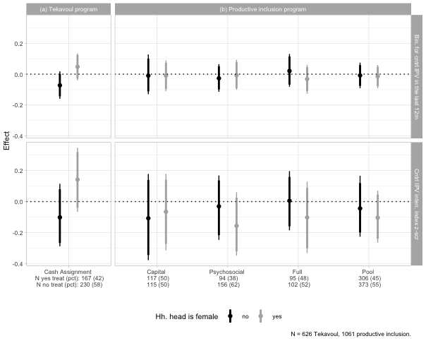

### Household head literacy

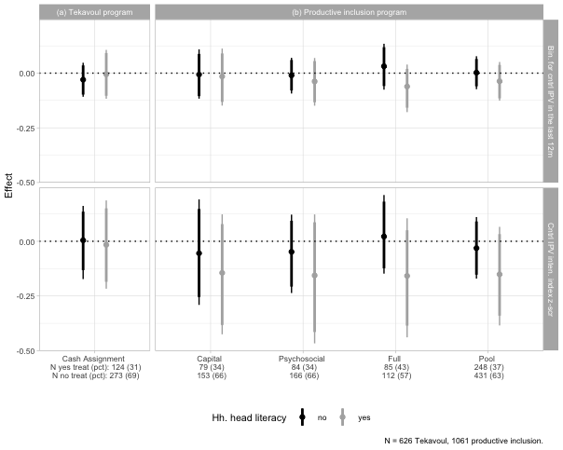

### Beneficiary literacy

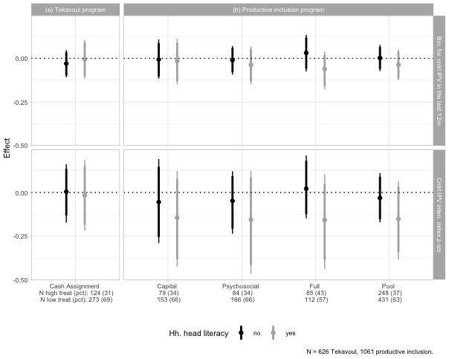

### Household head nbr. of years of education

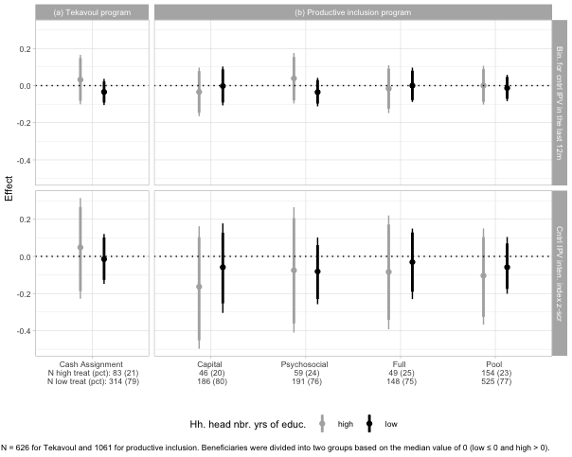

### Beneficiary nbr. of years of education

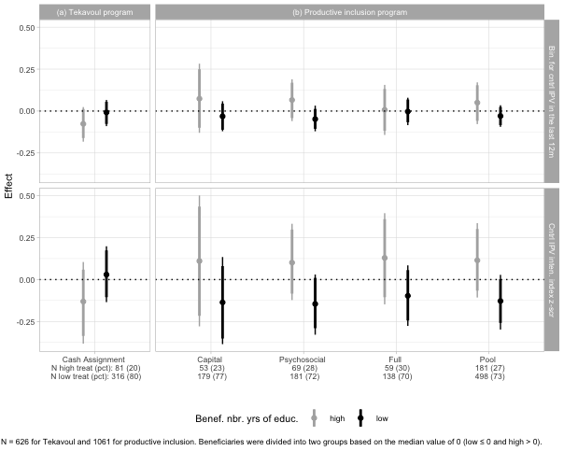

### Beneficiary share of saving own by partner

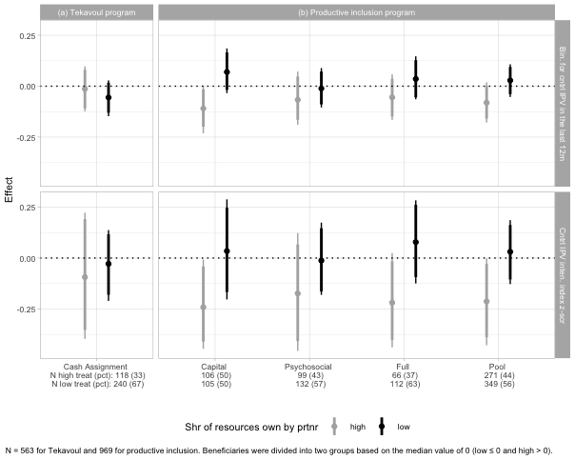

### Control over earnings

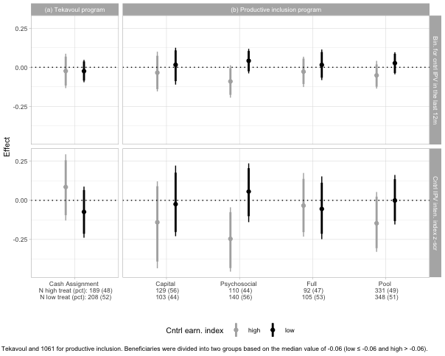

### Control over hh. resources

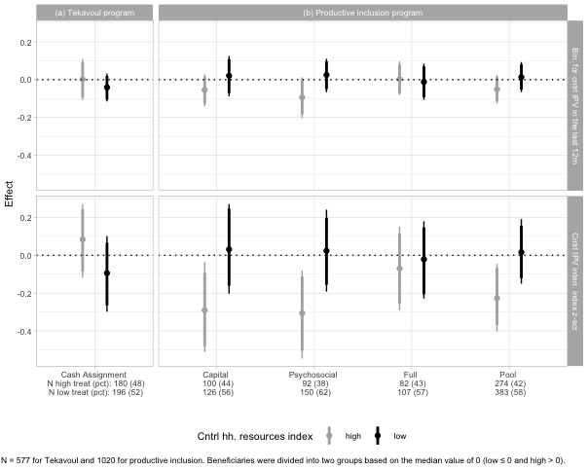

### Intra-household dynamics

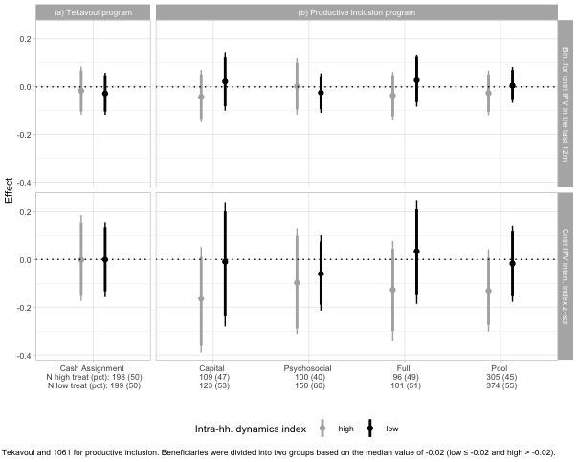

### Benef. share of total hh. revenues

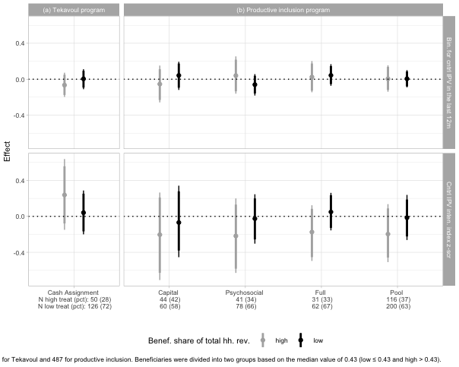

### Spousal age gap

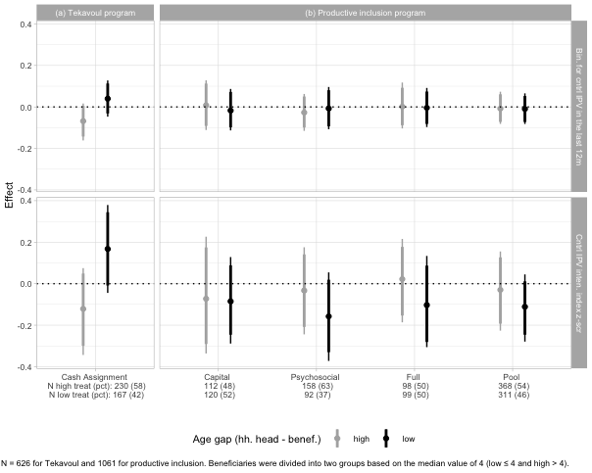

## Emotional Violence

### Household head is female

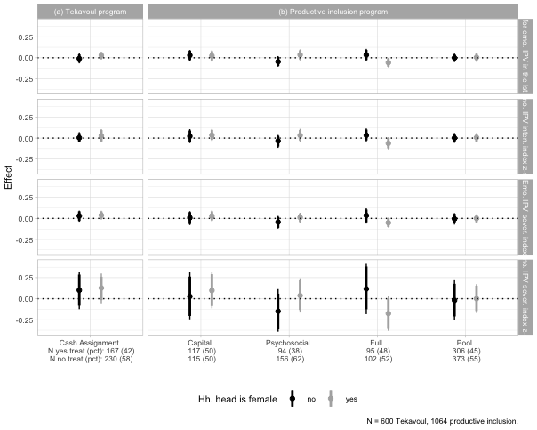

### Household head literacy

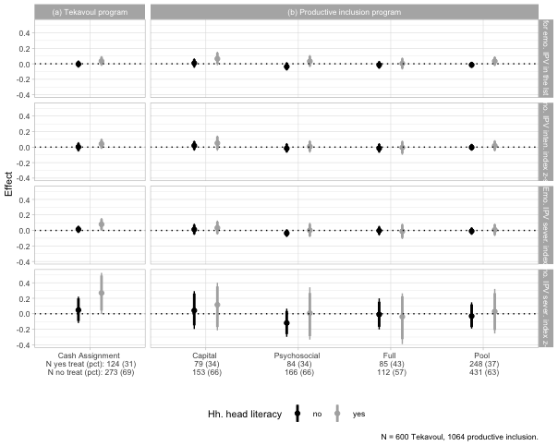

### Beneficiary literacy



### Household head nbr. of years of education

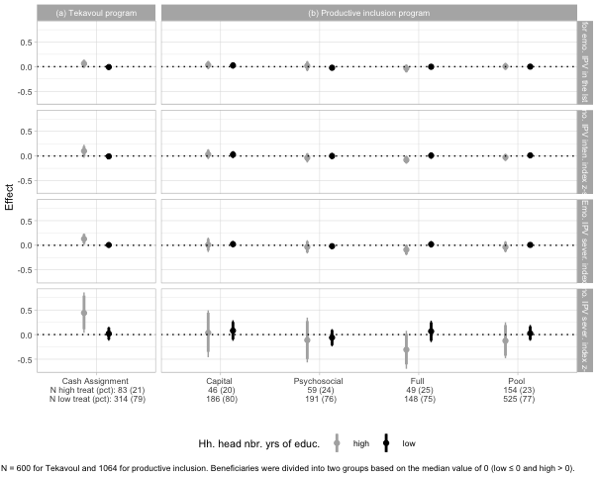

### Beneficiary nbr. of years of education

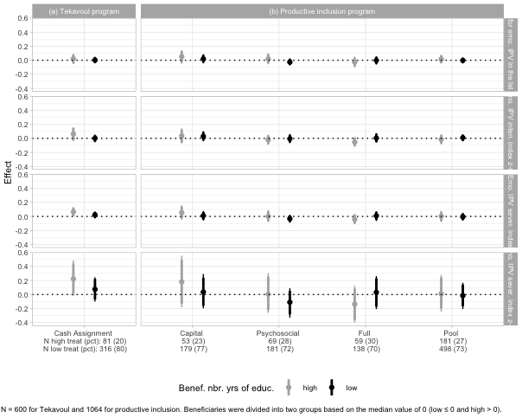

### Beneficiary share of saving own by partner

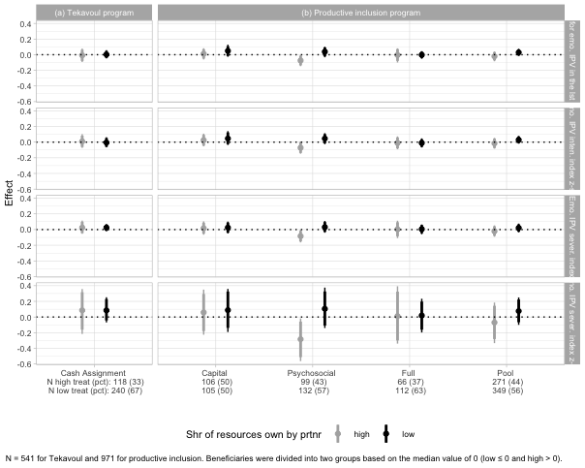

### Control over earnings

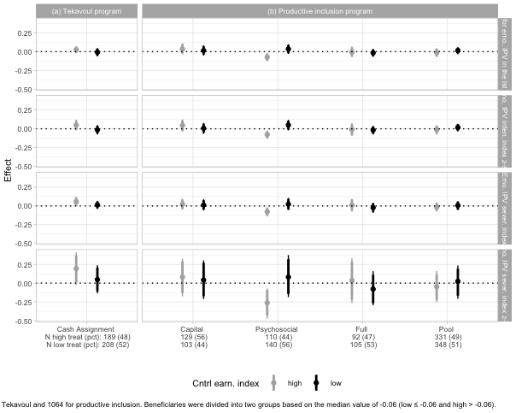

### Control over hh. resources

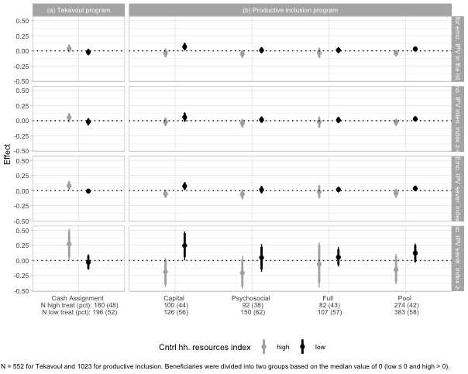

### Intra-household dynamics

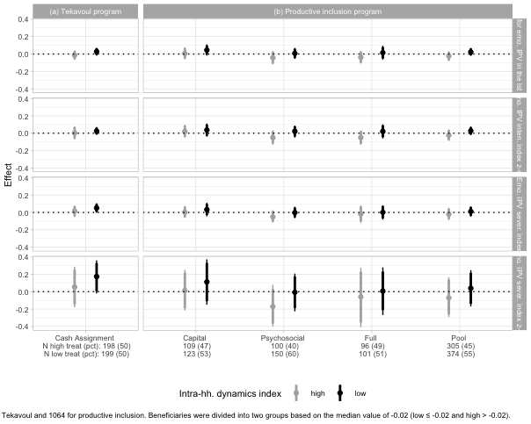

### Benef. share of total hh. revenues

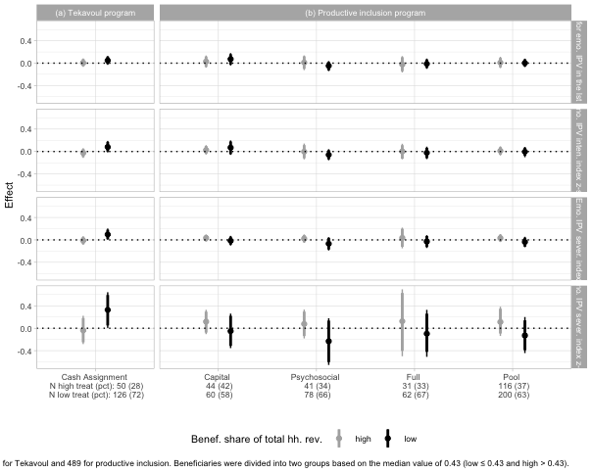

### Spousal age gap

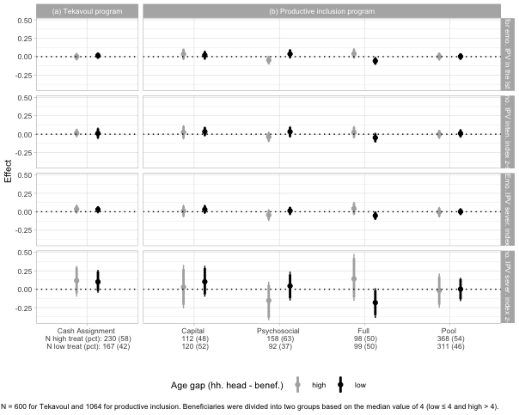

## Physical violence

### Household head is female

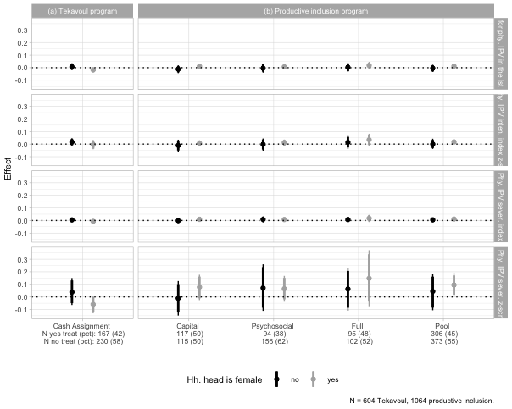

### Household head literacy

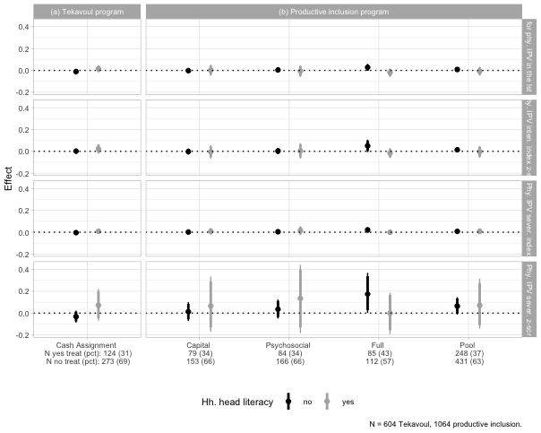

### Beneficiary literacy



### Household head nbr. of years of education

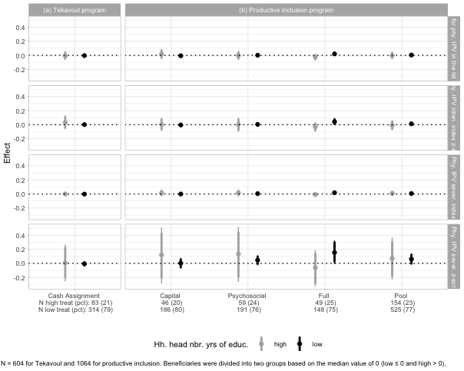

### Beneficiary nbr. of years of education

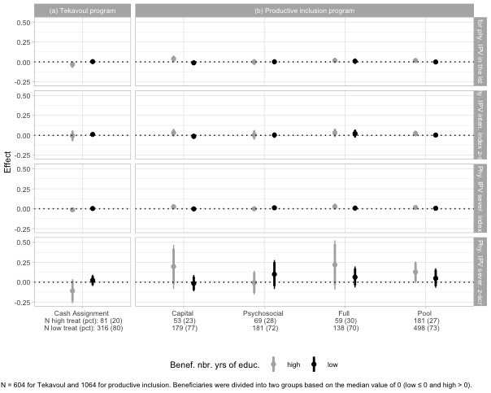

### Beneficiary share of saving own by partner

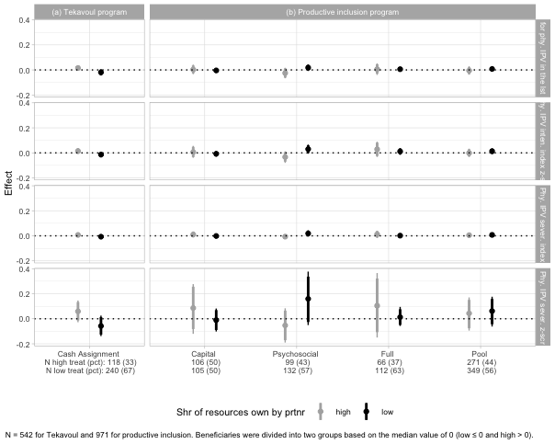

### Control over earnings

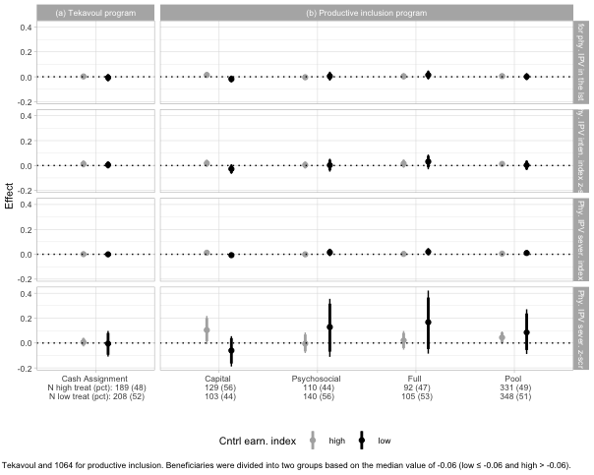

### Control over hh. resources

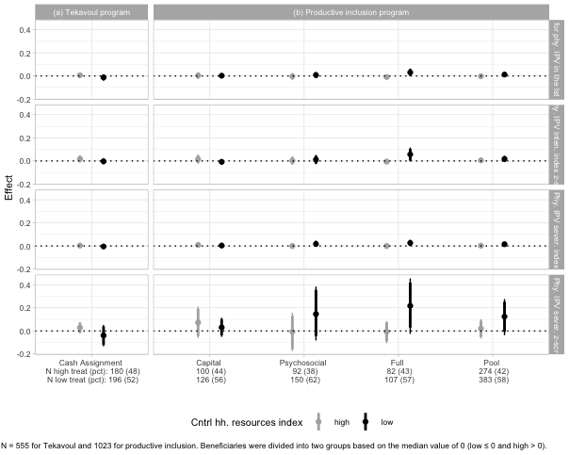

### Intra-household dynamics

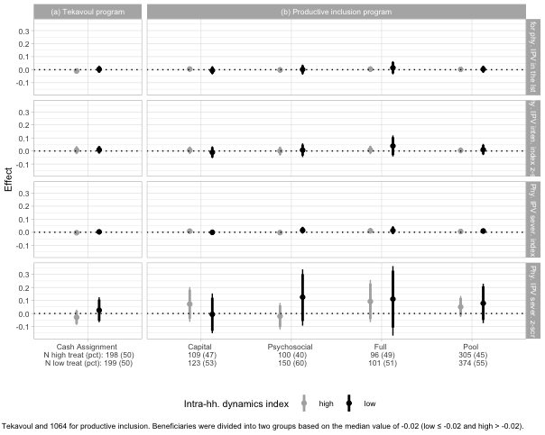

### Benef. share of total hh. revenues

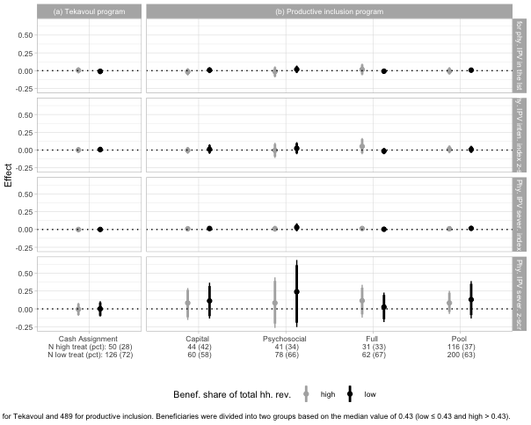

### Spousal age gap

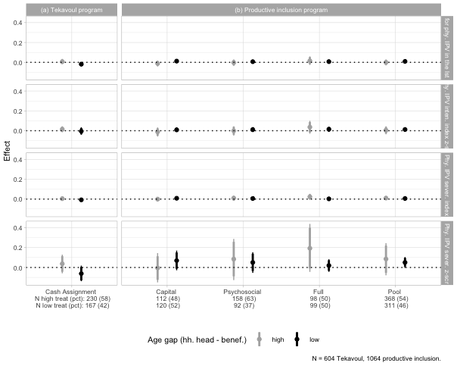

## Sexual Violence

### Household head is female

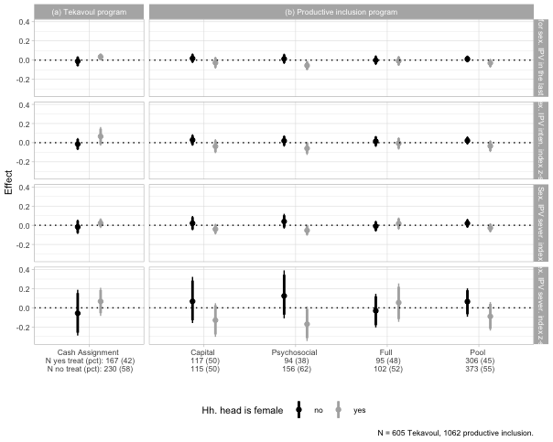

### Household head literacy

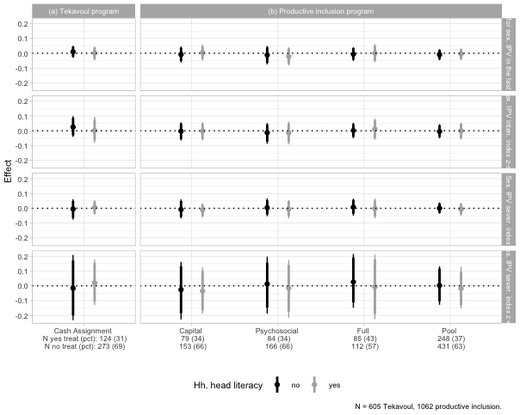

### Beneficiary literacy



### Household head nbr. of years of education

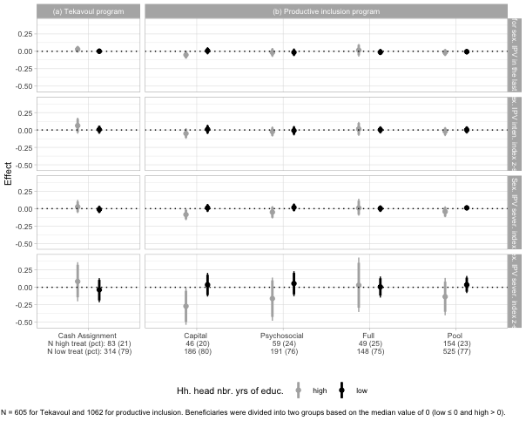

### Beneficiary nbr. of years of education

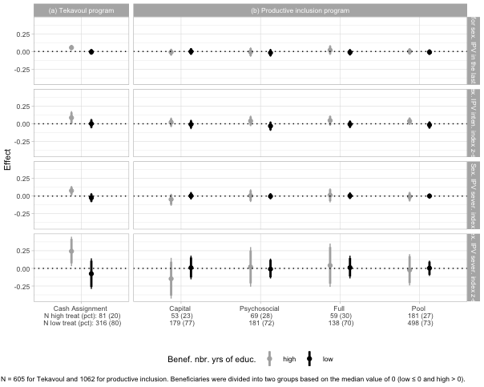

### Beneficiary share of saving own by partner

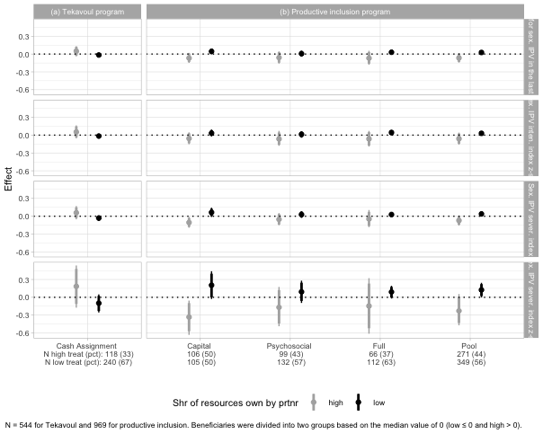

### Control over earnings

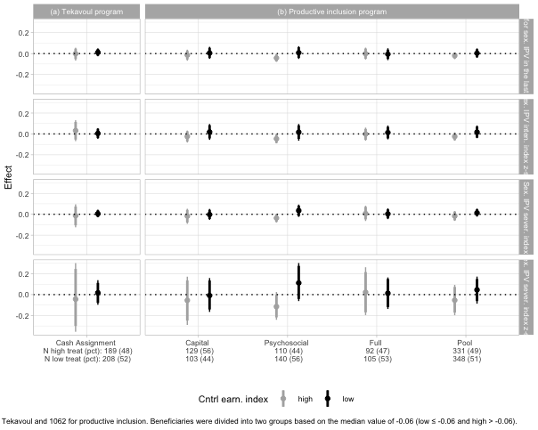

### Control over hh. resources

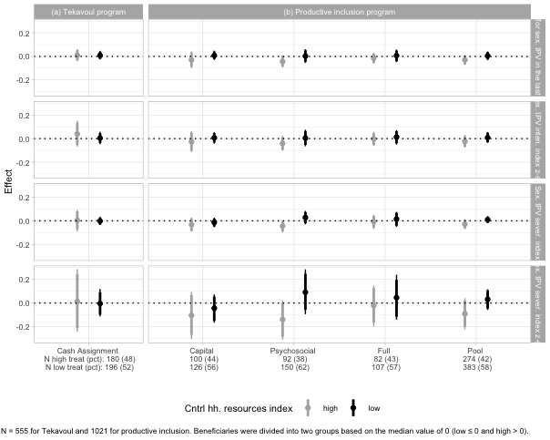

### Intra-household dynamics

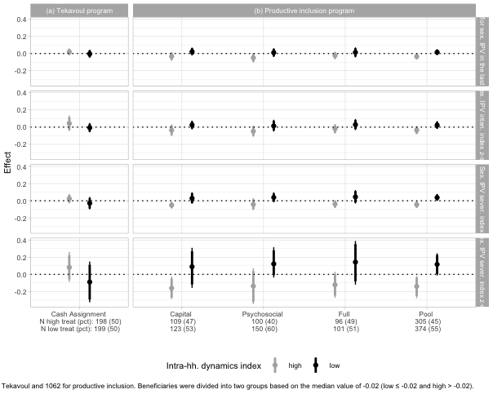

### Benef. share of total hh. revenues

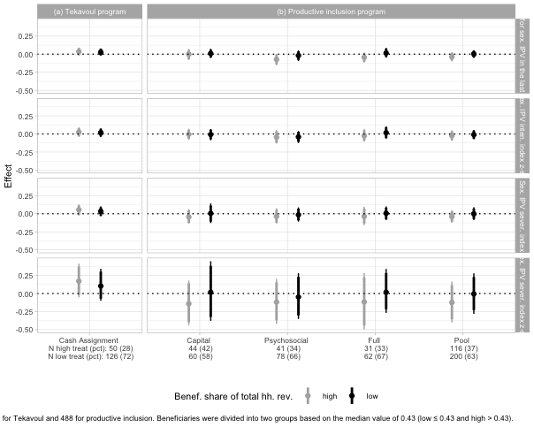

### Spousal age gap

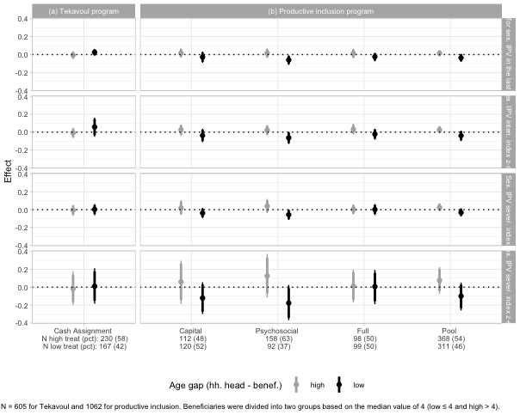

## Economic Violence

### Household head is female

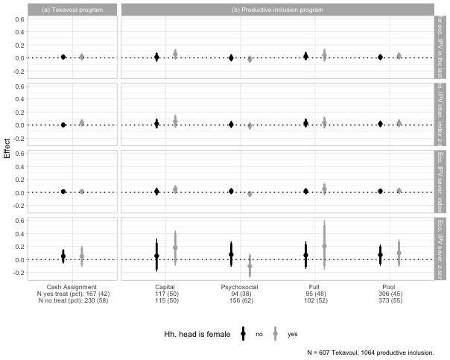

### Household head literacy

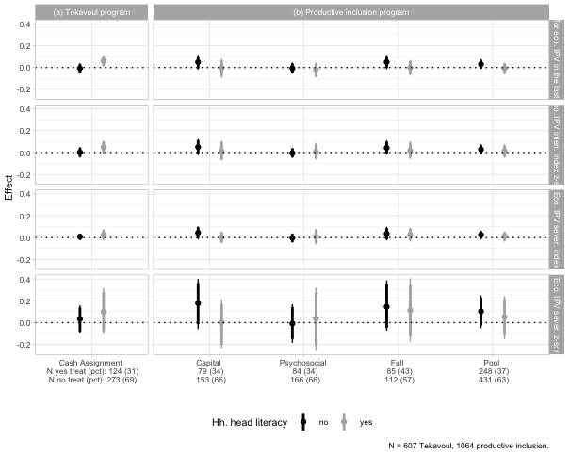

### Beneficiary literacy

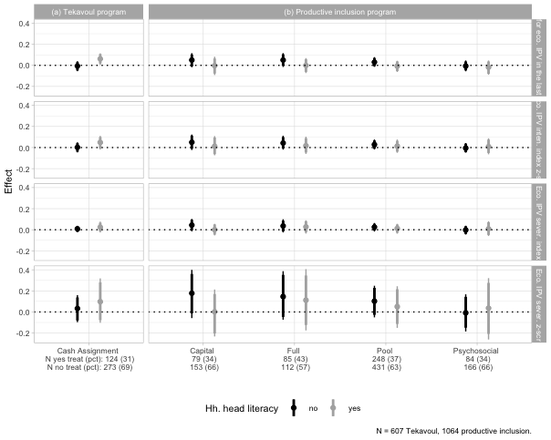

### Household head nbr. of years of education

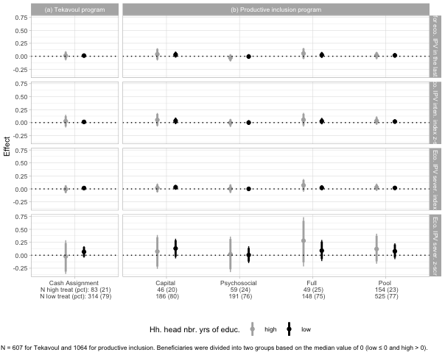

### Beneficiary nbr. of years of education

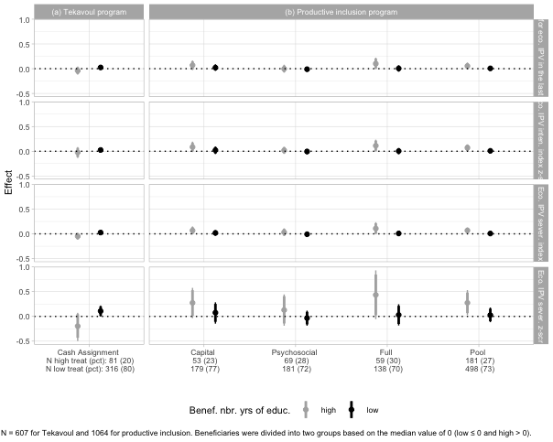

### Beneficiary share of saving own by partner

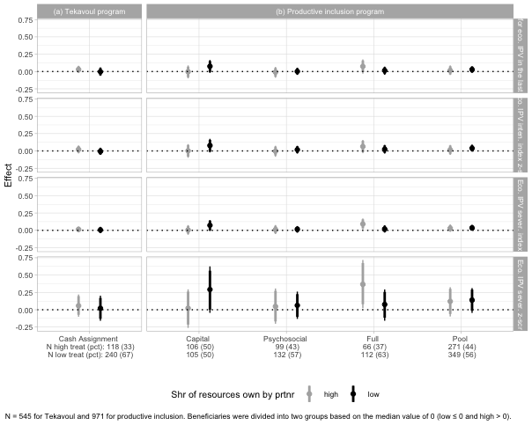

### Control over earnings

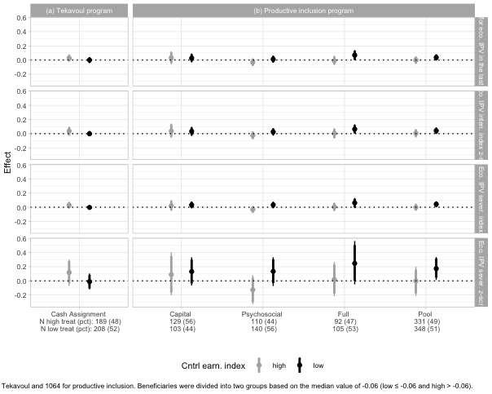

### Control over hh. resources

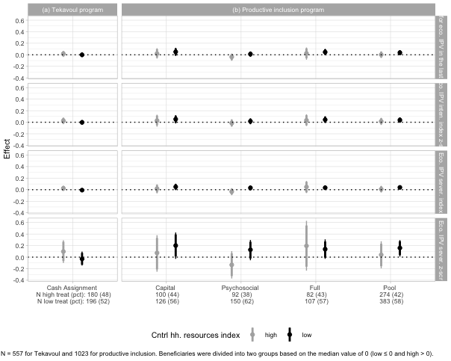

### Intra-household dynamics

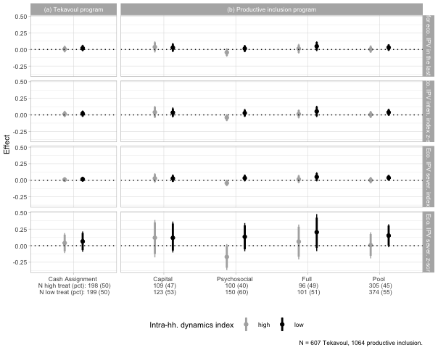

### Benef. share of total hh. revenues

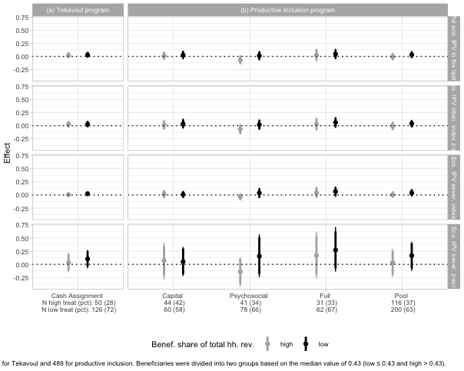

### Spousal age gap

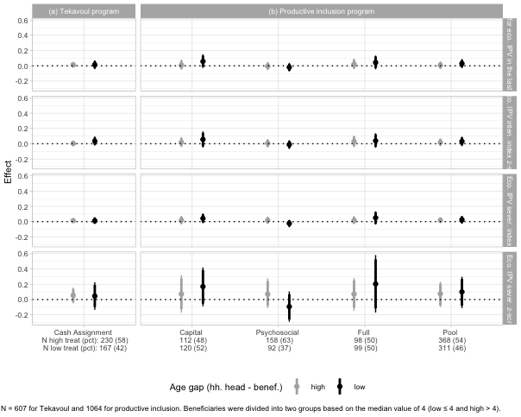

## Other types of violence

### Household head is female

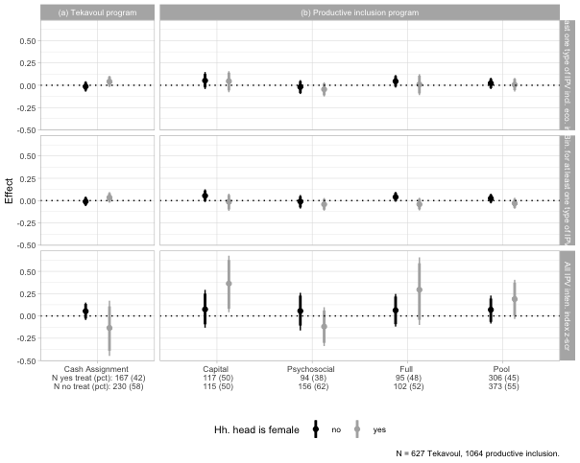

### Household head literacy

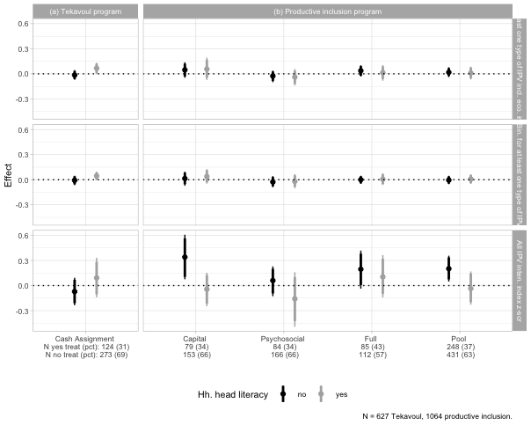

### Beneficiary literacy



### Household head nbr. of years of education

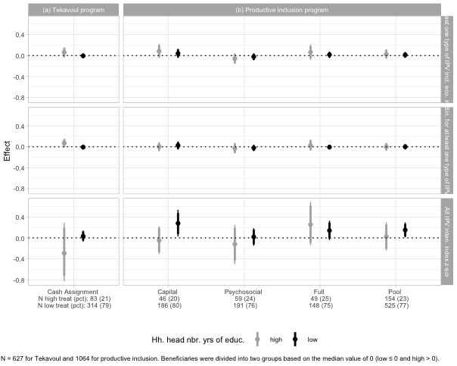

### Beneficiary nbr. of years of education

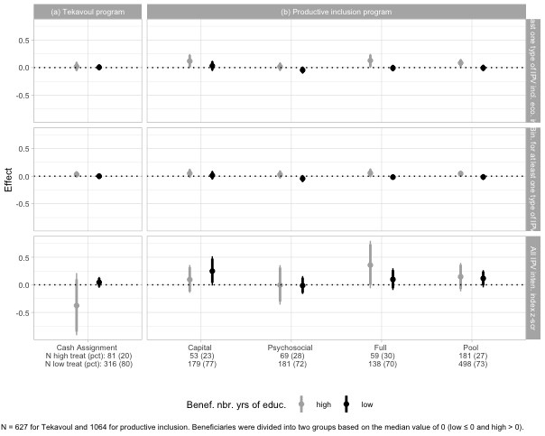

### Beneficiary share of saving own by partner

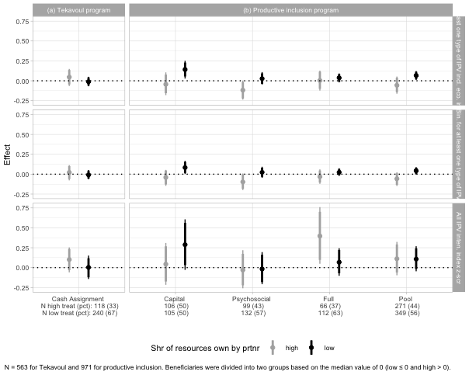

### Control over earnings

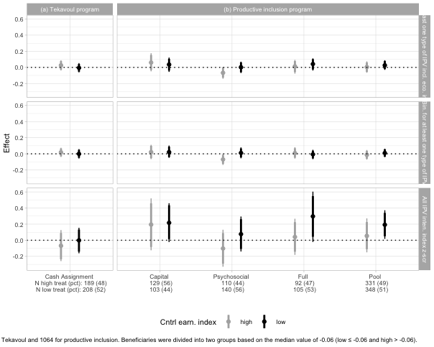

### Control over hh. resources

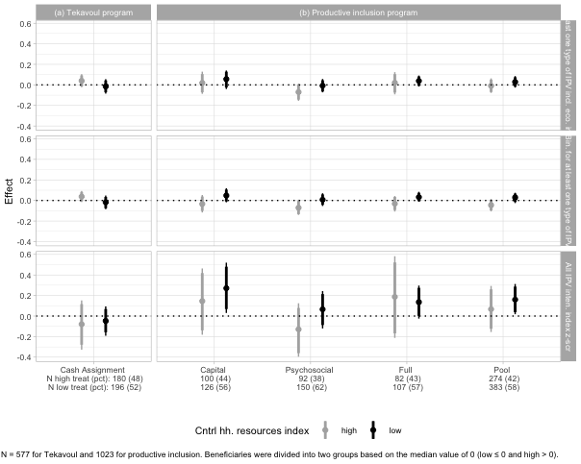

### Intra-household dynamics

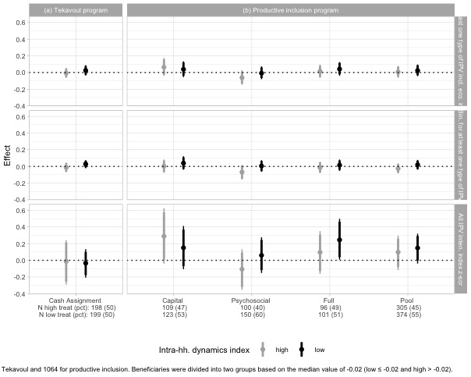

### Benef. share of total hh. revenues

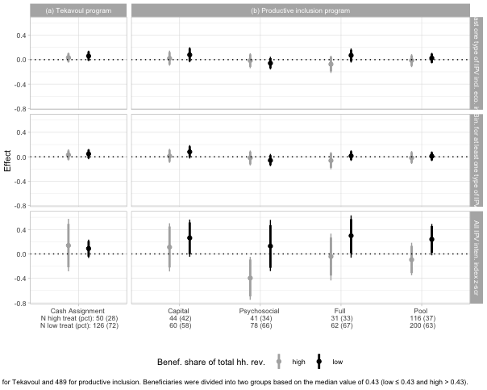

### Spousal age gap

