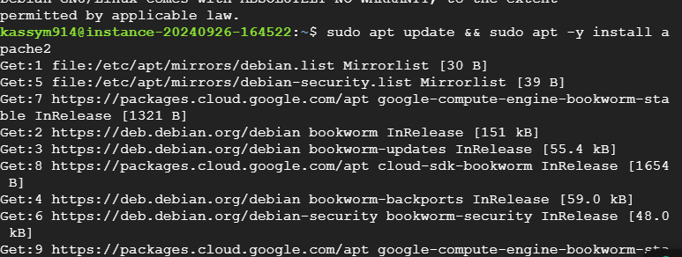

Connection fails

But data is saved

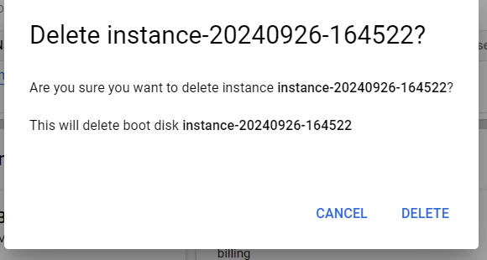

Data is lost

Exercise 5

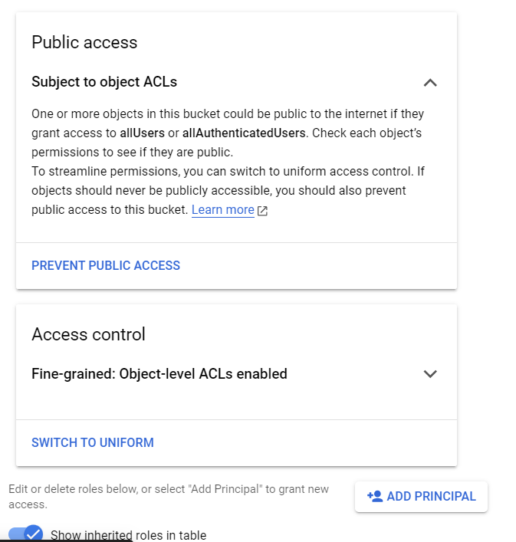

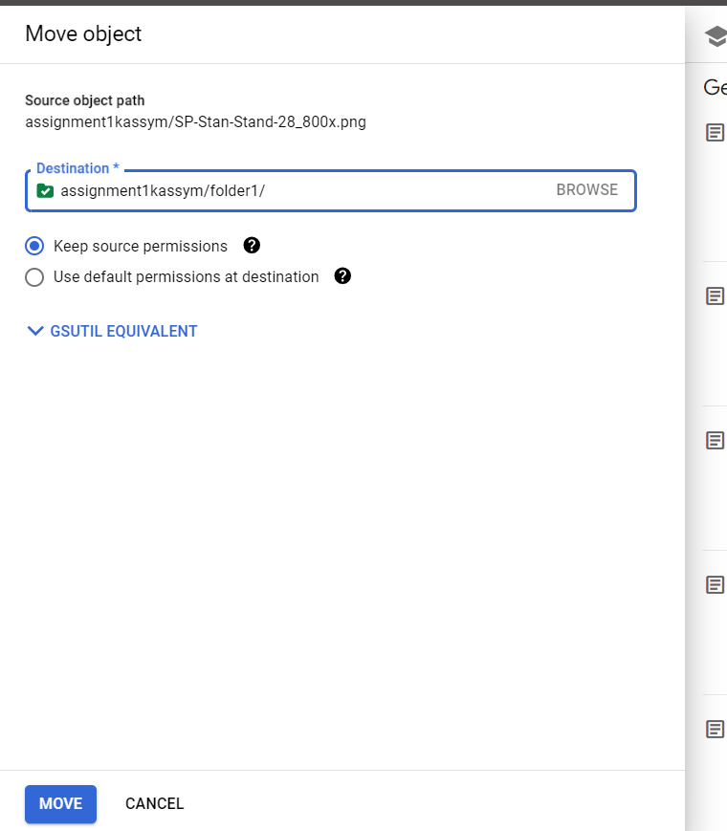

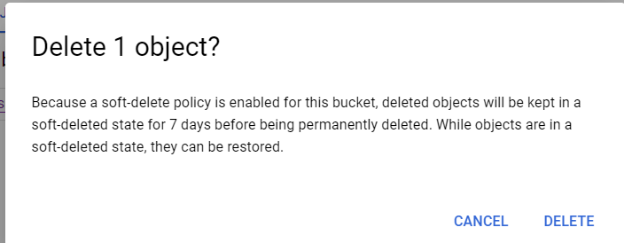

Exercise 6

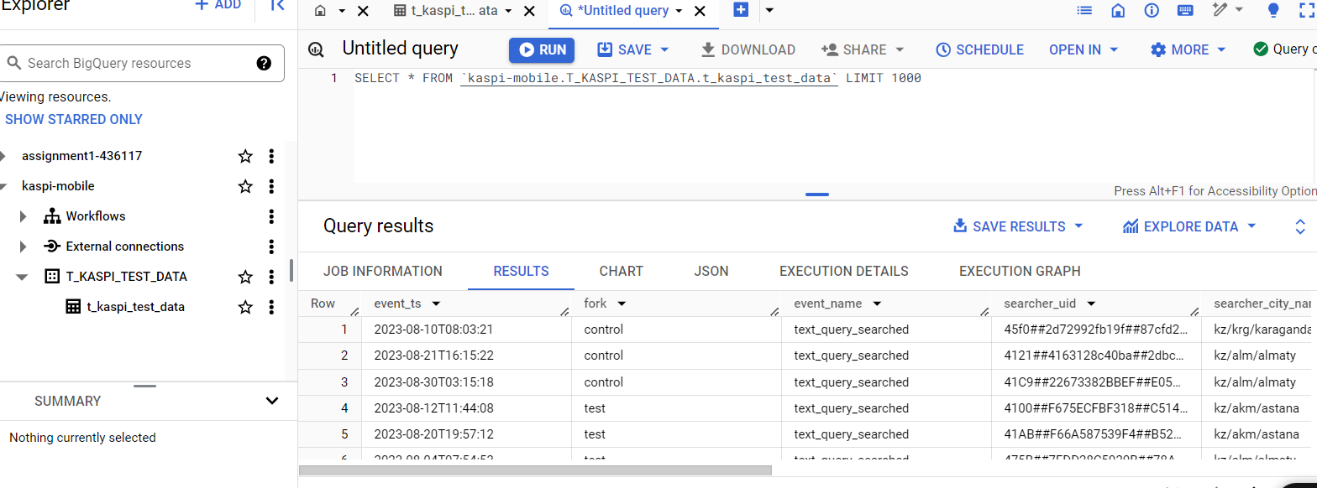

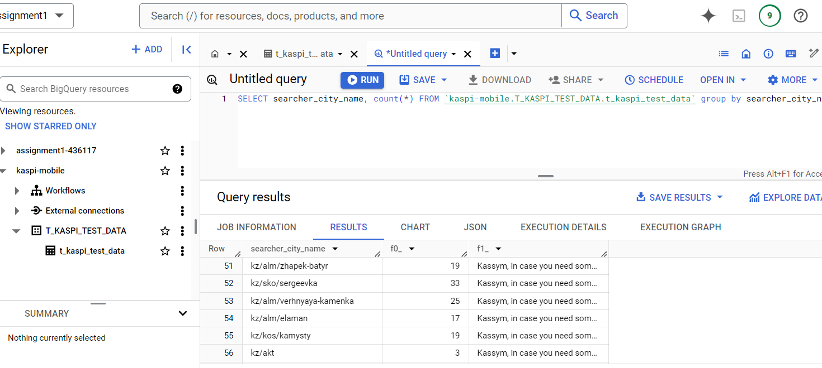

Visualizing



