1. Question : How can you retrieve all the information from the cd.facilities table?

How can you retrieve all the information from the cd.facilities table?

Expected Results

| **facid** | **name** | **membercost** | **guestcost** | **initialoutlay** | **monthlymaintenance** |
| --- | --- | --- | --- | --- | --- |
| 0 | Tennis Court 1 | 5 | 25 | 10000 | 200 |
| 1 | Tennis Court 2 | 5 | 25 | 8000 | 200 |
| 2 | Badminton Court | 0 | 15.5 | 4000 | 50 |
| 3 | Table Tennis | 0 | 5 | 320 | 10 |
| 4 | Massage Room 1 | 35 | 80 | 4000 | 3000 |
| 5 | Massage Room 2 | 35 | 80 | 4000 | 3000 |
| 6 | Squash Court | 3.5 | 17.5 | 5000 | 80 |
| 7 | Snooker Table | 0 | 5 | 450 | 15 |
| 8 | Pool Table | 0 | 5 | 400 | 15 |

**Answer & Discussions**

**select** * **from** cd.facilities;

The SELECT statement is the basic starting block for queries that read information out of the database. A minimal select statement is generally comprised of select [some set of columns] from [some table or group of tables].

In this case, we want all of the information from the facilities table. The from section is easy - we just need to specify the cd.facilities table. 'cd' is the table's schema - a term used for a logical grouping of related information in the database.

Next, we need to specify that we want all the columns. Conveniently, there's a shorthand for 'all columns' - *. We can use this instead of laboriously specifying all the column names.

1. Question : You want to print out a list of all of the facilities and their cost to members. How would you retrieve a list of only facility names and costs?

You want to print out a list of all of the facilities and their cost to members. How would you retrieve a list of only facility names and costs?

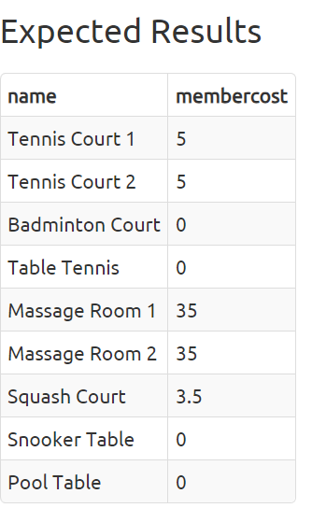

Answers and Discussion Hide

select name, membercost from cd.facilities;

For this question, we need to specify the columns that we want. We can do that with a simple comma-delimited list of column names specified to the select statement. All the database does is look at the columns available in the FROM clause, and return the ones we asked for, as illustrated below

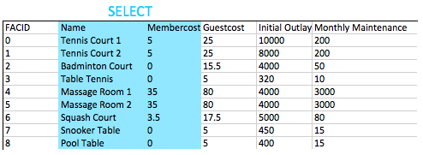

Generally speaking, for non-throwaway queries it's considered desirable to specify the names of the columns you want in your queries rather than using *. This is because your application might not be able to cope if more columns get added into the table.

1. Question : How can you produce a list of facilities that charge a fee to members?

How can you produce a list of facilities that charge a fee to members?

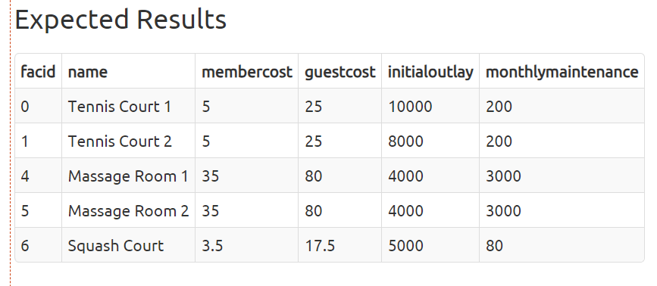

Answers and Discussion

**select** * **from** cd.facilities **where** membercost > 0;

The FROM clause is used to build up a set of candidate rows to read results from. In our examples so far, this set of rows has simply been the contents of a table. In future we will explore joining, which allows us to create much more interesting candidates.

Once we've built up our set of candidate rows, the WHERE clause allows us to filter for the rows we're interested in - in this case, those with a membercost of more than zero. As you will see in later exercises, WHERE clauses can have multiple components combined with boolean logic - it's possible to, for instance, search for facilities with a cost greater than 0 and less than 10. The filtering action of the WHERE clause on the facilities table is illustrated below:

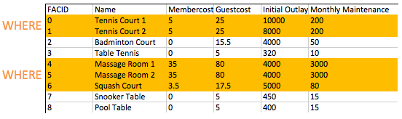

1. Question

bskjhbkjrgbjktebnlrkynl

1. Question

vasjhdvfhbkjgbkjhngjgnj

1. Question

basdjhafbgjkbgnknhlkjfgld

1. Question

AKJBSDJHEWBHRFGJKETHBJKH

1. Question
2. Question
3. Question
4. Question
5. Question
6. Question
7. Question
8. Question
9. Question
10. Question
11. Question
12. Question
13. Question
14. Question
15. Question
16. Question
17. Question
18. Question