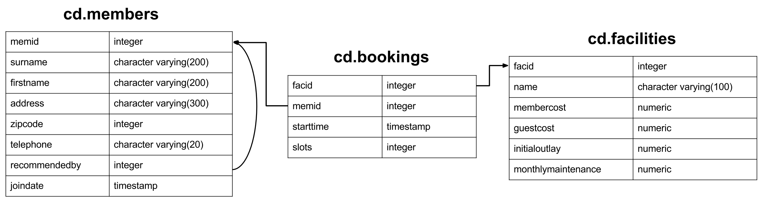

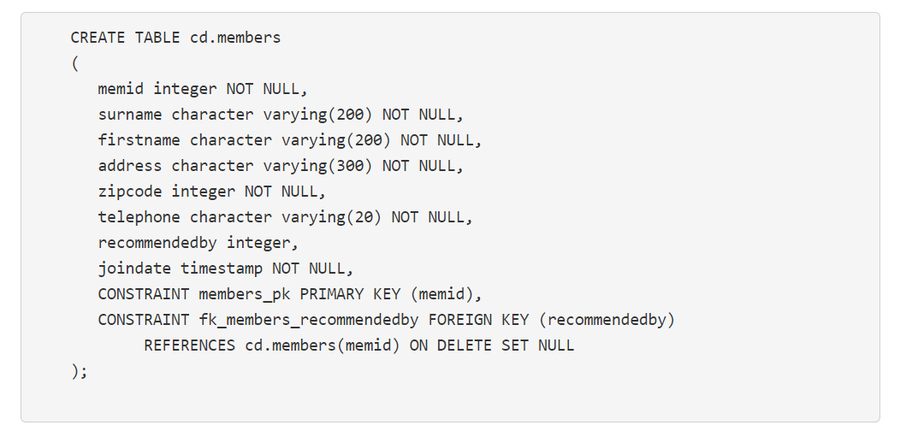

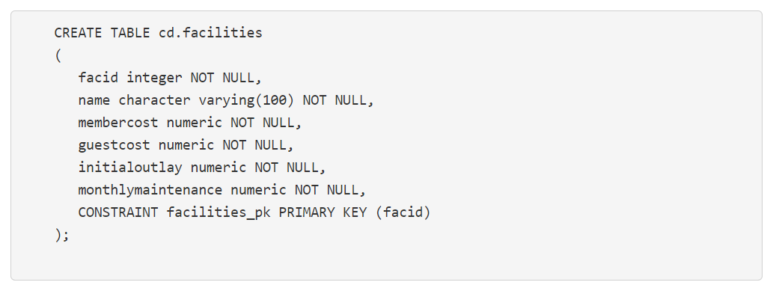

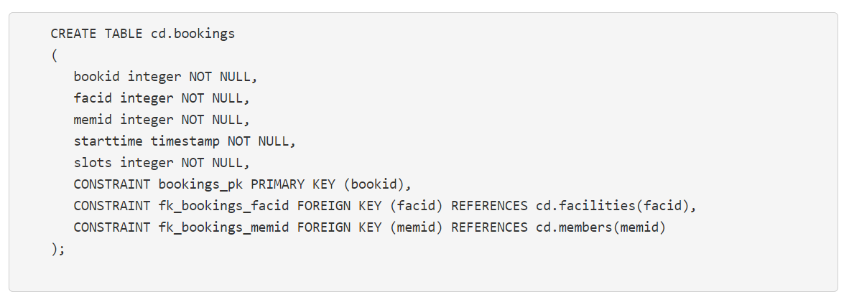

Finally, run psql -U <username> -f clubdata.sql -d postgres -x -q to create the 'exercises' database, the Postgres 'pgexercises' user, the tables, and to load the data in

More information on <https://pgexercises.com/>