NORTH-POINT SOFTWARE MAILING ANALYTICS
Phanidhar Venkata Naga Kasuba
CSDA 6010 Z1 FA – Analytics Practicum
Webster University
Professor: Dr. Willie Rivers

Executive Summary
The North-Point Software Mailing Analytics project addressed the critical business problem of inefficiency and profitability of the direct mailing campaigns of the company. Having access to a consortium database of more than five million potential customers, North-Point aims to determine the 200,000 most likely to buy the product, thus enhancing the conversion rates and reducing the amount of marketing money wasted. Using data analytics and machine learning will be our approach. Exploratory data analysis indicated that the most effective factors that drive purchase behavior are transaction frequency, recentness of customer record updates, and previous web order history. The analysis also revealed that a few high-value customers make up a disproportionate share of total spending, and it is essential to target and engage them correctly.
To overcome these issues, a number of predictive and analytical models were created, such as classification (Decision Tree, Logistic Regression, and Random Forest) to predict the probability of purchase, regression (Linear, Random Forest, and Stepwise) to predict the potential to spend, and K-Means clustering to group customers based on their behavioral patterns. The best predictor of purchasers was the Random Forest model, which was found to be 81.7% accurate, and the best predictor of spending was the Stepwise Regression model, which was highly efficient in making predictions and very easy to interpret. To ensure our predictions were accurate for the entire customer pool, we re-calibrated the model probabilities from our balanced training sample (50% purchase prevalence) to the pilot campaign's 5.3 % actual base rate. We then tested the model's effectiveness using gain and decile-lift charts to verify its ability to rank prospects. The analysis confirmed strong targeting ability and the model achieved a projected 1.8 times more than Lift factor over random selection, indicating that our ranked list is more effective at finding buyers than simply mailing randomly.
These results will provide North-Point Software with practical information that will help it maximize mailing lists, customize marketing approaches to certain customer groups, and distribute resources efficiently. On the whole, the project shows that data-driven decision-making can contribute greatly to marketing performance and growth of the business in the long run.

Introduction
North-Point Software is a company which deals with the development and sale of games and educational software. Since its establishment, the company has evolved to be a mere software manufacturer to distributing third-party titles. Understanding the need to increase its consumer base, North-Point has invested in using direct mail as one of the means of reaching potential customers. In recent times the firm edited a new list of product offerings and was ready to deploy them in a new mailing exercise. This effort shows how the firm has attempted to integrate data-driven marketing and product innovation in a strategic effort.
To make the most gains out of this marketing campaign, North-Point had to become a member of a consortium of listing companies dealing with computer hardware and software products. The benefit of the membership of this consortium is that a huge, shared base of customers is offered with each company contributing their respective list of customers and in exchange, can obtain the same number of names out of the pool. Notably, such an arrangement not only expands the possible reach of the firm but also enables it to predict model on the aggregated information to enable more informed choices on that of the recipients of the mailing.
According to this, North-Point was to give 200,000 customer names and had a right to take out the same amount of 5,000,000 name pool. The company is trying out the potential of this resource by carrying out a pilot mailing to 20,000 customers, where 1,065 bought the item, which is 5.3% in response rate. To prepare the data to be entered in machine learning, a stratified sample was built containing 1,000 purchasers and 1,000 non-purchasers. Such balanced data enhances the performance of model training, albeit that probability estimates would have to be re-adjusted to the actual purchase rate in the real world to prevent over-optimism.
The present project will use machine learning technology to tackle the mailing analytics issue, and eventually enhance the efficiency of a campaign. The analysis will give practical information on the purchase behavior among customers by examining supervised and unsupervised approaches to classification, prediction, and clustering respectively. It is hoped that the implications of the study will enable North-Point to pinpoint high-value customers, optimize future mailings, and improve on the investment of marketing in general.
Business Problem
North-Point Software has the challenge of identifying and reaching high potential customers in a consortium mailing list of more than five million contacts efficiently. The company will need to choose 200,000 prospects to include in its direct mailing campaign, although random selection lead to low response rates and higher marketing expenses. This business issue is to identify the most probable customers who will respond and buy, therefore enhancing the conversion rates and marketing ROI. To deal with this, North-Point aims to use predictive analytics to streamline its selection process, so that its marketing resources are focused on the customers most likely to make a purchase and have a long-term value.

Business Goal
The main objective of North-Point Software is to increase the profitability and efficiency of its direct mailing campaigns by making decisions that are based on data. The company will target to raise the response rate of more than 5.3, decrease the mailing cost per acquisition, and enhance customer lifetime value (CLV) by targeting outreach. This project is in line with the overall strategic intent of North-Point to incorporate analytics in its marketing processes to enhance its competitive edge in the software market. The success will be determined by the measurable changes in the campaign conversion rates, cost reduction through less waste of time and money on marketing, and the growth of revenue through the high-value customer groups that will be identified using predictive modeling.
Analytical Goals
The analytical goals of the given project are aimed at converting the marketing problems of North-Point Software into quantifiable, data-driven information that can be directly used to make strategic decisions. The former aims at forecasting the probability of a customer to make a purchase based on classification models like Decision Tree, Logistic Regression, and Random Forest. These supervised learning methods will determine the most promising prospects that will react to the mailing campaign of the company, thus enhancing the response rates and minimizing the marketing expenses that are not necessary. The second goal is to estimate the potential spending based on regression models, which will estimate the amount that a customer will spend once he/she purchases. The analysis will aid in prioritizing the high-value customers and predicting the possible revenue input of various groups of customers.
The third goal is to divide customers into behavioral clusters with the K-Means clustering to reveal the concealed patterns and categorize customers according to their similarities in terms of their engagement, frequency of purchase, and spending behavior. This segmentation will help the company to develop customized marketing plans to each segment- rewarding loyal customers, re-engaging moderate buyers and reactivating inactive customers. All these analytical objectives are intended to provide practical information that will improve customer targeting, campaign effectiveness, and overall marketing return on investment.
Analytical Approach
The analytical process is based on a systematic and repetitive model that combines data preprocessing, model building, and performance assessment. This will start with data cleaning and transformation to achieve accuracy and consistency. Exploratory data analysis and correlation assessment will then be used to analyze predictor variables in terms of relevance. Classification and regression supervised learning models will be constructed to predict the likelihood of purchase and the spending behavior, and unsupervised learning (K-Means clustering) will demonstrate natural groupings of customer behavior. The data will be divided into training (65 percent) and testing (35 percent) in order to test the model generalizability and to compare the performance using the measures of accuracy, precision, recall, R 2, and RMSE. Because the modeling sample was intentionally balanced (around 50% purchasers) to create stable training, the raw probabilities predicted by the model were overly optimistic. To fix this, we later re-adjusted (re-calibrated) those probabilities to match the pilot campaign's true math 5.3% base purchase rate. All final lift and gain results reported use these adjusted scores. The models that perform the best will then be utilized to create actionable lists of customers to be mailed to in the future and analytical output will be directly aligned with the business objectives of North-Point.
Data Exploration
Data Understanding
The sample data given on the mailing analytics of North-Point Software has 2,000 observations in equal numbers, half were purchasers and the other half non-purchasers hence the response rate was 50. The purpose of this stratified sampling strategy is to enhance the model training performance but it requires probability correction to maintain the actual rate of purchase in the real world of 5.3 per cent of the test mailing. The data is categorical and numerical and it contains the demographics of the customers, purchase history, source information and behavioral attributes. The main predictor variables are binary variables (i.e. whether or not the customer lives in the U.S., whether or not they are a male, whether or not the place of address is residential, or whether or not they made an order online or not). Moreover, the marketing channel/list/source variables derive the customer was acquired as well as the numerical variables frequency of transactions, days since last update and days since the first update present further details on the customer activity.
Two of the outcome variables are especially important, namely: the purchase indicating whether a customer reacted to the test mailing, and the spending, the dollar amount spent by purchasers. A combination of these variables makes it possible to not only classify (purchaser vs. non-purchaser) and predict (expected spending) but also. The variety of the dataset enables the use of various methods of analysis: supervised models are used to forecast purchase probability, regression models are used to approximate the amount of spending, and unsupervised clustering algorithms are used to determine particular customer groups. The data structure, distribution, as well as the attributes definitions should be properly understood because it is the basis of the proper preprocessing of the data, a meaningful selection of the model, and finally, the quality of the insights to support the business and marketing goals of North-Point.
Attribute Definition
Variable Name | Description
sequence_number | Unique identifier or row index for each record
US | Indicates if the customer address is in the U.S.
source_a … source_w | Marketing source or list the customer came from (15 binary variables)
Freq | Number of transactions in the last year from source catalog
last_update_days_ago | Days since the last update to the customer record
1st_update_days_ago | Days since the first update to the customer record
Web order | Customer has placed at least one web order
Gender=male | Gender indicator for the customer
Address_is_res | Indicates if the address is a residential address
Purchase | Response to the test mailing (purchase made or not)
Spending | Dollar amount spent by the customer if purchase was made

Numerical Data
The numerical data included in the North-Point dataset gives the useful information about the customer activity and the purchasing behavior. The variables to be considered are the frequency of transactions in the past one year and it is denoted as Freq, the last update date in days ago denoted as last_update_days_ago and the days that the customer has been in the system denoted as 1st_update_days_ago. Lastly is the Spending which is the dollar amount used in the mailing of the test to customers who have already made a purchase. These numerical variables are very important in modeling in that they may be used to distinguish between active, high-value customers and inactive, or less-engaged prospects, and may also be transformed or normalized to increase predictive accuracy.
Categorical Data
The North-Point data are largely categorical and mainly they are binary in nature and include the information of the customers about their demographics, behavior and source. These are US which is an identification of whether or not the customer lives in the United States, Gender=male which is used to indicate the gender of the customer and Address is residential which is used to specify whether or not the customer is at home. Also, 15 source variables (e.g., source_a, source_b, source_c, etc.), which reflect the detailed marketing lists or even acquisition channels in which customers were attracted, are present. The target variable Purchase will also be categorical and will represent whether the customer has responded to the mailing or not and most of these binary indicators will also serve as predictors in making possible buyers and non-buyers. A combination of these categorical features would give a setting of the customer demographics, channels of acquisition, and behavior which can be used in classification and clustering analysis.
Missing Values
There are no missing values in any of the variables in the dataset as it has been assured by the exploratory checks with the help of R. The general dataset as well as individual column data contains a count of zero of missing data, so the data is complete and consistent to analyze. This is beneficial to the modeling process since it does not require imputation or data cleaning operations concerning null values and the emphasis can be laid in transforming the variables, analyzing distributions, and making the data supervised and unsupervised learning tasks ready.
Count of Zeros
ColSums(software = = 0) is giving the number of zeros in each column of your data. A zero in this case does not indicate missing data, it is a legitimately recorded value given the many variables that are binary (0 or 1). As an illustration, in the source a column, there are 1,747 rows that have a 0, which is the number of customers that were not acquired via source A and the rest of the records, which have a value of 1, which are the number of customers that were acquired via source A. Likewise, on such variables as Web.order, a zero will imply that the customer has never ordered a web order, and the value of Gender.male will be zero to indicate that the customer is not a male.
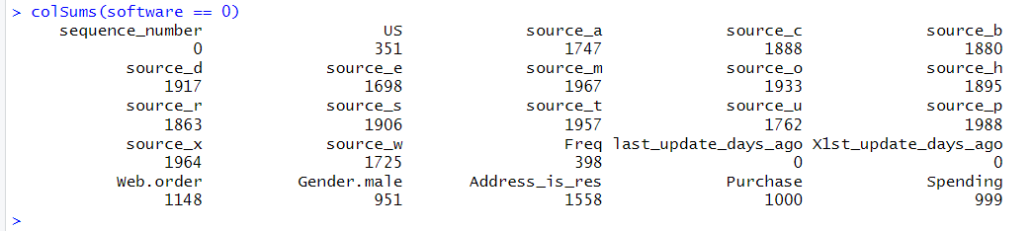
In the case of numerical variables, any number that is zero may mean there was no activity or expenditure at all. As an example, the Freq column has the numbers zero as some clients have not purchased anything during the previous year. There are 999 zeros in the column Spending, which is also to be expected since all non-purchasers (Purchase = 0) will not have a speck of spending registered. This is in line with the structure of the dataset with half of the rows constituting the non-purchasers of the stratified sample. These are not meaningless zeros and are an indication of authentic behavior and not errors or missing information.
On the whole, the zeros can be viewed as key categorical / behavioral predictors in the dataset. In binary predictor columns, they are nothing but the “No/ False category. They underline inactivity in numerical columns i.e. in customers who did not order or spend. It is important to note that there is a distinction between missing values and zeros: given that no variables contain any missing values, the zeros should not be considered missing data but a valid input feature that can be used to distinguish between purchasers and non-purchasers by the machine learning models.
Statistics and Diagrams
US vs Non-US Customers
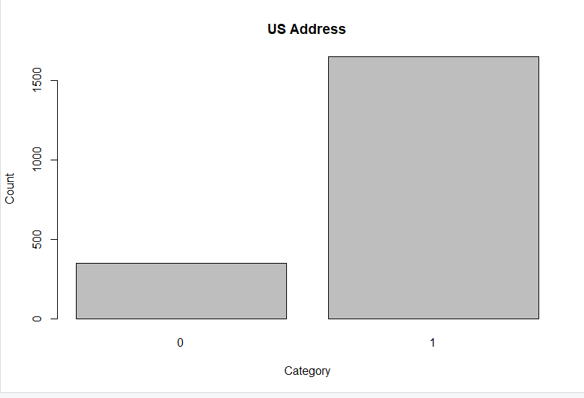
The bar plot of the US Address reveals that the majority of the consumers in the dataset are found in United States and the minority are non-US consumers. This also implies that the mailing list of the company includes mostly domestic mail and this may define the main target of its marketing campaigns.

Customer Acquisition from Source A
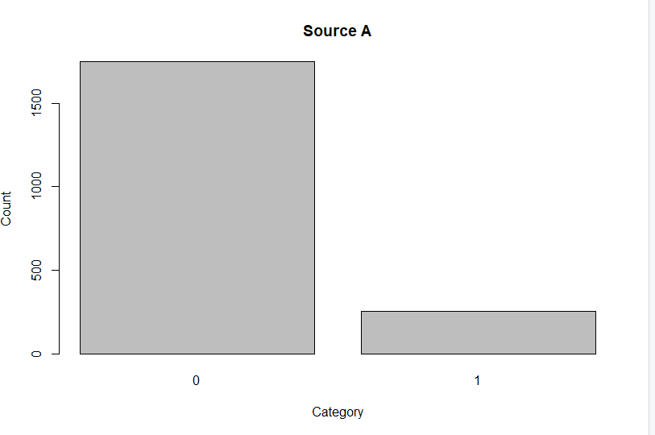
In Source A, it can be seen that a small proportion of customers were procured through the given source as compared to the rest who could not. This distribution indicates that although the Source A is included in the acquisition mix, it is not a very significant contribution.
Customer Acquisition from Source B
The same tendency can be seen in the plot of Source B, which shows that an extremely tiny percentage of the customers was referred to this channel, and the majority of customers were not referred to it. This implies that the Source B is a small source in data.
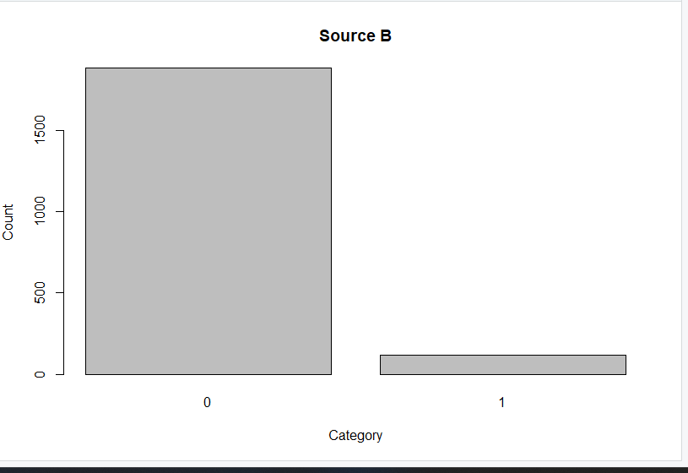
Customer Acquisition from Source C
The Source C distribution also reveals that the majority of the customers are not related to this source as only a limited group is labeled to be a part of it. This is an additional trend that most acquisition sources serve a limited number of customers.
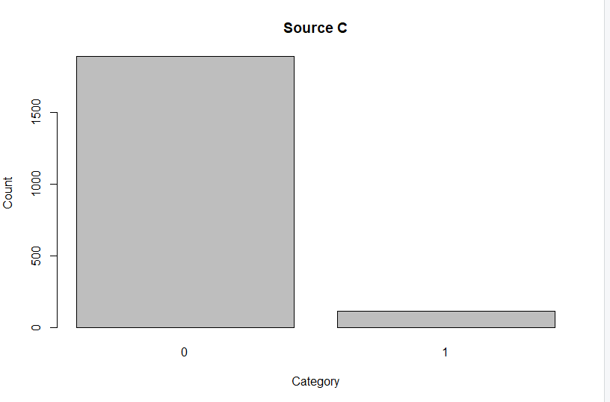
Customer Acquisition from Source D
In the case of Source D, the bar chart indicates that almost all customers are not connected with this channel and only very few customers are connected with this channel. This highlights its position as an insignificant route of acquisition.
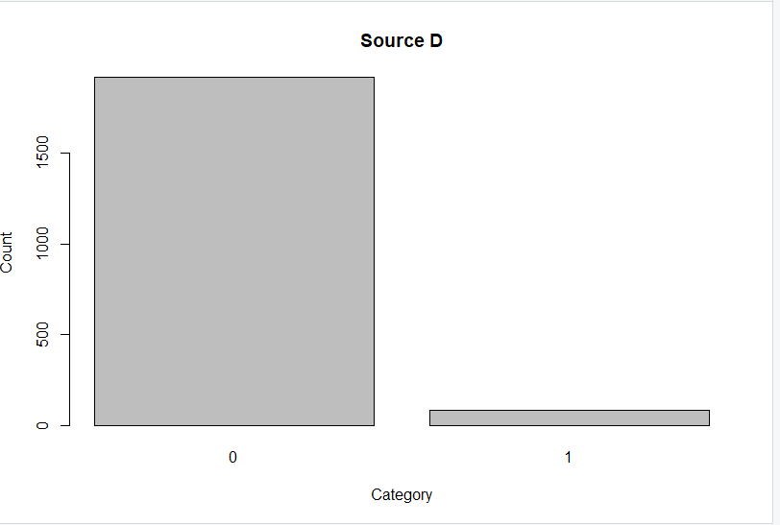
Customer Acquisition from Source E
According to the Source E plot, there are slightly more customers than in previous sources, yet this number is still lower than that not covered. This implies that Source E is more conspicuous yet not so popular in general.
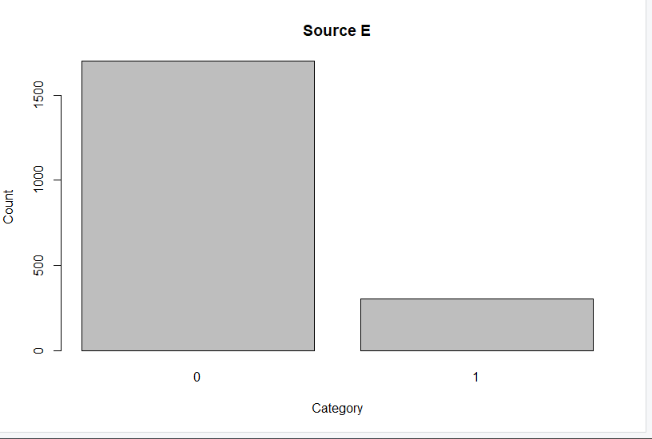
Customer Acquisition from Source M
The Source M plot indicates a significant imbalance in the plot since the number of customers per this channel is almost zero and almost all the data points are zero. This implies it is a source which is rarely consulted.
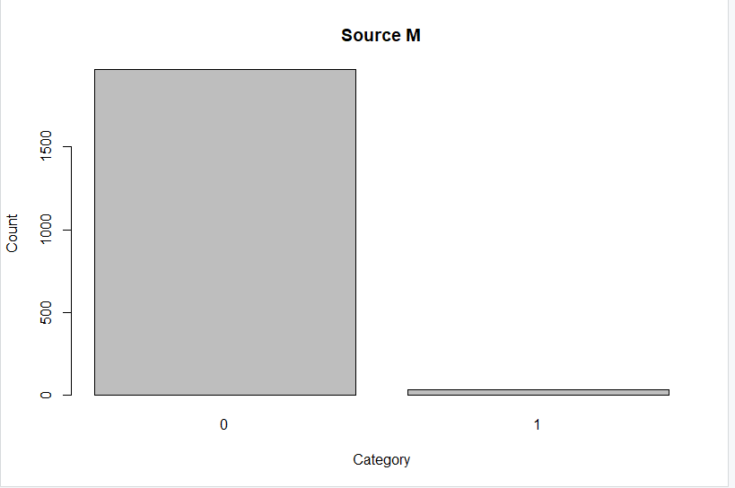
Customer Acquisition from Source O
In the case of Source O, the customers that are in this channel are few as indicated by the chart in comparison to the very large numbers that do not. This trend depicts a low coverage of this source in the data.
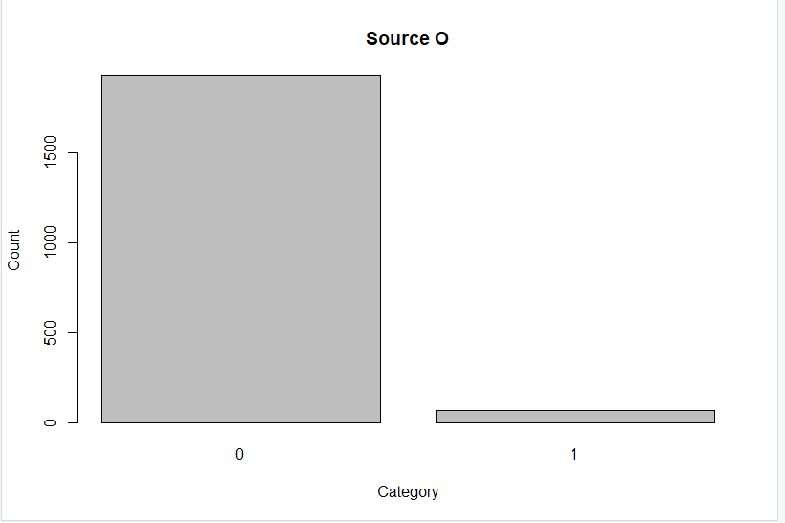
Customer Acquisition from Source H
The distribution of Source H is also predominated with the numbers 0s, and only a few percent of customers have their relation with this source. Similar to other sources, its significance will be subject to the presence of unique purchasing habits among those few customers.
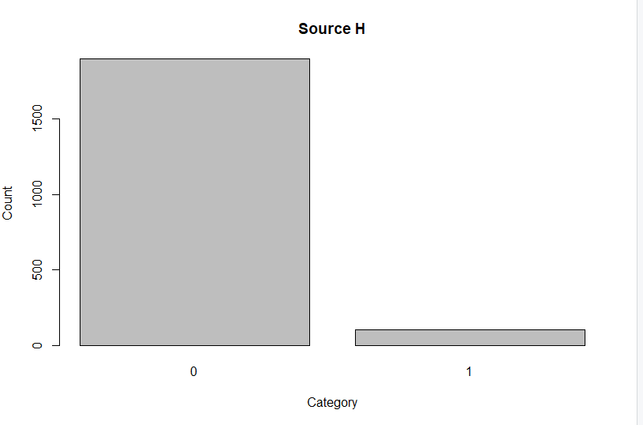
Customer Acquisition from Source R
Lastly, the Source R plot shows that few customers are received through this channel and most of them are not. This is in line with a general pattern that majority of acquisition sources are niche components of the dataset.
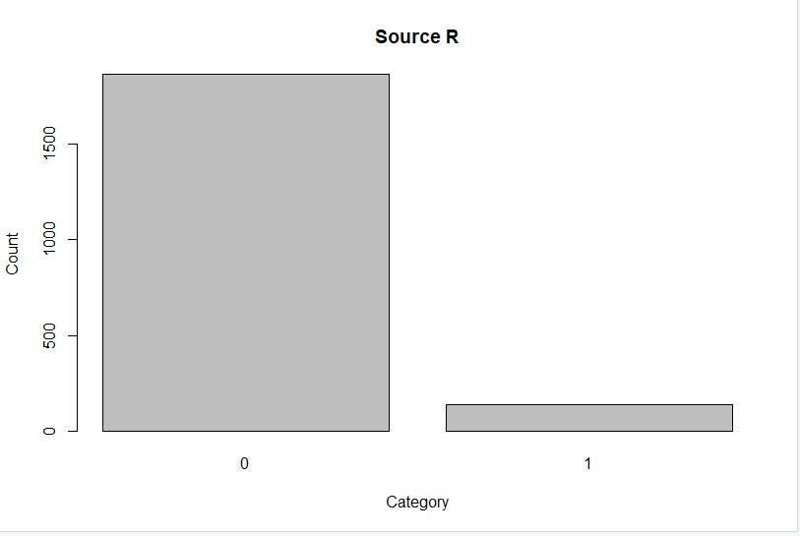
Customer Acquisition from Source S
Source S plot indicates that the percentage of customers associated to this channel is only a small minority and most customers are not associated to this channel. This makes Source S one of the niche acquisitions directions in the dataset.
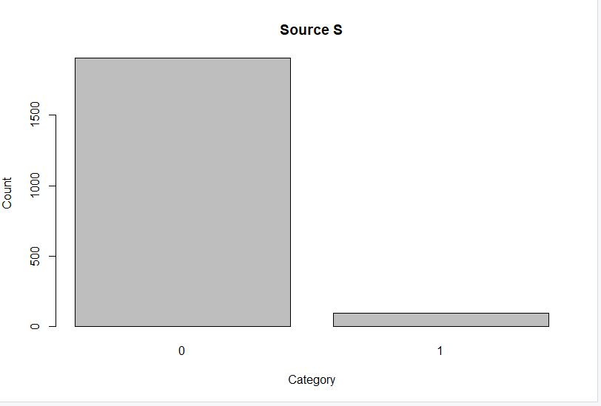
Customer Acquisition from Source T
The source T distribution reveals that barely any customers can be tied to this source with the majority being ones. This implies that it has a low contribution to the total customer acquisition.
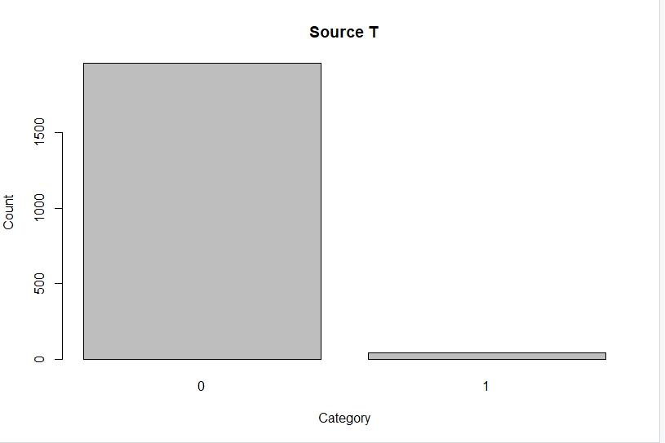
Customer Acquisition from Source U
The Source U plot indicates that the number of customers covered by this channel as a proportion of the total number is not great; however, it is more pronounced than those covered by other sources. This implies that this source has a little more presence than others.
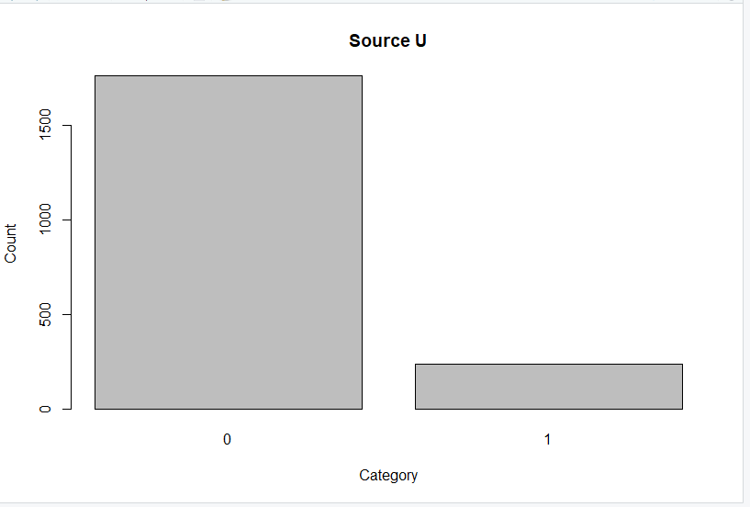
Customer Acquisition from Source P
As shown in the visualization of Source P, almost all customers are identified by zero and a insignificant percentage are related to this source. This means that source P adds minimal contributions to the dataset.
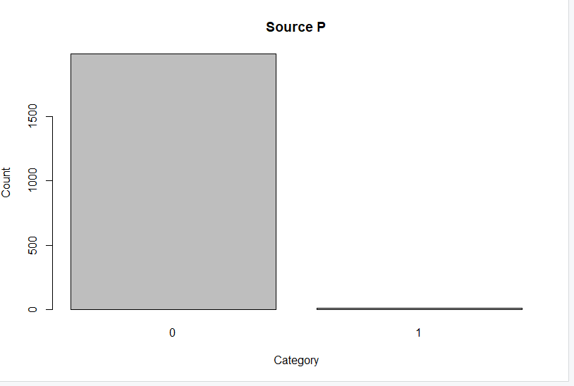
Customer Acquisition from Source X
Like other sources, the Source X distribution has a very minor number of customers linked to it and can be identified as non-members of this channel. This represents a very skewed trend.
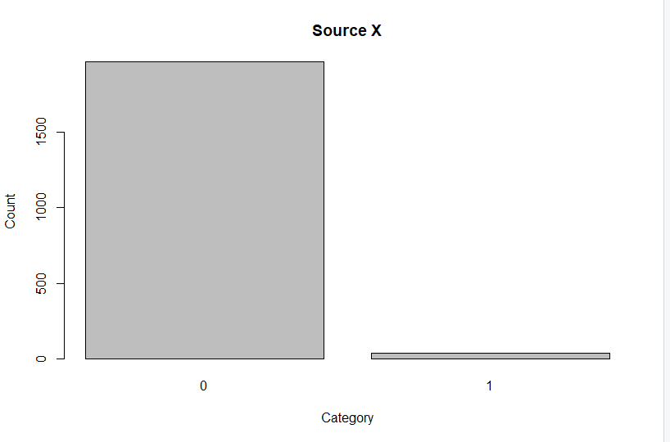
Customer Acquisition from Source W
Source W plot shows a little more customers connected to this channel than other minor sources, but again, most of them are a zero. This implies that Source W might have a certain impact, but it is minor.
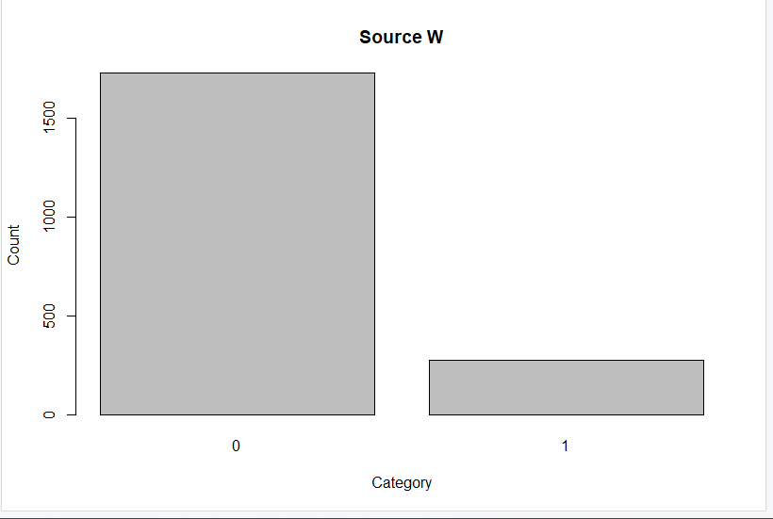
Transaction Frequency in Last Year
The scatter graph of Frequency of Transactions (Freq) indicates that the largest number of customers transacted with a few times and there were large numbers of customers who had low frequencies with few numbers having higher frequencies up to 15. This distribution focuses on heavy skewness on low engagement.
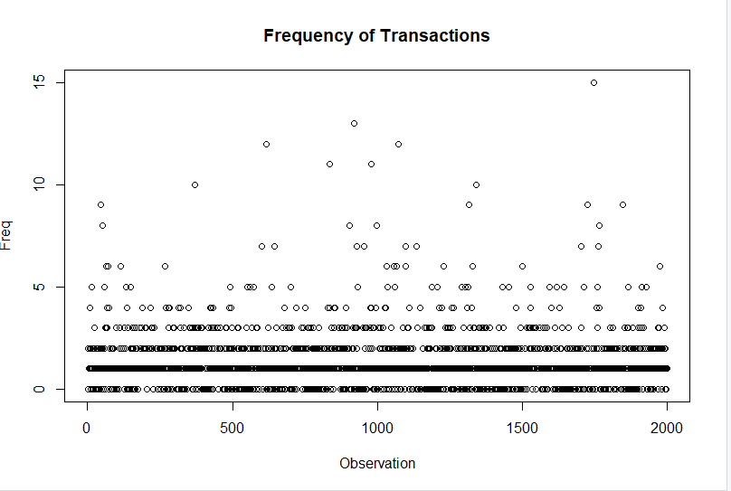
Days Since Last Customer Record Update
The Last Update (Days Ago) line chart shows that the values are wide spread, with the updates all over the dataset and up to more than 4,000 days. This distribution implies that there are many differences in the latest time of updating the customer records.
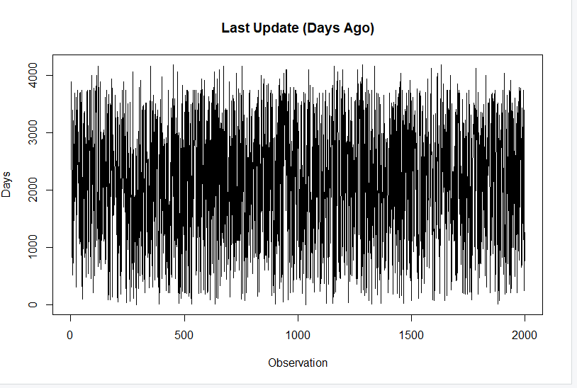
Days Since First Customer Record Update
The Bigger Picture First Update (Days Ago) line chart also extends to more than 4,000 days, the records being spread widely with time. This shows variety in the length of stay of customers in the database with the recent entries the latest and the old ones being the oldest.
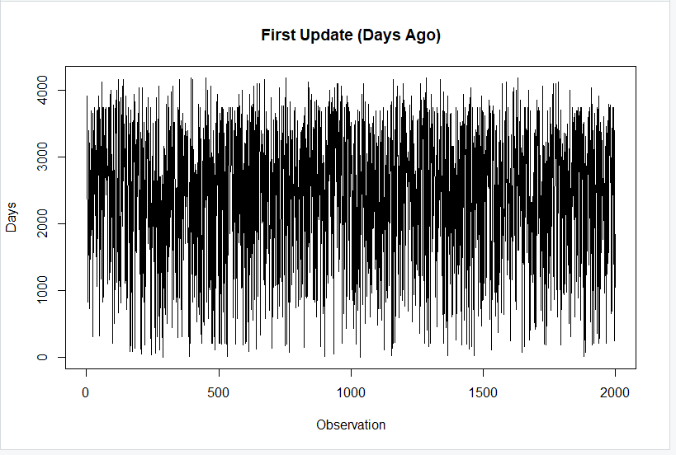
Web Order Indicator
The bar plot of Web Order reveals that the data is not highly skewed and that there were slightly more customers who did not make a web order than those ones who made a web order. This implies that online shopping is a material channel although it is not the greatest channel.
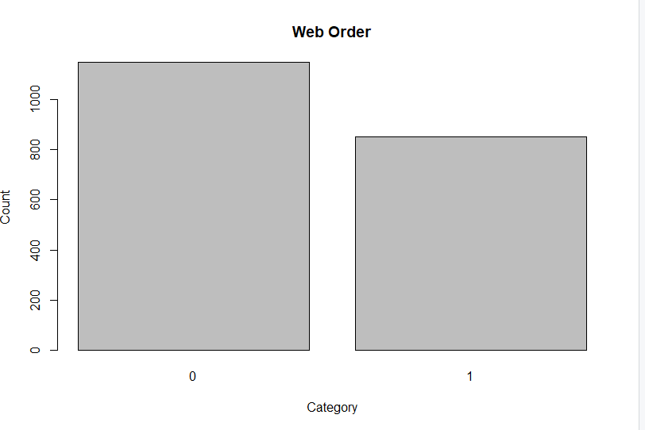
Customer Gender (Male vs Non-Male)
The bar plot of Gender (Male = 1) indicates that the dataset has almost an equal ratio of males and non-males. This implies that the customer base is well balanced so that there can be significant comparisons between the gender groups.
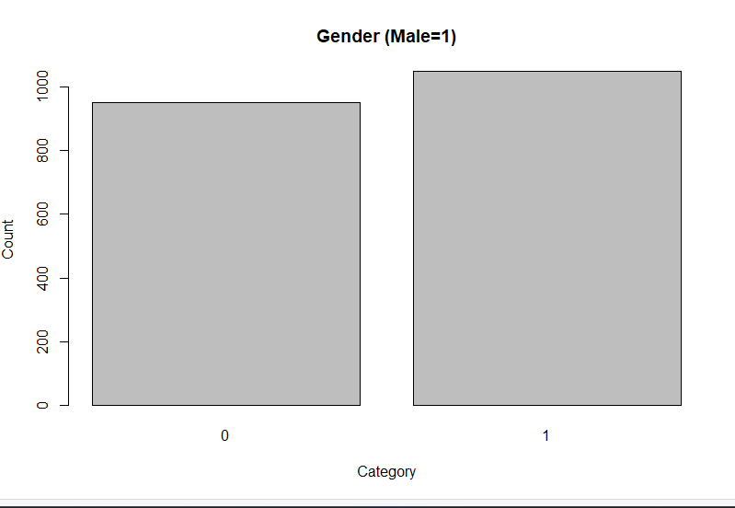
Residential vs Non-Residential Address
Address Distribution shows that most of the customers are listed under non-residential addresses with the remaining few percentage of addresses under residential. This tendency indicates that a lot of customers can be business or institutional customers but not individuals.
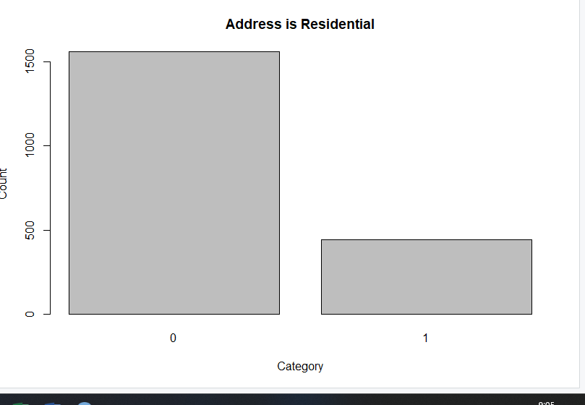
Customer Purchase Response
The Purchase plot shows the ideal ratio of those customers who purchased and those who did not. This balance is the best balance to model on, as it gives the same representation of both end results to aid in prediction analysis.
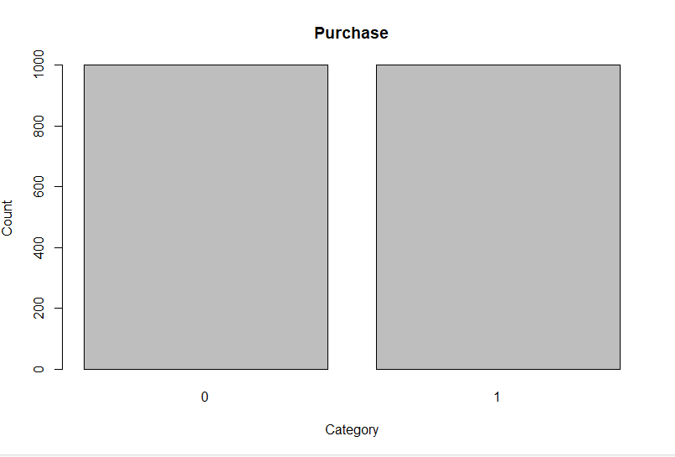
Customer Spending Distribution
The scatter plot of Spending Distribution demonstrates that the majority of the customers spend comparatively low sums and there is a high concentration around the lowest part of the graph. Nonetheless, there are significant outliers (spending value greater than 1,000) and this indicates that the existence of a few customers of high value is present.
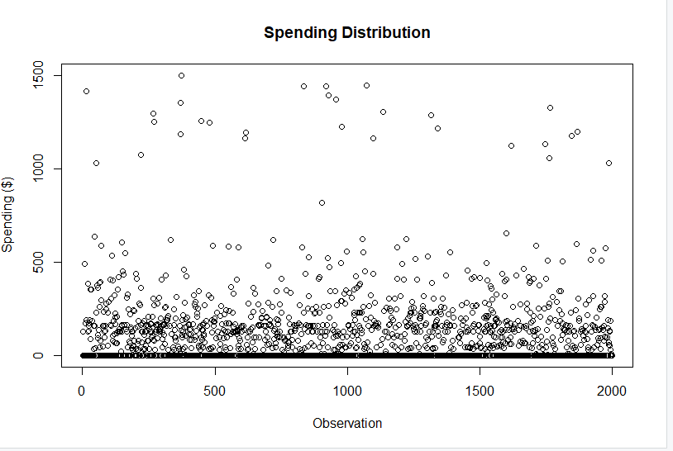
Predictor Relevancy and Analysis
Purchase Rate by US
The bar plot between US and non-US customers reveals nearly the same number of purchasers and non-purchasers in both groups. This shows that location in the US and out of the US does not play a significant role on whether a customer will respond to a mailing. In the case of North-Point, this implies that geography is not a good predictor of purchase response and marketing resources cannot be distributed disproportionately by geography without further segmentation.
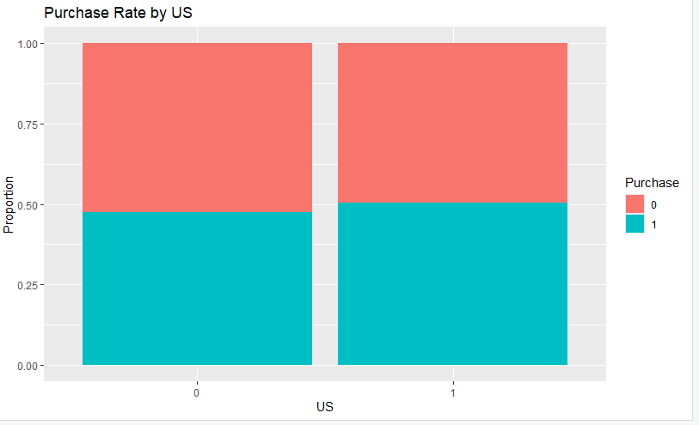
Purchase Rate by Web Order
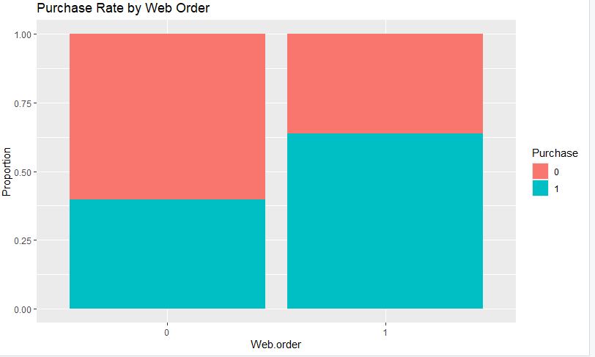
The difference is evident in the Web Order plot, where customers who have already placed a web order have a higher percentage of purchases than those who have not. This shows that previous online purchasing is a significant predictor of subsequent purchases. This is also a strategic choice as North-Point can target customers who have already surfed the web, as they are more likely to become a customer and this increases the effectiveness of the mailing campaigns.
Purchase Rate by Gender
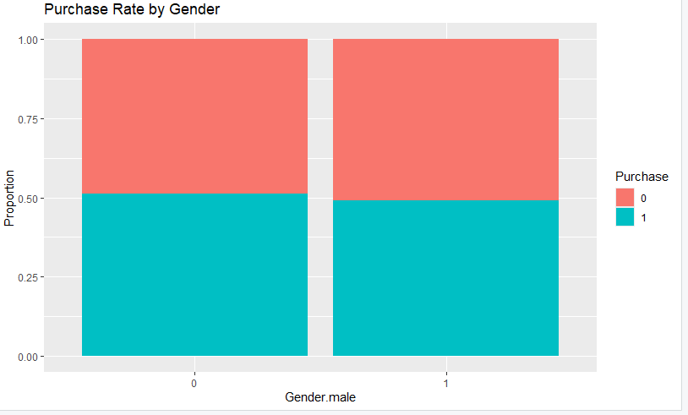
The Gender-based purchase rate plot indicates almost similar rates of purchasers and non-purchasers of males and non-males. This implies that gender is not a distinguishing variable in forecasting the response of the mailing in this dataset. In the case of North-Point, gender-based targeting is not likely to be associated with huge returns, and instead, it should target behavioral or transactional indicators.

Purchase Rate by Address Type
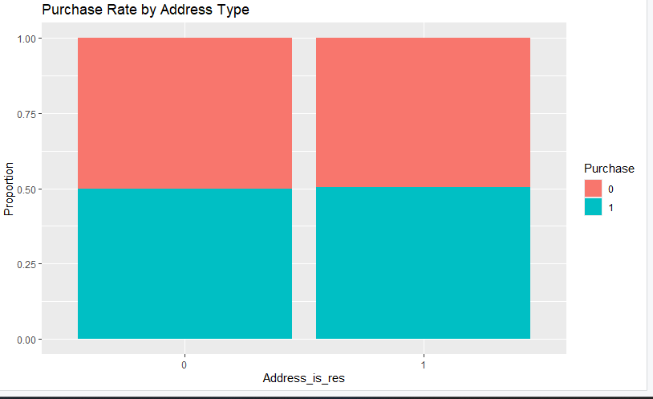
In the Address Type plot, the purchase rates of residential and non-residential addresses are almost the same. This means that the fact that a customer has a personal or business address does not have a significant influence on his or her probability of buying. In marketing terms, this implies that North-Point does not have to segment campaigns according to address type alone and resources should be channeled to more behavior-based aspects.
Frequency by Purchase
The boxplot of transaction frequency (Freq) vs Purchase status is quite striking: purchasers tend to have more frequent transactions, and non-purchasers tend to be at very low frequencies. This is a good sign that previous involvement with the company is an indicator of future purchases. North-Point ought to focus on customers that have a history of high frequency transactions since they are a greater likelihood of conversion and revenue influence.
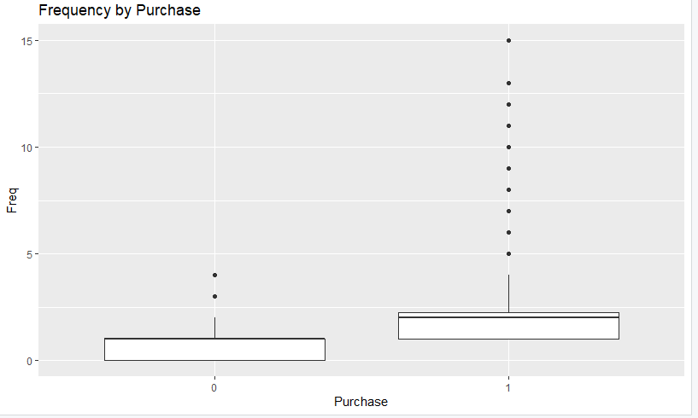
Last Update Days Ago by Purchase
The boxplot indicates that the last update records of non-purchasers are usually higher (greater values) whereas those of purchasers are usually more recent. This implies that customers in the database that have been updated recently are more interested and responsive and those that have not been active in the database will be less likely to buy. In the case of North-Point, this underscores the need to have current and updated records of customers since recency of engagement is one of the most important predictors of purchase behavior.
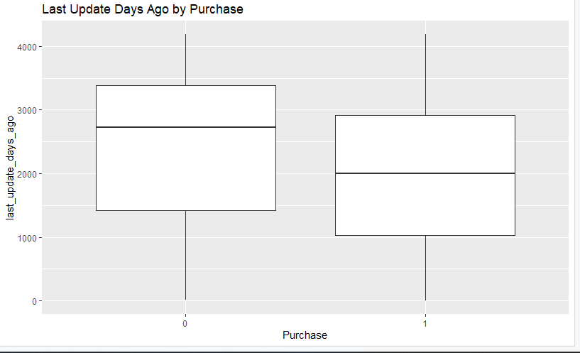
First Update Days Ago by Purchase
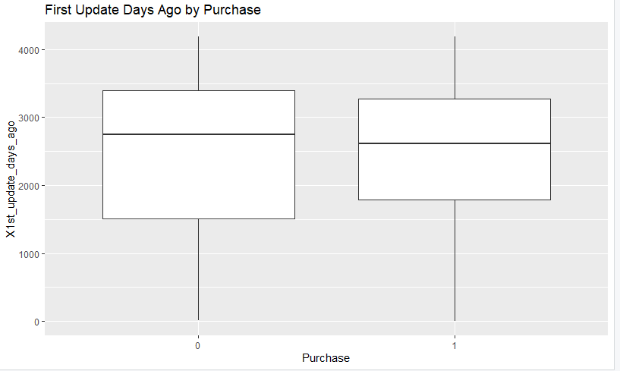
The update variable of the first variable shows that the purchasers tend to have been in the system a little bit shorter than non-purchasers, but the overlap is substantial. This means that new customers can be a little more responsive than old and long-term customers who might be less active with time. Marketing wise, North-Point ought to strike a balance between developing newer customers to create loyalty and re-developing the older customers through specific campaigns to rekindle interest.
Spending by Purchase
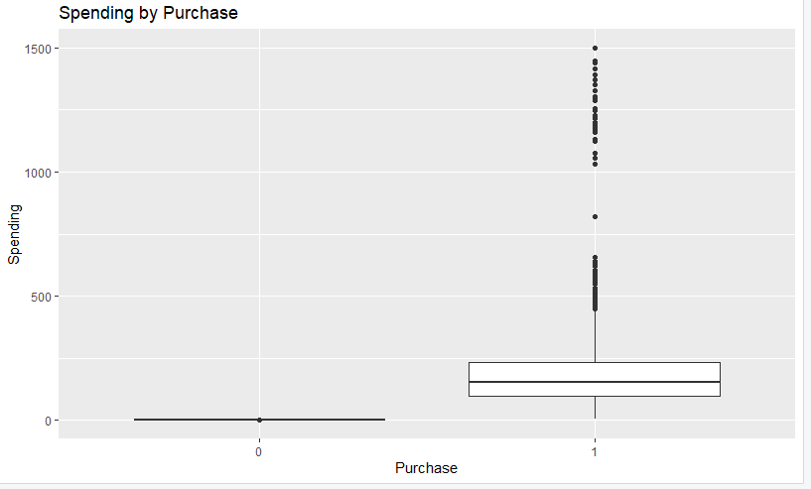
The plot of Spending by Purchase makes the difference between non-purchasers and purchasers clear: non-purchasers have a fixed spending value of zero and purchasers a wide range of spending, with some very high-value outliers. This means that the majority of customers are relatively low spenders, but there are a few buyers who are huge revenue sources. In the case of North-Point, this supports the business case of predictive modeling - not only does identifying likely purchasers increase the conversion, but also makes sure that campaigns are targeted at attracting those high-value spenders who generate disproportionate revenue impact.
Spending by US
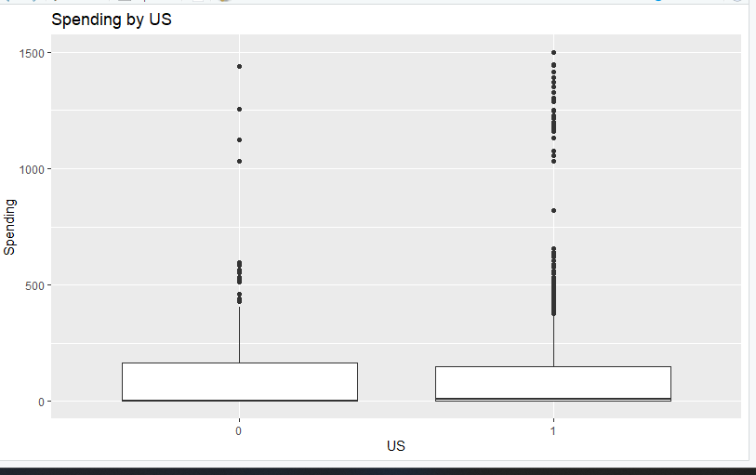
The Spending by US boxplot indicates that the distribution of spending by both the US and non-US customers is similar and the distribution is highly varied with few extreme outliers. This implies that geographic location is not a strong factor that influences the amount of money that a customer will spend after making a purchase decision. In the case of North-Point, it implies that location is not the determinant of spending value, but the company must still make sure that it reaches the entire world in its campaigns because there are high-value customers both locally and internationally.

Spending by Web Order
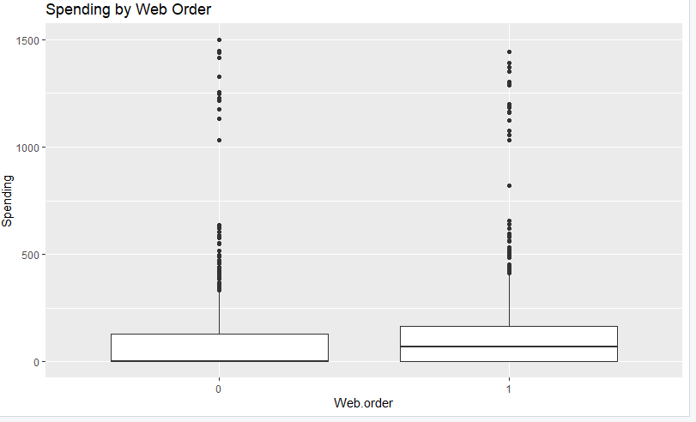
The plot of Spending by Web Order suggests that the level of spending is widely comparable between customers who have and have not placed web orders, but web-order customers might be more variable. This implies that web orders are predictive of likelihood of purchase, but not predictive of the amount actually purchased. In the case of North-Point, this means that web order history can be employed to target conversion, but to maximize revenue, other criteria (frequency or recency of updates) must be employed to determine customers who have high spending potential.
Spending by Gender
The Spending by Gender plot indicates almost the same distributions of spending between males and non-males with both groups having outliers of high-value customers. It means that gender does not play a major role in determining the extent to which a customer will spend after making a purchase. In the case of North-Point, this implies that marketing campaigns do not require so much differentiation based on gender and resources should be shifted to behavioral and transactional variables with greater predictive power.
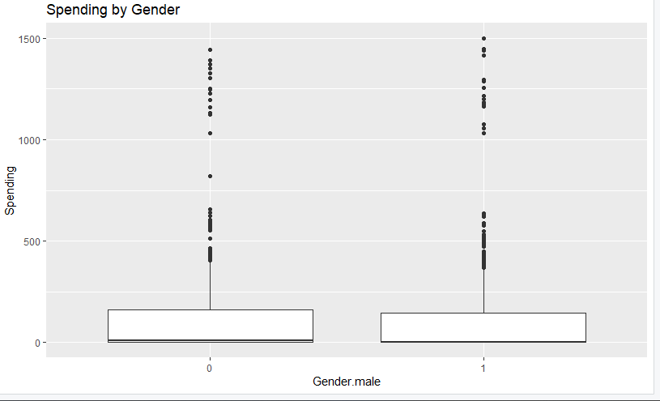
Spending by Address Type
The Spending by Address Type plot indicates that there is not much difference between residential and non-residential customers. The two groups have a huge number of low spenders with a small number of very high spenders. This implies that the type of address is not a significant factor in purchase spending. In the case of North-Point, this implies that mailing strategies should not use address type as a segmentation criterion, and more valuable information can be obtained using past purchase behavior and recency.
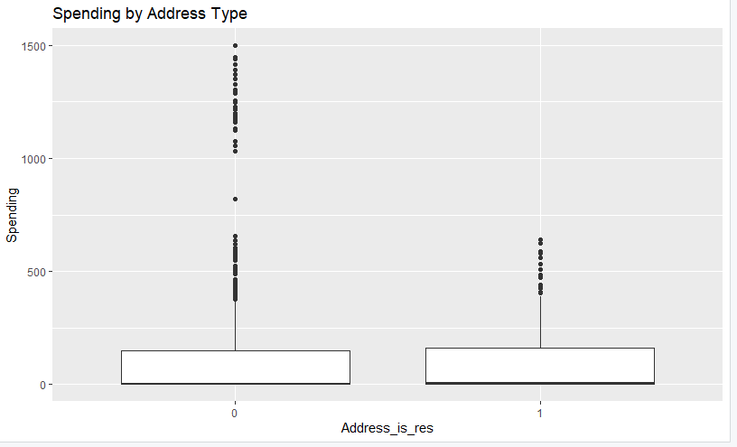
Spending by Purchase
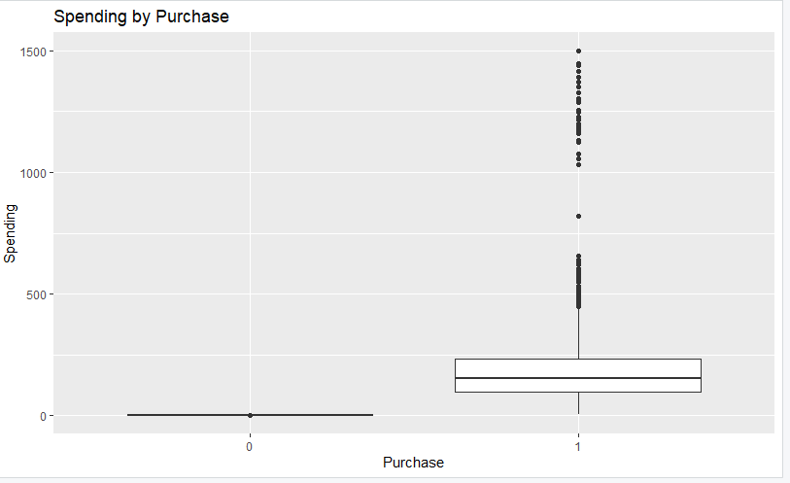
The most glaring gap in this plot is the zero spending of non-purchasers and the broad range of spending of purchasers that includes high-value outliers. This further confirms that the purchase behavior is the entry point to revenue and purchase prediction models are essential. The business implication to North-Point is that the accuracy of purchase prediction is directly related to revenue since the mailings are sent to individuals who have potential to spend.
Spending by Frequency Bins
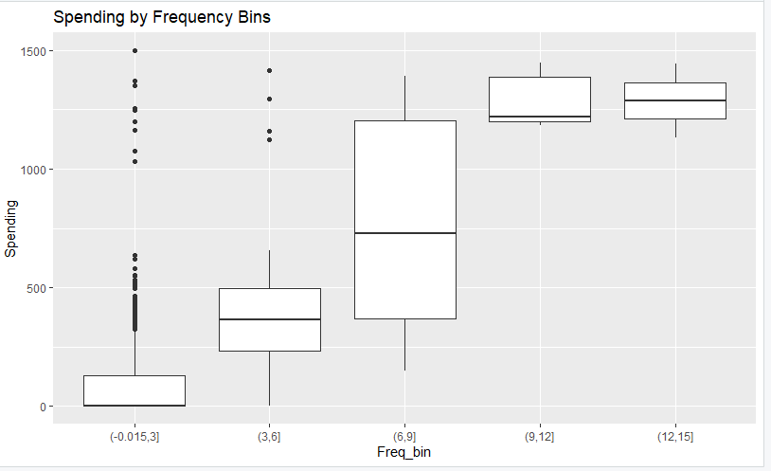
The Spending by Frequency Bins plot shows a very distinct pattern, as the customers who have more frequent transactions also spend more, and the median spending is higher in the bins. High frequency customers are usually the most important customer in terms of reliability and revenue generation. This is important to North-Point because frequency is an important targeting factor when mailing because frequent buyers are not only more likely to buy, but also spend significantly more.
Spending by Last Update Quartiles
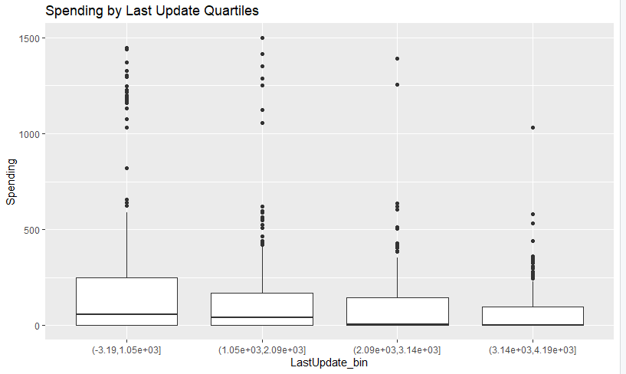
This plot demonstrates that the customers whose updates are more recent (below the 75 th percentile of days since last update) are slightly more likely to spend more than the customers whose records have not been updated in a long time. Although the pattern is not as high as frequency, it indicates that recency of engagement is also important to revenue potential. In the case of North-Point, this facilitates the business practice of maintaining fresh customer records and targeting campaigns to customers who are active in the recent past and have a higher chance of giving higher returns.
Spending by First Update Quartiles
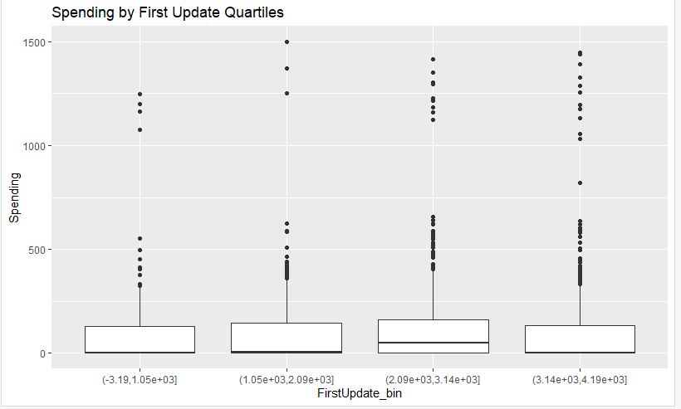
The Spending by First Update Quartiles plot indicates that the distributions of spending are rather even throughout all quartiles, and there is no significant tendency between the length of time in the system and the level of spending. This implies that database tenure is not a good revenue generator. In the case of North-Point, it implies that the time a customer has been in the system should not be used to make marketing decisions, but more dynamic factors like frequency of engagement and recent activity should be.
Dimension reduction
The use of dimension reduction methods like the Principal Component Analysis (PCA) or feature selection is typically used when the dataset has a very large number of correlated or redundant variables that can complicate the modeling process or cause overfitting. In the North-Point Software mailing dataset, the predictors are quite few and most of them are categorical or binary in nature, including US, Web Order, Gender and Address Type. These variables are already interpretable and meaningful in the business context and therefore, do not need to be transformed into abstract components which may complicate the interpretation.
Also, the numerical variables included in the dataset (e.g., frequency of transactions, last update days ago, and first update days ago) are not numerous and are not strongly correlated with each other. This guarantees that there is no big issue of multicollinearity and that all the predictors can contribute an independent value in predicting the purchase behavior or the spending. The downsizing in this case would be a possibility of losing some important customer insights that are directly linked to the interpretable business features.
Lastly, due to the balanced sample (equal number of purchasers and non-purchasers) and not too large-dimensional dataset, the current classification and regression models like decision trees, logistic regression, and random forests are capable of working with the predictors without the necessity of dimension reduction. Here, it is possible to retain all the original predictors so that the business can relate the analytical insights more to actionable strategies without compromising interpretability and transparency.
Data engineering and transformation
Some of the variables in this dataset are categorical in nature like binary indicators like US, Web Order, Gender, Address Type, and several source variables. To be able to process these categorical features, machine learning algorithms may require them to be converted into numerical forms. These variables were converted to factors in R to ensure proper handling during modeling. For logistic regression, R automatically converts factors into dummy or indicator variables, while for decision trees and random forests, factors are processed natively without requiring additional encoding. Since these fields are already binary indicators, label encoding was not applied.
Numeric variables (Freq, last_update_days_ago, 1st_update_days_ago, Spending) were used directly for analysis. For k-means clustering, numeric features were standardized to place them on a comparable scale. Additional binned variables (e.g., Freq_bin, LastUpdate_bin, FirstUpdate_bin) were created only for visualization purposes and were not used in the regression models. The sequence_number column was excluded from all analyses.
Data partitioning methods
In order to construct strong predictive models, the dataset should be subdivided into groups that can be used to train the model and evaluate its performance. One of the most common and useful methods is the 65 35 split, in which 65 percent of the data is used to train the model, and the remaining 35 percent is used to test it. The training part allows the model to memorize the patterns, relationships, and predictor relevancy in the dataset, whereas the test part allows an objective estimate of the extent to which the model can be extended to previously unknown data. This will aid in avoiding overfitting, in which the model may be very good on the training data but be poor on new, unseen observations.
In the North-Point Software mailing data case, an 65 35 split will guarantee that the training set contains sufficient data points to reflect significant patterns in customer buying behavior and spending habits, as well as reserve a large enough portion to test performance. As the dataset is equal in terms of purchasers and non-purchasers (stratified sample), the partitioning process must also be balanced in such way that both training and testing sets reflect the actual diversity of the results. This 65-35 break down will be useful in creating the models that can better predict customer reaction to future mailing.
The benefit of the approach is that it is simple and is common in data science practice. The model is trained using 65 percent of the data, which provides sufficient exposure to the variation in predictors like frequency, recency of updates and previous web orders. The 35 percent test sample then serves as a realistic simulation of new campaign information, which gives practical information on how the campaign is likely to perform in the real world. Through this partitioning strategy, North-Point will be assured that the models are not only properly trained but also in a position to give reliable predictions that can support the business objectives of the company to enhance mailing efficiency and reach out to high-value customers.
Model Selection
Decision Tree (Classification)
A decision tree is a basic but a very potent model that breaks down the data into smaller groups depending on the predictor variables, and finally creates rules that determine whether a customer will purchase or not. It is effective with categorical and numerical predictors, e.g. web orders, frequency of purchases, recency of updates. In the case of North-Point, decision trees are interpretable, which means that the marketing team can interpret the decision trees to see what factors most heavily influence the purchase decision, and can translate those rules into actionable targeting strategies.
Logistic Regression (Classification)
Logistic regression is a statistical model that approximates the likelihood of a binary outcome, e.g. whether a customer will buy (1) or not (0) given the predictor variables. It works especially well when predictor-target relationship is linear in the log-odds space. In the mailing issue, logistic regression can be used to estimate the extent to which each variable (e.g., frequency, gender, or address type) affects the probability of purchase, not only to provide predictive value but also to provide interpretable coefficients to make evidence-based business decisions.
Random Forest (Classification & Regression)
Random forest is an ensemble algorithm that uses a combination of decision trees to enhance better prediction and decrease overfitting. It can withstand noisy data and can deal with both categorical and continuous predictors. In the case of North-Point, a random forest model will be able to make very accurate predictions of the likelihood of purchase and also predict the level of customer spending, so it will be appropriate in identifying both potential responders and high-value customers to target in the mailing campaign.
Linear Regression (Regression)
Linear regression is used to predict a continuous variable, e.g. customer spending, using linear relationships with predictors. Such variables as frequency of purchases and recency of updates may be good predictors of the level of spending in this dataset. In the case of North-Point, linear regression provides a simple and understandable method to predict anticipated expenditure among the customers who buy the product and the business can invest in marketing to those customers with greater revenue potential.
Random Forest Regression (Regression)
Random forest regression is used when the outcome of interest is continuous, such as spending, and the ensemble concept of random forests is used. It can predict complex nonlinear associations between predictors and spending levels by averaging the predictions of several decision trees. In the case of North-Point, this model will give more precise and consistent spending forecasts than linear regression in situations where the spending pattern is not always linear, allowing high-value customers to be targeted more precisely.
Stepwise Regression (Regression)
Stepwise regression is a method of variable selection in which predictors are included or dropped out of the model depending on some statistical criterion such as p-value or information criterion (AIC/BIC). This will guarantee that only the most pertinent predictors are used, enhancing the simplicity of the model and preventing overfitting. In the case of North-Point, stepwise regression may be used to determine the most significant factors that contribute to customer spending in order to ensure that the models are not too complex and still provide valuable data to support strategic targeting.
K-means (Clustering)
To support marketing strategy, we will run a simple K-means clustering on behavioral predictors (e.g., prior web order, purchase frequency, recency, and selected source indicators). Numeric features will be standardized before fitting. We will choose the number of clusters k using silhouette and elbow checks (keeping k small and interpretable). The goal is not to drive the 200k mail cutoff; that decision comes from the calibrated response/value models. Instead, cluster labels will help profile groups (e.g., high-recency customers, inactive customers, moderately recent customers) so the business can tailor creative, offer, and follow-up strategy. We will not allow any target leakage, and we will document each cluster’s size and key feature averages for marketing use.

Modeling and Implications
K-Means Clustering
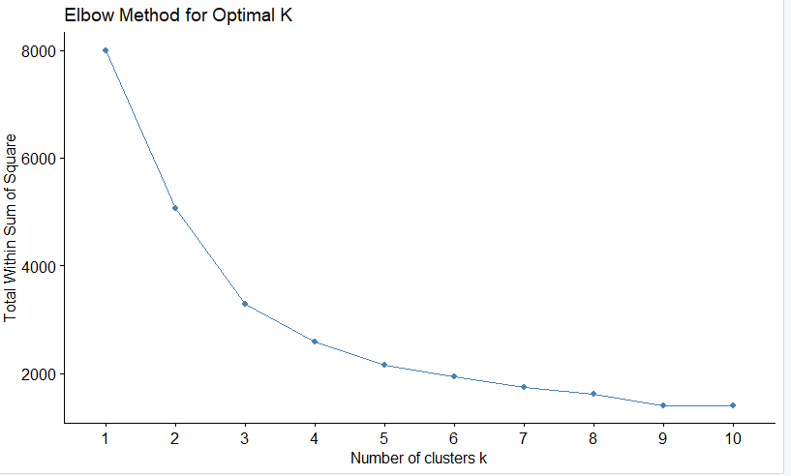
The North-Point Software Mailing Analytics K-Means clustering analysis was used to cluster the customers according to their behavioral and transactional characteristics. The Elbow Method graph indicates that the sum of squares (WSS) inside the cluster reduces quickly until k = 3, after which it reduces significantly slower creating an elbow. This inflection point indicates that there are three clusters that provide a good compromise between simplicity and explanatory power. Equally, the Silhouette Method supports this decision and demonstrates the greatest average silhouette width at k = 3, which represents a high level of separation among clusters and cohesiveness within the clusters. Combined, these measures confirm that the data can be described by three different groups of customers.
These three segments are further distinguished in the K-Means clustering visualization as distinct groups with distinct behavioral patterns. Cluster 1 (blue) is low-frequency and low-spending customers - occasional buyers who have low engagement and might need reactivation campaigns. Cluster 2 (yellow) comprises moderately involved customers who buy periodically and react to targeted marketing in a positive way, which is a good conversion. Cluster 3 (gray) is composed of the high-value customers who are high in terms of transaction frequency and spending level and this is the most profitable and loyal base of the company. This segmentation is in line with the objective of North-Point to ensure that it maximizes the efficiency of mailing by establishing the customers who are most likely to buy and spend more.
These insights offer a strategic approach to differentiated marketing in a business context. The company will be able to customize campaigns to each segment: retention and reward programs to high-value buyers, personal incentives to moderate buyers, and awareness or re-engagement campaigns to inactive customers. In addition, combining this clustering output with predictive classification models will help North-Point to refine its mailing lists, minimize waste, and boost conversion rates. In general, K-Means clustering converts raw customer data into actionable intelligence, whereby precision-based marketing and enhanced profitability at customer levels can be realized.
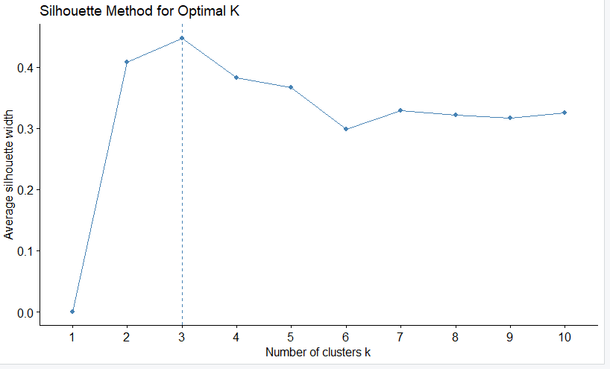
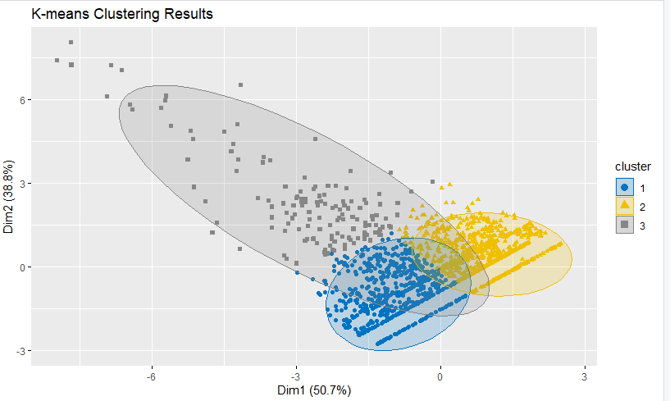

Decision Tree
The purchase behavior prediction decision tree model had an overall accuracy of 78.6 and that is, it correctly identified almost four out of five customers as either purchasers or non-purchasers. The model has good diagnostic strength, and sensitivity of 82% (true purchasers) and specificity of 75% (false purchasers). These findings indicate that the model is slightly biased towards identification of purchasers- an excellent marketing feat, as it is cheaper to miss potential buyers than to send mails to a small number of prospects with no interest. The moderate agreement beyond chance as indicated by the Kappa value of 0.57 and the balanced accuracy of 0.79 indicates that the model has well represented and well learned both positive and negative classes.
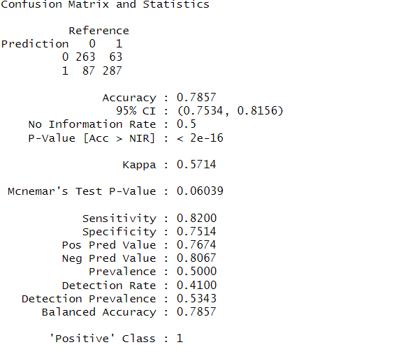
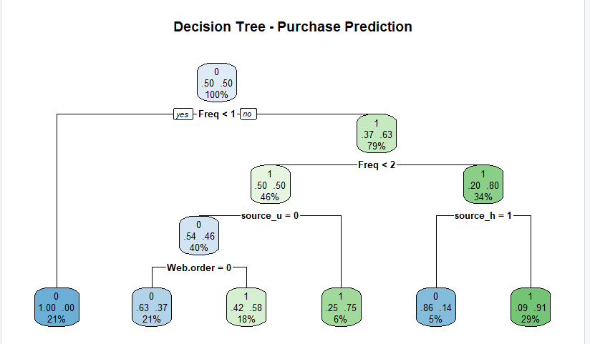
The decision tree diagram illustrates transaction frequency (Freq) as the most important predictor in purchase choices. Those customers who have recorded less than one transaction are predominantly grouped as non-purchasers, and the preceding activity is one of the main determinants of responsiveness. Using Web.order refines the classification further to the additional splits including sourceu, sourceh and Web.order (customers in one or more transactions). In particular, those linked to sourceh = 1 and that exhibit moderate levels of frequency will be most likely to purchase (probability of 90% and above) whereas inactive or engaged customers of other sources are unlikely to buy. The business rules of the tree have a hierarchical manner of structure which enables North-Point to translate the predictive insights directly into actionable mailing strategies.
In the case of North-Point Software, this decision tree model provides the explicit manner of how to optimize the mailing campaigns. The company will be able to achieve significant response rates by targeting customers whose transaction frequencies and web order history are recent, which will also minimise the unnecessary mailing expenditures. Besides, the model identifies particular marketing sources, such as sourceh and source_u, which are linked with greater purchase probabilities, and which can be better resource allocated across channels. Since it is interpretable, the decision tree will be especially helpful in the non-technical stakeholder, hence, the decision tree is the best place to base campaign planning, segmentation, and future predictor models.
Logistic Regression
The logistic regression model, which was employed to forecast customer buy behavior, had an accuracy of 79 and this suggests that the level of predictability is strong in classifying purchasers and non-purchasers. The Kappa of 0.58 is another test that confirms the presence of a moderate consensus over randomness, and that there is some underlying underlying pattern of the data that is reflected in the model. Its balanced accuracy of 0.79 implies that the model acts consistently within both classes without favoring any single group, i.e. purchasers and non-purchasers. Such performance shows that even though logistic regression is very simple, it proves to be effective in separating between likely and unlikely customers to make a purchase.
Based on the performance metrics, the model had a sensitivity of 77.7% and a specificity of 80.3 with a slightly balanced capability of identifying an actual purchaser (true positive) and an actual non-purchaser (true negative). The positive predictive value of 79.8% and negative predictive value of 78.3% show that when the model makes predictions on purchase or non purchase, it is accurate almost four out of five times. These statistics indicate that the model is somewhat on the safe end, in terms of minimizing the false positives but good recall of the real customers- an optimal trade-off in the direct marketing setting whereby the mailing costs have to be minimal.

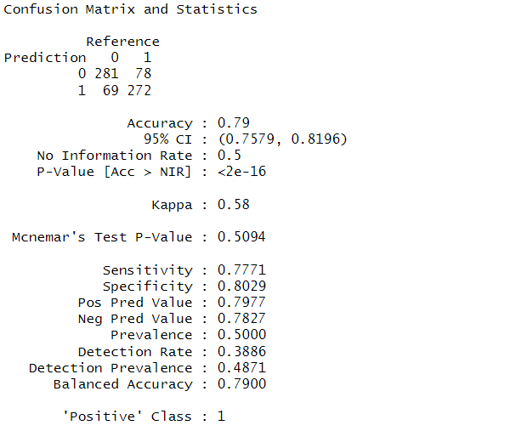
In the case of North-Point Software, the logistic regression findings can be of significance to the business. The fact that the model can give interpretable coefficients means that marketing analysts can directly tell which variables, including web order history, frequency of past transactions, and the recency of updates have the strongest impact on the likelihood of purchase. The interpretability allows the company to focus on attributes of the key customers to optimize the mailing lists and the customized campaigns. In general, the model logistic regression presents a tradeoff between precision, interpretability, and practicality in marketing, and thus it is a reliable tool to predict customer response during future mailing campaign.

Random Forest
The accuracy of the Random Forest classification model was large, at 81.7, and this was better than the Decision Tree and Logistic Regression models in general predictive ability. The Kappa value of 0.63 shows significant concord of the predicted and the actual classification and this proves that the model is good enough to record the significant behavioral and transaction patterns that are available to differentiate between purchasers and non-purchasers. The random forest model has a balanced accuracy of 81.7, which is the same between the two classes and hence can be said to be robust and less biased. This very accuracy proves that the ensemble method of aggregation of the predictions of several trees manages to reduce overfitting and promote generalization.
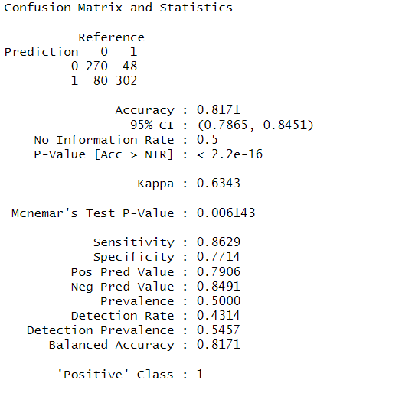
Diagnostic perspective shows that the Random Forest model has a sensitivity of 86.3 percent and a specificity of 77.1 percent, which demonstrates its high capacity to accurately recognize real buyers as well as good performance in recognizing a non-buyer. Its positive predictive value of 79.1 percent and negative predictive value of 84.9 percent further indicate that the model is also dependable in predicting actual buyers and eliminating the non-responsive customers. High sensitivity and balanced specificity make this model the best model to use in marketing since the model maximizes the number of potential buyers without over-inclusiveness in false positives that would result in unnecessary costs of sending mails to potential buyers.
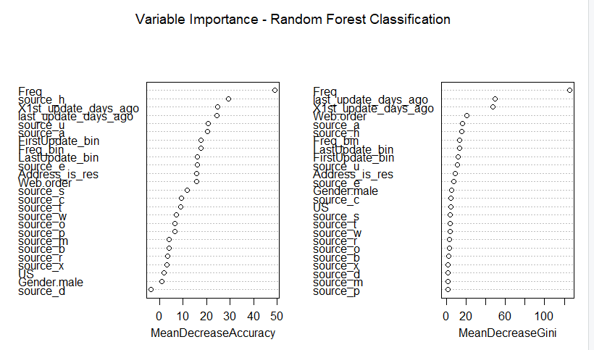
In the case of North-Point Software, however, the Random Forest model provides the most reliable and business feasible model of prediction when compared to all the other algorithms that have been experimented with. It uses several predictors including purchase frequency, web order history, and the latest update of the account so as to come up with the customers who are most likely to respond to future mailings. The interpretability and strength of the model including the measures of the importance of the variables enable the marketing analysts to focus on the most important behavioral motivators that drive purchases. This model can be efficiently applied strategically to direct mailing list optimization, efficient marketing budget assignment, and high-likelihood customer-based loyalty programs design. On the whole, it is possible to note that the Random Forest model is the most desirable to maximize the effectiveness of the campaign and increase the returns of North-Point to its marketing investment.
Probability calibration and targeting metrics
We trained the Random Forest on the balanced sample and then recalibrated its predicted probabilities to the pilot base rate (5.3%). Using the calibrated scores on the 35% test split, we computed gains and decile-lift. Results show strong ranking power: 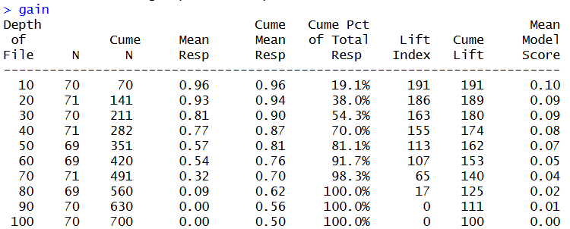
By mailing only the top 30 % of prospects (approx. 211 names), the model captures 54.3 % of all purchasers in the test set. By contrast, a random selection would only capture 30 % of total purchasers.
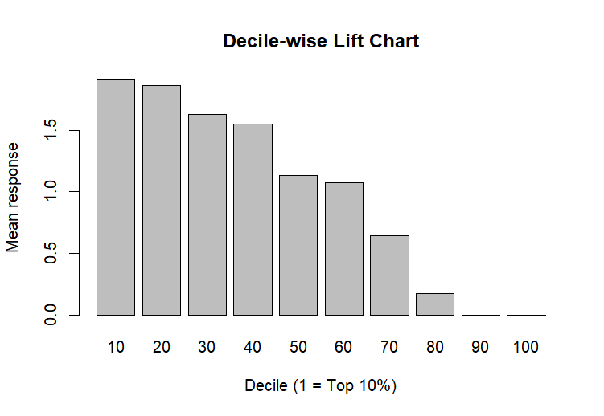
The Lift Index (which is the Conversion Rate / Baseline Conversion Rate) for the top decile (10 %) is 191. This translates to 1.91 times more than Lift over random selection, proving the model is nearly double the efficiency of the pilot campaign. The chart visually demonstrates this lift. The bar heights in the first three deciles are significantly above the 1.0 baseline, indicating strong performance. Conversely, mailing the bottom 30% (deciles 80-100) yields virtually no buyers, validating the strategy to eliminate low/no profit segments to reduce wasted revenue on marketing.
These metrics confirm that concentrating mailings on the highest-scored segments yields substantially more buyers per 1,000 pieces mailed.

Linear Regression
The multiple linear regression model was constructed to explain customer spending behavior in terms of combined response of demographic, behavioral, and transactional variables. The model had a value of 0.5362 as the R2 value, which implies that almost 53.6 percent of the customer spending variation is accounted by the predictors in the model. Although it is a medium amount of explained variance, it indicates that the linear model explains a lot of important relationships between spending and the variables of transaction frequency, recency of updates and web order history. The Root Mean Square Error (RMSE) of 131.27 shows that the average error of the spending in the form of dollars is quite expected, as the dataset contains a lot of variation and there are outliers.
The scatter plot of actual and predicted spending indicates that the relationship is positive and linear with most of the data being at the lower expenditure levels. The red regression line is very close to the overall increasing pattern as it proves that the values that are predicted rise in direct relation to actual spending. Nevertheless, the data is observably spread out along the line, particularly on the higher levels of expenditure meaning that the model has some difficulties with extreme values or high spending outliers. This variability indicates that there can be some nonlinear relationships or effects of interaction that cannot be well captured using a simple linear model. This notwithstanding, the model is quite successful at determining the overall pattern of spending and a benchmark of the factors that most impact spending.
Business-wise, the model can offer some useful information to the North-Point Software regarding the determinants of customer expenditure. The number of transactions and time of last update seems to be good predictors of increased spending with the notion that active and recently active customers are the largest contributors to revenue. The model may be used to make predictions of the future revenue of the targeted customer group and to plan individual promotional campaigns to high frequency or newly changed customers. The multiple linear regression model is very interpretable and, even though it could be possible to achieve a better prediction by using a more complex nonlinear model e.g. Random Forest Regression, it is an ideal model to formulate inferences that could be used in practical marketing decisions.
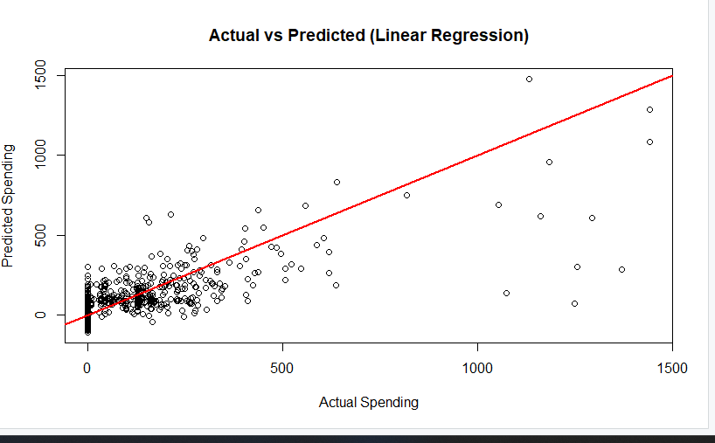
Random Forest Regression
Random Forest regression model was utilized to forecast behavior of customers in terms of spending behavior that was predicted using various demographic, transactional, and behavioral characteristics. The model had a R 2 of 0.5311 which reveals that it explains about 53.1% variation in spending which can be compared with the linear regression model but done in a nonlinear ensemble manner. The fact that RMSE equals 140.50 indicates that the amount of prediction error is moderate and this is natural because the number of customers with very low or zero values of spending is large. This notwithstanding, random forest provides a more adaptable way of modeling, which takes into consideration complicated interactions among variables which the conventional linear regression might fail to achieve.
The actual vs predicted spending scatter plot shows that the majority of the customers will be concentrated at the lower levels of spending although the predicted values are inclined towards the general overall upward trend of the actual spending as depicted by the red reference line. But just as in the linear model, higher amounts of spending have visible dispersion, which implies that extreme spenders are harder to predict because they are fewer and are less predictable. The model works effectively on the majority of low-to-moderate spenders where it produces steady and predictable forecasts, which is beneficial in the practical business application where the interest is on an average customer behavior and not the extreme of the situation.
In business terms, the regression model of the random forest offers good understanding of non-linear relationship, which is affecting customers to spend money at the North-Point Software. The characteristics of frequency of transactions, the recentness of update and web order history are probably all important in forecasting the extent to which a customer would spend after purchasing something. This model is beneficial because it is also very robust and does not overfit, which allows making reliable predictions when working with different customer profiles. The model is more flexible and has a greater capacity to generalize, therefore it is more effective at finding spending patterns, making revenue predictions, and helping to analyze high-value customer segmentation into strategic marketing focus groups in the future.
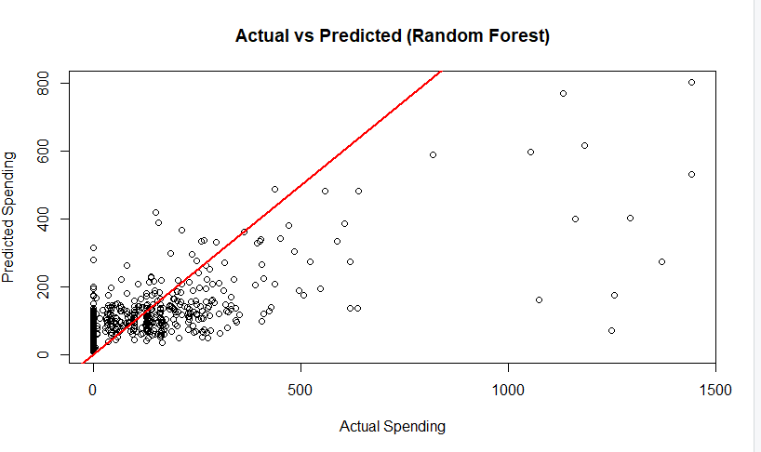
Stepwise Regression
To model the customer spending behavior, Stepwise Regression model was used, which operates based on automated variable selection that stands to remove the statistically significant predictors. This model attained a R 2 of 0.5393 which implies that the percentage of the variation in spending that is explained by the features chosen is approximately 53.93 which is slightly better as compared to the standard linear regression model. The value of RMSE (130.82) indicates the moderate prediction error, which indicates that the model is quite accurate in predicting customer spending without lacking simplicity and interpretability. The outcome indicates that the elimination of irrelevant or redundant predictors can increase the efficiency of the model without affecting the power of the model to explain.
The scatter diagram of the actual and predicted spending reveals that the relationship is positive linear with most of the points concentrated in the low range of spending and are inclined with the overall direction of the red regression line. The fact that the actual and predicted values are relatively close with most of the customers suggests that the data is concentrated around the model. Despite the obvious dispersion between higher spending outliers, the general trend is that the stepwise model was able to include the most significant predictors in the least possible overfitting. The increase in the stability of prediction particularly in the middle level of spending supports the practical reliability of the model in business prediction.
Strategically, the Stepwise Regression will offer North-Point Software a very simple to interpret and fast model that only identifies the important variables affecting customer spending, probably among them are the frequency of transactions, web order history, and recency of record updates. This simplified model will allow marketers to concentrate on the most effective drivers of revenue without wasting on the complexity. Its accuracy and simplicity balance make it the best to communicate insight to the management and incorporate predictive results in its operational decisions. Overall, it can be concluded that the Stepwise Regression model is a useful tool to identify the patterns of customer spending and make relevant future marketing investments due to its high performance and interpretability level.
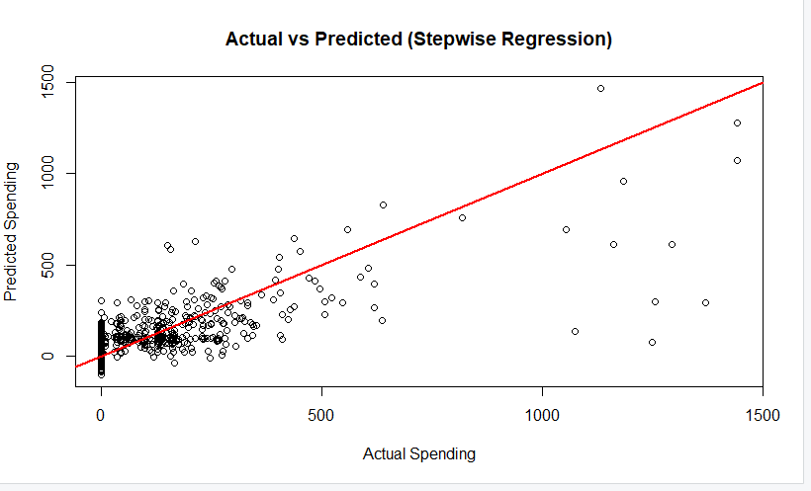
Comparison of Algorithms
All three classification algorithms Decision Tree, Logistic Regression, and the Random Forest, had good performance in indicating the likelihood to make a purchase, though with different levels of accuracy, interpretability, and strength. Decision Tree achieved accuracy of 78.6 percent with great interpretability and definite rules of decision-making like the prevalence of frequency and web order history to define the purchase outcomes. The Logistic Regression model was used next with a very close accuracy of 79 as it offers useful statistical analysis on the effects that each factor has on the possibility of purchasing a product. In the meantime, the best overall performance was that of the Random Forest model, which was accurate in 81.7% and Kappa, with a value of 0.63, indicating that it possesses the highest predictive capability and could deal with the intricate predictor-predictor interactions.
Once we picked our best model, the predicted purchase probabilities needed crucial adjustment. We re-calibrate them against the pilot's true 5.3% base rate. We did this purely to ensure our final sales forecasts were accurate for the business. This adjustment didn't actually change how well the model ranked the customers.
The three methods, Multiple Linear Regression, Random Forest Regression, and Stepwise Regression worked similarly in regression modeling with the R2 values fluctuating between 0.53 and 0.54. The Multiple Linear Regression model offered a reference point with a medium predictive ability and interpretability and can be handy to detect linear correlations between spending and customer characteristics. Random Forest Regression estimated nonlinear interactions but with a bit higher error (RMSE = 140.50), indicating its vulnerability to the outliers and zero-spending customers. The Stepwise Regression model was found to be the best overall balance with the highest R2 of 0.5393 and lowest RMSE of 130.82 and displayed that automated variable selection was found to enhance predictive efficiency and simplicity of the model.
All in all, the Random Forest algorithm has shown itself to be the most competitive in classification with its better accuracy and generalization aptitude and Stepwise Regression, the most efficient of the two models in spending prediction because of its simplicity and interpretability. The Decision Tree is still useful in visual and managerial interpretation, and the Logistic Regression is a good compromise in terms of interpretability and performance. Combined, these models offer a full analytical system to the North-Point Software, such as classification models to find potential buyers and regression models to predict the possible expenditure to allow the company to target their products and best allocate their resources and optimize marketing investment.

Conclusion
North-Point Software Mailing Analytics project was an example of the successful implementation of the predictive analytics and machine learning to evolve existing marketing campaigns into high-impact strategies based on data. By applying a compromise of both classification and regression modeling, the analysis determined the important behavioral and transactional predictors including purchase frequency, recency of updates, and web order history that have a strong predictive significance on the probability to purchase and the amount of purchase. Such insights not only contribute to better knowledge of customer behavior but also can give the basis of maximizing the mailing decisions, costs reduction, and efficiency of the campaigns. The created models provide a holistic understanding of the customer engagement and fill the disjunction between explanatory knowledge and business action plans.
Assessment of the classification models indicated that all three methods including Decision Tree, Logistic Regression as well as Random Forest worked well, with the latter having the best accuracy and reliability. The Random Forest model is the optimal tool for ranking prospects based on purchase propensity. This prompts the importance of ensemble techniques in the analysis of complex data and in the detection of concealed patterns that may be missed by individual-model techniques. To ensure our financial forecasts were accurate, we performed a final crucial step the predicted purchase probabilities were re-adjusted (re-calibrated) to match the pilot campaign's true 5.3% base response rate. This adjustment is necessary because it ensures that all probability-based business estimates such as the expected number of buyers or the expected revenue are realistic when we apply them to the full mailing population. While this step doesn't change the model's overall ranking accuracy, it provides a reliable financial foundation for integrating the classification and regression results into a single, trustworthy value framework.
Equally, regression models served to reveal how the purchasers spend their money, and Stepwise Regression is the most convenient and accurate. The fact that the results of the consistent R 2 of models confirm customer spending behavior is predictable with a reasonable degree of certainty when using both transactional and behavioral data, although with some fluctuation.
Essentially, the project demonstrates that North-Point Software can use analytics to better its marketing decision and customer targeting. The results indicate that data-driven segmentation and predictive modeling can be used to greatly enhance the outcomes of mailing because of targeting the high-probability and high-value customers. These models can be applied in future campaigns to enable the company to use the resources more effectively, obtain higher response rates and maximize profitability. All in all, this project will provide a powerful analytical background of the continuing predicate marketing endeavors, as part of the long-term objective of North-Point Software to reach sustainable growth by means of smart customer understanding and informed decision-making with the help of data.

Recommendations
According to the results of this analysis, North-Point Software must implement a customer targeting strategy, which is based on data when performing the mailing campaign in future. The models also make it clear that the purchase frequency, recent engagement, and web order history are the most influential predictors of purchase behavior. Thus, the company must give priority to customers with a record of high frequency transactions or added records saying that they are more likely to favorably aid in response to mailings. These can be combined as Expected Value calculated as Calibrated Probability times Predicted Spending to create the ultimate ranking for customer selection. Targeting only the top 10–30% of customers by Expected Value is projected to maximize the financial return on the mailing cost. During deployment, each customer record will receive both a calibrated probability of purchase and a predicted spending amount. The recalibration step is essential as it aligns the model’s probabilities with the real-world response rate, preventing the overestimation of buyers.
Furthermore, the direction of marketing must be improved to feature the individualized offers and the product recommendations to such high-engagement customers, which may also lead to high rates of conversion, and will save the money that is wasted on mailing.
North-Point must also consider incorporating progressive modelling and real-time data into the marketing analytics to enhance the predictive accuracy of the analytics. Although the Random Forest model was quite effective when it came to classification and Stepwise Regression was the most successful in terms of spending prediction, they can be improved by retraining them regularly with new campaign data. By adding more attributes of customers, like the metrics of digital engagement, product preferences, and speed of response, it is possible to make the dataset more rich and do even more accurate targeting. Cross-validation and ensemble techniques are also worth pursued by the firm to provide strong performance and protect overfitting in the subsequent model deployments.
Lastly, North-Point Software ought to use the experiences of clustering and predictive models to create differentiated marketing strategies to various groups of customers. Reward programs and exclusive offers should be used to retain high-value and loyal customers (according to Cluster 3) to retain them, whereas moderate-frequency customers can be offered re-engagement offers. Potentially inactive or low frequency customers could need an awareness campaign or lower levels of pilot mailing in order to gauge their responsiveness. North-Point can not only enhance the performance of sales in the short-term, but also in the long-term customer relationship, brand loyalty, and the overall positive payoff of the marketing investment by aligning the marketing activities with the data-driven information.

