Dashboard Additions
- Layby Overview
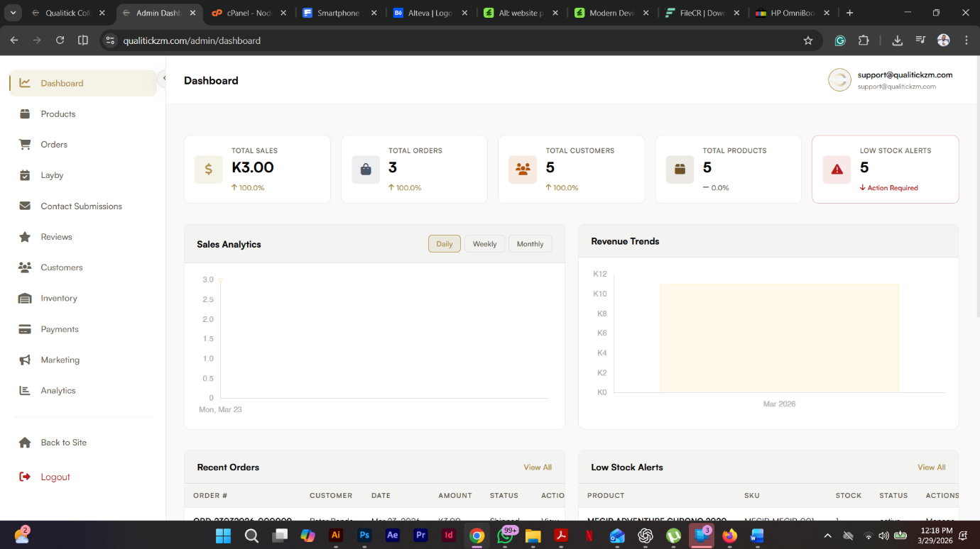
OUTSTANDING PAYMENTS
K1,999
2
OVERDUE
2
COMPLETED
ACTIVE LAYBY ORDERS
3

Over due layby, possibly have email/automation for reminders to clients.

