DATA ANALYTICS PROJECT REPORT
Budget vs Actual
Expense Analysis
From raw Kaggle data to an interactive Power BI dashboard — sourcing, cleaning in Google Colab, modeling in Power Query, and visual storytelling.
Kaggle Dataset • Google Colab (Python) • Power Query • Power BI
PREPARED BY
Sonupal Veeradasari (Mazino) • Pavan Kumar
MBA – Business Analytics, Lovely Professional University
August 2026

Table of Contents
1. Introduction & Project Objectives
2. About the Dataset
3. Data Cleaning & Preparation (Google Colab)
4. Data Modeling in Power BI (Power Query & DAX)
5. Dashboard Design
6. Results – KPI Overview & Dashboard View
7. Results – Department & Category Analysis
8. Results – Regional & Payment Channel Analysis
9. Key Insights & Recommendations
10. Conclusion, Tools Used & References
Executive Summary
This report documents an end-to-end data analytics project that traces a departmental expense dataset from its raw, Kaggle-sourced form through cleaning in Python (Google Colab), modeling in Power Query, and final visualization in an interactive Power BI dashboard. The analysis covers 10,002 cleaned transactions spanning three years (2021–2023) across six departments, six expense categories, five regions, and four payment methods.
The headline finding is that actual expenditure exceeded budget across every department, region, category, and payment channel, with total actual spend of ₹890M against a budget of ₹796M — an overspend of ₹95M, or approximately 11.9%. Marketing and HR are the largest contributors to this gap, together accounting for roughly ₹38M of the total variance, while Finance is the most disciplined department. The report closes with practical, data-backed recommendations for tightening budget-setting and monitoring.

1. Introduction & Project Objectives
Organizations routinely set departmental budgets at the start of a financial cycle, but actual spending frequently drifts from these plans. Without a systematic way to track and visualize the gap between planned and actual expenditure, finance teams struggle to identify where overspend is occurring and why. This project was undertaken to address that gap by building a complete analytics pipeline — from raw data to an interactive dashboard — that makes budget variance visible, explorable, and actionable.

Objectives
- Source and understand a real-world, transaction-level budget vs. actual expense dataset.
- Clean and prepare the dataset using Python (pandas) in Google Colab, ensuring data quality before analysis.
- Model the cleaned data in Power BI using Power Query and DAX to calculate variance metrics.
- Design an interactive Power BI dashboard with KPI cards, charts, and slicers for department- and region-level exploration.
- Derive actionable insights and recommendations from the visualized data to support budget-planning decisions.

Scope
The analysis is limited to the fields available in the source dataset — transaction date, department, expense category, region, budget amount, actual amount, payment method, and transaction ID. It does not incorporate external factors such as inflation, headcount changes, or macroeconomic conditions that may explain the observed variances; these are noted as directions for further investigation in the recommendations section.

2. About the Dataset
The source dataset was obtained from Kaggle as a transaction-level financial record covering three years of departmental spending. It was supplied as an Excel file and uploaded to Google Colab for cleaning before being loaded into Power BI.

Dataset Profile
Attribute | Detail
Source | Kaggle — Budget vs Actual Expense dataset
Original format | Excel (.xlsx)
Raw transaction rows | 10,010
Cleaned transaction rows | 10,002
Data columns | 8
Time period covered | 2021 – 2023 (3 years)
Departments | 6 (HR, Sales, Finance, Operations, Marketing, IT)
Expense categories | 6 (Travel, Utilities, Training, Marketing, Infrastructure, Salaries)
Regions | 5 (Central, East, North, South, West)
Payment methods | 4 (Card, UPI, Bank Transfer, Cash)

Column Descriptions
Column | Description
Date | Transaction date (2021–2023)
Department | HR, Sales, Finance, Operations, Marketing, IT
Category | Travel, Utilities, Training, Marketing, Infrastructure, Salaries
Region | Central, East, North, South, West
Budget Amount | Planned spend for the transaction
Actual Amount | Actual spend recorded for the transaction
Payment Method | Card, UPI, Bank Transfer, Cash
Transaction ID | Unique record identifier

3. Data Cleaning & Preparation (Google Colab)
Before the dataset could be modeled in Power BI, it was inspected and cleaned in Google Colab using Python's pandas and NumPy libraries. The notebook (Cleaning.ipynb) followed a structured, five-step wrangling process.

Cleaning Workflow
- Load & Inspect — Read the Kaggle Excel file into a pandas DataFrame and reviewed df.head(), df.info(), and df.describe() to understand structure, data types, and summary statistics.
- Check for Nulls — Ran df.isnull().sum() and found a small number of missing values: 1 in Department, 1 in Category, 3 in Region, and 3 in Transaction ID.
- Remove Duplicates — Applied df.drop_duplicates() to ensure every transaction row was unique.
- Drop Missing Rows — Used df.dropna() to remove incomplete rows, leaving a fully populated dataset with no null values.
- Export Cleaned File — Saved the result as cleaned_budget_vs_actual_data.xlsx, ready for import into Power BI.

Data Quality Outcome
10,010  Raw Rows | 10,002  Cleaned Rows | 8  Rows Removed | 0.08%  Data Loss

Only 8 of the original 10,010 rows (0.08%) were removed due to missing values or duplication, indicating the source dataset was already of high quality. This minimal data loss means the cleaned dataset remains highly representative of the original three-year record.

4. Data Modeling in Power BI (Power Query & DAX)
With a clean dataset in hand, the next stage was to load and shape the data inside Power BI Desktop so it was ready for visualization.

Modeling Steps
- Import — Loaded cleaned_budget_vs_actual_data.xlsx into Power BI Desktop via Get Data.
- Assign Data Types — In Power Query Editor, set Date to Date/Time, Budget Amount and Actual Amount to whole numbers, and all remaining fields to Text.
- Create Measures — Built DAX measures to quantify budget performance at any level of aggregation.
- Load to Model — Applied the query and loaded the shaped table into the report's data model, ready for visuals and slicers.

Key DAX Measures
Measure | Logic | Purpose
Total Variance | Actual Amount − Budget Amount | Quantifies absolute overspend/underspend
Variance % | (Actual − Budget) / Budget | Expresses variance as a proportion of budget

5. Dashboard Design
The dashboard was designed to move a reader from a high-level summary to department- and region-level detail within a single screen, using KPI cards for headline numbers, charts for comparison, and slicers for interactive filtering.

Visual Elements
Visual | Type | Purpose
Total Budget / Actual / Variance / Variance % | KPI Cards | Headline performance at a glance
Budget vs Actual by Department | Clustered column | Surfaces which departments exceed budget
Budget vs Actual by Category | Clustered bar | Flags spending categories with the biggest gaps
Budget vs Actual Trend | Line chart | Tracks planned vs. spent value by region over time
Budget vs Actual by Region | Clustered column | Highlights regions with higher overspend
Actual Expense by Payment Method | Donut chart | Shows the spend split across payment channels
Overspending by Department | Sorted bar chart | Ranks departments by variance, descending

Slicers for Region and Department were added so that every visual on the page responds interactively to a user's selection, allowing a viewer to drill from the organization-wide picture down to a single department or region without leaving the page.

6. Results – KPI Overview & Dashboard View
Actual spending outpaced budget across every department, region, and category tracked in the dataset. The headline KPIs from the dashboard are summarized below.
₹796M  Total Budget | ₹890M  Total Actual Expense | ₹95M  Total Variance | +11.9%  Variance %

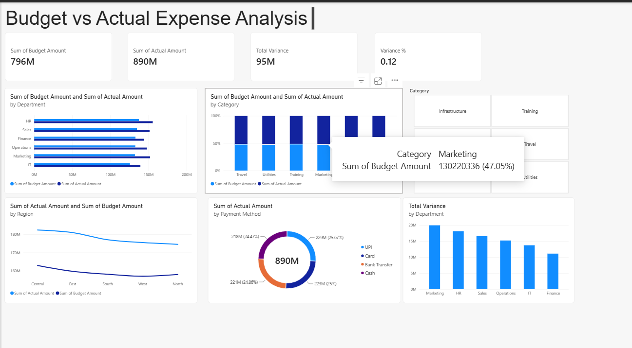
Figure 1: Budget vs Actual Expense Analysis — Power BI Dashboard
The dashboard confirms that the overspend pattern is systemic rather than isolated: every bar in the department, category, and region visuals shows actual spend (dark blue) exceeding budget (light blue), and the payment-method donut shows an even split across the four channels, indicating the pattern is not driven by any single payment channel.

7. Results – Department & Category Analysis

Budget vs Actual by Department
Department | Budget (₹) | Actual (₹) | Variance (₹) | Variance %
Marketing | 132,160,077 | 152,136,504 | 19,976,427 | 15.1%
HR | 137,431,733 | 155,552,618 | 18,120,885 | 13.2%
Sales | 134,827,509 | 151,443,488 | 16,615,979 | 12.3%
Operations | 132,642,724 | 147,869,274 | 15,226,550 | 11.5%
IT | 125,656,313 | 139,383,236 | 13,726,923 | 10.9%
Finance | 132,902,724 | 144,023,189 | 11,120,465 | 8.4%

Sorted by variance, Marketing and HR carry the largest absolute overspend — each roughly ₹18–20M above budget — while Finance is the most disciplined department, with the smallest variance of the six. Ranking departments this way turns a routine bar chart into a prioritized action list for finance teams.

Budget vs Actual by Category
Category | Budget (₹) | Actual (₹) | Variance (₹)
Salaries | 127,069,907 | 147,564,363 | 20,494,456
Utilities | 137,955,359 | 155,336,393 | 17,381,034
Marketing | 130,220,336 | 146,566,862 | 16,346,526
Travel | 140,096,770 | 155,119,656 | 15,022,886
Infrastructure | 127,892,175 | 140,903,653 | 13,011,478
Training | 132,386,533 | 144,917,382 | 12,530,849

Salaries shows the largest absolute variance of any category, followed closely by Utilities and Marketing spend. Travel and Utilities also stand out as categories that run consistently hot relative to their planned budgets.

8. Results – Regional & Payment Channel Analysis

Budget vs Actual by Region
Region | Budget (₹) | Actual (₹) | Variance (₹)
East | 159,693,097 | 180,953,620 | 21,260,523
Central | 162,879,057 | 182,386,711 | 19,507,654
South | 158,086,473 | 177,024,460 | 18,937,987
West | 157,004,504 | 175,505,843 | 18,501,339
North | 157,957,949 | 174,537,675 | 16,579,726

Overspend is broadly consistent across all five regions, with East showing the highest absolute variance and North the lowest. The narrow spread between regions (roughly ₹16.6M to ₹21.3M) suggests the overspend pattern is an organization-wide phenomenon rather than a regional anomaly.

Actual Expense by Payment Method
Payment Method | Actual Amount (₹) | Share of Total
UPI | 228,604,161 | 25.7%
Card | 222,575,503 | 25.0%
Bank Transfer | 221,334,885 | 24.9%
Cash | 217,893,760 | 24.5%

Each of the four payment channels accounts for a share within roughly one percentage point of an even 25%, indicating a balanced payment mix with no channel-specific concentration of risk.

9. Key Insights & Recommendations

Key Insights
- Overspend is broad-based — every department, region, category, and payment method spent above budget, indicating a systemic pattern rather than a single outlier.
- Marketing and HR lead the gap — together they account for roughly ₹38M of the ₹95M total variance and should be reviewed first.
- Payment mix is balanced — UPI, Card, Bank Transfer, and Cash are each within about one percentage point of a 25% share, so there is no channel-specific risk.
- Travel and Utilities run hottest — among the six expense categories, these show the largest budget-to-actual gaps.
- Finance is the benchmark department — its variance of 8.4% is the lowest of the six, and its processes may offer a model for other departments.

Recommended Next Steps
- Tighten budget-setting for Marketing and HR using 2021–2023 actuals as a baseline, rather than relying on last year's budget figure alone.
- Add monthly variance alerts in Power BI so overspend is caught mid-quarter rather than at year-end.
- Investigate Travel and Utilities contracts and vendors for renegotiation opportunities.
- Extend the model with external drivers (e.g. inflation, headcount, seasonality) to explain regional and category-level variance more precisely.
- Share the Finance department's budgeting approach as an internal best-practice reference for other departments.

10. Conclusion, Tools Used & References

Conclusion
This project demonstrates a complete, reproducible analytics workflow — from a raw Kaggle dataset, through Python-based cleaning in Google Colab, to a modeled and visualized Power BI dashboard. The resulting analysis shows that actual departmental expenditure exceeded budget by ₹95M (11.9%) over the 2021–2023 period, with the gap distributed broadly across departments, regions, categories, and payment methods rather than concentrated in one area. Marketing and HR emerge as the two departments requiring the closest budget review, while Finance offers a useful internal benchmark for disciplined spending. The interactive dashboard — with its Region and Department slicers — gives stakeholders a self-serve way to explore these patterns down to the transaction level, turning a static budget report into a living decision-support tool.

Tools & Technologies Used
Stage | Tool / Technology
Data sourcing | Kaggle
Data cleaning | Python (pandas, NumPy) in Google Colab
Data modeling | Power Query, DAX (Power BI Desktop)
Visualization | Power BI Desktop
Documentation | Cleaning.ipynb notebook, PowerPoint presentation

Project Artifacts
- Cleaning.ipynb — Google Colab notebook documenting the data-cleaning workflow.
- cleaned_budget_vs_actual_data.xlsx — the cleaned dataset used as the Power BI data source.
- Budget_vs_Actual_Expense_Analysis.pptx — presentation summarizing the project workflow and results.
- Live Power BI dashboard — interactive report with KPI cards, six core visuals, and Region/Department slicers.

References
- Kaggle — Budget vs Actual Expense dataset (source data).
- Microsoft Power BI documentation — Power Query and DAX reference materials.
- Python pandas documentation — data-cleaning functions (drop_duplicates, dropna, isnull).

