[1]

A Study of the Job Satisfaction level of Vicenarians and Tricenarians in Sri Lanka

M.K.I.Wickramasinghe, *229405N*

*Abstract*—Having some kind of an income generation is essential for everybody but, how happy and satisfied we are with that is directly affect our life and indirectly for everyone we are associating. In this study I have tried to estimate how happy and satisfied the people of age group 20-40 years (Vicenarians: 20-30 years and Tricenarians: 30-40 years) in Sri Lanka with their jobs. I choose this age group because they represent the larger percentage of the workforce.

*Index Terms*-- Hypothesis testing, JAWS Parameter, Job-related Affective Well-being Scale, Population, Sample.

# Introduction

I

n this paper I am trying to estimate the happiness and satisfaction level people in the age of 20-40 years in Sri Lanka with what they engaged in as a job. Since the parameter of interest is a qualitative measure, we have to find some indirect quantitative method to estimate it. This paper discusses the procedure I have taken to estimate it.

# Methodology

The target population of interested is the 20-40 year people in Sri Lanka and the population parameter of interest is the happiness and satisfaction level of them with their jobs.

To find-out a population parameter, the statistical approach is to estimate that through a sample of the population which known as Statistical Inference. Several factors affect in order for the estimate to be closer to the actual population parameter. The study should make sure the following things in order to conduct an unbiased study.

* Sample should be large enough.
* Sample should be an unbiased sample
* 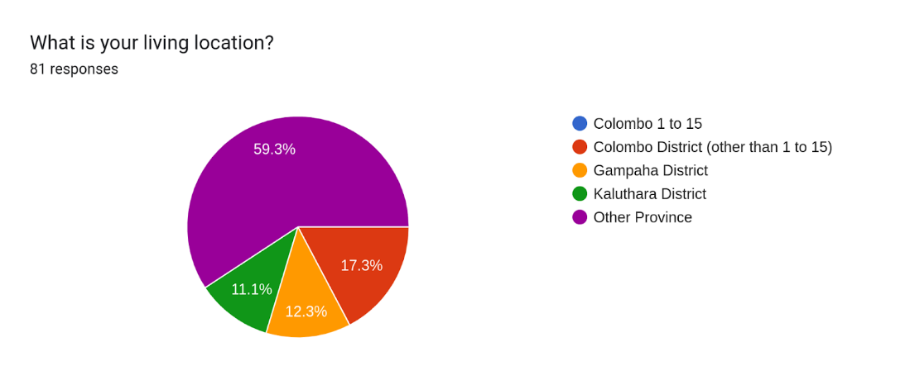Avoid other means of biases occur during statistical inference process.

Figure ‑: Living Location Distribution

## Sample Selection

The sample for the study was a subset of randomly selected friends, friends of friends, relatives, neighbors, villages, colleagues and co-workers of mine. The sample size was 80.

## Data Collection

The data collection method was through a questionnaire. The sample was raised a questionnaire to collect the necessary information regarding the sample demographics and the measures needed to estimate the parameter of interest. The questionnaire, collected data and other resources relevant to the study can be seen from [1].

## Demographic Information of the Sample

Following some demographic information about the sample.

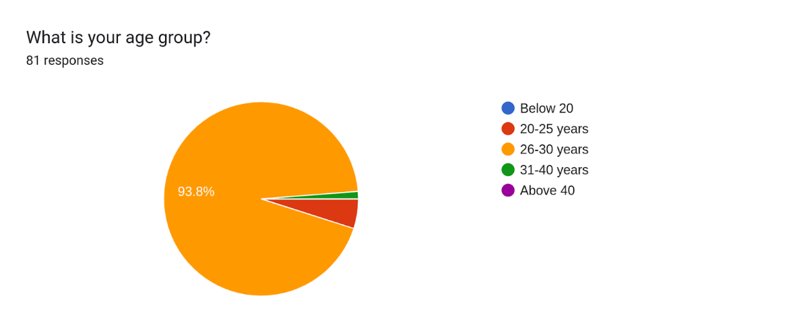

Figure ‑: Age Distribution

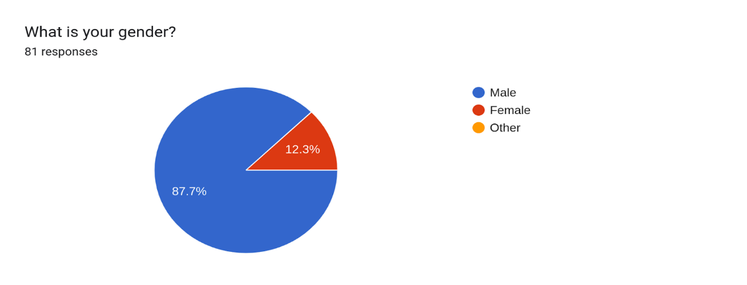

Figure ‑: Gender Distribution

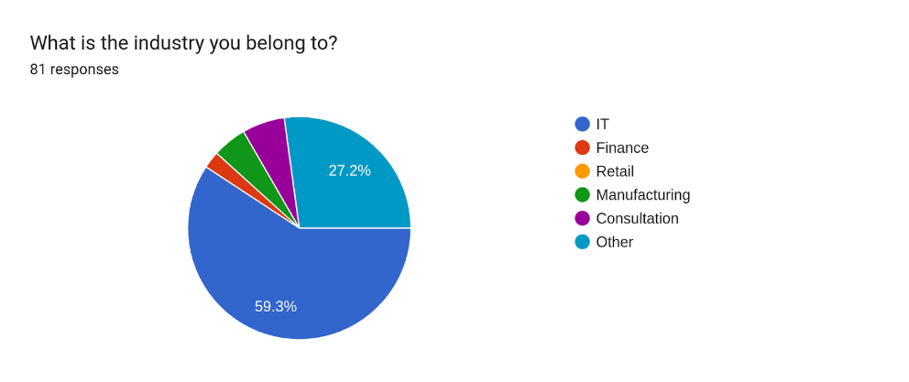

Figure ‑: Industry Distribution

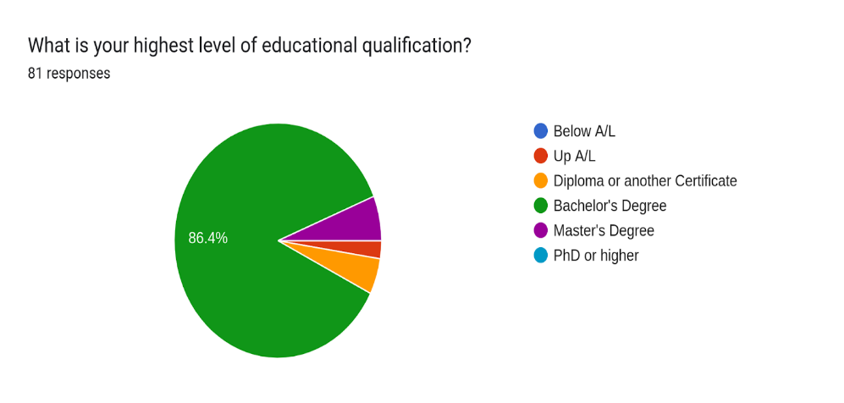

Figure ‑: Education Level Distribution

## Indicator Formation

The Job-related Affective Well-being Scale (JAWS) questionnaire was used to collect job related impressions of the sample. There are 20 questions and 10 of them are related with positive impressions and other 10 are related with negative impressions.

The responses for each question are belong to one of the responses of Never, Rarely, Sometimes, Quite often and Extremely often. Therefore, those responses can be considered as categorical-ordinal data. The responses were mapped as follows.

* Never – (-2)
* Rarely – (-1)
* Sometimes – 0
* Quite often – (+1)
* Extremely often – (+2)

Then, for the average score for all the positive impression questions and negative impression questions were separately calculated. Then the difference between the average score for positive impressions and average score for the negative impressions was used as the numeric representation for the job satisfaction level and it was named as the jaws-parameter.

$$jaws parameter \left(jp\right)=s_{pos}-s_{neg}$$

Where,

$s_{pos}-Average score for positive impression questions$

$s_{neg}-Average score for negative impression questions$

The *jaws -parameter* can be defined as the mean score of the JAWS questionnaire.

## Hypothesis testing

The following hypothesizes were defines as the null (H0) and the alternative (Ha) hypothesis.

* H0: Age 20-40 years’ people in Sri Lanka are not doing their jobs happily.
* Ha: Age 20-40 years’ people in Sri Lanka are not doing their jobs happily.

H0 was defined as above because Sri Lanka reside in the 127th place of the world happiness index [2].

Following are the calculated sample parameters.

* Average jp (**statistic**): 1.2075
* Std. jp (**s**): 1.0510
* Sample size (**n**): 80
* Standard Error (**SE**) = $\frac{s}{\sqrt{n}}= \frac{1.0510}{\sqrt{80}}=0.1175$
* Null parameter: 0

Since the sample size is considerably large (>30 [3]), we can assume the sampling distribution to be normal.

* z-score= $\frac{statistic-null}{SE}= \frac{1.2075}{0.1175}=10.2766$

Depending on the hypothesizes, this is a right-tailed test. Therefore,

* p-value = 4.4922x10-25 ~ 0

Therefore, the p-value provides strong evidence that we can reject the null hypothesis and accept the alternative hypothesis. We can conclude that the employed 20-40 years’ people in Sri Lanka are happy and satisfied with their jobs.

# discussion

A sampling bias could be there with the sample due to ~60% of the sample belongs to the IT industry and only ~40% are from the other industries, but when it comes to the final p-value of the test it was extremely small and almost zero. Therefore, we can compromise that industry bias from that smaller p-value. On the other hand, the majority of the sample is having a education level of bachelor’s or a higher level of education. Therefore, we could have adjusted the final conclusion as, “*the 20-40 years’ educated employed people in Sri Lanka are happy and satisfied with their jobs*”.

# References

1. Kasun-Imesha, ‘Kasun-Imesha/Jaws: Jaws Analysis in Sri lankan’, GitHub. .
2. J. F. Helliwell, R. Layard, J. D. Sachs, J.-E. D. Neve, L. B. Aknin, και S. Wang, ‘World happiness report 2022’, The World Happiness Report. 2022.
3. A. Ganti, ‘What is the Central Limit Theorem (CLT)?’, Investopedia. Investopedia, 2022.

1.