Kasun Abaywardana
NodeJS API Asessment

Fullstack Software Engineer - Web and GenAI - Tech Lead

1. Project Stack
Layer | Technology | Purpose
Runtime | Node.js 20 + TypeScript | Type compatibility
Framework | NestJS 11 | Node JS Express Based Framework
ORM | Prisma 6 | Type-safe DB access & schema management
Database | MySQL 8.0 | Relational persistence
Validation | class-validator + class-transformer | DTO validation with decorators
API Docs | Swagger / OpenAPI 3 (@nestjs/swagger) | Interactive API documentation
Logging | nestjs-pino + pino-http | Structured JSON observability
Testing | Jest + @nestjs/testing | Unit testing (backend)
Containerise | Docker Compose | Local MySQL 8 + Adminer UI
Frontend | Next.js 16 + React 19 + Tailwind CSS | Admin UI
Deploy (BE) | Railway | PaaS — auto deploy from GitHub
Deploy (FE) | Vercel | Next.js hosting

2. Project Structure
The monorepo contains two independently deployable applications under
backend/ and frontend/ with shared root-level npm scripts for concurrent local development.

Backend follows a strict layered architecture inside src/:
- Controller → validates HTTP input, delegates to service, shapes response
- Service → all business logic, cross-entity validation, throws NestJS HTTP exceptions
- Repository → all Prisma ORM queries
- Module → NestJS DI wiring per feature (registrations, students, teachers)
- Common → global exception filter, shared DTOs, error response shape

Key modules:
- registrations — register, common-students, suspend, retrieve-for-notifications
- students — upsert, suspend, paginated list with teachers(Additional API For FE)
- teachers — upsert, findByEmail
- prisma — singleton PrismaService (OnModuleInit / OnModuleDestroy lifecycle)
- health — GET /health liveness probe (For Railway Deployment)

3. Database & Migration Strategy

Schema
Three tables with cascade-delete foreign keys:
Table | Key Columns | Notes
teachers | id (PK), email UNIQUE | Auto-incremented PK, unique email index
students | id (PK), email UNIQUE, isSuspended BOOL | Suspension flag, unique email index
teacher_students | teacherId + studentId (composite PK) | Junction table — CASCADE on both FKs

Migration Strategy
- prisma/schema.prisma defines models declaratively; Prisma generates both the SQL migration and the TypeScript client
- Migrations live in prisma/migrations/ and are committed to version control
- Local dev: npx prisma migrate dev — applies pending migrations and regenerates the client
- Production: npm run deploy runs prisma migrate deploy then starts the server — fully automated via Railway deploy hook
- Docker Compose provides a local MySQL 8 instance with a health-check gate so the backend only starts after the DB is ready

4. API Endpoints & Swagger Documentation
All endpoints are documented with @nestjs/swagger decorators — request bodies, query params, and all possible response shapes (200 / 204 / 400 / 404) are described inline in the code. The Swagger UI is auto-generated at /api/docs.

Method | Path | Description | Response
POST | /api/register | Register students to a teacher (upsert) | 204 No Content
GET | /api/commonstudents | Students common to all queried teachers | 200 { students[] }
POST | /api/suspend | Suspend a student by email | 204 No Content
POST | /api/retrievefornotifications | Recipients: registered + @mentioned students | 200 { recipients[] }
GET | /api/students | Paginated list of all students with teachers | 200 paginated DTO
GET | /health | Liveness probe | 200 { status: ok }

Live Swagger UI:
https://admin-school-assignment-production.up.railway.app/api/docs

5. Deployment Architecture
The application is deployed as two fully managed, independently scalable services:
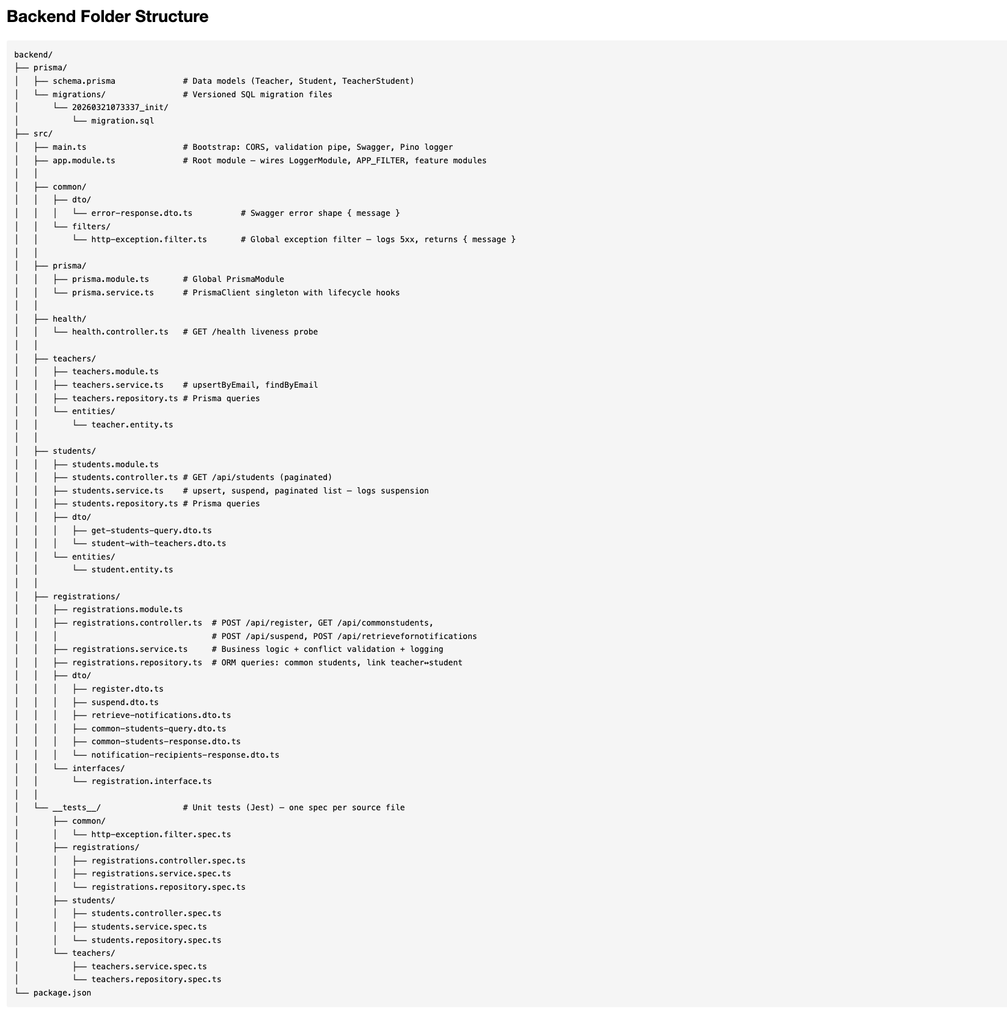

Backend → Railway
- Railway detects the backend/ subdirectory as the service root via railway.json
- Build step: nest build && prisma generate — compiles TypeScript and generates the Prisma client
- Start step: prisma migrate deploy && node dist/main — runs pending DB migrations then boots the server
- Railway provisions a managed MySQL 8 database plugin and injects DATABASE_URL automatically
- PORT is also auto-injected; ALLOWED_ORIGINS is set to the Vercel frontend URL for CORS
- Zero-downtime deploys on every push to main via GitHub integration

Frontend → Vercel
- Vercel imports the repository and uses frontend/ as the root directory
- BACKEND_URL env variable points to the Railway API URL; Next.js server-side API routes proxy requests to avoid CORS from the browser
- Edge-optimised CDN delivery for static assets; SSR for the admin page

Links
Service | URL
Frontend Live (Vercel) | https://admin-school-assignment.vercel.app
Backend API Live (Railway) | https://admin-school-assignment-production.up.railway.app
Swagger UI Live | https://admin-school-assignment-production.up.railway.app/api/docs

6. Unit Testing
71 tests across 9 test suites — all unit tests, zero external dependencies, no real database required. Every layer (controller → service → repository) is tested in isolation using Jest and @nestjs/testing with full NestJS dependency injection.
Test Considerations:
- PrismaService is mocked at the DI level — tests never touch a real database
- PinoLogger is mocked per-service using getLoggerToken() — logging calls are asserted without side effects
- Each suite calls jest.clearAllMocks() in beforeEach.

7. Observability (Structured Logging)
nestjs-pino (backed by Pino, the fastest Node.js logger) provides structured JSON logging in production and colourised pretty-print in development — zero configuration change required between environments.

What is logged automatically
- Every HTTP request and response: method, URL, status code, response time (pino-http middleware wired into LoggerModule)
- NestJS bootstrap messages (route registration, app start) replace the default NestJS console logger

PinoLogger is injected per-service using `@InjectPinoLogger(ServiceName.name)`, which makes logs request-scoped - every log line from a service call automatically carries the same reqId as the HTTP request log, enabling full request traceability without manual correlation IDs.

8. Other things in Backend
- Global exception filter
- Cross-table email validation
- Upsert-on-register : POST /api/register: teachers and students are upserted, and the teacher_students composite PK prevents duplicate links
- Parameterised ORM queries
- CORS guard : origin whitelist read from ALLOWED_ORIGINS env variable; unknown origins are rejected with a clear error, not silently passed
- Input validation : class-validator decorators on all DTOs with a custom exceptionFactory
- Extra endpoint : GET /api/students returns a paginated list of all students with their registered teachers and suspension status, useful for the admin FE

9. Frontend — React / Next.js Admin UI
A simple but complete single-page admin panel was built with Next.js 16 (App Router) and React 19 to demonstrate end-to-end API integration. The UI is deployed to Vercel and proxies all API calls through Next.js server-side route handlers to avoid CORS issues in the browser.

Components & Features
Component | API Used | What It Does
RegisterSection | POST /api/register | Form with teacher email + dynamic multi-email student input; success/error toast feedback
CommonStudentsSection | GET /api/commonstudents | Multi-teacher email input; displays intersection of registered students
NotificationsSection | POST /api/retrievefornotifications | Teacher + notification text input; displays eligible recipients
SuspendModal | POST /api/suspend | Modal dialog triggered from header; suspends a student by email
StudentsTableSection | GET /api/students | Paginated data table showing all students, their teachers, and suspension status

Technical Selections for Frontend
- Next.js App Router with "use client" components for interactive forms
- Tailwind CSS for utility-first responsive styling
- Shared TypeScript interfaces (types/index.ts) mirror the backend DTO shapes for type safety across the boundary
- Reusable UI primitives: Loader, Toast, Modal, EmailListInput shared across feature sections
- All API calls go through /app/api/* Next.js route handlers (server-side) — backend URL is never exposed to the browser

