**Designs and wireframes**

I have done wireframes and few designs for the website using **Figma** software and I have included the link for the Figma file [here](https://www.figma.com/file/ynn3ltof8Wxn0zg1RM5qt7/Kasun-Hewage---wireframes-%2B-designs?node-id=0%3A1). If necessary, it can be found in the report folder as well.

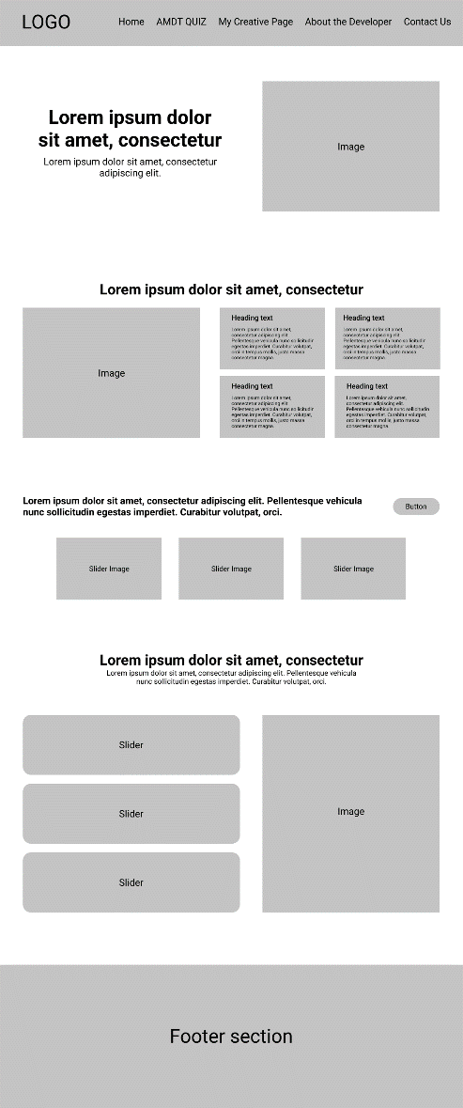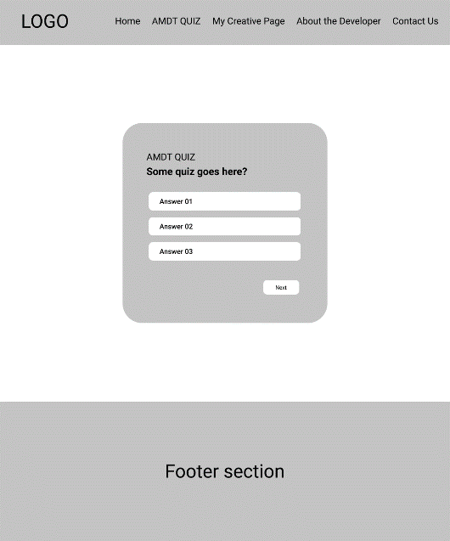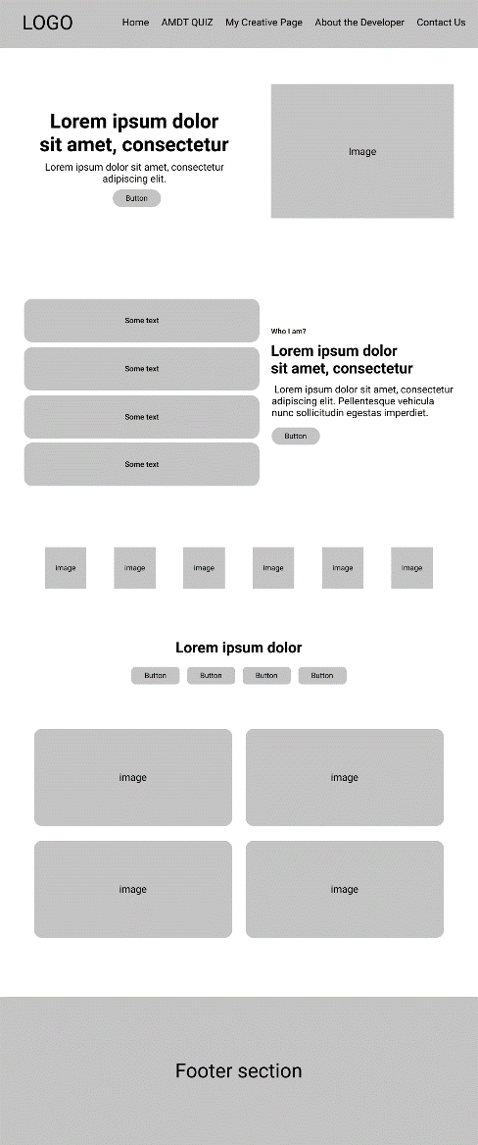

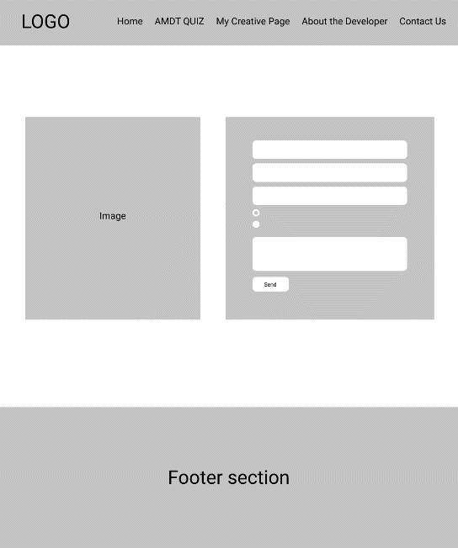

**Justifications to explain my code contribution**

I have built the website completely from the scratch with HTML / CSS / JS on my own.

**Navigation and Footer section –** These two parts have been created as reusable components since it has to be used for every single page. So that no need to create new navigation bar and footer for each page. Instead, I can link those components to each page. (Can be found in the Components folder)

**Navigation bar –** When the page is being scrolled down the navigation bar also being scrolled with the page. But I have set the navigation bar to be appeared when the page reaches a particular point while scrolling. Also, it disappears when scrolling to the top at the same particular point. In order to make it happen I’m using JavaScript to add and remove particular CSS classes from the HTML tag.

*// scrolling behavior of navbar*

document.addEventListener("scroll", () => {

  if (window.scrollY > 500) {

    navigation.classList.add("navOnScroll", "container");

  } else if (window.scrollY < 500) {

    navigation.classList.remove("navOnScroll", "container");

  }

});

**AMDT QUIZ**

All the questions have been saved in to an array as objects. Each object contains **Question, Answers, ID, Correct answer**.

*const* questions = [

  {

    id: 01,

    question: "Creativity starts in?",

    answers: {

      a: "AMDT",

      b: "Somewhere else",

      c: "I don't know",

    },

    correctAnswer: "AMDT",

  },

User is not allowed to procced to the next question without selecting an answer for the current question. If not answers it’s showing an error like this.

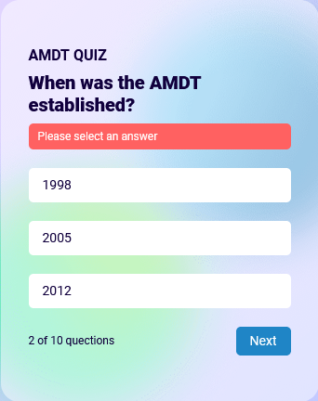

Here is the code snippet of checking whether answered or not

*//check whether answred*

  if (!isAnswered) {

    warn.classList.add("warn-message");

    return;

  }

**About the developer –** Completely made responsive with **CSS Media queries** except the footer and the navigation bar since those two are pre created reusable parts.

Some animations have been done for the header sections.

*/* animations */*

@keyframes *circle* {

  0% {

    scale: 100%;

  }

  25% {

    scale: 110%;

  }

  50% {

    scale: 100%;

  }

  75% {

    scale: 110%;

  }

  100% {

    scale: 100%;

  }

}

@keyframes *square* {

  0% {

    transform: rotate(25deg);

  }

  25% {

    transform: rotate(65deg);

  }

  50% {

    transform: rotate(25deg);

  }

  75% {

    transform: rotate(65deg);

  }

  100% {

    transform: rotate(25deg);

  }

}

**Contact us –** Validations for the input fields have been created from the scratch with JavaScript.

*// check input fields*

  Array.from(requiredFields).map((*el*) => {

    if (el.value == "") {

      el.classList.add("red-border");

      throw "Empty fields";

    }

  });

*// check select field*

  if (requiredFields[3].value == "--- Select Your District ---*") {

    requiredFields[3].classList.add("red-border");

    throw "No district provided";

  }

*// validate email*

  if (!requiredFields[1].value.match(emailValidate)) {

    requiredFields[1].classList.add("red-border");

    throw "Invalid email";

  }

*// validate mobile number*

  if (

    requiredFields[2].value.length > 10 ||

    requiredFields[2].value.length < 10

  ) {

    requiredFields[2].classList.add("red-border");

    throw "Invalid phone numver";

  }

**Usability principles which have been used**

1. **Visibility of system status -** The system should always keep users informed about current state and actions through appropriate visual cues and feedback.

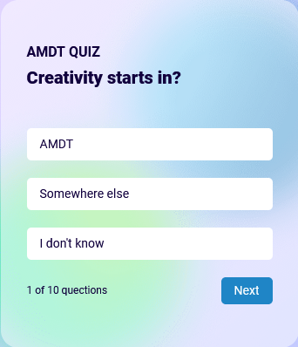In the Quiz page it is indicating the current number of the question.

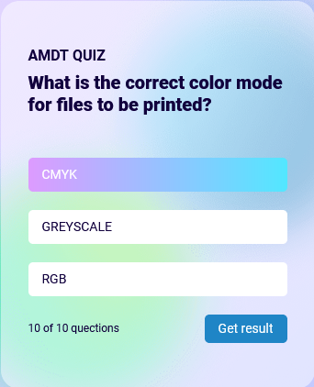Once the final question has been reached it’s indicating the Get result button to let know it’s time to see the result.

And also, if an answer is selected it’s indicating the answer which has been selected

1. **User control and freedom –** User might mistakenly select a wrong answer and might need to re correct it.

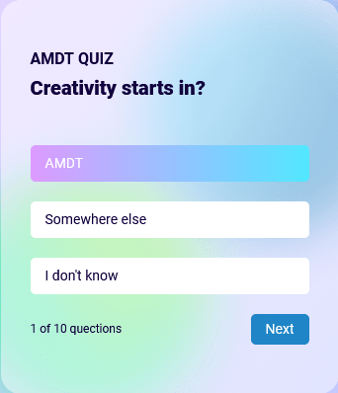If the user thinks given answer is wrong and wants to recorrect it. He / she is completely free to switch between the answers before clicking Next. Currently selected answer will be taken as the submitted answer by the user when clicking next.

**User feedback**

1. Recreating a better UI for the **contact us** page and adding some background animations.
2. Giving an effect to the buttons on hover in the **About the Developer** page
3. Adding few more animated shapes.