

QUIZ APPLICATION-PROJECT REPORT

DEADLINE: 14th of August

national school of business management

SE101.3 Object Oriented Programming with Java

GROUP ASSIGNMENT 16.2

**CONTENT**

* Project Scenario
* Overview of the System

1. Introduction
2. Drawbacks
3. Scope

* Functionalities
* UML diagram
* System Design
* Experience
* Resources
* Group Members

# Assignment Title: Object Oriented Design and Implementation

Submission Deadline: 7th August 2017 (will notify the Viva)

Weighting to final grading: 20%

**Assessment Outcome:**

* Produce high-quality OO solutions to the given problems, documented using UML diagrams
* Produce high-quality, working Java code that adheres to the conventions of good coding style
* Display insight into strengths and weaknesses of the structure and performance, and final product and into personal development practices.

This coursework requires you to use UML and Java/NetBeans to design and implement an object oriented system according to a selected specification (E.g. Student Mgt Sys, Library Mgt Sys, Banking Application, etc.).

1. Implementation: The solution must include both a data model and a graphical user interface (GUI).
2. Report: You also need to evaluate the quality of your final product and your personal practice throughout this assignment. You may discuss how you have practiced OOP and other learnt concepts inside your project.

**INTRODUCTION**

The software**Quiz application**manages the activity of quiz conduction in a school or college or any institution where lecturer can upload multiple choice questions for exam or assignment purpose. The system is user friendly and the user will find it easy to answer the question. Even this is called a quiz application the user as known as student can also learn the subject since lecturer can upload notes for learning purposes.

At first, the student is needed to register his/her name along with all the information needed and need to select username and password for the login process. Using this username and password, the student can login into the **“QUIZ”** software.  Next procedure is answering the quiz. As soon as the student selects the quiz menu strip, the questions with 4 options will be displayed. The student has to type any one option and click on next option. ON this click next set of question and answers will be displayed. This will continue till the end of the question.

The admin has the authority to add or modify any questions or options. The answers of each question will be saved in the database. At the end of quiz marks will be displayed for students.

We used all the OOP Concepts such as Encapsulation, Inheritance, Polymorphism.

We also embedded other concepts such as JDBC, Exception handling, GUI.

**DRAWBACKS**

**SCOPE**

For the purpose of this project, the project will benefit the user to improve there knowledge by learning and measuring is taking mini quizzes.

**FUNCTIONALIES**

Following functionalities will be included in the implemented system.

* Managing student information
* Sign up
* Sign in
* Change password
* Managing admin information
* Sign up
* Sign in
* Change password
* Upload Notes
* Upload Quiz
* Learn Java
* Challenge
* Display quiz mark.

**SIGN IN and SIGN UP**

Student can sign up by creating an account at first. Lecturer can also create their account using the create an account window. After that after signing in you can use the whole application with in your scope.

**ADD QUIZ**

Admin has the authority of this function. An admin can add the questions to the database and when added it will be showed in Students Account.

**Upload Notes**

There is another option to an admin named as “Upload Notes”. The admin can Upload academic learning notes and It will be displayed on User Accounts.

**User Challenge**

When a student is logged in they can either take a quiz or learn. By taking a quiz they can measure their knowledge improve their knowledge.

**User Learn**

If user is lack of knowledge they can learn the subject before taking quizzes. That is why we have created a function to learn the subject.

**UML DIAGRAM**

**SYSTEM DESIGN**

**LOGIN**

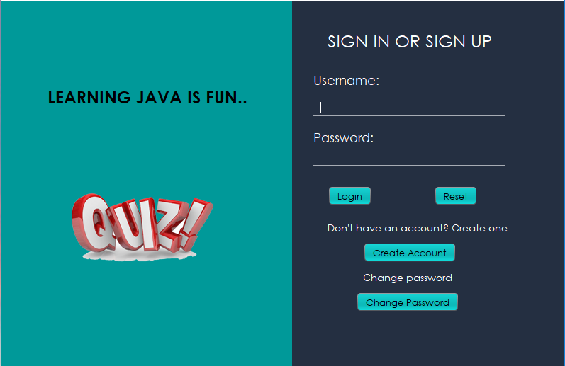

**CREATE ACCOUNT**

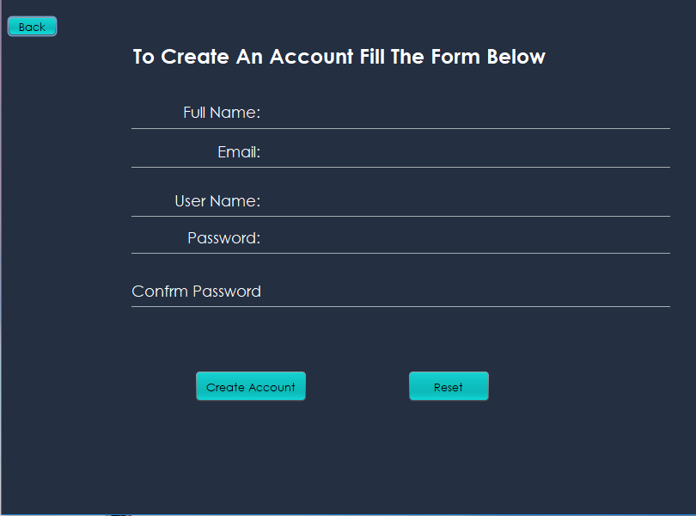

**CHANGE PASSWORD**

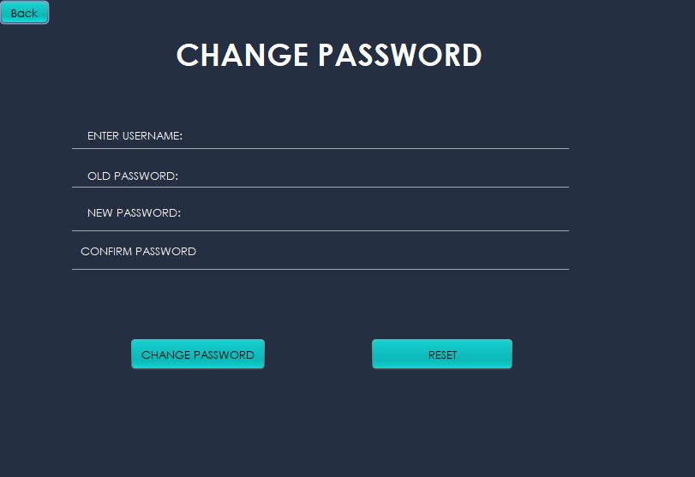

**STUDENT HOME**

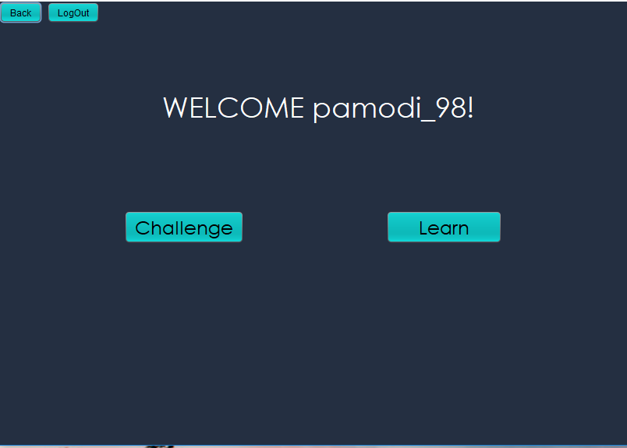

**ADMIN HOME**

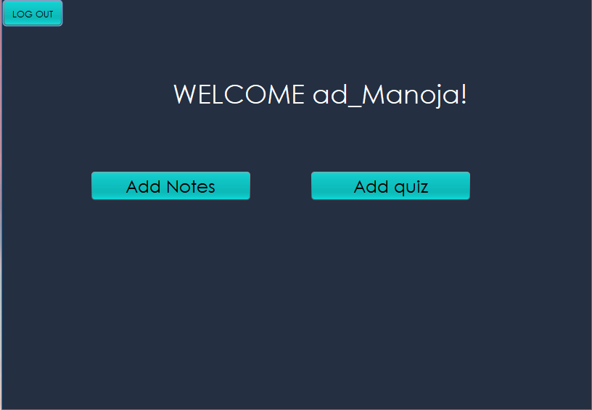

**QUIZ WINDOW**

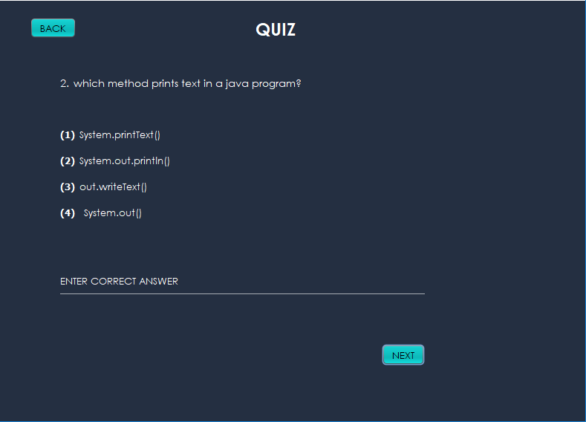

**MARK WINDOW**

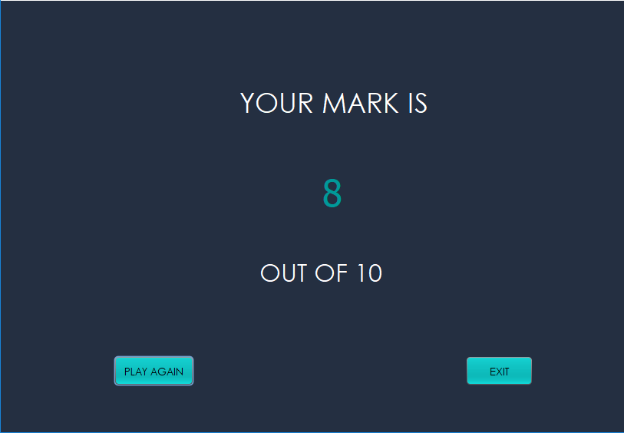

**LEARN WINDOW**

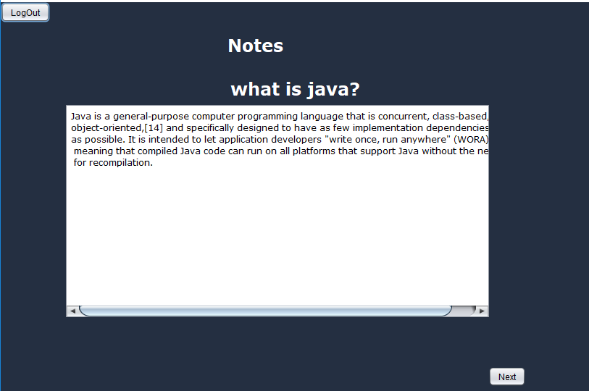

**ADD QUIZ WINDOW**

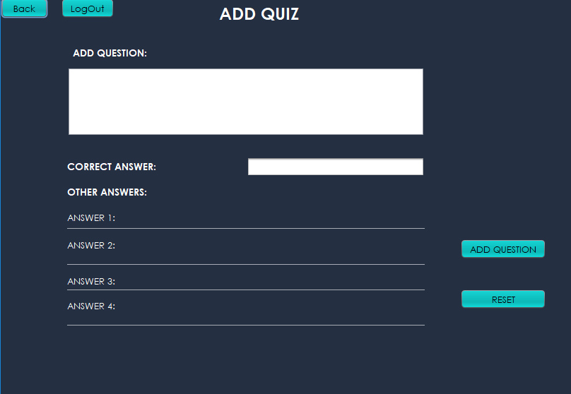

**ADD NOTE**

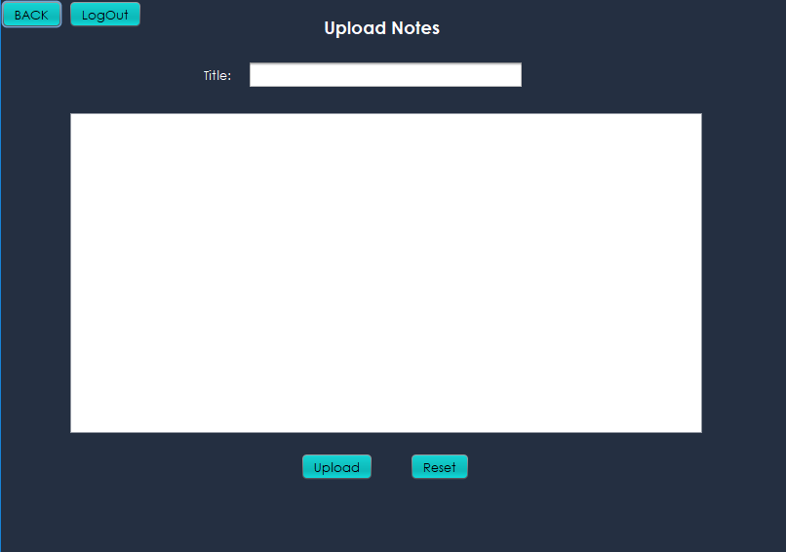

**EXPERIENCE**

This was a collective effort from group members succeeding all the problems and challenges. While developing this application we learnt lots of things related to a Quiz Application. We carefully used our theory knowledge to develop this Application and understood how to design a user-friendly application. Finally, we understood how important to maintain errors.

**RESOURCES**

* YOUTUBE
* STACK OVERFLOW
* ORACLE
* LECTURE SIDES
* TUTORIALS POINT

**GROUP MEMBERS**

1.Pamodi Rathnayake - BSC-UCD-CSC-16.2-016

2.Helitha Thalagalaarachchi - BSC-UCD-CSC-16.2-025

3.S.Y Kasun Ishanka - BSC-UCD-CSC16.2-021