**MONGODB**

**Ecllipse to mongodb connection:**

package connection;

import com.mongodb.MongoClient; import com.mongodb.MongoCredential;

import com.mongodb.client.MongoDatabase;

public class MongoDB {

public static void main(String[] args) { try {

MongoClient db

= new MongoClient("localhost", 27017);

MongoCredential credential; credential

= MongoCredential

.createCredential( "GFGUser", "mongoDb", "password".toCharArray());

System.out.println( "Successfully Connected"

+ " to the database");

MongoDatabase database

= db.getDatabase("mongoDb"); System.out.println("Credentials are: "

+ credential);

}

catch (Exception e) { System.out.println(

"Connection establishment failed"); System.out.println(e);

}

}

}

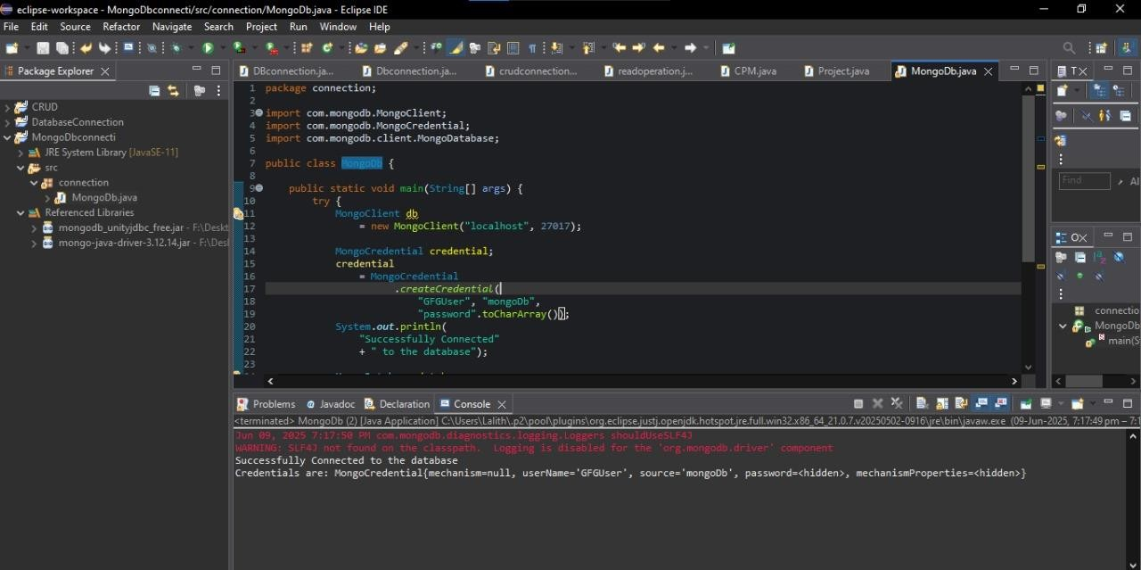

**Creating mongodb client:**

package connection; import org.bson.Document;

import com.mongodb.client.MongoClient; import com.mongodb.client.MongoClients; import com.mongodb.client.MongoCollection; import com.mongodb.client.MongoDatabase; import com.mongodb.client.MongoIterable;

public class MongoDb {

public static void main(String[] args) {

// Creating a Mongo client

MongoClient mongoClient = MongoClients.create("mongodb://localhost:27017");

MongoIterable<String> loop1 = mongoClient.listDatabaseNames(); for (String name : loop1) {

System.out.println(name);

}

}

}

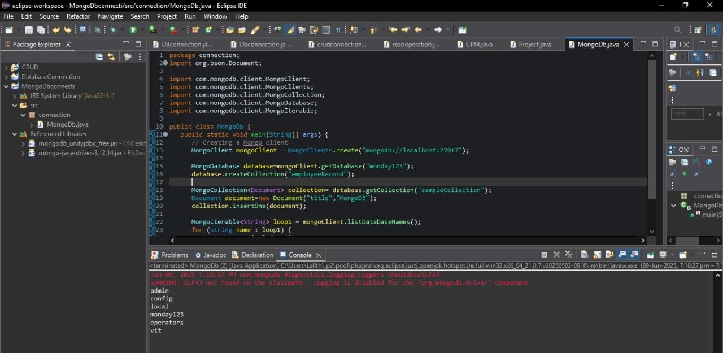

**Create:**

package connection;

import org.bson.Document; import com.mongodb.client.*;

import com.mongodb.client.MongoClient; import com.mongodb.client.MongoClients;

public class Create {

public static void main(String[] args) {

MongoClient mongoClient = MongoClients.*create*("mongodb://localhost:27017"); MongoDatabase db = mongoClient.getDatabase("companyDB"); MongoCollection<Document> collection = db.getCollection("employee");

Document emp1 = new Document("name", "Alice")

.append("age", 30)

.append("department", "HR"); collection.insertOne(emp1); System.***out***.println("Document inserted successfully.");

}

}

**Ecllipse:**

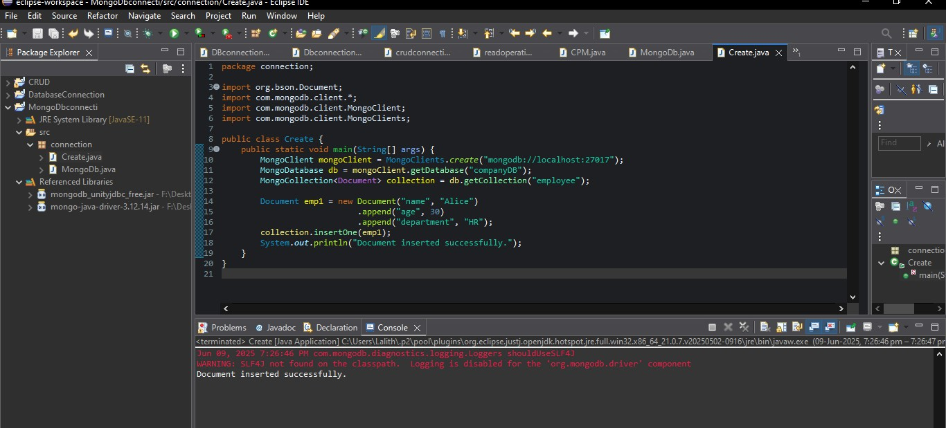

**Mongodb:**

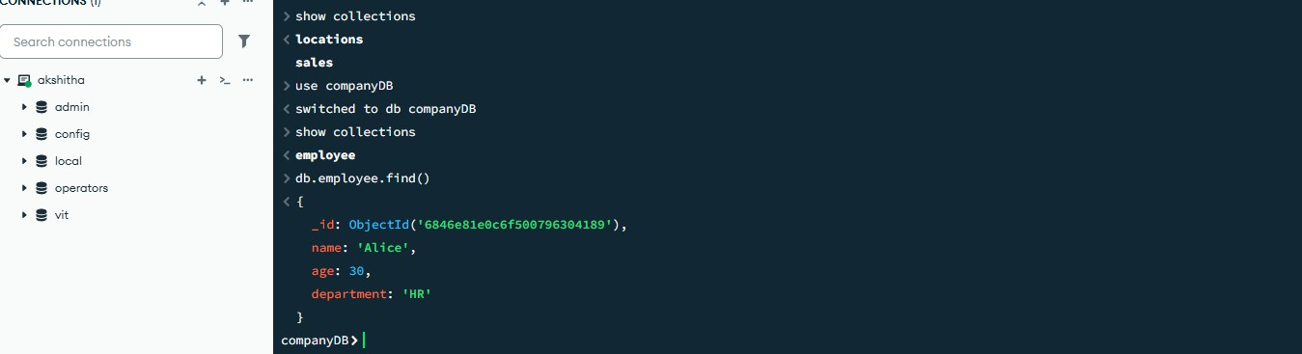

**DatabaseDropped:**

package connection;

import com.mongodb.client.MongoClient; import com.mongodb.client.MongoClients; import com.mongodb.client.MongoDatabase;

public class Create {

public static void main(String[] args) {

try (MongoClient mongoClient = MongoClients.*create*("mongodb://localhost:27017")) { MongoDatabase db = mongoClient.getDatabase("companyDB");

db.drop();

System.***out***.println("Database dropped successfully.");

}

}

}

**Ecllipse:**

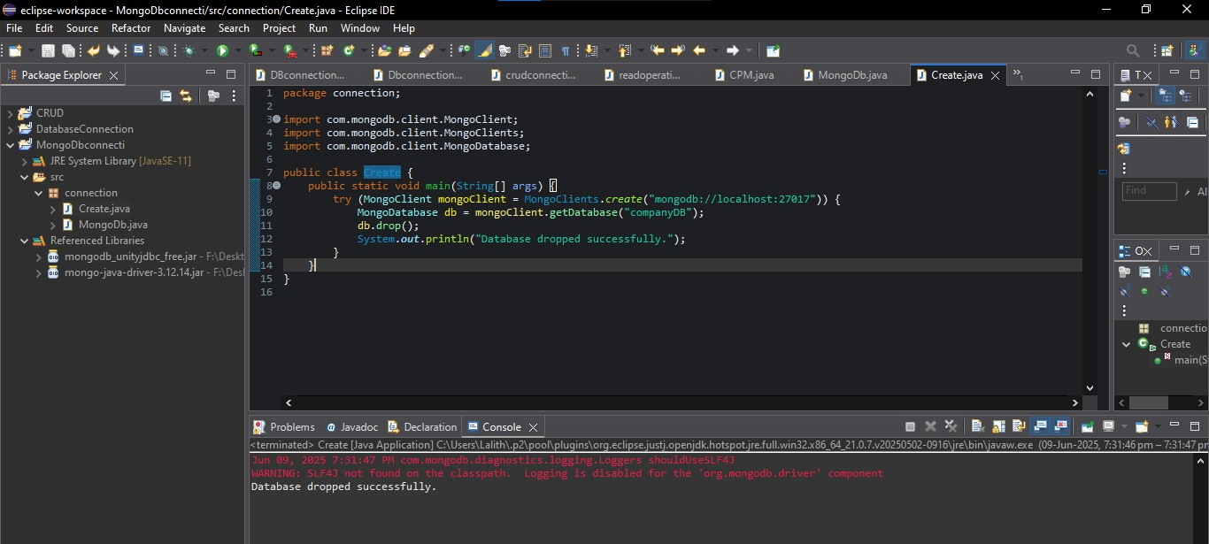

**MONGODB:**



**Show collections:**

package connection;

import com.mongodb.client.*; import org.bson.Document;

public class Create {

public static void main(String[] args) {

MongoClient mongoClient = MongoClients.*create*("mongodb://localhost:27017");

MongoDatabase db = mongoClient.getDatabase("vit");

System.***out***.println("Collections in 'vit' database:"); for (String name : db.listCollectionNames()) {

System.***out***.println("- " + name);

}

mongoClient.close();

}

}

**Ecllipse:**

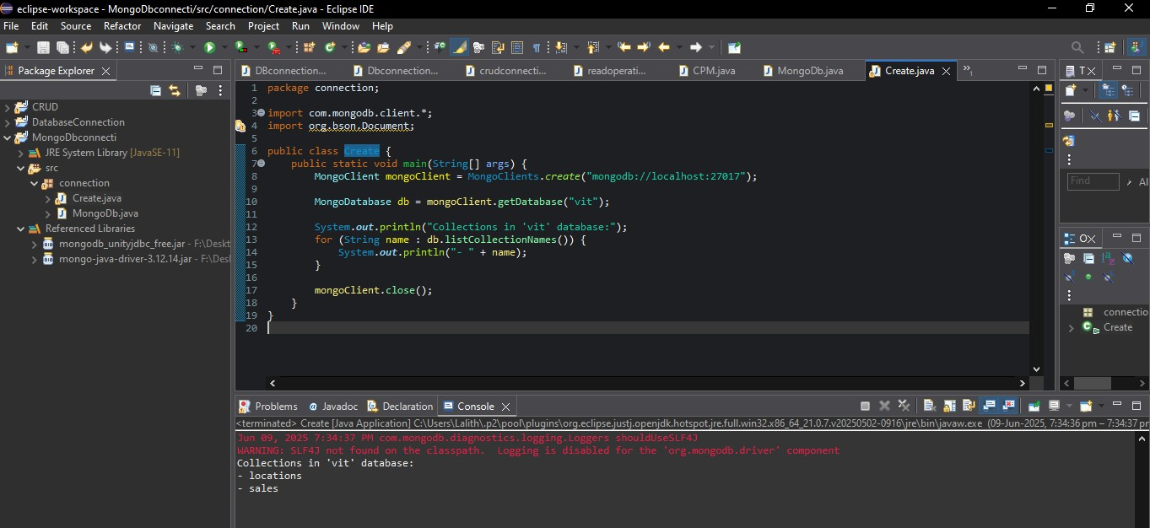

**Inserting records:**

package connection;

import java.util.ArrayList; import java.util.List;

import org.bson.Document;

import com.mongodb.client.MongoClient; import com.mongodb.client.MongoClients; import com.mongodb.client.MongoCollection; import com.mongodb.client.MongoDatabase;

public class Create {

public static void main(String[] args) {

// Creating a Mongo client

MongoClient mongoClient = MongoClients.*create*("mongodb://localhost:27017"); MongoDatabase database = mongoClient.getDatabase("myDb");

// Get the collection

MongoCollection<Document> collection = database.getCollection("sampleCollection");

Document document = new Document("First_Name", "Mahesh")

.append("Last_Name", "Parashar")

.append("Date_Of_Birth", "1990-08-21")

.append("e_mail", "[mahesh_parashar.123@gmail.com](mailto:mahesh_parashar.123@gmail.com)")

.append("phone", "9034343345");

collection.insertOne(document);

List<Document> documents = new ArrayList<>();

documents.add(new Document("First_Name", "Radhika")

.append("Last_Name", "Sharma")

.append("Date_Of_Birth", "1995-09-26")

.append("e_mail", "[radhika_sharma.123@gmail.com](mailto:radhika_sharma.123@gmail.com)")

.append("phone", "9000012345"));

documents.add(new Document("First_Name", "Rachel")

.append("Last_Name", "Christopher")

.append("Date_Of_Birth", "1990-02-16")

.append("e_mail", "[Rachel_Christopher.123@gmail.com](mailto:Rachel_Christopher.123@gmail.com)")

.append("phone", "9000054321"));

documents.add(new Document("First_Name", "Fathima")

.append("Last_Name", "Sheik")

.append("Date_Of_Birth", "1990-02-16")

.append("e_mail", "[Fathima_Sheik.123@gmail.com](mailto:Fathima_Sheik.123@gmail.com)")

.append("phone", "9000054321"));

collection.insertMany(documents);

System.***out***.println("Documents inserted.");

}

}

**Ecllipse:**

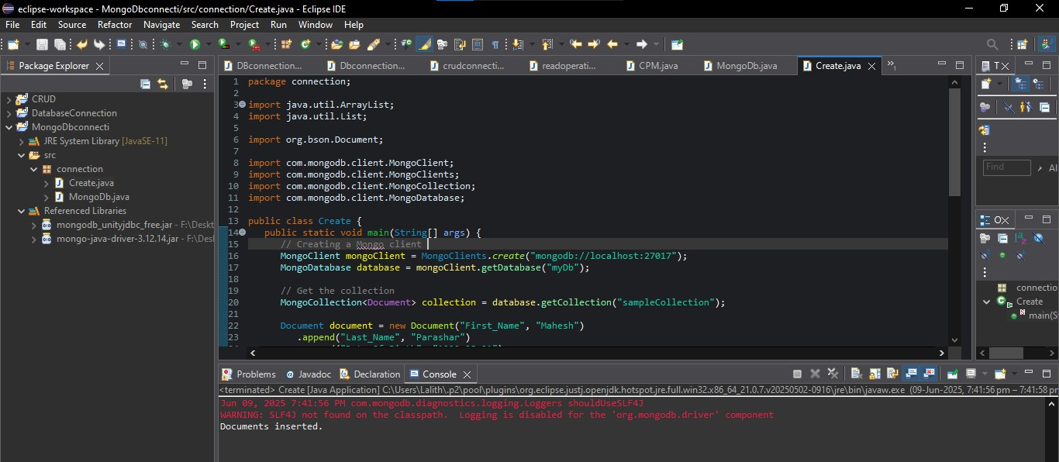

**Mongodb:**

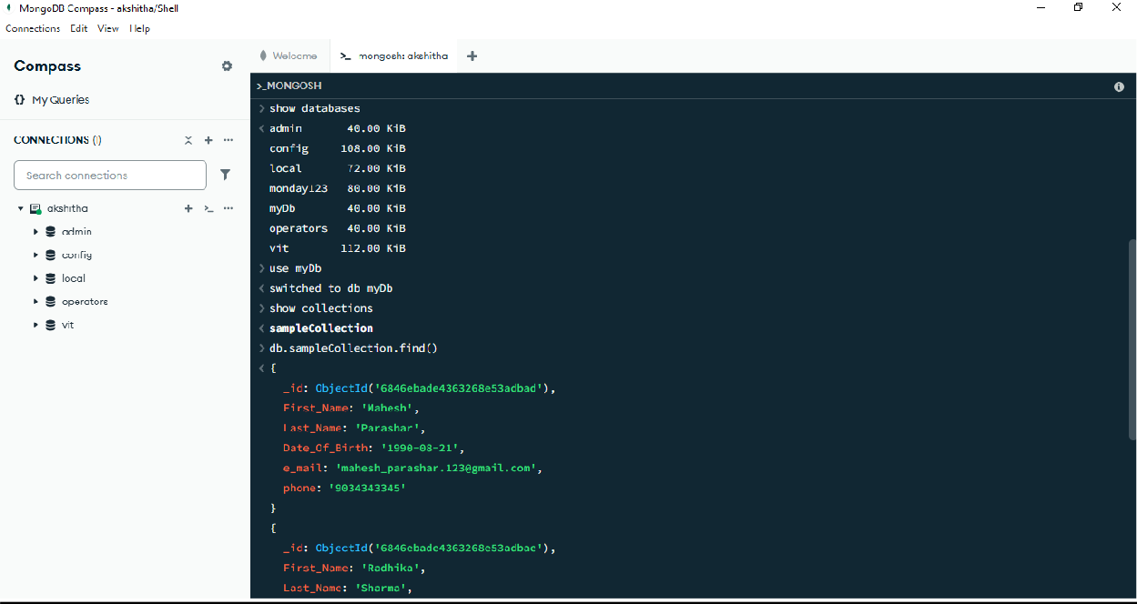

**Retrive the documents in ecllipse:**

package connection;

import com.mongodb.client.*; import org.bson.Document;

public class Create {

public static void main(String[] args) {

MongoClient mongoClient = MongoClients.*create*("mongodb://localhost:27017"); MongoDatabase database = mongoClient.getDatabase("myDb"); MongoCollection<Document> collection = database.getCollection("sampleCollection"); FindIterable<Document> documents = collection.find();

for (Document doc : documents) { System.***out***.println(doc.toJson());

}

mongoClient.close();

}

}

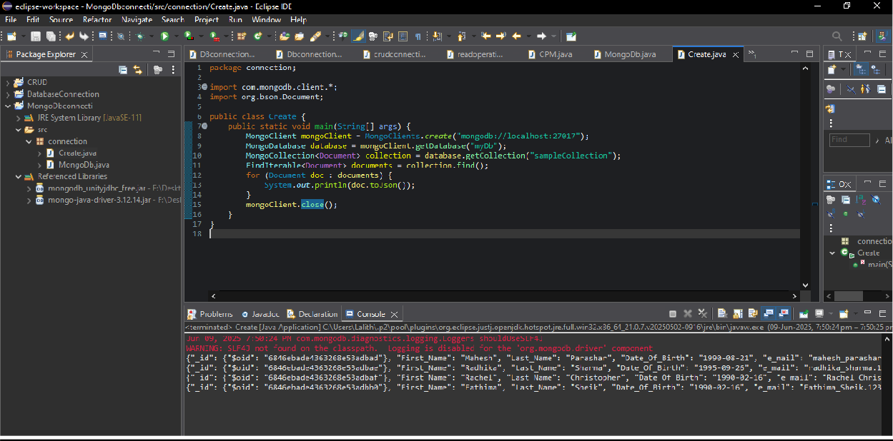

**Update records:**

package connection;

import com.mongodb.client.*;

import com.mongodb.client.model.Filters; import com.mongodb.client.model.Updates; import org.bson.Document;

import java.util.Scanner;

public class Create {

public static void main(String[] args) {

try (Scanner scanner = new Scanner(System.***in***)) {

// Connect to MongoDB

MongoClient mongoClient = MongoClients.*create*("mongodb://localhost:27017"); MongoDatabase database = mongoClient.getDatabase("myDb"); MongoCollection<Document> collection = database.getCollection("sampleCollection");

// Get user input

System.***out***.print("Enter email to update: "); String email = scanner.nextLine();

System.***out***.print("Enter new phone number: "); String newPhone = scanner.nextLine();

// Update document where e_mail matches input email collection.updateOne(

Filters.*eq*("e_mail", email), Updates.*set*("phone", newPhone)

);

System.***out***.println("Update completed successfully.");

mongoClient.close();

} catch (Exception e) { e.printStackTrace();

}

}

}

**Ecllipse:**

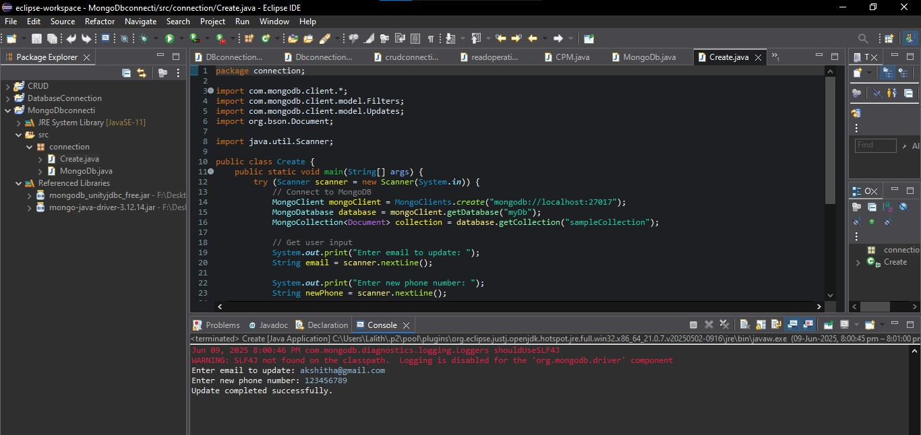

**Udate many records:**

package connection;

import com.mongodb.client.*; import org.bson.Document; import java.util.*;

public class Create {

public static void main(String[] args) {

try (Scanner scanner = new Scanner(System.***in***)) {

// Connect to MongoDB

MongoClient mongoClient = MongoClients.*create*("mongodb://localhost:27017"); MongoDatabase database = mongoClient.getDatabase("myDb"); MongoCollection<Document> collection = database.getCollection("sampleCollection");

System.***out***.print("Enter number of documents to insert: "); int count = scanner.nextInt();

scanner.nextLine(); // consume newline

List<Document> documents = new ArrayList<>();

for (int i = 0; i < count; i++) {

System.***out***.println("\nEnter details for document " + (i + 1));

System.***out***.print("First Name: "); String firstName = scanner.nextLine();

System.***out***.print("Last Name: "); String lastName = scanner.nextLine();

System.***out***.print("Date of Birth (YYYY-MM-DD): "); String dob = scanner.nextLine();

System.***out***.print("Email: "); String email = scanner.nextLine();

System.***out***.print("Phone: "); String phone = scanner.nextLine();

Document doc = new Document("First_Name", firstName)

.append("Last_Name", lastName)

.append("Date_Of_Birth", dob)

.append("e_mail", email)

.append("phone", phone);

documents.add(doc);

}

collection.insertMany(documents);

System.***out***.println("\nAll documents inserted successfully.");

mongoClient.close();

} catch (Exception e) { e.printStackTrace();

}

}

}

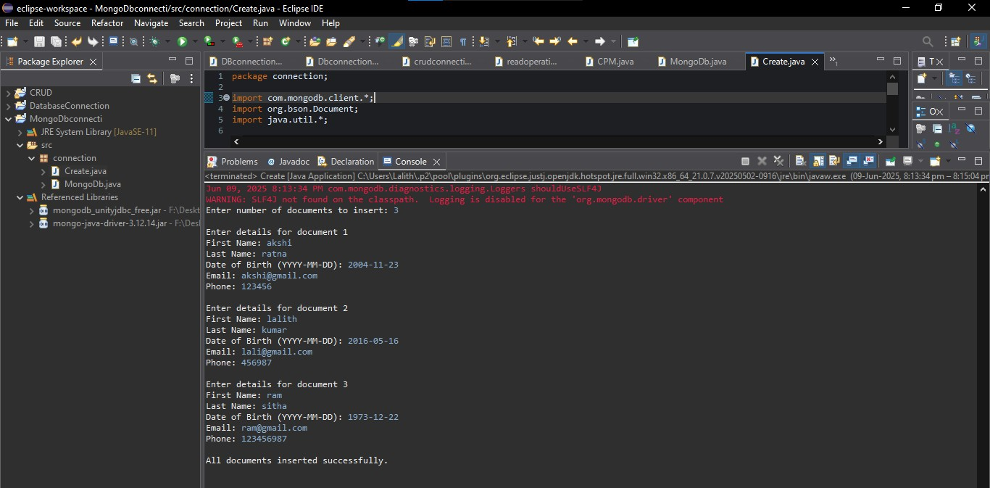

**Mongodb:**

