Assignment #04 Report
AI-assisted software evolution: multi-room Smart Campus Room Availability Checker
Course: Software Engineering
Student: Akhali Kasymzhomart
ID: 24B031661
Group: Thursday 9-12:00

Item | Details
Starting point | Equivalent reconstruction of the Assignment 3 prototype: a separate Bolt.new React/TypeScript app (Version 4), see section 1.0; git tag a3-baseline (commit 238bdf2)
Final version | git tag final (commit 0d768a5); every step of the plan is one tagged commit (appendix A)
Result in one line | 5 fictional rooms, capacity and equipment filters, empty state and room switching added; code split from 3 files (one 242-line App.tsx) into 21 small files; 63/63 automated tests pass (baseline: 30/30 on the unchanged code); duplicated rule copies 19 to 3.
AI assistants used | Claude Sonnet 5.5 (planning, implementation, tests, measurement, report drafting) and Gemini (independent plan review; model label not recorded). Details in AI_Evidence.docx.
Companion files | README.md (setup, run, test), source of the initial and final versions, git history, test outputs, screenshots, AI_Evidence.docx

Submission checklist
Requirement from the assignment | Where it is shown
Existing availability rules still work | the 20 original rule cases pass; of the 9 original UI tests 6 pass unchanged and 3 were adapted for per-room blocked status (sections 3.4 and 4)
At least four fictional rooms | 5 rooms in src/data/rooms.ts (section 2)
Capacity and equipment filters work | filter unit tests, UI tests, browser run, screenshots (sections 2 and 4)
At least ten executable tests | 63 tests; commands and results in section 4
Refactoring and evaluation evidence | diagrams, decisions and comparison table (sections 3 and 5)
AI use and human review documented | AI_Evidence.docx; sections 1.5, 1.6 and 6

1. Task 1: Codebase analysis

1.0 Relationship to Assignment 3
My Assignment 3 submission (a Python can_book function and a Bolt.new vanilla-JavaScript page for Room A204) is a separate project, and its code is not the starting point of this work. The assignment allows an equivalent minimal version, so I started from a second Bolt.new prototype of the same product: a React and TypeScript app (Bolt Version 4) for Room B-204. It has the same acceptance criteria AC1-AC6, the same fictional data (now = 540, one booking 600-660, not blocked), the same rule signature canBook(start, end, now, blocked, existing) and the same 120-minute and 1440-minute limits. It is an equivalent reconstruction, not the exact Assignment 3 code. The git tag a3-baseline is only the name of this starting commit.
Differences from the Assignment 3 submission: (1) React and TypeScript instead of vanilla JavaScript and Python; (2) the room is called B-204, not A204; (3) the baseline checks the blocked flag first, while the Assignment 3 Python function checks it after the bounds and duration rules (AC3 only requires that a blocked room is rejected, so both orders meet it); (4) the baseline came with no tests, so its 30 tests were written in step 1 of this assignment. The 20 rule cases T1-T20 use the same boundary values as the Assignment 3 expected-results table (for example 660-720, 720-840, 720-841 and 540-570). Where this report or the test names say "Assignment 3 behavior" or "Fix 1 / Fix 2", they mean the behavior of this baseline.

1.1 Context given to the AI assistant
I did not hand over the whole repository. The assistant got a short brief, saved as docs/PROJECT_CONTEXT.md: a file map with line counts and responsibilities, the six acceptance criteria AC1-AC6 from Assignment 3 (and two behaviors of the baseline: a changed input clears the old result, and a blocked room says "Room is blocked" first), the new requirements F1-F5, and the constraints (extend, don't rewrite; one change at a time; no new runtime dependencies; no credentials or private data shared). It was asked for a small plan, not a rewrite. The plan was written to docs/PLAN.md and committed (ecee002) before any source file was edited.

1.2 Baseline record (commit a3-baseline)
Measure | Value | How obtained
Source size | 311 lines: App.tsx 242, canBook.ts 56, main.tsx 10, index.css 3 | wc -l src/App.tsx src/lib/canBook.ts src/main.tsx src/index.css
Build, typecheck, lint | all pass (1565 modules, JS 151.03 kB) | npm run build / typecheck / lint
Automated tests in the project | none (the baseline has no test script) | inspected package.json (no test script)
Duplicate-code detector | 0 exact clones | npx jscpd@4 src --min-lines 4 --min-tokens 30; the copies below differ in names, so a token tool does not see them

1.3 Maintainability risks (file and function references)
# | Risk | Where in the baseline | Why it matters for the new feature | Priority
R1 | One 225-line component mixes state, parsing, validation, handlers and all markup | src/App.tsx, function App, lines 17-242 | Filtering would add more state and markup to the same function; nothing can be tested alone | High
R2 | The only room is hard-coded at module level | App.tsx lines 5-7: NOW, EXISTING_BOOKINGS, ROOM_NAME | No Room type or catalog; the bookings given to canBook are one global constant | High
R3 | "Hide the old result" is copied by hand | setResult(null) at App.tsx lines 41, 89, 144, 165; result kept as state | a forgotten copy is how a stale result appears; choosing a room would add another source of stale results (F5) | High
R4 | Duplicated parsing and validation | startNum/endNum/startValid/endValid (lines 23-27); two near-identical input blocks (lines 132-151, 153-172); Number.isInteger also in canBook.ts line 21 | Every rule change must be repeated | Medium
R5 | Magic numbers repeated in several files | 1440 in canBook.ts lines 7, 34 and App.tsx lines 11, 142, 149, 163, 170; 120 in canBook.ts lines 8, 45 | A limit change can leave the UI and the rule out of sync | Medium
R6 | Result card repeats the ok/error branch | App.tsx lines 196-225 (seven result.ok checks) | A new kind of result multiplies the ternaries | Medium
R7 | Unused dependency, no test tooling | package.json: @supabase/supabase-js unused; no test script | Dead dependency widens the attack surface; no safety net for refactoring | Low

1.4 Prioritized plan (written before editing)
Step | Change | Risks addressed | Commit / tag
1 | Safety net: Vitest + Testing Library; characterization tests run on the unchanged code | R7 | b10b0c5 step1-safety-net
2 | Extract the domain layer (constants, types, rules, time helpers); behavior unchanged | R5, part of R4 | 37ae539 step2-domain
3 | Split the UI into components and one state hook; result derived, not stored; still one room | R1, R3, R4, R6 | 2bd85b0 step3-components
4a | Room catalog (5 rooms) and filterRooms with unit tests | R2 | aa79dc0 step4a-catalog
4b | Filter UI, room list, room switching, empty state, per-room blocked status; integration tests | F1-F5 | ad8f130 step4b-feature-ui
5 | Remove the unused dependency, README, measurement and mutation scripts | R7 | 7336b9e step5-cleanup

1.5 Independent review by Gemini and my decisions
After the plan was written I gave PROJECT_CONTEXT.md and PLAN.md to Gemini in a new chat and asked for missed risks, steps to change and over-engineering. The full prompt and answer are in AI_Evidence.docx (entry A10). I checked each point against the code and the test results:
Gemini suggestion | Decision | Reason and evidence
Keep "blocked" as room data, not UI state (App.tsx) | Accepted | Already planned (decision D2); made explicit in step 4b by deleting the demo toggle. This changed behavior, so three tests were adapted (section 3.4).
Keep strings and numbers apart (form text vs domain number) | Accepted | Done in step 2: parseWholeMinutes and parseAttendees are the only places where text becomes a number.
Remove the Supabase dependency first (step 0) | Modified | Removed, but last (step 5): the baseline numbers and the safety-net tests had to be taken on the unchanged package set. Result: 0 matches for supabase in package.json and the lock file.
Replace useReducer by useState | Partly accepted | The filter hook already uses plain useState (3 calls). I kept the reducer only for the check form, so that "any edit hides the old result" lives in one place (measure D5: 4 copies to 2).
Merge domain and data folders into utils and types.ts | Rejected | Task 3 asks to separate rules, data, filtering and UI. A folder with no React import lets the 44 rule and filter tests run without a DOM (about 10 ms).
Drop the UI characterization tests, they "will break immediately" | Rejected (1.6) | Wrong in practice: the nine UI tests passed unchanged after the 242-to-43-line split.

1.6 One suggestion I rejected, and why
Gemini advised dropping the UI tests because the 242-line component was "about to be torn apart" and the tests would "break immediately". I rejected this for a practical reason: those tests describe what a user sees (labels, buttons, messages), not how the code is built. Evidence: step 3 replaced the whole component with 8 new files (7 components and one hook), and all nine tests still passed without any edit (30/30, docs/evidence/step3_components_tests.txt). After the feature step only three of them failed, and they pointed exactly at the two behaviors I changed on purpose: the removed demo toggle (two tests) and the room name now showing twice (one test that was too loose). Without them I would have had no proof that the baseline behavior survived. The useful half of Gemini's advice, keep fast unit tests for the pure rules, was already in the plan.

2. Task 2: Feature extension
The catalog has five fictional rooms in src/data/rooms.ts. Each has an id, name, capacity, equipment list, blocked status and its own bookings. Times are minutes after midnight (600 = 10:00); the current time stays fixed at 540 (09:00).
Room | Seats | Equipment | Blocked | Own bookings
Room B-204 (the baseline room) | 12 | projector, whiteboard | no | 600-660
Lecture Hall A-101 | 120 | projector, whiteboard, video conference | no | 570-690, 780-900
Computer Lab C-310 | 30 | projector, computers | no | 660-780
Seminar Room D-015 | 8 | whiteboard | no | none
Studio E-402 | 20 | projector, whiteboard, video conference | yes (maintenance) | 600-660

How the requirements are met. F1: a room matches when capacity >= attendees (empty or invalid input means no requirement). F2: a room must have every ticked item. F3: blocked rooms that match are still listed, marked "Blocked", and checking them always answers "Room is blocked" because the rule function reads the blocked flag first. F4: when nothing matches, the room list, form and result are replaced by "No rooms match your requirements" with a Clear filters button. F5: the answer is computed from the selected room and the entered times, so choosing another room shows that room's answer for the same times at once. The check uses only the selected room's bookings, because the room is the only thing passed to the rule function. If a filter removes the selected room, the first remaining match becomes selected. The original rules (valid time, 120-minute limit, overlap, immutability) are the same function as before, canBook, with the same messages.

Demonstration (real browser, Chromium)
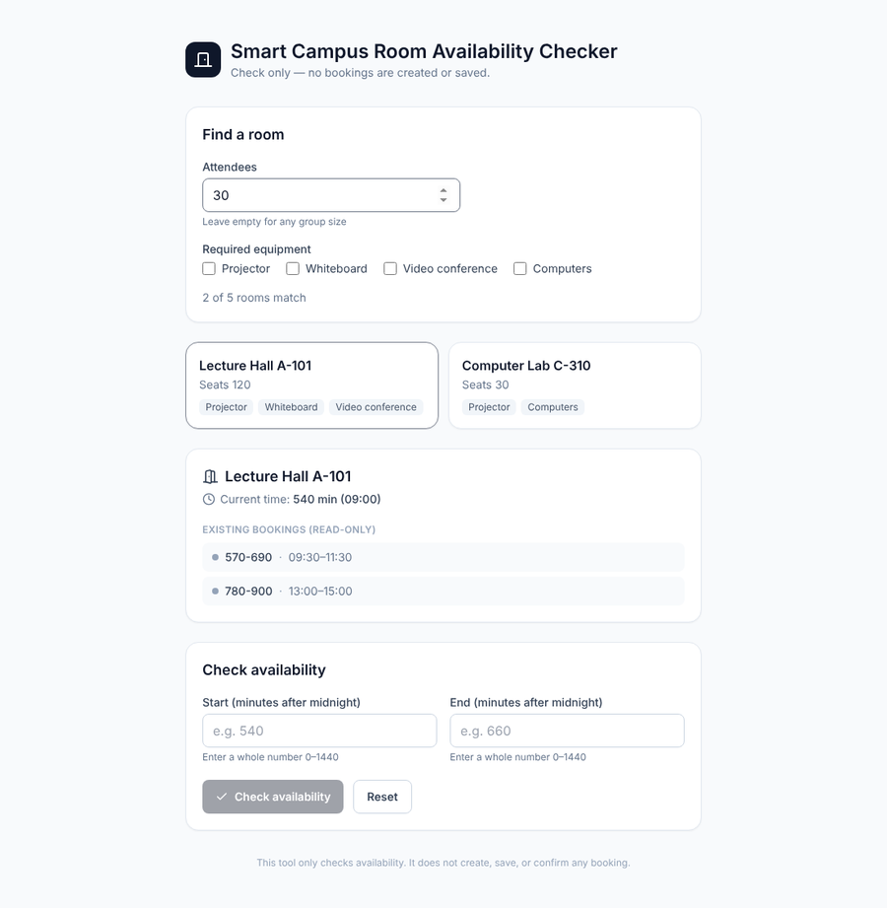  30 attendees: exact capacity matches (A-101, C-310) | 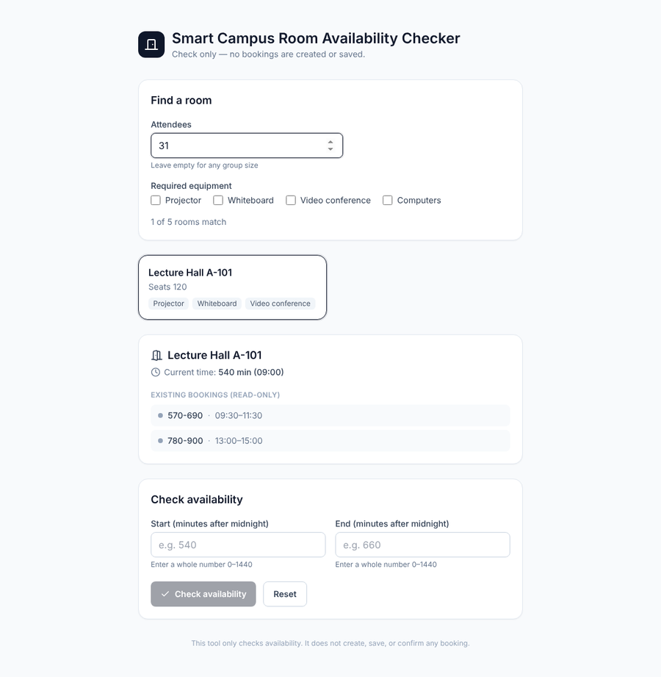  31 attendees: insufficient capacity removes C-310

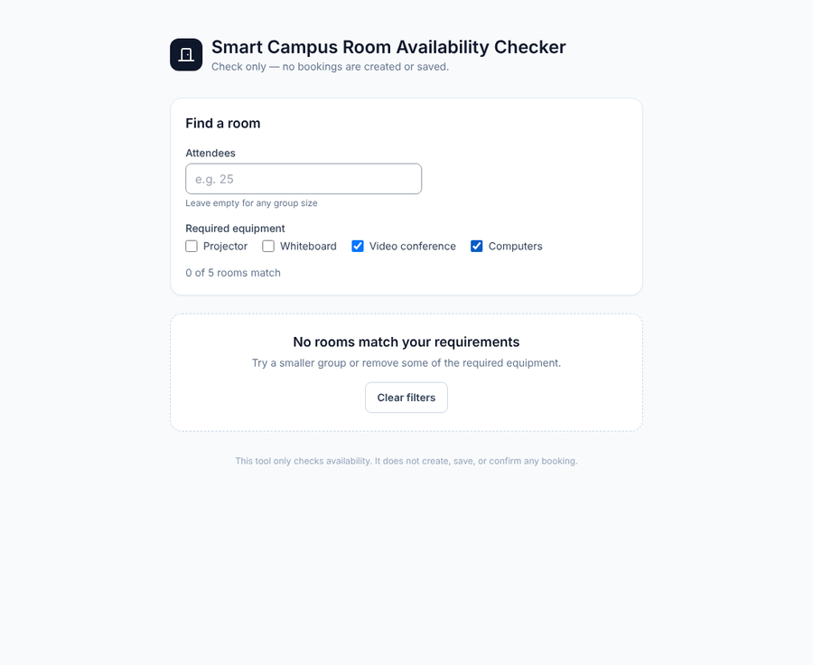  Computers + video conference: empty state | 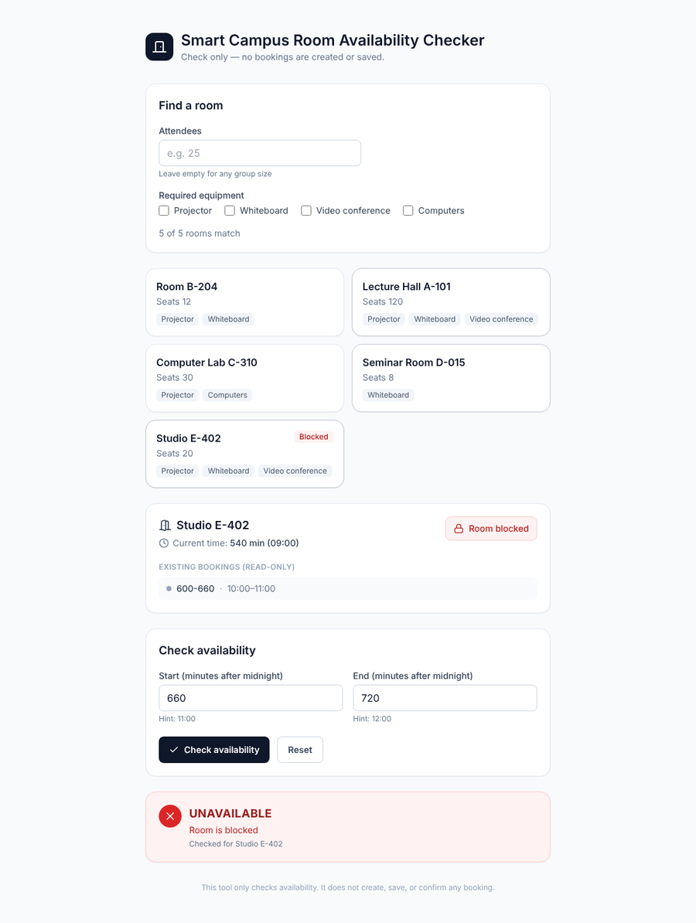  Blocked room E-402: "Room is blocked"

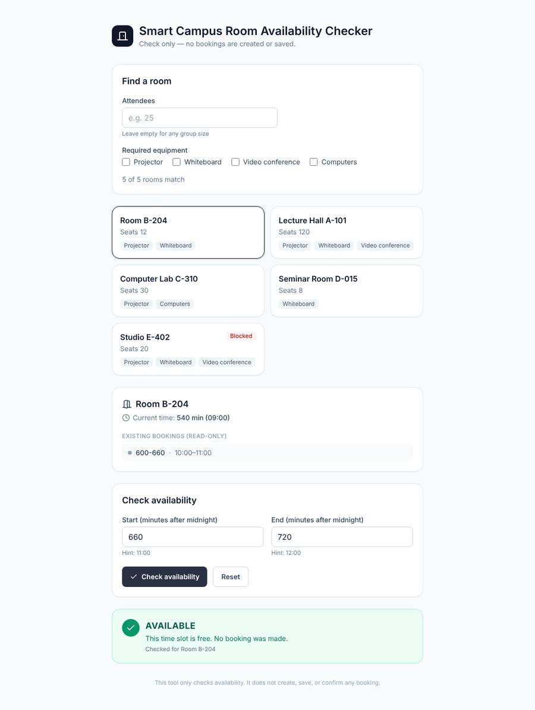  Room B-204, 660-720: AVAILABLE | 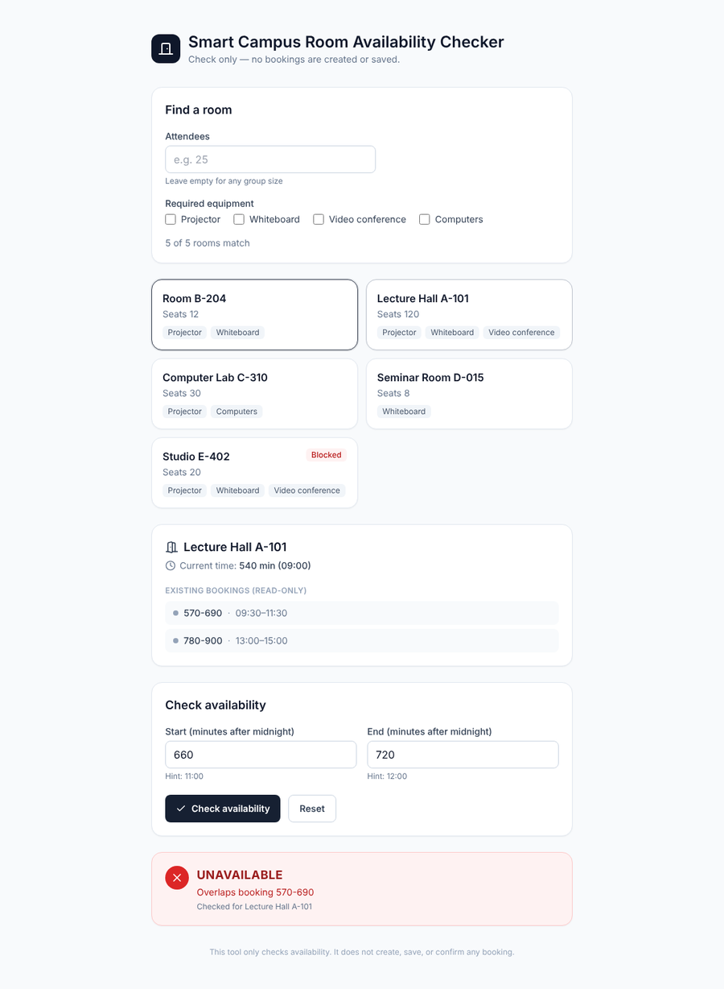  Same times, switched to A-101: UNAVAILABLE (own booking 570-690) | 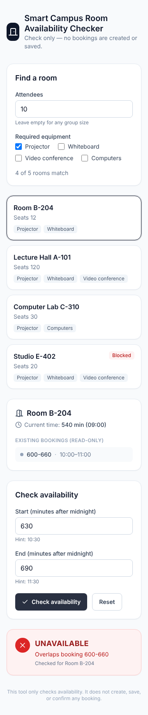  360 px wide: no horizontal scroll

3. Task 3: Refactoring

3.1 Module diagrams, before and after
Before (a3-baseline):
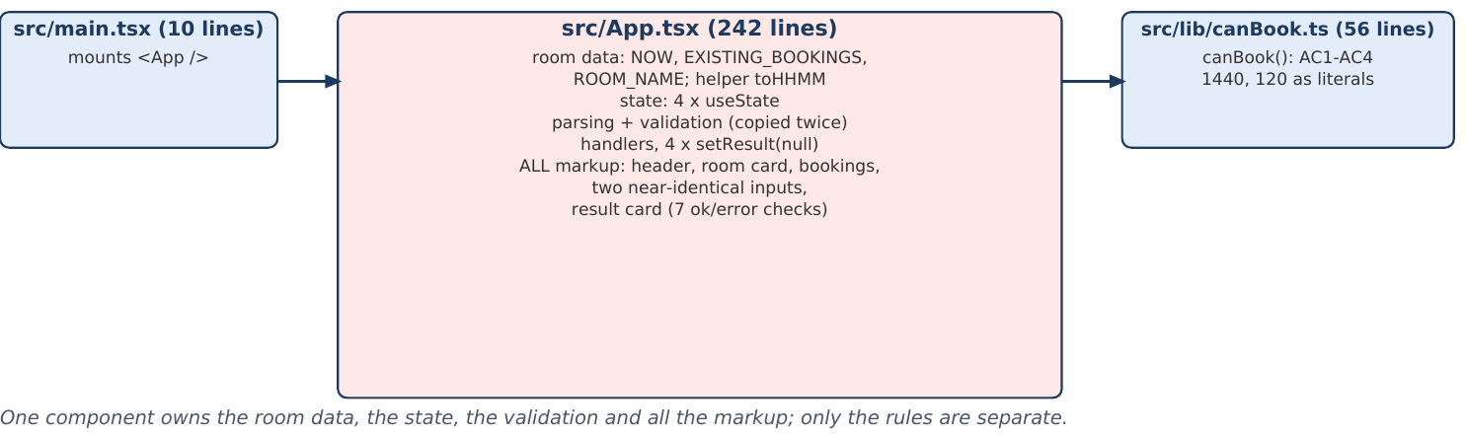

After (final):
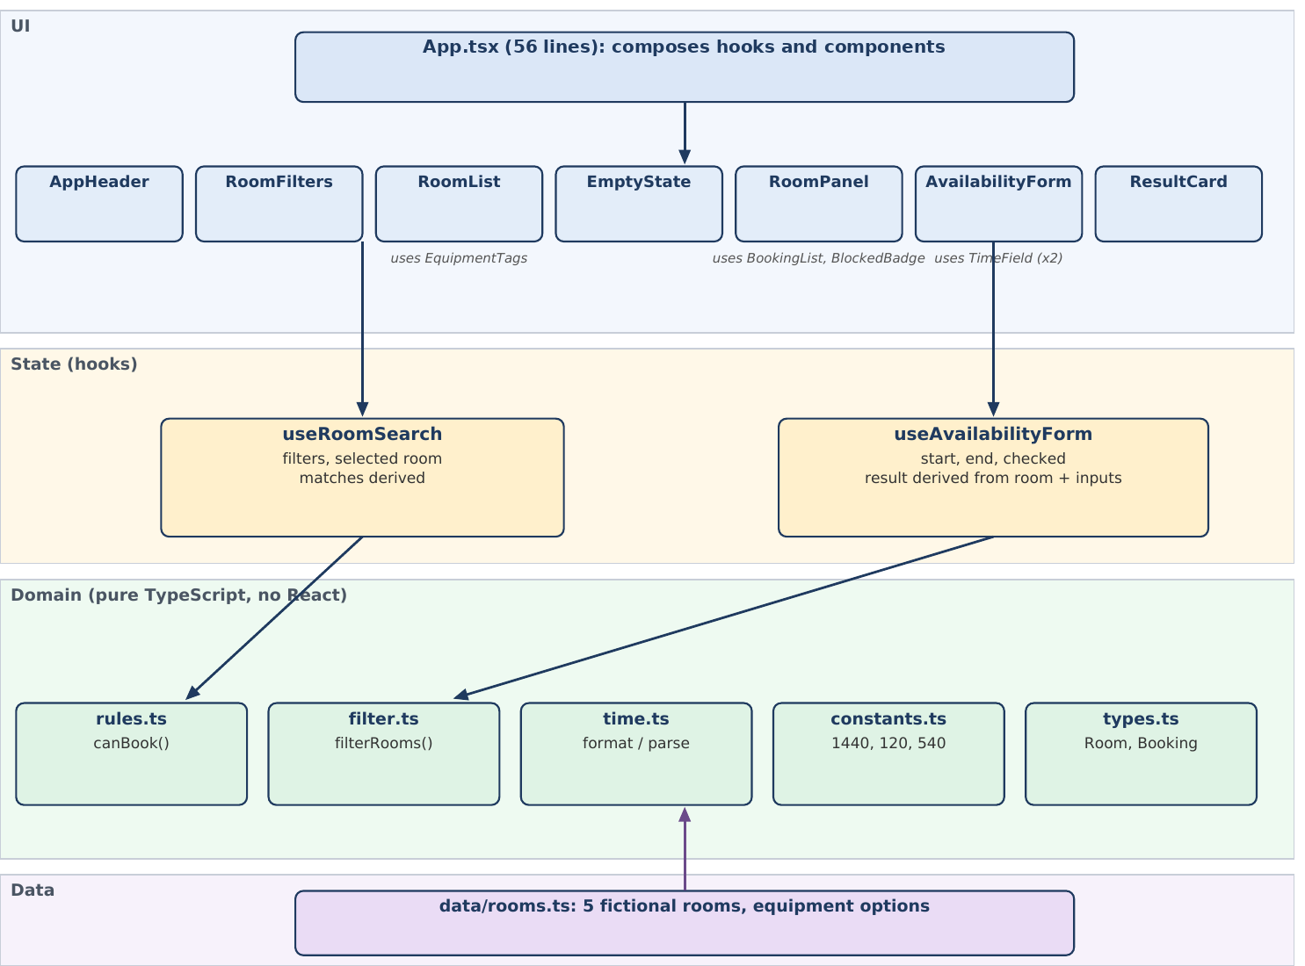

Arrows show "uses". The domain folder imports no React, and the data file only holds plain objects.

3.2 Responsibilities
Part | Files | One responsibility
Domain | constants, types, rules, filter, time | The rules and numbers of the product, as pure functions that can be tested without a screen
Data | data/rooms.ts | The fictional catalog and the equipment options
State | useRoomSearch, useAvailabilityForm | What the user typed or selected; the matches and the result are derived from it
UI | 11 components + App.tsx (56 lines) | Show data and send user actions up; no rules inside

3.3 Design decisions and justification
Decision 1: the result is derived, not stored. In the baseline the result was state and four handlers had to remember to clear it (R3); a forgotten copy is how a stale result appears. Now the hook stores only the inputs and whether a check was requested, and computes the result from the current room and inputs. A stale result cannot happen by construction, and room switching (F5) needed no extra code. Evidence: the places that hide a result went from 4 to 2 lines, and the F5 integration test passes.
Decision 2: the domain layer is pure TypeScript. Rules, filtering, time helpers and the numbers 1440 and 120 live in src/domain/ and import nothing from React. Each limit is written once in constants.ts and the messages are built from it, so the rule and the labels cannot drift apart (R5). It also keeps the 20 original rule cases running in about 4 ms.
Decision 3: one reusable field and one result lookup. Start and End use the same TimeField component (the hint text is now written once), and ResultCard reads its colors, icon and label from one table instead of seven ok/error checks (R4, R6). A new kind of result is one new table entry.
Kept on purpose: the signature canBook(start, end, now, blocked, existing) is unchanged, so the step 1 tests apply to it as they were. No state library was added (Redux or Zustand would be a new dependency for a handful of fields).

3.4 Behavior before and after
The 21 rule tests and 9 UI tests written in step 1 were run on the unchanged baseline (30/30), after the domain extraction (30/30) and after the component split (30/30). The test files were unchanged except one import path. Only the feature step changed behavior, and only here: the demo "Room blocked" toggle became per-room blocked data (required by the assignment). Three tests were adapted for that and are marked in src/App.test.tsx.

4. Task 4: Automated testing

4.1 Commands and actual results
Command | Result | Run by
npm test (30 tests on the unchanged baseline code) | 30 passed / 30 | me (sandbox), docs/evidence/step1_baseline_tests.txt
npm test (final) | 63 passed / 63 (5 files) | me (sandbox) and the student on Windows: 63 passed, 7 s
npm run typecheck, npm run lint | both exit code 0 (lint prints a typescript-eslint warning that TypeScript 5.6.3 is not officially supported) | both
npm run build | built, 1582 modules, JS 156.76 kB (baseline 151.03 kB) | both
node scripts/e2e-browser.mjs (Chromium) | 13 of 13 browser checks passed | me (sandbox)
bash scripts/mutation-check.sh | 6 of 6 planted defects detected | me (sandbox)
Walk-through of filtering, room switching, blocked room, empty state and 360 px layout in npm run dev | all scenarios behaved as expected | the student

Output files are in docs/evidence/ (one per step); the student's own terminal output is saved as test-results/student_local_run.txt.

4.2 What the 63 tests cover
File | Tests | Covers
src/domain/rules.test.ts | 21 | AC1-AC5 regression: the 20 baseline cases (T1-T20) plus a test that bookings are not modified
src/domain/filter.test.ts | 18 | F1, F2, combined filters, blocked rooms still listed (F3), catalog unchanged, attendees parsing
src/data/rooms.test.ts | 5 | Catalog integrity: 4+ rooms, unique ids, valid fields, well-formed bookings, a blocked room, the baseline room kept
src/App.test.tsx | 9 | Baseline UI behavior in the new UI (button state, hints, available, overlap, blocked first, result cleared on edit, reset)
src/App.integration.test.tsx | 10 | Integration through the real UI: F1 exact and insufficient capacity, F2 all items, F3, F4 empty state, F5 room switching with each room's own bookings

4.3 Boundaries required by the assignment
Boundary | Test (file: case) | Expected
Exactly 120 minutes vs 121 | rules: T4 (720-840) and T5 (720-841) | available / "Duration cannot exceed 120 minutes"
Touching vs overlapping | rules: T1 (660-720), T13 (599-600) touching; T2, T14, T16 overlapping | touching available; overlap "Overlaps booking 600-660"
Exact capacity vs insufficient | filter and UI: 30 attendees keeps the 30-seat lab; 31 attendees removes it | two rooms, then one room
Start exactly now | rules: T6 (540-570) and T12 (541-571) | rejected / accepted
Day end | rules: T10 (ends 1441) and T11 (ends 1440) | rejected / accepted
Room data isolation | UI: 660-720 is AVAILABLE in B-204 and D-015, but overlaps in A-101 (570-690) and C-310 (660-780) | each room answers from its own bookings

4.4 Requirement to test traceability
Requirement | Tests
AC1 valid time, start after now, integers | rules T6-T12, T17, T18; UI: button disabled until whole numbers, hint
AC2 120-minute maximum | rules T4, T5
AC3 blocked room | rules T3, T19, T20; UI: blocked-first message, blocked room never available
AC4 overlap rules | rules T1, T2, T13-T16; UI: touching available, overlap reason
AC5 clear result, data not modified | rules: input not modified; filter: catalog not modified; UI result text and icon
AC6 messages and responsive layout | UI message tests; browser run at 360 px (no horizontal scroll) and screenshot
F1 capacity | filter: exact, insufficient, too many; integration: 30 and 31 attendees, invalid input
F2 equipment (ALL items) | filter: one item, two items, impossible combination; integration: tick projector, whiteboard, video conference
F3 blocked never available | filter: blocked room still listed; integration: blocked room tagged and reported "Room is blocked"
F4 empty state | integration: empty state shown, form hidden, Clear filters restores the list
F5 room switching refresh | integration: same slot in four rooms; no invented result; filter change moves the selection

4.5 Do the tests catch mistakes? (mutation check)
scripts/mutation-check.sh plants one deliberate defect at a time, runs the suite and restores the file:
Planted defect | Tests failing | Detected
capacity compared with > instead of >= | 3 | yes
equipment uses some() instead of every() | 24 | yes (noisy: some([]) is false, so most room lists break)
overlap uses <= (touching rejected) | 6 | yes
duration limit off by one (>= 120) | 1 | yes
blocked flag ignored | 3 | yes
check uses the first room's bookings | 2 | yes

5. Task 5: Quality evaluation
No number below is estimated. Each one was produced by a command that can be run again; scripts/measure.mjs was run on the baseline commit and on the final commit.
Measure | Original (a3-baseline) | Final | How obtained
Automated tests passed / total | 30 / 30. The baseline had no tests; these 30 were written in step 1 and run on the unchanged baseline code | 63 / 63 | npm test; the original figure is the output saved in docs/evidence/step1_baseline_tests.txt
Duplicated logic locations (extra copies of the same rule) | 19 | 3 (16 removed) | node scripts/measure.mjs <dir> counts places where the same rule or literal is written again (table 5.1); references to a named constant do not count
Source files / lines (non-test) | 3 files, 308 lines | 21 files, 635 lines | measure.mjs over src/**/*.ts(x) without tests. The code doubled in size because of the new feature and the extra files
Largest source file | App.tsx, 242 lines | RoomFilters.tsx, 58 lines | same script
Typecheck / lint / build | pass / pass / pass | pass / pass / pass | npm run typecheck / lint / build
Production JS size | 151.03 kB | 156.76 kB | npm run build output (grew with the new feature)
jscpd exact clones | 0 | 0 | npx jscpd@4 src --min-lines 4 --min-tokens 30; not informative here, the copies differ in names

5.1 Duplicated rule copies, per rule
ID | Rule written more than once | Baseline | Final
D1 | day limit 1440 written as a literal | 7 copies (6 extra) | 1 (0 extra)
D2 | booking limit 120 written as a literal (rule data excluded) | 2 copies (1 extra) | 1 (0 extra)
D3 | whole-number check for time input, Number.isInteger (lines) | 3 copies (2 extra) | 2 (1 extra)
D4 | time-field hint text "Hint:" written out | 2 copies (1 extra) | 1 (0 extra)
D5 | places that hide the old result (setResult(null) / reducer "...state, checked: false") | 4 copies (3 extra) | 2 (1 extra)
D6 | result.ok ok/error branches | 7 copies (6 extra) | 2 (1 extra)

The remaining copies are intended: D3 keeps a whole-number check in the input parser and in the rule (defense in depth); D5 has two reducer cases (start and end edits); D6 has one lookup for the card style and one for its message.

5.2 Code structure
The baseline had one component that did everything (App.tsx, 242 lines) and one rule file. The final version has the layers from section 3.2: 5 domain files, 1 data file, 2 hooks, 12 UI files (11 components and App.tsx) and main.tsx (21 source files in total), each with one job. The largest file has 58 lines.

5.3 Remaining limitations
(1) The UI tests run in jsdom, so layout and CSS are checked only by the browser script and the screenshots, not by npm test. (2) The catalog and bookings are hard-coded for one fixed day and one fixed time, with no way to edit them. (3) Times are typed as minutes after midnight, which is awkward for real users. (4) When a filter removes the selected room, the first match is selected silently. (5) The code base is twice as large as before. That is a cost of the new feature, not an improvement. (6) npm run lint prints a typescript-eslint warning about TypeScript 5.6.3; it still exits with code 0.

6. Task 6: AI reflection
Drafted by the assistant in my name from my test results and answers; I reviewed it before submitting. (260 words)
I gave the assistant a short project brief instead of the whole repository: a file map with line counts, the six acceptance criteria from Assignment 3, the new requirements F1-F5 and my constraints (no new runtime dependencies, one change at a time, same visual style). It wrote a plan before touching any code, and I had Gemini review that plan independently.
Most suggestions were useful. The split into domain, hooks and components worked, and deriving the result from the inputs removed the stale-result risk of the baseline. Some output was wrong: a test looked up "Room B-204" by text and failed because the name now appears twice, and the first version of the duplication counter counted two lines that were not real copies. Gemini was right to keep "blocked" as room data, but it told me to drop the UI tests because they would break. I rejected that. The nine tests survived the 242-to-43-line split unchanged, and the three that failed later pointed exactly at the behavior I had changed on purpose.
I checked the result myself on my own computer: npm test (63 passed), typecheck, lint and build, and I walked through filtering, room switching, the blocked room and the empty state in the running app. The tests decided the order of the work: safety net first, then refactoring, then features. Planting six deliberate bugs showed that the tests really catch mistakes.
Next I would automate the 360 px check, show a visible message when the check button is disabled, and move the room data out of the code.

Appendix A: commit references and reproduction
Tag | Commit | Change | Files / lines
a3-baseline | 238bdf2 | Bolt.new React/TypeScript baseline (initial version) | -
(docs) | ecee002 | context brief and plan, before any code edit | -
step1-safety-net | b10b0c5 | Vitest + 30 tests on unchanged code | 9 files, +1376 -22 (mostly package-lock)
step2-domain | 37ae539 | extract domain layer | 7 files, +68 -31
step3-components | 2bd85b0 | components + hook | 10 files, +309 -220
step4a-catalog | aa79dc0 | catalog + filter logic + unit tests | 7 files, +185 -2
step4b-feature-ui | ad8f130 | filters, room list, switching, empty state | 15 files, +381 -66
step5-cleanup | 7336b9e | remove dependency, README, scripts | 5 files, +139 -122
final | 0d768a5 | final evidence and screenshots | a3-baseline..final: 55 files, +2739 -358

To reproduce: git clone a4-repo.bundle a4; cd a4; git checkout final; npm ci; npm test. More commands are in README.md. The initial version is in initial/ and the final version in final/ of the submission folder.

