**Neural-Network-and-Naïve Bayes Python Report**

Firstly, I imported the necessary libraries and classes that we will used in my code.

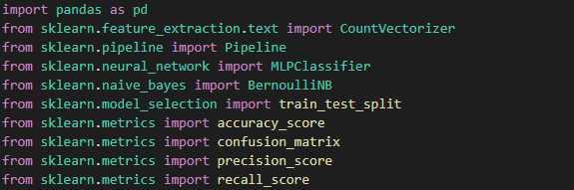

I then retrieved CSV file as a pandas dataframe using the pd.read_csv function. Also, I extracted the columns individually using their index positions using iloc. Moreover, I split the dataset into X and y then training the model with 80% data from the dataset and 20% to the testing.

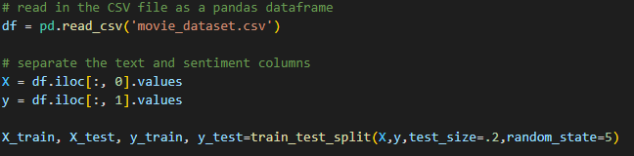

Furthermore, I defined the two pipelines being the neural network pipeline and the Bernoulli naïve bayes pipeline, each includes two steps, a CountVectorizer step to transform the text into a numeric representation, and a classification step to make predictions. And pass in the X_train and y_train variables to the fit method to train the models on the movie dataset.

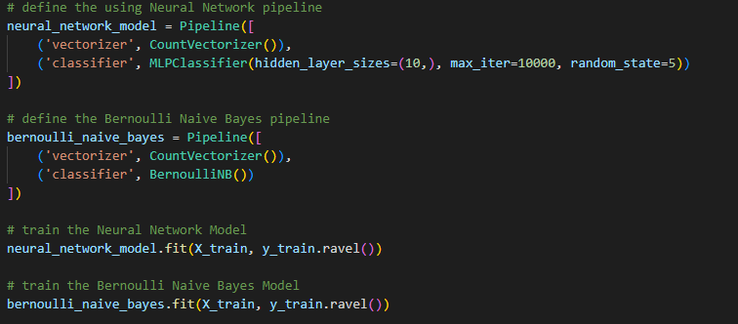

Finally, I printed predictions using the predict method of each pipeline and then checked the model accuracy, confusion matrix, precision and recall score of each pipeline.

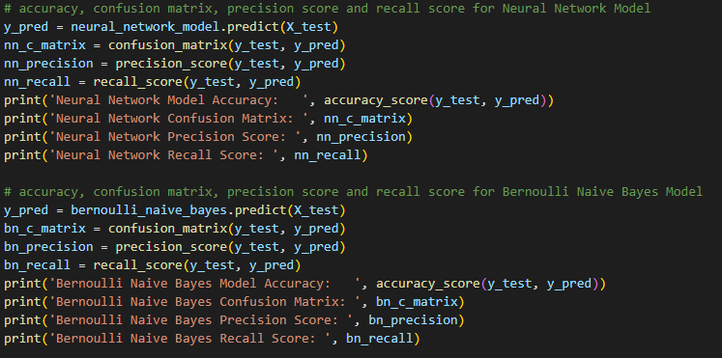

**RESULTS**

The confusion matrix indicates that the neural network model has good performance, as it correctly predicted a large number of both positive and negative instances, and has relatively low false positive and false negative rates.

2220 (True Negative), 293 (False Positive), 298 (False Negative), 2189 (True Positive)

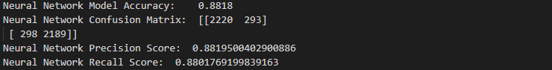

The confusion matrix indicates that the Bernoulli Naïve Bayes model has good performance, as it correctly predicted a large number of both positive and negative instances, and has relatively low false positive and false negative rates.

2055 (True Negative), 458 (False Positive), 283 (False Negative), 2204 (True Positive)

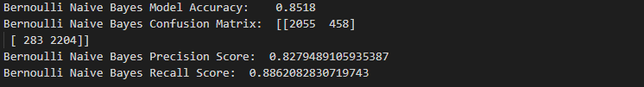

In conclusion, the accuracy, precision score, and the false positive rate of Neural Network Confusion Matrix is higher, which means that the Bernoulli Naïve Bayes model is more likely to predict a false positive result.