***Information Technology – Documentation  
Group Assignment*  
*Gurveena Kaur and Kathryn Gill***



Planning the multipage website -   
The main purpose for this website is to build;

* Navigation Bar
* Minimum of seven pages
* Design –Consistency, content quality and use.
* Text/ Labelling
* Steady look all over the presented pages

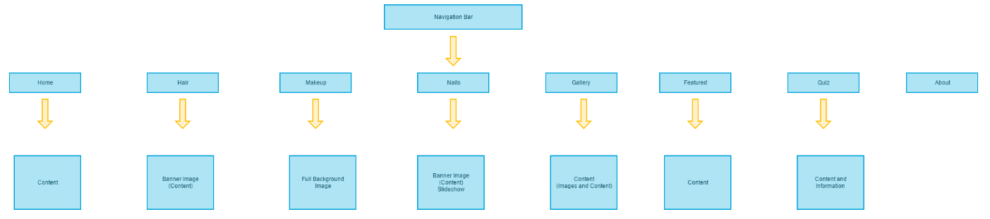 *The Target audience:*The Target Audience looks at users of certain media sites. In this particular website of ours “Makeup and Beauty” is aimed towards teenagers and adults. The types of content and style that are valued in this website are the visualization and the information provided.  
For the website to be artistic, they should be well presented to the adults and teenagers. That the designs and colours have a sense of complexity and the content should be presented well on all pages.   
Site Map  
  
The site map explains the main purpose for the structure of the webpage we are building for our website. The page includes 10 tabs on the navigation bar. These include The Home, Hair, Makeup, Mails, Gallery, Featured, Quiz and the about page. They all include the main information of the pages. Some of these are used for the main pages and they show the main purpose of the pages to demonstrate the pages links towards the e-hub-learning. On the home page, we have added a full screen image as the background and big button in the middle of the page.   
  
Moving on to the logo of our brand, we have used our initials “KGGK” – representing Gurveena Kaur and Kathryn Gill. As you can now tell, we created the logo using the techniques we learned in semester 1 – Inscape and Gimp.

*Visualization –*

## Home Page - Second Page - Fourth Page -

## 

# Assets and Resources:

The main source to create this project is all software used. To HTML, CSS and JavaScript. I am using a Text editor which is the Sublime Text. I have used the Paint app to create the Document Structure. Other online sources are used from Gliffy, this site was used to make the Site Map of this project. The Gantt chart was produced using a Gantt Team Website, this allows to section the Gantt chart as needed. Some other resources that were used to create this documentation was to seek advice from students.

One essential asset is required in this project for the allocated time of 3-4 weeks that has been given to complete the project.   
Some elements that are important to understand are to be able to think and create new ideas for the website to look modern. The ability to use the devices properly. Also the general knowledge of HTML, CSS, jQuery, JavaScript-Code validity, code readability and JavaScript.

*Putting together a palette:*  
Colour is the main aspect of a website and there are various other websites where are easy colours to choose from. The colour scheme for my website is a modern style. These colours will highlight the website, from the use of these colours the webpage will appear stronger and presence. Also, modern for the purpose for our website. As it is a makeup webpage.   
The colours that I will use are blue, white, green, yellow, pink, red black and etc. These colour will be used over the whole webpage. I am using these colours because it will reflect very well on my page’s design of the makeup pages. We are using images for the background because it will contrast with the black text. The other pallets we’ll be using for our webpage are all different modern vibrant colours. As it suits the theme of our webpage. We have used a light grey/blue for the whole webpage colour as it suits all the other pages on the website. It is more appealing to use these Panton colours than using bright colours on every other pages, which makes the page look less attractive.

## *Fonts*

To have the best result the website should have the same font through the webpage. So, that is what I am going to focus on, but at some points two different fonts can be made to work. The font used on the logo does not matter from the main website contents.   
Fonts are one of the second important part of a website for it to appeal presenting and appealing to users.   
“Josefin Sans” is the font we will be using on our website.

We will use Josefin Sans for the Banner as well and on the hyperlinks, this text will be used throughout the website, to keep it neat and simple. Although there will be italic forms used on some pages. This creates a clear and a moderate outlook on the pages.   
We have decided to stick up with one basic font for the website. It is because it appears more appealing.

## *Layout*

The aim for this website is to appear stylish and easy to use no matter how and what someone is viewing on the actual page. The layout of this website creates a vibrancy look with a modern feel to it. They provide a means for the user to engage with content that is both interesting and entertaining at the same time. It is supposed to be kept very modern and stylish at the same time because of the makeup topic. As the viewers enjoy the excitement of the modern feel of the beauty and makeup topic.  
It is kept very simple and modern for the viewers. As it attracts the audience more and because it is a makeup website it is supposed to look colorful but mode3rn at the same time. We have worked on the layout to look as much contemporary.   
We have designed the page to be easy access able. This way it is easier for the viewers to navigate the content easier. Also, the outlook of the page makes the theme presented neatly and this was our aim for this webpage.

## *Images*

The images will be a part of my house style and appear on appropriate page. The pictures will represent Hair, Makeup and Nails. The other pages will have different concepts from all the other pages. This is because they include other elements on the pages.   
For every page on the webpage, the elements of designs are different from all the other concepts used on the pages.   
*Bibliography –*

<https://www.gliffy.com/go/html5/9422761?app=1b5094b0-6042-11e2-bcfd-0800200c9a66> (Used to make the Site map)  
<https://www.pexels.com/> (Used for Images)

Creating The Plan: (Gantt Chart)In the requirement of this project is to organize time and resources that can be planned in the creation of this multipage website.

1: Requirements gathering and planning:

* Explaining the user audience
* Specify goals for website
* Creating the Gantt Chart
* Creating site map

2: Design phase:

* Gathering visual contents (Images and Multimedia)
* Concluding the site structure
* Identifying House Style {Font style, design elements and Design elements}
* Develop content listing and labels
* Producing and repairing the document structure/page layout

3: Implementation/testing phase:

* Code HTML/CSS/JS
* Validate HTML/CSS/JS
* Test the links for the website