This is a brief an inefficient way to get solidworks parts and assemblies into Unity. This particular task is still being researched.

1. In Solidworks, save your file (part or assembly as a .STL)
2. Download [Blender](https://www.blender.org/). **.blender** files are native to Unity.
3. Open Blender, go to File → Import → Stl (.stl)
4. Find your saved Solidworks .stl file and click it (if its an assembly highlight and open multiple .stl files)
5. Here you can render or do some other features. What I have found useful is the material. Click on the sphere meaning material.



1. Go to File → SaveAs → then you should be presented with a screen such as below. It is best practice to save directly to the the Asset folder in your project. Note, click the “Save As Blender File” when your done.

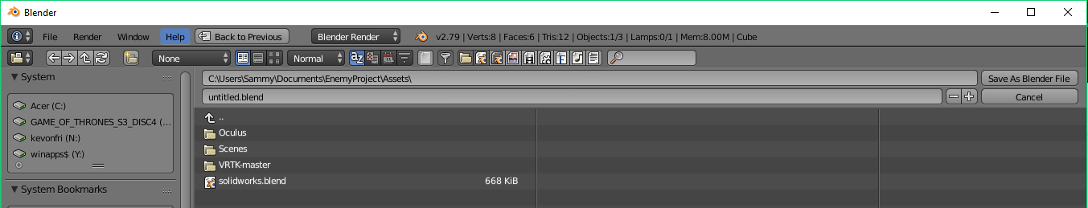

1. Your solidworks part/assembly should now be within the asset folder. Simple click and drag to the hierarchy

Below find instructions on how to pick up and inspect parts

Note: I have been experiencing a problem with getting the mesh collider to match the mesh (when I do grab an object it seems to be grabbing from a place on the object that is much farther than its body). I will be writing below how one can grab onto objects and keep them from a) exploding b)grabbing far off to the side c) gyrating

1. Follow the grabbing tutorial and add appropriate scripts/configure your avatar so they are capable of grabbing.
2. Make the following changes to the script (seen below).
   1. Turn off gravity
   2. Restrict movement and rotation in X, Y, and Z by freezing position and rotation.
   3. Click ‘Convex’
   4. Click ‘Precision Grab’

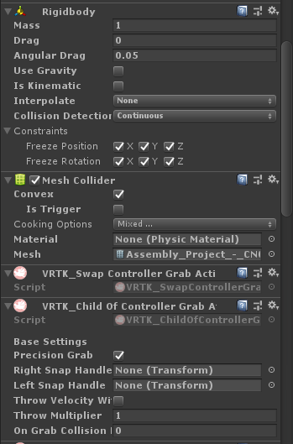

1. Thats is! Now explore your scene and disassemble your assembly.