1. Open Unity project 3D (Unity 2018.2)
2. Download VRTK from GitHub, drag and drop into assets
3. Get oculus integration from unity asset store
4. Delete main camera in new scene
5. Create new gameObject → 3D → cube
6. Scale the cube in the transform to be 20 x, 1 y and 20 z
7. Rename cube to floor
8. Move the floor down (because by creating all your objects at a 0 0 0 position you will effectively be seeing at floor level (alternatively look under OVRCameraRig and scroll down to OVR Manager (Script) look for Tracking and select Tracking Origin Type. Switch from ‘Eye Level’ to ‘Floor Level’ ← note if you are using local avatar this will suspend your viewpoint above your body and controller and should only be done if you can move up the local avatar (from a beginner’s standpoint it is recommended to move the VRTKSDK_Manager up or everything else down)))
9. Create new gameObject → 3D → cube
10. Rename the cube to player
11. To the player cube add a Rigidbody and the RC_Car script
12. Create empty gameObject call it [VRTK_SDKManager]
13. Underneath [VRTK_SDKManager] create [VRTK_SDKSetups]
14. Under [VRTK_SDKSetups] add VRTK_SDK Manager (Script)
15. Under [VRTK_SDKSetups] create empty gameObject Oculus
16. Add VRTK_SDKSetup script to oculus game object
17. Select GearVR (Android: Oculus) in sdk selection
18. Add OVRCameraRig and LocalAvatar as children of Oculus
19. On Oculus, under the VRTK_SDK Setup **script** (Note this is under the Oculus gameObject) object references, deselect auto populate and add game objects as seen below (this can be done by clicking and dragging from the hierarchy to the slots)

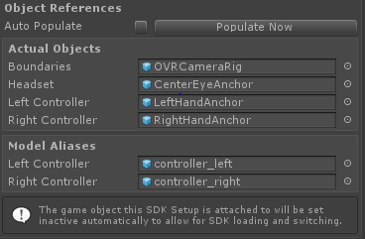

1. Create an empty gameObject that is child only to your scene. Call the [VRTK_Scripts]
2. Underneath [VRTK_Scripts] create two children called LeftControllerScriptAlias and RightControllerScriptAlias respectively
3. Select the RightController and Left Controller and add the VRTK_ControllerEvents and RC_Car_Controller scripts
4. Drag the player cube game object into the Rc Car slot under the RC_Car_Controller script