For the purposes of this tutorial, we will build a completely new scene.

1. Go to Asset Store. Download and import Standard Assets.
2. In the hierarchy click create → 3D Object → Terrain. Make sure that the terrain has a transform at the origin point (you can click on the transform’s cog and select ‘Reset’)
3. Click on the terrain in the hierarchy. Under the ‘Terrain’ component under the Terrain gameObject, you are presented with a toolbar. Read the explanations below to understand how each tool is used.





1. Use the Raise/Lower Terrain, Paint Height and Smooth Height tools to create a molded terrain. For this tutorial, try to raise most of the lalnd and lower it in some places. We will add water later into these depressions. Below is an example.

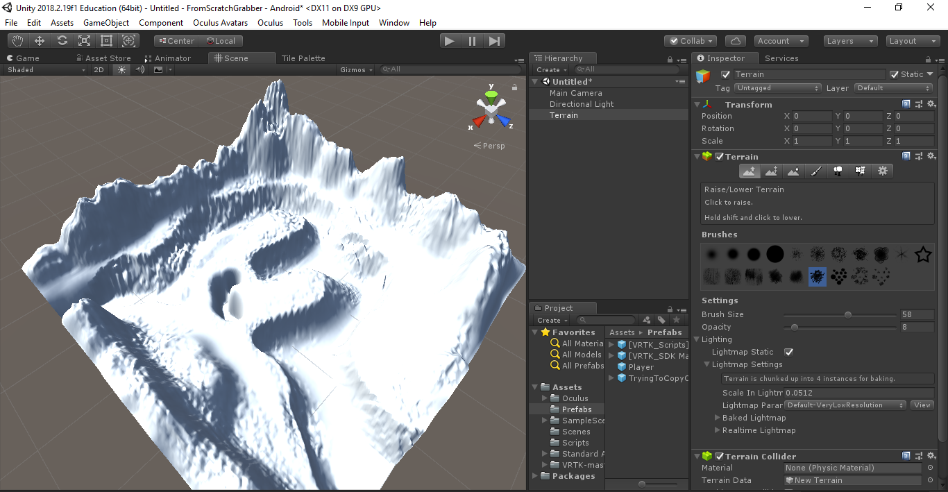

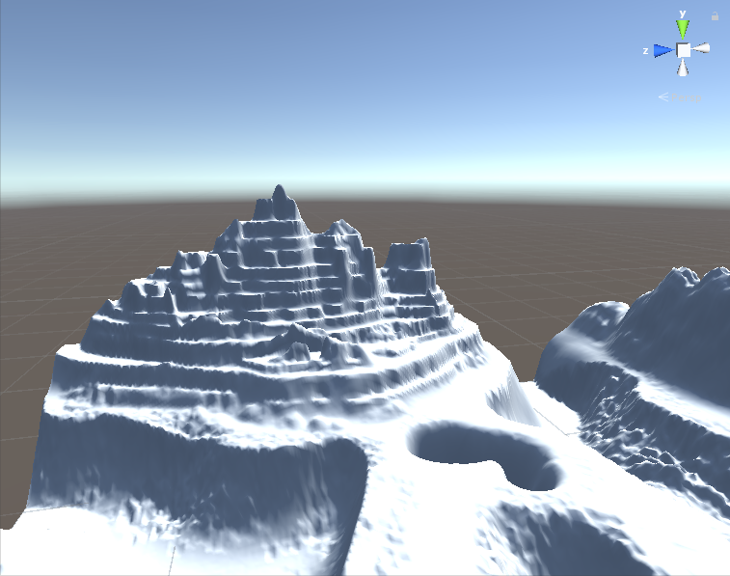

1. After creating your landscape, we will paint it. To do so, go into the Paint Texture tool.Under the edit texture cog, click Add Texture. You will be presented with a pop up box as shown.

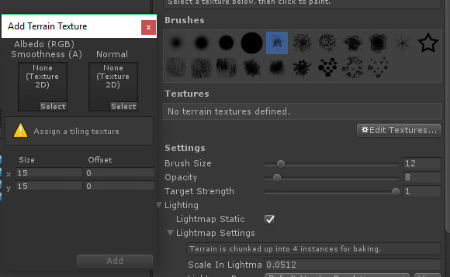

1. Click on select (under the leftmost ‘None (Texture 2D)’) and search for SandAlbedo. Select the sand and click add.
2. Repeat the previous step with GrassHillAlbedo, MudRockeyAlbedoSpecular, CliffAlbedoSpecular and GrassRockyAlbedo
3. Now click on each texture and using the brush size and opacity, paint on textures just as you did with the terrain. Below is an example.

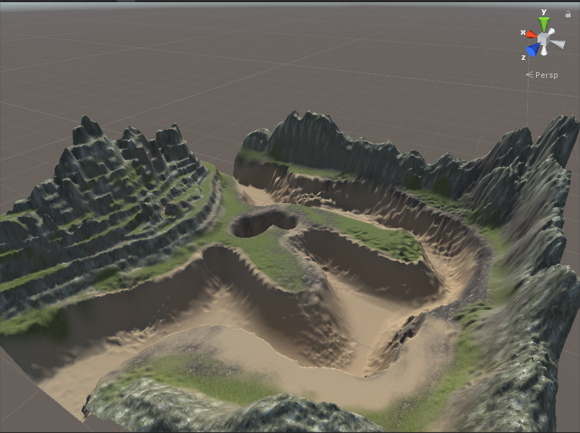

1. Great! We’ve made great progress. Now we will add water. Search in the project bar for WaterBasicDaytime. Grab the prefab (the one with the little cube next to it (look at picture below)) and drag it to the hierarchy. If you are having troubles finding the water (because it is so small and out of frame), double click on WaterBasicDaytime in the hierarchy.

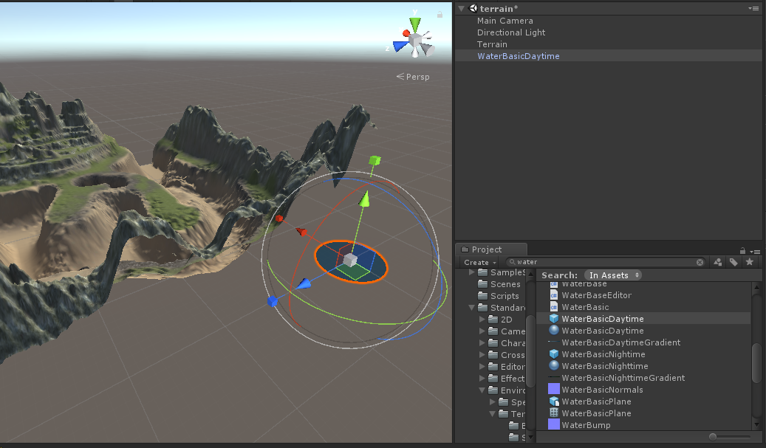

1. Click on the multi-tool (reference Points for concern doc). Grab the center grey cube and drag away from the body of water to increase its scale. Then using the red, green and blue arrows, position the water to be the height you want it to be at.

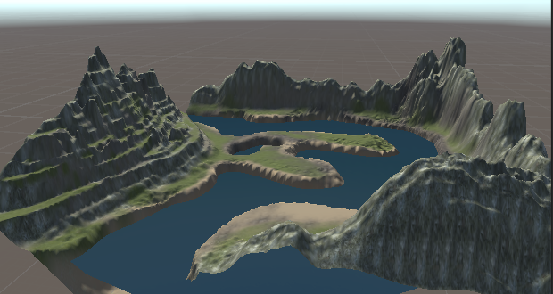

1. With that you are done!