**PREPARING FOR ADVISING WORKSHEET**

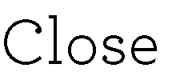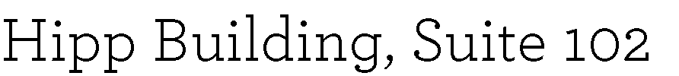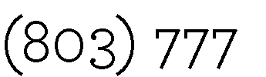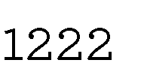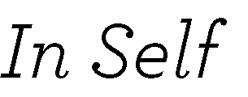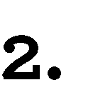

CSCE 190 A CHEM 111L A

CSCE 145 A CPLT 270 A

MATH 141 B+

CHEM 111 A

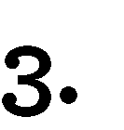

MATH 142 4 ARP: Calculus 2

CSCE 146 4 Lower Division Computing

CSCE 215 1 Lower Division Computing

PHYS 111 3 Scientific Literacy

PHYS 111L 1 Scientific Literacy

HIST 111 3 Historical Thinking



1. Would having a mix of different classes be more beneficial, so you don’t get tired of the same thing in every class.
2. What happens if I’m not completely sure I want to be in this major?
3. What’s the best way to plan my schedule for next semester with the classes suggested?

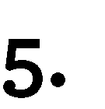

University **Advising** Center

**UNIVERSITY OF SOUTH CAROLINA**