RunWithMe

1. Introduction

It’s a website and mobile application for promotion a healthy lifestyle, finding collaborators and improving your physical fitness with another people and stay in touch them..

For example, you are a person who run every morning near your home and you want find a company to make this activity with collaborators. You go to the website or run mobile application, create the route, put the start time, pace, some description and share this route to another users. Users can view your route, timetable and can join to your activity.

2. Expected List of Features

* registaration and [authorization](https://context.reverso.net/%D0%BF%D0%B5%D1%80%D0%B5%D0%B2%D0%BE%D0%B4/%D0%B0%D0%BD%D0%B3%D0%BB%D0%B8%D0%B9%D1%81%D0%BA%D0%B8%D0%B9-%D1%80%D1%83%D1%81%D1%81%D0%BA%D0%B8%D0%B9/authorization). User should be able to create own account inm this service, put some information about yourself – like preferred running type, pace, places for activity
* create/edit/delete routes. Users should be able to create own routes and sharing it to another users, change some route parameters – such as start time, map route etc.
* view users routes and join route. Users should view and choose the most suitable routes for them
* tracking after start route (from mobile application). Users should be able to view in real time where is runners now – for example, to join after the activity starts.
* routes history. Information about completed routes should save and users can view it – route track, how many people were there,
* messaging. To arrange a meeting, users can send text message to route creator
* integration with social networks – for sharing some photos from running, for example

3. Market Survey

The most popular services for tracking activities are:

* runtastic
* endomondo
* runkeeper
* strava
* samsung health

All of this services have some features as tracking routes, workout history, some challenges and achievements for users. But in all cases format like competitions, not a collaboration.

Main idea of my service – is connecting people through activities and finding collaborators near your home. Just for run and making new contacts.

4. References

* [runtastic](https://www.runtastic.com)
* [endomondo](https://www.endomondo.com)
* [runkeeper](https://runkeeper.com)
* [strava](https://www.strava.com)
* [samsung health for android](https://www.google.ru/url?sa=t&rct=j&q=&esrc=s&source=web&cd=1&cad=rja&uact=8&ved=2ahUKEwjKv9W_yarlAhWSqIsKHfPkD30QFjAAegQIAhAB&url=https%3A%2F%2Fplay.google.com%2Fstore%2Fapps%2Fdetails%3Fid%3Dcom.sec.android.app.shealth%26hl%3Dpt&usg=AOvVaw11-dp_4-NR8YdA)
* [samsung health for ios](https://www.google.ru/url?sa=t&rct=j&q=&esrc=s&source=web&cd=1&cad=rja&uact=8&ved=2ahUKEwi4juvSyarlAhXhAxAIHV4aDSEQFjAAegQIBBAB&url=https%3A%2F%2Fapps.apple.com%2Fbr%2Fapp%2Fsamsung-health%2Fid1224541484&usg=AOvVaw2MaY7A1pG50Styqqnf5jLm)

# UI design

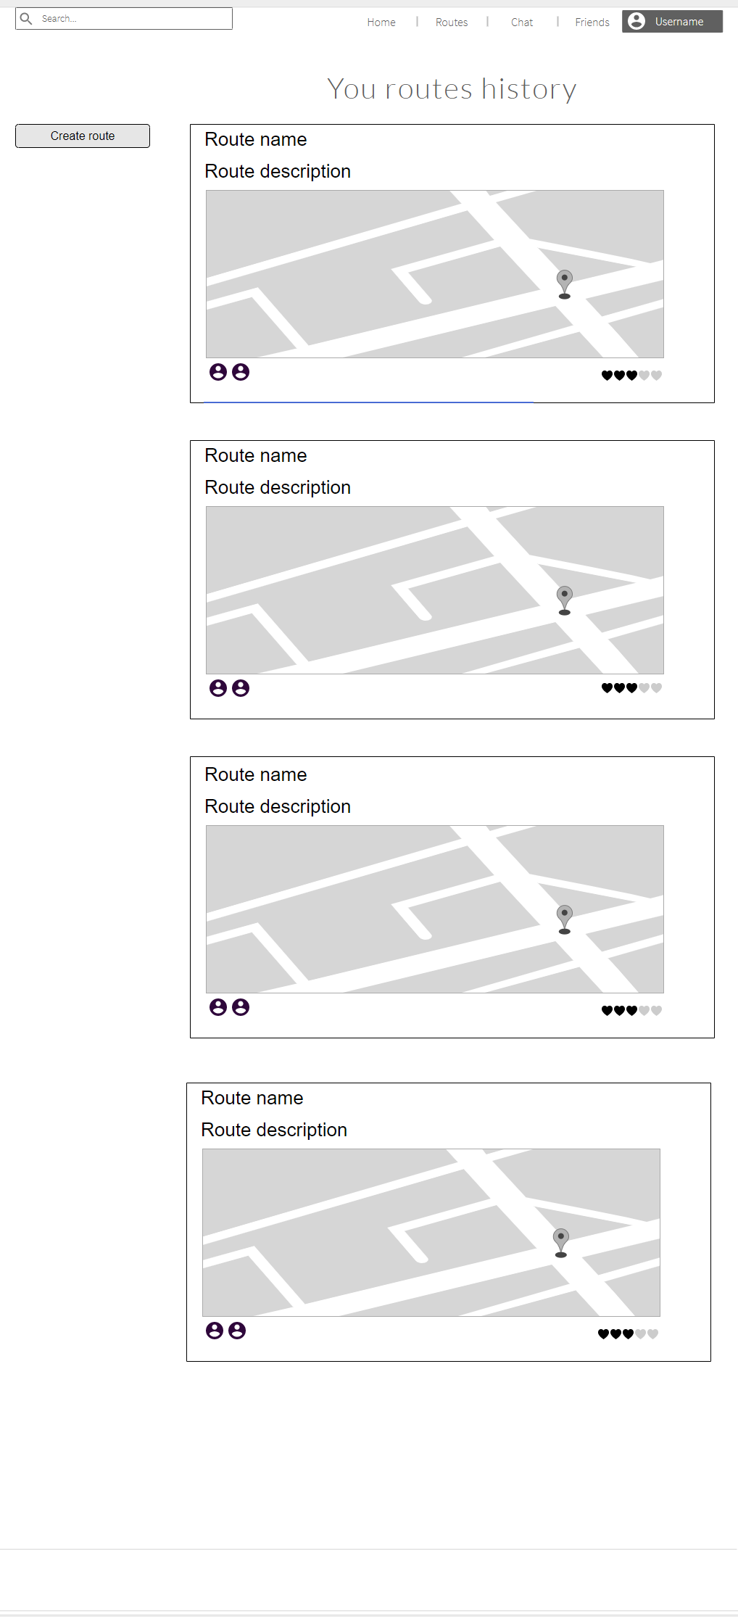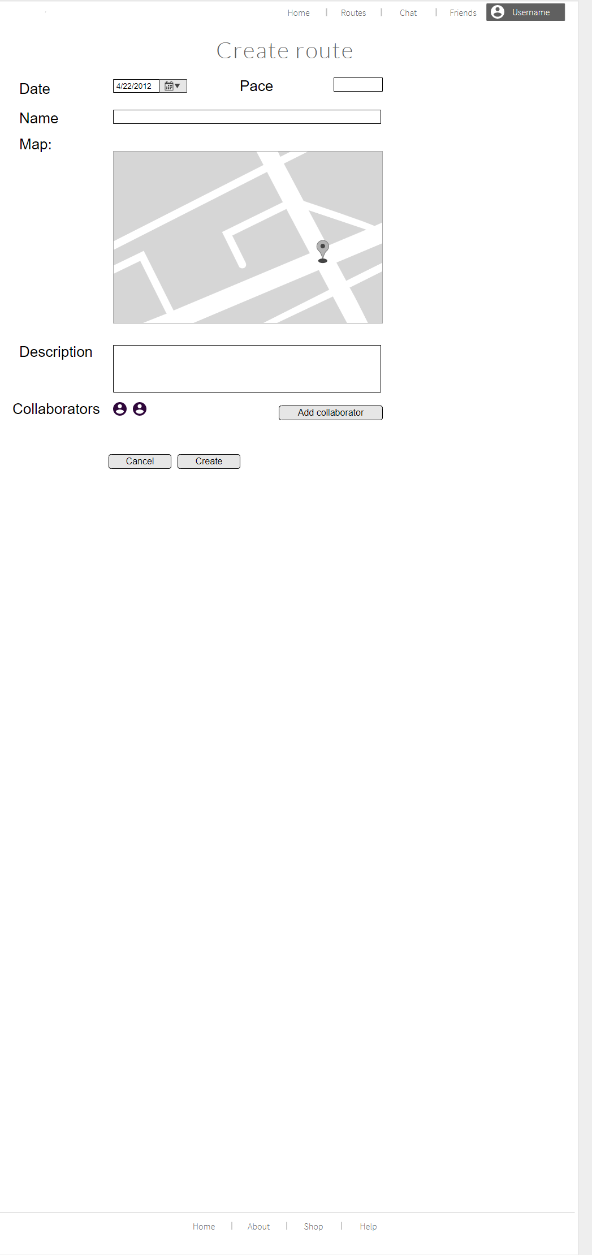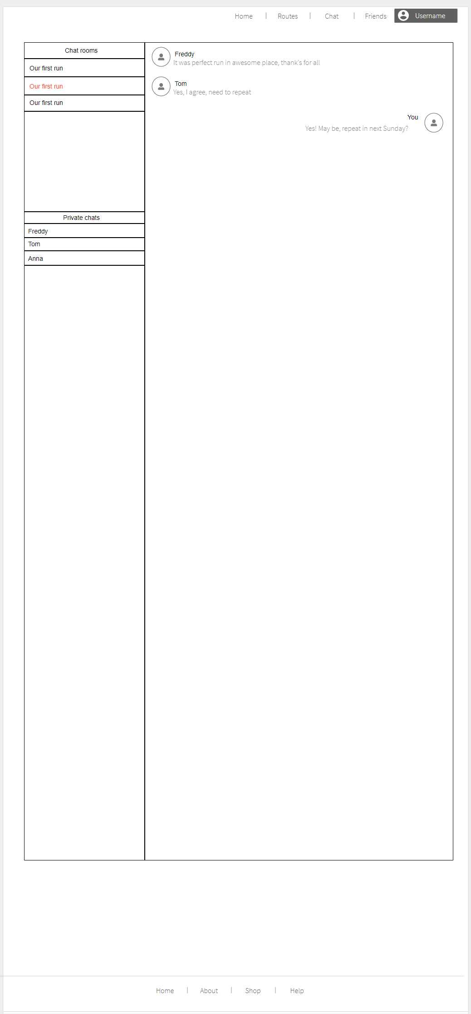

References

* [Mockups.com](https://www.runtastic.com)
* [RunWithMe mockup project](https://app.moqups.com/4gmhWw00gG/edit/page/a86bac5dc)