Software Design and Development
Project: ONLINE FOOD ORDERING SYSTEM
Team Members:
Harini
Prasanna
Chandini
Swathi
Haleema Shaik
Uma Nandini
Srilakshmi
Lakshmi Kala
Backend : Java (Spark Framework)
Frontend : HTML, CSS, JavaScript
Build Tool : Maven
1.System Overview
Purpose : Provide a simple, efficient platform for customers to order food online.
Objectives :
- Automate food ordering
- Improve customer convenience
- Manage restaurant menus and orders
- Connect frontend and backend

2. UML Diagrams
Use Case Diagram 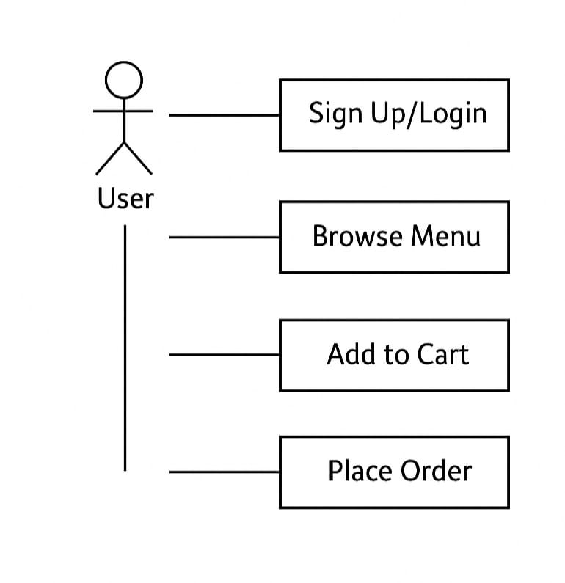
Sequence Diagram :

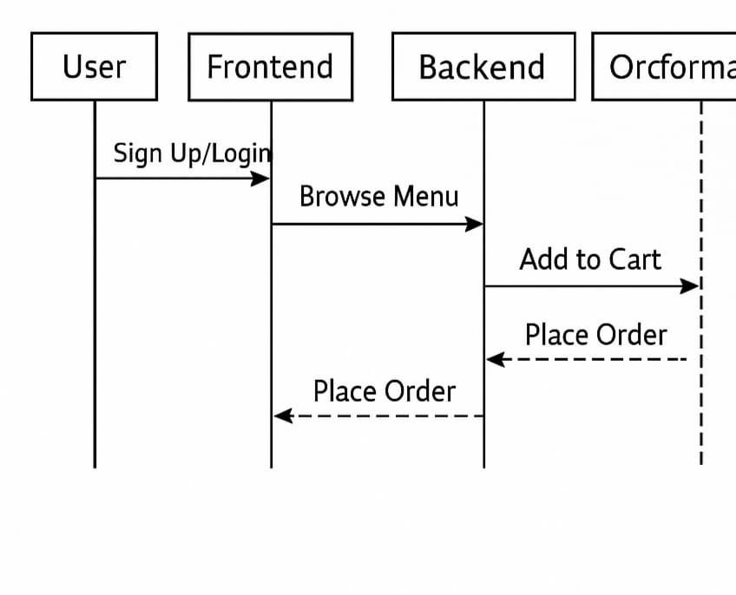
3. Flowchart :
Visual representation of the order process:
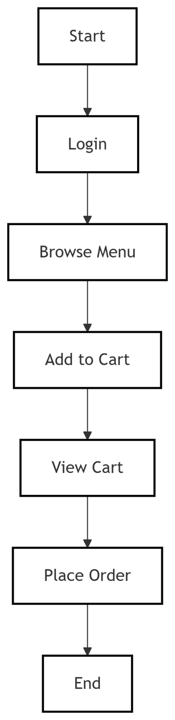
4. ER Diagram

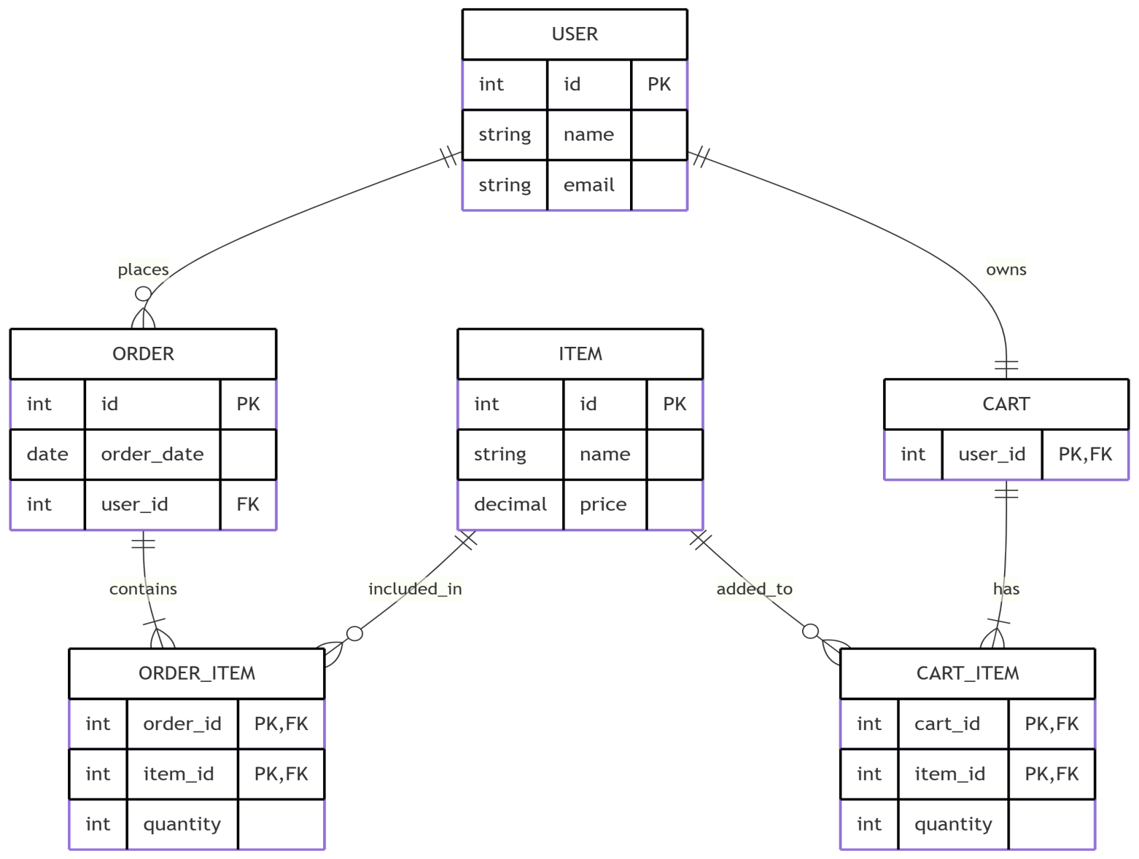

5. Architecture :
