Installation of Git, Java, Eclipse IDE, Spring Boot STS, Databases, VS Code, Node.js

(You might be already installed last semester)

1) Installation of Git
Steps:
- Go to the official Git website → https://git-scm.com
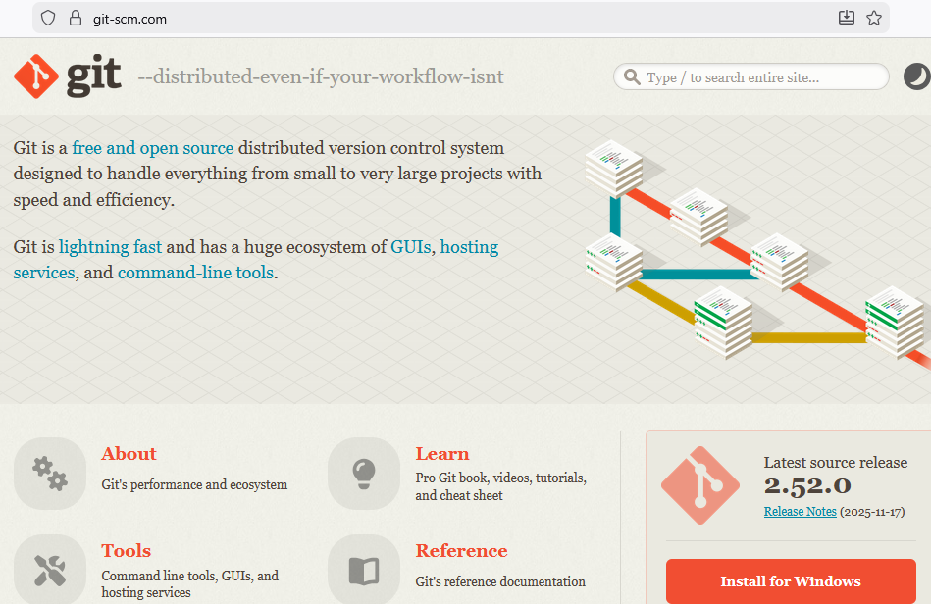
Click on Intall for Windows Button
• Open the downloaded .exe file
• Click Next until finish (keep default options)
• After installation, open Command Prompt and check: git - - version
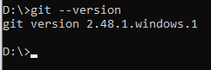

2) Installation of Java (JDK)
Steps:
- Go to → https://www.oracle.com/java/technologies/downloads/
(or use OpenJDK: https://adoptium.net/ )
• Download JDK 17 (LTS) or JDK 21 (LTS)
• Run the installer and complete the setup
• Set JAVA_HOME:
- Search Environment Variables
- 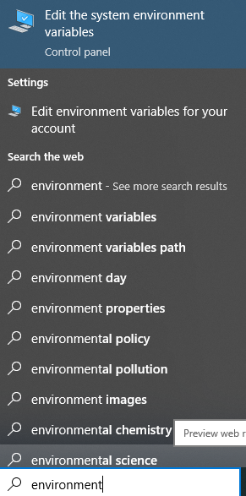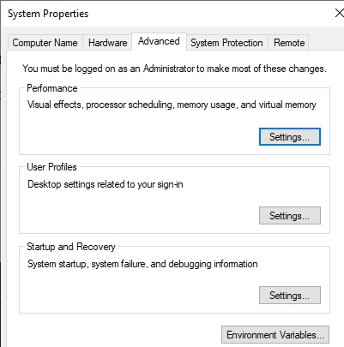
Click on “Environment Variable”
- Click on the “New” Button in the System Variable section, and variable name and path as follows:
Name: JAVA_HOME
Value: C:\Program Files\Java\jdk-17

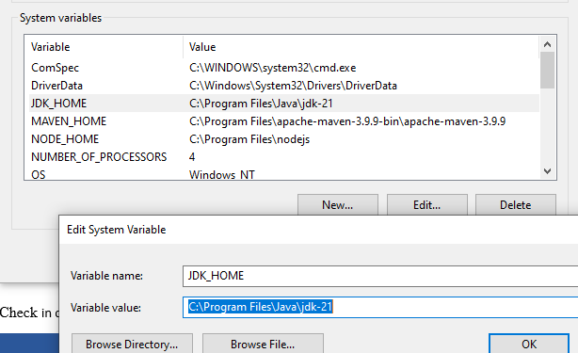
Check in command prompt: java –version
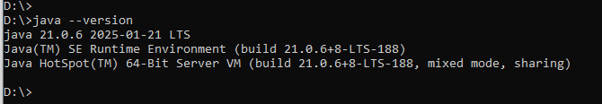

3) Installation of Eclipse IDE
Steps:
- Go to → https://www.eclipse.org/downloads/
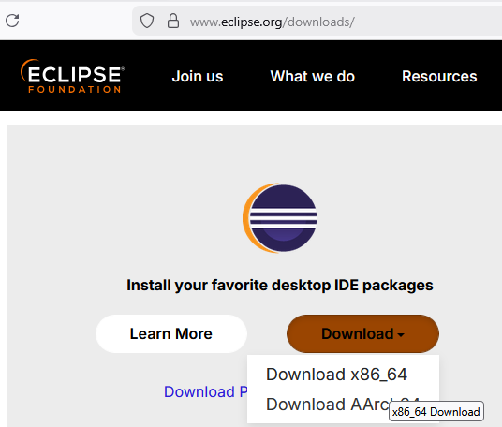
Click on Download x86_64
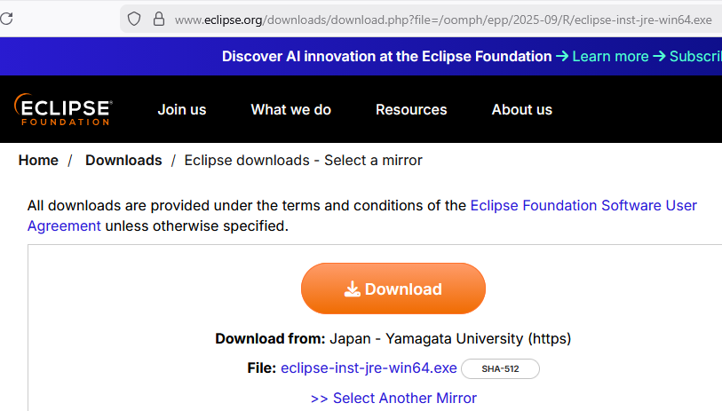
Click on Download Button. It will download latest version exe file.
Run the exe file. (Double click on the downloaded exe file)
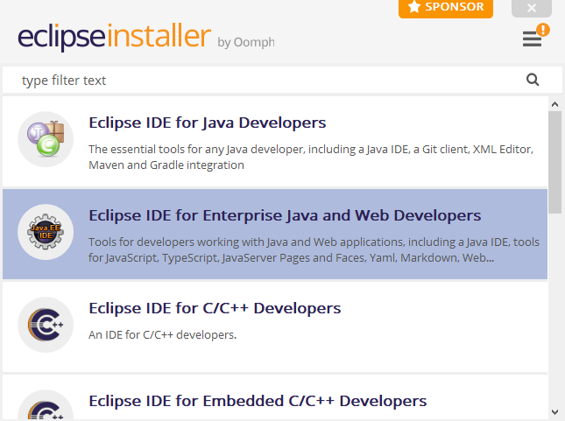
• Select the “Eclipse IDE for Enterprise Java and Web Developers” option
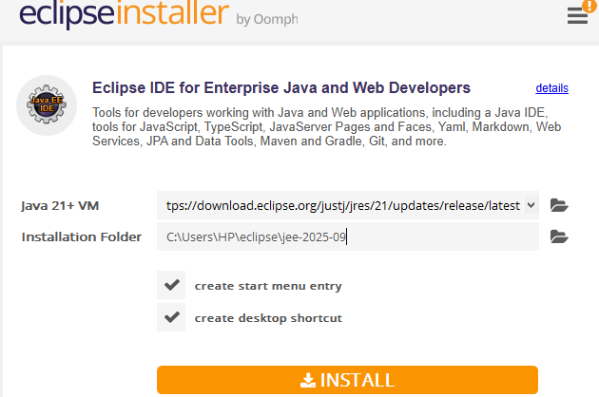
Click on the INSTALL button
• Choose workspace location (Where you want to store all you eclipse projects, specify its path, or keep it default one) →
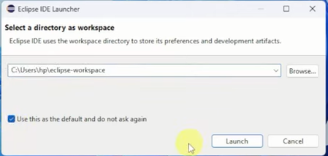
Click Launch

4) Installation of Spring Boot STS (Spring Tool Suite)
Steps:
- Go to → https://spring.io/tools
• Download STS for Windows
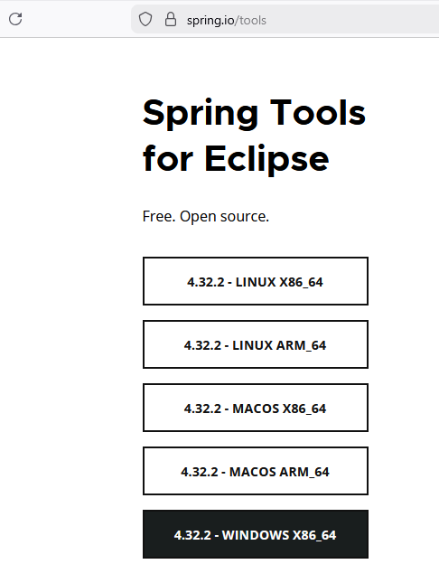
• Extract the ZIP
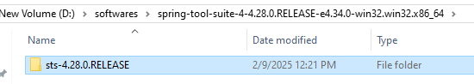
• Run SpringToolSuite4.exe
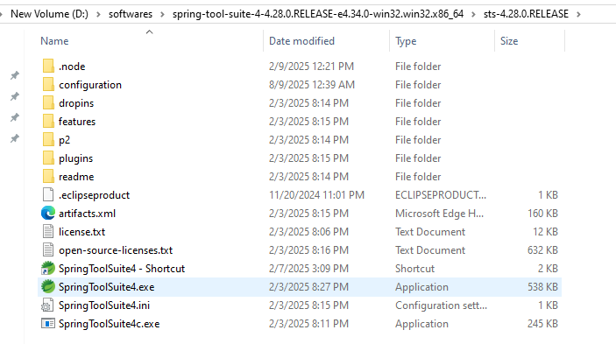
Create a shortcut for this exe file, and place it on the desktop, to open easily.
Right click on the exe file and choose “create shortcut” option
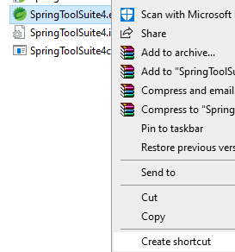

5) Database Installation (MySQL)
Steps:
- Go to → https://dev.mysql.com/downloads/installer/
- Download MySQL Installer (Community)
- Select:
  - MySQL Server
  - MySQL Workbench
- Click Install
- Set root password
- Finish setup
- 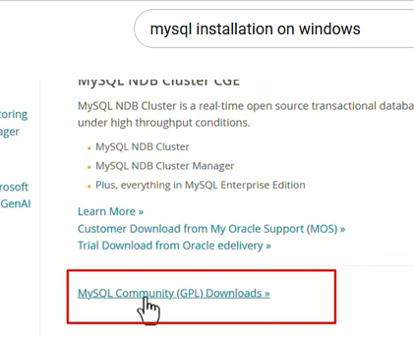
- 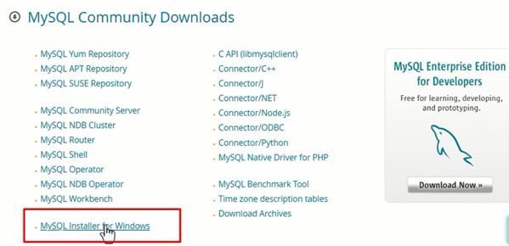
- 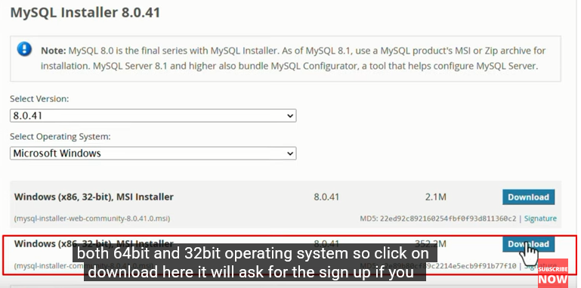

- 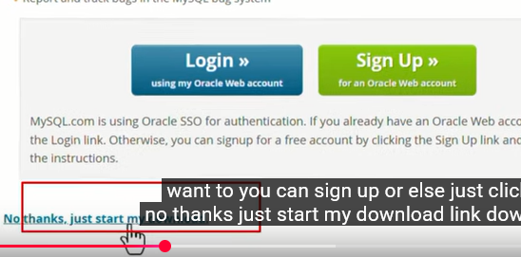

- 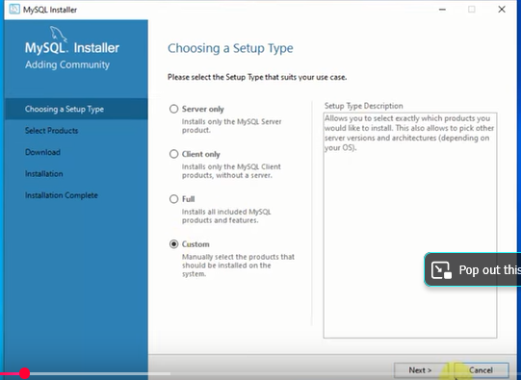
- 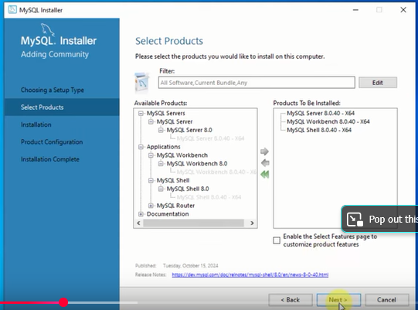
- 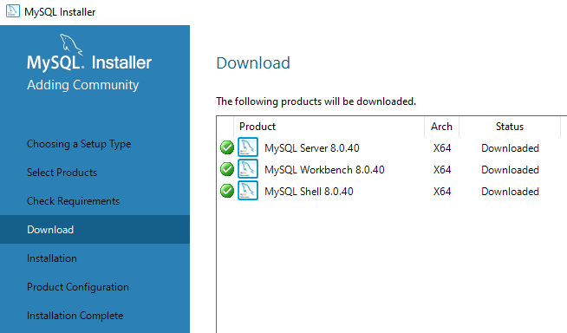

- Go with all default option by pressing NEXT
- 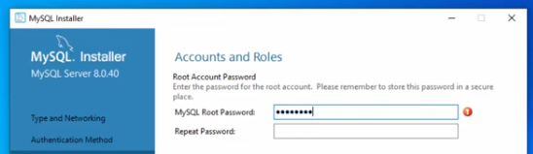
- Password : root
Remaining steps continue with default options.
Check: Open MySQL Workbench → login
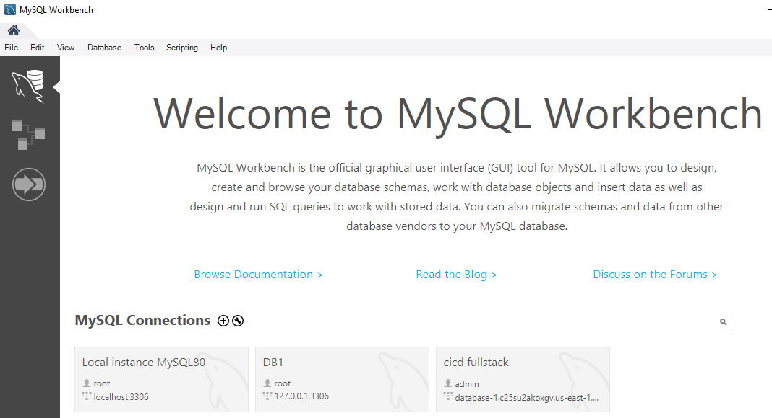

6) VS Code Installation

(You might be already installed last sem)
Steps:
- Go to → https://code.visualstudio.com
• Download Windows version
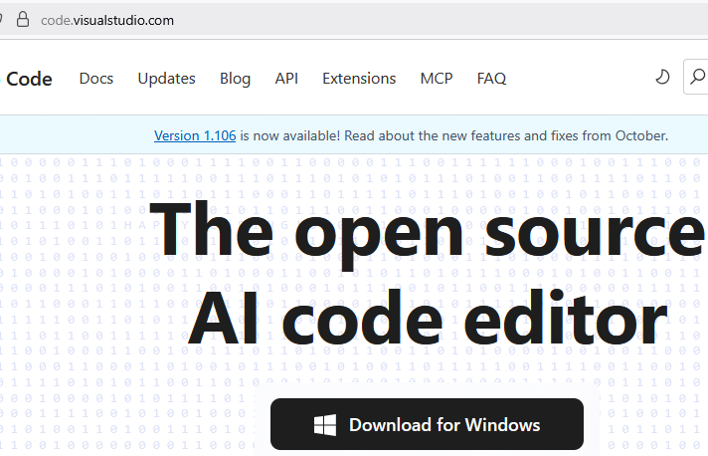
• Install with default options
• Open VS Code
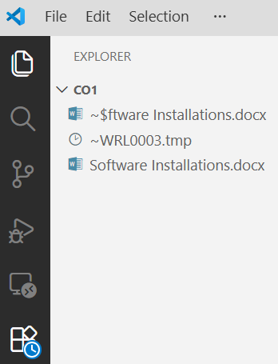
Click on the last option (3 rectangels Button to add the following extensions.)
Recommended Extensions:
- Java Extension Pack
- Spring Boot Extension Pack
- ES7+ Snippets
- Prettier

7) Node.js Installation

(You might be already installed last sem)
Steps:
- Go to → https://nodejs.org
• Download LTS version
• Install with default settings
• Check in Command Prompt: node -v
