
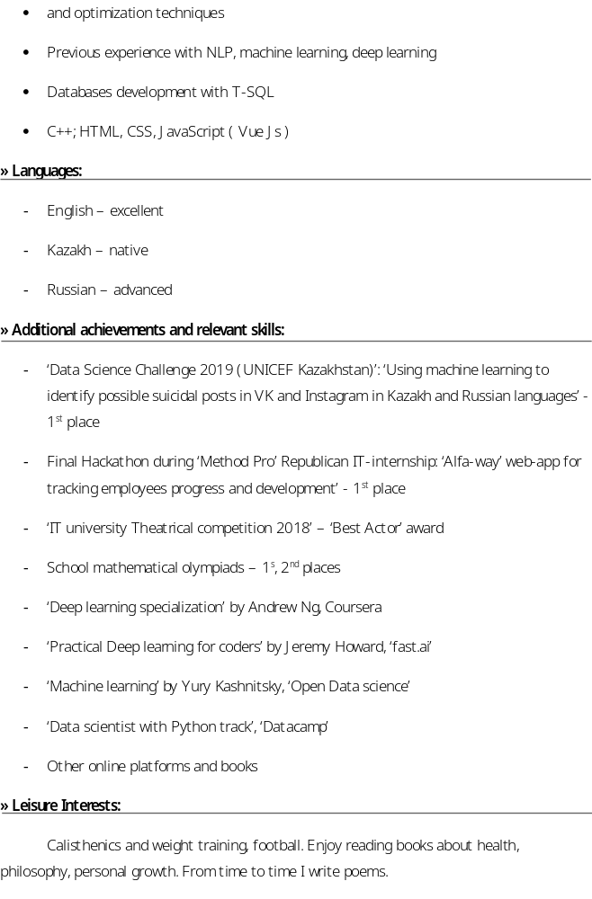
Hackathons:
- Alexa hackathon: Developed Alexa skill for tracking tube arrival times
- Jaxart: Developed marketing plan for sponsoring company

