## 6.3.1 Bootstrapping

The findings of the experiments presented in this dissertation, as well as the more general claims outlined here, point towards a number of potentially profitable directions for future research.

First, although I am critical of invoking bootstrapping explanations based simply on temporal order of events, both referential and conceptual bootstrapping are plausible and account for the observed data in human language learners fairly well. Unfortunately, because adult learners have already learned to establish reference, exploring the referential bootstrapping hypothesis using typical experimental participants and methodologies might be impossible. However, Imai & Kita (2014)’s *sound symbolism bootstrapping hypothesis*  is ripe for empirical testing: we already have evidence that infants attend to motivated word-meaning associations, and require only observations demonstrating that attention to motivated associations can be leveraged to establish reference for arbitrary ones.

The conceptual bootstrapping hypothesis suggests that learning non-arbitrary associations between words and meanings can enhance the ability of learners to recognize concepts and categories that are relevant to their language and can be leveraged for later language learning. Although adult learners have already established the ability to recognize categories and generalize across those categories (ref?) they might still benefit from non-arbtirariness in the establishment of new categories. Experimental stimuli like the “Yufo” (Gauthier and Tarr, 1997), where the distinction between the two types of images is not immediately apparent, even to adult learners, might allow for the best test of categorisation. Previously, authors have suggested that labelling superordinate categories generally allows children to learn to form those categories (Waxman & Hall, 1993; Waxman & Markow, 1995), and that relational concepts underpinning these categories can then be transferred to novel stimuli (e.g. Ratterman & Gentner, 1998). With systematicity at the level of the lexicon however, we are not interested in superordinate terms, but rather in how similarity within categories (or motivatedness of association) might similarly influence category formation. The “Yufo” stimuli used in Lupyan, Rakison, & McClelland (2007; Figure 6.08) are well suited to this task because the distinction between the two types is not immediately apparent, even to adult learners.

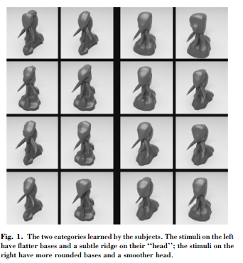

**Figure 6.08-** “Yufo” stimuli from Lupyan et al., 2007.

Lupyan et al. (2007) found that simply by having names, the category distinction between the two types of Yufos was made more salient and the categories were learned more easily, despite the fact that the inclusion of names required additional learning. In 2014, Lupyan & Casasanto returned to these stimuli, demonstrating that when the superordinate names for the two types of yufos were motivated (‘foove’ for round-headed yufos and ‘crelch’ for pointier yufos) categorization became easier. This result certainly seems to suggest that motivatedness, at least, might bootstrap category formation. I propose a simple extension of this experimental paradigm where names are given to these stimuli directly, rather than labeling only their category. This manipulation would allow for a test of whether motivatedness and systematicity can more generally bootstrap the acquisition of categories, and further whether these learned categories can then be generalized to more arbitrary labels.

The experiment suggested above addresses the claim that non-arbitrary word-meaning mappings might facilitate the learning of category boundaries, but what about the establishment of categories more generally? Again, adult participants are already aware of the fact that the objects in their language can belong to meaningful categories, but what about children? The conceptual bootstrapping hypothesis suggests, in addition to making relevant dimensions more salient for adult learners, that this saliency might underpin the recognition that categories exist at all, much in the same way that motivated word-meaning mappings can be suggested to underpin the establishment of reference. Testing this possibility requires infant participants, but might otherwise use a similar methodology to Lupyan & Casasanto (2014) (although preferential looking, rather than direct responding, would likely be required).