Chen_Kaiyan_Project2
Kaiyan Chen
2025-11-17

First Plot
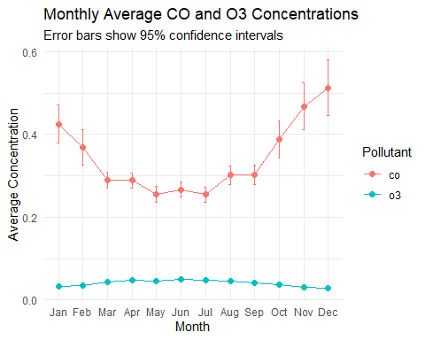

Second Plot
