# Database for One World Cafe

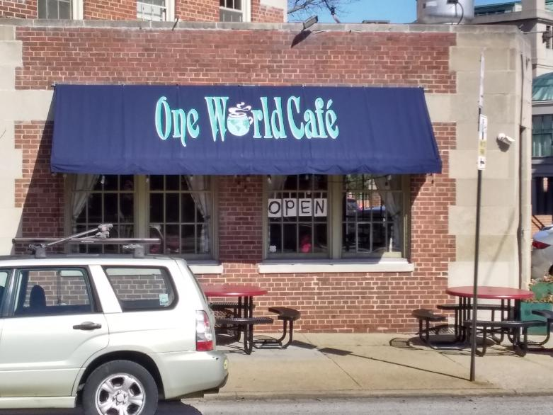

## Database Management Project

## Prepared by Group 2

## Spring 2021

# Table of Contents

Team Members ..………………………………………………………………………………………………………………………………… 2

Interviewee Signature ..………………………………………………………………………………………………………………………. 2

Introduction ..…………………………………………………………………………………………………………………………………….. 3

Business Profile ………………………………………………………………………………………………………………………………….. 3

Business Process ……………………………………………………………………………………………………………………..…………. 3

User Requirements …………………………………………………………………………………………………………………………….. 5

ERD ……………………………………………………………………………………………………………………………………………………. 6

Schema ………………………………………………………………………………………………………………………………………………. 7

Gantt Chart / Meeting Log ..………………………………………………………………………………………………………………... 8

# Group 2 Team Members:

* Deja Hamilton
* James Naurot
* Katherine Borowy
* Seth Graham

# Interviewee Signature:

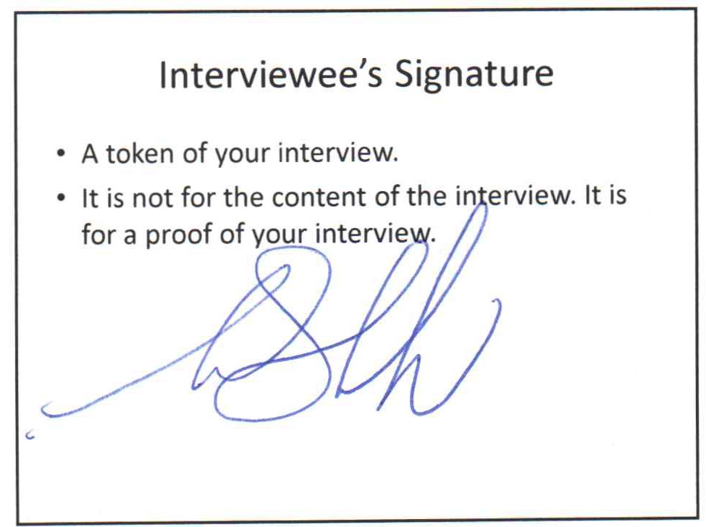

# Introduction

The One World Cafe database began in February 2021 to keep track of orders, employee roles and shifts, and overall workflow. The restaurant’s current system works well enough, but we plan to have a database model that will encompass all the needs of the restaurant. The current system has no database, and has two programs that do not interact with each other.

Our plan for this database will include an easy to follow database structure that will allow those who are not familiar with the system to make queries and find information to allow them to better run the establishment. It will also allow those two distinct programs, which originally did not interact with each other, to be easily communicated with each other and the person making the query.

Our team of four students will conduct work on this project. We will be using _____ to make the database and use ___ to create the GUI. This project will incorporate all of the database and software knowledge that the students are learning in this semester.

# One World Cafe Profile

One World Cafe is a restaurant serving vegan, vegetarian, and gluten free dishes in the Baltimore, Maryland area, specifically near Johns Hopkins University. The small business serves breakfast, lunch, dinner, and hosts specialty nights such as fundraisers and wine tastings for locals, Johns Hopkins students, and many more. They also provide catering services, and have one location.

# One World Cafe Process

### Ticket Creation Workflow

Customers can phone in an order for takeout, come into the restaurant and place an order to go, or be seated and place an order. The person taking the order places the information in the computer and a ticket is created. The ticket has the time, date, location of where the customer ordered (if the customer ordered over the phone, location is phone), employee id of the person taking the order, the ordered items, and a unique sequentially incremented number. The computer sends the ticket to a computer in the kitchen. If the order is to go, a bill is presented to the customer when the customer receives the food. If the customer is eating in, the customer receives the bill at the end of the meal. The person presenting the customer with the bill will collect payment and close the ticket. The method of payment is noted.

### Waiter Workflow

Waiters clock in at the start of their shift. Waiters are assigned to one of three locations: counter, bar, or dining area. Waiters in the dining area have their own “bank” from which they make change if a customer pays by cash. Waiters wait on customers and start tickets by placing orders into the computer. When the food is ready, the waiter is notified by the kitchen staff. The waiter then delivers the food to the customer. If the order is to go, a bill is presented, payment collected, and the ticket is closed. If the customer is eating in, the bill is presented to the customer at the end of the meal, and payment is collected. If the customer pays in cash and is seated in the dining area, the waiter makes change out of their “bank”. If the customer pays by credit card, the waiter swipes the card at one of the computers. Once the customer has paid, the ticket is closed. At the end of the shift, a Server Cash Out report is generated for each waiter. This is the difference between the total of the tickets generated by the waiter and what the restaurant took in from credit cards from those tickets. The waiter settles up with the restaurant from their “bank”.

Register Employee Workflow

A Register employee is a subclass of Waiter. A register employee has the additional privilege of using the register. There are two registers at One World Cafe, one in the bar area and one at the counter. Only one employee per shift is allowed to use a specific register. At the start of the shift, the register employee counts the drawer and the start count is noted. The workflow is identical to that of the waiter except that the register employee uses the register instead of having their own bank. At the end of the shift, the register employee is given a Server Cash Out report. The amount in the register should be equal to the drawer count at the start of the shift plus the Server Cash Out report. The register employee has to make up the difference. This is the primary reason why only one employee is allowed to use the drawer per shift. Each manager has register status, but usually does not open the drawer during a shift. Register employees also have the ability to generate reports. Server Cash Out reports are generated at the end of each shift and a Complex Sales Report is generated at the end of each day.

# User Requirements

### Process Modeling Requirements

There are three types of employees at One World Cafe: kitchen, waiter, and register. Each employee has the following information: employee ID, name, home address, phone number, salary/hour wage, SSN, shifts, and roles. All kitchen employees are salaried. Some waiters are salaried. An employee who is a waiter on one shift, could have register status on another shift.

There is also the Food Order or Menu type entity. There are many items on the menu that come with varying information stored on it (Availability, Price,Tax). The Menu can further be broken down into the various food categories each with their own attributes.

### Data Modeling Requirements

Users must have the ability to manually input information for employees, customers, and orders.

* Allow user to create, update, or delete employee information
* Allow user to input or edit food orders
* Allow user to take customer payment
* Allow user to pull up in stock items
* Allow user to create a total sales information sheet.

There are other user requirements that this database will generate.

### Expected Database Queries

* Compare sales from two different dates
* Complete sales for a person on a given shift (Server cash out/tip report)
* Complete sales of a shift
* Complete sales for a given day- this one is done nightly
  + Broken down by payment method- cash/Visa/AmEx/Mastercard/GrubHub
* Sales report of specials - returns number of specials sold, dollar amount of specials sold, #of other items sold. Can compare sales and/or items sold vs another date/time slot
* Sales report by hour - #items sold, $amount of items sold, cost of being open ( based on number of employees working during time period)
* Items available by time (i.e. Breakfast times, Lunch, etc.)
* Comparison of sales of different areas- each table has a number, each waiter has a specific area

# Entity Relationship Diagram

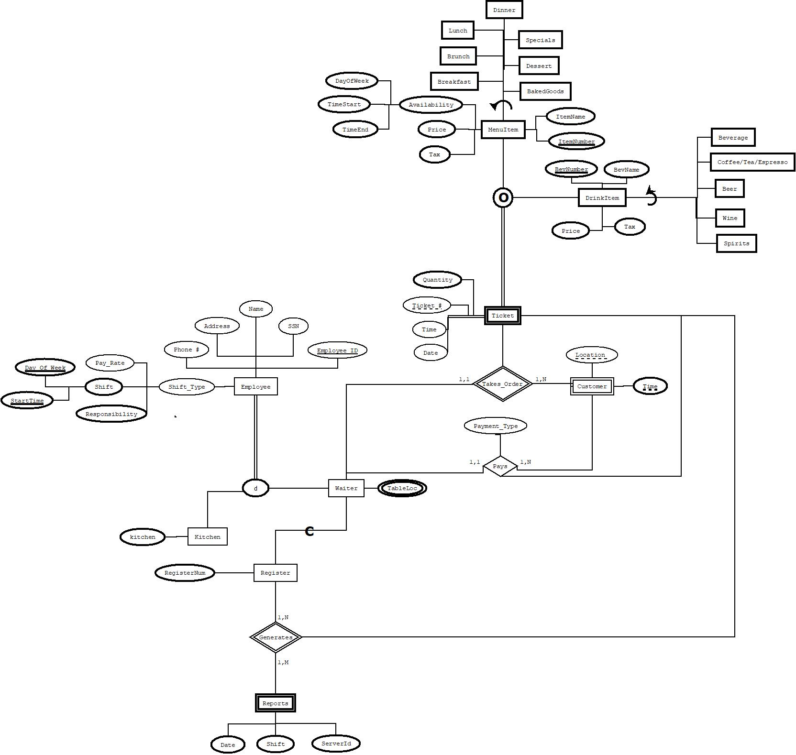

# 

# Schema

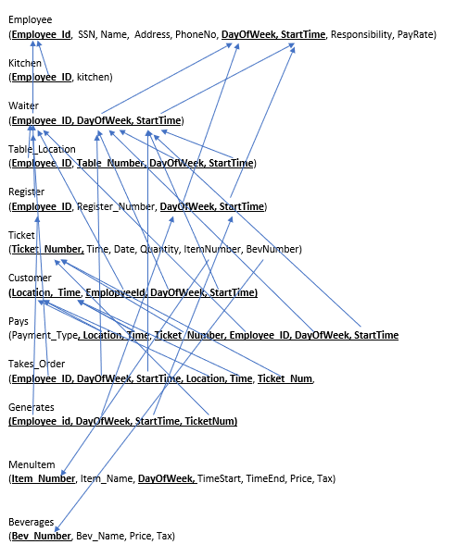

# Gantt Chart / Meeting Log

|  |  |  |  |  |
| --- | --- | --- | --- | --- |
| Task Name | Duration | Start | Finish | Member Names |
| Research on organizations | 3 days | Thu 2/11/21 | Sat 2/13/21 | All |
| Emails sent to organizations for confirmation | 5 days | Wed 2/17/21 | Sun 2/21/21 | All |
| Received project rubric | 1 day | Thu 2/25/21 | Fri 2/26/21 | All |
| Final Organization Decision | 1 day | Thu 2/25/21 | Fri 2/26/21 | All |
| Interview with Interviewee | 5 days | Thu 2/27/21 | Wed 3/3/21 | James |
| Received a signature from interviewee | 1 day | Wed 3/3/21 | Thu 3/4/21 | James |
| Listed possible queries | 1 day | Thu 3/4/21 | Fri 3/5/21  *Updated: Thu 3/11/21 | James and Kate |
| Drew the ERD | 21 days | Sat 3/6/21 | Sun 3/7/21    *Updated: Thu 3/11/21    *Updated: Mon 3/15/21  *Updated: Mon 3/26/21 | All |
| Schema Creation | 20 days | Sat 3/7/21 | Tue 3/10/21    *Updated:  Thu 3/11/21    *Updated: Sat 3/13/21    *Updated: Fri 3/26/21    *Updated: Sat  3/27/21 | Kate and James |
| Work on Project Report 1 | 21 days | Sat 3/6/21 | Thu 3/11/21    *Updated: Mon 3/8/21    *Updated:  Wed 3/10/21    *Updated:  Sat 3/13/21    *Updated: Mon 3/15/21    *Updated:  Wed 3/17/21    *Updated: Sat 3/20/21    *Updated: Fri 3/26/20    *Updated: Sat  3/27/21 | All |
| Submitted Project Report 1 | **N/A** | N/A |  |  |
| Database Creation |  |  |  |  |
| User Interface Creation |  |  |  |  |
| Testing database and interface |  |  |  |  |
| Discuss the requirements of final project |  |  |  |  |
| Finalize the project |  |  |  |  |
| Submit final project |  |  |  |  |
| Presentation creation |  |  |  |  |
| Practice for the presentation |  |  |  |  |
| Presentation of the project |  |  |  |  |