



Behaviour-Driven Adaptive Presentation in Digital Museums: Modelling Real-Time User Signals to Support Exploratory Engagement

Kate Forshaw
25259628

CIS4517 Research & Development Project
Supervisor: Dan Campbell

Final Project Report
September 28th, 2026
Word count: 18,258

This report is submitted in partial fulfilment of the requirements for the MSc Data Analytics Degree at Edge Hill University.
Abstract
Digital museum platforms increasingly support open-ended, curiosity-driven exploration, yet most still rely on static, search-centric interfaces that assume visitors arrive with clear goals and the vocabulary to express them. This project investigated whether real-time behavioural signals could be modelled to represent user interest and exploratory depth, and whether translating those signals into adaptive artefact presentation could support richer exploratory engagement, serendipitous discovery, and personalised pathways than a static interface allows, addressing three related gaps in literature: underdeveloped behavioural modelling, limited support for exploratory depth, and the near-absence of serendipity from adaptive system design. A Design Science Research methodology guided the ten-phase build of two functionally equivalent web-based prototypes, static and behaviour-adaptive, differing only in whether artefact presentation responded to six logged behavioural metrics: click frequency, total dwell time, mean dwell time, maximum navigation depth, revisit frequency, and unique artefact views. Thirty participants completed both conditions in a single session, in a within-subject, counterbalanced comparative study, generating 8,928 logged interaction events and 362 questionnaire responses, which were analysed using paired statistical testing and thematic analysis of open-text feedback.
The adaptive mechanism operated reliably, triggering 3,130 logged adaptive events across the participants tested under its finalised parameters without breaching its serendipity rate limit. Two of six behavioural metrics differed significantly between conditions: total dwell time fell and revisits rose under adaptation, a pattern more consistent with a reallocation of attention toward previously noticed artefacts than a uniform decline in engagement. Of four questionnaire measures, perceived relevance and overall experience improved significantly (p = .002 and p= .003 respectively), corroborated by a 66.7% stated preference for the adaptive condition, while perceived exploratory freedom and surprise showed no significant change, indicating that discovery was preserved rather than measurably enhanced. These effects are concentrated and the sample size limits what smaller effects the study could detect, but together the findings provide the first empirical evidence that lightweight, rule-based behavioural adaptation can meaningfully improve perceived relevance and user preference in a digital museum interface without narrowing exploratory freedom. The project contributes a validated, if narrower than initially scoped, behavioural signal framework, together with a reference implementation that practitioners without dedicated machine learning infrastructure could adopt.
Key words: adaptive interfaces, behaviour-driven personalisation, digital museums, exploratory engagement, serendipitous discovery, user behaviour modelling

Acknowledgements
I would like to thank my supervisor, Dan Campbell, for his helpful advice and support throughout the summer, and both him and David Walsh for first inspiring my interest in adaptive interfaces in digital museums. I am also grateful to my lecturers on the MSc Data Analytics programme, whose teaching helped me develop the skills I needed to become a data analyst and to carry out this project, and to my personal tutor, Paul Bakaki for always being available to talk and help, whether about university matters or post-university opportunities.
Thank you also to my partner, friends, family, and fellow students, who have supported me through a tough, busy year, and to everyone, including my pilot participants, who gave their time to take part in my study.
This project would not have been possible without the support of everyone named here.

Table of Contents
1. Introduction 8
1.1. Problem Context & Background 8
1.2. Problem Definition & Rationale 9
1.3. Aim & Objectives 9
1.4. Requirements Overview 10
1.5. Scope, Constraints & Assumptions 10
1.6. Expected Contributions 11
1.7. Structure of the Report 11
2. Literature Review 12
2.1. Theoretical Foundations 12
2.2. Review of Existing Systems, Tools, Technologies, or Studies 14
2.3. Evaluation of Alternative Approaches 15
2.4. Gap Analysis 17
2.5. Justification for Proposed Approach 18
3. Methodology 20
3.1. Research Strategy 20
3.2. Justification of Chosen Methodology 22
3.3. Experimental Design 22
3.4. Development Methodology 23
3.5. Data Collection Methods 25
3.6. Validity, Reliability & Bias Control 25
3.7. Ethical Considerations 26
3.8. Tools, Technologies & Platforms 27
4. Implementation 29
4.1. System Architecture 29
4.2. Core Implementation Details 33
4.3. Dataset Preparation & System Configuration 36
4.4. Experimental Procedure 37
4.5. Testing Strategy & Validation 41
5. Results, Evaluation & Discussion 45
5.1. Presentation of Results 45
5.2. Objective-by-Objective Evaluation 56
5.3. Comparison Against Literature 59
5.4. Limitations, Trade-Offs & Threats to Validity 60
5.5. Legal, Social & Ethical Implications 63
5.6. Professional and Industry Relevance 65
6. Conclusions, Critical Reflection & Future Work 67
6.1. Key Achievements & Contributions 67
6.2. Project Success 70
6.3. Critical Self-Reflection 74
6.4. Limitations 76
6.5. Recommendation for Future Work & Further Research 77
References 79
Appendices Content 88

List of Figures
Figure 1 Workflow for behaviour-driven adaptive prototype 21
Figure 2 Phased Build Roadmap 24
Figure 3 System Architecture Sketch 29
Figure 4 Adaptive System ERD 31
Figure 5 Behaviour Logging ERD 32
Figure 6 Metadata ERD 32
Figure 7 Questionnaire ERD 32
Figure 8 Scoring Pipeline Diagram 33
Figure 9 Study Protocol Flow Diagram 38
Figure 10 Main Interaction Flow Diagram 40
Figure 11 Boxplots of Each Questionnaire Dimension 47
Figure 12 Bar Charts of the Means of Each Behavioural Metric by Version 49
Figure 13 Bar Chart of Stated Overall Preference 49
Figure 14 Distribution of Suggestion Interest Score & Per-Participant Suggestion Click-Through Rate 51
Figure 15 Theme Frequency Across All Coded Free-Text Responses 54

List of Tables
Table 1 Dwell-Based Adaptive Rules 34
Table 2 Interest Score Range and Panel Composition (reproduced from Appendix D.5) 35
Table 3 Metadata Cleaning Rules (Condensed) 37
Table 4 Session Timing Structure 39
Table 5 Testing Phases Summary 41
Table 6 Paired Comparisons of Questionnaire Dimensions 46
Table 7 Paired Comparisons of Behavioural Metrics 48
Table 8 Crosstab of First Version and Preferred Version 50
Table 9 Sensitivity Check Excluding Pre-Serendipity-Rate Participants 51
Table 10 Thematic Framework Table 52
Table 11 Themes Clustered Across Stated Overall Preference 55
Table 12 Fulfilment of Objectives and Research Questions Against the Evidence Produced 69
Table 13 Metric-Level Results, Interpretation, and Success 72

List of Equations
Equation 1 Interest Score = (Σ (Signal Weight * Priority Multiplier)) / Number of Signals 34

Introduction

Problem Context & Background
Digital museums and online cultural heritage platforms have become central to contemporary cultural engagement, offering remote access to large-scale collections and supporting diverse forms of learning and exploration. These platforms increasingly function as cultural spaces, enabling open-ended discovery rather than simple fact retrieval (Marty, 2007; Navarrete, 2019). Advances in semantic enrichment and linked-data infrastructures have expanded the technical capacity of museums to publish and organise collections at scale (Hyvönen, 2020; Povroznik, 2025). However, the interaction models used to navigate these collections have not evolved at the same pace as their technical foundations.
A recurring challenge identified across the literature is the dominance of static, search-centric interfaces. These systems assume that users arrive with clear goals and the vocabulary to express them, despite evidence that many visitors do not know what they are looking for (Coburn, 2016). Studies of real user pathways show that exploration is typically non-linear, drifting, and curiosity-driven (Kreiseler et al., 2017), aligning with broader theories of exploratory search and sensemaking (Marchionini, 2006). Serendipitous discovery is also recognised as a meaningful component of digital cultural engagement, with unplanned encounters often enhancing curiosity, insight, and user satisfaction (Makri & Blandford, 2012). Yet static interfaces rarely support such experiences.
Recent work in behaviour-driven personalisation demonstrates the potential of using interaction patterns – such as dwell time, revisits, and navigation depth – to infer emerging interests (Chen & Chen, 2025; Xhembulla, 2016). Adaptive interpretation approaches similarly highlight the value of tailoring content to user context and behaviour (Not & Petrelli, 2018). Despite these advances, most digital museum platforms still present content uniformly and do not operationalise behavioural signals into real-time adaptivity. This disconnect between user behaviour and system response establishes the foundation for the research problem addressed in this project.

Problem Definition & Rationale
Three interrelated gaps emerge from the literature. First, behavioural modelling in digital museums remains underdeveloped: although dwell time, revisits, and navigation sequences are recognised as indicators of interest, their ambiguity and contextual variability limit their use in real-time systems. Second, exploratory depth is poorly supported, as static interfaces fail to respond to drifting, deep-dive, or serendipitous browsing modes identified in empirical studies. Third, serendipity is rarely integrated into adaptive logic, despite evidence that unexpected yet meaningful encounters significantly enhance engagement (Makri & Blandford, 2012). Existing personalisation approaches tend to prioritise relevance over surprise, creating tension between recommendation and serendipity.
Critically, no reviewed system combines these elements into a behaviour-driven, real-time adaptive model capable of adjusting artefact presentation during the user’s session (Ivanov & Velkova, 2025). This project addresses this gap by investigating how real-time behavioural signals can be modelled to represent user interest and exploratory depth (RQ1); how such signals can be used to drive adaptive artefact presentation (RQ2); how interaction patterns differ between static and behaviour-adaptive interfaces (RQ3); and what experiential impact this adaptation has on users’ perceived relevance, exploratory freedom, and discovery pathways (RQ4).

Aim & Objectives
Aim: To investigate and evaluate behaviour-driven adaptive techniques for digital museum interfaces by analysing real-time user interaction patterns and assessing how adaptive artefact presentation influences exploratory engagement, serendipitous discovery, and personalised pathways.
Objectives:
- Synthesise literature on behaviour-driven personalisation, exploratory search, and adaptive museum interfaces, across over thirty sources, to identify theoretical gaps informing the adaptation model.
- Develop a behavioural signal framework specifying six measurable indicators of user intent, exploratory mode, and serendipitous discovery.
- Construct static and adaptive web-based prototypes, built across a ten-phase development cycle, that operationalise the behavioural framework.
- Collect and analyse real-time interaction data from at least 20 participants across both prototypes to evaluate behavioural patterns against interest, exploratory depth, and serendipity.
- Evaluate the effectiveness of behaviour-driven adaptation by comparing static and adaptive conditions through paired statistical testing and thematic analysis of qualitative feedback.

Requirements Overview
This project’s primary requirement is a valid, ethically compliant dataset of genuine behavioural data collected directly from real participants, with no reliance on synthetic, downloaded, or simulated interaction logs. It requires a controlled comparative design capable of isolating the effect of adaptation, combining quantitative interaction logs with qualitative participant feedback.
The prototype exists to satisfy these research requirements. It must present two functionally equivalent conditions – static and behaviour-adaptive – that differ only in whether artefact presentation responds to real-time behavioural signals, log interactions with sufficient reliability for analysis, and operate within UK GDPR and the study’s ethical approval.

Scope, Constraints & Assumptions
The project’s scope is a controlled, within-subject comparison of static and adaptive versions of a purpose-built prototype, using a curated artefact instead of a live museum collection. Each participant completes both conditions in a single session on the same laptop; the sample is a convenience group of at least 20 fellow students, family, and friends, not a representative sample of general museum visitors.
Sessions take place across variable locations – university and researcher’s home – over controlled Wi-Fi. Adaptive suggestion refreshes are dependent on live server roundtrips; residual variation in adaptive update rhythm across participants is an accepted, reported limitation rather than engineered away, since altering it risked confounding the comparison. Running every session on a single controlled device removes browser and device variability as a confound but limits how far findings can be generalised.
The main assumptions are that logged behavioural signals – dwell time, clicks, revisits, and navigation depth – are valid proxies for exploratory interest, in line with the literature underpinning the framework, and that this convenience sample’s browsing behaviour reasonably approximates that of general digital museum visitors.

Expected Contributions
The project’s primary contribution is empirical: evidence on whether and how behaviour-driven adaptation affects exploratory engagement, serendipitous discovery, and personalised pathways during digital museum browsing, directly addressing posed research questions through a comparative dataset of static versus adaptive interaction patterns collected from real participants. This includes a validated behavioural signal framework linking dwell time, revisits, and navigation depth to exploratory modes – contributing empirical grounding to the three gaps identified in the literature: underdeveloped behavioural modelling, unsupported exploratory depth, and serendipity’s absence from adaptive logic.
Secondarily, although built as a research instrument rather than an end product, the prototype offers a reference implementation of behaviour-driven adaptive logic that other digital heritage projects could draw on.

Structure of the Report
The remainder of this report is structured as follows. Chapter 2 (Literature Review) critically synthesises the theoretical foundations, existing systems, and gaps underpinning the adaptation model. Chapter 3 (Methodology) details and justifies the research strategy, experimental design, and data collection methods. Chapter 4 (Implementation) describes the system architecture and logic, and study procedures. Chapter 5 (Results, Evaluation & Discussion) presents and evaluates findings against each objective and the literature. Chapter 6 (Conclusions, Critical Reflection & Future Work) summarises key contributions, reflects critically on the project, and outlines future research directions.

Literature Review

Theoretical Foundations
The design of the proposed system draws on theoretical work from information science, human-computer interaction and museum visitor studies, spanning stable visitor identity through to momentary attention allocation. Individually, none of this literature was developed with real-time, behaviour-driven artefact recommendation in mind.
Marchionini (2006) reframes information seeking as exploratory as opposed to fact-retrieval behaviour, distinguishing lookup from learning and investigation and arguing that the latter two require sustained, iterative interaction rather than a single query-response exchange; White et al. (2007) extend this into an interaction-design agenda, characterising exploration as non-linear, with users wandering, comparing and revisiting rather than converging on one answer. This body of work is largely descriptive, however, establishing that browsing should be supported without specifying how a system ought to decide, moment to moment, what to surface. Pirolli and Card (1999) supply that mechanism through information foraging theory, modelling users as bounded-rational foragers who follow information scent, proximal cues such as titles and previews, to maximise the value of information gained per unit of effort. Concepts such as information patches and scent-following translate directly into measurable behavioural proxies (dwell time, repeat engagement, movement between items) that a recommendation system can act on, although the theory originates in general information-seeking and workplace tasks rather than museum visitors specifically, meaning its applicability here remains an assumption rather than an established fact.
This optimisation-driven framing sits uneasily against research on serendipity. Makri and Blandford (2012), through critical-incident interviews with 28 researchers, and Makri et al. (2015), who directly observed 45 users across digital libraries, e-commerce platforms and news sites, both demonstrate that unplanned encounters, noticing something valuable while pursuing an unrelated goal, are behaviourally detectable, through topic shifts, goal-less browsing and sudden engagement with previously ignored content, rather than being purely a matter of self-report. A system tuned solely to foraging logic risks suppressing precisely the low-scent, unexpected encounters this literature identifies as valuable, so reconciling efficient recommendation with preserved opportunities for serendipity is a tension this literature raises without resolving.
Bitgood's (2016) Attention-Value model was developed specifically from museum-visitor observation and therefore carries greater ecological validity than the foraging or exploratory search literature. Attention is modelled as a three-stage process, capture, focus, engagement, governed by a cost-benefit calculation, and decades of observational studies show that observed behaviour, such as dwell time and repeat glances, predicts visitor interest more reliably than demographic data or stated preference. This supplies concrete, measurable proxies for the more abstract scent and value constructs used in foraging theory, effectively bridging the two literatures, although constructs such as crowding and physical proximity require re-interpretation as digital analogues (session load, scroll proximity) since Bitgood's model was formulated for physical exhibition spaces.
Falk (2016) operates at a markedly different level of abstraction, arguing that visit behaviour is shaped less by demographics than by stable, identity-related motivations, and proposing five visitor types, explorers, facilitators, experience seekers, professionals/hobbyists and rechargers, through which identity predicts behaviour and memory. Where foraging and attention theory model moment-to-moment mechanics, Falk frames identity as relatively stable across an entire visit. The two levels are complementary in principle, but the link is untested in Falk's own work, which draws on physical-visit interviews and self-report rather than digital trace data; inferring identity-like categories from clickstream behaviour alone, as this project proposes, extends beyond what Falk's model directly supports.
Fan and Poole (2006) provide the conceptual vocabulary needed to position the system within the wider personalisation literature, distinguishing personalisation (system-initiated) from customisation (user-initiated) and proposing a three-dimensional classification of what is personalised, for whom, and by whom. Their caution that over-personalisation can erode serendipity restates, in personalisation-theory terms, the same tension between foraging-driven optimisation and serendipity research identified above, confirming this trade-off is recognised in the wider literature rather than being specific to this project.
Together, these strands span macro-level identity, meso-level exploratory framing, and micro-level attention and foraging mechanics, with serendipity research acting as a counterweight throughout.

Review of Existing Systems, Tools, Technologies, or Studies
Coburn (2016) built and tested Collections Dive, a browsing interface developed with Microsoft Research and Newcastle University that replaced keyword search with a highly visual, serendipity-driven layout; user testing found that 70% of participants attributed their enjoyment directly to the visual interface, and engagement time increased significantly once search was no longer the default entry point. Xhembulla’s (2016) MusA system pursued a similar aim through indoor positioning instead of visual redesign, inferring visitor type from movement, dwell time, and gaze to drive a location-aware guide, while Stock et al.’s (2007) PEACH project combined animated agents, location tracking and post-visit personalised summaries into one of the earliest large-scale adaptive museum systems, generating adaptive video documentaries from inferred interest and explicit like/dislike feedback. All three demonstrate that behaviourally inferred interest can drive real-time content change in a museum setting, although each relies on infrastructure, indoor positioning or agent-based presentation, that a purely web-based system does not require.
Not and Petrelli (2018) offer a more transferable architecture through the meSch project, proposing a three-layer model of customisation, context-awareness and adaptivity, tested across tangible installations such as NFC-triggered audio guides and object-recognition storytelling. Their case studies show personalisation embedded in interaction rather than added afterwards, and their curator interviews found that heavy automated adaptivity was valued less than transparent, user-controllable personalisation, a finding that echoes the concern raised earlier that over-personalisation can erode serendipity.
Beyond museum-specific prototypes, several recommendation architectures show how behavioural or contextual signals can be operationalised at scale. Amato et al.’s (2017) SCRABS system uses an ontology-driven data model and layered big-data architecture to update multimedia recommendations as visitors move through the Paestum archaeological site, treating physical proximity as the trigger where a digital museum would use interaction behaviour instead. Konstantakis et al. (2020) enrich a matrix-factorisation recommender with cultural tourist typologies collected from over 200 visitors at the Acropolis Museum and find that the resulting hybrid model outperforms standard collaborative filtering, evidence that richer user features, of which behavioural signals are one, improve recommendation accuracy. Liu et al. (2018), working outside cultural heritage entirely, propose a news recommendation system that continuously updates its output list using push and click frequency, browsing replacement strategies from cache theory to retire stale recommendations and promote emerging interests; their reported gains in click-through rate provide a direct precedent for treating artefact recommendations as a dynamically maintained list rather than a fixed set.
Khamaj and Ali (2024) go further, using reinforcement learning and a deep Q-network to rearrange interface elements in real time based on timestamped click and view data, with reward signals derived directly from engagement, although the authors note that scalability and computational cost remain open problems.
Hyvönen (2020) frames this progression as three generations of cultural heritage portals, search-and-browse systems, analytics-embedded portals, and AI-driven systems capable of surfacing serendipitous connections, illustrated through BiographySampo’s aggregation of over 13,000 linked biographies. Position against taxonomy, most of the museum-specific systems above, Collections Dive, MusA, PEACH remain closer to the first two generations, while SCRABS and the hybrid recommender edge toward the third without fully reaching it.

Evaluation of Alternative Approaches
The context-triggered logic used by SCRABS, meSch and PEACH shares a common structure: predefined thresholds or layers convert a sensed signal, proximity, dwell time, interaction history, directly into a content change. This approach is interpretable and cheap to compute, which matters given Not and Petrelli’s (2018) finding that curators favour personalisation they can inspect and explain over heavier automated inference; its weakness is that thresholds are fixed at design time and cannot refine themselves as more behavioural data accumulates within a session.
Konstantakis et al.’s (2020) and Liu et al.’s (2018) recommenders instead learn latent structure from historical interaction data, matrix factorisation over hundreds of visitors in the former, continuously updated push and click statistics in the latter, and both outperform simpler heuristics once that data exists. Neither approach transfers cleanly to a single-session, first-time-visitor context: matrix factorisation needs a substantial user-item history to populate its latent factors, and Liu et al.’s dynamic adjustment module assumes a returning, identifiable user base rather than a convenience sample encountering the system once.
Khamaj and Ali’s (2024) reinforcement-learning approach sits between these two: it adapts within a single session rather than requiring cross-session history, but its deep Q-network still needs many interactions to converge on a useful policy, and the authors themselves flag computational cost as an open problem. It is also the least transparent of the approaches considered here, which cuts against the preference for interpretable personalisation raised above.
Gajos et al.’s (2010) SUPPLE system frames personalisation differently again, as a constrained optimisation problem in which an explicit cost function, weighted by preference, ability or consistency, is minimised to generate an interface, with new interfaces produced in under a second even across a large search space. Reframing artefact selection the same way, minimising a cost function that trades off relevance, novelty and cognitive load, would keep the same interpretability as the rule-based systems above while allowing the weighting to shift as behavioural evidence accumulates during sessions, without needing the historical data a learned recommender requires.
Wang and Li (2025) pursue a more data-intensive alternative again, chaining Kansei engineering, entropy-weighted TOPSIS and particle-swarm-optimised support vector regression to map interface features onto emotional response. The pipeline is a useful precedent for structuring a multi-stage optimisation process, collect signals, weight features, build a mapping model, validate, but it optimises for a different outcome, emotional response, than exploratory or serendipitous behaviour, and depends on a trained regression model that this project’s convenience sample and single-session design are too small to support reliably.
Pousman et al. (2007) supply the criteria against which all the above should be judged for a casual, non-expert audience: low cognitive load, tolerance for intermittent interaction, and evaluation through engagement and diversity of exploration rather than task completion. Measured against these criteria alongside the data constraints identified above, the heuristic and optimisation-based approaches are more readily compatible with single-session, small-sample, first-time-visitor deployment than the data-hungry recommenders or the slower-converging reinforcement-learning approach.

Gap Analysis
The theoretical grounding outlined above, scent following, attention-value proxies, patch exploitation, give dwell time, revisits, and navigation depth a reasonably strong claim to validity as interest signals. This validity is rarely operationalised as anything more than a fixed threshold, however: SCRABS, meSch, and PEACH convert a sensed signal into a content change through pre-set rules rather than a model that refines itself as a session progresses, and the systems that do learn from behavioural data, Konstantakis et al.’s typology-enriched recommender and Liu et al.’s dynamic adjustment module, need a volume of historical, cross-visitor data that a single first-time visit cannot supply. Behavioural modelling is therefore underdeveloped specifically at the point this project sits: real-time, within-session, and without a persistent user history to draw on.
Exploratory depth fares no better. Marchionini’s (2006) and White et al.’s (2007) account of learning investigation as iterative, non-linear activity, and Pirolli and Card’s (1999) distinction between exploiting a productive patch and abandoning it for a new one, both describe shifts in depth that unfold moment-to-moment within a single visit. None of the systems already reviewed detect this directly; threshold-based systems respond to a signal crossing a fixed point rather than a change in exploratory mode, and the recommenders considered as alternatives optimise a ranked list rather than distinguishing a visitor who is drifting from one who is exploiting. Exploratory depth is acknowledged in theory but effectively invisible to the systems built so far.
Serendipity is the clearest case of a gap the review itself explains rather than merely reports. A structural tension was already identified between foraging-driven optimisation and Makri and Blandford’s (2012) account of unplanned, valuable discovery; every alternative approach considered, hybrid recommenders, reinforcement learning, cost-function optimisation, is built to raise relevance or engagement, not to protect the low-scent, unexpected encounters serendipity research values. Not and Petrelli’s (2018) curators reached the same conclusion from the opposite direction, favouring restrained, transparent adaptivity over heavier automation precisely as it preserves visitor agency. Serendipity is not merely unaddressed in existing systems; the optimisation logic most of them rely on works against it by design.
None of the three gaps is isolated. A system that models behaviour only through fixed thresholds cannot detect exploratory depth reliably, and a system optimised purely for relevance has no mechanism left over to protect serendipity once depth is detected. The composite gap this project addresses is therefore not any one of these individually but their combination: a real-time, single-session, behaviourally grounded model of exploratory depth that deliberately preserves space for unplanned discovery, which the systems and approaches reviewed above do not currently provide. The following section sets out how the proposed rule-based adaptive mechanism is designed to close this combined gap.

Justification for Proposed Approach
Positioned against Fan and Poole’s (2006) classification introduced earlier, the proposed adaptive mechanism is implicit, individual-level personalisation of both content and interface: it infers interest from behaviour rather than asking for it, and it adapts what is shown rather than only allowing a visitor to select it themselves. This sits closer to Not and Petrelli’s (2018) adaptivity layer than to pure customisation, a deliberate choice given how consistently behaviourally inferred interest featured across the theoretical foundations covered above.
The mechanism itself follows the cost-function logic demonstrated by Gajos et al.’s (2010) SUPPLE rather than a learned recommender or reinforcement-learning policy: artefact selection is treated as minimising a weighted cost across relevance, novelty, and cognitive load, updated as behavioural evidence, dwell time, revisits, navigation depth, accumulates within a session. This keeps the interpretability curators are shown to value while avoiding the historical, cross-visitor data a matrix-factorisation or reinforcement-learning approach would need and that a single, first-time visit cannot supply.
A cost function tuned to relevance would reproduce the same optimisation bias identified in the foraging literature, therefore the weighting deliberately reserves space for lower-scoring, unexpected artefacts rather than always surfacing the highest-scoring match; this is a direct attempt to operationalise Makri and Blandford’s (2012) account of serendipity as a designed feature rather than an accidental by-product of imperfect recommendation.
Read against the composite gap identified above, this design targets all three components at once rather than any one in isolation: behavioural modelling is grounded in dwell time, revisits and navigation depth as interest proxies; exploratory depth is addressed by updating the cost function continuously within a session rather than against a fixed threshold; and serendipity is preserved by design rather than left to chance. Whether this combination performs as the literature suggests is a question the remainder of this report is built to test.

Methodology

Research Strategy
The project adopts a Design Science Research (DSR) Methodology, a framework suited to socio-technical problems that are addressed by iteratively designing, building, and evaluating an artefact capable of generating new knowledge (Wieringa, 2010). Positioning the prototype as a research instrument rather than a finished product allows the static and adaptive interface pair to serve as the vehicle through which the research questions are investigated empirically.
The methodological workflow (see Figure 1) is structured around five interconnected phases, aligned with the core DSR cycles of problem identification, design, development, demonstration, and evaluation: requirements gathering and early user research, prototype design and implementation, behavioural data collection, behaviour analysis, and evaluation. Each phase feeds directly into the next. Requirements analysis shaped the behavioural signal framework underpinning the adaptive mechanism; this framework informed the design and development of the static and adaptive prototypes; the resulting prototypes were used to collect behavioural data from participants; this data was analysed to characterise exploratory depth, interest signals, and serendipitous encounters; and the analysis outputs, combined with participant feedback, formed the basis of the evaluation reported.
Although AI-assisted coding tools supported routine development tasks, all design decisions, adaptive logic, and evaluation processes remained research-led throughout, in keeping with DSR’s emphasis on the researcher’s ongoing control over the knowledge-generating process.
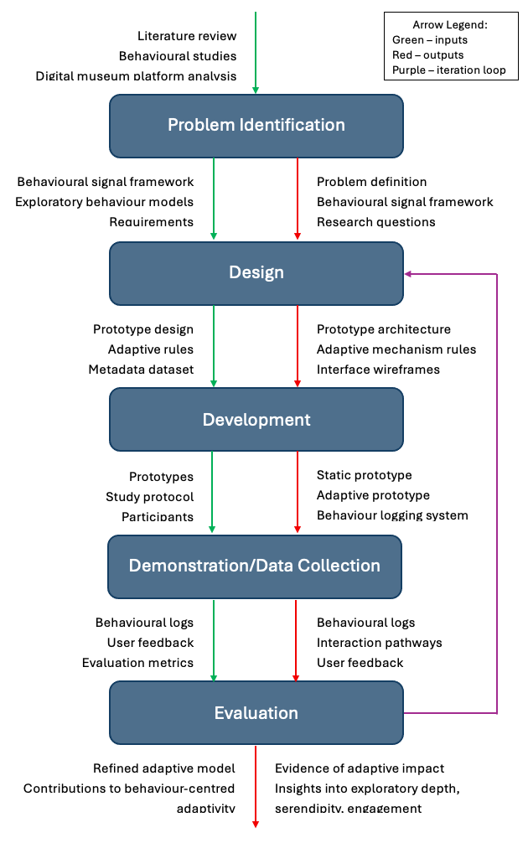
Figure 1 Workflow for behaviour-driven adaptive prototype

Justification of Chosen Methodology
DSR was chosen over a descriptive or synthesis-only strategy as the project’s aims requires more than an account of existing behaviour: it requires an artefact capable of generating and testing new interaction patterns before those patterns can be evaluated. Ivanov and Velkova’s (2025) systematic review found no existing system that combines behavioural modelling, real-time adaptation, and empirical evaluation within a single study, a gap that a literature synthesis or single desk-based enquiry could describe but not close. DSR’s requirement for an evaluable artefact addresses this directly: the static and adaptive prototypes are not identical to the investigation but the mechanism through which RQ1 and RQ2 are operationalised, ahead of RQ3 and RQ4 being assessed against the resulting data.
An action-research strategy was considered but set aside, as it assumes an existing organisational setting in which the researcher intervenes iteratively alongside practitioner stakeholders over multiple cycles (Baskerville, 1999); no such setting applies here, and the single-session, within-subject comparison this project requires is better suited to DSR’s build-then-evaluate structure than by ongoing organisational intervention. A fixed, single-pass experimental design was also considered and discarded, since it would treat the prototype as static once built, whereas the workflow in Figure 1 explicitly routes requirements and behaviour analysis findings back into prototype refinement (Hevner et al., 2004). DSR’s five-phase structure therefore matches both the object of the study, an interface that must be built to be tested, and the shape of the investigation, iterative, artefact-centred, and evaluation-driven, more closely than either alternative.

Experimental Design
The study uses a within-subject (repeated measures) design: every participant completes both the static and adaptive conditions rather than being assigned to only one. The independent variable is interface condition, with two levels, static and adaptive; the dependent variables are the behavioural interaction metrics and post-study questionnaire measures. Each participant explores a condition freely for seven minutes, separated by a transition screen, before completing the questionnaire once both conditions are finished.
Task order is counterbalanced across the sample: participants are assigned alternately to a static-first or adaptive-first sequence as they are recruited, giving an even split between the two orders as data collection progresses. Both conditions draw on an identical 60-artefact catalogue and share the same page layout; the adaptive panel is the only element present in one condition and absent from the other. Grid order is generated once per participant by a seeded ordering function keyed to their participant ID, so each participant sees the same artefact arrangement across both of their sessions, while the arrangement itself varies between participants.
Participants are recruited through a convenience sample, using a recruitment flyer circulated in person and through student networks (see Appendix I.1) (Etikan et al., 2016), the recruitment flyer could be scanned to lead people to the sign-up form (see Appendix I.2). Eligibility is limited to adults aged 18 and over; no prior museum knowledge or subject expertise is required. Sessions take place in person and typically last 15-20 minutes in total, held at a mix of campus and informal locations depending on participant availability. Thirty full study sessions were completed, split evenly between static-first and adaptive-first order, in addition to two pilot sessions used to validate the study protocol.

Development Methodology
Development followed an incremental, phase-based build in place of a single-pass implementation, reflecting Boehm’s (1988) spiral model: the artefact was constructed across ten sequential phases, moving from core database and logging infrastructure through the adaptive mechanism, error and fallback handling, artefact ordering, pilot testing, and full study simulation (see Figure 2; Appendix B.1). Each phase’s test cases had to pass before the next phase began (see Appendix E.1), so later phases could build on infrastructure already known to work rather than having to revisit it.

Figure 2 Phased Build Roadmap
This phased structure also shaped the adaptive mechanism itself. A rule-based, threshold-driven approach was chosen over a trained machine-learning model partly as it could be specified, tested, and adjusted within the same incremental structure, whereas a learned model would need its own data pipeline and training cycle outside it. The choice is also supported by the literature: dwell time, revisits, and switching patterns are known to be ambiguous and context-dependent (Bitgood, 2016; Bucklin & Sismeiro, 2009), favouring interpretable rules over a model whose reasoning would be harder to inspect mid-build. Kreiseler et al.’s (2017) exploratory modes, drifting, deep dives, object-to-object hopping map reasonably directly onto discrete thresholds, and persona-based visitor typologies (Almeshari et al., 2019) reinforced keeping the mechanism flexible rather than committing early to a fixed, learned model of intent.

Data Collection Methods
Behavioural data is collected automatically throughout both tasks via a shared event log, so no separate instrumentation is needed for the static and adaptive conditions (see Appendix B.10-B.12). Six quantitative metrics are derived from this log: click frequency, total dwell time, mean dwell time, max navigation depth, revisit frequency, and unique artefact viewing frequency. In the adaptive condition, the same log also records adaptive-panel activity, impressions and clicks, so panel engagement can be analysed alongside general browsing rather than as a separate dataset.
Data collection begins with consent and ends with a debrief, bracketing the two exploration tasks and transition screen already described. The post-study questionnaire (see Appendix I.4), completed once both tasks are finished, is a purpose-built PHP form rather than an external survey tool, so responses are stored directly against the same participant and session identifiers as the behavioural log rather than in a separate system (Creswell & Clark, 2007). It captures the four qualitative measures used in evaluation: perceived relevance, perceived surprise, exploratory freedom, and overall experience.

Validity, Reliability & Bias Control
The within-subject design and counterbalanced task order laid out earlier are the main controls on internal validity here. Comparing each participant against themselves across both conditions removes between-participant variability as a competing explanation for any difference observed (Charness et al., 2012), while counterbalancing keeps the two conditions from being confounded with the order in which they were experienced. Krasny-Pacini and Evans (2018) note that this logic holds even at modest sample sizes provided each participant serves as their own baseline, which is relevant given the scale of recruitment.
Content is controlled in the same way. Both conditions draw on the identical artefact catalogue and layout described, so the adaptive panel is the only element distinguishing the two interfaces, and any behavioural difference between conditions can be attributed to it rather than to what participants were shown. The per-participant seeded grid order serves a related but distinct purpose: it stops position acting as a proxy for interest, while deliberately avoiding a purely random shuffle in favour of a structured, subtheme-interleaved order, since uncontrolled randomness in artefact placement risks distorting the exploratory and serendipitous behaviour the study is trying to measure (Coburn, 2016).
Reliability is supported structurally by the prototype’s error and fallback system: every session is routed through the same guard logic regardless of missing sessions, database failures, or out-of-sequence navigation, so incomplete or corrupted sessions are flagged, not silently entering the dataset as valid data. This keeps the structure of data collection consistent across participants, independent of individual technical issues on the day.
Some threats remain only partially addressed. The convenience sample described earlier is unlikely to represent the wider population of digital museum users, and self-selection may favour participants already comfortable with exploratory web browsing. The prototype is also encountered for the first time within a single short session, so any novelty effect in the adaptive condition cannot be fully separated from a genuine adaptation effect using this design alone. These limitations will be revisited critically later.

Ethical Considerations
Ethical design began with approval through Edge Hill University’s ethics process before recruitment or data collection started (see Appendix H.1). Each participant receives an information sheet describing the study’s purpose, procedure, and data handling (see Appendix H.4), and gives written consent before their session begins (see Appendix H.5); a matching debrief sheet is given afterwards, restating their data rights and the researcher’s contact details (see Appendix H.6). Data handling follows GOV UK (2026) data protection guidance, so GDPR principles of purpose limitation and data minimisation shape the study design directly rather than being treated as a separate compliance step.
The study depends on tracking dwell time, clicks, and navigation patterns, the kind of behavioural analytics Joy et al. (2020) identify as ethically sensitive even when anonymised, therefore no personally identifying information, name, email address, IP address, is collected at any point. Participants are identified only by an anonymous participant code, generated at the start of their session, which links their behavioural log to their questionnaire responses without linking either to their identity. The same code lets a participant withdraw their data up to 14 days after taking part, without needing to disclose who they are beyond the code itself.
Risk was assessed systematically rather than informally: separate participant, data protection, legal/ethical, and personal risk registers were completed and mitigated before recruitment began (see Appendix H.2; H.3), and, read against the BCS (2022) Code of Conduct’s duty to have due regard for the wellbeing and legitimate rights of others, the study was judged to present no more than minimal risk to participants. Accessibility was considered at the same design stage, following GOV UK (2024) WCAG 2.2 guidance, so participation was not implicitly restricted to users without access needs.

Tools, Technologies & Platforms
Beyond the build itself, the project relied on a set of supporting tools. Literature was sourced primarily through Google Scholar and IEEE Xplore, chosen for their coverage of computing and HCI venues relevant to this project’s scope. Planning and tracking used Excel for the Gantt chart and participant study tracker (see Appendix A.1; A.2), and word for the risk assessment registers, testing plans, and other planning documents. Early design work, such as wireframes (see Appendix B.13-B.20), was drafted on paper before being formalised in Word.
The prototype itself was built and served locally through MAMP, with development carried out on Visual Studio Code; Claude Pro assisted with routine implementation tasks during coding, in line with the research-led AI use described earlier. The frontend uses HTML, CSS (see Appendix B.21), and JavaScript; the backend is written in PHP, chosen for straightforward integration with MAMP and to keep both the static and adaptive prototypes on the same lightweight stack; and a MySQL database stores artefact metadata, behavioural logs, and questionnaire responses in a single relational schema, suited to the session-level joins linking a participant’s clicks, dwell events, and survey answers.
Behavioural data analysis is conducted in Python, using Pandas to process the exported logs and Seaborn/Matplotlib for visualisation, chosen for their standard use in exploratory behavioural analysis and their compatibility with the CSV exports produced from the MySQL database.

Implementation

System Architecture
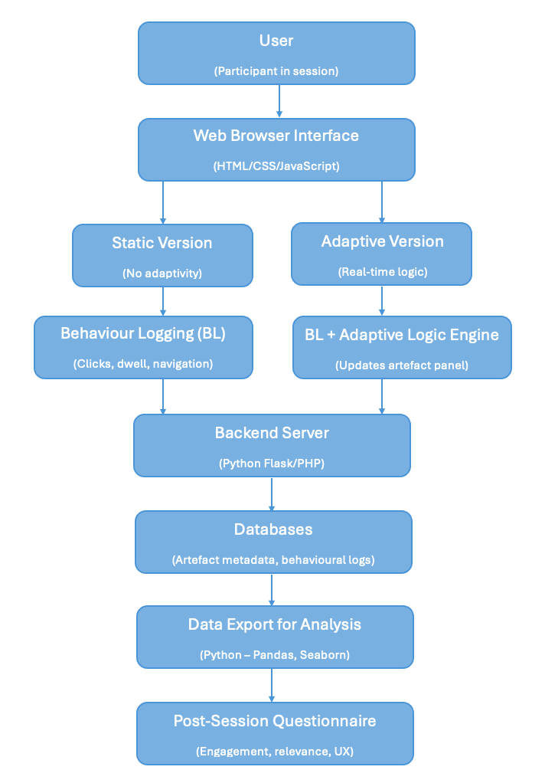
Figure 3 System Architecture Sketch
The prototype is a three-layer PHP/MySQL web application, served locally through MAMP and built on the toolset already justified. A presentation layer of seven participant- and researcher-facing pages sits above a logic layer of shared PHP modules that encapsulate the adaptive mechanism, which in turn calls a data layer combining a set of API endpoints with a single MySQL database accessed through PDO (see Figure 3; Appendix B.24). This separation keeps the adaptive logic testable independently of page rendering, consistent with the phased, test-gated build strategy outlined earlier and operationalises the design artefact called for by the Design Science Research strategy adopted (Wieringa, 2010), and follows the separation Fowler (2001) argues is essential for maintainable software – keeping presentation code isolated from the logic and data it depends on – here extended from user-interface code specifically to the full presentation/logic/data split described below.
Seven PHP pages implement this flow. First, index.php handles researcher-led participant setup and allocates the static-first or adaptive-first condition; static.php and adaptive.php are the two experimental interfaces, sharing the same page skeleton and artefact grid and differing only in whether the adaptive panel logic is invoked; transition1.php and transition2.php are the two self-paced transition screens between tasks; questionnaire.php renders and stores the post-study questionnaire. Finally, fallback.php is the shared destination for every guard-cause failure – missing session, broken database connection, or out-of-sequence navigation – across the other five pages, so no participant ever sees a raw PHP error screen.
Continuity across this sequence is maintained through five PHP session variables, each prefixed museum_ to avoid clashing with other locally hosted projects sharing the same MAMP session store. The museum_participant_id, museum_session_id, and museum_condition_name identify the participant, session, and allocated task order set at index.php; museum_adaptive_task_start timestamps the adaptive task for the seven-minute timer; and museum_fallback_logged flags whether a fallback event has already been logged for the session, preventing the same fault being recorded twice. Every page’s guard clause checks these variables before rendering and redirects to fallback.php if any are missing or inconsistent.
The logic layer comprises four includes/ modules, called from api/trigger_rule.php rather than from the page scripts directly. The artefact_order.php seeds a self-contained linear congruential generator from the participant’s ID, then interleaves artefacts round-robin across subthemes so both tasks present the same grid order to a participant without ever grouping consecutive artefacts from one subtheme (see Appendix D.7). The adaptive_rules.php evaluates the active rule set against a session’s current behavioural signals; adaptive_scoring.php converts the fired rules into an interest score and a suggestion mode; and adaptive_suggestions.php derives those signals from the session’s logged behaviour and assembles the four-artefact panel from related, deeper, cross-subtheme, serendipitous, or neutral candidate pools.
All persistent style state sits in a single MySQL database, digitalmuseum, of thirteen tables across four functional groups: artefact metadata (theme, subtheme, artefact), behavioural logging (session_log, event_log, adaptive_event, timeout), the adaptive system (adaptive_rule, adaptive_suggestion), and the questionnaire (questionnaire_item, questionnaire_response), with participant and study_conditions as control tables. Foreign keys chain every logged behaviour back to the participant, condition, and rule that produced it, which is the join structure the analysis depends on. These relationships are set out across four entity-relationship diagrams split by functional area – Adaptive System, Behaviour Logging, Metadata, Questionnaire (see Figures 4-7) – which align with the field-level data dictionary (see Appendix C).
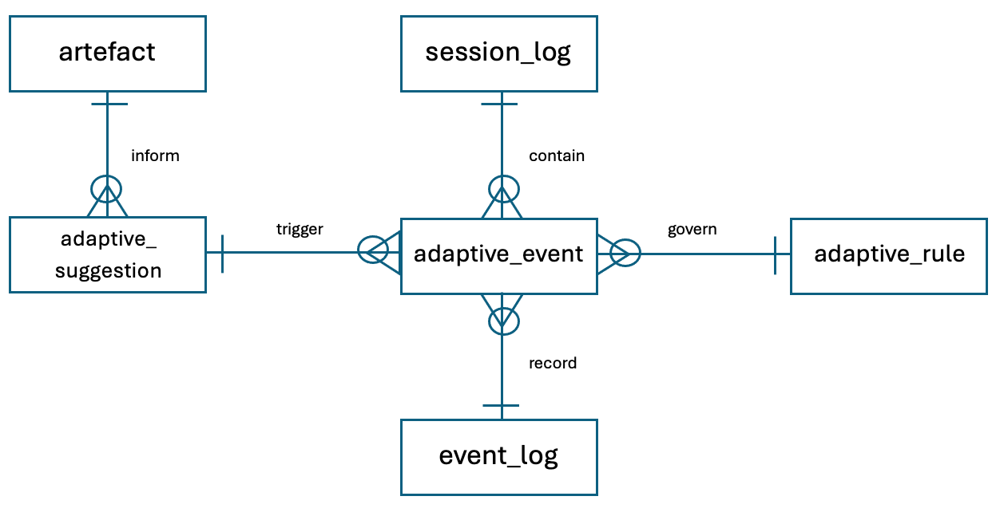
Figure 4 Adaptive System ERD
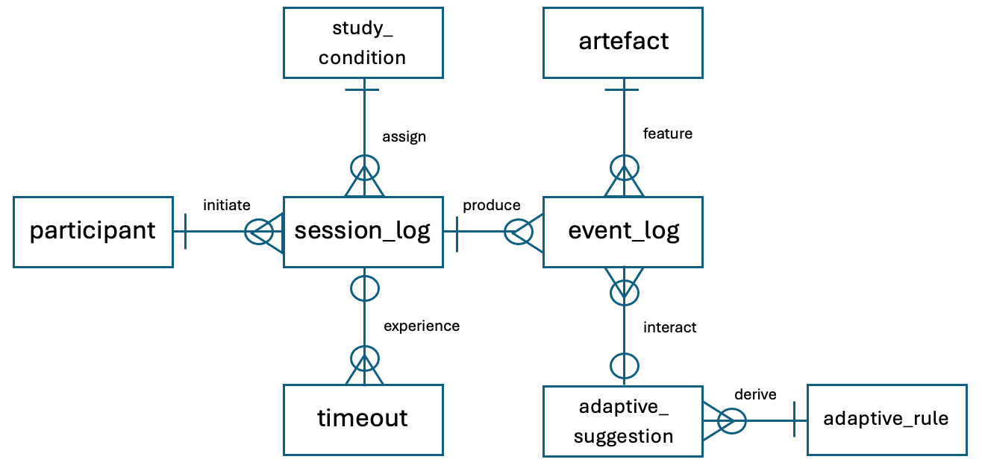
Figure 5 Behaviour Logging ERD


Figure 6 Metadata ERD

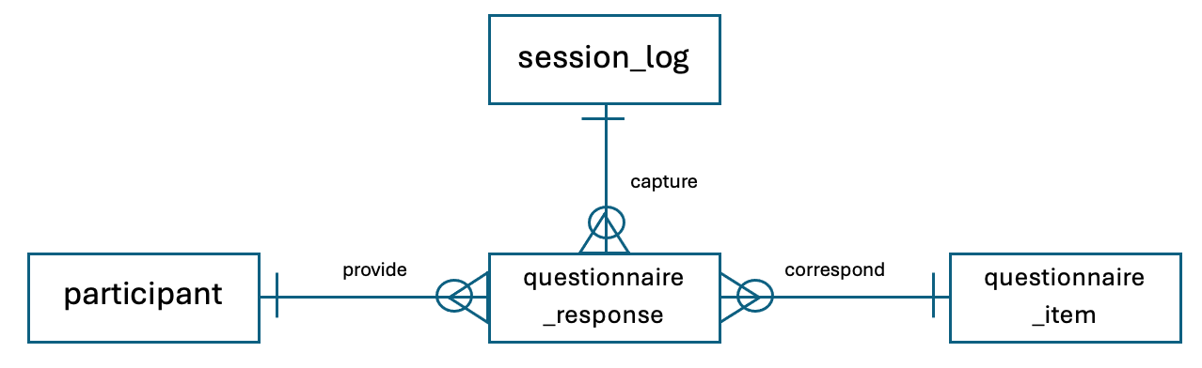
Figure 7 Questionnaire ERD
A theme may be categorised by many subthemes, and a subtheme may be grouped by many artefacts. A participant may initiate many session logs, and a session log may produce many event logs. A study condition may be assigned to many session logs. An adaptive suggestion must derive from an adaptive rule, and an adaptive rule may govern many adaptive events, just as an adaptive suggestion may trigger many adaptive events. An artefact may inform many adaptive suggestions, while an event log may record many adaptive events. A session log may experience many timeouts and may capture many questionnaire responses, each of which must correspond to a questionnaire item provided by a participant.

Core Implementation Details
This section sets out the parameters and formulas running through the pipeline, concerning the four includes/ modules that turn raw behaviour into a panel update (see Figure 3). Eight behavioural signals feed the engine – dwell time, revisit count, revisit interval, navigation depth, theme switches, subtheme switches, branching factor, and artefact popularity (see Appendix D.1) – all derived server-side from event_log and not sent by the client, so a participant’s browser is never trusted to determine their own adaptive condition. Artefact popularity, the only categorical signal, is bucketed into three fixed click count bands (0-2, 3-6, 7+).

Figure 8 Scoring Pipeline Diagram
These signals drive 27 rules across seven categories – dwell, revisit, navigation depth, theme switching, subtheme switching, branching factor, and four compound serendipity rules – stored as JSON in adaptive_rule.trigger_condition and evaluated as simple minimum/maximum range checks, except the four serendipity rules, which require every sub-condition to match rather than any one signal alone (see Appendix D.2). Table 1 reproduces the dwell category as a representative example, chosen over the other six as its four rules escalate cleanly on a single signal without the compound logic the serendipity rules need: weight, priority, and priority multiplier all increase together as dwell time lengthens, so a stronger signal both contributes more to interest score below and is more likely to win the conflict resolution that follows it.
Table 1 Dwell-Based Adaptive Rules
Dwell-Based Adaptive Rules
IF | THEN | Priority | Effect
dwell_time is light dwell (3-8s) | Add weak interest weight to artefact’s subtheme | Low | No panel update yet; contributes to cumulative interest score
dwell_time is engaged dwell (8-15s) | Add moderate interest weight to artefact’s subtheme | Medium | Panel may update if cumulative interest score passes threshold
dwell_time is deep dwell (15-30s) | Trigger theme reinforcement | High | Panel updates with 1-2 artefacts from same subtheme
dwell_time is immersive dwell (>30s) | Trigger deep-dive or serendipity mode | Very high | Panel shows deeper subtheme items + 1 serendipity artefact

Fired rules are combined into a single interest score using the Score Normalisation Formula specified for the adaptive rule weighting scoring model:
Equation 1 Interest Score = (Σ (Signal Weight * Priority Multiplier)) / Number of Signals
This averages each fired rule’s weighted contribution – consistent with dynamic recommendation-list adjustment approaches that recompute a ranking score from currently active signals rather than a fixed list (Liu et al., 2018) – and rounds to two decimal places to match adaptive_suggestion.interest_score’s DECIMAL (4,2) column. A single immersive-dwell rule (weight 1.8, *2.0) alone gives (1.8 * 2.0)/ 1 = 3.60, clearing the serendipity threshold outright; a deep-dwell rule (weight 1.2, *1.5) co-occurring with a light-dwell (weight 0.4, *1.0) instead averages to ((1.2 * 1.5) + (0.4 * 1.0)) / 2 = 1.10, one band lower than deep dwell alone (1.80) would give – averaging by signal count means a weaker co-occurring signal pulls the combined score down rather than adding to it.
That score is then classified into one of five bands (see Table 2), each mapped to a panel composition drawn from the five candidate-pool functions: related, deeper, cross-subtheme, serendipity, or neutral artefacts. Each band’s upper bound is treated as an inclusive cutoff – 0.51-0.59, for instance, falls into moderate rather than being left undefined – so every possible score has a defined outcome, not just the rounded example values; Table 2 reproduces the original ranges. The serendipity band’s two-artefact allocation operationalises the serendipitous-encounter concept directly into panel composition, rather than leaving serendipity as a theoretical property of the interface alone. In implementation, the composition actually served is selected by mode – reinforcement, deep-dive, exploratory drift, serendipity, or balanced browsing – rather than read directly off Table 2: the two agree at the extremes, since a score past the serendipity threshold always selects serendipity mode, but a mid-range score instead follows whichever single rule fired with the highest priority, so two sessions with an identical interest score can still receive different panels. The full mode-to-composition mapping is laid out in Appendix D.3.
Table 2 Interest Score Range and Panel Composition (reproduced from Appendix D.5)
Interest | Score Range | Panel Composition
Weak interest | 0.0 – 0.5 | Neutral items only
Moderate interest | 0.6 – 1.0 | 2 related + 2 neutral
Strong interest | 1.1 – 1.5 | 2 related + 1 deeper + 1 neutral
Very strong interest | 1.6 – 2.0 | 2 deeper + 1 related + 1 serendipity
Serendipity trigger | >2.0 | 2 serendipities + 1 related + 1 deeper

When several rules fire from one behavioural update, the priority-based conflict resolution decides which one drives the panel: any of the four serendipity rules wins outright, then the remaining rules rank by priority (very high, high, medium, low; Appendix D.4; D.6) – priority is checked before rank as several non-serendipity rules (dwell_immersive, navdepth_verydeep, subtheme_switch_rapid) also carry very high priority, and a plain rank sort alone cannot tell those apart from an actual serendipity trigger.
The two experimental conditions established are represented directly in the database: a two-row study_condition table (static_first, adaptive_first; Appendix C) referenced by session_log.condition_id and set into museum_condition_name at index.php. Nothing in the adaptive engine described above reads condition – the static prototype simply never calls it – so the two conditions differ only in whether this pipeline runs, matching the controlled comparison set out.

Dataset Preparation & System Configuration
The 60-artefact catalogue introduced is drawn from the Smithsonian Institution’s Open Access initiative, chosen for its professionally curated records, stable metadata and image URLs, and status as a globally recognised cultural heritage collection aligned with the digital heritage context this project sits within (Navarrete, 2019). Its CC0 licensing permits unrestricted reuse of both artefact text and imagery without watermarking or copyright risk (Margoni & Peters, 2016). Two themes, Animals and Everyday Objects, were selected as both are immediately recognisable to participants without specialist knowledge, while still being distinct enough to support theme-switching, subtheme-switching, and cross-theme serendipity as separate, detectable signals.
Curation followed six sequential steps (see Appendix B.22): defining the two-theme, twelve-subtheme thematic strategy; searching Smithsonian Open Access; identifying and curating candidate artefacts; cleaning metadata against the rules in Table 3; importing the cleaned set into the digitalmuseum database (raw sample in Appendix F.1); and connecting the same table to both prototypes. Five artefacts were selected per subtheme, prioritising high-resolution images, visual clarity, and scientific accuracy over exhaustiveness, and each candidate was individually checked for suitability for reinforcement, serendipity, and cross-theme jumps before finalised. The catalogue is a fixed 60-item set rather than a live query against Smithsonian’s collection, so the study’s independent variable is never confounded by which artefacts happen to be available at query time.
Table 3 condenses the cleaning rules applied to every artefact (see Appendix B.23 for full detail): titles use title case with no Smithsonian prefixes or scientific Latin names, for panel-display clarity; descriptions follow a fixed one-to-two-sentence structure combining an identifying statement with one engaging factual detail, since the dwell-time bands in Table 1 depend on descriptions being long enough to read but short enough to compare consistently across artefacts; and images are required at a minimum 1200px resolution with no watermarking, broken links, or load times over one second.
Table 3 Metadata Cleaning Rules (Condensed)
Rule Type | Key Requirements
Naming conventions | Title case; no Smithsonian prefixes; no abbreviations; no scientific Latin names
Description style | Sentence case; 1–2 sentences; binomial name where applicable; no subjective or promotional language
Theme consistency | Exact spelling and capitalisation; no synonyms; no new sub-themes introduced
Tag strategy | 1–3 lowercase tags; no duplicates; visual, material, or functional only
Image quality | Minimum 1200px; JPEG/PNG only; no watermarks, broken links, or load times over 1s

The schema is created once by create_tables.sql against the local MySQL instance already described, then seeded by four scripts: insert_metadata.sql for the 60-artefact catalogue, insert_conditions.sql for the two study conditions, insert_questionnaire_items.sql for the 14 questionnaire items, and insert_rules.sql for the 27 adaptive rules. Three further additional scripts, add_artefact_order.sql, add_interest_score.sql, and add_serendipity_weights.sql, extended the schema as later build phases required new columns, following the phase-gated approach rather than a single schema written up front.
One configuration parameter was revised after piloting: artefact_description length was extended from roughly five to ten words to fifteen to twenty, after pilot feedback that the shorter originals did not add enough learning value to hold attention. The revised length was deliberately bounded to preserve the dwell-time bands already tuned into the rule engine – long enough to sustain genuine reading, not so long that a light dwell reads as disengagement rather than a quick glance – so a downstream content change did not require the adaptive rules that depend on it.

Experimental Procedure
Each session executes the within-subject, counterbalanced protocol established as a fixed sequence of steps, carried out identically regardless of which condition order a participant is allocated (see Figure 9). The full script – the researcher’s spoken instructions, the consent materials, and the actions expected at each stage – is laid out in the study protocol design; this section describes how that script runs in practice and how each stage maps onto the pages, session variables, and database tables.

Figure 9 Study Protocol Flow Diagram
A session opens at index.php, where the researcher greets the participant, provides the information sheet and consent form, and, once written consent is given, assigns a participant code and a static-first or adaptive-first condition order. Both are recorded on the consent form and researcher log sheet as well as into museum_participant_id, museum_session_id, and museum_condition_name, so the paper record and database are set from the same allocation. The researcher explains the session flow verbally before the participant proceeds (see Appendix I.3) and follows the protocol’s neutrality requirement throughout the two tasks that follow: no artefact is pointed out, the adaptive mechanism is never described or hinted at, and participants are told only that suggestions may appear and that interface adapts quietly, so behaviour in either condition reflects a participant’s own exploration rather than researcher influence.
The two seven-minute tasks that follow are the static and adaptive interfaces, run in the order set at index.php: condition A presents static.php before adaptive.php, condition B the reverse, separated by a self-paced transition screen and followed by a second before the questionnaire. In both conditions participants are told to explore freely and click any artefacts that interest them; only in the adaptive condition are they additionally told that suggestions may appear based on their browsing. Table 4 sets out the timing this produces across a full session.
Table 4 Session Timing Structure
Stage | Duration | Notes
Consent & briefing | 2-3 min | Participant code & session order assigned
Static or Adaptive browsing | 7 min | Automatic timeout
Transition page 1 | 10-20 sec | No logging; participant continues when ready
Second browsing session | 7 min | Automatic timeout
Transition page 2 | 10-20 sec | No logging; participant continues when ready
Questionnaire | 3-5 min | No behavioural logging; qualitative data collection

Each task is bounded by an automatic timeout rather than a researcher-managed clock: museum_adaptive_task_start timestamps the task at its start, and the server redirects to the relevant transition page once seven minutes have elapsed, logging a timeout event to the timeout table regardless of what the participant was doing at that moment. This equalises exposure time across both conditions and both orders, controlling a further factor beyond the order effects counterbalancing already addresses (Charness et al., 2012), without the researcher having to interrupt the participant directly. Neither transition page logs any behavioural data: transition1.php’s button text changes to reflect whichever task comes next, transition2.php always leads to the questionnaire, and both wait for the participant to click continue at their own pace before the session resumes – the point at which the page sequence and, in the adaptive condition, the click-to-panel-update loop come together into the flow (see Figure 10; detailed per-version flows in Appendix B.2-B.9).
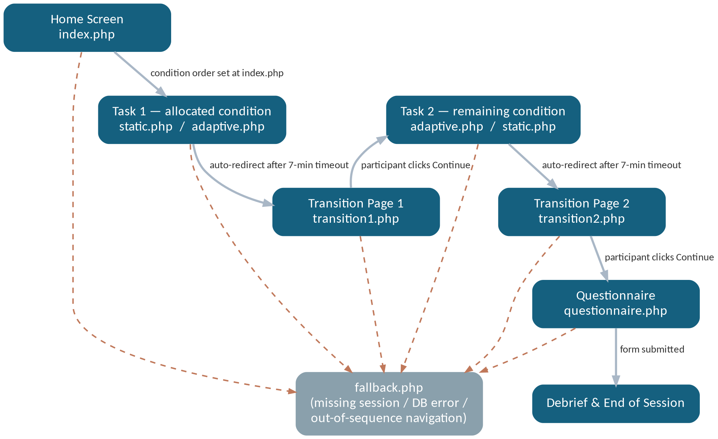
Figure 10 Main Interaction Flow Diagram
The session closes with questionnaire.php, which presents all fourteen questionnaire items directly on a single page – grouped into five sections (about the study, static feedback, adaptive feedback, comparison, and final thoughts) – rather than embedding an external Microsoft Forms instrument as originally planned. Each version-feedback section repeats the same four five-point Likert dimensions (perceived relevance, perceived surprise, exploratory freedom, overall experience) once for the version just completed, framed to that version by name; one multiple choice item records completion order and another records overall preference (static, adaptive, or no preference), and three free-text fields capture optional comments on each version plus a final reflection. Every response is still stored against participant_id, session_id, and item_id rather than relying on any third-party form storage. Participants are told their responses are anonymous and asked to answer honestly; once the form is submitted, the researcher provides the debrief sheet, pre-printed with the participant’s code, thanks the participant, reminds them of the withdrawal window, and logs the session as complete on the researcher log sheet.
Allocation, timing, transitions, and questionnaire delivery are all driven by the same session variables and logged against the same participant and session identifiers regardless of which condition a participant sees first, therefore the procedural structure of the session is identical across both orders – leaving condition and order as the only factors that vary systematically in the data analyses.

Testing Strategy & Validation
Testing followed the same phase-gated structure as the build itself: each of the ten development phases carries its own goal, test types, entry/exit criteria, and a table of individually numbered test cases, so a phase could not be marked complete until its own exit criteria passed – from Phase 1’s structural and referential-integrity checks on the database schema through to Phase 9’s full end-to-end simulation of both condition orders and Phase 10’s pilot session with a real participant before live data collection began. Table 5 condenses the full case-by-case record to phase level; the individual test cases and results are detailed in Appendix E (E.2-E.11 for individual phases). This operationalises the demonstration and evaluation phases of the Design Science Research cycle already adopted (Wieringa, 2010): each phase is a small demonstration-and-evaluation cycle, rather than testing being left as a single pass at the end.
Table 5 Testing Phases Summary
Phase | Focus | Test Cases | Result
1 – Database Foundation | Schema, foreign keys, seed data | DF1 – DF9 | All passed
2 – Behaviour Logging Engine | Event, timeout, and session endpoints | BL1 – BL8 | All passed
3 – Static Prototype | Home/static flow, guards, session setup | SP1 – SP9 | All passed
4 – Adaptive Logic Engine | Rule evaluation and scoring model | AE1 – AE8 | All passed
5 – Adaptive Prototype | Panel updates, heartbeat, panel-click logging | AP1 – AP6 | All passed
6 – Questionnaire Integration | Form load, submission, session_end logging | QI1 – QI3 | All passed
7 – Error/Fallback System | Guard-clause failures and recovery | FB1 – FB4 | All passed
8 – Artefact Order | Seeded shuffle and subtheme interleaving | AO1 – AO4 | All passed
9 – Full Study Simulation | End-to-end flow, both condition orders | FS1 – FS3 | All passed
10 – Pilot Testing | Real participant pilot session | PT1 – PT4 | 3 passed; PT2 initially failed, resolved and re-verified as PT4

Nearly every test case passed on first run; the one exception surfaced only at Phase 10, once a real participant was browsing rather than a scripted test harness. PT2 found that observed adaptive panel behaviour did not fully match the rule set: a pilot session logged the compound serendipity rule serendipity_theme_subtheme_switch firing ten times within a single second, as the frequency control adaptive logic already specified – at most one serendipity-triggered update every twenty seconds – had been designed but not yet enforced in code. Adding that twenty-second gate and re-running the case as PT4 confirmed the fix: a qualifying click sequence still updates the panel normally, an immediate second attempt is now blocked and logged as serendipity_rate_limited, and the panel updates again once the gap has passed. The fix shipped only after Phase 10 flagged it; the first two live sessions (ppt1, ppt2) had already run to completion under the pre-fix behaviour before it went live – a timing inconsistency the dataset carries rather than one smoothed over in cleaning.
Once live data collection was underway, the same event types, which Phase 2 tested individually, scaled to a full dataset without incident: the 30 retained sessions produced 8,928 event_log rows, 3,590 adaptive_event rows, and 2,748 adaptive_suggestion rows, every one of them belonging to a session with its session_start/session_end pair intact. The timeout table is the one exception worth naming precisely: 62 rows were logged against an expected 60 (30 sessions * two tasks each), and auditing the two extras traced both to a single session – participants 20 and 27 – where the same task version was logged twice, nine and sixty seconds apart respectively, consistent with the transition page’s auto-redirect firing its logging call twice rather than a second genuine timeout. No downstream analysis reads the duplicate as a real event as session_log’s own timeout_triggered_static and timeout_triggered_adaptive flags store one value per task regardless, but it is a logging-layer inconsistency worth flagging.
The exported dataset itself is scoped, not a raw table dump: export_full_study.php matches only participant codes of the ppt1 – ppt30, excluding the two pilot sessions and every throwaway code that Phase 1-10 tests scripts left in the participant table, and confirmed all thirty expected codes were present before writing a single row. In the same spirit as the guard-clause and fallback logging, it deliberately does not apply a completeness filter at export time: every session belonging to an in-scope participant is written out as-is, and a separate session_completeness_summary flags session_start/session_end counts, error_trigger counts, and required-questionnaire-item completion per session, so that judgement is made deliberately during analysis rather than silently at export. Against that summary, all 30 sessions look complete – one session_start, one session_end, zero error_trigger events, all ten required questionnaire items answered, and both tasks’ timeout flags set in every case.
Three of the thirty retained session carry a participant-level note, and none of them are flagged by the completeness summary above, as each retained session is the participant’s completed attempt rather than the interrupted one. Participant 9 restarted after an important phone call interrupted their first attempt; participant 21 restarted after refreshing the static task repeatedly caused that first attempt to never timeout – a genuine question about how the seven-minute timer behaves under repeated page reloads that this section can flag but not fully resolve without further code-level investigation. Neither restart left a trace in the exported tables: a restart begins a fresh participant_id and session_id at index.php rather than resuming a broken one, so the aborted first attempt was never written to session_log at all, and the retained session for both participants shows a single clean run with both timeout flags set. Participant 10’s note is different in kind rather than degree: they swiped back to the previous page a couple of times mid-task, and the seven-minute timer kept running regardless, redirecting on schedule as it would for any other session – a small piece of positive evidence that the timeout is driven by the server-side timestamp, not by anything client-side a stray navigation could disturb.

Results, Evaluation & Discussion

Presentation of Results
Before analysis began, the relevant Python libraries were imported and all data and lookup tables from the digitalmuseum database were loaded (see Appendix G.2–G.4; F.2; F.3), then validated and cleaned by checking for duplicates, nulls in inappropriate columns, implausible values, and referential integrity (see Appendix G.5). A readable session table (merging participant_code and condition_name, with a completeness filter) and an artefact lookup table were then built (see Appendix G.6). Each session was split into its static and adaptive halves; as phase_start was not logged directly, it was calculated as timeout_timestamp − 420s, reflecting the fixed seven-minute length of each phase (see Appendix G.7), and sanity checks confirmed adaptive_events were tagged only to the adaptive phase and every timeout_redirect was tagged with its correct version. Three summary tables were then built: one row per participant per version of core behavioural measures (Appendix G.8), adaptive engagement – how often the logic fired, its confidence, how many artefacts were suggested and clicked, and the mean interest score (Appendix G.9) – and questionnaire responses split by item_type with each item's formal name attached (Appendix G.10). The full notebook is provided in Appendix G.1, with the cleaned tables and outputs saved for reference (see Appendix G.20).
Thirty rows were found in session_log, 8,928 in event_log, 62 in timeout, 3,590 in adaptive_event, 2,748 in adaptive_suggestion, and 362 in questionnaire_response. No duplicate rows, duplicate keys, event_log nulls, or referential-integrity violations were found; implausible values such as dwell_duration = 0 were identified but retained, since a genuine sub-second dwell is plausible. All thirty sessions passed the completeness filter (started and completed, no errors triggered, all required questionnaire items answered, both timeouts triggered for each version), yielding the expected 60 rows of behavioural metrics (30 participants × 2 versions). Two session-version pairs logged a duplicate timeout row for the static version, consistent with the redirect firing before the page navigated away; the latest timeout was used for analysis. Adaptive-only events were correctly tagged, and no timeout_redirect events were left untagged. The self-reported order of completion (16 adaptive-first, 14 static-first) diverged slightly from the logged order (an even 15/15 split), traced to a single mismatch for participant 3 between the logged actual_first and the stated order. Further descriptive statistics are in Appendix G.11.
Paired tests were run on the four questionnaire dimensions (see Table 6). All four trended toward adaptive, though only two reached significances. Relevance produced the strongest result: the mean moved from 3.07 (static) to 4.00 (adaptive), with a highly significant Wilcoxon test (p = .002) and a rank-biserial r of -1.00, the maximum possible effect size, indicating every participant's rating either favoured adaptive or was tied, with no one rating static higher. Experience was the second significant result, with the mean rising from 4.07 to 4.47 (p = .003, r = -0.857), a large effect by conventional thresholds (Cohen, 2013), though not as extreme as relevance. Surprise (3.40 to 3.63, p = .365, r = -0.267) and freedom (4.00 to 4.20, p = .364, r = -0.276) both moved in the same direction, with adaptive scoring descriptively higher, but neither reached significance and both effect sizes were small. The two non-significant dimensions therefore failed to reach significance in a strikingly similar way, pointing to a two-tier split among the four questionnaire dimensions.
Table 6 Paired Comparisons of Questionnaire Dimensions
measure | n | mean_  static | mean_  adaptive | test | statistic | p | effect  _size | effect  _label | shapiro  _p_on  _diffs
relevance | 30 | 3.0667 | 4.0000 | Wilcoxon signed rank | 0.0 | 0.002 | -1.0000 | rank-biserial r | 0.0000
surprise | 30 | 3.4000 | 3.6333 | Wilcoxon signed rank | 44.0 | 0.3648 | -0.2667 | rank-biserial r | 0.0029
freedom | 30 | 4.0000 | 4.2000 | Wilcoxon signed rank | 38.0 | 0.3643 | -0.2762 | rank-biserial r | 0.0011
experience | 30 | 4.0667 | 4.4667 | Wilcoxon signed rank | 6.5 | 0.0031 | -0.8571 | rank-biserial r | 0.0000

Figure 11 showed static's upper quartile sitting close to where adaptive's lower quartile began, in line with the r = -1.00 effect size. The adaptive box was compressed hard against the top of the scale, raising the possibility of a ceiling effect – that the result was capped by the scale's maximum of 5 rather than by participants' actual enthusiasm (Šimkovic & Träuble, 2019). For freedom, the boxplot showed why the dimension fell short of significance in a way the p-value alone could not: static already sat high (median around 4-5) before adaptivity was introduced, leaving comparatively little room for adaptive to move the median further, a pattern consistent with a ceiling effect on the static condition itself. Surprise showed near-total overlap between the two boxes, both centred in the same 3-4 range with similar low-end outliers around 1 in both conditions. The boxplots for experience varied more widely: static was clustered tightly around 4 with few outliers, while adaptive shifted that whole cluster upward while remaining fairly narrow, indicating the gain was broad-based across participants rather than driven by a handful of outliers.

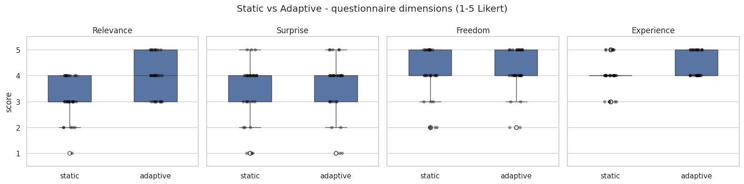
Figure 11 Boxplots of Each Questionnaire Dimension
Slope plots of each questionnaire dimension's per-participant change (static to adaptive) were generated (see Appendix G.12). These reinforced the almost universal upward trend for relevance, showing that the gain held for essentially every individual participant, not just on average. For surprise and freedom, the plots instead showed a crisscross of lines – some participants moved up, others down – rather than a flat cluster around no change, reflecting genuine heterogeneity in which increases and decreases cancelled out at group level rather than a uniformly weak or absent effect.
Paired tests were run on the six behavioural metrics (see Table 7); two effects reached significance. Total dwell time was the standout result: a fall from 212.27s to 180.80s under adaptive, t = 3.6677, p = 0.0010, d = 0.805, a large effect. Number of revisits was the other significant result, more than doubling from 0.53 to 1.20 (Wilcoxon p = .0064, r = -0.671), also a large effect; Shapiro-Wilk flagged n_revisits as strongly non-normal, in keeping with a low, skewed count variable and supporting the choice of the Wilcoxon test over the paired t-test (Fay & Proschan, 2010). The remaining four metrics – n_clicks (22.17 to 21.17, p = .412, d = 0.126), mean_dwell_s (10.85 to 9.85, p = .130, d = 0.273), max_navigation_depth (22.13 to 21.07, p = .758, r = 0.069), and n_unique_artefacts_viewed (21.63 to 19.93, p = .125, d = 0.242) – were all non-significant with small-to-negligible effects, all trending slightly lower under adaptive. Nearly every raw behavioural count was therefore flat to slightly lower under adaptive except revisits, which rose significantly within the same fixed 420-second window.
Table 7 Paired Comparisons of Behavioural Metrics
measure | n | mean_  static | mean_  adaptive | test | statistic | p | effect  _size | effect  _label | shapiro  _p_on  _diffs
n_clicks | 30 | 22.1667 | 21.1667 | paired t-test | 0.8329 | 0.4117 | 0.1263 | Cohen’s d | 0.2317
mean_  dwell  _s | 30 | 10.8495 | 9.8466 | paired t-test | 1.5569 | 0.1303 | 0.2732 | Cohen’s d | 0.3607
total_  dwell  _s | 30 | 212.2667 | 180.8000 | paired t-test | 3.6677 | 0.0010 | 0.8054 | Cohen’s d | 0.8993
max_  navigation  _depth | 30 | 22.1333 | 21.0667 | Wilcoxon signed rank | 189.0000 | 0.7582 | 0.0690 | rank-biserial r | 0.0167
n_revisits | 30 | 0.5333 | 1.2000 | Wilcoxon signed rank | 34.5000 | 0.0064 | -0.6714 | rank-biserial r | 0.0001
n_unique  _artefacts  _viewed | 30 | 21.6333 | 19.9333 | paired t-test | 1.5791 | 0.1252 | 0.2416 | Cohen’s d | 0.2374

Figure 12 showed that total_dwell_s was the only panel where the standard error (SE) bars for static and adaptive did not overlap at all; every other panel showed some degree of overlap. This reinforced total_dwell_s as the most reliable result, since the two conditions occupied genuinely separate territory once measurement uncertainty was accounted for. n_revisits came closest to a similar separation, though its error bars were wider relative to the gap between means, reflecting its status as a Wilcoxon-tested skewed count variable rather than the tighter, more normally distributed total_dwell_s. The two axes also told different stories at a glance: total_dwell_s ran on a 0-200+ scale and visually dominated, while n_revisits sat on a 0-1.4 scale, making its change look smaller than it was. Proportionally the pattern reversed – total_dwell_s fell by approximately 15%, while n_revisits more than doubled (a >100% relative increase) – confirming revisiting as the metric that moved the most in relative terms. Across the six panels, adaptive nudged almost every breadth-of-interaction measure slightly downward while pushing the one re-engagement measure up.

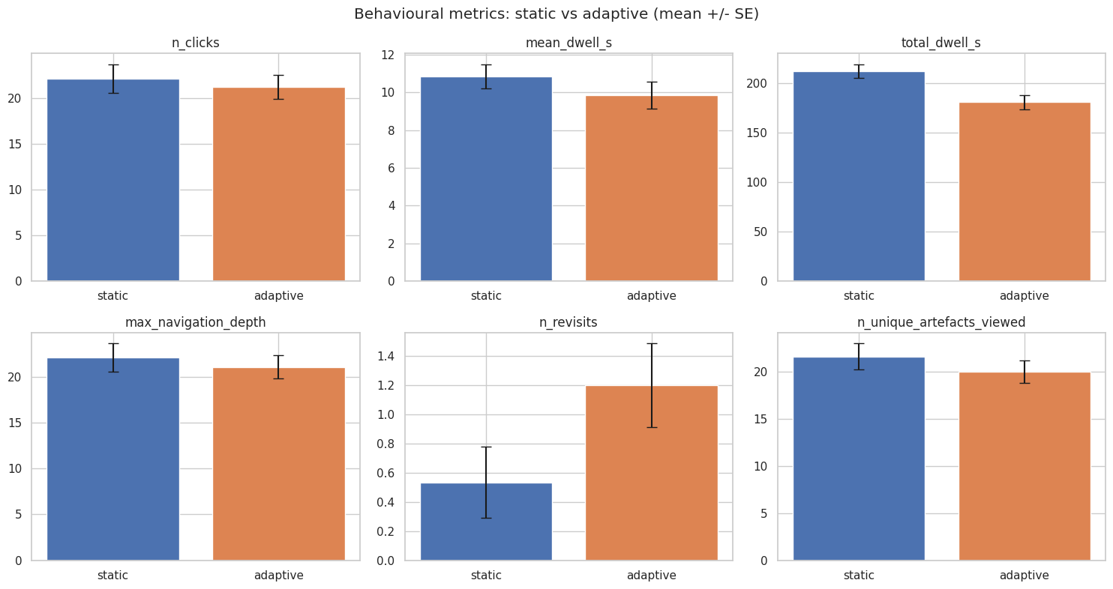
Figure 12 Bar Charts of the Means of Each Behavioural Metric by Version
Twenty of the 30 participants (66.7%) stated an overall preference for the adaptive version (see Figure 13) – an outright majority and exactly double the combined total of the other two groups. Static and no preference tied exactly at 5 each (16.7%), indicating that among the minority who did not prefer adaptive, static and no preference were equally likely outcomes. This pattern aligned with the significant, large-effect dimensions of relevance and experience reported above.
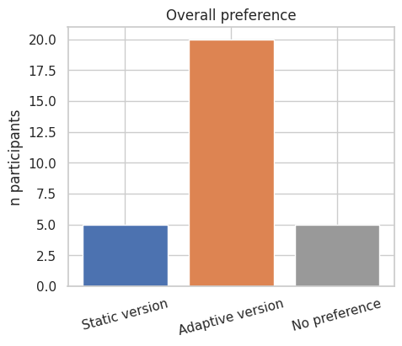
Figure 13 Bar Chart of Stated Overall Preference
When participants completed adaptive first, 80% went on to prefer adaptive, 20% had no preference, and none preferred static (see Table 8). When participants completed static first, 53.3% preferred adaptive, 13.3% had no preference, and 33.3% preferred static. Adaptive held up as the majority choice regardless of which version came first, and the asymmetry was notable: no participant who experienced adaptive first went on to prefer static, whereas a third of those who experienced static first still preferred it. Experiencing static first appeared to leave participants more open to preferring either version, whereas experiencing adaptive first left static less competitive.
Table 8 Crosstab of First Version and Preferred Version
actual_first | preferred_version
actual_first | Adaptive version | No preference | Static version
Adaptive version | 12 | 3 | 0
Static version | 8 | 2 | 5

The left panel of Figure 14 presented a suggestion-event-level distribution (n = 2,748 suggestion rows, not one point per participant), describing the suggestion engine's own scoring behaviour across the study rather than participant behaviour directly. The single tallest bar sat early (0.75-1.0), and the distribution fell fairly steadily from there to a distinct trough around an interest_score of 2.25-2.5 – the lowest point across the entire range, lower even than either tail – before rising into a second, smaller cluster peaking around 3.0-3.75 and dropping off sharply. This produced a two-humped, bimodal shape rather than noise around a single centre, consistent with suggestions being generated by multiple triggering rules with different scoring baselines.
The right panel, by contrast, was per-participant (n = 30, one value per person), visualising the between-person variability in engagement – each participant's own mean of clicked_flag across their suggestions. A third of participants essentially never clicked a suggestion during their session, placing the mode at, or very near, zero. From there the distribution had a long right tail: a handful of participants clustered around a 0.05-0.08 click rate, and one or two extended out as far as approximately 0.20 – roughly four times the sample's overall rate – producing a right-skewed, long-tailed distribution.
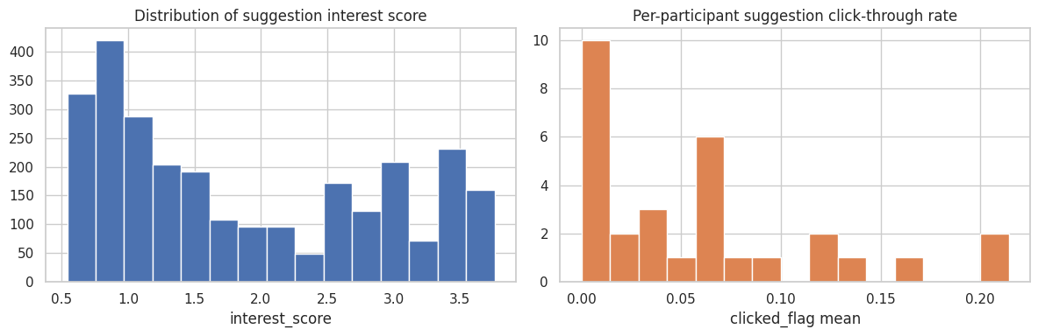
Figure 14 Distribution of Suggestion Interest Score & Per-Participant Suggestion Click-Through Rate
A sensitivity check excluding participant 1 and 2 was conducted (see Appendix G.13; G.14), since both took part before the adaptive suggestion engine's serendipity rate limit was finalised, meaning their sessions generated suggestion and trigger events under different system parameters to the remaining 28 participants. These two participants accounted for a disproportionate share of the raw suggestion event data – approximately 12.5-12.8% of all adaptive_suggestion and adaptive_event rows, despite being only 6.7% of the sample (see Table 9) – motivating a check that the headline engagement statistics were not distorted by this early configuration difference.
When ppt1 and ppt2 were excluded, both metrics moved down: click-through rate fell from 0.056 to 0.052 (a 7.1% drop) and mean trigger_confidence fell from 1.887 to 1.810 (a 4.1% drop), indicating these two participants had a slightly higher click-through rate and slightly higher-confidence suggestion triggers than the remaining 28. Neither shift was large enough to change the headline picture: click-through rate remained low, and mean trigger_confidence remained in roughly the same strong position, just short of the serendipity threshold. This trigger_confidence mean is a blended average across two genuinely different populations of triggers – ordinary confidence-scored ones and already-serendipitous ones – so it does not represent a typical trigger the way a mean normally would for a unimodal distribution; it sits between rather than within either population. Despite ppt1 and ppt2 contributing disproportionately more suggestion events, excluding them shifted the headline figures by only 4-7%.
Table 9 Sensitivity Check Excluding Pre-Serendipity-Rate Participants
Metric | Full sample (n = 30) | Excluding ppt1, ppt2 (n = 28)
Overall suggestion click-through rate | 0.056 | 0.052
Mean trigger_confidence | 1.887 | 1.810
adaptive_suggestion | 2748 | 2404
adaptive_event | 3590 | 3130

The thematic coding followed Braun and Clarke's (2012) six-phase framework. Familiarisation involved reading all free-text responses multiple times to get a feel for the data as a whole; a coding sheet was then built holding all 62 non-blank responses across four response types (static_comment, adaptive_comment, preference_reason, final_comments), each record retaining participant_id, item, question text, and stated preference alongside separate code/theme/notes fields for the coding itself (see Appendix G.21). Initial coding attached short labels to meaningful segments of text, allowing a single response to receive more than one code, and items 6 and 11 (which explicitly asked about each version in turn) were treated as a built-in axis for comparing what participants said about one version against the other rather than coding them in isolation. Themes were then generated by clustering related codes across the whole dataset, and each candidate theme was reviewed against its own extracts and the full dataset before being defined and named (see Table 10).
Table 10 Thematic Framework Table
Theme | Definition | N (extracts) | Example quote
Relevance, Personalisation & Interest Alignment | System-provided suggestions increase perceived relevance, reduce effort, and align browsing with personal interests. | 15 | “The adaptive version was very useful for show interests more suitable to myself”
Navigation Clarity, Ease & Efficiency | Interface qualities that make browsing smoother, clearer, and less cognitively demanding. | 11 | “Easy to navigate, some interesting information on some of the artefacts.”
Discovery, Learning & Serendipity | The interface supports unplanned, curiosity-driven encounters that expand knowledge or reveal new interests. | 10 | “I Selected some artefacts based on the suggestions that I didn’t find relevant in the static version, therefore learning more.”
Self-Directed Exploration & Autonomy | User values independent navigation without system influence; exploration is driven by personal interest and agency. | 9 | “I like to make my own mind up on what to view”
Comparative Evaluation & Balanced Views | Participants evaluate the two versions holistically, often expressing nuanced or neutral views. | 9 | “Both experiences have benefits and drawbacks, I think it depends on the individuals interests in history and artefacts, as well as personality…”
Exploration Constraints & Repetition | System behaviours that constrain exploration, reduce variety, or create friction. | 7 | “I like the suggested column however after a while the same options seemed to be suggested”

The thematic coding data was loaded and checked (see Appendix G.15; G.16); one row was dropped as its free-text response offered nothing (the participant had typed ‘n/a’), leaving 61 coded responses spread across 6 themes (see Figure 15; Appendix G.17). Relevance, Personalisation & Interest Alignment was the largest theme by a clear margin (15 extracts, versus 11 for the next largest), echoing the two significant, large-effect questionnaire dimensions (relevance and experience) and the majority stated preference for adaptive (66.7%). Discovery, Learning & Serendipity was the next largest theme, capturing participants' own accounts of unplanned or curiosity-driven encounters. The two themes tied at 9 extracts represented the qualitative account of the minority preference groups: Self-Directed Exploration & Autonomy captured participants who explicitly valued the static version's lack of system influence, aligning with the 5 participants who preferred static, while Comparative Evaluation & Balanced Views included order effects among its underlying codes, echoing the pattern in the actual_first × preferred_version cross-tab that participants who did static first were more likely to still prefer it. The least represented theme was Exploration Constraints & Repetition, the main critical theme, in which participants described the adaptive suggestions becoming repetitive over time.
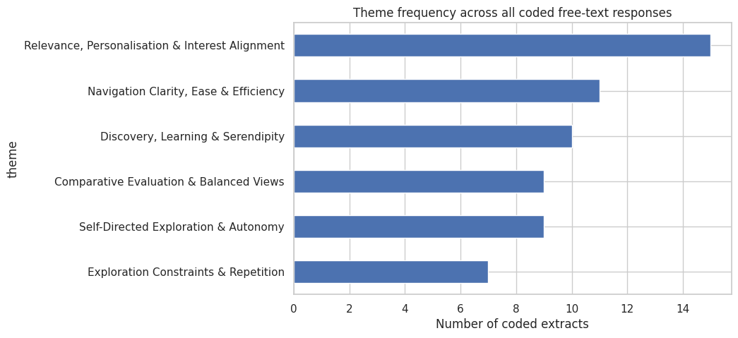
Figure 15 Theme Frequency Across All Coded Free-Text Responses
Relevance, Personalisation & Interest Alignment stood out again with 100% of its extracts coming from participants who preferred adaptive (see Table 11; Appendix G.19) – not one came from a no-preference or static-preferring participant. Navigation Clarity, Ease & Efficiency followed closely, with 90.9% of its extracts from adaptive-preferring participants. Exploration Constraints & Repetition drew 5 of its 7 extracts from participants who nonetheless said they preferred adaptive overall, indicating that even people who ultimately preferred the adaptive version voiced friction with it. By contrast, Comparative Evaluation & Balanced Views was the one theme where no-preference participants contributed the largest share (55.6%), and Self-Directed Exploration & Autonomy was the one theme where static-preferring participants prevailed (44.4%) – the two most counter-narrative themes were populated disproportionately by exactly the minority groups expected to represent them.
At first glance, Discovery, Learning & Serendipity appeared adaptive-dominated on raw counts, but its 60% share sat slightly below adaptive's 66.7% population share, while no-preference participants – just 16.7% of the sample – supplied 40% of this theme's extracts, approximately 2.4 times their expected share, suggesting discovery and serendipity resonated particularly with participants who had not settled on a decisive overall preference. No-preference participants were similarly enriched roughly 3.3 times above their base rate for Comparative Evaluation, while Self-Directed Exploration & Autonomy and Exploration Constraints & Repetition were both meaningfully enriched for static-preferring participants (approximately 2.7- and 1.7-times base rate respectively).
Table 11 Themes Clustered Across Stated Overall Preference
theme | preferred_version
theme | Adaptive version | No preference | Static version
Comparative Evaluation & Balanced Views | 3 | 5 | 1
Discovery, Learning & Serendipity | 6 | 4 | 0
Exploration Constraints & Repetition | 5 | 0 | 2
Navigation Clarity, Ease & Efficiency | 10 | 0 | 1
Relevance, Personalisation & Interest Alignment | 15 | 0 | 0
Self-Directed Exploration & Autonomy | 3 | 2 | 4

A face validity check was carried out to confirm each theme's extracts landed in the question types conceptually expected (see Appendix G.18). The cleanest example was Self-Directed Exploration & Autonomy, with 6 of its 9 extracts from static_comment and the rest from preference_reason, and none from adaptive_comment – nobody described valuing autonomy when talking about the adaptive experience, exactly what would be expected of a theme defined around independence from system suggestion. Relevance was similarly clean, dominated by preference_reason, consistent with relevance being the reason participants most often gave when asked outright why they preferred adaptive, rather than a general description of the interface. Discovery, Learning & Serendipity's largest source was final_comments rather than the more pointedly prompted questions, suggesting participants tended to raise it spontaneously in their closing remarks rather than only when asked pointedly about a version.

Objective-by-Objective Evaluation
Objectives (a) to (c) – synthesising the literature, developing the behavioural signal framework, and constructing the two prototypes – were achieved through the work reported in Chapters 2 to 4 and are not re-evaluated here. The results speak most directly to objective (d), analysing interaction data against interest, exploratory depth, and serendipity, and objective (e), comparing the two conditions using quantitative and qualitative measures, and are evaluated critically below against the four research questions those objectives were designed to answer.
RQ1 asked how real-time behavioural signals could be modelled to represent user interest and exploratory depth. Only two of the six signals specified in the framework – dwell time and revisits – moved in a way that reached significance, and this result admits more than one interpretation. The more generous interpretation is that these two signals are the framework’s genuinely valid indicators of a shift in exploratory mode, with the remaining four (clicks, navigation depth, and unique artefacts viewed) simply not capturing the construct as effectively. A more cautious interpretation, however, is that the fixed 420-second window and a sample of thirty compressed the variance available to detect smaller shifts, so the four non-significant signals cannot be dismissed as invalid on this evidence alone; the study was better powered to detect a large change in a skewed count variable like revisits than a subtler one in something like navigation depth. RQ1 is therefore only partially answered: the framework’s premise that behavioural signals can represent interest and exploratory depth held for two of six proposed indicators, but this design cannot distinguish a genuinely narrower set of valid signals from a broader set whose effects were simply too small, or too diluted by the fixed-time constraint, to detect here. The bimodal interest score distribution reported above offers weaker but complementary evidence at a more mechanical level, showing the scoring pipeline itself differentiating between suggestion types rather than collapsing to a single value, though this speaks to the model’s internal consistency rather than to whether its inputs validity track interest.
RQ2 asked how such signals could be used to drive adaptive artefact presentation. The consistently strong, rate-limited trigger confidence reported above demonstrated that the mechanism translating logged signals into suggestions worked reliably and safely across the sample; this part of RQ2 was answered with reasonable confidence. Whether those suggestions functioned as intended once presented is less clear-cut. The low click-through rate could be read as a partial failure of the adaptive layer to drive meaningfully engaging presentation, but it could equally reflect participants judging the suggestions passively – registering and discounting them without a click – which this data cannot distinguish from disengagement or irrelevance, since clicked_flag records only an action taken, not a suggestion noticed and rejected. Taken together, RQ2 was answered convincingly at the level of the mechanism generating and presenting suggestions, but only weakly and ambiguously at the level of participants acting on what was presented, which is the more direct test of whether adaptation was actually driving behaviour rather than running alongside it.
RQ3 asked how interaction patterns differed between the static and adaptive interfaces. Two competing explanations fit the same headline pattern of falling total dwell time and rising revisits within a fixed budget. One is that the adaptive panel prompted a genuine reallocation of attention toward returning to specific artefacts as opposed to a passive decline in engagement; the other is that the panel simply distracted participants from browsing, with revisits an incidental by-product rather than a deliberate behaviour. The significant rise in revisits, instead of a uniform decline across every measure, favoured the first explanation over the second: a pure distraction account would predict less of everything, not more of one specific behaviour alongside modest, non-significant dips elsewhere. This interpretation is not conclusive, however, since revisits and total dwell are not independent of one another within a fixed window, so part of what looks like reallocation could still be a mechanical consequence of time spent returning to artefacts rather than a meaningfully different exploratory strategy. The order effect asymmetry identified alongside the preference data offered some corroborating evidence that this pattern was a durable effect of the interface rather than an artefact of task order, though with only fifteen participants in each order group the crosstab percentages should be read as suggestive rather than statistically robust.
RQ4 asked what experiential impact this adaptation had on participant’s perceived relevance, exploratory freedom, and discovery pathways. Relevance produced the clearest answer: a significant, large effect quantitative gain, independently echoed by the largest qualitative theme being built entirely from adaptive preferring extracts. This convergence is not, however, fully independent evidence, since the same participants who rated adaptive higher on relevance were also the ones most likely to explain that preference in their own words afterwards; the qualitative theme corroborates the quantitative result more than it triangulates it from a genuinely separate source. Exploratory freedom produced a genuinely ambiguous answer: the absence of a significant quantitative shift could mean the adaptive layer neither enhanced nor eroded participants’ autonomy, but it is equally consistent with static’s already high baseline on this dimension leaving too little room to detect a real change either way, so this objective cannot be said to have been cleanly resolved by the data collected. Discovery pathways offered the most encouraging reading against the concern motivating this objective, since surprise held steady rather than declining and a substantial theme captured participants describing serendipitous encounters directly – but this was set against a distinct theme in which participants described the same suggestions becoming repetitive, so any claim that discovery was preserved needs to be qualified by an equally real cost in perceived variety over the course of a session, rather than treated as an unqualified success.
Taken together, these findings support a narrower conclusion than a general claim that adaptation improved the browsing experience. With only two of four questionnaire dimensions and two of six behavioural metrics reaching significance in a sample of thirty, the evidence for objective (e)’s comparison is real but concentrated rather than sweeping: adaptive was clearly preferred and produced a real, well-evidenced gain on relevance, a plausible but less certain gain on experience, and no clear harm to exploratory freedom or serendipitous discovery, set against a measurable narrowing of browsing breadth and a suggestion mechanism whose direct engagement fell well short of its ambient presence. Framed against the research questions, the results justify behaviour-driven adaptation as a targeted improvement on specific dimensions the framework was designed to influence, rather than as evidence that adaptation is unambiguously beneficial across every measure this study collected.

Comparison Against Literature
The behavioural signal results only partly bore out the case made for them. Pirolli and Card’s (1999) foraging theory and Bitgood’s (2016) Attention-Value model both treat dwell time and repeat engagement as reliable interest proxies, and the significant results for dwell time and revisits agreed with that claim. Navigation depth, which Marchionini (2006) and White et al. (2007) frame as a clear marker of exploratory investigation, showed no such effect. One interpretation is that the present results genuinely narrow the theory, since the earlier literature offered no basis for ranking the six signals against each other; a more cautious view is that the gap says more about this study’s power and duration, given that Bitgood’s model was built from sustained, in-person observation rather than a fixed seven-minute digital session. A sample of thirty could not distinguish these readings, so the result was better treated as a caution against assuming every theoretically motivated signal transfers cleanly here than as evidence for a narrower, definitive set of valid signals.
The relevance/serendipity tension raised through Makri and Blandford (2012) and Fan and Poole (2006) was the clearest theoretical stake in this comparison, since the adaptive mechanism was deliberately weighted to protect serendipitous artefacts instead of always surfacing the highest relevance match. Surprise not declining under adaptive, and Discovery, Learning & Serendipity remaining a substantial theme, echoed that design working; the Exploration Constraints & Repetition theme, however pointed toward an erosion of novelty that a purely quantitative reading of surprise would miss. The more defensible conclusion was not that the design resolved Fan and Poole’s (2006) tension, but that it avoided the tension collapsing within a single session; whether repetition would compound into a measurable loss of serendipity over longer or repeated use, the scenario their caution was written for, was not a question this design could answer.
The low click-through rate on individual suggestions sat closer to Not and Petrelli's (2018) finding that curators valued restrained, transparent adaptivity over heavy automation than to Liu et al.'s (2018) news-recommendation results, where continuously updated push and click statistics produced clear click-through gains. This comparison needed some caution: Not and Petrelli's finding came from curators judging a system rather than visitors using one, and Liu et al.'s ranked, continuously reordered list gives a more visible incentive to click than a series of individual suggestions does. The more cautious reading was that the result was consistent with suggestions being registered and considered rather than acted on directly, a form of engagement that click-through rate, an incomplete measure of a recommender's real value (Besbes et al., 2016), was not designed to capture; overt interaction and genuine engagement have been shown to diverge in exactly this way across other on-screen interaction techniques (Sundar et al., 2014), rather than the low rate being straightforward evidence that the mechanism was less effective than comparable systems.
Two further comparisons were suggestive of agreement without being direct tests of it: the minority who preferred static and valued its lack of system influence echoed Falk's (2016) claim that stable, identity-related motivations shape visit behaviour, though Falk's typology was built from physical-visit self-report rather than digital trace data. This pattern nonetheless echoed findings elsewhere that response to personalised versus self-directed interfaces varies systematically with individual disposition, with more experienced users tending to favour retaining control over an interface rather than accepting system-driven personalisation (Sundar & Marathe, 2010; Knijnenburg et al., 2011). Additionally, the 66.7% adaptive preference recorded here sat close to the 70% of Coburn's (2016) Collections Dive users who attributed their enjoyment to that system's redesign, a similarity of magnitude not evidence of a shared mechanism, given the different measures each study used. Taken together, these comparisons extended the gap analysis rather than closing it: before this study, behavioural signals were theoretically valid interest proxies and engineered relevance could in principle coexist with serendipity, but neither claim had been tested in a real-time, single-session setting without a persistent visitor history. What could now be said with more confidence was that a rule-based adaptive mechanism can be tuned to protect serendipity without sacrificing it within one sitting; what remained unresolved and was not something the existing literature could have settled in advance, was whether that balance holds under repeated or longer-term use, or on the signals this project's results could not yet confirm or rule out.

Limitations, Trade-Offs & Threats to Validity
Some of these threats were anticipated in the methodology and were revisited here considering what the data actually showed; others only became visible once the analysis itself was complete.
The clearest limit on every finding reported above was statistical: with thirty participants and a fixed 420-second window per condition, the study was well powered to detect only large effects, and several results should be read in that light. Relevance’s r = -1.00 and total dwell time’s d = 0.805 were large enough to survive this constraint comfortably, but the four non-significant behavioural signals and the two non-significant questionnaire dimensions could not be distinguished from a genuinely smaller, real effects the sample was simply too small to detect. Treating a non-significant result as evidence that a signal or dimension was unaffected by adaptation, rather than as an inconclusive test of a question this design could not resolve either way, would have overstated what the data supported (Altman & Bland, 1996).
The most consequential unresolved threat, flagged but not addressed in the methodology, was that every participant encountered both interfaces for the first time within a single short session, so any novelty effect specific to the adaptive panel’s presence could not be fully separated from a genuine effect of adaptation itself using design alone (Karapanos et al., 2009). Two considerations made a pure novelty explanation less plausible than a genuine adaptation effect, without ruling it out entirely: the quantitative relevance gain, the qualitative theme built independently from adaptive preferring extracts, and the mechanism-level reliability of trigger_confidence converged from three largely independent sources of evidence, which a first encounter novelty effect alone would not obviously predict producing in combination. The order effect asymmetry, where adaptive-first participants did not revert to preferring static, suggested the preference held up even once the panel’s novelty had already worn off within the same session. Neither consideration, however, was a substitute for the repeated exposure or longitudinal design this study did not use so the possibility that some portion of the adaptive gain reflected novelty rather than sustained value remained genuinely open.
As already flagged, the convenience sample’s self-selection (Couper, 2000) bore more heavily on the generalisability of the preference split (66.7% adaptive, 16.7% static, 16.7% no preference) than on the internal static-versus-adaptive comparison itself, since the within-subject design compared each participant against themselves regardless of who they were. A sample skewed toward digitally confident, exploration-inclined participants may nonetheless have under-represented exactly the visitor disposition Falk’s (2016) identity-based typology and the Self-Directed Exploration & Autonomy theme pointed to, meaning the small minority who preferred static in this sample could understate a genuinely larger such group in the wider population.
Counterbalancing was intended to prevent task order from confounding the static-adaptive comparison, on the assumption that order effects would net out symmetrically once the sample was split evenly between the two sequences. The crosstab suggested this assumption did not fully hold: no participant who experienced adaptive first went on to prefer static, while a third of those who experienced static first still did, an asymmetry rather than the even scatter simple counterbalancing predicts (Poulton, 1982). This did not overturn the headline preference result, since the crosstab was itself one part of the same convergent evidence discussed above, but it meant that any comparison not explicitly decomposed by order, which was most of what was reported, carried a residual order-related influence that counterbalancing had reduced, not eliminated.
Several narrower measurement limitations were already identified at the point they arose rather than repeated here. The ambiguity of clicked_flag as a measure of engagement meant the adaptive mechanism’s direct effectiveness could not be fully separated from participants engaging with suggestions passively. The score-normalisation formula’s averaging of co-occurring dwell signals, identified as diluting a strong individual signal once combined with a weaker one, meant trigger_confidence and interest_score may have understated true interest in some sessions rather than only reflecting it accurately. Though the two participants who took part before the serendipity rate limit was finalised introduced a genuine instrumentation change partway through data collection (Anderson-Cook, 2005), the sensitivity check bounded its effect on the headline figures to 4-7%, a case where a real limitation was identified and its practical impact was directly tested rather than left as an open question. The thematic coding was also carried out by a single researcher without an independent second coder; this is a limitation only if a codebook-style, inter-rater-reliability approach was the intended standard, and a reasonable approach if the reflexive thematic analysis tradition, where the researcher’s own interpretive judgement is treated as an analytic resource rather than a source of bias to control for, was followed instead (McDonald et al., 2019), the same open question already flagged against Braun and Clarke’s (2019) later guidance.
The choice of a rule-based, threshold-driven adaptive mechanism over a trained model, justified by its interpretability within an incrementally tested build and the absence of the cross-visitor history a learned model would need, was a deliberate trade-off, not a shortcoming, but it was not without cost (Rudin, 2019). A mechanism able to learn weighted combinations of signals directly from behavioural data might have avoided the averaging-dilution problem noted above, and might have identified a broader or differently weighted set of valid interest signals than the two of six the present rule-based design was able to distinguish; the interpretability and mid-build inspect ability gained by the simpler design came at the cost of exactly the kind of nuanced signal combination its own results suggested might have mattered.
Weighed together, these limitations bounded the confidence attached to specific findings more than they undermined the project’s central contribution. The relevance gain, the majority preference for adaptive, and the reliability of the mechanism generating suggestions rested on evidence robust enough to survive most of the threats considered here individually, even though no single threat could be fully ruled out. The more provisional findings, the four non-significant behavioural signals, the ambiguous exploratory freedom result, and the redistribution-versus-distraction reading of RQ3, were exactly the ones already carrying explicit hedges, and this section’s role was to make explicit why that caution was warranted rather than to introduced new doubt into results that had already been reported with appropriate confidence.

Legal, Social & Ethical Implications
The adaptive panels functioned, in effect, as a form of choice architecture, surfacing certain content ahead of other content on the basis of inferred as opposed to stated interest, and the results gave direct evidence that this mattered to more than a hypothetical minority: Self-Directed Exploration & Autonomy was the one qualitative theme where static preferring participants prevailed, built entirely from participants who explicitly valued the static version’s lack of system influence, with none of its extracts drawn from anyone describing the adaptive experience. Whether this constituted legitimate persuasion or something closer to manipulation was a genuinely open ethical question rather than a settled one (Susser et al., 2019). The mechanism’s interpretability, two of six signals, fixed thresholds, no hidden model, and the fact that a static preferring minority were able to identify and reject its influence rather than being covertly steered past it, favoured a view closer to persuasion. But interpretability to a researcher analysing the data afterwards was not the same as legibility to a visitor in the moment, and since no participant was ever shown how the mechanism worked, whether it would still read as legitimate once deployed outside a monitored study remained untested.
The results were similarly two-sided on whether adaptive suggestion widened or narrowed what participants encountered. The majority stated preference for adaptive and the two largest, cleanest themes, Relevance, Personalisation & Interest Alignment and Discovery, Learning & Serendipity, suggested the mechanism functioned as expansion rather than narrowing, at least within a single session. Exploration Constraints & Repetition complicated this: the smallest theme but drawn substantially from participants who still preferred adaptive overall, it captured the suggestions becoming repetitive over time, direct evidence from within this dataset of the homogenising risk long attributed to algorithmic personalisation generally (Bozdag, 2013). Given the novelty effect uncertainty flagged, a single 420-second session could not establish whether this narrowing would compound with a repeated exposure across multiple visits, precisely where the filter bubble concerns of this kind are usually raised; the repetition theme was better evidence for measured caution than for alarm, but it was evidence for caution, nonetheless.
Sustaining the kind of profile trigger_confidence relied on across repeat visits, rather than within one fixed session, would require the sort of persistent, visitor-level behavioural tracking the present anonymised, session-scoped data model was deliberately designed to avoid. Moving from this study’s design toward that kind of operational deployment would shift the relevant legal basis toward UK GDPR’s provisions on automated decision making and profiling (ICO, 2022). Content suggestions of this kind plausibly fell short of the ‘legal or similarity significant effect’ threshold that triggers the strongest such protections, but that ambiguity, rather than a confident conclusion either way, was the more defensible reading available, since this study was never tested at the scale or duration an actual deployment would involve.
The self-selection already discussed as a limitation raised a different concern here: not whether the sample generalised, but who would benefit if the mechanism were deployed. The inference was not without its own weakness: it rested on only five static preferring participants recruited through a flyer and student networks, a thin somewhat artificial base from which to project how an actual museum visitor population would divide under an opt-in-versus-default system. Even allowing for that, the direction of the risk was more defensible than its absence: a museum making the adaptive interface the default or sole mode of interaction, instead of retaining static as a true alternative, would risk converting a sampling limitation into an equity outcome, systematically underserving exactly the kind of visitor under-represented among this study’s adaptive preferring majority (Van Dijk, 2020). The clearest safeguard the results themselves pointed to was not a technical fix, but the design choice already built into the study: keeping static available as an unstigmatized option rather than a degraded fallback, as the evidence base for who would be disadvantaged by removing it was too thin to rule the risk out with confidence.
None of this bore on the validity of the findings; it concerned what should follow from them if the mechanism were taken further than this study tested. In each case a choice justified on other grounds, the mechanism’s interpretability, the minimal and session-scoped data model, and the retained static alternative, did much of the necessary ethical and legal work without fully resolving it, read against the BCS (2022) Code of Conduct duty invoked to have regard for the wellbeing and legitimate interests of others.

Professional and Industry Relevance
Two audiences were relevant here: museum and cultural heritage professionals considering adaptive interfaces for their own collections, and the wider practice of building personalisation systems under real world constraints of data, budget, and scale.
For museum practice specifically, the results offered a concrete, test case rather than a purely theoretical argument for behavioural-signal-driven personalisation, an area the sector’s own commentary has flagged as carrying real opportunity alongside real risk of eroding visitor trust through the data exchange personalisation depends on (American Alliance of Museums, 2018). The relevance gain, the majority preference for adaptive, and the reliability of a mechanism built from only two of the six candidate signals gave a museum considering this kind of tool something more specific to evaluate than a general claim that personalisation helps engagement. Treating the study’s own figures, 66.7% preference, r = -1.00 for relevance, as a sector benchmark would overreach what a single institution’s collection, a single fixed session, and thirty participants could support; but the design’s simplicity, no cross-visitor history, no training pipeline, meant the underlying pattern, not just the specific numbers, was realistically replicable by a museum team without dedicated machine learning infrastructure, which was arguably the more transferable finding of the two.
The same design choice had relevance beyond museums specifically. Favouring an interpretable, rule-based mechanism over a trained model could be read as a compromise forced by this project’s scope rather than a genuinely industry relevant pattern, since a trained model might simply perform better once sufficient data existed to justify one. The more defensible account, however, treated the interpretability itself as professionally valuable independent of scale: the fact that a static preferring minority in this same study could identify and the reject the mechanism’s influence was direct evidence that an auditable, explainable system supported exactly the kind of user-facing transparency increasingly expected of commercial personalisation systems and harder to demonstrate in black-box alternatives. What this project could not show was whether that interpretability held up at industry scale, across a content catalogue and visitor volume for larger than this study’s, where the same rule-based structure typically becomes harder to sustain.
The project’s own practice reflected this same principle in miniature: adopting a DSR methodology; phase-gated development; the sensitivity check examined; grounding claims with existing literature; and the risk registers completed and mitigated. Together, these reflected the kind of documented, revisable technical judgement the BCS (2022) Code of Conduct’s professional competence and integrity clause, maintaining awareness of relevant standards and working within the limits of current knowledge, asks of a practising professional, distinct from the Code’s public interest duty.
The project’s industry relevance sat closer to a credible adoption pathway than to a finished product: interpretable, replicable by a small team, and grounded in a real relevance gain, but tested once, on one collection, with one small sample, none of which a museum or a wider population practice adopting this approach could responsibly treat as already resolved.

Conclusions, Critical Reflection & Future Work

Key Achievements & Contributions
This project set out to investigate and evaluate behaviour-driven adaptive techniques for digital museum interfaces, assessing how real-time interaction signals could be modelled to represent user interest and exploratory depth, and how adaptive artefact presentation built from those signals affected exploratory engagement, serendipitous discovery, and personalised pathways. This aim was addressed through a literature-grounded gap analysis, a justified experimental methodology, a working static-and-adaptive prototype pair, and a controlled comparison of the two conditions; this section draws that work together against the five objectives and four research questions specified.
Objectives (a) to (c) were achieved in full: the literature review identified three interrelated gaps – underdeveloped behavioural modelling, unsupported exploratory depth, and serendipity’s absence from adaptive logic – that directly shaped the behavioural signal framework built and operationalised in the static and adaptive prototypes. The framework’s central claim, that logged interaction signals can be modelled to represent interest and exploratory depth (RQ1), was only partially confirmed by the data: two of the six proposed signals, dwell time and revisits, produced a significant effect. While navigation depth, clicks, and unique artefacts viewed did not, the result was treated as more consistent with a sample too small to detect subtler effects than with those four signals being genuinely invalid. What the data supported more confidently was RQ2: the mechanism translating signals into adaptive presentation worked reliably, with trigger confidence consistently strong and never breaching its rate limit across 3,130 logged adaptive events, excluding ppt1 and ppt2. Therefore, the framework functioned as designed at the mechanism level, but its premise that all six behavioural signals meaningfully index interest was only narrowly, not comprehensively, validated.
Objectives (d) and (e) – analysing interaction data against interest, exploratory depth and serendipity, and comparing the two conditions using quantitative and qualitative measures – were addressed by the full analysis reported. RQ3, asking how interaction patterns differed between the two interfaces, was answered with a specific and unexpected pattern: total dwell time fell significantly under adaptive while revisits rose, a reallocation of attention toward returning to already-noticed artefacts instead of a uniform decline in engagement, favoured over a simple distraction account. RQ4’s experiential questions were answered unevenly. Relevance produced the clearest gain – a highly significant, maximal-effect-size improvement (p = .002, r = -1.00), corroborated by a majority stated preference (66.7%) and the largest qualitative theme in the coded data – while exploratory freedom showed no significant shift and a distinct theme captured suggestions becoming repetitive over session, evidence that discovery and freedom were preserved rather than enhanced. The comparison objective (e) called for was therefore answered with a real but concentrated effect, not a uniformly positive one across every measure collected.
Against the two contributions outlined, the project’s primary, empirical contribution was delivered: a comparative dataset of static-versus-adaptive interaction from thirty real participants, and a validated – if narrower than originally scoped – behavioural signal framework, giving the three literature gaps identified above their first empirical grounding rather than leaving them as theoretical claims. The secondary contribution, a reference implementation other digital heritage projects could draw on, is more modest in what it has demonstrated: the architecture and rule-based logic are documented and interpretable, and its interpretably itself has professional value, but the claim that the implementation is reusable beyond this study has not been tested by any team other than this one and remains an implication of the design rather than a demonstrated fact. The implication carried forward into the sections that follow is that behaviour-driven adaptation showed a genuine, evidence capacity to improve specific aspects of a digital museum interface without measurably harming others, on a scale and in a form modest enough for practitioners without dedicated machine learning infrastructure to adopt – a targeted result, not a general one, and the more defensible for saying so.
Table 12 draws this section’s evaluation together in one place, distinguishing whether each objective or research question was addressed from how strongly the resulting evidence supported the underlying premise – process and outcome are not the same question, a distinction developed further later.
Table 12 Fulfilment of Objectives and Research Questions Against the Evidence Produced
Objective / Research Question | Fulfilled | Evidence | Success
(a) Synthesise literature to identify theoretical gaps | Fully | Literature review, Chapter 2; three gaps identified (behavioural modelling, exploratory depth, serendipity) | Very high
(b) Develop a behavioural signal framework | Fully | Framework specified, Chapter 3; operationalised in both prototypes, Chapter 4 | Very high
(c) Construct static and adaptive prototypes | Fully | System build, Chapter 4; tested and validated, Appendix E | Very high
(d) Analyse interaction data against interest, exploratory depth, and serendipity | Fully (data collected & analysed); framework only narrowly validated | Analysis, Chapter 5; 2 of 6 signals reached significance | Moderate
(e) Compare conditions using quantitative and qualitative measures | Fully (comparison conducted); findings concentrated, not uniform | Comparative evaluation, Chapter 5 | Moderate
RQ1 – Can real-time signals represent interest and exploratory depth? | Partially | Chapter 5; dwell time and revisits significant, four signals inconclusive | Moderate
RQ2 – Can such signals drive adaptive presentation? | Mechanism: fully; Participant uptake: partially | Chapter 5; trigger confidence reliable and rate-limited; click-through low | High (mechanism) / low (uptake)
RQ3 – Do interaction patterns differ between interfaces? | Yes, though a distraction explanation is not fully excluded | Chapter 5; dwell time fell, revisits rose (both large effects) | High
RQ4 – What experiential impact did adaptation have? | Unevenly | Chapter 5; relevance clearly improved, freedom and discovery preserved rather than enhanced | Moderate

Project Success
What the project achieved against its aim, objectives, and research questions has been established. This section judges whether that record constitutes success, against the criteria this project set for itself before the results were known. The interim report’s expected evaluation criteria defined success as delivering two functional prototype versions, reliable behavioural logging, a working adaptive mechanism that responds meaningfully to user interaction, and sufficient participant data to address all research questions and generate clear, evidence-based insights into behaviour-driven adaptation – a project-delivery standard and a research standard combined, judged separately below since delivering a working comparative instrument does not by itself guarantee that instrument produced uniformly positive findings.
The first two criteria were met without qualification. Two functionally equivalent static and adaptive prototypes were built, tested, and used to run thirty complete participant sessions, and the behavioural logging behind them proved reliable at scale: the resulting dataset – 8,928 event_log rows, 3,590 adaptive_event rows, and 2,748 adaptive_suggestion rows across the full study – contained no duplicate rows, no nulls in required fields, and no referential integrity violations once validated, and every session passed the completeness filter applied.
The third criterion, a mechanism that responds meaningfully, is less cleanly satisfied and is where an honestly critical judgement is needed rather than a restated success claim. At the system level the mechanism responded reliably and meaningfully: trigger confidence stayed consistently strong and never breached its rate limit. At the level of participant response, however, direct engagement with individual suggestions was low, so meaningfully held more confidently for the mechanism generating suggestions than for participants visibly acting on them – a distinction drew between RQ2 being answered convincingly at the mechanism level and only weakly at the level of participants acting on what was presented. The criterion was met, but on the more defensible half of what meaningful response could mean, not the fuller sense a reader might assume from the interim report’s wording.
The fourth criterion, sufficient data to address all research questions and generate clear, evidence-based insights, was also met: thirty participants were sufficient to answer all four research questions, and a mixed or partial answer is not the same as an unclear one. RQ1’s two-of-six-signal result, RQ3’s reallocation-versus-distraction reading, and RQ4’s uneven pattern across relevance, freedom, and discovery were each resolved to a stated, evidenced conclusion, even where that conclusion was hedged rather than absolute. Judging the project unsuccessful as not every finding favoured adaptation would confuse this criterion, which asked for clear insight, with a stricter one that was never set: that every research question resolve favourably toward the adaptive condition.
Whether success should be assessed on all objectives and research questions being met depends on what met is taken to mean. Read as actions to be carried out, all five objectives were completed, cleanly and in full. Read instead as a requirement that every research question resolve with an unambiguous, positive result, none of the four RQs was met outright; each returned an honest but partial or conditional answer. The first interpretation is the more defensible one for judging project success, since the objectives were written as a programme of research activity rather than as hypotheses to be confirmed; treating an evaluative research project as having failed due to its own evaluation producing mixed evidence would penalise it for doing exactly what an honest comparative evaluation is meant to do. Table 12’s separated Fulfilled and Success columns make this distinction explicit rather than leaving it implicit in the prose: first, all nine rows show an objective or question that was substantively addressed; second, only the process objectives (a)-(c) reach the top of the scale, with the evidence-dependent items (d), (e), and the four research questions clustering around Moderate to High.
The ratio of significant to non-significant results offers one further, more quantifiable lens, and Table 13 sets this out result by result, not as a single ratio: two of the four questionnaire dimensions and two of the six behavioural metrics reached significance, four of ten measured effects overall. Used alone, that headline figure would mislead in both directions. A sample of thirty was powered to detect only large effects, so several non-significant results reflect the study’s statistical power than a genuine absence of effect; and at least one non-significant outcome – exploratory freedom demonstrating no measurable harm under adaptation – was evidence of the design working as intended, not a shortfall to be counted against, as no result was rated very low.
Table 13 Metric-Level Results, Interpretation, and Success
Metric / Item | Result | Meaning | Success
Relevance (questionnaire) | Significant rise, maximal effect size | Strongest, most consistent evidence of an adaptive benefit; near-universal per-participant gain | Very high
Experience (questionnaire) | Significant rise, large effect | Broad-based improvement across participants, not driven by outliers | High
Surprise (questionnaire) | Non-significant rise, small effect | Adaptive preserved serendipity rather than eroding it, directly addressing the personalisation-versus-surprise tension | Moderate
Freedom (questionnaire) | Non-significant rise, small effect; static baseline already high | Autonomy neither enhanced nor eroded; likely constrained by a ceiling effect on static rather than a genuine null result | Moderate
Total dwell time (behavioural) | Significant fall, large effect | most statistically robust behavioural result; consistent with reallocation of attention rather than passive disengagement | High
Number of revisits (behavioural) | Significant rise, large effect | Re-engagement with previously seen artefacts increased sharply; corroborates the dwell-time reallocation reading | High
Clicks (behavioural) | Non-significant, negligible effect | No meaningful shift in raw click volume between conditions | Low
mean dwell per artefact (behavioural) | Non-significant, small effect | Inconclusive; consistent with limited power to detect a subtler shift | Low
Max navigation depth (behavioural) | Non-significant, negligible effect | No detectable difference in browsing breadth | Low
Unique artefacts viewed (behavioural) | Non-significant, small effect | No detectable narrowing or widening of the artefact set explored | Low
Suggestion click-through rate | Low, stable under sensitivity check | Suggestions registered but rarely acted on directly; consistent with passive engagement than disengagement or irrelevance | Low
Overall stated preference | 66.7% preferred adaptive; static and no preference tied at 16.7% each | Directly corroborates the relevance and experience gains; strongest single preference indicator in the study | Very high
Adaptive mechanism reliability | Trigger confidence consistently strong; serendipity rate limit never breached (3,130 logged events, excluding ppt1 & ppt2) | Mechanism functioned reliably at the system level, though this did not translate into high direct engagement | High

Weighed against the criteria the project set for itself, and as summarised across tables 12 and 13, the judgement is that the project succeeded: two working prototypes were delivered, logging proved reliable at scale, the adaptive mechanism responded meaningfully at the system level even where participant-level engagement was more muted, and sufficient data was collected to answer every research question with a clear, defensible, if appropriately hedged, conclusion. Judged instead against the stricter, unstated standard of every result favouring adaptation, the project would appear only partially successful – but that standard was never the one previously set and applying it retrospectively now would reward a less honest evaluation over the one carried out here.

Critical Self-Reflection
Looking back, I believe the groundwork for this project was truly thorough. The literature review drew on over thirty structured summaries (see Appendix A.3) before I began designing the behavioural signal framework, and detailed design documents meant I was building against a specification, not improvising. I followed the Gantt chart closely, and the phase-gated, incremental build-and-test strategy was the single decision that did the most to keep the project manageable, catching most defects close to where they were introduced. Running the study itself went smoothly too: ethical approval and participant materials were well in place before recruitment, I built real flexibility into scheduling around participants’ own availability, and the system behaved reliably across all thirty sessions. I believe I exercised sound, independent judgement while running a live study.
The part of the project I am least comfortable with is the period between pilot testing and the first two participant sessions. Pilot feedback led me to make genuine improvements to the system, and I believe that was the right call before running the Phase 10 tests against an unrevised version to protect the schedule. What I did not plan for was how little slack that left: the time spent on the pilot-driven changes ate into the buffer intended for the Phase 10 test suite, so PT2 was not run until after ppt1 and ppt2 had completed their sessions. Running PT2 late is how I discovered that the adaptive engine’s serendipity rate limit, part of the design logic from the outset, had never been implemented on a page Claude had assisted with during the build.
Applying the ‘five whys’ root-cause technique (Serrat, 2017): the tests that would have caught the gap were delayed by pilot-driven rework; that rework was prioritised as it felt more urgent than re-running a suite I expected to pass; and the gap itself was only possible as I had not checked that this one piece of specified logic was present in code I had not written myself. The project’s use of AI-assisted coding was framed as research-led, with design decisions and adaptive logic remaining under my control; this is exactly where that control slipped, not because using Claude for routine implementation was the wrong call – it plausibly saved time that went instead into the literature review and documentation evident in this report – but due to me providing a generated page the same light-touch review I would give my own previously-tested code. I should have checked it against that one piece of logic it most needed to contain, potentially running a test in that phase to check its existence. This was a real disorientating dilemma in Mezirow’s (1994) sense: it replaced an unexamined assumption, that AI-assisted code needed only a routine review, with a clearer position, that it needs at least the same verification as my own. The response once the gap was found, implementing the rate limit and running the sensitivity check was the correct path to take. This was a reflection-in-action, a fast adjustment made inside the problem (Schön, 1983); this section is reflection-on-action, asking why the gap existed as well as addressing how it was fixed.
I demonstrated strong project and time management, independent literature synthesis, mixed-methods analysis, ethical conduct, and flexible participant communication throughout, exactly the skills required for a heavy project. The skill still in need of development is narrower; verifying AI-assisted code against the original specification as rigorously as my own and building schedule buffer between dependent phases without assuming a fast turnaround. Applied to Kolb’s (1984) experimental learning cycle, the concrete experience was the incident itself, the analysis above is the reflective observation and abstract conceptualisation, and the active experimentation it points to is concrete: a verification checklist for any AI-assisted code before it reaches pilot or live testing, and a fixed minimum buffer before the first real participant.
This was one bounded, quickly identified lapse inside the project that was otherwise carefully planned and rigorously analysed. The research and planning skills this project called on were solidly strong, and the clearest lesson for my own future practice is not about motivation or effort, but about where I place my trust once a tool, not I myself, has produced something I am about to rely on.

Limitations
Several limitations sit at the level of the project as a whole. The most basic is scope: the adaptive mechanism was designed, built, and evaluated against a single institution’s digital collection. This bounds any claim of effectiveness to that particular cultural and technical context (Shadish et al., 2002); whether a comparable mechanism would transfer to a different collection, visitor demographic, or platform is a question the study was not designed to answer and would require replication elsewhere before the findings could be generalised with real confidence.
A second limitation follows from the experimental design. The within-subject, single-session structure was well suited to isolating the adaptive mechanism’s immediate effect, but cannot speak to engagement, novelty, or fatigue over repeated or longer-term use; a visitor returning across multiple visits may respond to adaptive suggestion differently once their familiarity with the collection changes (Karapanos et al., 2009). This is a structural property of the chosen methodology, not a statistical caveat on any particular result, and the project’s conclusions are best read as evidence about a single encounter rather than about sustained use.
Third, this was a solo-researcher project, and that shaped what could realistically be attempted within its scope. Every phase, from design through to analysis, was carried out by one person against a fixed academic timeline, which constrained how much parallel work or schedule buffer could be built in; the compressed period between pilot testing and the first two participants, reflected on personally, is one visible consequence of that structural constraint. A team-based or longer-funded project would have had more capacity to absorb this kind of disruption without it touching live data collection.
Finally, the decision to implement adaptivity as a rule-based mechanism instead of a learned model carries a further project-level consequence set against the aim stated. It demonstrates that behaviour-driven adaptive suggestion is feasible and evaluable within a Master’s length project; it does not demonstrate that adaptive personalisation behaves this way in general, since the conclusions drawn here concern this specific implementation, not adaptive recommendation as a technique. Scaling the approach beyond the project’s bounds would need to re-establish whether its central finding, that adaptivity protects serendipity, still holds once a different, less transparent mechanism replaces it.

Recommendation for Future Work & Further Research
The recommendations below follow directly from the limitations outlined and the specific unresolved questions flagged throughout. The most direct next step is to replicate this study at a larger scale: a multi-researcher team, a longer data-collection window, and a substantially larger and more diverse participant sample than the thirty recruited here would address the statistical power limitation and the single-institution scope limitation in one move and would allow the convenience sample skew to be tested against a more representative population rather than assumed away (Button et al., 2013).
A second, closely related direction is to move beyond the single-session design used here. Repeated or longitudinal exposure, across multiple visits not just one sitting, would test two things this project could only flag as open questions: whether the adaptive gain in relevance and dwell time reported persists once the novelty of the adaptive panel wears off, and whether the Exploration Constraints & Repetition theme identified compounds into genuine serendipity loss over time rather than remaining the mild, within-session effect observed here.
A larger, longer-running study of this kind would also generate the volume and diversity of interaction data a learned model needs to be trained and evaluated responsibly, something this project’s rule-based design deliberately avoided needing. Exploring a learned alternative once that data exist would test directly whether the interpretability this project prioritised was won at a genuine performance cost, or whether a simpler, auditable mechanism remains competitive even at scale; either answer would be a meaningful contribution future work is presently unable to make on the evidence provided.
This project set out to establish whether behaviour-driven adaptive suggestion could be built, deployed, and evaluated in a way that preserved the serendipitous discovery digital museum access is at risk of losing. The evidence produced supports a cautiously positive answer within the scope of a single Master’s length study. The limitations discussed and the recommendations above define where that answer still needs testing at scale. Doubt should not be cast on what was demonstrated here: that an interpretable, rule-based adaptive mechanism can increase perceived relevance and engagement without measurably narrowing the exploratory, serendipitous experience that motivated the project’s original aim.

References
ALMESHARI, M., DOWELL, J. and NYHAN, J., 2019, June. Using personas to model museum visitors. In: Adjunct Publication of the 27th Conference on User Modeling, Adaptation and Personalization, pp.401–405. Available from: https://doi.org/10.1145/3314183.3323867
ALTMAN, D.G. and BLAND, J.M., 1996. Absence of evidence is not evidence of absence [online]. Available from: https://d1wqtxts1xzle7.cloudfront.net/53208435/Absence_of_evidence_is_not_1-libre.pdf?1495287424=&response-content-disposition=inline%3B+filename%3DAbsence_of_evidence_is_not_1_pdf.pdf&Expires=1788780783&Signature=PiUu4vD4ebChlPeSd6oEHOdXa~R9rf0V39rIAM1Q6OAdGagb~dGp06suBh~gt0g0~rSGHNSJkp-FExCbtbrVFkhEQz98b6McA1to8R4Oid4IaZYUdmBNNQ4vjFqIZ7gMH~lgsNT7B5QkKjTrYPLsg9m0r2M~urY93S7uOzi8vsbl5~M6lKU6IJtceEuPABjUmiOiSWyu~IIU0NK~EcGawB3YG33WZ0Lo4DOGk01zPoVBbLAhMxWsvjk4wwFgxcE~MeAhK6Sl6tI65-wIYmE1JIY4glpREgmMRXdlDjbPLYiBZUN1AapjqI8OjQwZzmrINM1U4RoFUMGI73GJdzAHZQ__&Key-Pair-Id=APKAJLOHF5GGSLRBV4ZA
AMATO, F., MOSCATO, V., PICARIELLO, A., COLACE, F., SANTO, M.D., SCHREIBER, F.A. and TANCA, L., 2017. Big data meets digital cultural heritage: Design and implementation of scrabs, a smart context-aware browsing assistant for cultural environments. Journal on Computing and Cultural Heritage (JOCCH), 10(1), pp.1-23. Available from: https://doi.org/10.1145/3012286
AMERICAN ALLIANCE OF MUSEUMS, 2018. Museums and New Intelligences. Center for the Future of Museums. Available from: https://www.aam-us.org/programs/center-for-the-future-of-museums/projects-and-reports/museums-and-new-intelligences/
ANDERSON-COOK, C.M., 2005. Experimental and quasi-experimental designs for generalized causal inference. Available from: https://doi.org/10.1198/jasa.2005.s22
BASKERVILLE, R.L., 1999. Investigating information systems with action research. Communications of the association for information systems, 2(1), p.19. Available from: https://aisel.aisnet.org/cgi/viewcontent.cgi?article=2518&context=cais
BCS, 2022. Code of Conduct for BCS Members. Version 8. Swindon: BCS, The Chartered Institute for IT. Available from: https://www.bcs.org/media/2211/bcs-code-of-conduct.pdf
BESBES, O., GUR, Y. and ZEEVI, A., 2016. Optimization in online content recommendation services: Beyond click-through rates. Manufacturing & Service Operations Management, 18(1), pp.15-33. Available from: https://doi.org/10.1287/msom.2015.0548
BITGOOD, S., 2016. Attention and Value: Keys to Understanding Museum Visitors. Abingdon: Routledge.
BOEHM, B.W., 1988. A spiral model of software development and enhancement. In Readings in Human–Computer Interaction (pp. 281-292). Morgan Kaufmann. Available from: https://doi.org/10.1016/B978-0-08-051574-8.50031-5
BOZDAG, E., 2013. Bias in algorithmic filtering and personalization. Ethics and information technology, 15(3), pp.209-227. Available from: https://doi.org/10.1007/s10676-013-9321-6
BRAUN, V. and CLARKE, V., 2012. Thematic analysis. American Psychological Association. Available from: https://doi.org/10.1037/13620-004
BRAUN, V. and CLARKE, V., 2019. Reflecting on reflexive thematic analysis. Qualitative research in sport, exercise and health, 11(4), pp.589-597. Available from: https://doi.org/10.1080/2159676X.2019.1628806
BUCKLIN, R.E. and SISMEIRO, C., 2009. Click here for internet insight: Advances in clickstream data analysis in marketing. Journal of Interactive Marketing, 23(1), pp.35–48. Available from: https://doi.org/10.1016/j.intmar.2008.10.004
BUTTON, K.S., IOANNIDIS, J.P., MOKRYSZ, C., NOSEK, B.A., FLINT, J., ROBINSON, E.S. and MUNAFÒ, M.R., 2013. Power failure: why small sample size undermines the reliability of neuroscience. Nature reviews neuroscience, 14(5), pp.365-376. Available from: https://doi.org/10.1038/nrn3475
CHARNESS, G., GNEEZY, U. and KUHN, M.A., 2012. Experimental methods: Between-subject and within-subject design. Journal of Economic Behavior & Organization, 81(1), pp.1–8. Available from: https://doi.org/10.1016/j.jebo.2011.08.009
CHEN, W. and CHEN, Y., 2025. Virtual museum experience design and user behavior analysis. IEEE Access. Available from: http://doi.ieeexplore.ieee.org/10.1109/ACCESS.2025.3600420
COBURN, J. 2016. I don’t know what I’m looking for: Better Understanding public usage and behaviours with Tyne & Wear Archives & Museum online collections. Tyne & Wear Archives & Museums, UK. Available from: https://mw2016.museumsandtheweb.com/paper/i-dont-know-what-im-looking-for-better-understanding-public-usage-and-behaviours-with-tyne-wear-archives-museums-online-collections/index.html
COHEN, J., 2013. Statistical power analysis for the behavioral sciences. Routledge. Available from: https://books.google.co.uk/books?hl=en&lr=&id=2v9zDAsLvA0C&oi=fnd&pg=PR3&dq=Cohen,+J.+(1988)+Statistical+Power+Analysis+for+the+Behavioral+Sciences.+2nd+edn.+Hillsdale,+NJ:+Lawrence+Erlbaum+Associates.&ots=x8iFfTevB0&sig=x3UgWBT4_piMf6IqXFi1T9g3l2M&redir_esc=y#v=onepage&q&f=false
COUPER, M.P., 2000. Web surveys: A review of issues and approaches. The public opinion quarterly, 64(4), pp.464-494. Available from: https://www.jstor.org/stable/3078739
CRESWELL, J.W. and CLARK, V.P., 2007. Mixed methods research. Thousand Oaks, CA, 143. Available from: https://www.cambridgeenglish.org/Images/735110-studies-in-language-testing-volume-43.pdf#page=53
ETIKAN, I., MUSA, S.A. and ALKASSIM, R.S., 2016. Comparison of convenience sampling and purposive sampling. American journal of theoretical and applied statistics, 5(1), pp.1-4. Available from: https://doi.org/10.11648/j.ajtas.20160501.11
FALK, J.H., 2016. Identity and the Museum Visitor Experience. Abingdon: Routledge.
FAN, H. and POOLE, M.S., 2006. What is personalization? Perspectives on the design and implementation of personalization in information systems. Journal of Organizational Computing and Electronic Commerce, 16(3-4), pp.179-202. Available from: https://doi.org/10.1080/10919392.2006.9681199
FAY, M.P. and PROSCHAN, M.A., 2010. Wilcoxon-Mann-Whitney or t-test? On assumptions for hypothesis tests and multiple interpretations of decision rules. Statistics surveys, 4, p.1. Available from: 10.1214/09-SS051
FOWLER, M., 2001. Separating user interface code. IEEE Software, 18(2), pp.96–97. Available from: https://ieeexplore.ieee.org/document/914754
GAJOS, K.Z., WELD, D.S. and WOBBROCK, J.O., 2010. Automatically generating personalized user interfaces with Supple. Artificial Intelligence, 174(12-13), pp.910-950. Available from: 10.1016/j.artint.2010.05.005
GOV UK, 2024. Accessibility and assisted digital: Understanding WCAG 2.2. Gov.uk, Service manual. Available from: https://www.gov.uk/service-manual/helping-people-to-use-your-service/understanding-wcag
GOV UK, 2026. Data Protection. Gov.uk. Available from: https://www.gov.uk/data-protection
HEVNER, A.R., MARCH, S.T., PARK, J. and RAM, S., 2004. Design science in information systems research1. MIS quarterly, 28(1), pp.75-106. Available from: https://doi.org/10.2307/25148625
HYVÖNEN, E., 2020. Using the Semantic Web in digital humanities: Shift from data publishing to data-analysis and serendipitous knowledge discovery. Semantic Web, 11(1), pp.187-193. Available from: https://doi.org/10.3233/SW-190386
ICO, 2022. Automated decision-making and profiling. ICO. Available from: https://ico.org.uk/for-organisations/uk-gdpr-guidance-and-resources/individual-rights/automated-decision-making-and-profiling/
IVANOV, R. and VELKOVA, V., 2025. Analyzing visitor behavior to enhance personalized experiences in smart museums: A systematic literature review. Computers, 14(5), p.191. Available from: https://doi.org/10.3390/computers14050191
JOY, A., STAHL, T., MOHNIKE, C., JIRAGE, R., KULA, K.D. and DAIM, T.U., 2020. Ethical Issues of Data Tracking and Analytics. In: Innovation Management in the Intelligent World: Cases and Tools. Cham: Springer International Publishing, pp.81–97. Available from: https://link.springer.com/chapter/10.1007/978-3-030-58301-9_6
KARAPANOS, E., ZIMMERMAN, J., FORLIZZI, J. and MARTENS, J.B., 2009, April. User experience over time: an initial framework. In Proceedings of the SIGCHI conference on human factors in computing systems (pp. 729-738). Available from: https://doi.org/10.1145/1518701.1518814
KHAMAJ, A. and ALI, A.M., 2024. Adapting user experience with reinforcement learning: Personalizing interfaces based on user behavior analysis in real-time. Alexandria Engineering Journal, 95, pp.164-173. Available from: https://doi.org/10.1016/j.aej.2024.03.045
KNIJNENBURG, B.P., REIJMER, N.J. and WILLEMSEN, M.C., 2011, October. Each to his own: how different users call for different interaction methods in recommender systems. In Proceedings of the fifth ACM conference on Recommender systems (pp. 141-148). Available from: https://doi.org/10.1145/2043932.2043960
KOLB, D.A., 1984. Experiential Learning: Experience As the Source of Learning and Development. Researchgate.net [online]. Available from: https://www.researchgate.net/publication/235701029_Experiential_Learning_Experience_As_The_Source_Of_Learning_And_Development
KONSTANTAKIS, M., ALEXANDRIDIS, G. and CARIDAKIS, G., 2020. A personalized heritage-oriented recommender system based on extended cultural tourist typologies. Big Data and Cognitive Computing, 4(2), p.12. Available from: https://doi.org/10.3390/bdcc4020012
KRASNY-PACINI, A. and EVANS, J., 2018. Single-case experimental designs to assess intervention effectiveness in rehabilitation: A practical guide. Annals of Physical and Rehabilitation Medicine, 61(3), pp.164–179. Available from: https://doi.org/10.1016/j.rehab.2017.12.002
KREISELER, S., BRUGGERMANN, V. and DORK, M., 2017. Tracing exploratory modes in digital collections of museum Web sites using reverse information architecture. First Monday. Available from: https://doi.org/10.5210/fm.v22i4.6984
LIU, D.R., CHEN, K.Y., CHOU, Y.C. and LEE, J.H., 2018. Online recommendations based on dynamic adjustment of recommendation lists. Knowledge-Based Systems, 161, pp.375-389. Available from: 10.1016/j.knosys.2018.07.038
MAKRI, S. and BLANDFORD, A., 2012. Coming across information serendipitously – Part 1: A process model. Journal of Documentation, 68(5), pp.684-705. Available from: https://doi.org/10.1108/00220411211256030
MAKRI, S., BHUIYA, J., CARTHY, J. and OWUSU-BONSU, J., 2015. Observing serendipity in digital information environments. Proceedings of the Association for Information Science and Technology, 52(1), pp.1-10. Available from: https://doi.org/10.1002/pra2.2015.145052010019
MARCHIONINI, G., 2006. Exploratory search: from finding to understanding. Communications of the ACM, 49(4), pp.41-46. Available from: https://dl.acm.org/doi/abs/10.1145/1121949.1121979
MARGONI, T. and PETERS, D.M., 2016. Creative Commons Licenses: empowering open access. Editorial Office News, 9(2). Available from: https://eprints.gla.ac.uk/149666/1/149666.pdf
MARTY, P.F., 2007. Museum websites and museum visitors: Before and after the museum visit. Museum management and curatorship, 22(4), pp.337-360. Available from: https://doi.org/10.1080/09647770701757708
MCDONALD, N., SCHOENEBECK, S. and FORTE, A., 2019. Reliability and inter-rater reliability in qualitative research: Norms and guidelines for CSCW and HCI practice. Proceedings of the ACM on human-computer interaction, 3(CSCW), pp.1-23. Available from: https://doi.org/10.1145/3359174
MEZIROW, J., 1994. Understanding transformation theory. Adult education quarterly, 44(4), pp.222-232. Available from: https://doi.org/10.1177/074171369404400403
NAVARRETE, T., 2019. Digital heritage tourism: innovations in museums. World Leisure Journal, 61(3), pp.200-214. Available from: https://doi.org/10.1080/16078055.2019.1639920
NOT, E. and PETRELLI, D., 2018. Blending customisation, context-awareness and adaptivity for personalised tangible interaction in cultural heritage. International Journal of Human-Computer Studies, 114, pp.3-19. Available from: 10.1016/j.ijhcs.2018.01.001
PIROLLI, P. and CARD, S., 1999. Information foraging. Psychological Review, 106(4), p.643. Available from: https://doi.org/10.1037/0033-295X.106.4.643
POUSMAN, Z., STASKO, J. and MATEAS, M., 2007. Casual information visualization: Depictions of data in everyday life. IEEE Transactions on Visualization and Computer Graphics, 13(6), pp.1145-1152. Available from: http://doi.ieeexplore.ieee.org/10.1109/TVCG.2007.7054
POULTON, E.C., 1982. Influential companions: Effects of one strategy on another in the within-subjects designs of cognitive psychology. Psychological Bulletin, 91(3), p.673. Available from: https://doi.org/10.1037/0033-2909.91.3.673
POVROZNIK, N., 2025, July. The Evolution of Museum Web Interfaces: Insights on user-centric design. In Proceedings of EVA London 2025 (pp. 103-104). BCS Learning & Development. Available from: http://dx.doi.org/10.14236/ewic/EVA2025.22
RUDIN, C., 2019. Stop explaining black box machine learning models for high stakes decisions and use interpretable models instead. Nature Machine Intelligence, 1(5), pp.206-215. Available from: https://doi.org/10.1038/s42256-019-0048-x
SCHÖN, D.A., 1983. The Reflective Practitioner – How Professionals Think in Action. Raggeduniversity.co.uk [online]. Available from: https://raggeduniversity.co.uk/wp-content/uploads/2025/03/1_x_Donald-A.-Schon-The-Reflective-Practitioner_-How-Professionals-Think-In-Action-Basic-Books-1984_redactedaa_compressed3.pdf
SERRAT, O., 2017. The five whys technique. In Knowledge solutions: Tools, methods, and approaches to drive organizational performance (pp. 307-310). Singapore: Springer Singapore. Available from: https://doi.org/10.1007/978-981-10-0983-9_32
SHADISH, W.R., COOK, T.D. and CAMPBELL, D.T., 2002. Quasi-experiments: interrupted time-series designs. Experimental and quasi-experimental designs for generalized causal inference, 1, pp.171-205. Available from: https://www.academicpeds.org/wp-content/uploads/gravity_forms/66-cffe81f82d0c22a20931a4634aea2e41/2023/03/Shadish-Cook-Cambell_2002_-ITS_Designs_OCR.pdf
ŠIMKOVIC, M. and TRÄUBLE, B., 2019. Robustness of statistical methods when measure is affected by ceiling and/or floor effect. PloS one, 14(8), p.e0220889. Available from: https://doi.org/10.1371/journal.pone.0220889
STOCK, O., ZANCANARO, M., BUSETTA, P., CALLAWAY, C., KRUGER, A., KRUPPA, M., KUFLIK, T., NOT, E. and ROCCHI, C., 2007. Adaptive, intelligent presentation of information for the museum visitor in PEACH. User Modeling and User-Adapted Interaction, 17(3), pp.257-304. Available from: https://doi.org/10.1007/s11257-007-9029-6
SUNDAR, S.S., BELLUR, S., OH, J., XU, Q. and JIA, H., 2014. User experience of on-screen interaction techniques: An experimental investigation of clicking, sliding, zooming, hovering, dragging, and flipping. Human–Computer Interaction, 29(2), pp.109-152. Available from: https://doi.org/10.1080/07370024.2013.789347
SUNDAR, S.S. and MARATHE, S.S., 2010. Personalization versus customization: The importance of agency, privacy, and power usage. Human communication research, 36(3), pp.298-322. Available from: https://doi.org/10.1111/j.1468-2958.2010.01377.x
SUSSER, D., ROESSLER, B. and NISSENBAUM, H., 2019. Online manipulation: Hidden influences in a digital world. Geo. L. Tech. Rev., 4, p.1. Available from: https://access.heinonline.com/HOL/LandingPage?handle=hein.journals/gtltr4&div=6&id=&page=
VAN DIJK, J., 2020. The digital divide. Cambridge, UK: Polity. Journal of the Association for Information Science and Technology, 72(10), pp.13-30. Available from: https://books.google.co.uk/books?hl=en&lr=&id=6DvKDwAAQBAJ&oi=fnd&pg=PA1996&dq=Van+Dijk,+J.,+2020.+The+Digital+Divide.+Cambridge:+Polity.&ots=6BrPyKUbsy&sig=zI7Gcu7Hh6Ad938GtPkXCX0jez0&redir_esc=y#v=onepage&q=Van%20Dijk%2C%20J.%2C%202020.%20The%20Digital%20Divide.%20Cambridge%3A%20Polity.&f=false
WANG, Z. and LI, F., 2025. Design of panoramic virtual museum interactive interface based on entropy weight TOPSIS and PSO-SVR. npj Heritage Science, 13(1), p.201. Available from: https://doi.org/10.1038/s40494-025-01760-5
WHITE, R.W., DRUCKER, S.M., MARCHIONINI, G., HEARST, M. and SCHRAFEL, M.C., 2007. Exploratory search and HCI: designing and evaluating interfaces to support exploratory search interaction. In: CHI'07 Extended Abstracts on Human Factors in Computing Systems, pp.2877-2880. Available from: https://doi.org/10.1145/1240866.1241100
WIERINGA, R., 2010. Design science methodology: principles and practice. In: Proceedings of the 32nd ACM/IEEE International Conference on Software Engineering – Volume 2, pp.493–494. Available from: https://doi.org/10.1145/1810295.1810446
XHEMBULLA, J., 2016. Enhancing the museum experience with a sustainable solution based on contextual information obtained from an on-line analysis of users’ behaviour. Available from: https://tesidottorato.depositolegale.it/bitstream/20.500.14242/114368/1/xhembulla_jetmir_thesis.pdf

Appendices Content
Please see separate appendices document to view them. All code for the build and tests can be found in the artefact submission.
Appendix | Title | Page
A | Project Plan | 5
A.1 | Gantt Chart | 5
A.2 | Study Tracker | 5
A.3 | Literature Review Summary | 6
B | System Design & Diagrams | 8
B.1 | Design Roadmap/Checklist | 8
B.2 | High-Level Interaction Flow Diagram – Static First | 9
B.3 | High-Level Interaction Flow Diagram – Adaptive First | 10
B.4 | Detailed Interaction Flow – Static Version | 11
B.5 | Detailed Interaction Flow – Adaptive Version | 12
B.6 | Detailed Interaction Flow - Questionnaire | 13
B.7 | Detailed Interaction Flow – Transition Page 1, Static First | 14
B.8 | Detailed Interaction Flow – Transition Page 1, Adaptive First | 15
B.9 | Detailed Interaction Flow – Transition Page 2 | 16
B.10 | Behaviour Logging Pipeline | 17
B.11 | Behaviour Logging Diagram – Static Version | 18
B.12 | Behaviour Logging Diagram – Adaptive Version | 19
B.13 | Home Screen Wireframe | 20
B.14 | Static Prototype Wireframe | 21
B.15 | Adaptive Prototype Wireframe | 22
B.16 | Artefact Detail Modal Wireframe | 23
B.17 | Questionnaire Screen Wireframe | 24
B.18 | Transition Page 1 Wireframe | 26
B.19 | Transition Page 2 Wireframe | 26
B.20 | Error/Fallback Screen Wireframe | 27
B.21 | CSS Style Summary Table | 28
B.22 | Metadata Process | 30
B.23 | Metadata Cleaning Rules | 31
B.24 | API Summary Table | 32
C | Data Dictionary | 33
D | Algorithms & Rule Specifications | 40
D.1 | Behavioural Signal Framework | 40
D.2 | Adaptive Rule Specification | 42
D.3 | Panel Composition Rules | 46
D.4 | Rule Weighting Table | 46
D.5 | Panel Selection Logic | 46
D.6 | Signal Weight Tables | 47
D.7 | Artefact Order Design Principles | 49
E | Test Cases & Results | 50
E.1 | Testing Plan & Test Case Tables | 50
E.2 | Phase 1 Test Case Results | 59
E.3 | Phase 2 Test Case Results | 61
E.4 | Phase 3 Test Case Results | 63
E.5 | Phase 4 Test Case Results | 65
E.6 | Phase 5 Test Case Results | 66
E.7 | Phase 6 Test Case Results | 67
E.8 | Phase 7 Test Case Results | 68
E.9 | Phase 8 Test Case Results | 70
E.10 | Phase 9 Test Case Results | 71
E.11 | Phase 10 Test Case Results | 76
F | Experimental Datasets | 77
F.1 | Artefact Metadata (First 30 rows) | 77
F.2 | Behavioural Log Data (First 30 rows) | 79
F.3 | Post-Study Questionnaire Data (First 30 rows) | 82
G | Analysis Notebook & Outputs | 83
G.1 | Analysis Notebook | 83
G.2 | Setup Output | 95
G.3 | Get Data Output | 95
G.4 | Load All Tables Output | 95
G.5 | Validate & Clean Raw Data Output | 95
G.6 | Build Readable Sessions Table Output | 96
G.7 | Split Each Session into Static & Adaptive Halves Output | 97
G.8 | Behavioural Metrics per Participant * Version Output | 98
G.9 | Adaptive-Only Engagement Metrics Output | 98
G.10 | Questionnaire Responses Output | 99
G.11 | Descriptive Statistics Output | 100
G.12 | Within-Subject Change per Participant Slope Plot | 101
G.13 | Adaptive Suggestion Effectiveness Output | 102
G.14 | Sensitivity Check Excluding Participants Output | 102
G.15 | Load Thematic Coding Output | 103
G.16 | Thematic Coding Data Check Output | 104
G.17 | Theme Frequency Output | 104
G.18 | Triangulation Against Qualitative Data Output | 104
G.19 | Concentration Check Output | 105
G.20 | Save Cleaned Tables & Results Output | 105
G.21 | Qualitative Coding Sheet (First 11 rows) | 106
H | Ethics Approval & Risk Assessments | 108
H.1 | Signed Ethical Check List | 108
H.2 | Risk Profile & Key | 111
H.3 | Risk Registers | 113
H.4 | Participant Information Sheet | 118
H.5 | Participant Consent Form | 120
H.6 | Participant Debrief Sheet | 121
I | Supplementary Materials | 123
I.1 | Recruitment Flyer | 123
I.2 | Sign-Up Form – Word Copy | 124
I.3 | Verbal Study Instructions | 126
I.4 | Post-Study Questionnaire – Word Copy | 127

