Design & Implementation of An Interactive Visualisation System for Optimisation of Hospital Resource Allocation.

CIS4144 Data Analytics & Visualisation
Dr Huaizhong Zhang
Kate Forshaw
25259628

Word count: 2248

Contents
- Introduction ……………………………………………………………………………...3
  - Background ………………………………………………………………………….3
  - Aim & Objectives …………………………………………………………………...4
- System Design ……………………………………………………………………………5
- Data Cleaning ……………………………………………………………………………7
  - Dataset Overview …………………………………………………………………...7
  - Cleaning Process ……………………………………………………………………7
- Interactive Visualisation – EDA ………………………………………………………..9
- Optimisation for Resource Allocation …………………………………………….......19
  - Data Preparation …………………………………………………………………..19
  - ML Method ………………………………………………………………………...19
  - Model Evaluation ………………………………………………………………….19
- Discussion ……………………………………………………………………………….23
  - Main Findings & Recommendations ……………………………………………..23
  - Limitations & Improvements ……………………………………………..............23
- Conclusion …………………...………………………………………………………….24
- References …………………...…………………………………………………….........25
- Appendices ……………………………………………………………………………...30

Design & Implementation of An Interactive Visualisation System for Optimisation of Hospital Resource Allocation.
  - Background
Hospitals face persistent operational pressures due to fluctuating patterns in patient admissions. Demand can rise unpredictably, creating sudden surges that strain capacity and force hospitals to accelerate discharges to accommodate incoming patients (Reid et al., 1999; Sharma et al., 2008). Seasonal peaks – particularly during winter – further intensify this pressure, contributing to overcrowding, delays in care, and increased demand for clinical resources (Morbey et al., 2020). Emergency admissions require immediate intervention, whereas routine or urgent cases can be deferred, creating additional complexity in prioritising patient flow (NHS Midlands & Lancashire, 2026). When resources are not allocated effectively during these fluctuations, hospitals experience overworked staff, weakened quality of care, higher operational costs, and increased risks to patient safety (Malematja et al., 2025).
Data analytics plays a critical role in addressing these operational pressures by enabling hospitals to understand patterns in patient flow, anticipate periods of high demand, and allocate resources more effectively. By analysing historical admissions alongside demographic and clinical factors, hospitals can identify the drivers of resource utilisation and gain insight into how demand evolves over time. Interactive visualisations support administrators by transforming complex datasets into interpretable insights, comparing patient groups and uncovering relationships that may not be visible through static analysis alone (Weissgerber et al., 2016). Further, adopting predictive modelling will help them plan staffing levels, bed capacity, and equipment availability with greater accuracy (Balogun et al., 2022). In this context, developing an interactive analytical workflow provides a robust foundation for improving operational efficiency and supporting evidence-based resource planning.

  - Aim & Objectives
Aim: Design, implement, and evaluate an interactive analytical workflow that enables hospital administrators to explore patient admissions, clinical patterns, and resource-related trends through dynamic visualisations, and to evaluate predictive models that support evidence-based resource allocation.
Objectives:
- To clean, standardise, and prepare the historical admissions dataset, resolving missing values, inconsistencies, and outliers to ensure reliable analysis and modelling.
- To conduct exploratory and interactive visual analysis of using dynamic plots that allow filtering, comparison, and detailed inspection of admissions, diagnoses, outcomes, and clinical indicators.
- To design a conceptual interactive visualisation system roadmap, outlining how interactive analytical components support historical decision making.
- To develop and evaluate machine learning models for predicting resource-related outcomes, supported by interactive visualisations.
- To assess the workflow’s effectiveness in supporting operational decision making and provide recommendations for improving hospital resource allocation.
- System Design
The system is designed as an interactive analytical workflow that enables hospital administrators to explore historical admissions, clinical characteristics, and resource-related patterns. It consists of four core components: data cleaning and preparation, interactive exploratory visualisation, predictive modelling, and evaluation. Each component contributes to a coherent pipeline that transforms raw hospital data into actionable insights (see figure 2.1.).

Figure 2.1. Block Diagram of Solution Roadmap
The data cleaning and preparation module standardises inconsistent formats, resolves missing values, and derives key variables such as duration of stay. This ensures analytical reliability and provides a stable foundation for both visualisation and modelling (Chu et al., 2016). The interactive visualisation module enables users to filter, compare, and explore trends dynamically through time-series plots, demographic distributions, clinical indicators, and correlation structures. This interactivity enhances interpretability and supports scenario-based reasoning (Packham et al, 2005).
The machine-learning module applies supervised models to predict resource-related outcomes, using engineered features derived from admissions, demographics, and clinical markers. Finally, the evaluation module presents model performance through interactive visualisations, enabling users to assess predictive value and operational relevance (Zhou et al., 2021). This design is feasible within a notebook-based environment and provides a practical, scalable framework for data-driven resource planning.

- Data Cleaning
  - Dataset Overview
The dataset contained two years of cardiology admissions, including demographic information, admission details, laboratory results, comorbidities, and clinical outcomes. It had 15,757 rows of data and 56 columns, consisting of demographics, admission details, laboratory values, diagnoses and complications, and outcomes. Initial inspection revealed several structural issues: inconsistent column naming, mixed data types, missing admission and discharge dates, categorical fields encoded as single letters, and laboratory values stored as objects (see appendices 1, 2, 5 & 6). These inconsistencies required systematic cleaning to ensure the reliability of subsequent visualisation and modelling.
  - Cleaning Process
Column names were standardised to a consistent lowercase, underscore-separated format to support reproducible processing (see appendices 3 & 4). Admission and discharge dates were converted to UK datetime objects, with invalid entries coerced to missing values (see appendix 7). Categorical variables such as gender, locality, and admission type were recorded into descriptive labels, while laboratory measurements were converted to numeric types (see appendices 8, 9, 10 & 17).
A missingness profile showed substantial gaps in admission and discharge dates and moderate missingness in several laboratory fields (see appendices 11 & 12). Rows missing both dates were removed, while single date missingness was retained with indicator variables to preserve temporal information (see appendices 13 & 14). Laboratory values with moderate missingness were imputed using the median, and BNP – due to its high missingness – was retained with a missingness flag rather than imputed (see appendices 15 & 16).
A computed duration of stay variable was generated and validated against recorded values, revealing a consistent one-day difference reflecting standard hospital practice of counting both admission and discharge days (see appendices 18 & 19). Duplicate admissions were removed to ensure each row represented a unique encounter (see appendix 20).
Further, outliers were detected across all numeric variables using an IQR function (see appendices 22 & 23). Several clinical markers, including creatinine, urea, glucose and BNP, displayed a high number of extreme values. These reflect genuine severe presentations typical of an advanced cardiology unit rather than data errors, so no outlier removal was performed (Rangaswami et al., 2019). Binary diagnosis flags also appeared as outliers due to the limitations of the IQR method for categorical 0/1 variables. Retaining these values preserves clinical validity of the dataset and ensures that subsequent visualisations and predictive models capture the full spectrum of patient severity.
The final cleaned dataset consisted of 11,738 rows and 61 columns and display settings were defined for plots, providing a consistent and analytically robust foundation for interactive visualisation and modelling (see appendix 21, 24 & 25).

- Interactive Visualisation – EDA
The analysis begins with an exploration of admissions over time (see appendices 26-28). The monthly trend plot shows a steady rise in admissions across 2017 and 2018, with clear seasonal fluctuations and a pronounced increase approaching early 2019 (see figure 4.1.). When admissions are separated by type, emergency activity consistently exceeds OPD, yet both follow the same underlying trajectory, indicating shared temporal drivers of demand (see figure 4.2.). The rolling average smooths short-term variability and reinforces the presence of a genuine upward trend rather than random month-to-month noise (see figure 4.3.). Together, these three visuals provide a coherent picture of increasing service pressure over the study period and highlight the persistent dominance of emergency care in shaping overall hospital demand (Samadbeik et al., 2024).
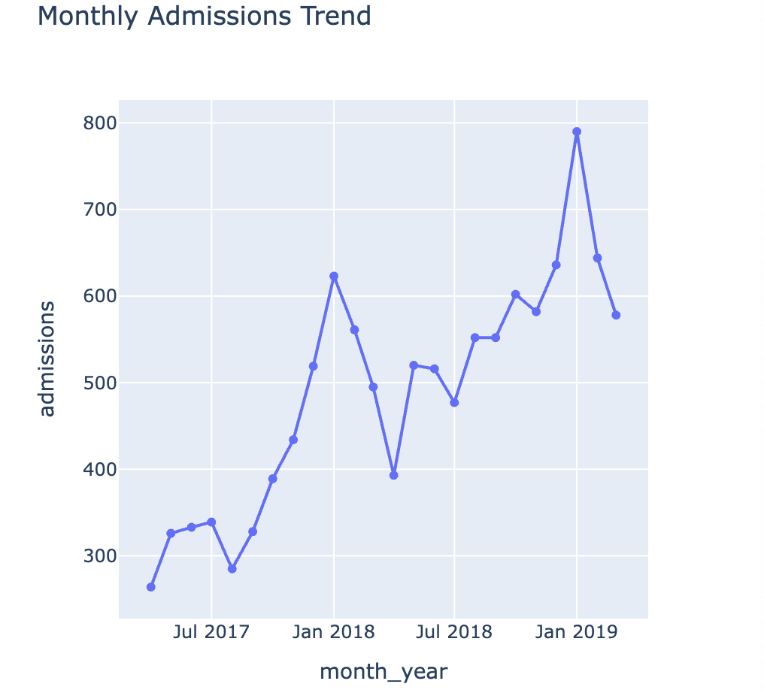
Figure 4.1. Interactive line chart of monthly admissions trend
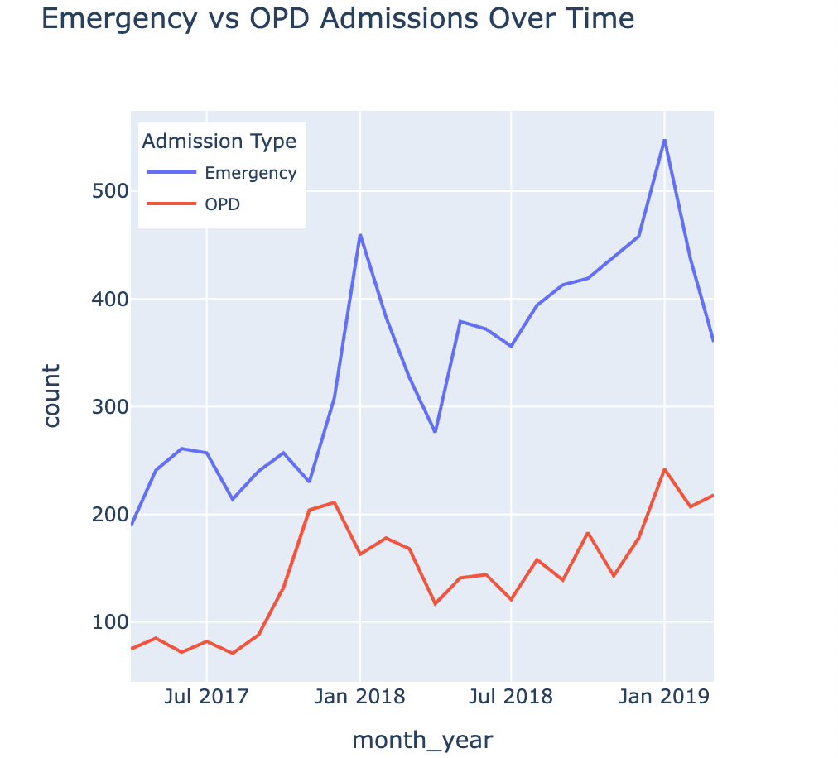
Figure 4.2. Interactive line graph of emergency vs OPD admissions over time
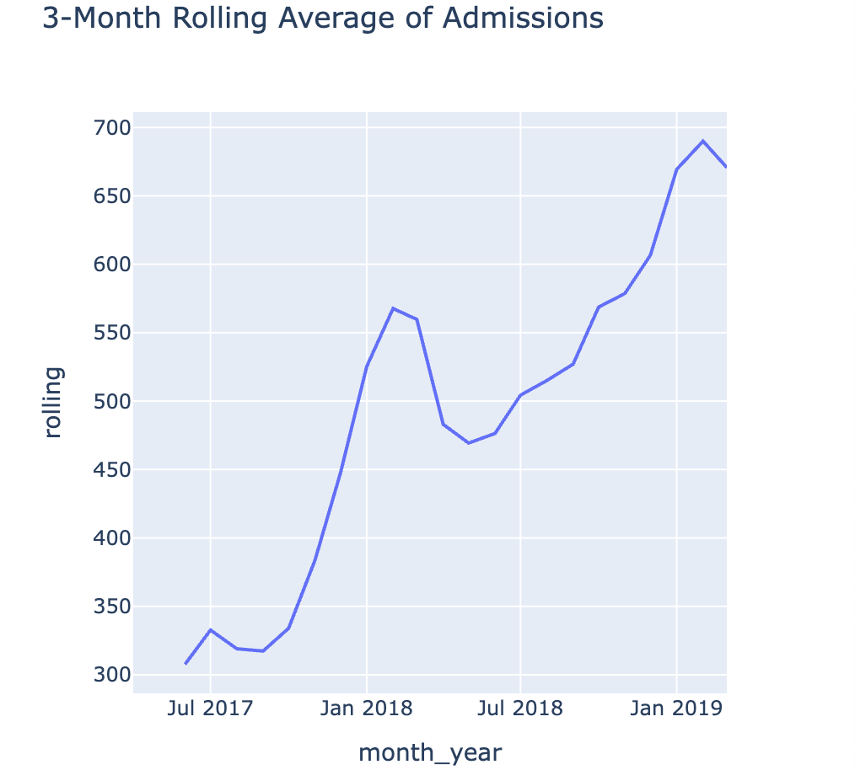
Figure 4.3. Interactive line chart of admissions 3-month rolling average
Turning to patient demographics, the age distribution shows a predominantly older population, with admissions clustering most densely between approximately 55 and 65 years (see appendix 29 & figure 4.4.). This concentration of middle-to-late adulthood admissions provides important clinical context for the subsequent analyses, as many of the biomarkers and conditions examined – including renal dysfunction, heart failure, and acute coronary syndromes – are strongly age-associated. The demographic profile therefore aligns with established evidence that cardiovascular and renal morbidity increase substantially with age (Singh et al., 2019; Dimopoulos et al., 2008).
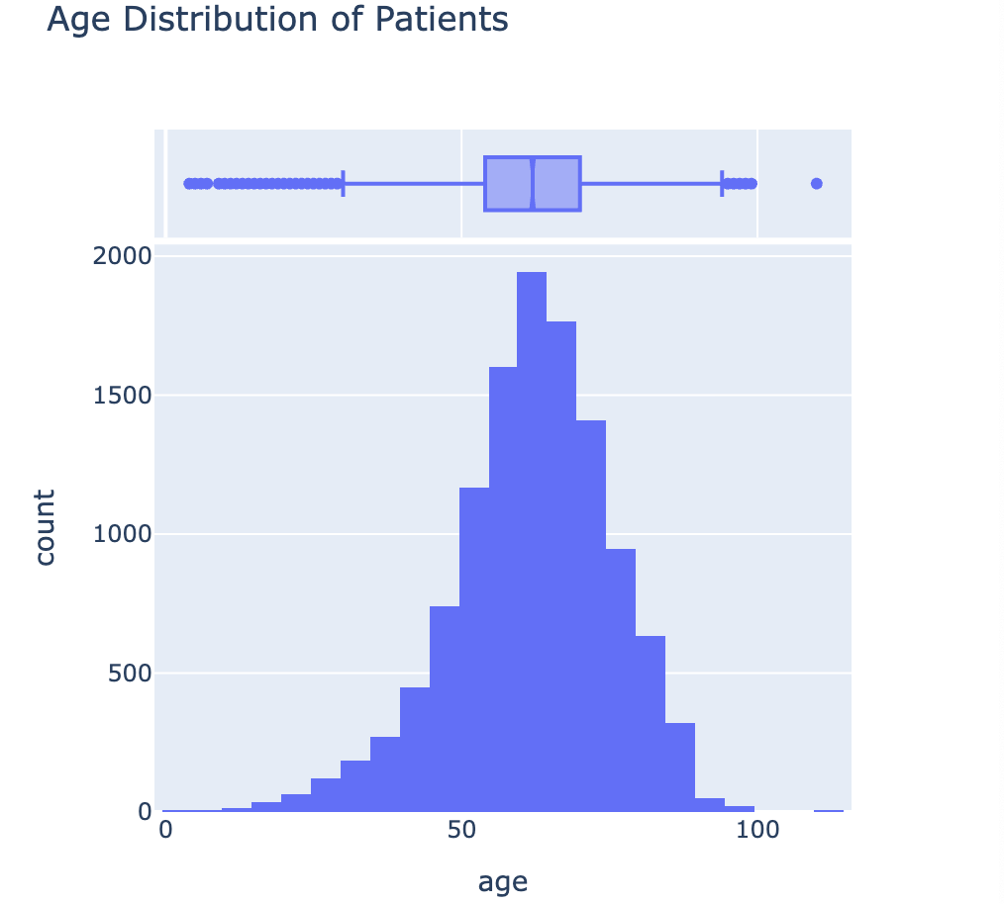
Figure 4.4. Interactive histogram, boxplot, and KDE of patient age distributions
The distribution of key biomarkers displays distinct variability patterns across the three panels (see appendix 30 & figure 4.5.). Creatinine, haemoglobin, and ejection fraction display moderate spread, with EF showing the widest range within this group. Glucose and urea exhibit more pronounced skewness, particularly glucose, which contains several high-value outliers consistent with acute metabolic disturbance (Corado, 2024). BNP, shown separately due to its substantially larger scale, demonstrates extreme variability and numerous high outliers, reflecting the severity of cardiac dysfunction in a subset of patients (Romano, 2025). These patterns are reinforced in the pair plot (see appendix 31), where diffuse scatter and weak linear relationships between age, creatinine, EF, and duration of stay indicate that these variables interact in complex, non-linear ways rather than through simple pairwise associations (see figure 4.6.).
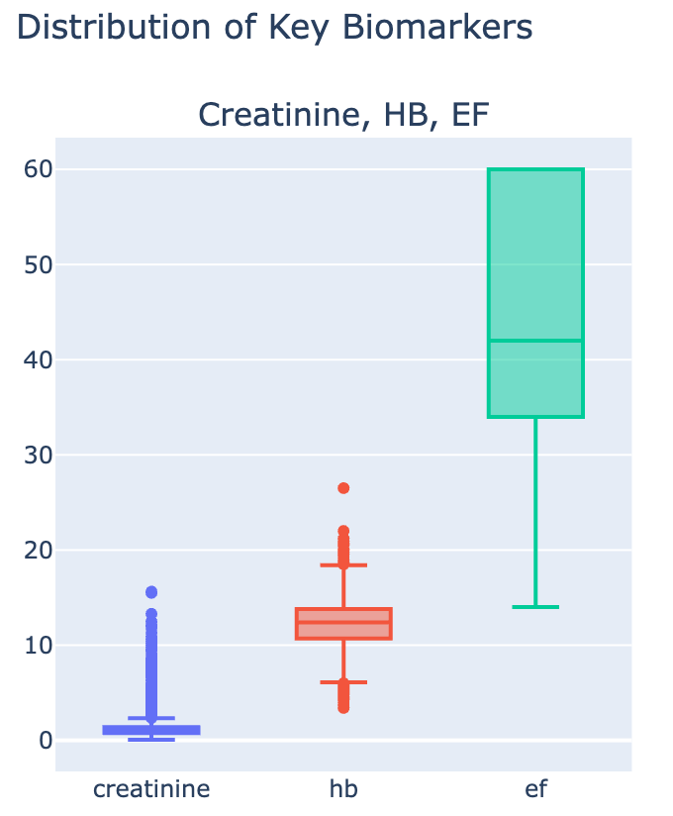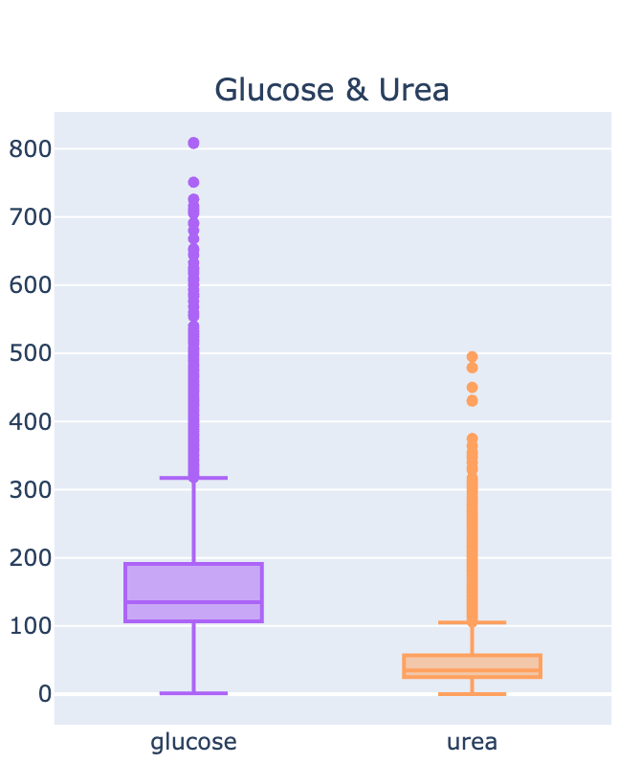
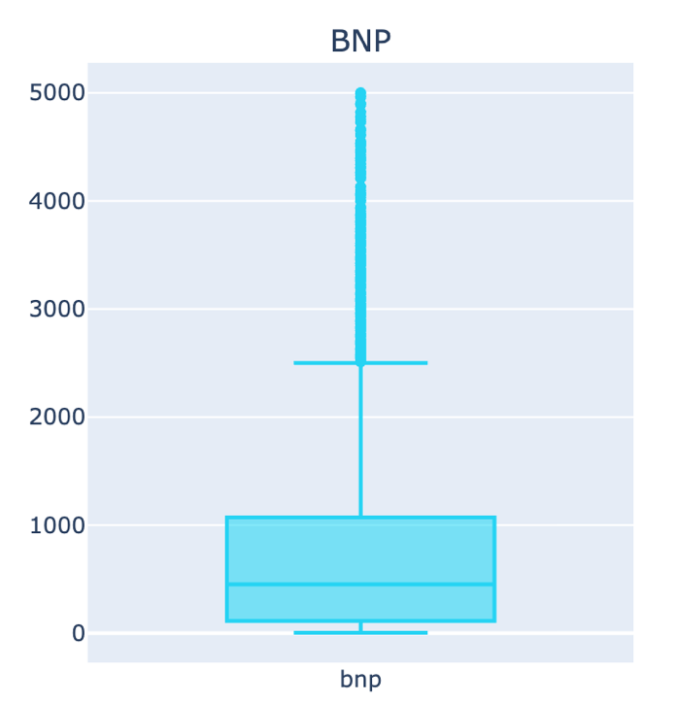
Figure 4.5. Interactive three-panel boxplots of biomarker distributions
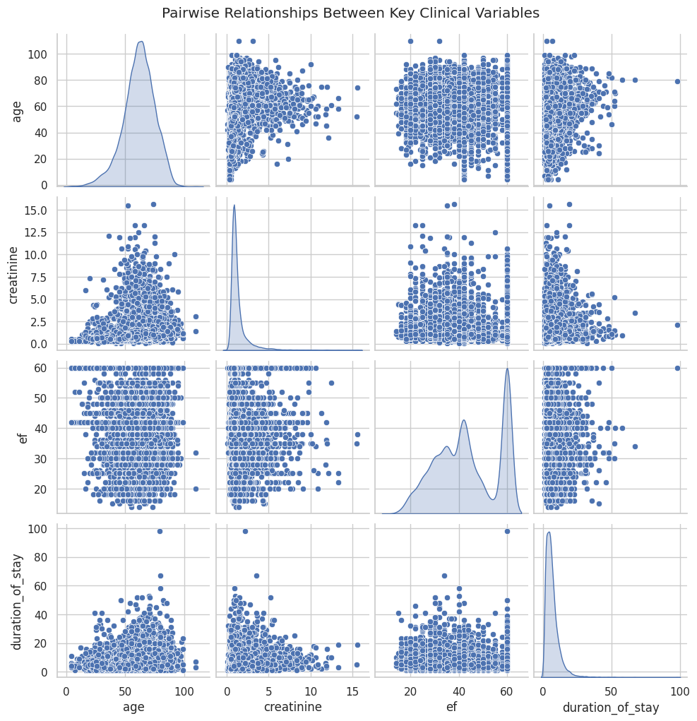
Figure 4.6. Pair plot of clinical variables
A deeper look at diagnostic patterns determines that ACS is the most common presentation, followed by heart failure, with AKI and STEMI forming a secondary but still clinically significant group (see appendix 32 & figure 4.7.). Valvular disease and stroke appear far less frequently, highlighting a clear concentration of admissions around acute coronary and decompensated cardiac conditions (Kotecha & Rakhit, 2016). The diagnosis co-occurrence heatmap reinforces this pattern (see appendix 33): the strongest association is observed between ACS and STEMI, reflecting their shared pathophysiological pathway, while other diagnoses show only weak correlations (see figure 4.8.). This indicates that although comorbidities are present, they are not uniformly distributed across conditions, suggesting that most diagnoses occur as distinct clinical entities rather than tightly linked clusters (Awoyode et al., 2024).
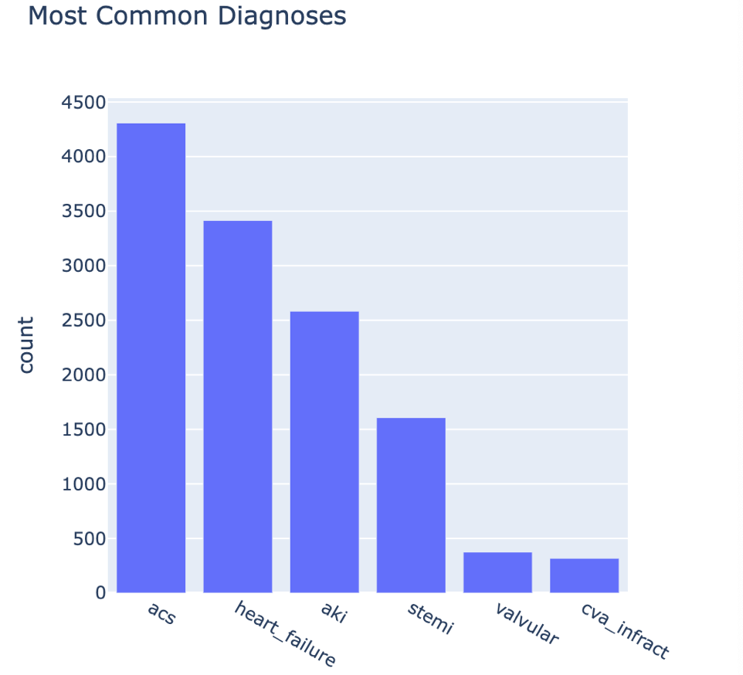
Figure 4.7. Interactive bar chart of most common diagnoses
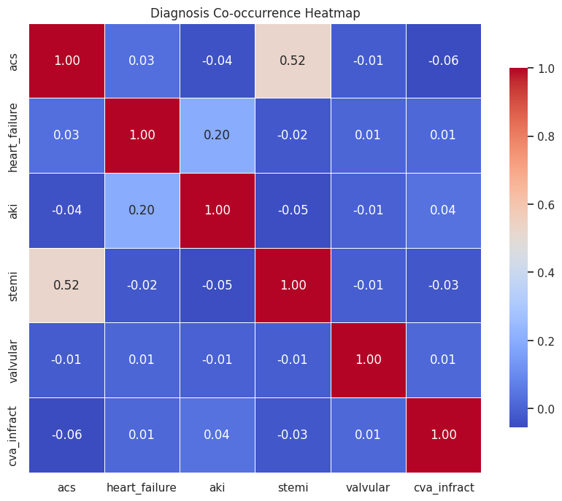

Figure 4.8. Clustered heatmap of diagnosis co-occurrence
The analysis of duration of stay by admission type highlights a clear divergence between emergency and OPD cases (see appendix 34). Emergency admissions exhibit substantially longer and more variable stays, with a wide distribution and a long upper tail that reflects the complexity and severity of acute presentations (see figure 4.9.). In contrast, OPD admissions are short and tightly clustered, indicating low-acuity cases that require minimal inpatient time. This pattern aligns with the earlier temporal findings and reinforces the interpretation that emergency activity is the primary driver of extended hospital resource use.
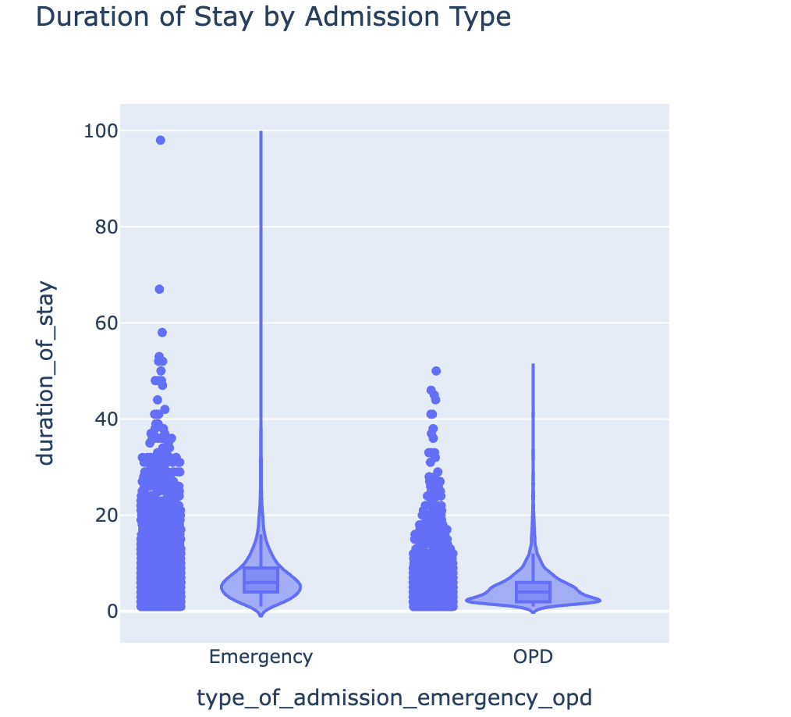
Figure 4.9. Interactive violin plot of duration of stay by admission type
Outcome patterns further contextualise these findings (see appendix 35). The distribution of patient outcomes shows that most admissions result in discharge, with DAMA and mortality representing only small proportions of cases (see figure 4.10.). This highly skewed pattern infers that, despite the clinical variability observed in biomarkers, diagnoses, and length of stay, most patients experience successful resolution of their admission (Wagner et al., 2013). The relatively low rates of DAMA and expiry are consistent with the predominance of acute but treatable cardiac presentations in this dataset.
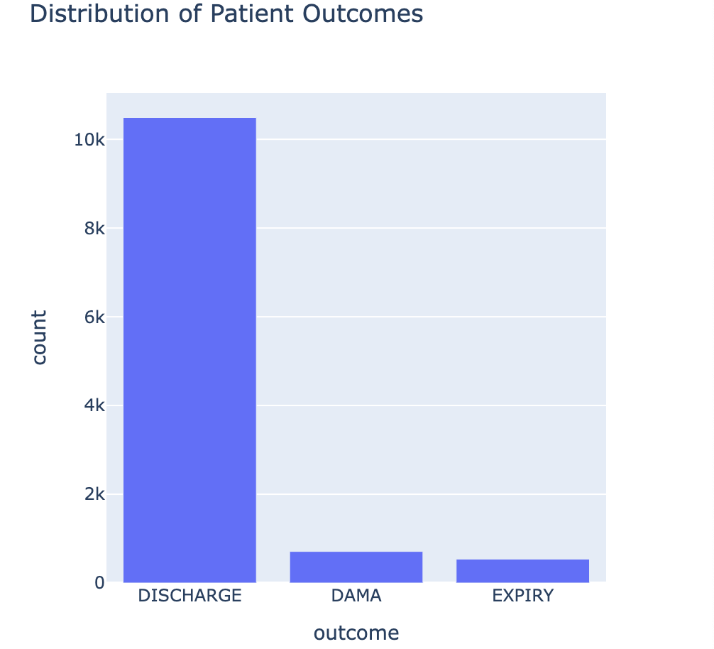
Figure 4.10. Interactive bar chart of patient outcomes distribution
Finally, the numeric clinical variable correlation heatmap and K-Means clustering provide a more structural view of the dataset (see appendices 36 & 37). The strongest relationship is observed between urea and creatinine, reflecting renal function as a coherent and internally consistent clinical dimension (Traynor et al., 2006), while the weak correlations with duration of stay indicate that length of stay (LOS) is shaped by multiple interacting factors rather than any single biomarker (Eskandari et al., 2022) (see figure 4.11.). The clustering analysis identifies three distinct patient groups based on creatinine and EF, suggesting the presence of meaningful clinical subtypes that differ in both renal impairment and cardiac function (see figure 4.12.). This segmentation supports the potential for stratified analysis and highlights underlying heterogeneity within the population.
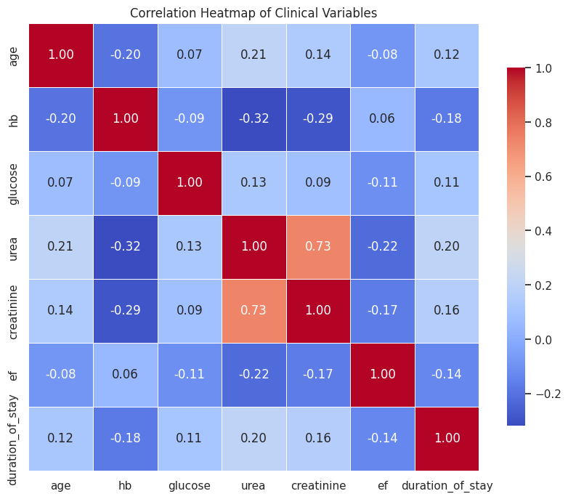
Figure 4.11. Correlation heatmap of clinical variables
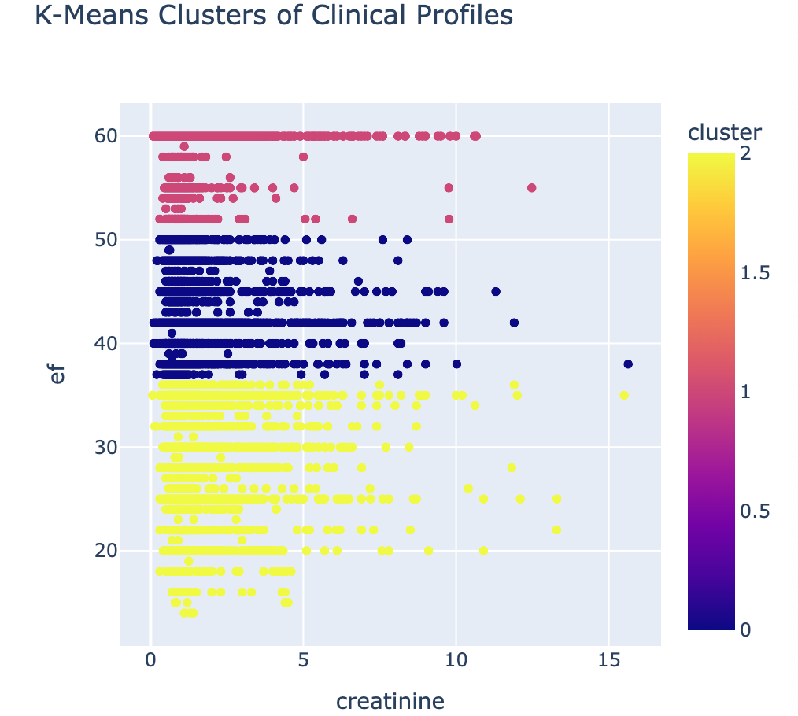
Figure 4.12. Interactive scatter plot of clinical profile K-means clusters
- Optimisation for Resource Allocation
  - Data Preparation
Preparation began with importing required libraries for machine learning (see appendix 38). Duration of stay was selected as the target as LOS explicitly represents how long a patient occupies hospital resources, indicating it is an accurate and actionable measure for planning beds, staffing, and clinical workload (Karthikeyan et al., 2024) (see appendix 39). Leakage columns were identified and excluded from the feature variables as they represent information that would not be available at the time of prediction, leading to model failure in the real-world (Sasse et al., 2025). Numeric and categorical features were identified (see appendix 40 & 41).
Eighty percent of the data was used to train the models, while the remaining 20% was held to test model performance (see appendix 42). A fixed random state ensured that the split was reproducible. Scaling and one-hot encoding were implemented to account for any remaining missing values and convert the categorical labels into a numerical format, establishing proportional features and ordinal structure (Qiu et al., 2022) (see appendix 43).
  - ML Method
The ML models selected were Linear Regression (LR), Random Forest (RM), and Gradient Boosting (GB) (see appendix 44). A pipeline was built to fit each model: training them on the training data; predicting LOS on the test data; calculating MAE, RMSE, and R2; and storing the results in a comparison table (see appendix 45). MAE measures how many days the model is off (on average), RMSE determines how big the mistakes are, and R2 demonstrates how much of duration the model can explain (Khoshvaght et al., 2025).
  - Model Evaluation
All three models demonstrated similar performance, with GB achieving the lowest RMSE and highest R2, indicating slightly better predictive ability (see appendices 46 & 47). The MAE of approximately 2.9 days suggests that the models’ predictions are within three days of true LOS (see figure 5.3.1.). Despite the modest R2 values, LOS is difficult to predict as it is influenced by numerous unrecorded factors (Stone et al., 2022). Subsequent analysis was focussed on GB.
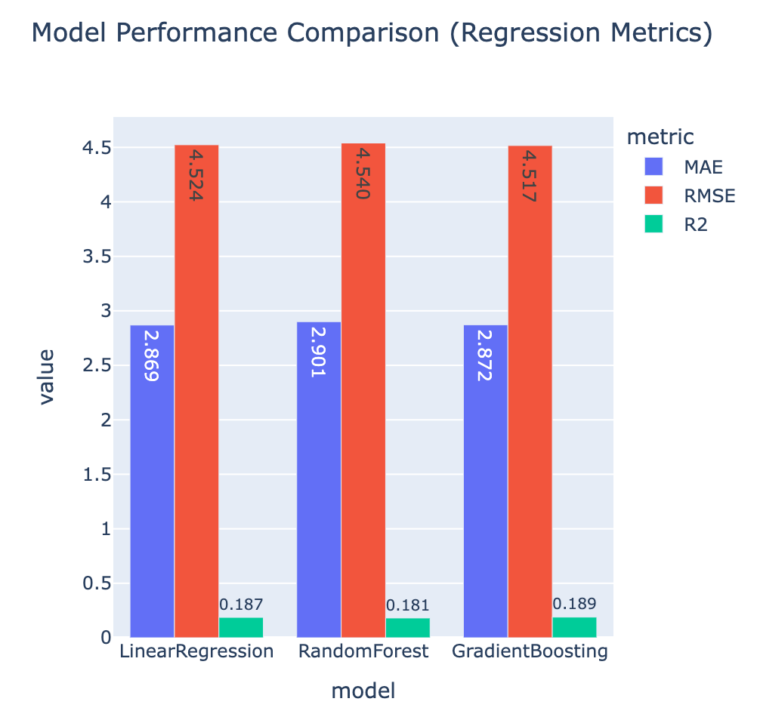
Figure 5.3.1. Interactive bar chart of model performance comparison
The true versus predicted plot presents that predictions broadly follow the diagonal trend, inferring GB captures the general relationship between admission-time features and LOS, however it tends to underestimate longer admissions where data is sparse (see appendix 48 & figure 5.3.2.). This is reinforced by the residual distribution, centring tightly around zero and displaying a right-skew, suggesting most predictions are reasonably accurate while significant underestimations occur rarely for prolonged stays (see appendix 49 & figure 5.3.3.). The feature importance plot demonstrates that GB relies primarily on clinical variables alongside admission type and age, highlighting that GB is learning plausible physiological and contextual signals rather than noise (see appendix 50 & figure 5.3.4.).
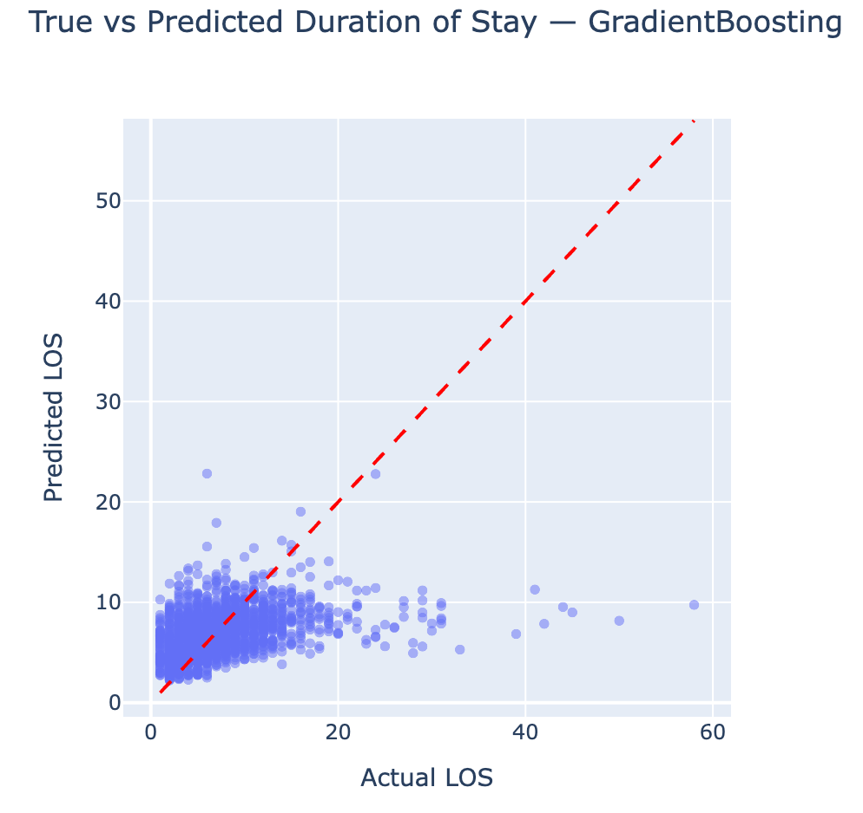
Figure 5.3.2. Interactive scatter plot of true vs predicted LOS
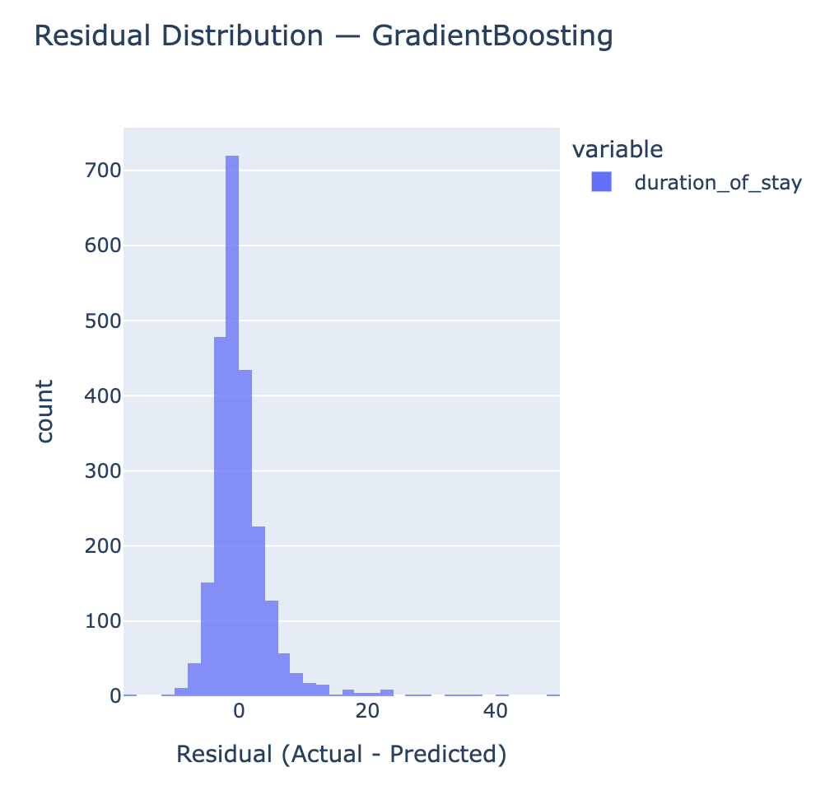
Figure 5.3.3. Interactive histogram of residual distribution
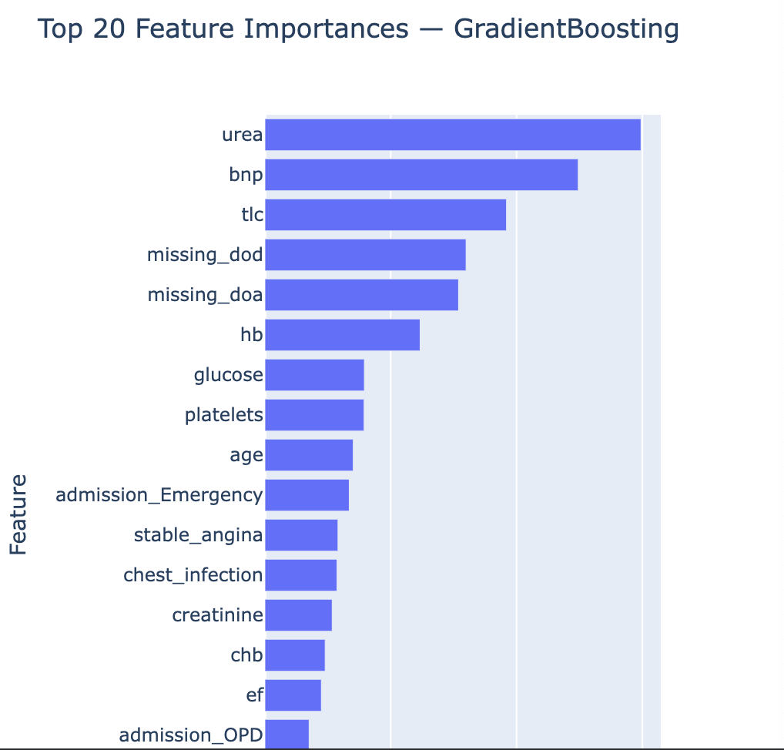
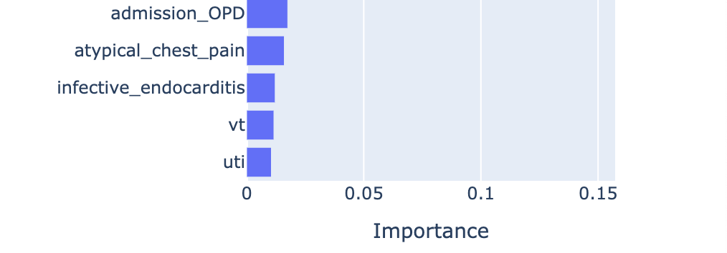
Figure 5.3.4. Interactive bar chart of feature importance
- Discussion
  - Main Findings & Recommendations
The strong influence of biomarkers suggests that early identification of patients with abnormal values could enable proactive planning for longer admissions. Emergency activity represented the dominant driver of demand and is associated with substantially longer and more variable stays, illustrating a need for flexible surge capacity and targeted operational planning during peak periods. The predictive model provides clinically meaningful estimates of LOS within approximately three days, which could be incorporated into discharge planning and bed-management workflows to improve patient flow. Observed diagnostic patterns suggest that targeted care pathways for high-impact groups could streamline treatment processes and reduce avoidable delays. Moreover, historical patterns should be used to forecast expected surges in winter, adjusting staffing rosters, elective activity, and bed availability accordingly.
  - Limitations & Improvements
This interactive visualisation system has several limitations that should be acknowledged. The predictive performance of GB was modest, reflecting the inherent difficulty of modelling LOS using clinical variables alone. Missingness in key fields required imputation and indicators, which may have introduced bias. The dataset lacked operational variables such as staffing levels, bed occupancy, and weekend effects, all of which are known to influence LOS but were not available for modelling. The model systematically underestimated prolonged admissions, implying limited ability to capture rare, complex cases. Moreover, the dataset was drawn from a single cardiology centre, limiting generalisability, and the modelling approach did not incorporate temporal patterns or advanced feature engineering. Future work should focus on improving data completeness, integrating operational metrics, exploring more sophisticated models and engineered features, and expanding the dataset to enhance predictive accuracy and applicability.
- Conclusion
Overall, the interactive visualisation system provides a robust and intuitive platform for exploring hospital admissions and clinical patterns. It enhances situational awareness, supports operational decision-making, and lays the groundwork for predictive modelling by revealing the key drivers of resource use. The system validates how interactive analytics can meaningfully improve understanding of patient flow and help hospitals plan resources more efficiently.

- References
AWOYODE, R., Ray, D.N., AKAMAH, J.A. and OKAFOR, H., 2024. Co-occurrence of Obstructive Coronary Artery Disease and Takotsubo Cardiomyopathy. Cureus, 16(4). Available from: https://assets.cureus.com/uploads/case_report/pdf/161020/20240527-21774-1n4t0d.pdf
BALOGUN, E.D., OGUNSOLA, K.O. and OGUNMOKUN, A.S., 2022. Developing an advanced predictive model for financial planning and analysis using machine learning. IRE journals, 5(11), pp.320-328. Available from: http://issn.org/resource/ISSN/2456-8880
CHU, X., ILYAS, I.F., KRISHNAN, S. and WANG, J., 2016, June. Data cleaning: Overview and emerging challenges. In Proceedings of the 2016 international conference on management of data (pp. 2201-2206). Available from: https://doi.org/10.1145/2882903.2912574
CORADO, A.M., 2024. Hyperammonemia and inborn errors of metabolism. Translational Pediatrics, 13(2), pp.200-202. Available from: https://doi.org/10.21037/tp-23-593
DIMOPOULOS, K., DILLER, G.P., KOLTSIDA, E., PIJUAN-DOMENECH, A., PAPADOPOULOU, S.A., BABU-NARAYAN,, S.V., SALUKHE, T.V., PIEPOLI, M.F., POOLE-WILSON, P.A., BEST, N. and FRANCIS, D.P., 2008. Prevalence, predictors, and prognostic value of renal dysfunction in adults with congenital heart disease. Circulation, 117(18), pp.2320-2328. Available from: https://doi.org/10.1161/CIRCULATIONAHA.107.734921
ESKANDARI, M., ALIZADEH BAHMANI, A.H., MARDANI-FARD, H.A., KARIMZADEH, I., OMIDFAR, N. and PEYMANI, P., 2022. Evaluation of factors that influenced the length of hospital stay using data mining techniques. BMC Medical Informatics and Decision Making, 22(1), p.280. Available from: 10.1186/s12911-022-02027-w
KARTHIKEYAN, P., BHARATH, M., VISHNUMRAM, M.K. and SRIRAM, B., 2024, July. Forecasting patient length of stay for optimal hospital resource allocation. In 2024 IEEE International Conference on Smart Power Control and Renewable Energy (ICSPCRE) (pp. 1-6). IEEE. Available from: https://doi.org/10.1109/ICSPCRE62303.2024.10675160
KHOSHVAGHT, H., PERMALA, R.R., RAZMJOU, A. and KHIADANI, M., 2025. A critical review on selecting performance evaluation metrics for supervised machine learning models in wastewater quality prediction. Journal of Environmental Chemical Engineering, 13(6), p.119675. Available from: https://doi.org/10.1016/j.jece.2025.119675
KOTECHA, T. and RAKHIT, R.D., 2016. Acute coronary syndromes. Clinical Medicine, 16(6), pp.s43-s48. Available from: 10.7861/clinmedicine.16-6s-s43
MALEMATJA, D.N., NKOSI, E.M. and NENE, S.E., 2025. The impact of insufficient resources on the quality-of-service delivery at a primary healthcare clinic in Limpopo. curationis, 48(1), p.2696. Available from: 10.4102/curationis.v48i1.2696
MORBEY, R.A., CHARLETT, A., LAKE, I., MAPSTONE, J., PEBODY, R., SEDGWICK, J., SMITH, G.E. and ELLIOT, A.J., 2020. Can syndromic surveillance help forecast winter hospital bed pressures in England?. PLoS One, 15(2), p.e0228804. Available from: https://journals.plos.org/plosone/article?id=10.1371/journal.pone.0228804#sec005
NHS MIDLANDS & LANCASHIRE, 2026. Urgent and emergency healthcare: the differences explained. Staffordshire and Stoke-on-Trent, Integrated Care Board [online]. Available from: https://staffsstoke.icb.nhs.uk/improving-urgent-and-emergency-care/urgent-and-emergency-healthcare-the-differences-explained/
PACKHAM, I.S., RAFIQ, M.Y., BORTHWICK, M.F. and DENHAM, S.L., 2005. Interactive visualisation for decision support and evaluation of robustness—in theory and in practice. Advanced Engineering Informatics, 19(4), pp.263-280. Available from: https://doi.org/10.1016/j.aei.2005.07.006
QIU, S., LIU, Q., ZHOU, S. and HUANG, W., 2022. Adversarial attack and defense technologies in natural language processing: A survey. Neurocomputing, 492, pp.278-307. Available from: https://doi.org/10.1016/j.neucom.2022.04.020
RANGASWAMI, J., BHALLA, V., BLAIR, J.E., CHANG, T.I., COSTA, S., LENTINE, K.L., LERMA, E.V., MEZUE, K., MOLITCH, M., MULLENS, W. and RONCO, C., 2019. Cardiorenal syndrome: classification, pathophysiology, diagnosis, and treatment strategies: a scientific statement from the American Heart Association. Circulation, 139(16), pp.e840-e878. Available from: https://doi.org/10.1161/CIR.0000000000000664
ROMANO, M., 2025. Heart failure syndromes: different definitions of different diseases—do we need separate guidelines? A narrative review. Journal of Clinical Medicine, 14(14), p.5090. Available from: 10.3390/jcm14145090
REID, F.D., COOK, D.G. and MAJEED, A., 1999. Explaining variation in hospital admission rates between general practices: cross sectional study. Bmj, 319(7202), pp.98-103. Available from: https://www.bmj.com/content/319/7202/98.short?casa_token=OYpHZPS2bZUAAAAA:6_xj7tgbFcgAn5xBDDvI6OIY7YRtOZeOLxV068TjcGk9qoD_hy8kpxear2BvRRi_AtxJ-1RFLGxZ
SAMADBEIK, M., STAIB, A., BOYLE, J., KHANNA, S., BOSLEY, E., BODNAR, D., LIND, J., AUSTIN, J.A., TANNER, S., MESHKAT, Y. and DE COURTEN, B., 2024. Patient flow in emergency departments: a comprehensive umbrella review of solutions and challenges across the health system. BMC health services research, 24(1), p.274. Available from: 10.1186/s12913-024-10725-6
SASSE, L., NICOLAISEN-SOBESKY, E., DUKART, J., EICKHOFF, S.B., GOTZ, M., HAMDAN, S., KOMEYER, V., KULKARNI, A., LAHNAKOSKI, J.M., LOVE, B.C. and RAIMONDO, F., 2025. Overview of leakage scenarios in supervised machine learning. Journal of Big Data, 12(1), p.135. Available from: https://link.springer.com/article/10.1186/s40537-025-01193-8
SHARMA, R., STANO, M. and GEHRING, R., 2008. Short‐term fluctuations in hospital demand: implications for admission, discharge, and discriminatory behavior. The Rand journal of economics, 39(2), pp.586-606. Available from: https://doi.org/10.1111/j.0741-6261.2008.00029.xDigital Object Identifier (DOI)
SINGH, G.M., BECQUART, N., CRUZ, M., ACEVEDO, A., MOZAFFARIAN, D. and NAUMOVA, E.N., 2019. Spatiotemporal and demographic trends and disparities in cardiovascular disease among older adults in the United States based on 181 million hospitalization records. Journal of the American Heart Association, 8(21), p.e012727. Available from: https://doi.org/10.1161/JAHA.119.012727
STONE, K., ZWIGGELAAR, R., JONES, P. and MAC PARTHALAIN, N., 2022. A systematic review of the prediction of hospital length of stay: Towards a unified framework. PLOS digital health, 1(4), p.e0000017. Available from: 10.1371/journal.pdig.0000017
TRAYNOR, J., MACTIER, R., GEDDES, C.C. and FOX, J.G., 2006. How to measure renal function in clinical practice. Bmj, 333(7571), pp.733-737. Available from: 10.1136/bmj.38975.390370.7C
WAGNER, J., GABLER, N.B., RATCLIFFE, S.J., BROWN, S.E., STROM, B.L. and HALPERN, S.D., 2013. Outcomes among patients discharged from busy intensive care units. Annals of internal medicine, 159(7), pp.447-455. Available from: 10.7326/0003-4819-159-7-201310010-00004
WEISSGERBER, T.L., GAROVIC, V.D., SAVIC, M., WINHAM, S.J. and MILIC, N.M., 2016. From static to interactive: transforming data visualization to improve transparency. PLoS biology, 14(6), p.e1002484. Available from: https://doi.org/10.1371/journal.pbio.1002484
ZHOU, J., GANDOMI, A.H., CHEN, F. and HOLZINGER, A., 2021. Evaluating the quality of machine learning explanations: A survey on methods and metrics. Electronics, 10(5), p.593. Available from: https://doi.org/10.3390/electronics10050593
- Appendices
Appendix 1 Import, load and summarise dataset code
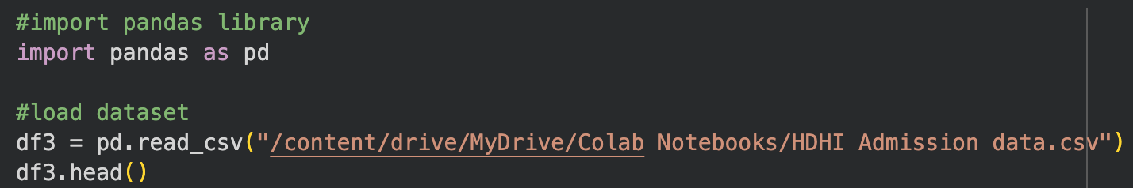
Appendix 2 Summarise dataset output
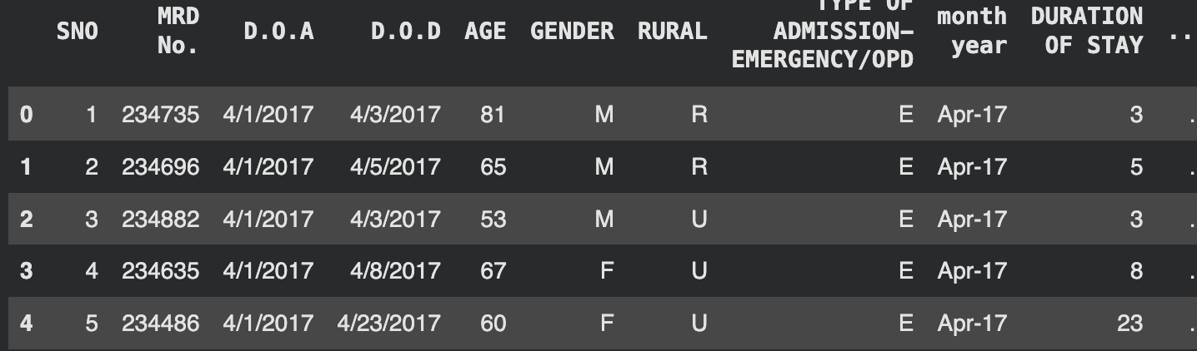
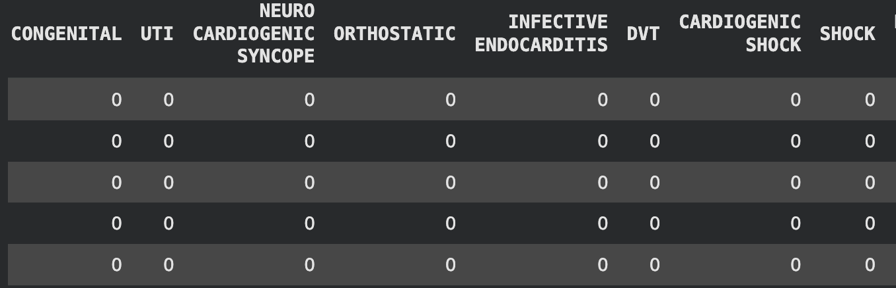

Appendix 3 Standardise column names code
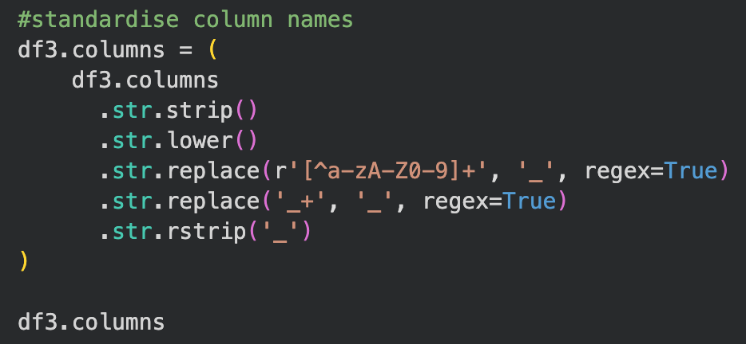
Appendix 4 Column names output
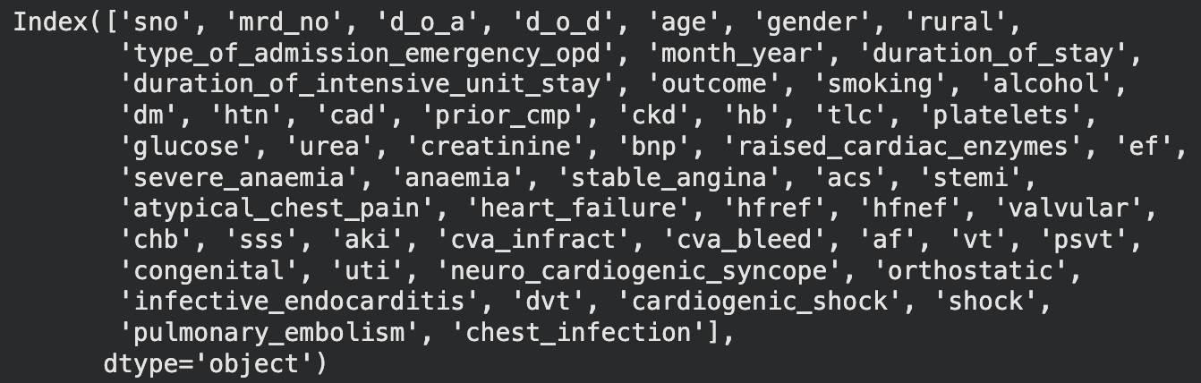
Appendix 5 Information and sample of dataset code
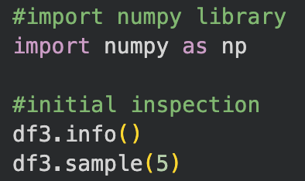

Appendix 6 Information and sample of dataset output
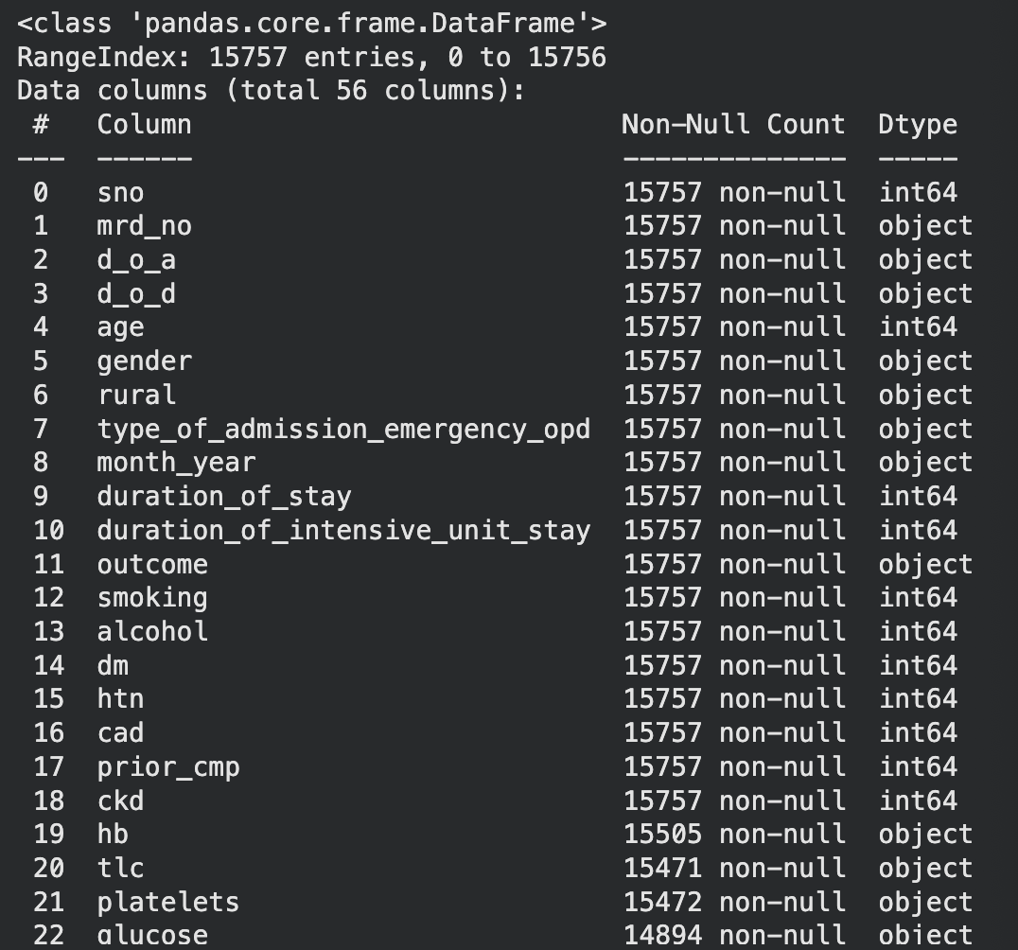
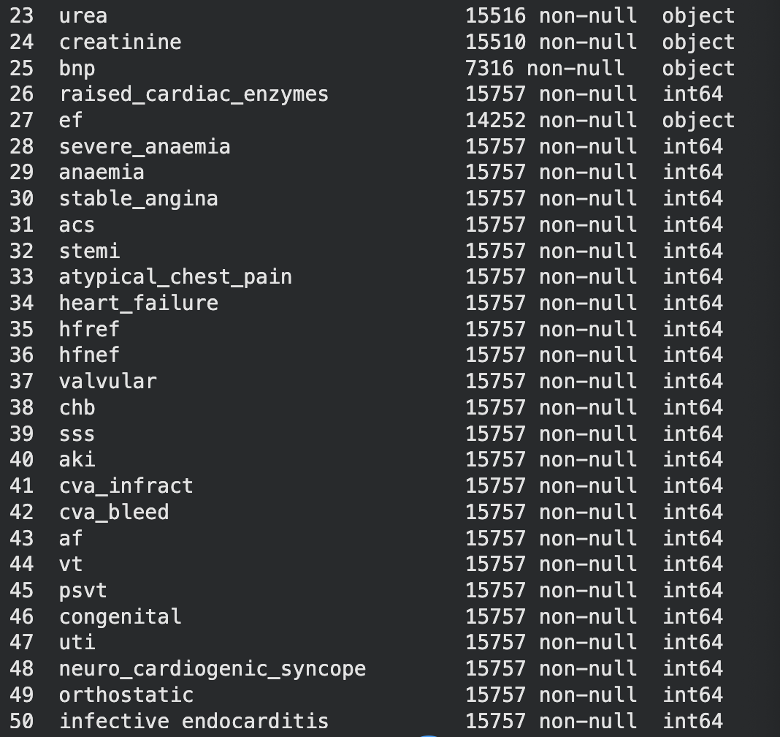
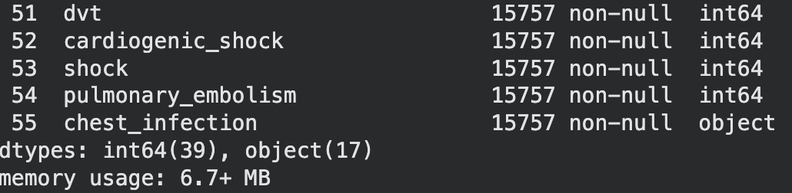
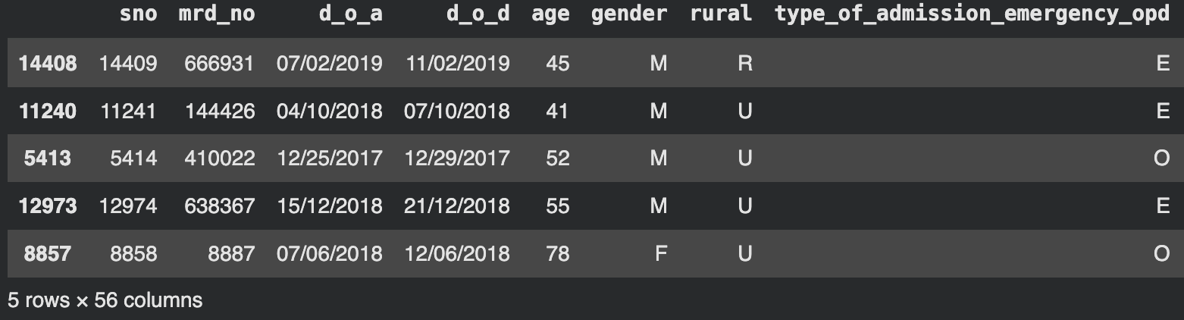
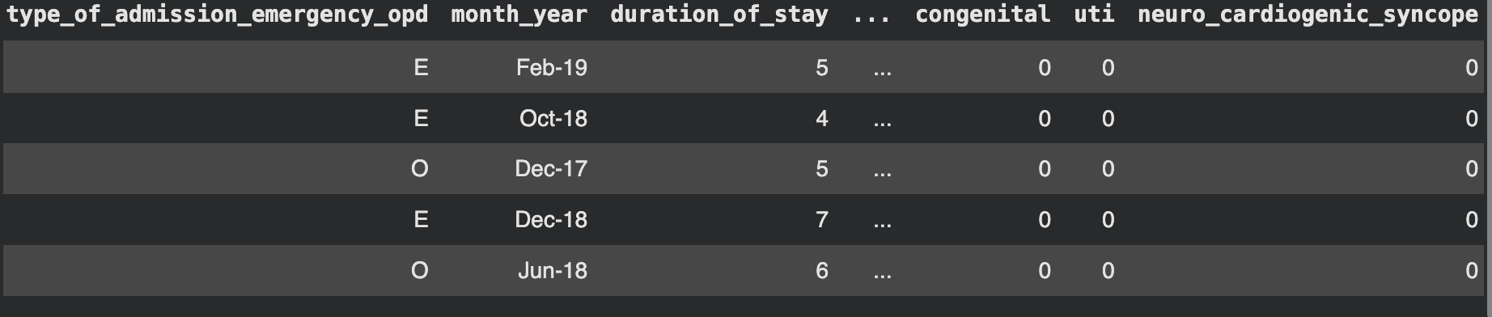
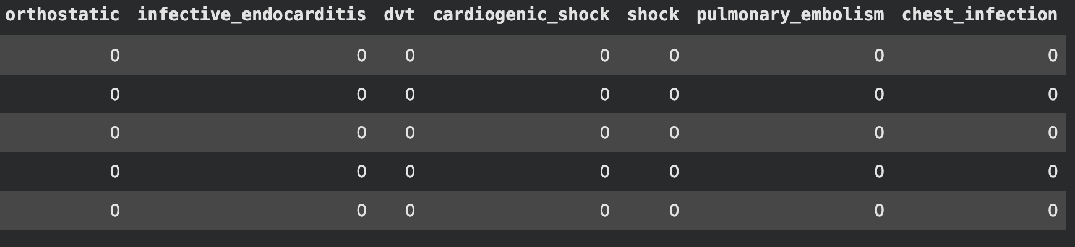
Appendix 7 Convert date columns code
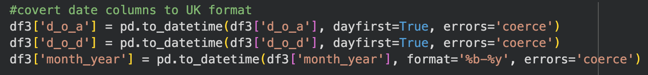
Appendix 8 Convert categorical fields code
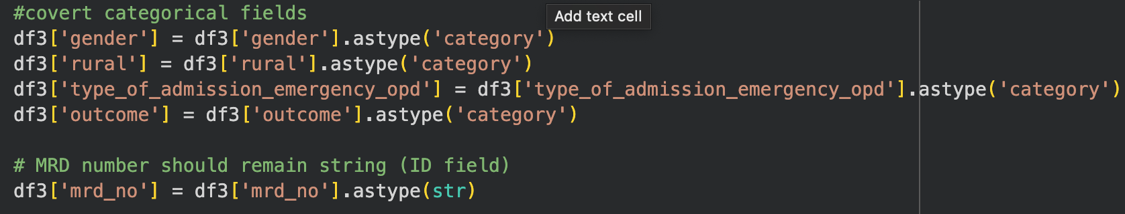
Appendix 9 Convert lab values code
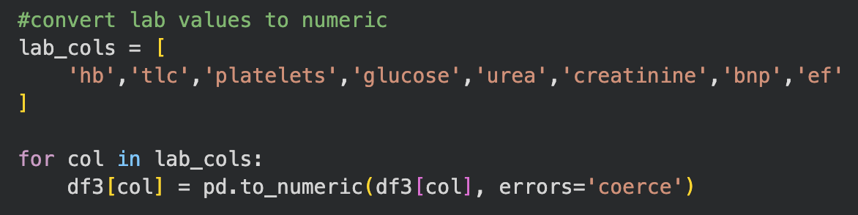

Appendix 10 Fix chest infection code
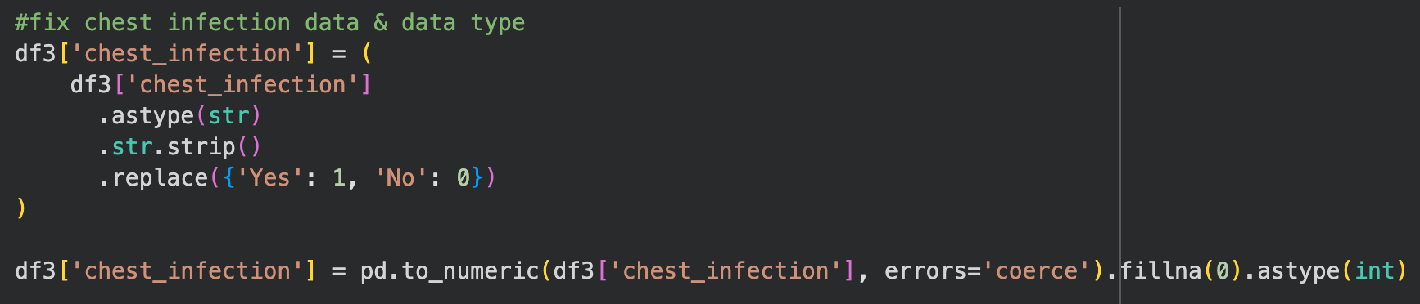
Appendix 11 Check missing values code

Appendix 12 Missing values output
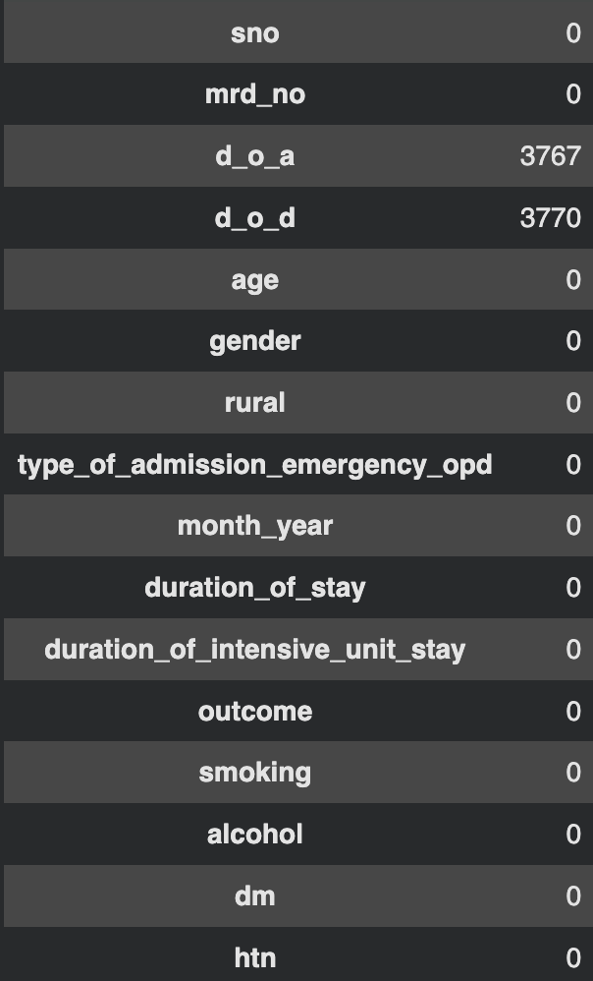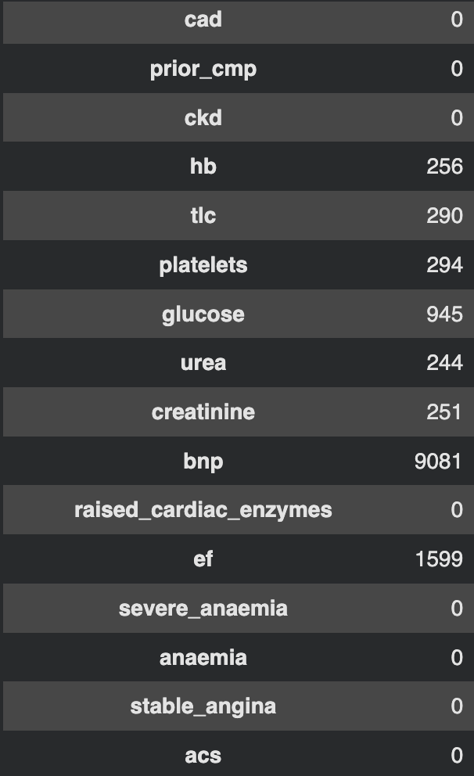
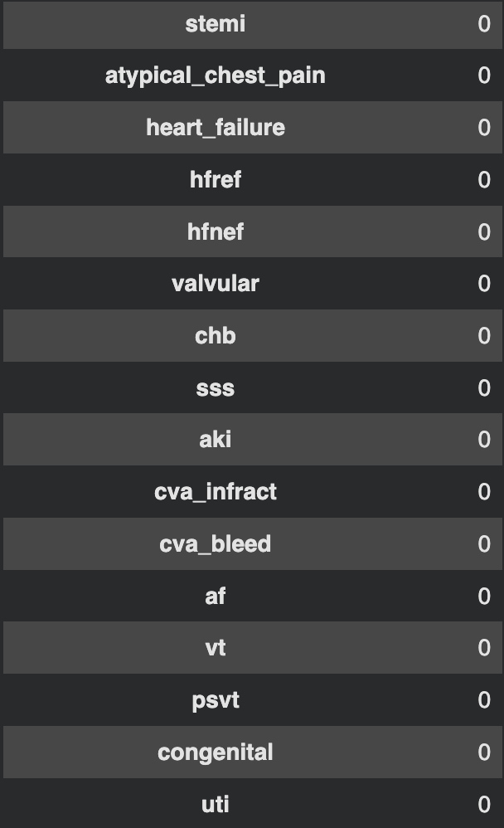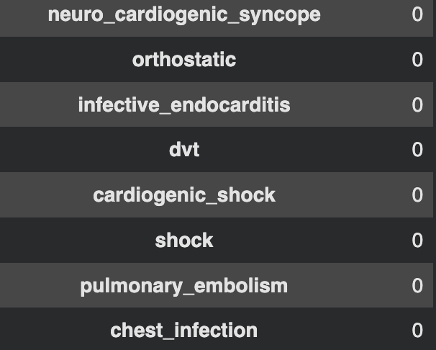
Appendix 13 Drop rows with both dates missing code
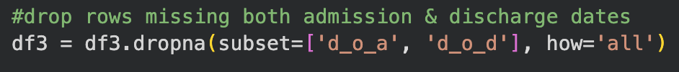
Appendix 14 Add indicators for singular missing dates code
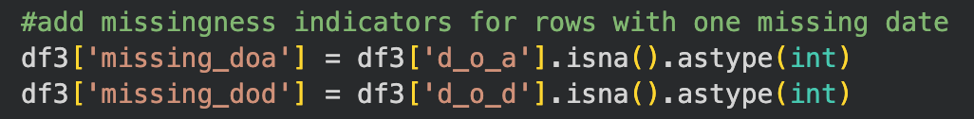
Appendix 15 Impute lab values with median code
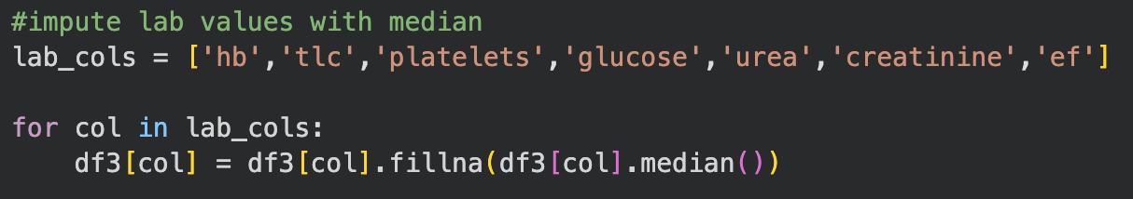

Appendix 16 Add indicator for BNP
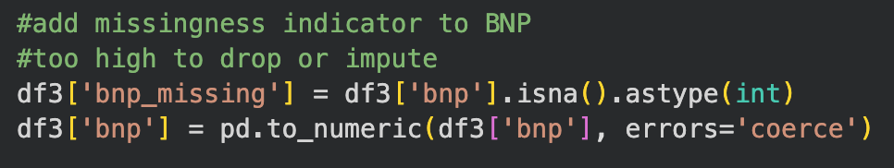
Appendix 17 Standardise categorical labels code
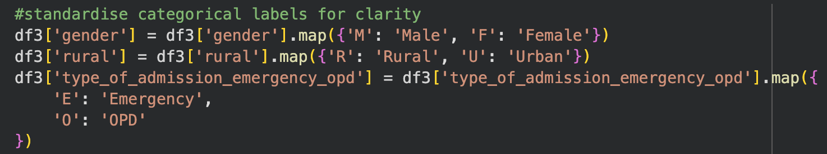
Appendix 18 Validate duration and inspect mismatches code
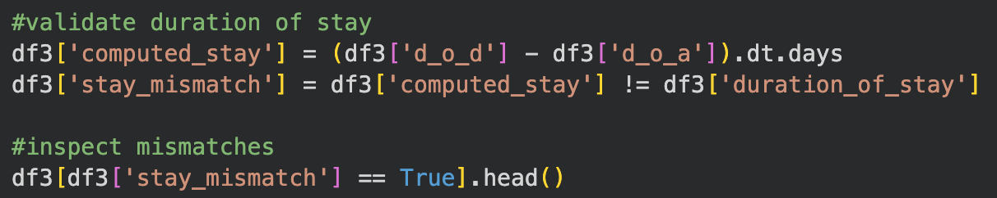
Appendix 19 Computed stay and mismatch output
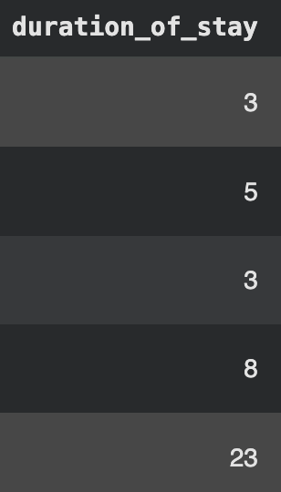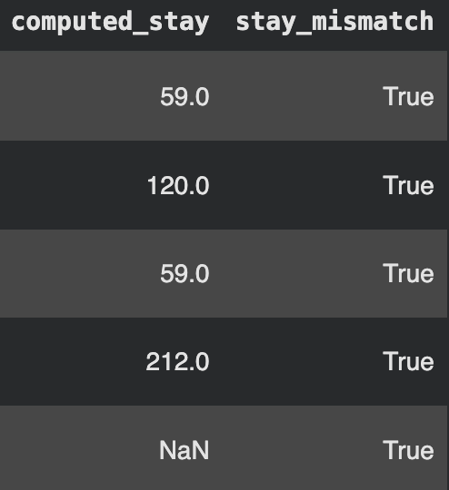
Appendix 20 Remove duplicates code
Appendix 21 Export cleaned dataset code
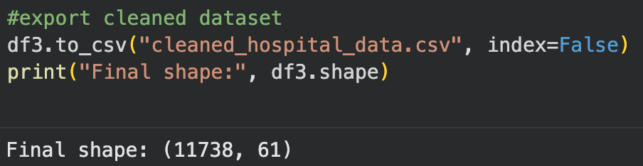
Appendix 22 Outlier detection code
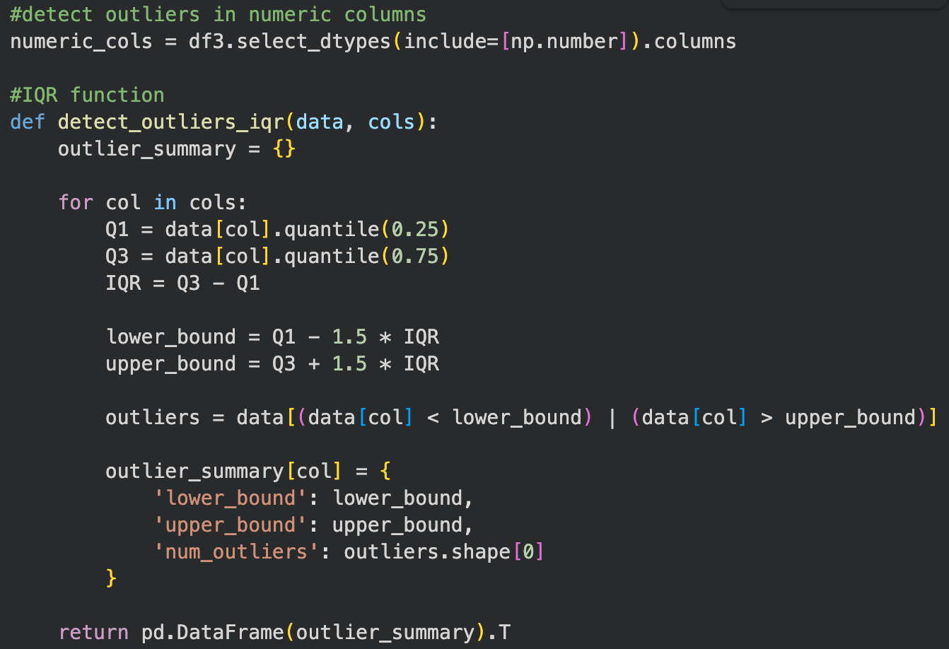

Appendix 23 Outlier detection output
 | lower_bound | upper_bound | num_outliers
sno | -5724.750 | 22979.250 | 0.0
age | 30.000 | 94.000 | 267.0
duration_of_stay | -4.500 | 15.500 | 584.0
duration_of_intensive_unit_stay | -5.000 | 11.000 | 547.0
smoking | 0.000 | 0.000 | 585.0
alcohol | 0.000 | 0.000 | 757.0
dm | -1.500 | 2.500 | 0.0
htn | -1.500 | 2.500 | 0.0
cad | -1.500 | 2.500 | 0.0
prior_cmp | 0.000 | 0.000 | 1737.0
ckd | 0.000 | 0.000 | 1165.0
hb | 6.050 | 18.450 | 121.0
tlc | -0.050 | 21.150 | 590.0
platelets | -1.000 | 463.000 | 362.0
glucose | -19.000 | 317.000 | 630.0
urea | -23.000 | 105.000 | 1064.0
creatinine | -0.175 | 2.345 | 1226.0
bnp | -1325.000 | 2507.000 | 352.0
raised_cardiac_enzymes | 0.000 | 0.000 | 2347.0
ef | -5.000 | 99.000 | 0.0
severe_anaemia | 0.000 | 0.000 | 233.0
anaemia | 0.000 | 0.000 | 2121.0
stable_angina | 0.000 | 0.000 | 974.0
acs | -1.500 | 2.500 | 0.0
stemi | 0.000 | 0.000 | 1607.0
atypical_chest_pain | 0.000 | 0.000 | 305.0
heart_failure | -1.500 | 2.500 | 0.0
hfref | 0.000 | 0.000 | 1734.0
hfnef | 0.000 | 0.000 | 1690.0
valvular | 0.000 | 0.000 | 375.0
chb | 0.000 | 0.000 | 314.0
sss | 0.000 | 0.000 | 75.0
aki | 0.000 | 0.000 | 2584.0
cva_infract | 0.000 | 0.000 | 318.0
cva_bleed | 0.000 | 0.000 | 43.0
af | 0.000 | 0.000 | 540.0
vt | 0.000 | 0.000 | 372.0
psvt | 0.000 | 0.000 | 93.0
congenital | 0.000 | 0.000 | 111.0
uti | 0.000 | 0.000 | 714.0
neuro_cardiogenic_syncope | 0.000 | 0.000 | 98.0
orthostatic | 0.000 | 0.000 | 106.0
infective_endocarditis | 0.000 | 0.000 | 23.0
dvt | 0.000 | 0.000 | 168.0
cardiogenic_shock | 0.000 | 0.000 | 537.0
shock | 0.000 | 0.000 | 397.0
pulmonary_embolism | 0.000 | 0.000 | 164.0
chest_infection | 0.000 | 0.000 | 278.0
missing_doa | 0.000 | 0.000 | 915.0
missing_dod | 0.000 | 0.000 | 929.0
bnp_missing | -1.500 | 2.500 | 0.0
computed_stay | -7.500 | 20.500 | 1547.0

Appendix 24 Import EDA libraries code
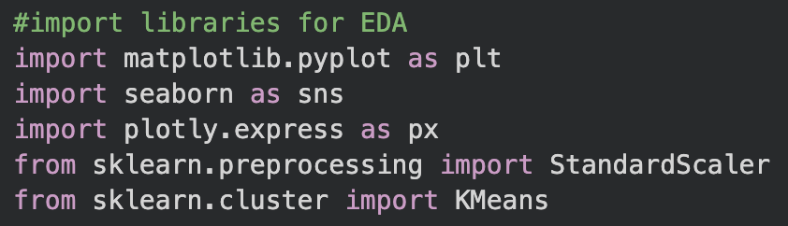
Appendix 25 Set display settings for plots code
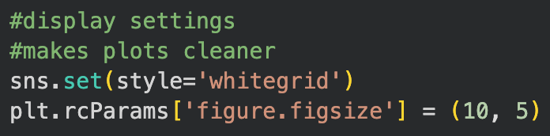

Appendix 26 Monthly admissions trend plot code
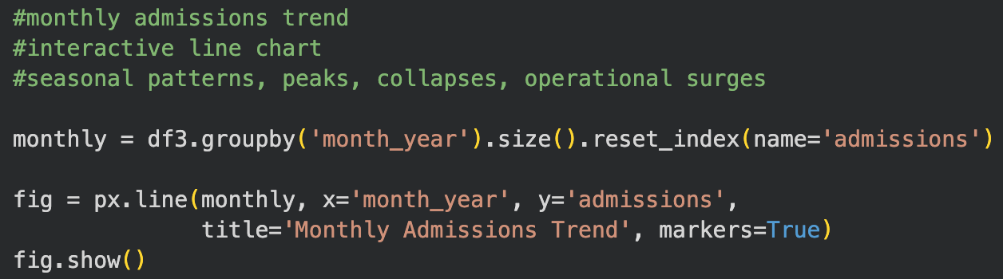
Appendix 27 Emergency vs OPD admissions over time plot code
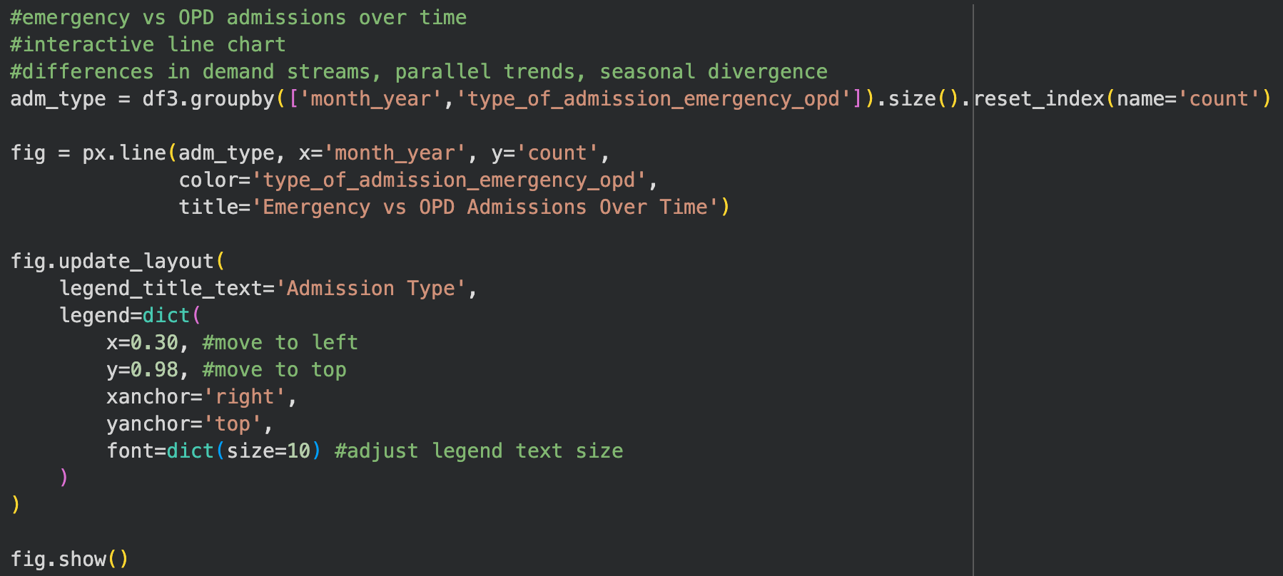
Appendix 28 Rolling average trend plot code
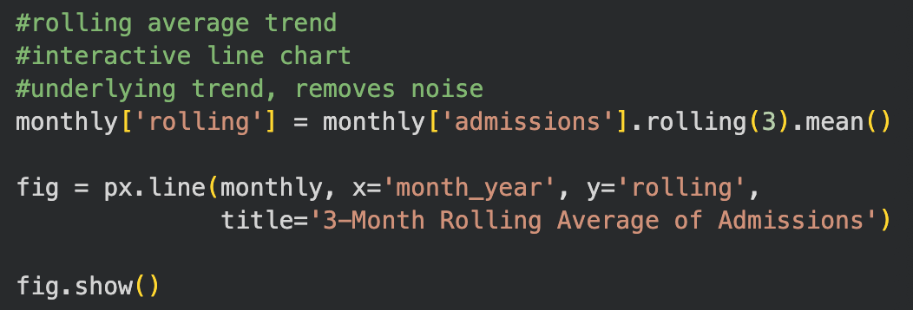

Appendix 29 Age distribution of patients plot code
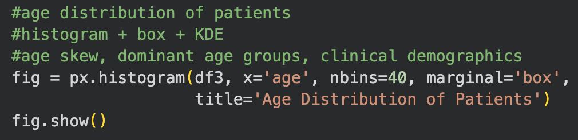
Appendix 30 Biomarker distributions plot code
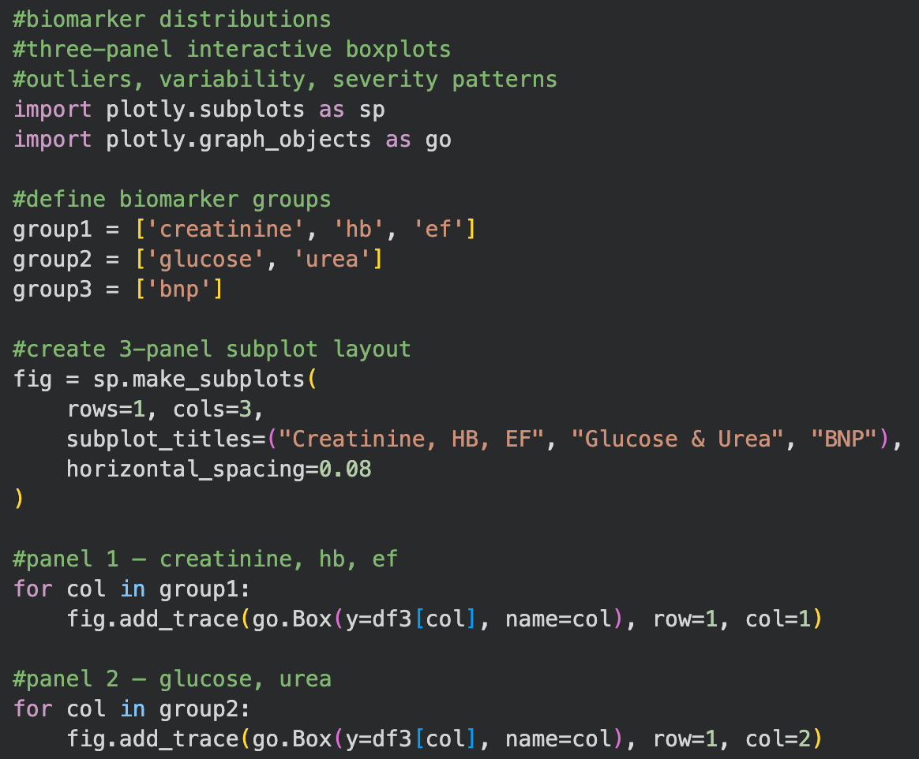
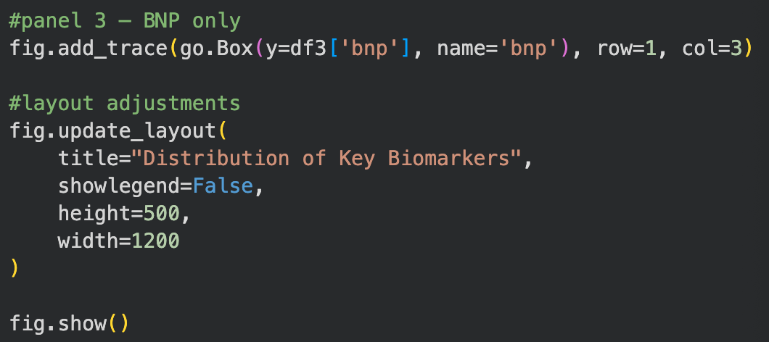
Appendix 31 Pair plot of clinical variables code
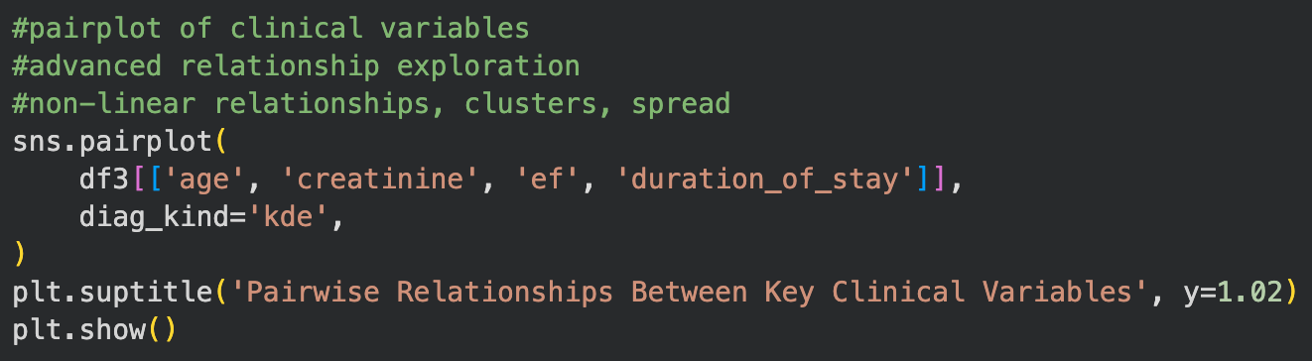
Appendix 32 Most common diagnoses plot code
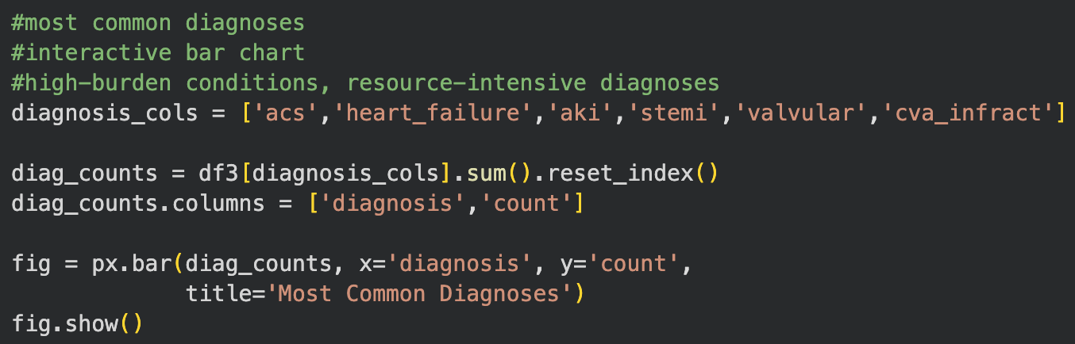
Appendix 33 Diagnosis co-occurrence plot code
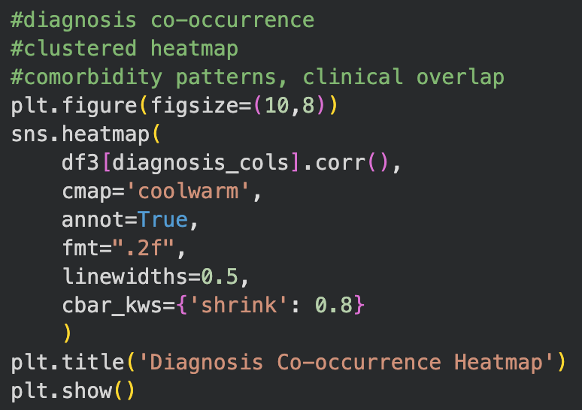

Appendix 34 Duration of stay by admission type plot code
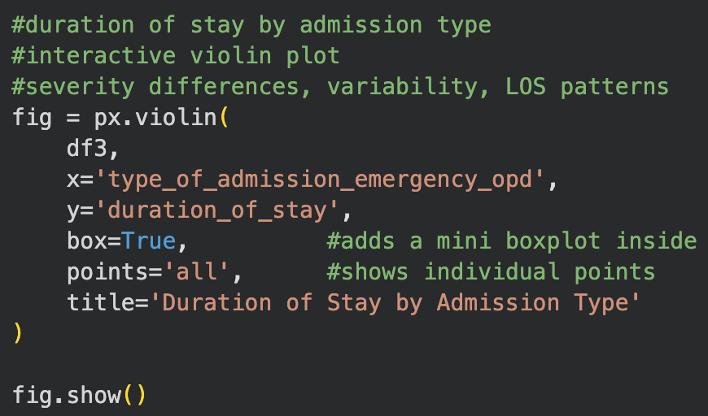
Appendix 35 Patient outcomes distribution plot code
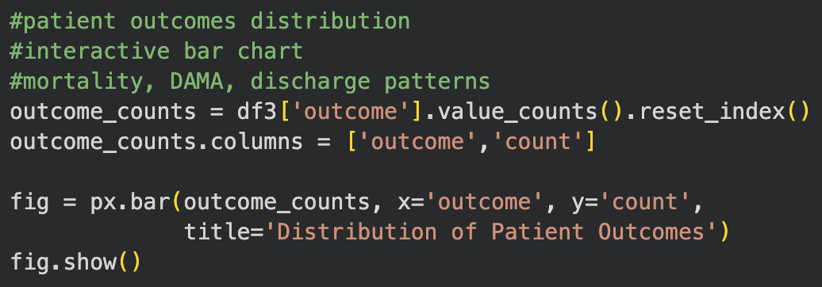
Appendix 36 Correlation heatmap of key numerical clinical variables code
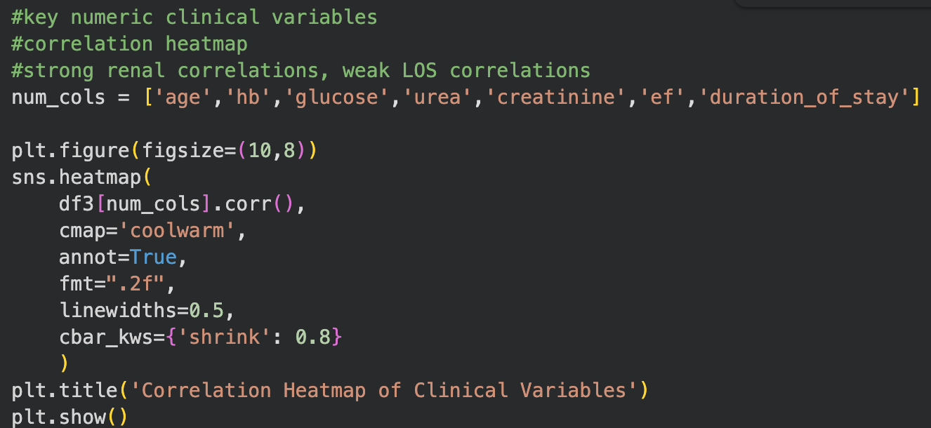
Appendix 37 K-means clusters of clinical profiles plot code
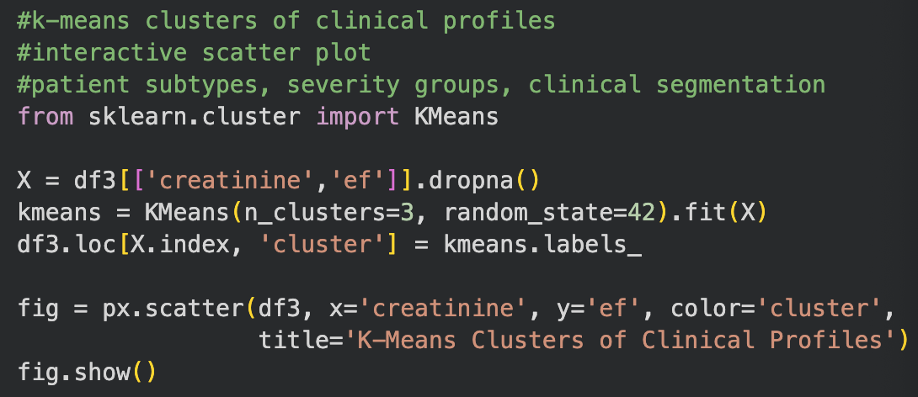
Appendix 38 Import ML libraries code
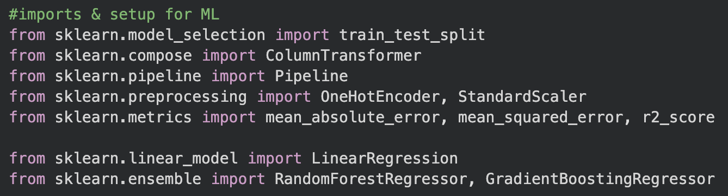
Appendix 39 Define target and feature sets code
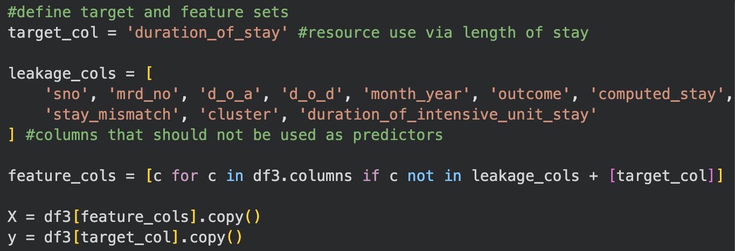

Appendix 40 Identify numeric and categorical features code

Appendix 41 Numeric and categorical features output
Numeric features: ['age', 'smoking', 'alcohol', 'dm', 'htn', 'cad', 'prior_cmp', 'ckd', 'hb', 'tlc', 'platelets', 'glucose', 'urea', 'creatinine', 'bnp', 'raised_cardiac_enzymes', 'ef', 'severe_anaemia', 'anaemia', 'stable_angina', 'acs', 'stemi', 'atypical_chest_pain', 'heart_failure', 'hfref', 'hfnef', 'valvular', 'chb', 'sss', 'aki', 'cva_infract', 'cva_bleed', 'af', 'vt', 'psvt', 'congenital', 'uti', 'neuro_cardiogenic_syncope', 'orthostatic', 'infective_endocarditis', 'dvt', 'cardiogenic_shock', 'shock', 'pulmonary_embolism', 'chest_infection', 'missing_doa', 'missing_dod', 'bnp_missing']
Categorical features: ['gender', 'rural', 'type_of_admission_emergency_opd']

Appendix 42 Train-test split code
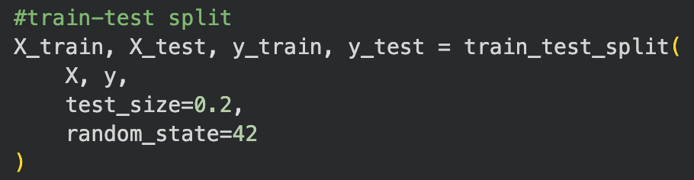

Appendix 43 Scaling and one-hot encoding code
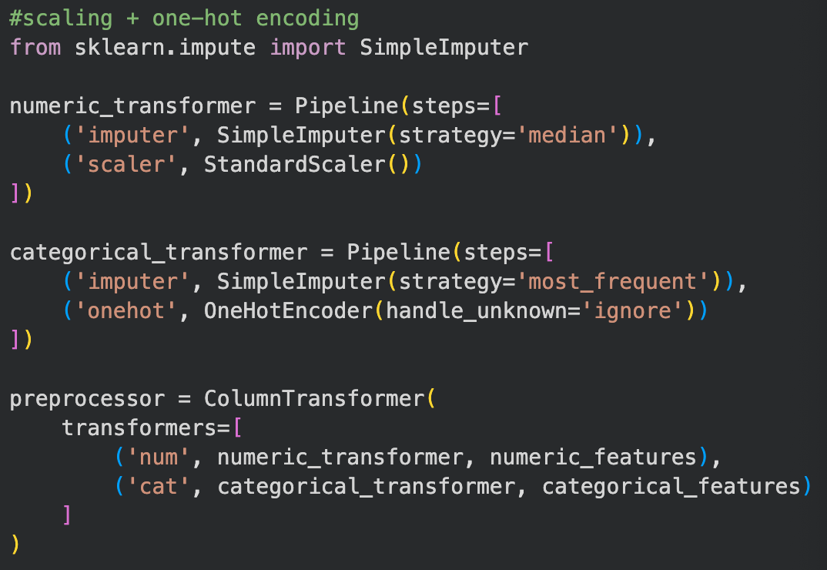
Appendix 44 Define ML models code
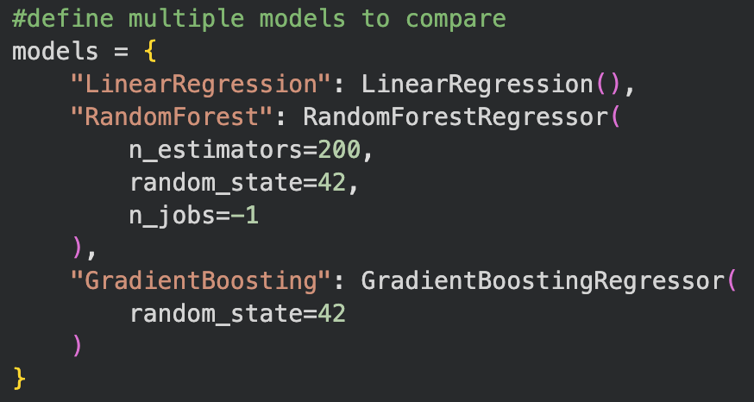

Appendix 45 Train and evaluate models code
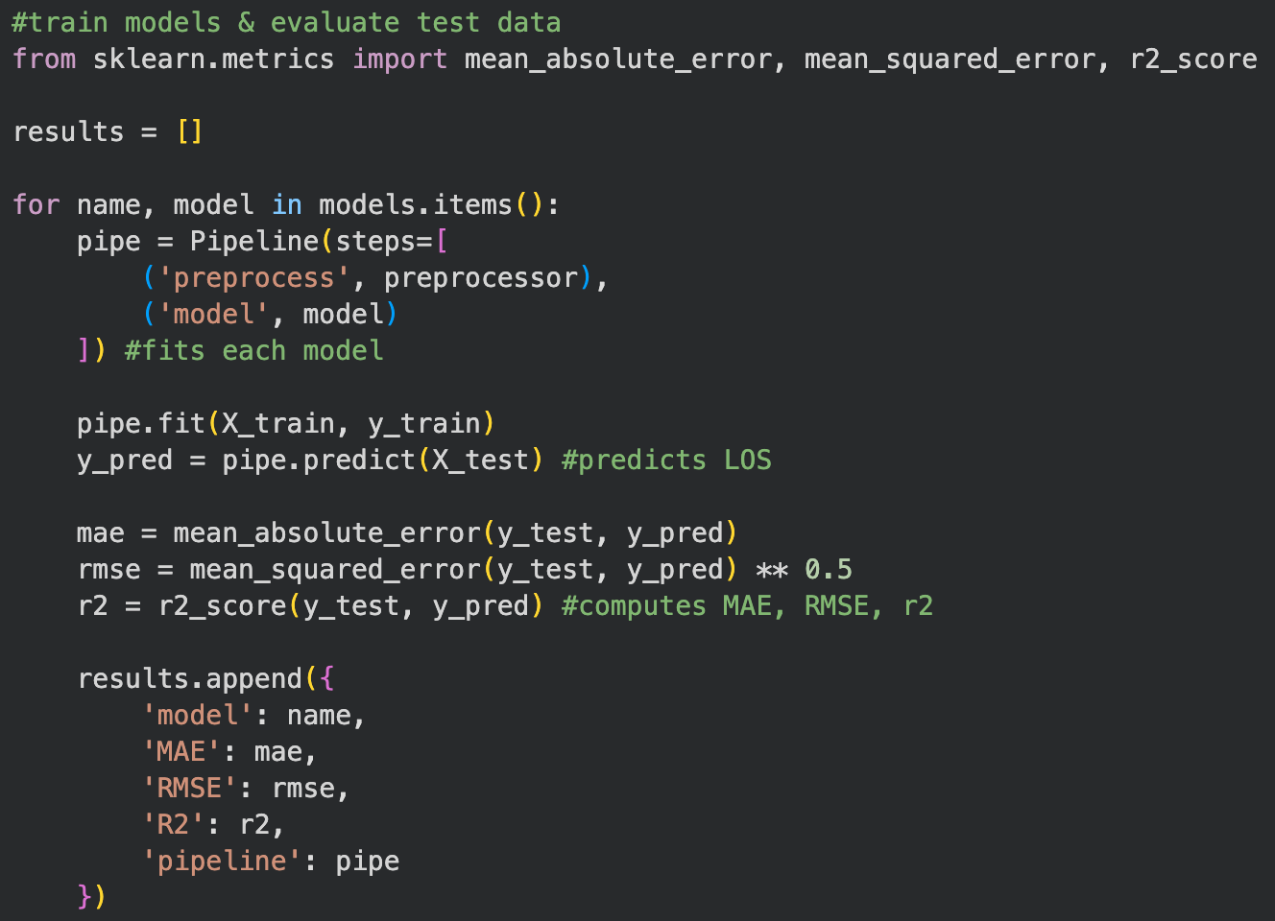
Appendix 46 Test model results output
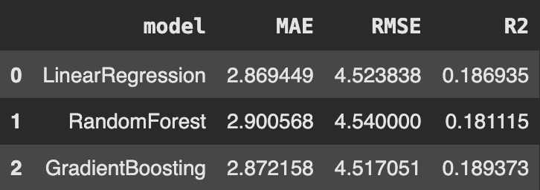

Appendix 47 Model performance comparison plot code
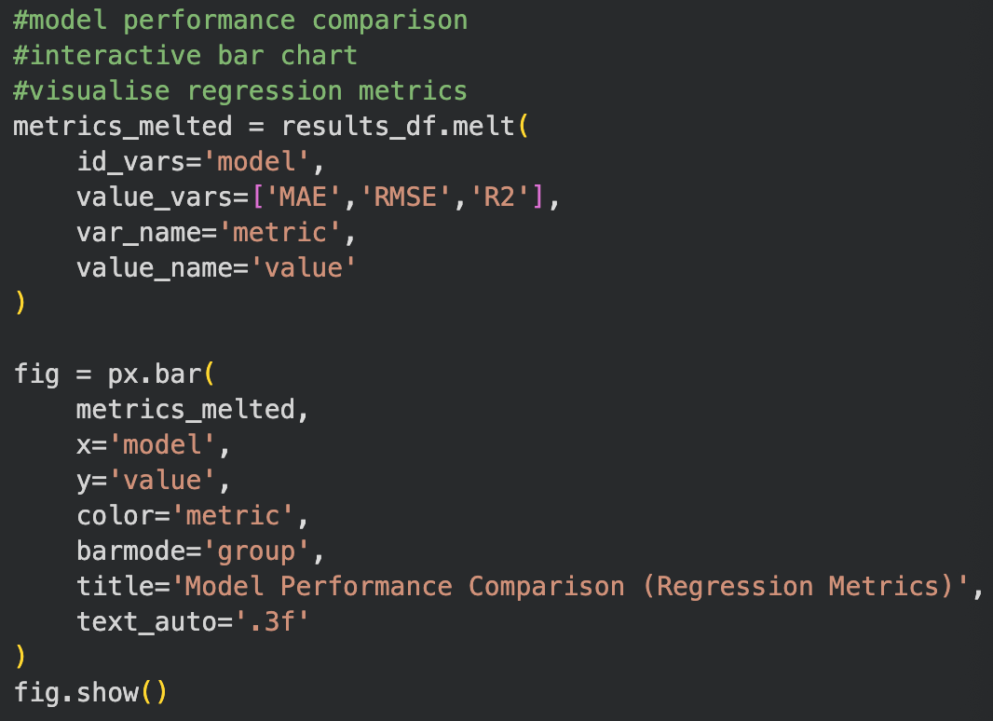

Appendix 48 True vs predicted plot code
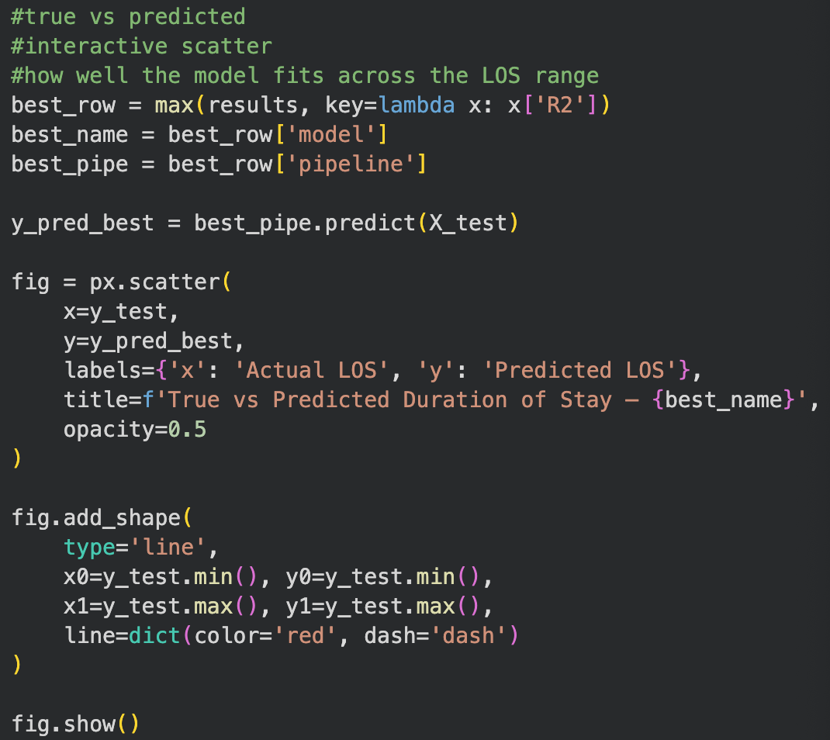
Appendix 49 Residual distribution plot code
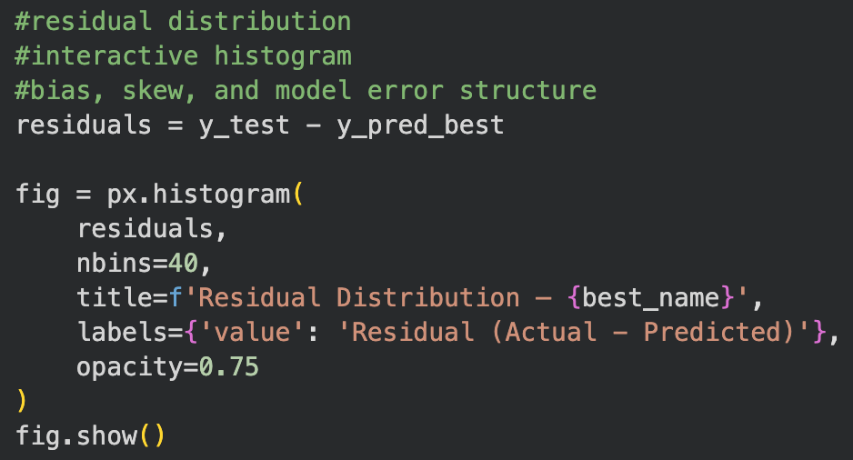
Appendix 50 Feature importance plot code
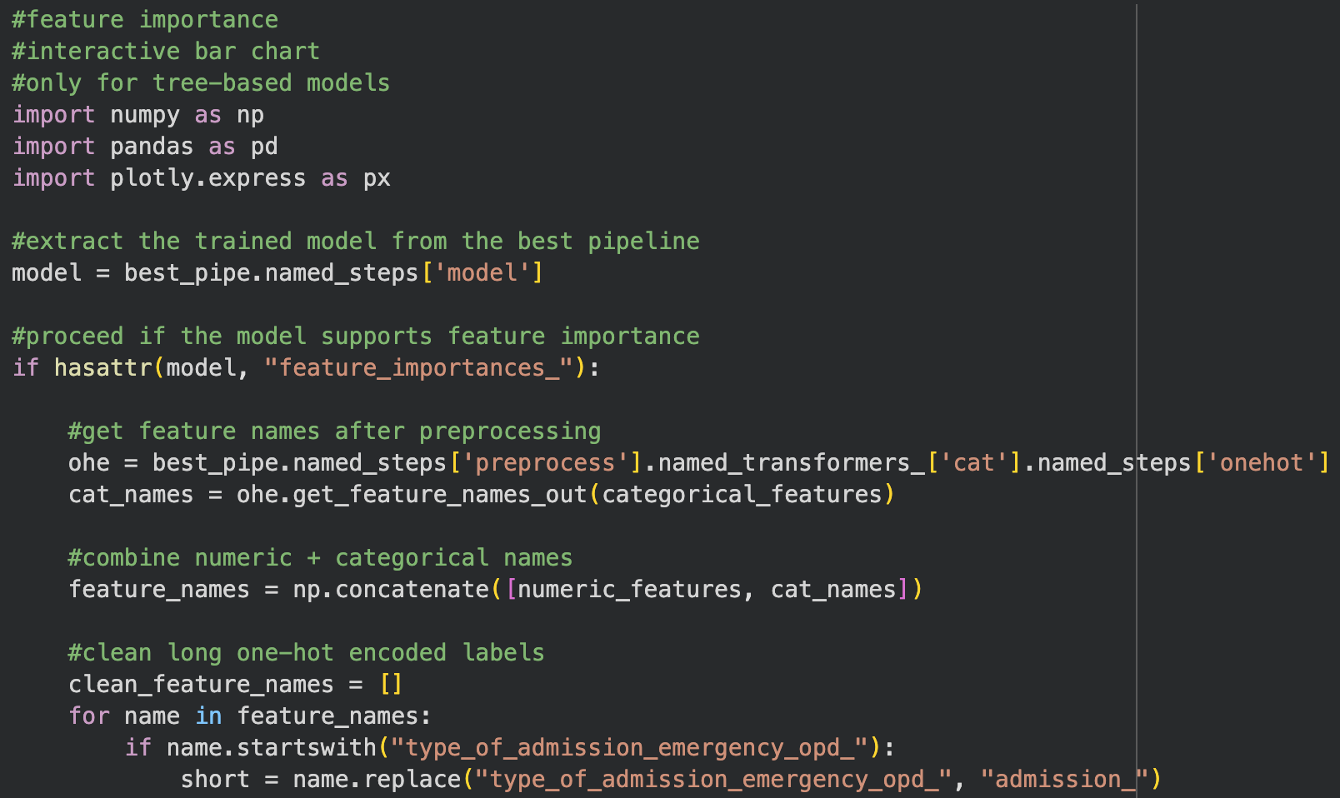
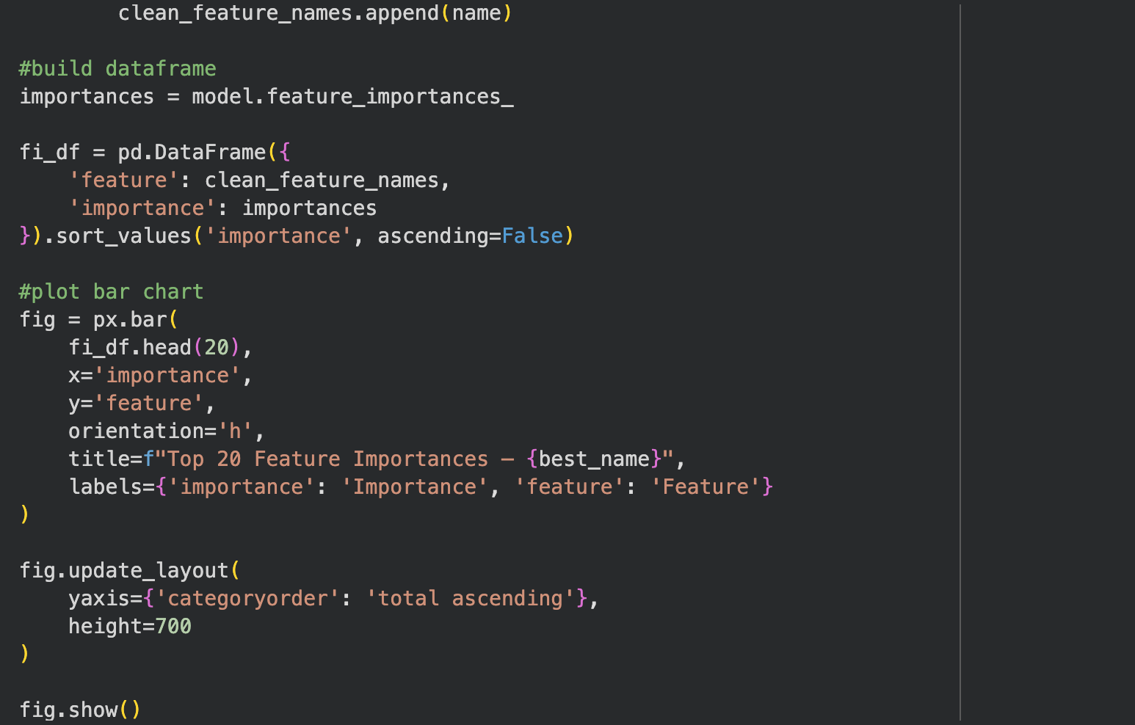
Appendix 51 Google Colab link if jupyter file does not open
https://colab.research.google.com/drive/1xili1zRqEg7gpZeYfdd_r2dszHnpftjO?usp=sharing

