Fitts' Law Experimental Findings

Karl Betcher, Ethan Stone, Madeline Ellingson, Kate Gordon

# 1. Experimental Protocol:

## Independent Variables:

Circle Size (4 levels)

Distance (4 levels)

Direction (2 levels)

## Dependent Variables:

Time-to-click (in seconds)

Errors (or mis-clicks) per task

## Confounding Variables:

Mouse sensitivity settings

Display configuration and size

Individual differences in motor skills

# 2. Linear Regression using Fitts’s Law:

Fitts’s Law is expressed as:

$$MT=a+b*ID$$

Where:

MT is the time to complete the task,

ID is the Index of Difficulty, and

a and $b$ are both constants.

From our regression analysis, we obtained that the line of best fit between ID and the Index of Performance was

$$MT = 0.88 * ID + 0.80 (R^{2}=0.95)$$

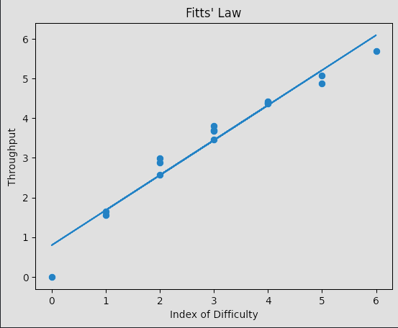

# 3. Analysis of Findings:

## Effect of Different Directions:

Once the data is separated out by direction (left/right), a regression analysis returned the two results:

Left: MT = 0.88 * ID + 0.87 (R2 = 0.94)

Right: MT = 0.89 * ID + 0.73 (R2 = 0.96)

The difference between the performance in the two directions is minimal, and the effect of direction is negligible.

## Differences Among Participants:

Error Rates: Individual differences may contribute to variations in error rates. Participants with higher error rates might struggle with precision.

Time Completions: Participants with better motor skills may complete tasks faster. However, outliers need to be scrutinized, as they might indicate other factors influencing performance.

Distance Traveled: Variations in mouse control among participants can lead to differences in the distance traveled.

# 4. Discussion of Problems and Limitations:

## Problems Encountered:

Technical issues or bugs in the program could affect data accuracy. A significant portion of the cleaning process was removing entries in data that were from bugs or other technical issues.

Individual differences, such as familiarity with mouse control, might influence results.

## Limitations:

This experiment assumed that the index of difficulty is the sole predictor of task completion time, neglecting other potential factors.

This experiment may not account for variations in individual learning curves over the 320 trials.

# 5. Conclusion:

Our findings support Fitts' Law as a predictor of pointing task completion time. However, individual differences and potential outliers highlight the need for a more comprehensive understanding of the factors influencing human-computer interaction.