Questions and Exercises to work out and turn in:
Grading Guidelines (See Appendix):
In general, a right answer will get full credit when:

- It is right (worth 25%)
- It is right AND neatly presented making it easy and pleasant to read. (worth an extra 15%)
- There is an obvious and clear link between 1) the information provided in the exercise and in class and 2) the final answer. A clear link is built by properly writing, justifying, and documenting an answer (worth an extra 60%).
- Calculation mistakes will be minimally penalized (2 to 5% of full credit) while errors on units will be more heavily penalized.

Late Submission : as specified in the syllabus. Day counting starts one minute after the deadline.
Check Your Submission: after submitting, download your submission to check whether it is the right version and it is complete. after submitting, download your submission to check whether it is the right version and it is complete. A wrong version will get at least a 25 points penalty that cannot be claimed back by the Leniency Policy for Borderline Incidents. So, check your submissions.

- You are welcome/encouraged to discuss exercises with other groups or the instructor. But, ultimately, personal writing is expected.

- USE THIS EDITABLE FILE AS THE STARTING DOCUMENT YOU WILL TURN IN. KEEP IN THE QUESTIONS AND INSERT YOUR ANSWERS RIGHT AFTER THE QUESTIONS/PROMPTS. DO NOT DELETE ANYTHING.
- IF USING HAND WRITING (STRONGLY DISCOURAGED), REWRITE THE QUESTIONS.
- FAILING TO FOLLOW TURN IN DIRECTIONS /GUIDELINES WILL COST A 30% PENALTY.

Objectives of this assignment:
- Resume introduction to basic Unix commands.
- Explore commands related to processes

What you need to do:
- Execute and understand basic Unix commands on Engineering Tux machines. You must complete all tasks on an Engineering Unix Tux machine, otherwise a 0 will be assigned.
- Always document your work by taking/inserting screenshots. To save space, clip out the screenshots to contain only relevant information. See Appendix for the required information.
- Insert answers as indicated (right after the question/directions)
(Reminder) In order to save space, for this assignment and future ones, clip out the screenshots to contain only the relevant information (the date, the Tux machine you are using for the question, the Auburn username, and material related to the question/task). A 25 points penalty will be applied when any required information is missing. Make sure that the screenshots are easily readable.

Exercise 1: Basic Unix Commands (30 points)

(Well written short answers are acceptable for this assignment)
The objective of this exercise is to get familiar with basic frequently used commands.

Task:
Consider these basic frequently used Unix commands:
who, history, pwd, cp, mv, kill, date, cat, ps, top

For each of the above commands,
- Provide a brief description (you may use the man command, but use ultimately your own words)
- The who command shows what users are currently logged into a system.
- The history command shows a list of previously used commands.
- The pwd command is short for print working directory and displays the current working directory.
- The cp command is short for copy. It copies a given source file or files to a directory.
- The mv command is short for move. It moves a given source to a given directory.
- The kill command ends a process or terminates it.
- The date command gives the current date given by the system as well as the current time given by the system.
- The cat command is short for concatenate. Concatenate means to join two things together so this command is used to create or view or merge contents of two files.
- The ps command displays a snapshot with information about active processes.
- The top command displays a real time view of the running processes. It gives a list of processes and threads that are active with its information and system information.
2) Execute the command on a Tux machine
3) Briefly comment the results/outcomes of the execution
- The who command when executed, showed my username only, “pts/0”, and the time and date. This shows I am the only user logged into the current system, the system is a pseudo terminal slave (which is the virtual terminal I connected to through ssh kmk0120@gate.eng.auburn.edu), it is my first session in the terminal, and the time I logged into the terminal.
- The history command when used displayed all of the commands I have used most recently. It also had them numbered when listed. The most recent ones were at the bottom with the highest number.
- The pwd command displayed “/home/u3/kmk0120” which shows that the print of the working directory is that I am currently in the home directory. The u3 is most likely a group created by the administrators of the terminal to describe what kind of user I am, and then it shows my username.
- The cp command returned with “cp: missing file operand” and another line saying “Try 'cp --help' for more information.” Most likely because I didn’t give it anything to copy and no destination to copy to.
- The mv command returned with “mv: missing file operand” and on another line “Try 'mv --help' for more information.” Because I never gave it information to move or a destination.
- The kill command returned with “kill: usage: kill [-s sigspec | -n signum | -sigspec] pid | jobspec ... or kill -l [sigspec]” because I did not give it information on what to terminate or there was not a process running.
- The date command returned with an abbreviation of the day of the week “Mon” then an abbreviation of the month “Feb” and then the day of the month “16”, then the time “21:51:35” for hour of the day, minute, and second and then showed the time zone and year “CST 2026” therefore showing the day of the week, month, day of the month, time, time zone, and year based on information provided by the system.
- Using the cat command without any additional information resulted in it moving to the next line.
- The ps command returned with “ PID TTY TIME CMD
1121786 pts/1 00:00:00 bash
1121862 pts/1 00:00:00 ps”
The table it returns with has columns for PID or Process ID, TTY for the terminal controlling the process, TIME for CPU time used, and CMD for Command that started the process. Thus showing that the processes I am running in my current terminal are bash that used 00:00:00 of the CPU time, is executed in the second terminal (pts/1) I have opened a session in, and has the process ID 1121789. I also have the process ps that also took 00:00:00 time in the CPU and is also done in the second terminal I have a session in or the pts/1, and the process ID for it is 1121862. So the processes are put in different rows with the information of them being separated into columns.
- The top command returned in how long the system had been running which was “22:08:15 up 63 days, 11:40”, how many users currently logged in which was just one, the load average which was “load average: 12.63, 13.01, 12.76”. The number of tasks which were 428 the number of task running which was 14, the number of tasks sleeping which was 414, stopped tasks which were 0, zombie tasks which were 0, more system information including “ MiB Mem : 31566.5 total, 21601.2 free, 2197.2 used, 7768.2 buff/cache
MiB Swap: 15980.0 total, 15980.0 free, 0.0 used. 27215.1 avail Mem” and then a table which had the columns PID, USER, PR, NI, VIRT, RES, S, %CPU, %MEM, TIME+, and COMMAND, which all related to information about the processes running and changed in real time while the rows each represented a process running.
4) Report any unexpected behavior. The commands top, ps, date, pwd, history, and who worked as expected but cp and mv returned with missing operand and said to try to use the –help operand because there was missing information that the command couldn’t be used without additional information. The kill command returned with how kill usage to prompt that it needs more information to be used. The cat command had the most unexpected behavior because while I knew the others wouldn’t work without more information it simply returned with something that indicated that, but when using the cat command with no additional information it just moved to the next line waiting for more information without prompting that something was missing or wrong or letting me execute a new command.

Provide a screenshot only for the commands who and pwd.
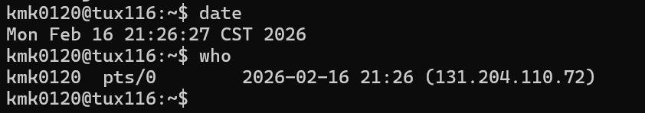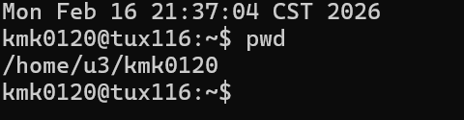

Exercise 2: Process Management Tools/Commands (70 points)
The objective of this exercise is to observe the "life" of processes using two commonly used Unix commands: ps and top.
In order to produce answers consistent with the answer key, you must execute ONLY the commands you are asked to perform in exactly the order given.
In order to complete this hands-on lab, you must complete the following actions:
- Download the C program lab2.c from Canvas
- Move lab2.c to your Auburn home directory lab2 that you created in M1: hands-on laboratory exercise. This directory's path is ~/nnnn/lab2 where ~ is your Auburn home directory path (watch if necessary the video about how to move files from your local machine to your Auburn home directory). Observe that you do not need to know the C programming language to complete this hands-on laboratory exercise. When executed, the program lab2.c creates (forks) three child processes. The parent process and children run infinite loops. The only way to stop them is to kill them.
- Log on any Tux machine
- Go to your lab2 directory at ~/nnnn/lab2 (See M1: Hands-on Lab..)
- Type ls to insure that the file lab2.c is in the current directory (i.e., ~/nnnn/lab2)
- Type date .
- Type the command cc -o lab2 lab2.c (This will compile lab2.c and produce executable lab2)
- take and insert here a screenshot (clip out …..)
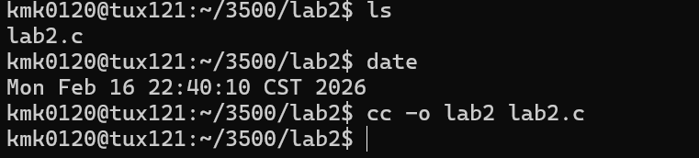
- Insure that the compilation is successful. Check whether the executable lab2 is in the current directory (use ls -al). If successful, complete the following actions and answer the questions:

1) (7 points) Type the ps command (consider a man ps to learn about ps)
What are the processes IDs and names listed by the command ps?
Answer here ...... The first process ID is 1121786 and its name or CMD is bash and the second process ID is 1138426 and its name or CMD is ps.
Insert a screenshot here to document your answer
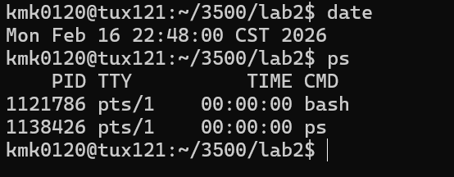
2) (7 points) Type the command ./lab2& followed by return and then type the command ps. Do not forget the '&' character. If you do not add the '&' caracter, you will not be able to get the prompt for the next commands.
What are the processes IDs and names listed by the command ps? You can insert a screenshot here to answer the question
Answer here ......The first process ID is 1121786 and the name or CMD is bash, the next one is 1138468 and the name or CMD is lab2, the next ones process ID is 1138470 and the name or CMD is lab2, the next ones process ID is 1138471 and the name or CMD is lab2, the next ones process ID is 1138472 and the name or CMD is lab2, the next and final ones process ID is 1138556 and the name or CMD is ps.
Insert a screenshot here to document your answer (clip out ….)
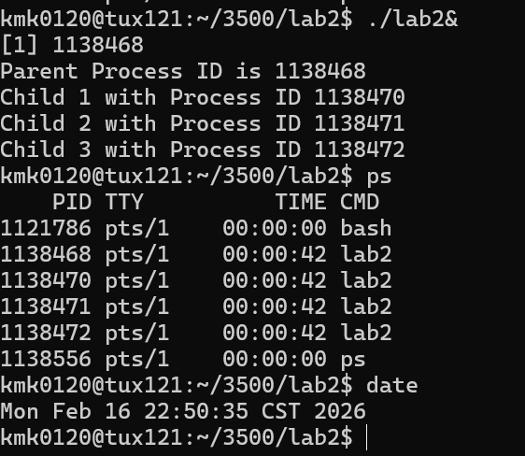
The program lab2 creates 4 processes: a parent process and 3 child processes. The parent has a smaller process ID than its children's.

3) (7 points) In order to kill a process with process ID n, you must type the command kill -9 n. For this question, kill two child processes. Type the command ps and take a screenshot
Insert the screenshot here...... (clip out the screenshot to show only the relevant information)
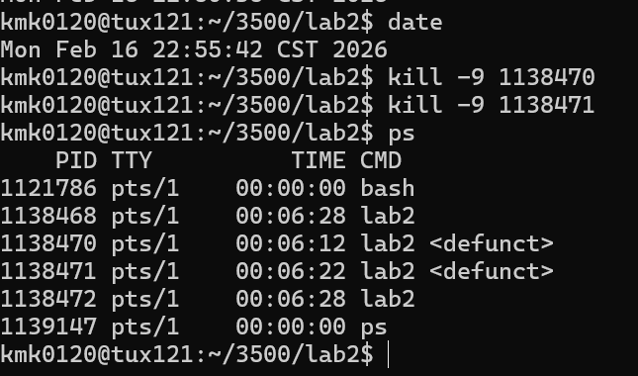
Do the killed processes show up on the screenshot?
Answer here… Yes.
If the two child processes still show up, how are they different from the alive child process?
Answer here… They have “<defunct>” displayed next to their information.

4) (7 points) Kill the parent process and type the ps command
Take a screenshot
Insert the screenshot here...... (clip out the screenshot to show only the relevant information)\
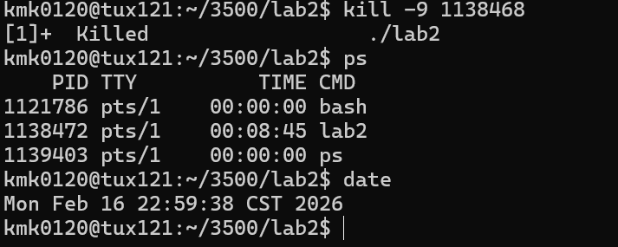
Do the killed processes show up?
Answer here… No.
Does the alive child process still show up?
Answer here… Yes.
If yes, kill it. Check with ps that all processes created by lab2 were killed.

5) (7 points) Let us call Terminal A the terminal you used so far for all the previous questions you answered so far. Keep Terminal A open and open a new terminal B. Use Terminal B to log on the SAME Tux machine you used under Terminal A. Execute on Terminal A the command ./lab2& followed by return and then the command ps.
Do you see (on Terminal A) the processes created by the program lab2?
Answer here.... Yes
Insert a screenshot here to document your answer
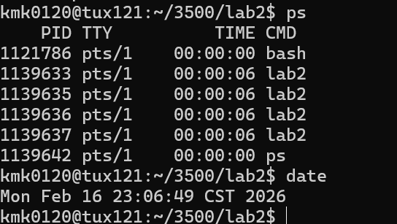
Type on Terminal B the command ps. Do you see (on Terminal B) the processes created by the program lab2?
Answer here....No
Insert a screenshot here to document your answer
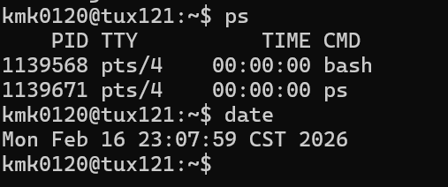
If no, can you explain why the processes created by the program lab2 do not appear on Terminal B when executing ps? Do a man ps or Google ps to understand and document your answer.
I started the process on terminal A and the process tracks the TTY or terminal and since the ps only shows the processes of the current terminal TTY it only appears is the ps command of terminal A since its that TTY where I started the process and not the same TTY to appear in terminal B so it’s not there.

6) (7 points) On Terminal B, type the command top -U username (where username is your Auburn username).
Do you see on Terminal B the processes created by the program lab2?
Yes
How many "zombies" appear on Terminal B? (Search for "Zombie" on Terminal B...)
0

7) (7 points) On Terminal A, kill two child processes.
Do you see on Terminal B the processes created by the program lab2?
Yes
How many "zombies" appear on Terminal B?
2
Google "zombie Unix processes". Based on your experience in this hands-on laboratory exercise, what is a "Zombie" process?
A terminated process that is still in the system or included in the system process table.

8) (7 points) On Terminal A, kill the parent process.
Do you see on Terminal B the processes created by the program lab2?
I see the child process I did not kill but I do not see the parent process or either of the two child processes I did kill.
How many "zombies" appear on Terminal B?
0
.

9) (7 points) Type on Terminal A the command ps
Does the information provided by ps on Terminal A match the information provided by top on Terminal B
yes
Based on your experience with ps and top, what is (are) the key difference(s) between them?
Ps shows the processes currently active for the TTY of that terminal you are in and the information is static and just shows the information about the PID, TTY, TIME, and CMD of the processes, while the top command shows the information for the system as well as the processes for that system not just the ones for that terminal tracked by the TTY, it also has real time information and more information including PID, USER, PR, NI, VIRT, RES, SHR, S, %CPU, %MEM, TIME+, COMMAND.

10) (6 points) On Terminal A, kill the last child process.
Do you see on Terminal B the processes created by the program lab2?
no
How many "zombies" appear on Terminal B?
0
Type ps on Terminal A.
Answer here 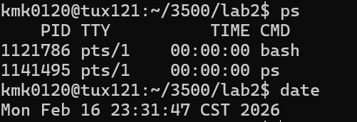
Hit on Terminal B the key 'q' to leave the command top.

All the above questions are an opportunity to discover more about Unix OS commands. Use man and the Internet to learn more. Doing just the minimal will not make you proficient. Knowing well Unix may help you in an interview for your dream job.

Do not hesitate to ask questions or seek help on Piazza. Start early to avoid getting stuck at the last minute when your classmates and instructors are not available.

- What you need to turn in:
- Electronic copy of this file (including your answers) (standalone). Submit the file as a Microsoft Word or PDF file.

- Recall that answers must be well written, documented, justified, and presented to get full credit.

- How this assignment will be graded:
- A right answer will get full credit when:
- It is right (worth 25%)
- It is right AND neatly presented making it easy and pleasant to read. (worth 15%)
- There is an obvious and clear link between 1) the information provided in the exercise and in class and 2) the final answer. A clear link is built by properly writing, justifying, and documenting an answer (worth 60%).
- Calculation mistakes will be minimally penalized (2 to 5% of full credit) while errors on units will be more heavily penalized.

- You are welcome/encouraged to discuss exercises with other students or the instructor. But, ultimately, personal writing is expected.

Appendix: Grading: What is an OBVIOUS and CLEAR LINK?
Here is an example to explain what an obvious and clear link is and how we grade your work.
Consider the following problem:
"(100 points) John travels from Auburn to Atlanta in his car at a speed of 50 mph. Leaving at 8am, at what time will John reach Atlanta".
Here are the answers of three students and their scores:
Student 1 answers: "10am". Student 1 will get 25 points.
Student 2 answers : "John will reach Atlanta at 10am". Student 2 will get 25+15 = 40 points
Student 3 answers: "The time t to travel a distance d at speed v is equal to d/v = d/50mph. The problem does not provide the distance d from Auburn to Atlanta. Based on Google, the distance from Auburn to Atlanta is approximately 100 miles (document is here). Therefore, the time t = 100 miles/50mph = 2 hours. Since John left at 8am, he will then reach Atlanta at 8am + 2 hours = 10 am".
Student 3 will get 25 + 15 + 60 = 100 points
Do you see the direct link going from the data provided in the question to the final answer, using general knowledge/formula and documents?.... Can you now solve the following problem and get 100 points?
"(100 points) Alice travels from Auburn to Atlanta in her car at a speed of 50 mph. Leaving at 8am, at what time will Alice reach Atlanta assuming that she had a flat tire that delayed her 30 minutes".

Screenshot: Required Information
In order to save space, for this assignment and all FUTURE ones, clip out the screenshots to contain only the relevant information. When applicable, ALL screenshots must show the date, the machine you are using for the exercise and the username of one of the team mates. Make sure that the screenshots are easily readable. Below is template screenshot:

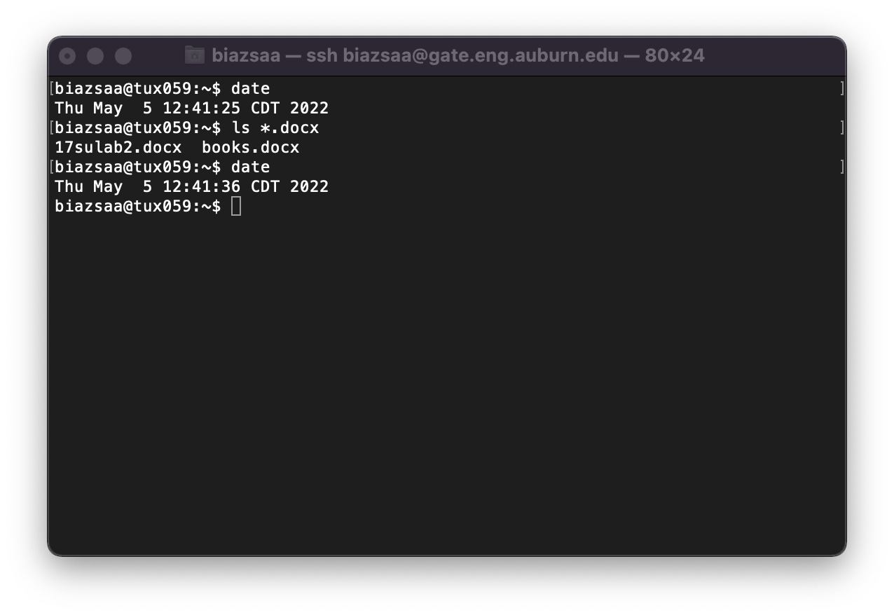

See on the appendix what an obvious and clear link is.

