Exercises to work out and turn in:
Grading Guidelines (See Appendix):
In general, a right answer will get full credit when:

- It is right (worth 25%)
- It is right AND neatly presented making it easy and pleasant to read. (worth an extra 15%)
- There is an obvious and clear link between 1) the information provided in the exercise and in class and 2) the final answer. A clear link is built by properly writing, justifying, and documenting an answer (worth an extra 60%).
- Calculation mistakes will be minimally penalized (2 to 5% of full credit) while errors on units will be more heavily penalized.

Late Submission : as specified in the syllabus. Day counting starts one minute after the deadline.
Check Your Submission: after submitting, download your submission to check whether it is the right version and it is complete. after submitting, download your submission to check whether it is the right version and it is complete. A wrong version will get at least a 25 points penalty that cannot be claimed back by the Leniency Policy for Borderline Incidents. So, check your submissions.

You are welcome/encouraged to discuss exercises with other groups or the instructor. But, ultimately, personal writing is expected.
- USE THIS EDITABLE FILE AS THE STARTING DOCUMENT YOU WILL TURN IN. KEEP IN THE QUESTIONS AND INSERT YOUR ANSWERS RIGHT AFTER THE QUESTIONS/PROMPTS. DO NOT DELETE ANYTHING IF USING HAND WRITING (STRONGLY DISCOURAGED), REWRITE THE QUESTIONS.
- FAILING TO FOLLOW TURN IN DIRECTIONS /GUIDELINES WILL COST A 30% PENALTY.

Objectives of this assignment:
- to work on a Unix based system
- to become familiar with the notion of a process
- to assess/evaluate the fairness and reliability of the CPU scheduler on Tux machines

What you need to do:
- Examine and understand the pseudocode of a provided C source program lab3. (You do not need to dig into the C code)
- Run experiments of lab3
- Collect and process data about the experiments
- Build plots
- Interpret and discuss the plots
- Conclude about the fairness and reliability of the CPU scheduler.
Important:
- One submission per team. You must complete all tasks on an Engineering Unix Tux machine, otherwise a 0 will be assigned
- Writing and presentation of your report are considered to grade your hands-on lab. Your conclusions must be supported by the data/measurements you collect. Your conclusions must be correct.
- Questions about this lab must be posted on Piazza if you need timely answers.
- Work ahead. Do not wait until the last minute.

(Reminder) In order to save space, for this assignment and future ones, clip out the screenshots to contain only the relevant information (the date, the Tux machine you are using for the question, the Auburn username, and material related to the question/task). A 25 points penalty will be applied when any required information is missing. Make sure that the screenshots are easily readable.

Exercise (100 points)
This hands-on lab has multiple parts: 1) Compile, execute, skim, and understand the pseudocode of a provided C program, 2) run experiments, 4) collect data, and 5) analyze and report your results.
The instructor designed and implemented in C the provided C program lab3.c.

The Provided C Program
The help you understand the C program, the instructor provides here its pseudocode:
Inputs:
n_{p}: number of concurrent processes to execute
n_{m}: number of minutes each process must run
Output:
Displays when each process starts executing its task
Displays the index $c$ achieved by the task executed by each process. The more a process "computes" (uses the CPU), the higher is c.
Collects (writes$c$ to a file) (done by each child process)
Displays the amount of time the process "ran" on the CPU (done by each child process)
Process the data collected by each process. (Done by Parent process)
Displays mean, standard deviation (std) and percentage std/mean of $c$ (Done by Parent process)
Code (Parent):
for i=1 to n_{p}
create (fork) a process P_{i}
for i=1 to n_{p}
"green light" P_{i} to start its task
Compute/displays mean and standard deviation/mean of $c$ collected by child processes.

Code of Process P_{i} (Child Process):
wait for green light
Display start time
Execute A computing task for n_{m} minutes (increases $c$)
Displays the amount of time the process competed for the CPU (should be n_{m} minutes)
Collects (writes $c$ to a file "file.dat")

Do not hesitate to ask questions or seek help on Piazza. Start early to avoid getting stuck at the last time when your classmates and instructor are not available.

What You Need To Do:
- Download the C program lab3.c from Canvas
- Store lab3.c to your Auburn home directory lab3 that you created in M1: hands-on laboratory exercise. This directory's path is ~/nnnn/lab3 where ~ is your Auburn home directory path.
- Log on any Tux machine
- Go to your lab3 directory at ~/nnnn/lab3 (See M1: Hands-on Lab..)
- Type ls to insure the file lab3.c is in the current directory (i.e., ~/nnnn/lab3)
- Type the command cc -o lab3 lab3.c -lm (This will compile lab3.c and produce executable lab3)
- Insure that the compilation is successful. Check whether the executable lab3 is in the current directory (use ls -al). If successful, complete the following actions and answer the questions:
- Test the program lab3 for running three child processes for 2 minutes
- To test lab3, type the command ./lab3 3 2
- Observe the outputs produced by lab3 execution
- After you become familiar with lab3, you will need to check whether lab3 is a good measurement tool meeting some requirements described below.
- After checking the requirements, you will run lab3, collect data, plot your results, and discuss your results

Requirements (for lab3 to be a good measurement tool)
1) Requirement I: If we run one process multiple times for the same number of n_{m} minutes, the number $c$ should be the same each time within $±10\%$
2) Requirement 2: If we run n_{p} processes multiple times for k* n_{m} minutes, the number displayed should be $k$ times larger than the number displayed for running n_{m} minutes within $±10\%$. For example, if I run 20 processes for $4×5$ minutes, the number displayed should be $4$ times larger than the number displayed for running 20 processes for $5$ minutes within $±10\%$.
3) Requirement 3: If we run 100 processes multiple times for 2 minutes, the number displayed should be $10$ times larger than the number displayed for running 1000 processes for 2 minutes within $±10\%$. For this requirement, your code will be tested with these values 100 and 1000.

CPU Scheduling Evaluation:
The objectives are:
a) to check whether lab3 program meets the requirements
b) to evaluate the fairness and the reliability.
We describe below the experiments you must conduct to achieve the objectives.

a) Checking whether your task meets the requirements
Requirement 1 (10 points):
- Run lab3 five times during 2 minutes with np = 1 (one process). For each run of lab3, collect and report here the five values you collected for $c$.
Report here ....
The first time I ran it the value of c = 263835
The second time I ran it the value of c = 266412
The third time I ran it the value of c = 287561
The fourth time I ran it the value of c = 298269
The fifth time I ran it the value of c = 298372

Insert a screenshot here to document your answer (recall, we must see date, username and Tux name) 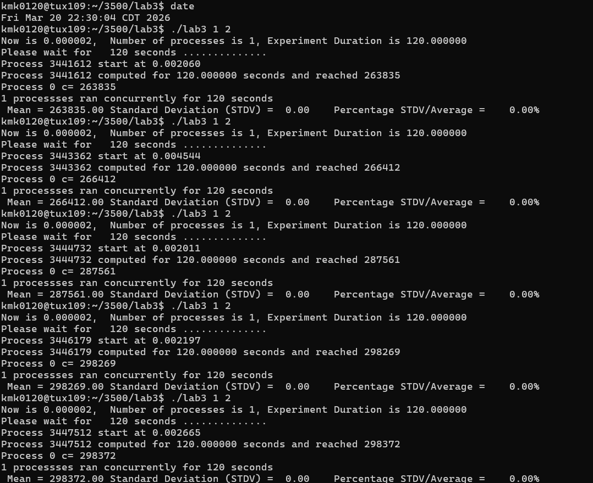
Are the five values within $±10\%$of the mean of the 5 values of c?
Answer here .... Justify your answer
263835 + 266412 + 287561 + 298269 + 298372 = 1,414,449
And 1414449/5 = 282889.8
So the mean is 282889.8 and 10% of that is 282889.8 * 0.1 = 28288.98 so all answers need to be within +10% or -10% of that m mean so 282889.8 + 28288.98 = 311178.78 and 282889.8 – 28288.98 = 254600.82 so the range the answers need to be in is 254600.82 to 311178.78
The first time I ran it the value of c = 263835, SO this IS in range
The second time I ran it the value of c = 266412, SO this IS in range
The third time I ran it the value of c = 287561, SO this IS in range
The fourth time I ran it the value of c = 298269, SO this IS in range
The fifth time I ran it the value of c = 298372 , SO this IS in range
So, yes, all values are in the range of 10% + or – the mean of the values of c

Requirement 1I (10 points):
First, Run lab3 once during 2 minutes with np = 20 (20 processes).
Collect the mean (for all 20 processes) $c_{2}$.
Report and post a screenshot documenting the mean and percentage standard deviation/mean of your experiment
The mean $c_{2}$= 165400.85
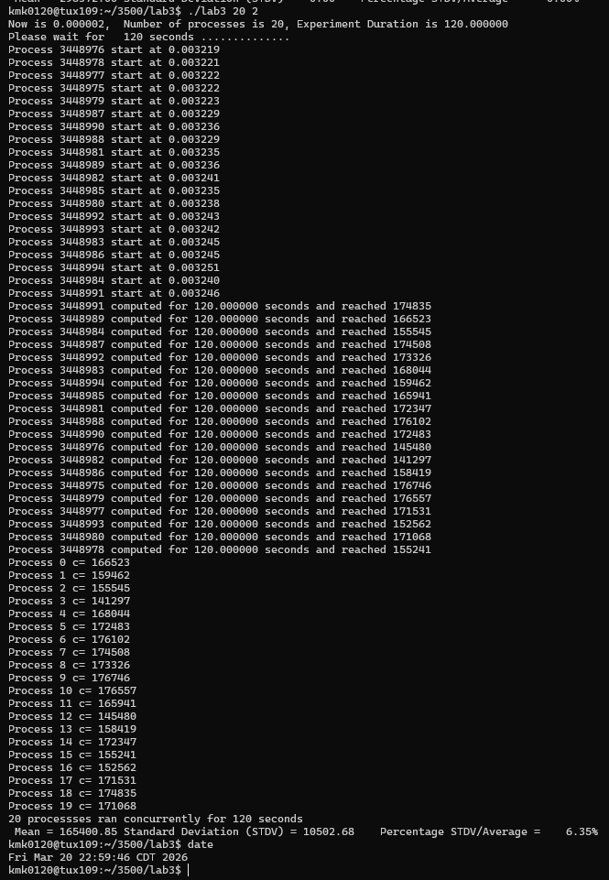

Second, Run lab3 once during 3*2 (6) minutes with np = 20 (20 processes).
Collect the mean (for all 20 processes) $c_{6}$
Report and post a screenshot documenting the average and percentage standard deviation/mean of your experiment Is $c_{6}≈3×c_{2}$ within $±10\%$?
Answer here, justify. $c_{6}=$489608.40 and $c_{2}$= 165400.85 so 165400.85 x 3 = 496202.55 and 10 percent of that is 496202.55 * 0.1 = 49620.255 so the upper bound is 496202.55 + 49620.255 = 545822.805 and the lower bound is 496202.55 - 49620.255 = 446582.295 so c6 needs to be in range of 446582.295 to 545822.805 and $c_{6}=$489608.40 which is in that range so its true!
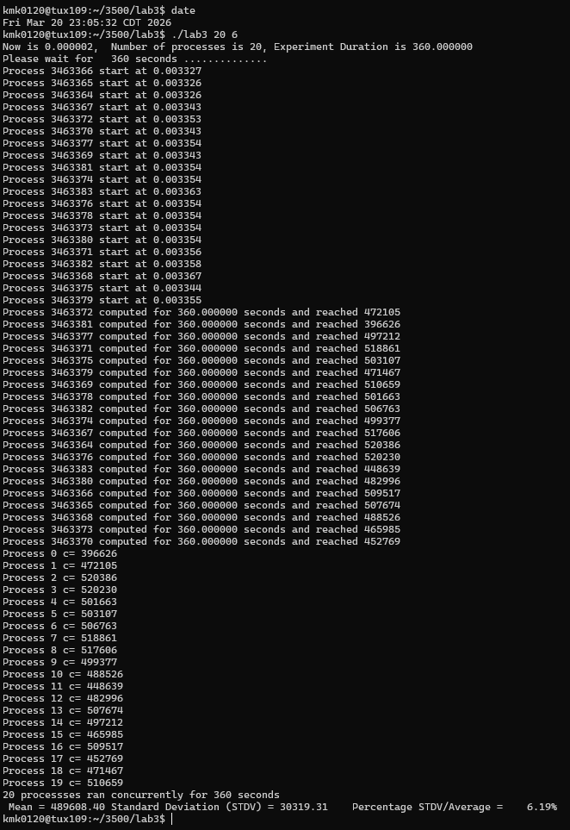
Requirement 1I1 (10 points):
First, Run lab3 once during 2 minutes with np = 100 (100 processes).
Collect the mean (for all 100 processes) $c_{100}$
report here.. post a screenshot documenting the average and percentage standard deviation your experiment
The mean $c_{100}= 33417.98$
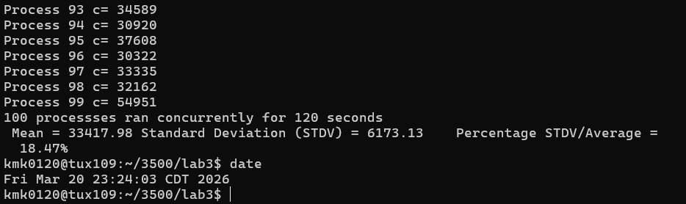

Second, Run lab3 once during 2 minutes with np = 1,000 (1000 processes).
Collect the mean (for all 1,000 processes) $c_{1000}$
Report: post a screenshot documenting the average and percentage standard deviation/mean of your experiment
Is $c_{100}≈10×c_{1000}$ within $±10\%$?
Answer here, justify. ) $c_{1000}= 3340.47$ and then $c_{100}= 33417.98$ $c_{1000}= 3340.47$ which times 10 is $33404.7$ and ten percent of this is $33404.7*0.1=3340.47$ the upper bound $33404.7+$ $3340.47= 36745.17$and the lower bound $33404.7-$ $3340.47=$ 30064.23 so the range that c100 needs to be in is 30064.23 to $= 36745.17$ and then $c_{100}= 33417.98$ which is in range so it is true $c_{100}≈10×c_{1000} within 10\%$

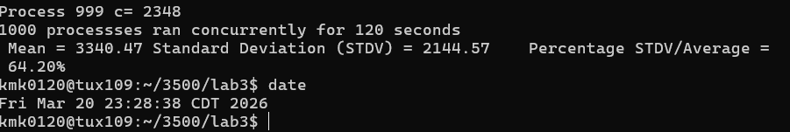
a) (30 points) Fairness: If the CPU scheduler is fair, the measure c (number displayed by lab3) must be close for all child processes you run within the same experiment. We call an experiment the fact to run the program lab3 once. We measure how the values c produced by each child process are close by computing the percentage of the standard deviation/mean: the lower is this value, the closer are the c values of the processes, and the fairer is the CPU scheduler. Ideally, all processes must use the CPU for the same duration and therefore reach the same value c.
In order to evaluate fairness, you must conduct one experiment during 2 minutes for each of the following values of n_{p} (number of processes): 2, 5, 10, 20, 40, 60, 80, 100, 200, 400, 500, 1000. For each experiment with value $np$, compute the percentage of the standard deviation/mean of the measure c your task displays for each process. Plot the percentage of the standard deviation/mean of c versus the number of processes (put the np values 2, 5, 10, 20, 40, 60, 80, 100, 200, 400, 500, 1000 on the x-axis and the percentage of the standard deviation/mean of c on the y-axis) Discuss this plot and draw reasonable conclusions regarding fairness. In other words, is the CPU scheduler of the Tux machines fair based on the data you collected?
Insert a screenshot for one experiment only. 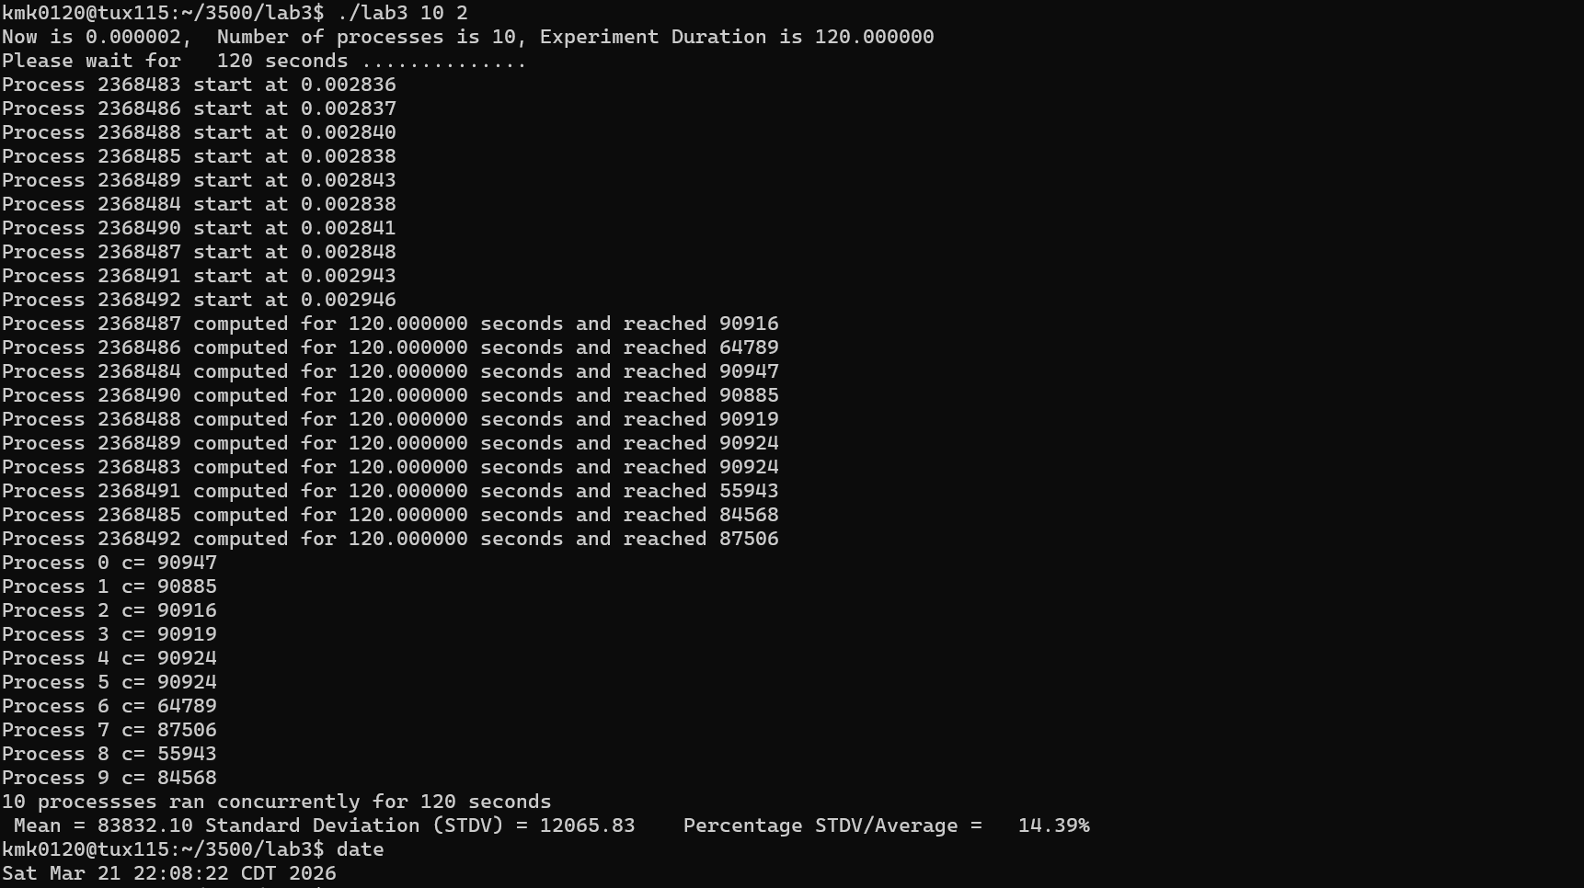
Insert your plot here .... –

Discuss your plot here .....
Number of Processes = np; Mean(c) = c(np); Standard Deviation/Mean Percentage = %(np);
Np = 2; C(2) = 275389.00; sd(2) = 35.00; %(2) = 0.01%
Np = 5; C(5) = 255704.00; sd(5) = 86.01; %(5) = 0.03%
Np = 10; C(10) = 83832.10; sd(10) = 12065.83; %(10) = 14.39%
Np = 20; C(20) = 77206.75; sd(20) = 7971.81; %(20) = 10.33%
Np = 40; C(40) = 38508.60; sd(40) = 4013.26; %(40) = 10.42%
Np = 60; C(60) = 25236.18; sd(60) = 3670.29; %(60) = 14.54%
Np = 80; C(80) = 19757.65; sd(80) = 2950.67; %(80) = 14.93%
Np = 100; C(100) = 15263.54; sd(100) = 2940.86; %(100) = 19.27%
Np = 200; C(200) = 7723.06; sd(200) = 2312.94; %(200) = 29.95%
Np = 400; C(400) = 3841.99; sd(400) = 1376.28; %(400) = 35.82%
Np = 500; C(500) = 3162.41; sd(500) = 1600.00; %(500) = 50.59%
Np = 1000; C(1000) = 1591.05; sd(1000) = 1114.36; %(1000) = 70.04%

From the plot below you can see that as experiment increases in number of processes(np) the standard deviation/mean percentage increases. The standard deviation/mean percentage shows how unfair a process may be because if the standard deviation/mean percentage being high means that the value of c’s over the processes, aka the amount of CPU time the process takes, differ greatly. A small standard deviation/mean percentage means the value of c’s over processes, aka the amount of CPU time the process takes doesn’t differ much. If the CPU time differs greatly between processes that is unfair CPU scheduling because we want processes to have similar CPU times for fairness. SO the standard deviation/mean percentage being high shows unfair CPU scheduling while the percentage being low shows fairness. In the plot we see that as np increases the percentages get higher. This means that as the number of processes(np) get higher, the more unfair the CPU scheduling is. Therefore, CPU scheduler of the Tux machines is fair for the small np but as we increased np the CPU scheduler of the Tux machines becomes unfair. Not fair for large np’s.

b) (20 points) Reliable: If the CPU scheduler is reliable, the average measure c (number displayed by lab3) for n_{p} processes must remain the same (within $±10\%$.) for successive experiments running for the same number of processes n_{p} each time. In other words, if you execute the same process on a machine, the execution time should not widely vary: the execution time should not be one time 2 minutes, then 2 hours, then 1 minute, then 30 minutes.....
In order to evaluate reliability, run 10 times lab3 with np=100 (100 process) during 2 minutes (./lab3 100 2). Insert a screenshot for one experiment (run) only. 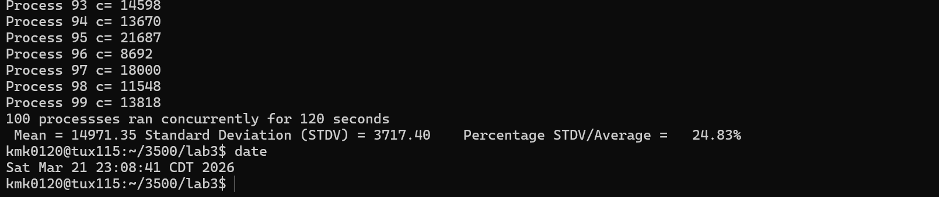
Report here the mean of c for each run
Run 1: Mean(c) = 15258.42
Run 2: Mean(c) = 15289.84
Run 3: Mean(c) = 15445.48
Run 4: Mean(c) = 15437.70
Run 5: Mean(c) = 15532.64
Run 6: Mean(c) = 15397.14
Run 7: Mean(c) = 15326.06
Run 8: Mean(c) = 15225.49
Run 9: Mean(c) = 14838.38
Run 10: Mean(c) = 14971.35
Plot here the mean versus the run # (put the values 1, 2, ....10 on the x-axis) and the mean on the y-axis. (no tables)
Discuss here this plot and draw reasonable conclusions regarding reliability. In other words, is the CPU scheduler of the Tux machines reliable based on the data you collected?
Given just the values you can find the overall mean value of the 10 runs by addi g them all together and dividing by 10. So 15258.42 + 15289.84 + 15445.48 + 15437.70 + 15532.64 + 15397.14 + 15326.06 + 15225.49 + 14838.38 + 14971.35 = 152722.5 and 152722.5/10 = 15272.25 which is the overall mean and to find 10% of this just times by 0.1 so 15272.25 * 0.1= 1527.225 so the upper bound is 15272.25 + 1527.225 = 16799.475 and the lower bound is 15272.25 - 1527.225 = 13745.025 so all of the runs mean(c) need to be between 13745.025 and 16799.475. In the chart the limits of the y axis are both within that range and all of the run are in the limits so it can be seen from the chart that all of the runs match the requirements for the CPU scheduler of the Tux machines to be reliable. You can also see hoe close together the values of the Mean(c) are in the range for each run showing that is is actually very reliable.
Do not hesitate to ask questions on Piazza if you have any doubt.
Getting Started
- compile the code I provided you by typing:
cc -o lab3 lab3.c -lm
- Execute the code (evaluate 1 process during 2 minutes): ./lab3 1 2
- Observe what is displayed
- Compile and execute to check whether your task meets the requirements (see above)
- Make sure to complete all required tasks.
- Do not hesitate to ask questions on Piazza or during office hours.

Common mistakes
1) Finish the code at the last minute: you will not have enough time to collect data and write a good report
2) Finish the lab/report at the last minute without polishing may result in a low score. You must have time to reflect about the meaning of these experiments and the conclusions you may draw.

What to turn in?
One file:
Electronic copy of this file that includes your answers. I repeat: you must insert your answers and plots in this file. Do not delete anything from this file. This file with your plots and answers must be put posted separately on Canvas (not in a zipped folder). A penalty of 30 points will be applied if these instructions are not followed.

Good writing and presentation are expected.

In case of doubt, do not hesitate to ask questions on Piazza.

What you need to turn in:
- Electronic copy of this file (including your answers) (standalone). Submit the file as a Microsoft Word or PDF file.

- Recall that answers must be well written, documented, justified, and presented to get full credit.

- How this assignment will be graded:
- A right answer will get full credit when:
- It is right (worth 25%)
- It is right AND neatly presented making it easy and pleasant to read. (worth 15%)
- There is an obvious and clear link between 1) the information provided in the exercise and in class and 2) the final answer. A clear link is built by properly writing, justifying, and documenting an answer (worth 60%).
- Calculation mistakes will be minimally penalized (2 to 5% of full credit) while errors on units will be more heavily penalized.

- You are welcome/encouraged to discuss exercises with other students or the instructor. But, ultimately, personal writing is expected.

Appendix: Grading: What is an OBVIOUS and CLEAR LINK?
Here is an example to explain what an obvious and clear link is and how we grade your work.
Consider the following problem:
"(100 points) John travels from Auburn to Atlanta in his car at a speed of 50 mph. Leaving at 8am, at what time will John reach Atlanta".
Here are the answers of three students and their scores:
Student 1 answers: "10am". Student 1 will get 25 points.
Student 2 answers : "John will reach Atlanta at 10am". Student 2 will get 25+15 = 40 points
Student 3 answers: "The time t to travel a distance d at speed v is equal to d/v = d/50mph. The problem does not provide the distance d from Auburn to Atlanta. Based on Google, the distance from Auburn to Atlanta is approximately 100 miles (document is here). Therefore, the time t = 100 miles/50mph = 2 hours. Since John left at 8am, he will then reach Atlanta at 8am + 2 hours = 10 am".
Student 3 will get 25 + 15 + 60 = 100 points
Do you see the direct link going from the data provided in the question to the final answer, using general knowledge/formula and documents?.... Can you now solve the following problem and get 100 points?
"(100 points) Alice travels from Auburn to Atlanta in her car at a speed of 50 mph. Leaving at 8am, at what time will Alice reach Atlanta assuming that she had a flat tire that delayed her 30 minutes".

Screenshot: Required Information
In order to save space, for this assignment and all FUTURE ones, clip out the screenshots to contain only the relevant information. When applicable, ALL screenshots must show the date, the Tux machine you are using for the exercise and the Auburn username of one of the team mates. Make sure that the screenshots are easily readable. Below is template screenshot:

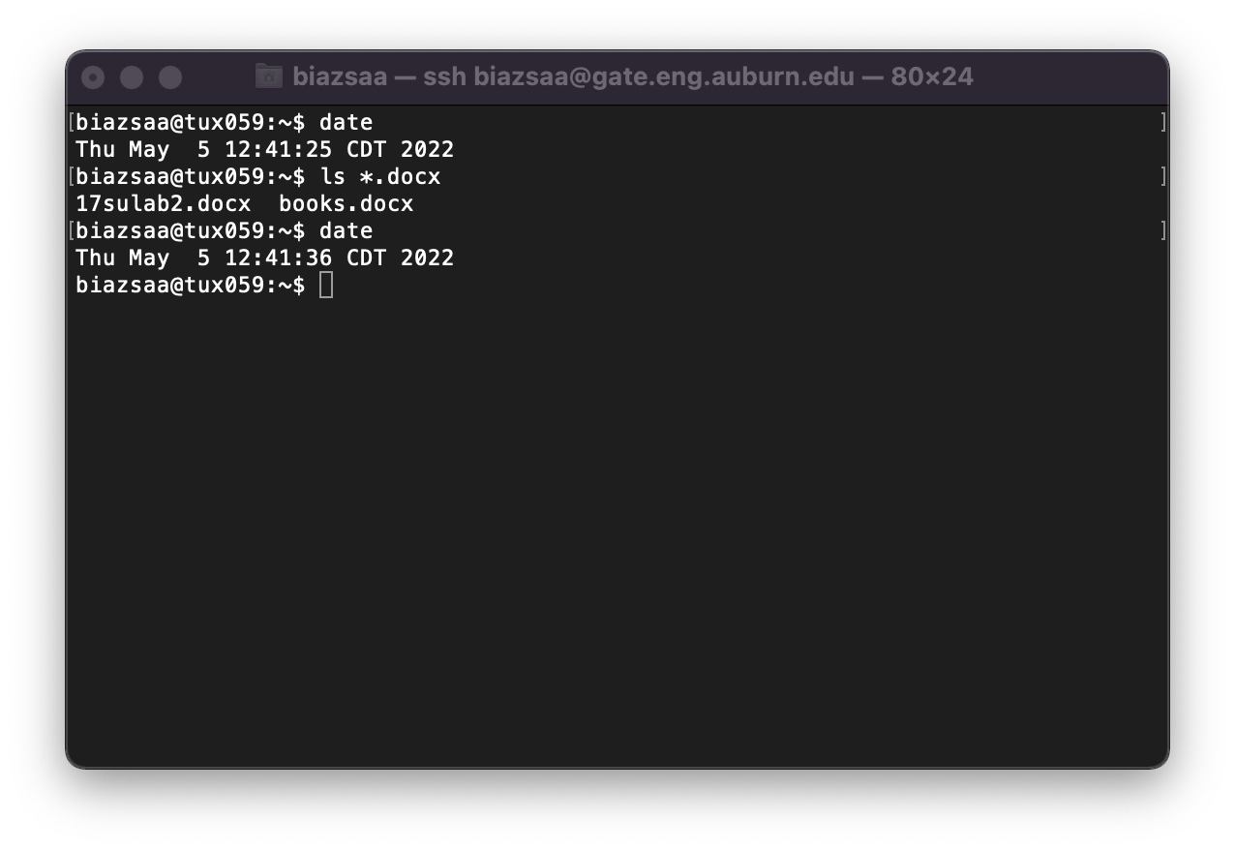

See on the appendix what an obvious and clear link is.
Review Appendix about the required information on ALL screenshots

