European Optical Market
& Competitor Analysis

Portfolio case for a Market Intelligence working-student application
Focus: European ophthalmic spectacle lenses
Data cut: September 2026
Scope. The analysis focuses on prescription spectacle lenses in Europe rather than the broader eyewear market, as frames, contact lenses and intraocular lenses have different demand drivers and competitive dynamics.

1. Executive summary
- Germany shows a value-versus-volume gap. Between 2022 and 2025, sector revenue rose from EUR 6.69bn to EUR 7.025bn (+5.0%), while complete-spectacle sales fell from 12.52m to 11.77m and spectacle-lens sales from 38.73m to 36.56m.
- Demographics support long-term relevance. People aged 65+ represented 22% of the EU population in 2025, supporting the relevance of presbyopia correction and premium progressive lenses.
- Personalisation is a common competitive theme. Rodenstock, Essilor, ZEISS and HOYA all use biometric, behavioural or wearer-specific inputs. Rodenstock's more distinctive story is the depth of biometric measurement and visual-sensitivity positioning.
- Pediatric myopia management is a distinct competitive category. MyCon 2, Stellest, ZEISS MyoCare and MiYOSMART show that competition increasingly extends beyond standard vision correction.
- Channel structure differs materially. EssilorLuxottica combines wholesale with a large proprietary retail and e-commerce footprint, while Rodenstock, ZEISS and HOYA are more strongly partner-led in their go-to-market models.

2. Market definition and method
Primary market. Prescription spectacle lenses sold in Europe through optical retailers and eye-care professionals, including single-vision, progressive, occupational/digital, photochromic and pediatric myopia-management lenses. Premium coatings are treated as a lens value-add.
Broader context. The GMI forecast uses a wider ophthalmic-lens definition including spectacle lenses, contact lenses and IOLs. It is therefore used only as external market context, not as an estimate of Rodenstock's addressable spectacle-lens market.
Evidence base. The analysis combines Eurostat, ZVA industry data, official company product pages, company reports and selected scientific literature. Germany is used as a transparent mature-market deep dive rather than as a proxy for all of Europe.

3. Broader European market context
Global Market Insights estimates the broader European ophthalmic-lens market at USD 5.4bn in 2025, USD 5.7bn in 2026 and USD 8.5bn in 2035, implying a 4.6% CAGR. The source definition explicitly includes spectacle lenses, contact lenses and IOLs; contact lenses alone accounted for USD 2.9bn in 2025. For that reason, the figures below are used only to show the broader category direction, not the size of the spectacle-lens market.

2025 estimate | 2026 estimate | 2035 forecast | 2026–35 CAGR
USD 5.4bn | USD 5.7bn | USD 8.5bn | 4.6%

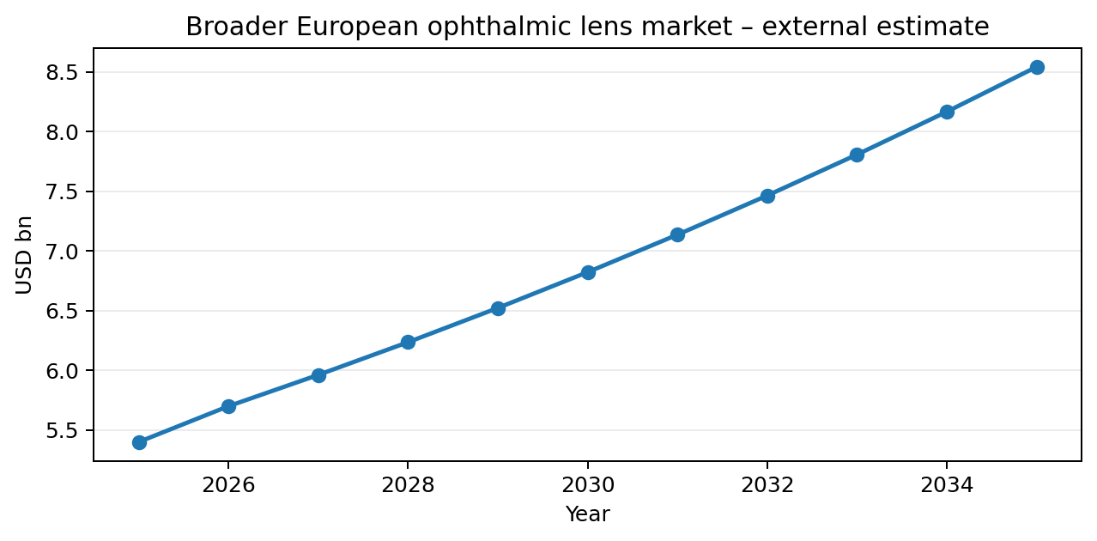
Figure 1. Broader European ophthalmic-lens external forecast. Scope includes spectacle lenses, contact lenses and IOLs.
Interpretation. The external forecast suggests that the wider ophthalmic category is not static, but the headline growth rate should not be used to claim a precise growth rate for European spectacle lenses. The more defensible portfolio conclusion comes from combining broader context with transparent country-level and competitor evidence.

4. Germany as a mature-market deep dive
Germany provides a useful example of a mature European optical market. ZVA data show a clear divergence between market value and physical volumes between 2022 and 2025.
Metric | 2022 | 2023 | 2024 | 2025
Industry revenue (EUR bn) | 6.688 | 6.763 | 6.975 | 7.025
Complete spectacles sold (m) | 12.52 | 12.18 | 12.00 | 11.77
Spectacle lenses sold (m) | 38.73 | 37.74 | 37.18 | 36.56
Optical retail locations | 11,100 | 11,000 | 10,820 | 10,700
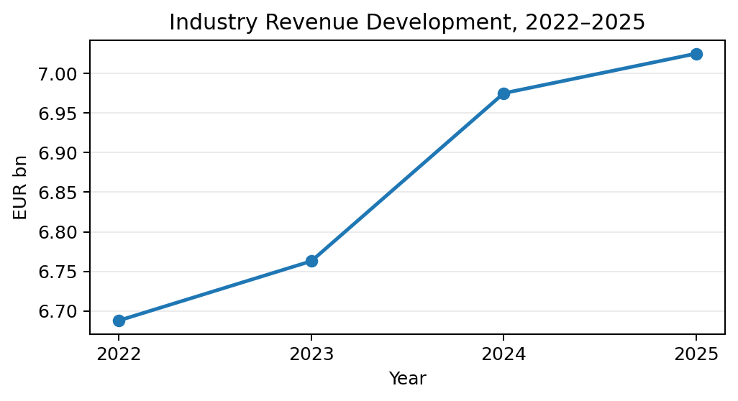 | 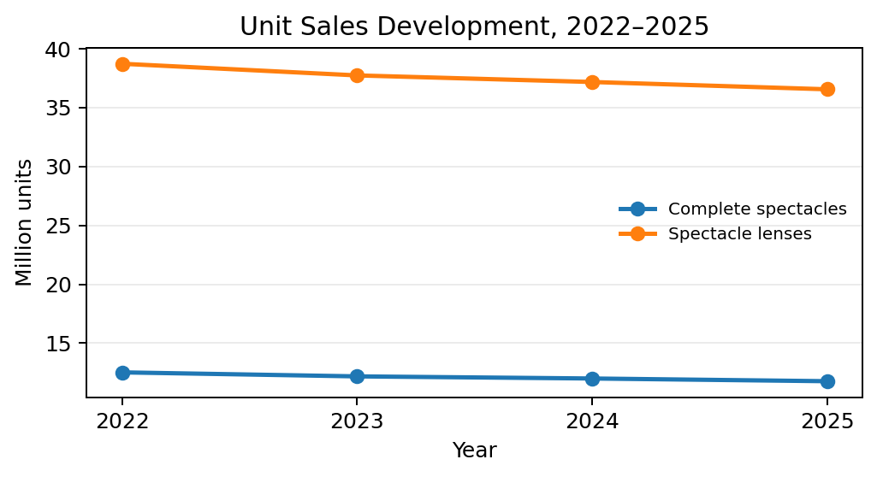
Figures 2–3. German optical market development, 2022–2025. Revenue and unit sales are shown separately because they use different units.
The pattern is consistent: sector revenue increased by about 5.0% over the period, while complete-spectacle volume declined by about 6.0%, spectacle-lens volume by about 5.6% and the number of retail locations by about 3.6%. This suggests that value development is more resilient than unit growth and increases the importance of product mix, premiumisation and differentiation.
Market structure. In 2025, the ten largest German optical companies accounted for 55% of sector revenue, while online sales represented about 5%. For a premium lens manufacturer, this makes both key-account management and the in-store professional journey strategically important.

5. Competitor benchmark
The benchmark compares four major premium-lens competitors using public product and channel evidence. The purpose is to identify different competitive profiles, not to declare an overall winner.

5.1 Product and technology evidence
Company | Personalisation example | Pediatric myopia | Premium coating | Core differentiation
Rodenstock | B.I.G. EXACT Sensitive | MyCon 2 | Solitaire LayR | Biometric eye model, visual sensitivity and DNEye-based measurement
Essilor | Varilux XR series | Stellest | Crizal Sapphire HR | AI-supported progressive design and broad lens ecosystem
ZEISS Vision Care | Progressive ClearMind Individual 3 | ZEISS MyoCare | DuraVision Plus Gold UV | Anatomy/behaviour-based individualisation and premium optics positioning
HOYA Vision Care | Hoyalux iD MySense | MiYOSMART | Hi-Vision Meiryo | Visual Sensory Intelligence, personalised progressives and strong myopia-management visibility

Product takeaway. Personalisation is no longer unique as a category message: all four companies use richer individual inputs in premium lens design. Rodenstock therefore needs to defend the distinctiveness of its biometric depth rather than rely on the word “personalised” alone.

5.2 Channel model / reach
Company | Public channel evidence | Analyst interpretation
Rodenstock | Sales offices and distribution partners in 85+ countries; distribution primarily through professional optical partners | Broad international reach, but less direct vertical integration into retail than EssilorLuxottica
EssilorLuxottica | 300,000+ optical partners, ~18,000 physical stores and 71 online platforms | Most vertically integrated channel model in the comparison, spanning wholesale, proprietary retail and e-commerce
ZEISS Vision Care | 450+ ZEISS Vision Centers in almost 50 countries, operated with independent eye-care professionals | Branded partner-led retail concept supported by a broad professional network
HOYA Vision Care | Supplies lenses in 110 countries through 43 labs; sells to eye-care providers rather than directly to patients | B2B-focused model with a large international lab and eye-care-provider network

6. Market trends, Rodenstock position & strategic implications
The useful question is not whether Rodenstock already has a product in each trend. In several areas it does. The more relevant Market Intelligence question is how the external trend changes the value of Rodenstock's existing position and where a gap, risk or opportunity remains.
Trend | Rodenstock current position | Gap / opportunity | Strategic implication
Ageing / presbyopia | Strong progressive portfolio | Demographics support long-term category relevance | Expand premium progressive value through comfort, adaptation and measurable wearer benefits
Pediatric myopia management | MyCon 2 | Strong competing platforms: Stellest, MiYOSMART and MyoCare | Strengthen clinical evidence, optician education and communication around MyCon 2
Personalisation / data-driven design | B.I.G. EXACT + biometric positioning | Personalisation is common competitor language | Differentiate biometric depth and prove wearer outcomes rather than relying only on the word 'personalised'
Premium coatings | Solitaire LayR | All major competitors offer strong premium coatings | Use coating as part of a broader premium proposition rather than as a stand-alone differentiation claim
Retail concentration | Partner-optician model | Large accounts represent a substantial share of German sector revenue | Adapt B2B propositions to large accounts and independent premium opticians
Online remains secondary | Strong professional / optician journey | Digital is more likely to complement consultation than replace it | Use digital tools to support measurement, consultation and the in-store customer journey

Overall implication. Rodenstock already participates in most of the important product themes. The strategic challenge is therefore less about entering missing categories and more about making its biometric differentiation provable, defending MyCon 2 against well-established myopia platforms, packaging coatings into a broader premium proposition and adapting commercial support to different optical-channel structures.

7. Limitations
- Market-size scope. The external GMI market estimate combines spectacle lenses, contact lenses and IOLs; it is not used as a precise spectacle-lens TAM.
- Country comparability. Germany is a transparent mature-market example, but European countries differ in reimbursement, retail structure, prescribing behaviour and channel mix.
- Product claims. Official product pages are marketing sources. Claims are useful for mapping positioning and features but are not directly comparable when companies use different test methods.
- Channel metrics. Public channel data are reported in different units (countries, stores, partners, labs), so the report compares channel models descriptively rather than ranking them numerically.
- No internal data. A real company project would validate these findings with internal sales data, customer research, paid databases and account-level economics.

8. Sources
[1] Global Market Insights – Europe Ophthalmic Lenses Market https://www.gminsights.com/industry-analysis/europe-ophthalmic-lenses-market
[2] Eurostat – Demography of Europe 2026 https://ec.europa.eu/eurostat/web/interactive-publications/demography-2026
[3] ZVA – Branchenbericht 2025/2026 https://www.zva.de/news/zva-branchenbericht-2025-2/
[4] ZVA – Branchenbericht 2025/2026 PDF https://www.zva.de/wp-content/uploads/ZVA-Branchenbericht-2025.pdf
[5] Rodenstock – B.I.G. VISION / B.I.G. EXACT Sensitive https://www.rodenstock.com/bigvision
[6] Rodenstock – Children's lenses / MyCon 2 https://www.rodenstock.com/lenses/childrens-lenses
[7] Rodenstock – Lens portfolio / Solitaire LayR https://www.rodenstock.com/lenses
[8] Rodenstock – company / channel footprint (85+ countries) https://www.rodenstock.com/company/press/Awards_BIG-EXACT-Sensitive
[9] Essilor – Varilux XR series https://www.essilor.com/us-en/products/varilux/varilux-xr-series/
[10] Essilor – Stellest https://www.essilor.com/us-en/products/stellest/
[11] Essilor – Crizal Sapphire HR https://www.essilor.com/in-en/products/crizal/crizal-sapphire-hr/
[12] EssilorLuxottica – 2025 Annual Report https://www.essilorluxottica.com/api/getCapContent/?download=false&id=291040
[13] ZEISS – Progressive ClearMind https://www.zeiss.com/vision-care/en/need-new-lenses/clearmind-progressive-lenses.html
[14] ZEISS – MyoCare https://www.zeiss.com/vision-care/en/eye-care-professionals/lenses/lenses-for-every-need/lenses-to-manage-myopia-progression-in-children.html
[15] ZEISS – DuraVision Plus Gold UV https://www.zeiss.com/vision-care/en/eye-care-professionals/lenses/coatings-technologies/duravision-gold-uv.html
[16] ZEISS – Vision Center channel model https://www.zeiss.com/vision-care/en/newsroom/vision-care-press-kits/zeiss-vision-center.html
[17] HOYA – Progressive lenses / Hoyalux iD MySense https://www.hoyavision.com/vision-products/progressive-lenses/
[18] HOYA – MiYOSMART https://www.hoyavision.com/de/produkte/miyosmart/
[19] HOYA – Hi-Vision Meiryo https://www.hoyavision.com/uk/vision-products/coatings/hi-vision-meiryo/
[20] HOYA Vision Care – FAQ / channel footprint https://www.hoyavision.com/en-us/newsroom/frequently-asked-question/
[21] PubMed – Analysing myopia in Europe: a comprehensive meta-analysis (2025) https://pubmed.ncbi.nlm.nih.gov/41420781/

