**UI SCREENSHOT**

Start generation button:

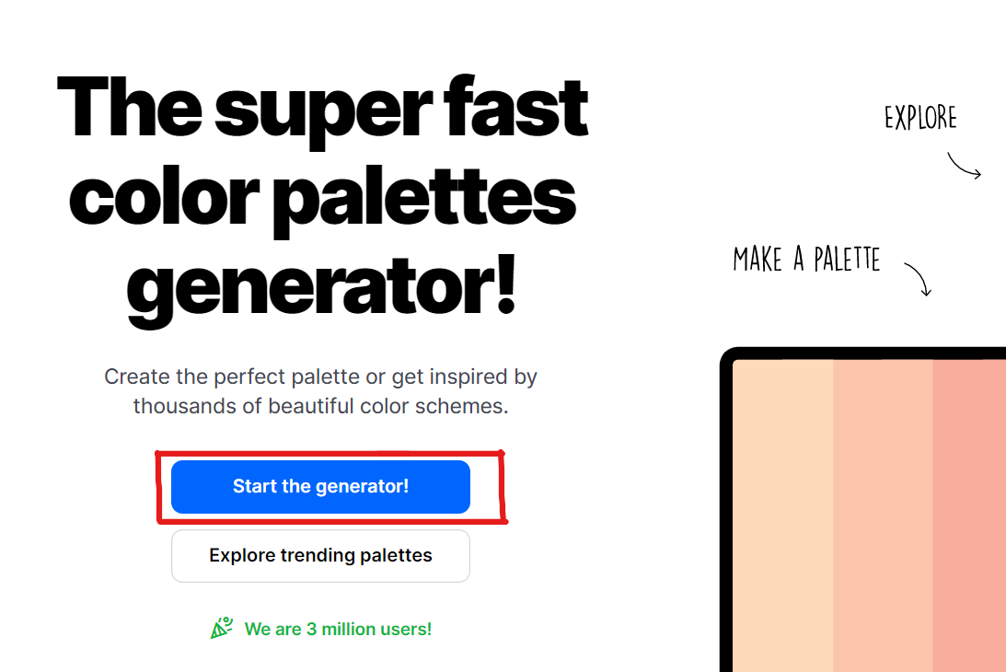

**HTML screenshot**

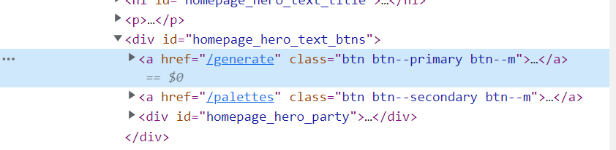

**DOM Locator:**

document.getElementsByClassName("btn btn--primary btn--m")[0]

**CSS Locator:**

#homepage_hero_text_btns > a.btn.btn--primary.btn--m

**xPath Locator**

//*[@id="homepage_hero_text_btns"]/a[1]

**2.**

**UI Screenshot**

Sign up button

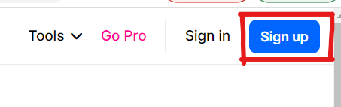

**HTML screenshot**

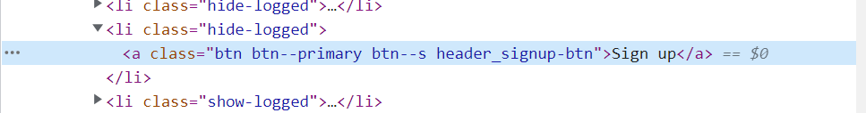

**CSS Locator**

#header_nav > ul > li:nth-child(5) > a

**xPath Locator**

//*[@id="header_nav"]/ul/li[5]/a

**3.**

**UI Screenshot**

Android app button

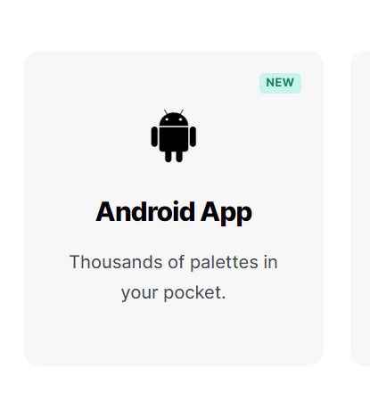

**HTML Screenshot**

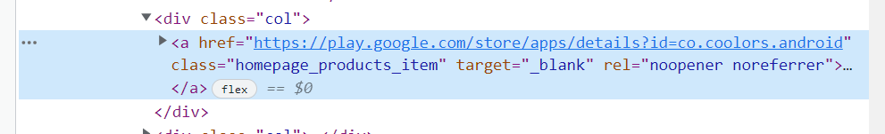

**CSS Locator**

#homepage_products > div > div:nth-child(2) > a

**xPath Locator**

**/**/*[@id="homepage_products"]/div/div[2]/a