“PGBooking: An Online

#### Booking System For Hotels and Resorts

#### In Puerto Galera”

A non-thesis Project

Presented to the Faculty of the

College of Computer Studies

#### MINDORO STATE UNIVERSITY

Calapan City Campus

Masipit, Calapan City, Oriental Mindoro

In Partial Fulfillment

of the Requirements for the Course of

#### APPLICATION DEVELOPMENT AND EMERGING TECHNOLOGY

De Guzman, Yuan Gabriel T.

Logatoc, Kate Angela

Medrano, Dominic E.

Rivera, Katherine B.

BSIT III-F1

October 2023

i

**TABLE OF CONTENTS**

**Chapter 1. Introduction**

Project Context 1

Objectives 4

Scope and Limitations 6

Definition of Terms 7

Chapter 2. Requirements Specification

Hardware and Software Requirements ... 9

Functional Requirements 11

Non-Functional Requirements ... 15

Operational Requirement 15

Performance Requirement .......................16

Security Requirement 18

ii

#### CHAPTER 1. INTRODUCTION

In this chapter, researchers will thoroughly examine the fundamental aspects of the project, thereby establishing a solid basis for the system that lies ahead.

## Project Context

In the dynamic landscape of travel and tourism, the demand for efficient and user-friendly booking systems is more critical than ever. PGBooking aims to address this need by introducing a specialized online booking system focused on Puerto Galera, a renowned destination in the Philippines. The travel and hospitality industry has seen a significant shift towards online platforms for booking accommodations and activities. Puerto Galera, with its picturesque landscapes and diverse attractions, is a prime location for such a system. PGBooking seeks to streamline the booking process for tourists, offering a centralized platform for reserving accommodations and recreational activities within the Puerto Galera region. As a comprehensive online booking system, PGBooking will serve as a digital repository for various services and experiences offered in Puerto Galera. The system's primary objective is to enhance the overall tourism experience by providing a one-stop solution for travelers to plan and book their entire trip seamlessly. The repository will include information about hotels, resorts, and local activities available in Puerto Galera. Through open standards and user-friendly interfaces, PGBooking ensures that users can easily search, retrieve, and book services, optimizing their travel planning process. PGBooking represents a significant advancement in Puerto Galera's tourism infrastructure, providing a digital repository for a wide array of services. This project not only contributes to the efficiency of tourism management but also enhances the overall experience for tourists, thereby promoting the sustainable growth of Puerto Galera's tourism industry.

There have been changes in hotel management systems as we are becoming more and more advanced. In the past bookings were made manually inside the hotel. But now it’s been digitalized and now users can just send forms to reserve a room at a hotel remotely. According to (Zhou, W., & Liu, Z. (2022), due to the improvement of people’s living standards, the traditional hotel management model has been unable to meet the needs of customers. Traditional hotel management model also has the defects of low efficiency.(Nandasiri et al., 2022) and (Ukamaka Betrand et al., 2023) both created an online hotel booking system in which customers are offered various facilities such as check-in, checkout, and entry editing, advance payments, option to cancel reservation, produce receipts, and view hotel rooms. These systems have the same features as “PGBooking” does. But (Madhura et al., 2023) took it a step further by integrating AI to the system and having an AI driven chatbot and concierge, designed to deliver user friendly interface, allowing customers to ask questions. “PGBooking” has a similar function only that it is a real time chat with real hotel staff. The thing these researches have in common is that they only feature a single hotel which greatly limits it due to the fact that users will prefer to look and browse through multiple hotels to compare prices and rooms. They are also lacking in producing useful data that can be used in the future as they are only focusing on bookings of the users and only keeping records. Their websites are very simplistic in nature and users don’t have much freedom in them either as they are only allowed to book and browse in a single hotel. “PGBooking” aims to fill these gaps and help not only the hotels but also PG tourism to provide even better hotel booking experience.

## Objectives

The project aims to design, develop, and implement an Online Hotel Booking System tailored to the needs of travelers and tourists. This system is designed to simplify and enhance the hotel and resort reservation process, offering an efficient, user-friendly, and comprehensive platform for booking accommodations. It addresses various challenges travelers encounter when searching for hotels and resorts, making reservations, and managing their bookings, all while ensuring secure and seamless transactions. The ultimate goal is to provide an outstanding user experience, along with fostering a culture of trust and reliability in the online hotel and resort booking industry.

Specifically, this study aims to:

• Allow tourists to book a hotel or resort hustle free.

• Allows tourists to choose any hotel and resort in Puerto Galera.

• Create a statistical data demographics like age group and gender.

• Provide users with the ability to create and manage their profiles, view booking history, and receive booking confirmations.

• Allows travelers to leave reviews and ratings for hotels and resorts, aiding others in their decision-making process.

• Develop an administrative interface for hotel and resorts administrators to manage room availability, user data, and address customer concerns.

• Ensure that the system complies with relevant laws and regulations, including data protection and consumer rights.

• Develop a system for sending automated notifications to users, including booking confirmations, reminders, and updates on their reservations.

• Develop a predictive hotel and resort performance forecasting and tourists’ inflation forecasting.

• Develop a performance data of hotel and resort daily, monthly and yearly.

## Scope and Limitations

This study is centered on the development of an Online Hotel and Resort Booking System for Puerto Galera Tourism, catering to customers, hotels, and resorts as its primary user groups. Customers can effortlessly search for and book resort and hotel rooms, while hotels and resorts can easily manage their webpages and amenities along with seeing all the booking they might receive. The system's design places a strong emphasis on user-friendliness and cross-platform accessibility, accommodating users through web browsers and mobile applications. It integrates essential features for efficient hotel and resort room management, including real-time availability updates, secure payment processing, and automated user notifications. However, it's essential to acknowledge potential limitations related to the rapid evolution of technology and customer preferences may pose challenges in keeping the system up-to-date and competitive. Recognizing these scope and limitations is critical for setting the project's boundaries and objectives.

## Definition of terms

To enhance clarity and facilitate comprehension, the following terminology is conceptually and operationally elucidated:

**Hotel** - An establishment that provides temporary lodging, accommodations, and often additional services and amenities for travelers and guests in exchange for payment.

**Booking** - The process of reserving and securing accommodations or services in advance.

**Guest** - a person who patronizes a hotel, restaurant, etc., for the lodging, food, or entertainment it provides.

**Resort** - An establishment that offers a comprehensive vacation experience, providing lodging, recreational activities, and various amenities for guests seeking leisure and relaxation, often situated in scenic or exotic locations.

**Puerto Galera** - a tourist spot located at Oriental Mindoro, Philippines.

**Puerto Galera Tourism** - a government group that works and manages the hotels and other activities that promotes tourism in Puerto Galera

**Forecasting** - is the process of making predictions or estimates about future events, trends, or outcomes based on past and present data. It involves analyzing historical data and using various methods and models to make informed projections about what may happen in the future. Forecasting is commonly used in business, economics, meteorology, and other fields to aid in decision-making and planning.

**Amenities** - include in-room extras such as air conditioning, entertainment (TV/music), Wi-Fi, toiletries, robes and more.

**Review** - a report that gives someone's opinion about the quality of a book, performance, product, etc.

**Ratings** - a measurement of how good, difficult, efficient a hotel or resort is.

# CHAPTER 2. REQUIREMENTS SPECIFICATION

This chapter outlines the specific requirements, features, and functionalities significant to the researchers' system development.

## Hardware and Software Requirements

**Hardware Requirements**

**Storage (SSD)** – 256GB to 512GB SSD will be used by the developers to store, access, and manage the system’s data efficiently. A 512GB to 1TB or larger is also recommended for better performance.

**Memory (RAM) and Processor (CPU)** – The developers will be using 8GB to 16GB RAM and Intel Core i3 11th gen processor to provide smoother performance in handling the system’s data. 16GB to 32GB RAM or more and Intel Core i5 processor or higher are recommended for much smoother performance.

**Network Connectivity** – The modem is the device used to access the internet and it provides 35 Mbps download speed. It is used by the developers to provide a quick and reliable network connection for the system. A download speed of at least 25-50 Mbps is recommended, this ensures faster file uploads and downloads.

**Mobile Devices** – iOS and Android mobile devices will be used to test and try out the responsiveness and compatibility of the system in mobile devices enhancing its efficiency and flexibility.

**Software Requirements**

**Visual Studio Code** – a streamlined code editor with support for development operations like debugging, task running, and version control. The required version is 1.83.1 or higher.

**CodeIgniter 4** – An open-source PHP framework. Version 4 is the required version to develop the researchers’ system.

**Vue JS** – A progressive JavaScript Framework used for developing mobile apps simultaneously with a single codebase. Version 2.7.14 or higher is required.

**MySQL** – Version 8.0.30 or higher is required for storing and managing the system’s structured data.

**User Interface Templates** – A designer-made web template based on Bootstrap 5, HTML and CSS will be used by developers along with other optional JavaScript plugins for easy customization of the user interface.

**Web browsers** – Samples are Google chrome, Firefox, and Microsoft edge, etc. These are used to access and display the necessary web-based contents and manage the system’s communication with online services and resources.

**Windows 10 and Windows 11** – Are versions of the Windows operating system that will be used for the developers’ system.

**Laragon** - A powerful development environment and server stack for building and managing the researchers’ system. Version 7 to 8.2 is required.

**phpMyAdmin** – The latest version (currently 5.2.1) is required to be used for supporting a wide range of operations and manage the system’s MySQL databases.

**Functional Requirements**

**Tourists:**

Tourists should be able to:

1. Enable users to sign up and log in using their chosen username, email, and password.

1. Enable account validation via autogenerated email codes and implement account recovery with a recovery code for forgotten passwords.
2. User must able to view and edit their user profile and information.
3. View and manage their current booking.
4. View booking history and check hotel room availability, pricing, and dates.
5. View list of available hotels in Puerto Galera.
6. View and navigate each hotel's personalized homepage.
7. Book a reservation.
8. Contact the admin for their queries and concerns.
9. Chat the hotel for information and refunds.
10. Secure their booking by uploading the receipt of their downpayment.
11. Search for a specific hotel and resorts.
12. Receive push notifications for app updates, promotions, and discounts.
13. Receive SMS notifications for the confirmation of their reservation.
14. View and leave ratings and reviews.

**Hotel and Resorts:**

Hotel and Resorts should be able to:

1. Register with their preferred username, email, and password.
2. Authenticate with their username, email, and password.
3. Validate their account with autogenerated code using their email address.
4. Verified their account by uploading necessary documents for legitimacy.
5. Recover their account with a recovery code if they forgot their password.
6. View and edit their hotel profile and information.
7. View the reservations in their hotel with tourists’ profiles and information.
8. View ratings and reviews.
9. Chat with the tourist.
10. Add rooms and set room pricing and availability.
11. View, edit, and manage their homepage.
12. Upload pictures for their homepage.
13. Confirm and cancel a reservation.
14. View and download weekly, monthly and yearly sales reports.
15. View the daily number of tourists who successfully booked in their hotel in a chart.

**Admin:**

Admin should be able to:

1. View and download hotel performance daily, monthly, and yearly reports.
2. View and download tourists' percentage coverage data and reports.
3. View predictive hotel performance forecasting and tourist inflation forecasting.
4. View and download tourist statistical data such as demographics like age group, gender, and place originated from.
5. Manage and verify both tourists’ and hotels’ accounts.

## Non-Functional Requirements

### Operational Requirement

1. The system must adhere to data privacy regulations and maintain hotel, resort, and guest data confidentiality.

2. The system's interface and coding should comply with web development standards and best practices to ensure consistent operation across various platforms.

3. The system should be compatible and operate on various browsers and devices, including desktops, laptops, tablets, and smartphones, ensuring accessibility for hotel guests regardless of their device.

4. The system should include robust error handling and validation mechanisms to prevent the submission of incomplete or inaccurate bookings and registrations.

5. The system should allow the registered hotels and resorts to upload relevant images to their webpages to let potential guests know more about their hotel and resort.

6. The system should be designed to accommodate a large number of guests during peak seasons to avoid compromising the system’s performance.

7. The system should have a user-friendly interface that is easy to navigate to make it more accessible and ensure ease of use for hotel and resort staffs and guests of varying technical expertise.

8. The system should provide clear and user-friendly documentation or guidance to help hotel and resort staffs and guests navigate and utilize its features effectively.

### Performance Requirement

1. The system should provide rapid response times for hotel and resort registrations, bookings, searches, and hotel and resort rooms’ preview by loading within 2 seconds to ensure a seamless and efficient hotel registration and guest booking process.

2. The system should be able to support at least 1000 of concurrent users without significant performance degradation, to ensure that all guests can access and use the system concurrently.

3. The system should maintain 99.9% uptime, with minimal downtime or maintenance periods, to ensure continuous accessibility for hotel and resort staffs, guests, and tourism administrators.

4. The system should allow uploading of images based on the internet speed and size of the image.

5. Retrieval of guest data, and hotel and resort information should be executed swiftly within 3 seconds, enabling tourism administrators to access and assess each of the registered hotels’ statistical data without encountering delays or system lag.

### Security Requirement

1. All sensitive data, including personal information of guests, resort, and hotel data, must be encrypted using hashing both during transmission and storage to prevent unauthorized access and data breaches.

2. Guest and hotel and resort accounts must be secured with strong password requirements by using regular expression and data validation.

3. The system must enforce role-based access control to ensure that only authorized personnel can access and modify sensitive hotel and guest data.

4. The system must comply with relevant data privacy laws and regulations.

20

**CHAPTER 3. DESIGN AND DEVELOPMENT METHODOLOGIES**

This chapter presents the methods and strategies used in this study in order to develop an approach that matches its objectives. It was obtained using different processes, specifications, analysis, data gathering instruments, and evaluation that guides the researchers to manage and control the research.

**System Design**

**Database Design**

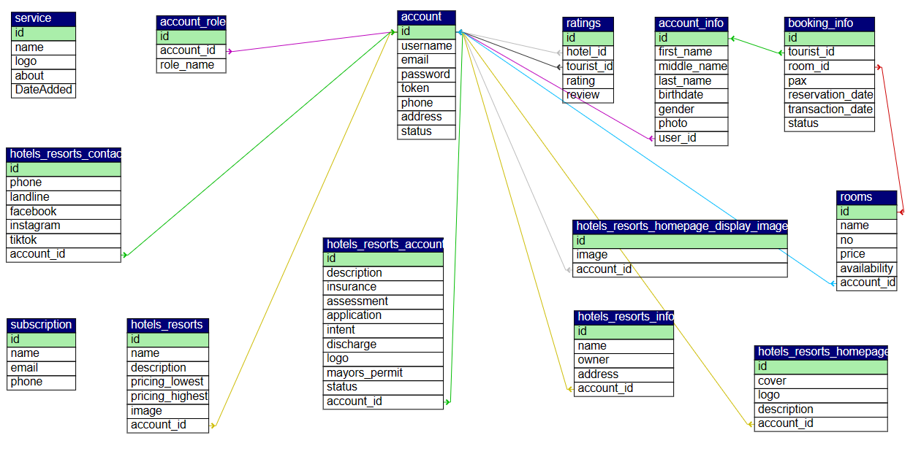

**Figure 1: Database Design**

Figure 1 encapsulates the system’s database schema. The schema contains all the related tables containing information about the tourists and hotels that is used in the system.

**Architectural Diagram/ Block Diagram**

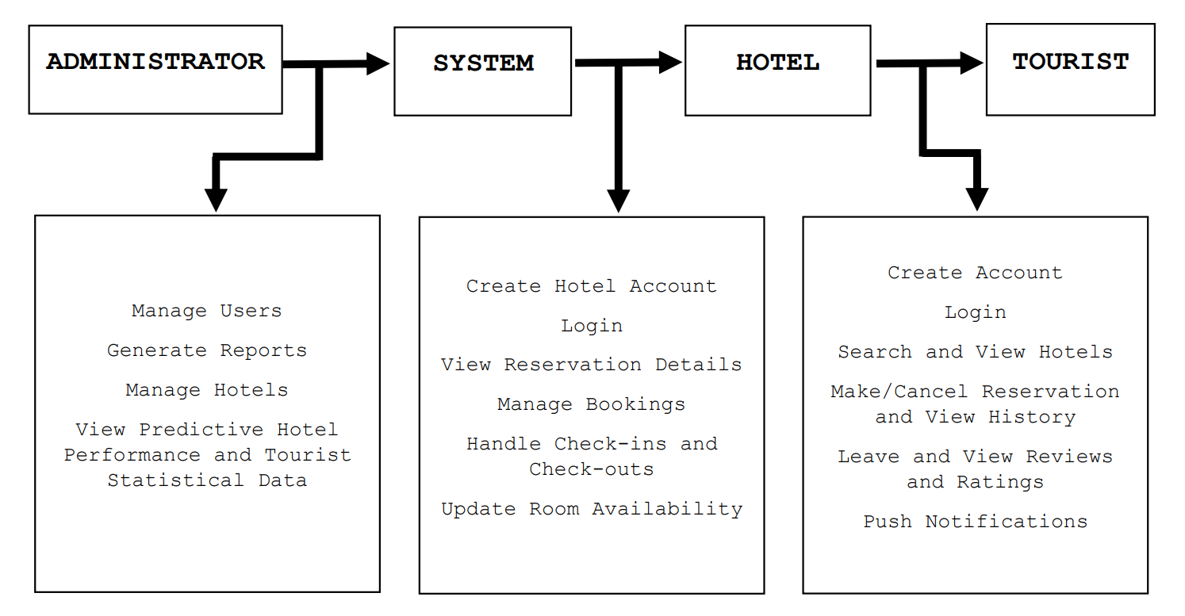

**Figure 2: Architectural Diagram**

This diagram illustrates the interaction between the three main entities: Administrator, Hotels, and Tourists, along with the key functionalities described for each entity. The arrows indicate the flow of information and actions within the system.

**DFD Level 0**

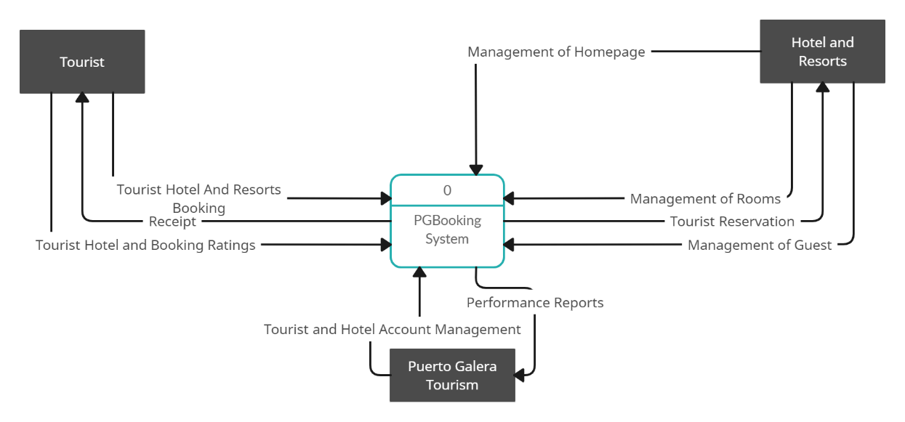

**Figure 3: DFD Level 0**

Figure 3: DFD Level 0 illustrates the interactions and data flows between the Admin, Hotels, and Tourists.

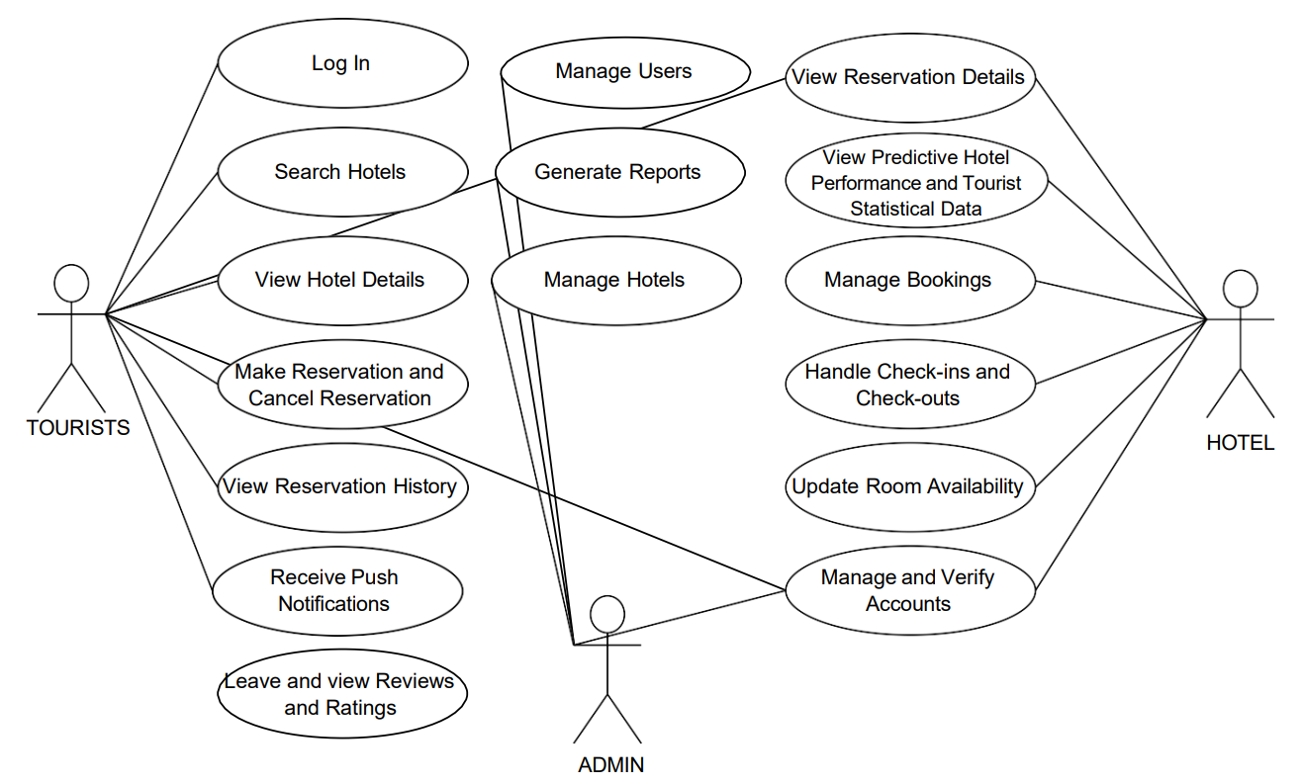**UML Use-case Diagram**

**Figure 4: UML Use-case Diagram**

This diagram provides a visual representation of the interactions between the system's actors (Administrator, Hotels, and Tourists) and their respective use cases.

**Agile Methodology** - Agile method is chosen for this research due to the method's emphasis on the user’ demands, flexibility and agility which makes it a great option for development. Agile's iterative methodology is particularly well-suited for this project where requirements may change or evolve over time, and where customer feedback is crucial. It enables early risk minimization, rapid market change adaptability, and continual improvement as it assures a user-friendly experience by giving priority to necessary functions. Incremental development, a feature of agile, lowers time-to-market, encourages team cooperation, and maintains quality standards. Travelers' seamless and fulfilling experiences are in line with the goals of this user-centric, adaptable, and effective strategy. Using Agile in developing "PGBooking" can significantly contribute to providing an outstanding booking experience by promoting user-centric development, adaptability, frequent iterations, and quality assurance. The ability to respond to user feedback, rapidly deliver value, and adapt to changing needs ensures that the system remains competitive and user-friendly. It also can significantly enhance the efficiency of hotel management in developing “PGBooking”. The iterative, flexible, and user-centric approach ensures that the system is well-suited to the hotel's unique needs, providing improved booking and management capabilities while allowing for quick adaptation to changing requirements and market conditions.

**REFERENCES**

Madhura, D., Prajakta, M., Tanaya, Z., Vijaya, N., Ashish, K. . S., Bhakti, T., & Neha, P. (2023). An AI Integrated Online Hotel Management System. Journal of Web Engineering & Technology, 9(1), 1–18.

Nandasiri, K. G. N. D., Gamage, M. I. S., Wanniarachchi, M. Y., Lakshani, N. V. M., Silva, D. I. De, & Cooray, D. (2022). Hotel Reservation System. International Journal Of Engineering And Management Research, 5(5), 527–533.

Ukamaka Betrand, C., Juliet Onyema, C., & Martina Awaji, N. (2023). Automated Hotel Management Information System. Journal of Research in Engineering and Computer Sciences, 1(1), 19–28.

Zhou, W., & Liu, Z. (2022). Design and Optimization of Hotel Management Information System Based on Artificial Intelligence. Scientific Programming, 2022. https://doi.org/10.1155/2022/2445343