## Background

Huzzah! Now that MS Outlook is our email client, it is possible to send email directly from R. This is a test R Markdown document that renders the output into a word document, then inserts the content into the body of an email. I’m still obviously working out the kinks.

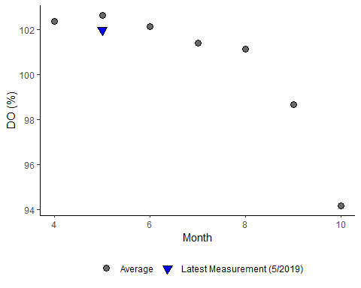

Figure 1. Recent report for Dissolved Oxygen (%)

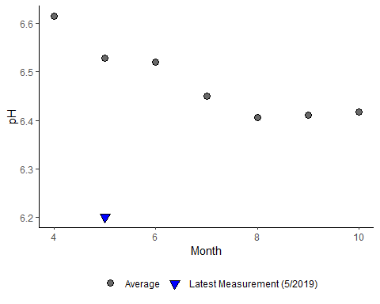

Figure 2. Recent report for pH