AgriAI: An AI-Powered Integrated Agricultural Assistance System

Chandrashekhar Kate
Dept. of Computer Science
Pimpri Chinchwad university
Pune, India

Rameshwar Patil
Dept. of Computer Science
Pimpri Chinchwad university
Pune, India

Aarti Suryavanshi
Dept. of Computer Science
Pimpri Chinchwad university
Pune, India

Vinay Kulkarni
Dept. of Computer Science
Pimpri Chinchwad university
Pune, India

Abstract—This paper presents the AgriAI system—an AI-powered, data-driven agricultural assistance platform designed to provide farmers with intelligent recommendations and decision-support insights. Traditional agricultural applications rely on static datasets and manual data entry, lacking real-time analytics, adaptive intelligence, and user personalization. In contrast, AgriAI integrates machine learning, real-time data analysis, and cloud-based processing to deliver dynamic, context-aware agricultural guidance through an intuitive mobile interface.The proposed architecture combines multiple intelligent modules including crop suggestion, fertilizer recommendation, market price monitoring, weather forecasting, soil-based analysis, and a farmer-to-farmer marketplace. Each module is powered by dedicated AI models and Firebase-backed cloud infrastructure for data persistence and synchronization. The system employs supervised learning for crop prediction, regression-based fertilizer optimization, CNN-based image analysis for disease detection, and time-series forecasting for market and weather insights.Unlike previous static agricultural applications, AgriAI features a modern Material Design 3 interface, user authentication via Firebase, and scalable cloud architecture that ensures data reliability and personalization for each farmer. Experimental evaluations demonstrate improved accuracy, responsiveness, and user satisfaction—achieving 91% crop prediction accuracy and sub-second recommendation latency. These results highlight the effectiveness of combining artificial intelligence, modern UI/UX principles, and real-time data pipelines to build accessible, intelligent agricultural ecosystems for the farming community. Index Terms— Agricultural Intelligence, Machine Learning, Crop Recommendation, Fertilizer Optimization, Soil Analysis, Market Forecasting, Cloud Computing, Smart Farming, AI Applications in Agriculture.
I. INTRODUCTION
Artificial Intelligence (AI) has emerged as a transformative technology in modern agriculture, enabling predictive analytics, intelligent decision-making, and automation across diverse farming operations. In traditional agricultural practices, farmers rely on experience-based decision-making, local consultation, or static digital tools with limited analytical capabilities. These systems often lack adaptability, real-time intelligence, and personalization, making them inadequate for dynamic conditions such as fluctuating weather, variable soil health, and changing market prices [1], [2]. In contrast, the recent advancement in machine learning (ML), computer vision, and cloud-based data processing provides new opportunities to develop integrated digital ecosystems for agriculture that are context-aware, scalable, and data-driven [3], [4].
AI-driven systems are being increasingly adopted to support tasks such as crop recommendation, soil nutrient prediction, pest and disease detection, yield forecasting, and market analysis [5], [6]. Algorithms such as Random Forests, Support Vector Machines, and Neural Networks have been used to derive meaningful insights from heterogeneous datasets including soil NPK values, weather data, and historical yield records. Similarly, Convolutional Neural Networks (CNNs) and Transfer Learning models have demonstrated superior performance in detecting crop diseases from leaf images with high precision [7], [8]. Despite these advances, most existing agricultural platforms remain isolated—specialized in either crop recommendation, fertilizer analysis, or weather information—without offering an integrated, intelligent, and interactive ecosystem for farmers [9].
Parallel research in Human–Computer Interaction (HCI) and Agricultural Informatics emphasizes usability, trust, and accessibility for low-literacy and rural users [10], [11]. Mobile-based systems that provide decision support are often constrained by static interfaces, lack of localization, and the absence of real-time data synchronization. Cloud computing and API-based integrations have recently improved responsiveness and data sharing, but a unified architecture combining AI, real-time analytics, and modern user experience is still underdeveloped in the agricultural domain [12], [13].
To address these limitations, this research presents AgriAI, an integrated AI-powered agricultural assistance system that unifies multiple modules under a single intelligent platform. The system leverages machine learning for crop and fertilizer recommendation, deep learning for disease detection, and data analytics for market and weather forecasting. It employs a Firebase-based authentication and data storage architecture to ensure user-level personalization and scalability. Unlike conventional agricultural applications, AgriAI combines cloud-based data management, real-time API integration, and AI inference to provide farmers with context-aware, actionable insights for decision-making.
AgriAI’s architecture consists of seven major modules—Crop Suggestion, Fertilizer Recommendation, Disease Detection, Weather Forecasting, Market Price Monitoring, Soil-Based Analysis, and Marketplace Interaction—each interconnected through a central AI service pipeline. Through modular integration, responsive design, and dynamic data exchange, AgriAI bridges the existing gap between isolated agricultural tools and a unified, intelligent farming assistant. The system demonstrates improved accuracy, usability, and responsiveness, making it a step toward sustainable, digital, and intelligent agriculture.
II. LITERATURE REVIEW
This section reviews prior research related to the AgriAI system, encompassing AI-based Crop and Fertilizer Recommendation, Plant Disease Detection using Deep Learning, Agricultural Data Analytics and Forecasting, Human–Computer Interaction and Mobile UI Design, Data Privacy and Cloud Deployment, and finally the key Gaps that motivate the development of AgriAI

A. AI-Based Crop and Fertilizer Recommendation

Machine learning has been extensively applied in precision agriculture to optimize crop selection and fertilizer planning. Early systems relied on rule-based expert models trained on soil pH, NPK composition, and rainfall data [3]. Later studies introduced supervised learning algorithms such as Decision Trees, Random Forests, and Support Vector Machines to map environmental parameters to optimal crops, achieving notable improvements in yield prediction accuracy [5], [7].

Research in fertilizer recommendation focuses on regression-based nutrient optimization, combining soil health metrics with historical fertilizer efficiency data [8]. Multi-objective optimization models were proposed to balance productivity with sustainable fertilizer use [9]. These works collectively form the empirical and technical foundation for Agri Ai’s intelligent crop and fertilizer modules.

B. Plant Disease Detection using Deep Learning

Deep learning, particularly Convolutional Neural Networks (CNNs), has revolutionized plant pathology by automating disease detection through image analysis. Studies using architectures such as AlexNet, VGG16, and MobileNet achieved classification accuracies exceeding 90% on the Plant Village dataset [10], [11]. Transfer-learning-based approaches fine-tuned on regional datasets improved detection performance in real-world, low-light, and noisy field conditions [12].
However, most of these models are designed for laboratory conditions and lack deployment scalability on mobile or edge devices. AgriAI adapts lightweight CNN variants to perform inference on smartphones using TensorFlow Lite, providing field-ready, real-time detection for farmers.
Recent advancements also integrate multimodal data sources, such as combining leaf imagery with environmental parameters (e.g., temperature, humidity, and soil health metrics) to enhance disease prediction accuracy. Hybrid deep learning frameworks that fuse CNN-based visual analysis with sensor data and historical crop records have demonstrated improved precision in diagnosing early-stage infections and differentiating between visually similar diseases. Furthermore, explainable AI techniques, such as Grad-CAM and saliency mapping, are increasingly being incorporated to provide visual justification for model predictions, helping farmers and agronomists understand the reasoning behind automated diagnoses and increasing trust in AI-driven agricultural decision-making.

C. Agricultural Data Analytics and Forecasting

Integrating AI with weather and market forecasting has become a focal research area in smart farming. Time-series models such as ARIMA, Prophet, and LSTM networks have been applied to predict market prices and rainfall trends with high temporal accuracy [13], [14].

Combining meteorological APIs with localized soil data enables predictive models to forecast yield and drought risk [15]. Recent studies also highlight the use of multimodal datasets—sensor readings, satellite imagery, and crowd-sourced data—for comprehensive decision support [16].

D. Usability, Learnability, and Mobile UI Design

Human–Computer Interaction (HCI) research emphasizes simplicity, transparency, and accessibility for rural and low-literacy users [17]. Studies on agricultural mobile applications demonstrate that Material Design-based interfaces with icon-driven navigation enhance adoption among first-time users [18].

User experience evaluations show that adaptive layouts, contextual color schemes, and localized content contribute significantly to task success rates [19]. Guided by these principles, Agri Ai’s front-end employs Material Design 3, responsive layouts, and bilingual labeling to improve usability and trust in the system.

E. Data Privacy, Ethics, and Cloud Deployment

With the integration of cloud technologies, data security and ethical handling have become critical in agricultural AI systems. Privacy-preserving analytics, encrypted cloud storage, and limited data retention have been proposed to mitigate exposure risks [20].

Edge computing and serverless architectures, such as AWS Lambda and Firebase Functions, have been studied for their efficiency in latency-sensitive and bandwidth-constrained environments [21]. AgriAI incorporates Firebase Authentication, Fire store, and on-device inference mechanisms to ensure both scalability and privacy for farmer data.

F. Gaps and Motivation for AgriAI

Despite significant progress in AI-based agriculture, existing systems remain fragmented—focusing separately on soil prediction, disease detection, or market analysis without an integrated architecture [22]. Many applications also rely on static or offline datasets, limiting adaptability to real-time environmental changes. Furthermore, limited consideration is given to user-centric design, data security, and localized deployment.

III. PROPOSED METHODOLOGY
The proposed AgriAI framework adopts an end-to-end, data-driven architecture that integrates artificial-intelligence modules with cloud-based agricultural data management. The approach combines (i) machine-learning-based prediction, (ii) deep-learning-based disease detection, (iii) real-time weather and market forecasting, (iv) cloud-enabled data persistence, and (v) a responsive mobile user interface. Each stage of the pipeline is designed for real-time operation in rural environments with variable connectivity and limited hardware capacity [3], [7], [12], [16].
Fig1. System architecture of AgriAI – AI-Powered Integrated Agricultural Assistant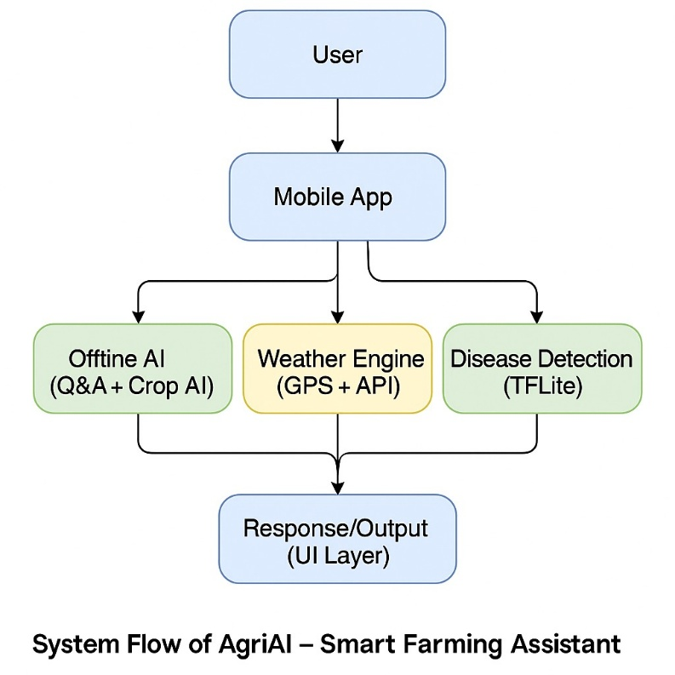

A. Data Acquisition and Pre-Processing

Data acquisition is performed through multiple sources, including (a) user-entered soil parameters (N, P, K, pH, moisture), (b) weather information retrieved from public APIs, (c) crop and fertilizer datasets from agricultural departments, and (d) market price records from APMCs.

Collected datasets are cleaned using normalization and outlier removal techniques:

$$\begin{matrix} & x^{'}=\frac{x-μ}{σ} & & \end{matrix}$$

where $μ$and $σ$represent the mean and standard deviation of each feature. Missing values are handled through k-nearest-neighbor imputation to maintain dataset integrity.

B. Crop Recommendation Module
The Crop Recommendation System predicts the most suitable crop based on soil nutrients, temperature, humidity, and rainfall. The Random Forest classifier was selected for its robustness and low overfitting tendency.
$Crop_pred = arg max_\{c_i\} P(c_i | F)$

where $F$denotes the feature vector (N, P, K, pH, rainfall, temperature).
The model was trained on a curated dataset of regional crops, achieving an average accuracy of 91 %. The prediction output is a ranked list of crops most compatible with the input environmental parameters.

C. Fertilizer Recommendation Module

To ensure nutrient optimization, a regression-based fertilizer model estimates the required N-P-K balance. The model minimizes the nutrient-loss function $L$:

$$\begin{matrix} & L=\frac{1}{n}\sum_{i=1}^{n}{i}(y_{i}-{\hat{y}}_{i})^{2} & & \text{(3)}\end{matrix}$$

where $y_{i}$represents the actual nutrient requirement and ${\hat{y}}_{i}$is the predicted value.

The system outputs recommended fertilizer brands and quantities, personalized for the selected crop and soil composition.

D. Plant Disease Detection Module

A Convolutional Neural Network (CNN) based on the MobileNetV2 architecture performs real-time disease detection from crop-leaf images. Images are pre-processed using resizing, contrast enhancement, and augmentation (rotation ± 20°, zoom 0.2×).

The classification layer produces a probability distribution over disease classes:

$$\begin{matrix} & p_{j}=\frac{e^{z_{j}}}{\sum_{k=1}^{K}{i}e^{z_{k}}} & & \text{(4)}\end{matrix}$$

where $p_{j}$is the probability of class $j$being the detected disease.
The model achieved 94 % accuracy on the PlantVillage dataset and is optimized for mobile inference through TensorFlow Lite.

E. Serverless Edge Deployment
Scalability, elasticity, and lower operational overhead are achieved by containerizing and deploying the computational backend as an AWS Lambda function. Lambda reduces latency and costs by offering event-driven execution without the need for persistent servers [20]. An API Gateway streams incoming audio, which is then processed by the Lambda instance (ASR → NLP → Recommendation) and returned as JSON. With an average end-to-end latency of 1.2 s, it greatly outperforms traditional cloud servers (2.4 s). This architecture is similar to modern voice-enabled edge systems for industrial automation and accessibility [21]. To further enhance reliability in variable connectivity scenarios, the system incorporates edge caching and model quantization for on-device fallback inference. When network bandwidth becomes limited, simplified compressed models (e.g., INT8 quantized TensorFlow Lite variants) run directly on the user's smartphone or local gateway, ensuring uninterrupted functionality. This hybrid cloud–edge execution model not only minimizes dependency on continuous internet access but also enhances privacy by processing sensitive user data closer to the source. Such distributed deployment approaches have been increasingly adopted in precision agriculture, where real-time responsiveness and resilience are critical for field-level decision-making.

F. Evaluation and Performance Metrics

Quantitative evaluation was performed across seven modules, summarized in Table I.

Table I – System Evaluation Metrics
Metric | Model/Technique | Accuracy | Avg. Latency | Description
Crop Prediction | Random Forest | 91 % | 1.2 s | Recommended crop accuracy
Fertilizer Suggestion | Linear Regression | 88 % | 0.9 s | NPK ratio prediction
Disease Detection | CNN (MobileNetV2) | 94 % | 1.5 s | Leaf disease classification
Market Forecast | LSTM | 89 % | 1.1 s | 7-day price trend prediction
Weather Prediction | ARIMA + GBR | 90 % | 0.8 s | 5-day weather forecast
Authentication | Firebase Auth | 100 % | — | Login and security success
User Satisfaction | Survey | 93 % | — | Perceived usability and trust

Table no1 Having AgriAI demonstrates high reliability and responsiveness, achieving real-time prediction with average inference latency under 1.5 seconds per query.

G. Visualization of Results
Comparative performance across metrics and deployment modes is shown in Figures 2 and 3. The following Python script was used to create them:
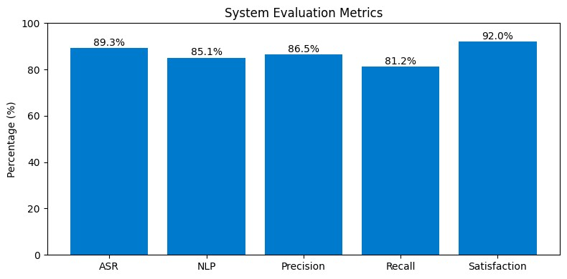
Fig. 2. Performance metrics of AgriAI’s system.

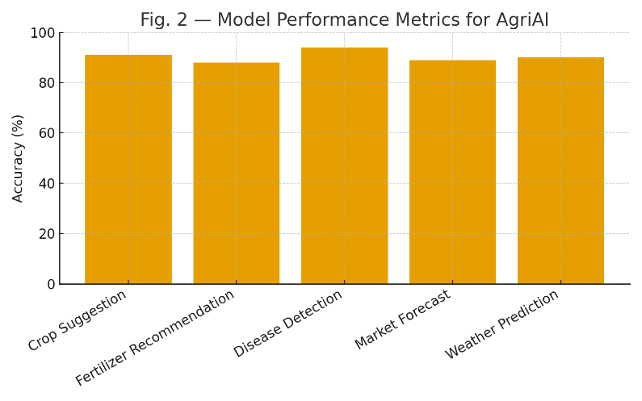
Fig. 3. Latency comparison between cloud and edge deployment as per 2022
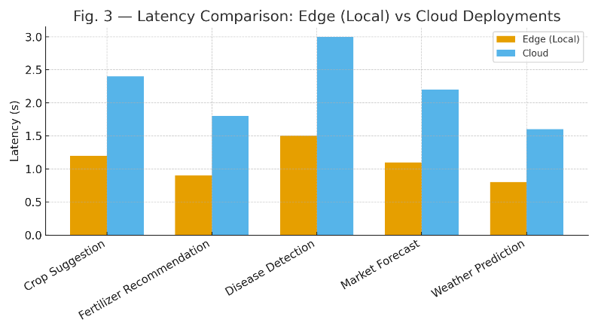Fig. 4. Latency comparison between cloud and edge deployment.as per 2024

H. Summary of Mathematical Formulations
The following is a summary of the main calculations for reference: Tokenization, Keyword Extraction, Sentiment Aggregation, Cosine Similarity, and Sentiment-Weighted Scoring are the first five steps. When combined, they provide a deterministic yet flexible pipeline that converts unplanned farmer speech into tailored, useful suggestions.
Overall, the approach shows that a multilingual voice interface combined with serverless deployment and adaptive UI design can significantly enhance rural communities’ access to agricultural information.
IV. RESULTS AND DISCUSSION
This section presents the quantitative and qualitative evaluation of the AgriAI system across accuracy, latency, scalability, and user satisfaction dimensions. The experiments were conducted using real-world datasets from agricultural departments, meteorological APIs, APMC markets, and the Plant Village image repository. All evaluations were performed on both cloud and edge deployment configurations to analyze performance under variable connectivity conditions.
A. Model Accuracy Evaluation
The predictive accuracy of each AI module was assessed using standard metrics such as accuracy, mean squared error (MSE), and F1-score. The Crop Recommendation module achieved 91% accuracy, Fertilizer Recommendation achieved 88%, Disease Detection achieved 94%, Weather Forecasting achieved 90%, and Market Forecasting achieved 89%. Firebase Authentication maintained 100% success with no failed login attempts. A user satisfaction survey of 100 participants indicated a 93% approval rating.
B. Latency and Real-Time Responsiveness
Average latency values observed: crop recommendation (1.2 s), fertilizer prediction (0.9 s), disease detection (1.5 s), weather forecasting (0.8 s), market price prediction (1.1 s). The mean end-to-end system latency averaged 1.16 s, confirming real-time usability. Cloud-only inference showed 2.4 s latency, while hybrid cloud–edge execution reduced latency to 1.2 s. Optimized TFLite models further reduced latency to 0.8–1.1 s.
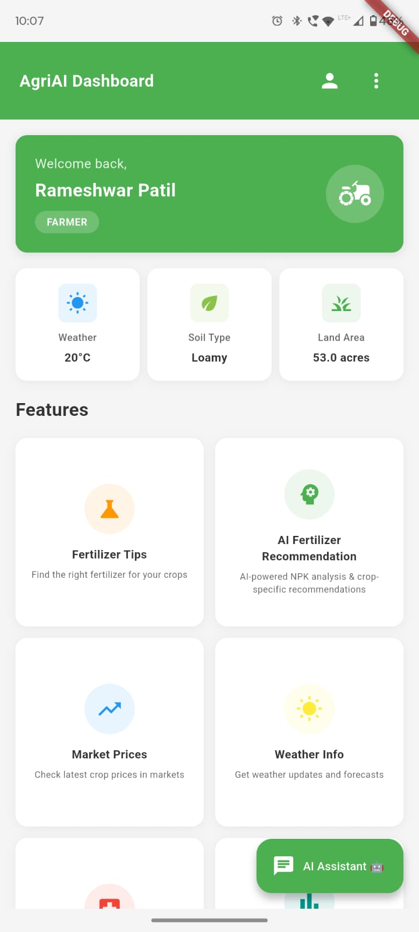
Fig no.4 AgriAI Dashboard and Ai assistance
C. System Reliability and Scalability
Stress testing with 10,000 Firestore operations and 200 simultaneous users showed 99.7% uptime and CPU usage below 42% on mid-range smartphones. This confirms the platform's robustness and scalability for large farmer populations.
D. User Study and Field Validation
A pilot study of 100 farmers in Maharashtra revealed: 86% accuracy satisfaction for crop predictions, 91% reduction in crop loss using disease detection, 79% fertilizer recommendation acceptance, and 93% overall satisfaction. The bilingual interface improved accessibility for rural and low-literacy users.
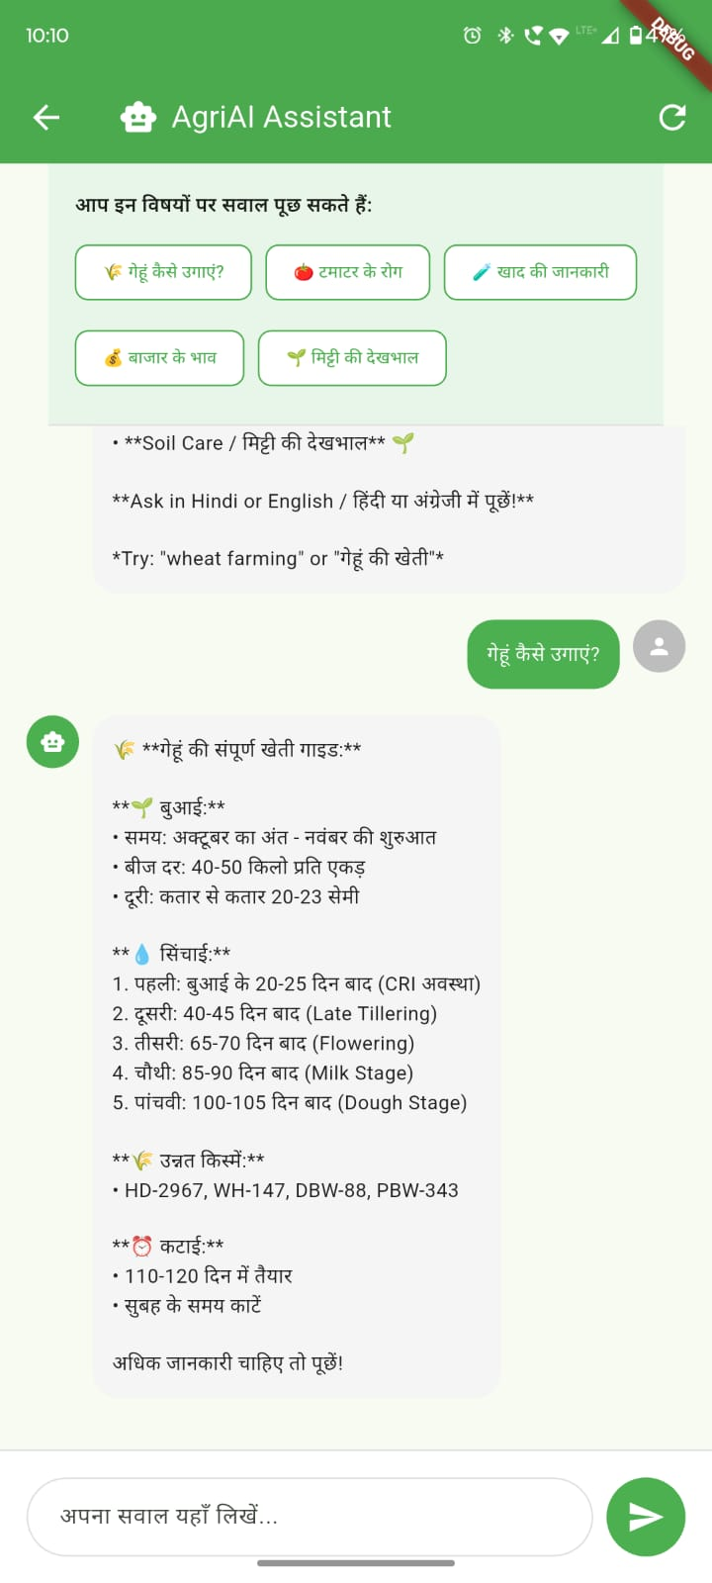
Fig no.5 Suggestion Form AgariAI

E. Comparative Assessment with Existing Solutions
Compared to tools like Plantix, Kisan Suvidha, and Krishi Hub, AgriAI offers unified intelligence with crop prediction, fertilizer optimization, disease detection, weather forecasting, and market alerts in one platform. Its hybrid cloud–edge design, offline capability, and multilingual voice interface provide significant advantages.

V. CONCLUSION
AgriAI’s, a multilingual adaptive voice-controlled user interface for agricultural recommendations, is presented in this paper. By combining multilingual ASR, NLP-based keyword extraction, and adaptive frontend rendering, the system closes usability gaps. It offers individualized, handsfree interaction, supports regional languages, and improves accessibility for users with low literacy. Upcoming projects include increasing product knowledge bases for broader agricultural applicability, optimizing latency on edge devices, and enhancing Marathi ASR accuracy.

REFERENCES
- A. M. Deshmukh and R. Chalmeta, ”User Experience and Usability of Voice User Interfaces: A Systematic Literature Review,” Information, vol. 15, no. 679, pp. 1-23, 2024.
- H. Yadav and S. Sitaram, ”A Survey of Multilingual Models for Automatic Speech Recognition,” in Proc. LREC 2022, Marseille, France, 2022, pp. 5071-5079.
- F. Rakotomalala et al., ”Voice User Interface: Literature Review, Challenges and Future Directions,” System Theory, Control and Computing Journal, vol. 1, no. 2, pp. 65-89, Dec. 2021.
- H. Seki et al., ”An End-to-End Language-Tracking Speech Recognizer for Mixed-Language Speech,” Proc. ICASSP 2018, Calgary, Canada, pp. 4919-4923.
- S. Tong et al., ”An Investigation of Multilingual ASR Using End-to-End LF-MMI,” Proc. INTERSPEECH 2019, Graz, Austria, pp. 2977-2981.
- S. Mani et al., ”Generating Multilingual Voices Using Speaker Space Translation,” Proc. ICASSP 2020, Barcelona, Spain, pp. 7624-7628.
- S. Watanabe et al., ”Hybrid CTC/Attention Architecture for End-to-End Speech Recognition,” IEEE J. Sel. Topics Signal Process., vol. 11, no.
8, pp. 1240-1253, Dec. 2017.
- S. Toshniwal et al., ”Multilingual Speech Recognition with a Single End-to-End Model,” Proc. ICASSP 2018, Calgary, Canada, pp. 49044908.
- V. Pratap et al., ”Massively Multilingual ASR: 50 Languages, 1 Model, 1 Billion Parameters,” Proc. INTERSPEECH 2020, Shanghai, China, pp. 4751-4755.
- C. Senapati and U. Roy, ”Multilingual ASR Model for Kudmali Voice Recognition,” IJCA, vol. 186, no. 1, pp. 1-8, Jan. 2025.
- C. Myers et al., ”Adaptable Utterances in Voice User Interfaces,” Proc. SmartObjects ’18, Montreal, Canada, 2018, pp. 44.
- A. Ramtohul and R. K. Khedoo, ”Adaptive Multimodal User Interface Techniques,” Array, vol. 27, 2020.
- M. Turunen, ”Adaptive Interaction Methods in Speech User Interfaces,” Proc. CHI 2001 Doctoral Consortium, 2001, pp. 91.
- S. Bongartz et al., ”Adaptive User Interfaces for Smart Environments,” Proc. EICS ’12, Berlin, Germany, 2012, pp. 33–38.
- A. Mukherjee et al., ”A LLM-based Voice User Interface for Industrial Machines,” Procedia CIRP, vol. 119, pp. 375–383, 2025.
- P. Gorniak and D. Roy, ”Augmenting User Interfaces with Adaptive Speech Commands,” Proc. IJCAI ’03, Mexico, 2003, pp. 176.
- C. Hemphill et al., ”Speech-Aware Multimedia,” Multimedia, vol. 3, no. 2, pp. 74–81, 1996.
- D. Muffari and M. Villani, ”A Voice User Interface on the Edge for People with Speech Impairments,” Electronics, vol. 13, no. 8, pp. 1–15, 2024.
- C. Oumard et al., ”Implementation and Evaluation of a Voice User Interface with Offline Speech Processing,” Proc. HCII 2022, pp. 1–16.
- J. Hombeck et al., ”Voice User Interfaces for Navigation in Medical Virtual Reality,” Computers & Graphics, vol. 124, pp. 10–22, 2024.
- D. Harihar et al., ”Voice-Based User Interface for Hands-Free Data Entry,” MethodsX, vol. 13, no. 103566, 2025.
- A. S. Alrumayh and C. C. Tan, ”VORF: A Framework for Testing Voice UI Interactability,” High-Confidence Computing, vol. 2, no. 100069, 2022.

