Bolts, Nuts & washers
- Hex Bolts
High-Strength Hexagonal Head Bolts

- Designed for structural, mechanical, and industrial fastening applications.
- Made from premium-grade steel to provide high tensile strength and durability.
- Features a hexagonal head for easy tightening with standard tools.
- Available in multiple grades (5.8, 8.8, 10.9, 12.9) for various load requirements.
- Surface finished with zinc plating or galvanizing for corrosion resistance.
- Ideal for construction, machinery assembly, and metal structures.

- Anchor Bolts
Precision-Built for Heavy-Duty Structural Anchoring

- Used for fixing steel structures, machinery, and columns to concrete surfaces.
- Size: M8 – Length: 100 mm – Hole Size: 12 mm – Drilling Depth: 50 mm.
- Made of high-strength steel to ensure stability and load-bearing capacity.
- Provides secure and durable anchoring in construction and industrial applications.
- Ideal for foundations, metal supports, and mechanical installations.

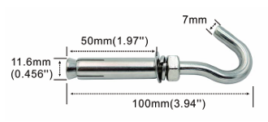
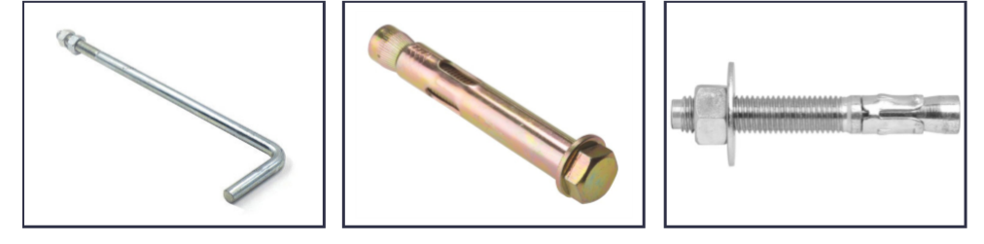

- Hex Nuts & Washers
High-Performance Washers & Nuts
- Complete deep thread design ensures uniform force distribution and prevents slipping.
- Smooth, burr-free surface with high-quality workmanship for strong and durable fastening.
- Standard hexagonal shape — easy to use, install, and tighten.
- Polished surface with high strength and excellent corrosion resistance.
- Superior rust and oxidation resistance for long-term durability.
- Made of premium 304 stainless steel, ideal for home, automotive, and industrial applications.
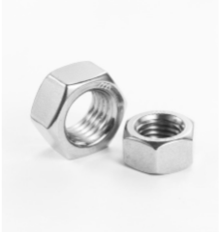
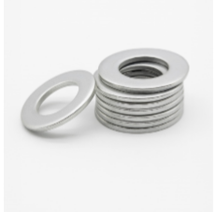

- Spring Nut
Self-Locking Spring Channel Nut
Spring nuts and channel nuts are for use in 8/5-1 strut

- Used with strut channels to fasten metal fittings and equipment securely.
- The spring design holds the nut in position for quick and easy installation.
- Strong metal teeth ensure a firm grip on channel edges for stable connections.
- Made of carbon steel with electro-galvanized coating for corrosion resistance.
- Ideal for electrical, mechanical, and support system installations in buildings and industrial projects.

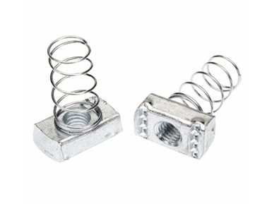

- MILD STEEL THREADED ROD
Precision-Engineered Threaded Rods

- Mild Steel Threaded Rods
- Made from high-quality mild steel for superior strength and durability.
- Available in various sizes from M6 to M64.
- Complies with international standards ASTM, DIN, and ISO.
- Coated for protection — galvanized or anti-corrosion finishes.
- Ideal for construction, industrial fastening, and mechanical systems.

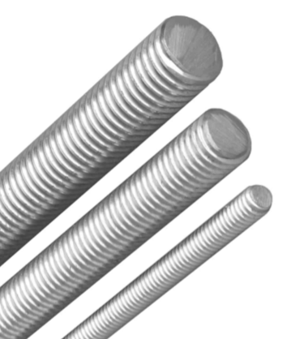
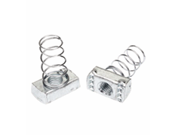

Screws
- Drywall Screws

- Designed for fixing drywall and gypsum boards to metal or wooden frames.
- Features a bugle head that prevents tearing of the board surface.
- Made from hardened steel for high strength and durability.
- Twinfast thread ensures quick penetration and firm holding power.
- Black phosphate coating for corrosion resistance and smooth installation.
- Available in various sizes and lengths for multiple applications.
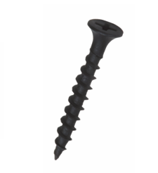

- Self-Tapping & Wood Screws
Versatile Fasteners for Wood and Metal Applications

- Designed for fastening wood, steel, and light structural materials.
- Available with various head types: Pan Head, Countersunk Head, Truss Head, Wafer Head, and Bugle Head.
- Phillips drive for easy installation and strong grip.
- Different thread points (#2, #3, #4, #5) suitable for multiple material thicknesses (2–12 mm).
- Plated surface provides excellent corrosion resistance.
- Ideal for wood-to-metal, sheet-to-frame, roofing, and framing applications.

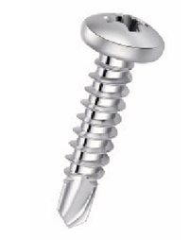

- Nylon frame fixing Screws
Reliable Anchoring Solution for Concrete and Masonry
- Designed for fixing frames, windows, and structural elements into concrete, brick, and solid walls.
- Consists of a high-strength nylon plug and a galvanized screw for firm and secure installation.
- Provides excellent grip and load capacity in solid and perforated building materials.
- Suitable for use in concrete, sand-lime brick, and solid red brick.
- Corrosion-resistant and easy to install with a hammer or screwdriver.
- Ideal for construction, finishing, and frame mounting applications.
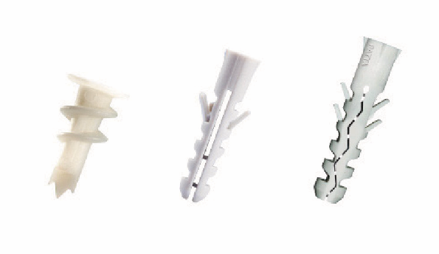

Fixings & Anchors

- Fixing Anchors
Strong and Reliable Fastening Solutions for Concrete and Masonry
- Designed for concrete, brick, and stone applications.
- Available types:
  - Drop-in Anchor: for pipes, ceilings, and fixtures.
  - Shield Anchor: for medium-duty fixing in brick or block walls.
  - Metal Frame Anchor: for light materials like wood and plaster.
  - Bolt Anchor: for heavy-duty use in cracked or solid concrete.
  - Wedge Anchor: for strong, permanent structural fixing.
- Made of high-quality steel with corrosion resistance and high load capacity.
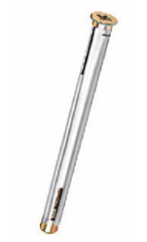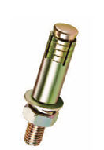
- Fixing Gun
Manual Steel Rivet & Nail Gun
- Designed for quick and secure fastening of nails into steel, concrete, and wooden surfaces.
- Easy to use — simply insert the nail, align vertically, and press firmly.
- Provides high-impact power for strong penetration and precise fixing.
- Suitable for construction, installation, and metal or wood works.
- Durable steel body ensures long service life and consistent performance.

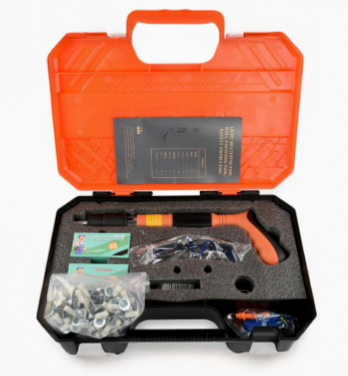

- Cartridges
Steel Nail Cartridges for Fixing Guns

- Designed as replacement cartridges for nail and fixing guns.
- Made of bold stainless steel with fine plating for stability and durability.
- Offers five power adjustment levels for controlled penetration (1st gear = highest power, 5th gear = lowest).
- Provides strong impact, reliable firing, and smooth operation.
- Suitable for use on concrete, steel plates, wooden boards, and brick walls.
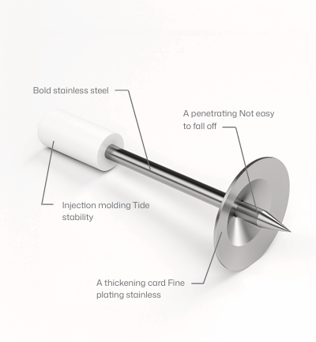

Metal Framing System
- Metal Framming
Galvanized Steel Profiles for Drywall and Partition Systems

- Composed of Runners (horizontal) and Studs (vertical) made of galvanized steel.
- Provides structural stability and alignment for drywall partitions and ceiling systems.
- Runner: fixed to the floor and ceiling to hold the vertical studs.
- Stud: inserted into runners to support gypsum boards.
- Engineered for strength, precision, and easy installation.
- Ideal for commercial and residential wall framing applications.

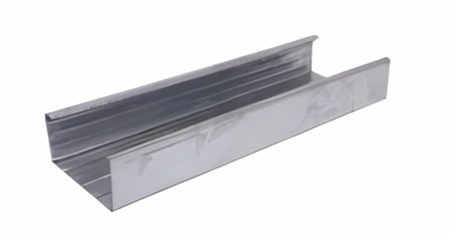
- Marble Angle
Adjustable Bracket for Vertical Marble Installation

- Designed for fixing and aligning marble panels on vertical surfaces.
- Made of high-strength steel for durability and precise adjustment.
- Provides strong support and accurate alignment during installation.
- Ideal for facades, wall cladding, and decorative stone works.
- Corrosion-resistant finish ensures long-lasting performance even in outdoor environments.
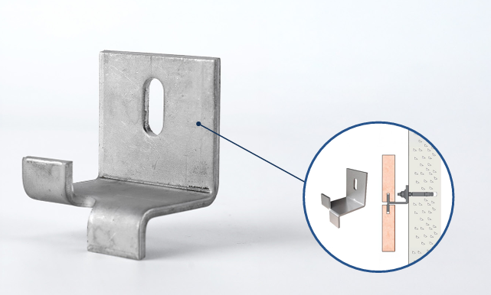

- Block Ladder
Steel Reinforcement for Masonry Stability

- Used between block and brick courses to improve wall strength and stability.
- Helps resist wind loads, reduce cracks from shrinkage or temperature changes, and enhance wall bonding.
- Made from galvanized steel wire for corrosion resistance and long-lasting performance.
- Available in multiple sizes (widths: 50–300 mm, length: 3000 mm).
- Ideal for structural reinforcement in walls and partitions.

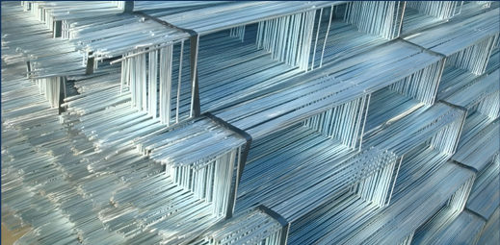

Wire & Mesh
- Wire Mesh
Expanded Metal Mesh for Plaster and Reinforcement

- Used as anti-crack reinforcement in plastering and masonry works.
- Provides strong bonding between plaster layers and enhances structural stability.
- Made of galvanized steel to resist corrosion and ensure durability.
- Suitable for walls, ceilings, and brick/block constructions.
- Available in multiple mesh sizes and lengths for different project needs.

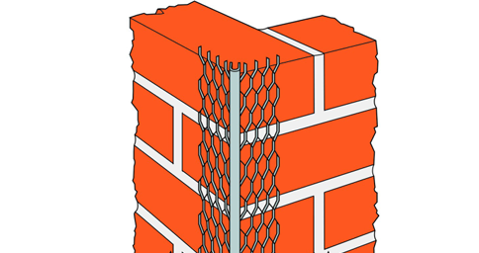

- Binding Wire
Galvanized Steel Wire for Construction Use

- Made from high-quality galvanized steel for superior strength and corrosion resistance.
- Used for tying and securing reinforcement bars, mesh, and other construction materials.
- Offers excellent flexibility and durability in harsh site conditions.
- Commonly supplied in 7 kg coils and available in multiple gauges (12–22).
- Ideal for masonry, concrete, and general construction applications.

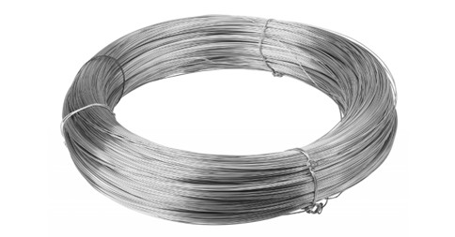

- Wire Clip
Galvanized V-Clip Ceiling Connector

- Made of galvanized steel wire for use in drop ceiling assemblies.
- Designed in a V-shape to connect metal furring channels securely.
- Provides strong support and alignment between ceiling components.
- Ensures easy installation and long-lasting structural stability.
- Ideal for suspended ceilings and drywall framing systems.

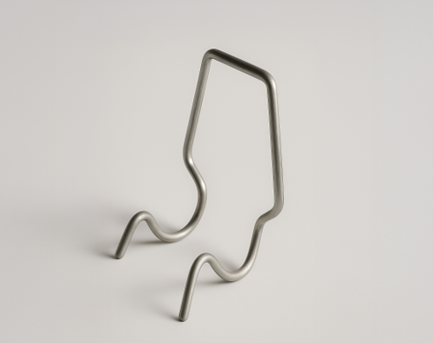

Measuring Tools
- Sola
High-Precision Spirit Levels for Professional Use
- Manufactured by SOLA, a leading brand in precision measuring instruments.
- Designed for accurate alignment and leveling in construction and finishing works.
- Made of aluminum box profile, red epoxy coated for durability and visibility.
- Features one horizontal and one vertical vial made of unbreakable acrylic block.
- Provides maximum measuring accuracy:
  - Standard position: ±0.5 mm/m
  - Inverted position: ±1.0 mm/m
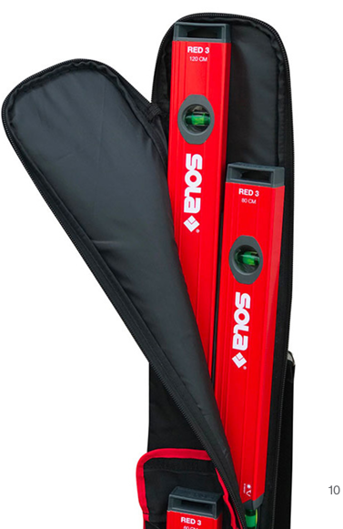
- Comes with shock-absorbent end caps and 30-year leakage warranty on vials.

- KEDAS Cutting & Grinding Discs
High-Performance Discs for Fast and Precise Cutting
- Designed for hard steel, sheet steel, structural steel, and tool steel.
- Made from aluminum oxide with resin bonding for long service life and high productivity.
- Provides extremely fast cutting with consistent performance.
- Certified according to EN 12413 for safety and quality.
- Ideal for industrial, construction, and metal fabrication applications.

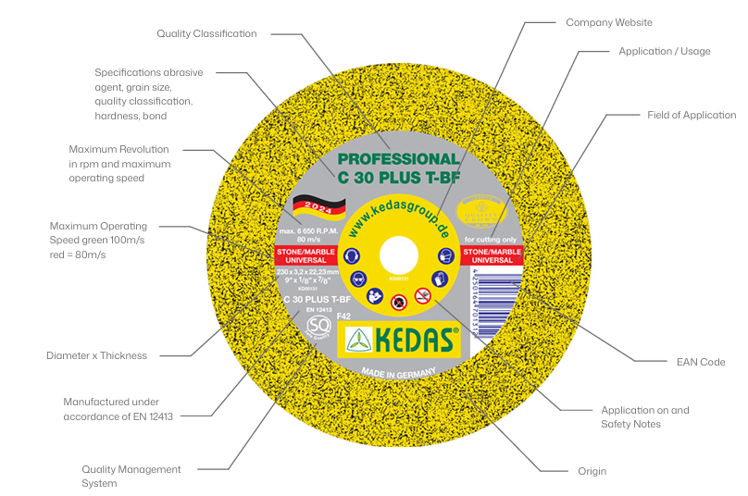

- ORBOFIX Tile Leveling System
Professional System for Perfect Tile Alignment
- Designed to ensure even tile spacing and perfect leveling during installation.
- Includes tile clips and wedges for maintaining consistent joint width.
- Prevents uneven surfaces, lippage, and misalignment between tiles.
- Made from durable plastic with uniform thickness for easy tightening.
- Ideal for ceramic, porcelain, and marble tile installations.
