**Utah Lake Groundwater**

The estimated groundwater contribution to Utah Lake was based on published USGS groundwater modeling studies. The USGS reports broke up Utah Lake Valley into northern and southern portions.

Northern Utah Valley groundwater estimates from Cederberg et al. 2009. From Table 4, estimated mean annual (1975-2004) groundwater inflow to Utah Lake is 25,500 ac-ft/yr.

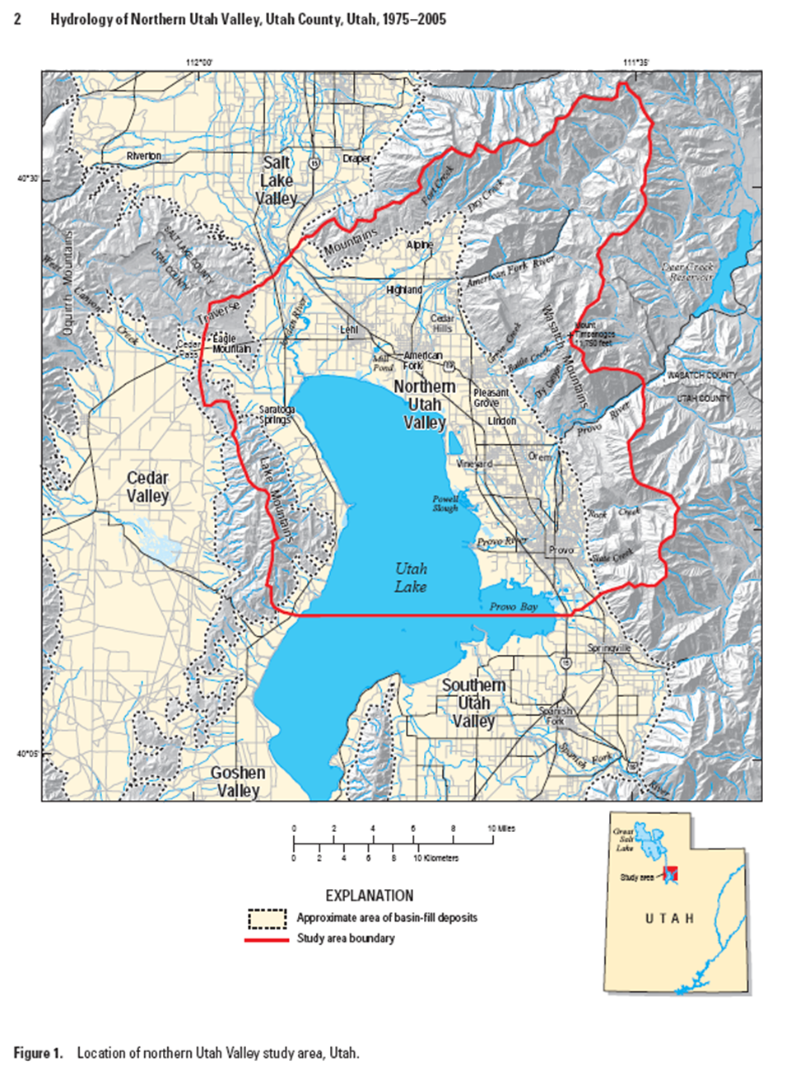  
Source: Cederberg et al. 2009

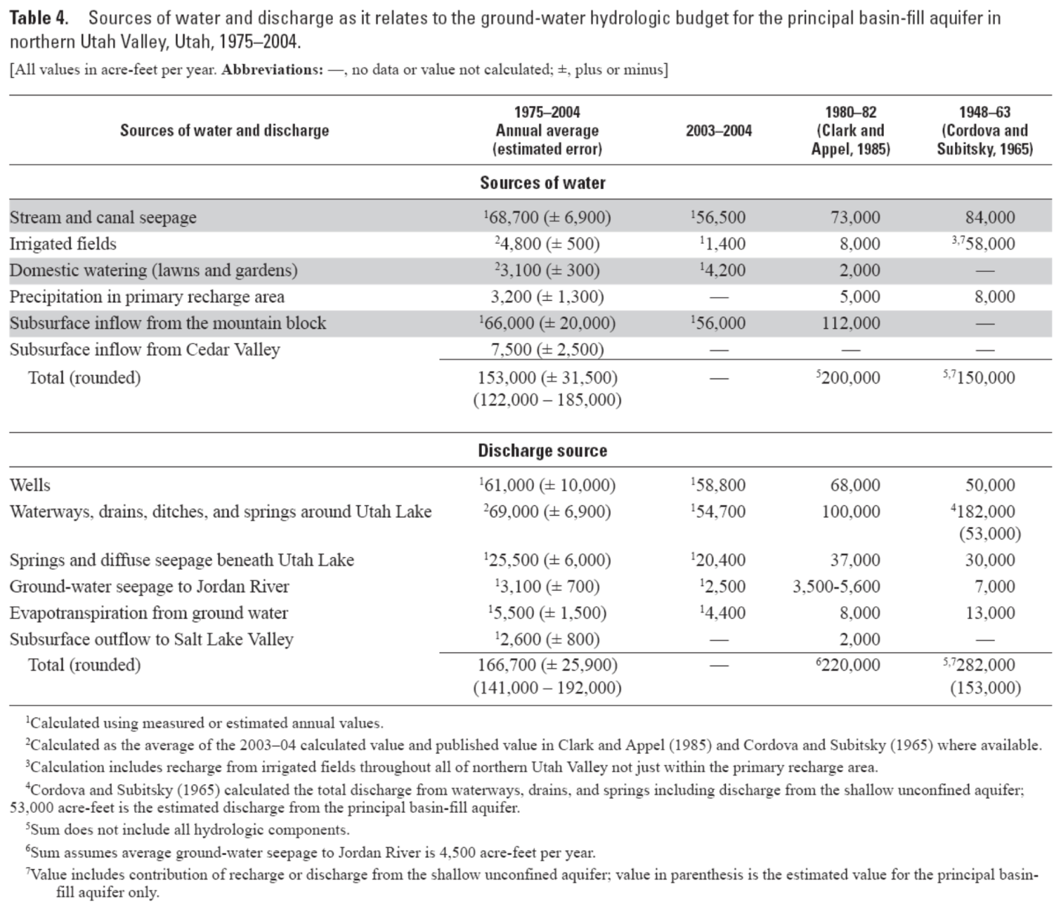 Source: Cederberg et al. 2009

Southern Utah Valley groundwater estimates from Brooks and Stolp 1995 and Brooks 2013. From Table 1, estimated mean annual groundwater inflow to Utah Lake is 9,600 ac-ft/yr and to Goshen Bay is 3,600 ac-ft/yr.

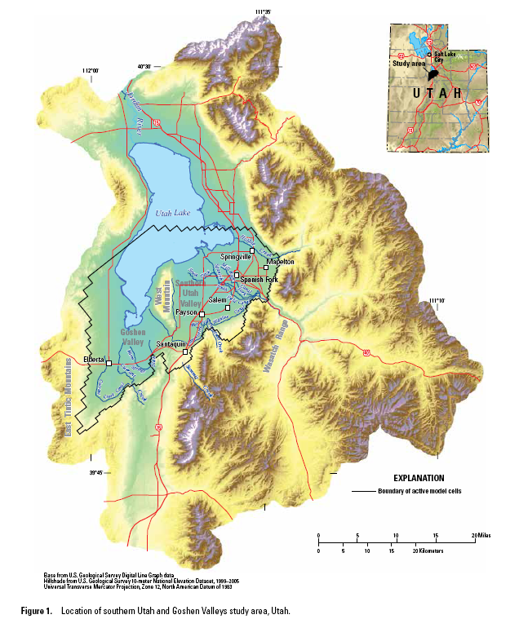  
Source: Brooks 2013

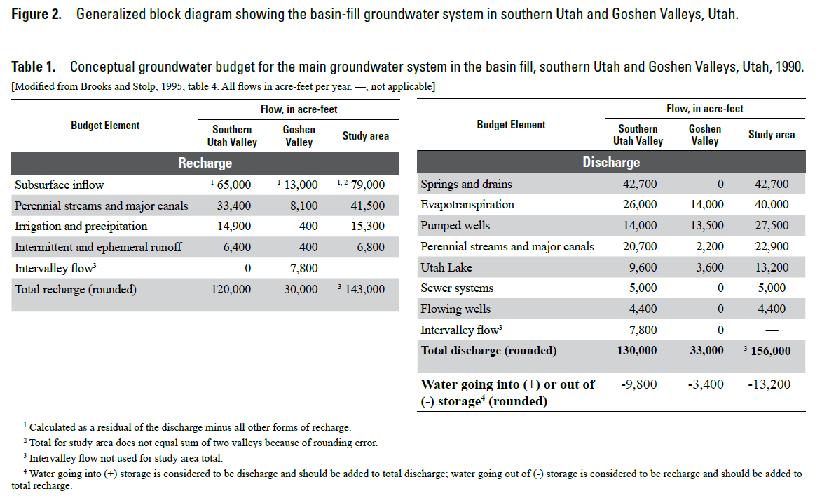Source: Brooks 2013

Total mean annual groundwater discharge to Utah Lake is estimated to be 38,700 ac-ft/yr.

From Appendix A of LKSIM User’s Manual 2008 Version, the LKSIM model of Utah Lake includes the following groundwater inputs : *For the 1950-1999 period, fresh groundwater inflows averaged 74,025 ac ft/yr as shown in Table A-3. As shown in Table A-4 total mineralized inflow averages 24,525 af/yr for the 1950-1999 period. For the mineral inflows, about 10,000 af/yr is issuing from exposed shoreline springs or from identified underwater orifice areas, the remaining 17,100 af/yr occurs in non-measurable seeps and springs, largely in the bed of the lake.*

Therefore, the LKSIM estimate of total groundwater is approximately 98,550 ac-ft/yr, or 59,850 ac-ft/yr greater than the USGS estimate.

**Utah Lake Water Balance**

A monthly water balance for Utah Lake was calculated for water year 2006-2018. based on the following equation:

With, *QI* = total inflow (m3)  
 *ΔS* = change in storage (m3)  
 *QO* = outflow (m3)  
 *ET* = evapotranspiration (m3)  
 *P* = precipitation (m3)

The stage-storage-surface area table for the EFDC grid was developed using the Storage Capacity Tool in ArcGIS ArcMap 10.5 Spatial Analyst extension. Lake elevation data was obtained from UDWR under the “Utah Lake Storage Content (Gage Reading)” station name. The monthly change in storage (*ΔS*) was then calculated by using the lake elevation data to determine the storage content based on the stage-storage table for the EFDC grid.

The precipitation volume, *P*, and evapotranspiration volume, *ET*, were calculated by multiplying the *P* and *ET* depth by the lake surface area obtained from the stage-surface area table. The precipitation depth measured at the Provo BYU station was reduced to reflect that less rain falls on the lake relative to the east bench along the Wasatch Mountains. Using ArcGIS, the mean annual precipitation over Utah Lake was calculated using the Utah Lake boundary and PRISM 30-year normal (1981-2010) raster data. The precipitation measured at the Provo BYU station was then adjusted by the ratio of the mean annual precipitation over Utah Lake to the mean annual precipitation at Provo BYU station (0.705). The Priestley-Taylor method was used to estimate evapotranspiration depth from Utah Lake.

Utah Lake has only one outflow location to the Jordan River. The Utah Division of Water Rights publishes outflow records for Utah Lake which were used to determine outflow, *Qo*,.

1. For 9/1/2005-12/31/2008, monthly flow records for “Utah Lake Outflow” were used.

2. For 1/1/2009-9/30/2018, daily flow records for “05 Jordan Narrows (Total)” were used.

With all of the terms on the right hand side of the water balance equation, the total inflow to the lake was calculated, *QI.* The total inflow can be further subdivided into the following components:

With, *QI* = total inflow (m3)  
 = groundwater inflow (m3)  
 *QWW* = treated wastewater inflow (m3)  
 = gaged surface inflow (m3)  
 = ungaged surface inflow (m3)

Only two of the surface inflows were actively gaged during the period: Provo River and Hobble Creek. The flows from the wastewater treatment plants (WWTP) were based on monthly Discharge Monitoring Reports (DMR) submitted to Utah Division of Water Quality (UDWQ). Constant mean annual rates were used for the groundwater inputs, based on estimates published by the USGS. All other surface water, stormwater, and irrigation return flows were ungaged and unknown during the period.

**Utah Lake Flow Volumes (ac-ft)**

|  |  |  |  |  |  |  |  |  |  |
| --- | --- | --- | --- | --- | --- | --- | --- | --- | --- |
| **Water Year** | **Inflows** | | | | | | **Outflows** | | |
| **WWTP** | **Ground-water** | **Gaged Surface** | **Ungaged Surface** | **Precip** | **Inflow Total** | **Jordan River** | **Evap** | **Total Outflow** |
| 2006 | 51,023 | 38,682 | 199,825 | 346,141 | 104,688 | *740,358* | 303,760 | 335,193 | *638,953* |
| 2007 | 51,416 | 38,682 | 136,990 | 151,791 | 74,998 | *453,877* | 235,100 | 320,490 | *555,590* |
| 2008 | 54,884 | 38,788 | 125,067 | 192,191 | 74,067 | *484,998* | 172,200 | 298,180 | *470,380* |
| 2009 | 59,694 | 38,682 | 186,898 | 274,645 | 109,107 | *669,026* | 267,298 | 299,927 | *567,225* |
| 2010 | 58,463 | 38,682 | 119,003 | 207,948 | 83,297 | *507,394* | 280,623 | 314,165 | *594,788* |
| 2011 | 63,665 | 38,682 | 425,952 | 468,173 | 148,767 | *1,145,239* | 589,183 | 333,138 | *922,321* |
| 2012 | 57,291 | 38,788 | 157,922 | 148,410 | 59,316 | *461,726* | 423,397 | 329,905 | *753,301* |
| 2013 | 57,053 | 38,682 | 71,998 | 151,346 | 69,980 | *389,060* | 159,943 | 300,383 | *460,326* |
| 2014 | 57,461 | 38,682 | 71,986 | 136,355 | 88,049 | *392,534* | 164,238 | 289,574 | *453,812* |
| 2015 | 54,967 | 38,682 | 64,875 | 116,905 | 79,065 | *354,494* | 142,605 | 286,916 | *429,521* |
| 2016 | 54,838 | 38,788 | 64,505 | 105,238 | 70,172 | *333,542* | 129,295 | 277,539 | *406,834* |
| 2017 | 54,556 | 38,682 | 262,324 | 205,972 | 88,715 | *650,249* | 126,110 | 331,444 | *457,554* |
| 2018 | 52,494 | 38,682 | 103,336 | 87,255 | 45,803 | *327,571* | 145,961 | 256,751 | *402,712* |
| Mean | 56,432 | 38,711 | 147,729 | 209,013 | 87,410 | *539,295* | 260,695 | 307,764 | *568,459* |

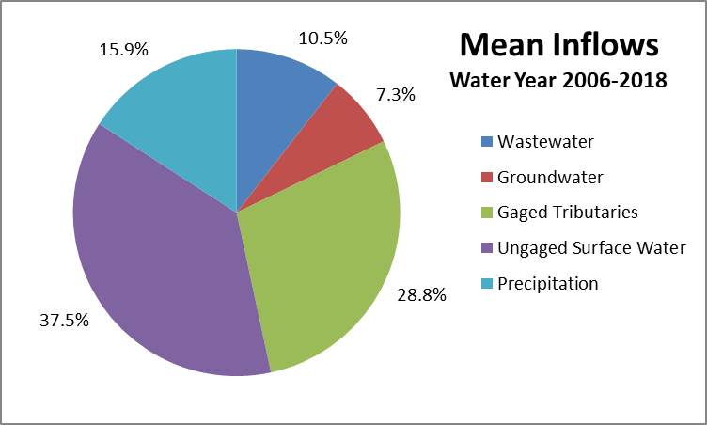

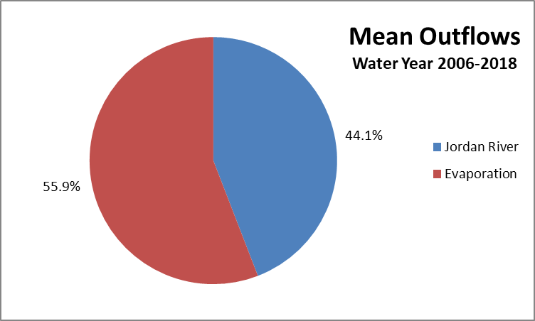

**References**

Brooks, L. E. and Stolp, B. J. 1995. Hydrology and Simulation of Ground-water Flow in Southern Utah Valley and Goshen Valley , Utah United States Geological Survey.

Brooks, L. E. 2013. Evaluation of the groundwater flow model for southern Utah and Goshen Valleys, Utah, updated to conditions through 2011, with new projections and groundwater management simulations. United States Geological Survey.

Cederberg, J. R., Gardner, P. M. & Thiros, S. A. 2009. Hydrology of Northern Utah Valley, Utah County, Utah, 1975-2005. United States Geological Survey.