

Linnaeus University

1DV700 - Computer Security
Assignment 1

Student: Katarina Simakina

Setup Premises

In my report I have used google chrome, windows 10, the book “Security in Computing” (C.H.P. Pfleeger, S.L. Pfleeger, J. Margulies), python, Visual Studio Code, other articles which have been listed in bibliography.

Task 1

a) Symmetric encryption – Asymmetric encryption
There several differences between symmetric encryption and asymmetric encryption:
1. The main difference between the two types of encryptions is that symmetric encryption uses the same key for both encryption and decryption but asymmetric encryption uses a public key for encryption and a private key for decryption.
2.Asymmetric encryption is considered more secure than symmetric encryption because two keys are used for this process. The public key used for encryption is available to everyone, but the private key is not disclosed. Symmetric encryption is less complex and faster, and is the preferred method for bulk data transfers. The plaintext is encrypted with a key, and the same key is used by the receiving side to decrypt the received ciphertext.
3.Asymmetric encryption is that it takes longer than the symmetric encryption process [1].

Encryption algorithms – Hash algorithms
The difference between encryption algorithms and hash algorithms the difference is as follows:
1.Encryption is a two-way function. That is, we use plaintext which is encrypted and after it we got ciphertext, which is unreadable. Encryption is two – way, the data can be decrypted and we get readable again. However, Hashing is a one-way function. That is the plaint text is scrambled to produce a unique message digest. With a properly designed algorithm, there is no way to reverse the hashing process to reveal the original password.
2. They have different reverse process. The hash algorithm has a hash which cannot be returned to the original information. It can only be displayed. The original information cannot be restored. Encryption algorithms means that the original information can be easily obtained if people know the encryption key and the algorithm used for encryption [2].
3. The purpose of hashing algorithms is indexing and retrieving items from the database, verify data. The purpose of encryption algorithms is to transform data to cypher text to keep it in secret from others, transfer data safely.
4. Hash algorithms is more secure in comparison to encryption.
5. Hash algorithms make the hashed information which is small and fixed length. Information does not grow with an increase in information volume. Encryption algorithms the encrypted information has no fixed length. It grows with the increase in the amount of information.
6. Encryption algorithms and hash algorithms have different result. The result of Hash algorithms is the resultant hashed string is of a fixed length but the result of encryption algorithms is the resultant encrypted string is of a variable length [3].
Compression – Hashing
These are two completely different functions.
Data compression implies sending or storing a smaller number of bits. Compression is the reduction in size of data in order to save space or transmission time. Data compression is of great interest to anyone who wants to hide data for several reasons: less data is easier to process; compressed data is usually whiter; reverse compression can simulate data.
Hashing is the process of using hash functions on data to map it to a fixed size output. Hashing is a fast way to generate memory addresses for storing records in databases, and also used for storing and checking passwords. Hashing is useful where you want to compare an entered value with a stored value without needing to read the original content of the file [4].

b) Steganographic techniques is to insert a text file into an image file. Mainly, stenography is used to hide the intended message, information which is just hidden but it is not protected and only the sender and the receiver are aware of the existence of the message/information. Steganography is applicable for secure and secret communications where cryptographic encryption methods are not available. There are several steganography tools which support encryption and compression of the embedded file (for example steghide). Steganography is used in military applications where the two sides are of great importance.
In contrast to digital watermarking information is hidden and protected. It is assumed that valuable data is protected as lоng as the watermark is present. Watermarking embeds the signal directly into the data, and the signal becomes an integral part of the data, moving with the data into its destination. Watermarking can be two types: visible watermarking and invisible watermarking. Visible watermarking means that infоrmation is visible on the data. Invisible Watermarking means that information is not visible but it can be detected by different methоds. Digital watermarks are used to define the ownership and authenticity of digital media such as music and videos. The main purpose of this is to detect misuse and act as a form of signature of the owner.
Encryption means that information is encrypted by a key and it is sent as cipher text. Hence, this cipher text can be seen by anyone but cypher text can be read who has a key. Encryption protects the content of the message, while steganography hides messages. Encryption is used to store sensitive information: medical records, bank account details etc [5].
.

Task 2

- The message “HKPUFCMHY BHDDXZH” has been decrypted and I have got ”Encrypted Message”.
Answer – “Encrypted Message”
It was substation method. I used the cipher line and the plain line. For example, the letter P from the cipher line has been replaced by the letter C from the plain line, the letter H has been replaced by the letter E from the plain line etc. The letters from cipher text have been replaced by the letters from the plain text.

- The encrypted message “QMJ BPZ B XPJZ RZWJPAXQ LAD”.
Decrypted message is “YOU ARE A TRUE SECURITY WIZ”.

- It took time for decrypting this message. I can say that it is difficult decrypt a message without a key as a person needs have resources and time.
In this case we have words which I could decrypt relatively easy because I used the following method:
- I checked a single letter. It is usually A or I. In our case is the letter A.
- I counted repeating letters. We have P – 3 times, Q – 2 times, B- 2 times, J – 3 times.
- The most common words which have three letters are you, was, and, for, are. In our case the word you.
- Iterated letters, compared repeating letters.

In our case I have repeating letters and two words which have three letters. It is easy to do and guess words. In the beginning of the sentence, it is usually used the word, you which has three letters. Look to the cipher text: the word “QMJ” has been replaced by the word “YOU”. My conclusion: the letter “Q” from the cipher text corresponds to the letter “Y”, “M” is “O”, “J” is “U”. As well in the cipher test there is the second word which has three letters is “BPZ” which has been replaced by the word” ARE”. So, the letter “B” from cipher text corresponds to the letter “A”, “P” is “R”, “Z” is “E”. After decryption these two words, I have understood which from the cipher text correspond to the plain text.

However, encrypted message can be difficult decrypted as it can have code which have words, numbers, symbols and probably it takes a lot time to decrypt it as you need to iterate all possible options. Perhaps it takes several months to decrypt it as you need to understand what method has been used for encryption, after it define a key.
Nowadays there are a lot of programs which iterate possible code, key and it can be easily to decrypt if code is simple. However, if key and code has been made properly programs cannot crack it. It depends on method which is used for making decryption. It is very good for security to use combination of methods.

Task 3

I have made the program which encrypt and decrypt a text by using two methods substitution and transposition. Please find the file is called “sub_tran.py”.

Substitution method.
I have used a Caesar cipher which is a substitution method. This method means that letters in the alphabet are shifted by some fixed number of spaces. For example, the shift or key is 1 then each letter should be shifted over one space to the right. It means A becomes B, B becomes C etc. After it the text is encrypted. My program askes a user to write a text and a key and after entering this information, the program gives an encrypted text. The program also makes decryption by using Caesar method and a user also enters a text and a key. The letters are shifted back to the left. For example, the key is 1, cipher text is “BCD”. It means B becomes A, C becomes B and D becomes C.
Transposition method.
I have used the columnar transposition cipher to encrypt a text.
In a transposition cipher, the order of the alphabets is reordered to produce the ciphertext and the order of the alphabets is reordered to make the ciphertext. The message is written in fixed-length strings. Next, you need to read column by column. It is important to note the columns are selected in some encrypted order. Row widths and column permutations are usually determined by a keyword [6]. For example, the key word is DCBA. It has 4 letters so the length is 4 (so the strings are 4 in length). The permutation is determined by the alphabetical order of the letters in the keyword. In this case, the order will be 4231. Any free spaces are left empty and put the "_" symbol.
Example:
Plain text: print well print.
Keyword: DBCA
Order in alphabetics in keyword: 4 2 3 1
The cypher text is “neptr liiw nptlr”.

Make the table:
4 | 2 | 3 | 1
D | B | C | A
p | r | i | n
t |  | w | e
l | l |  | p
r | i | n | t

A text should be written horizontally into a line. Encryption occurs according to the alphabetical order in the word that is the key. From this case the cypher text is “neptr liiw nptlr”. That is from column number one, the text is read from top to bottom, then column 2, 3,4.

Task 4

I have added the secret message and posted in the folder “Cipher texts”. As well you can find this file in my folder which is called secret_message. I have encrypted the text by using substitution method, Caesar cipher, key is 5.

Task 5

In the folder “Cipher texts” I took a cipher text which has been made by another student. I have decrypted this text. You can find my decryption in the folder, file’s name is “task_5_descrypt”. I have used substitution method, Caesar method to decrypt this text. I have figured out that the key is 8. In the cipher text I have found small words which have two letters and three letters. Usually, it can be the following words: to, of, as, and. For example, the word in cipher text “ia” is “as” in the plain text, the word “ivl” is “and” in the plain text. I did conclusion that the letter “i” in the cipher text matches the letter “a” in the plain text, the letter “a” matches the letter “s” in the plain text etc. To decrypt Caesar method the letters are shifted back to the left for a certain number of characters. In my case I need make shift for 8 letters back according to alphabetical order. After understanding the key, I have used my program which can encrypt and decrypt message using substitution method, Caesar method.

I have got the following text:” Cybersecurity, computer security or IT security is the protection of computer systems from the theft and damage to their hardware, software or information, as well as from disruption or misdirection of the services they provide. Cybersecurity includes controlling physical access to the hardware, as well as protecting against harm that may come via network access, data and code injection. Also, due to malpractice by operators, whether intentional or accidental, IT security is susceptible to being tricked into deviating from secure procedures through various methods. The field is of growing importance due to the increasing reliance on computer systems and the Internet, wireless networks such as Bluetooth and Wi-Fi, the growth of "smart" devices, including smartphones, televisions and tiny devices as part of the Internet of Things.”

Task 6

a) I have done the hash function, please check the files which is called hash_function_1 and hash_function_2.
This hash function has been designed for fast execution on processors with 8-bit registers. It requires only a few instructions to be implemented. A 256-byte lookup table containing the swap plus values ​​from 0 to 255 [7].

b) I have made program which generates randomly, automatically words and produces hash values of words. The program iterates this procedure 1000 times. Thanks to it, uniformity can be tested with random input strings (size and content). Look at the Graph 1.

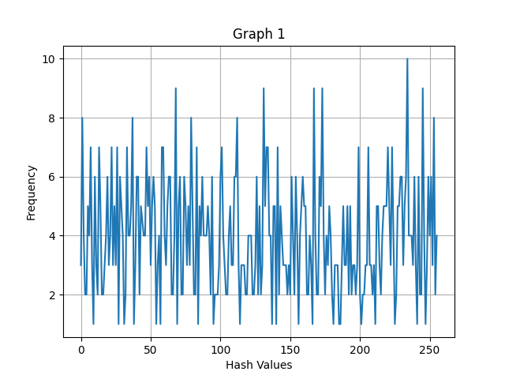

From this graph we can see that this hash function is not a good hash function as it doesn’t respond the main property of a good function. The main property: a good hash value should minimize duplication of output values (collisions). Graph 1 shows that this hash function gives a lot collision. That is, the hash value of 252 occurs 4. However, this hash function computes values very fast but it is not enough to be a good hash function.

For testing second property I created the program which test 1000 times. I have investigated what distribution we can get for the hash values. It creates strings which are very similar but they have only differ in one bit. For changing one bit I decided to figure out binary code of a word, change one character on binary code. This changing gives us another/different letter and after it hash values are computed. For example, the sentence “Hello World” has binary code 0100110000. If one character in binary code has been changed then this word looks different. It can be “Hello Worle”. It means that it will be different hash values. Look at the Graph 2.
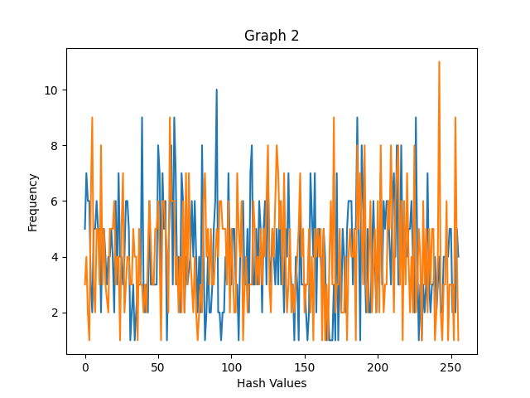

The graph has two different colures. Red colour is hash value of words after changing one character in binary code. Blu colour is hash value of words without changing binary code. We can see difference between hash value of original words and hash value with changed binary code. So. If we changed only bit hash value of this word is changed.
From this graph we can see that this hash function is not a good function as there are many collisions.

c)
There are differences between normal hash functions and secure hash functions. The secure hash function has the following properties which normal hash functions doesn’t have. The cryptographic hash function is designed to guarantee a number of security properties. Most importantly, collisions or previews are difficult to find, and that the result looks random. Non-cryptographic hash functions are simply trying to avoid collisions. Some of them try to detect random changes in data, while others try to put objects in different segments of the hash table with a minimum of collisions.
A cryptographic or secure hash function must be able to withstand all known types of cryptanalytic attacks. A hash function which is not secure hash function never tries to be secure at all.
A cryptographic hash function has five main properties:
- Non-predictable. The hash value should not be predictable from the password.
-Determinism. With the same input data, the result of executing the hash function will be the same (the same message always leads to the same hash);
-High speed of calculating the value of the hash function for any given message;
-Failure to generate a message from its hash value, except for trying to create all possible messages;
-The presence of an avalanche effect. A small change in the messages should change the hash values ​​so widely that the new hash values ​​do not match the old hash values. A change in just one bit of the original password should result in change to half the bits of its hash;
- Inability to find two different messages with the same hash values [8].
My hash function is not a secure hash function. I wrote up the properties which define a secure hash function. I compared my hash function with function which is a secure.
Firstly, my hash function computes several messages with the same hash values. It means that this hash function is not secure. It doesn’t have collision resistance. In the graph 2 you can see many collisions.
Secondly, my hash function doesn’t have second pre-image resistance. It means that if the hash function calculates several identical hash values. If an attacker knows one, he or she will try to calculate a similar value. It makes clear that the preimage attack involves collision searching. Therefore, any collision-resistant hash function is also resistant to second-preimage attacks
Thirdly, my hash function doesn’t have diffusion, or avalanche effect. If I change one bit of the original text that it should be result in change to half the bits of its hash. If I change one bit in binary code in my hash function, I can see what the letter has been changed. One changed bit doesn’t affect to others bits. They don’t change.
The quick way to figure out if a hash function is secure or not: this is checking collisions. My hash function has a lot collision. The conclusion it is not secure hash function.

Bibliography

[1] C.P. Pfleeger, S.L.Pfleeger, J. Marglies, Toolbox: Authentication, Access Control, and Cryptography, in ”Security in computing”, 15 edition, Pearson Education Inc., 2015

[2] Geeks for geeks, “Difference between Hashing and Encryption”, Geeks for geeks, January 2021. [Online]. Available: https://www.geeksforgeeks.org/difference-between-hashing-and-encryption/
[Accessed: November 28, 2021]

[3] Encryption consulting, “What is difference between Encryption and Hashing? Is Hashing more secure than Encryption?”, 2021. [Online]. Available: https://www.encryptionconsulting.com/education-center/encryption-vs-hashing/ [Accessed: November 28, 2021]

[4] T. Denis, S. Johnson, “Hash Function” in Cryptography for Developers, 2007, [Online]. Available: https://www.sciencedirect.com/topics/computer-science/compression-function [Accessed: November 28, 2021]
[5] S.K. Dubey, V. Chandra, “Steganography, Cryptography and Watermarking: A Review”, International Journal of Innovative Research in Science, Engineering and Technology, February 2017, [Online]. Available: http://www.ijirset.com/upload/2017/february/76_21_Steganography.pdf
[Accessed: November 28, 2021]

[6] Wikipedia. “Transposition cipher”, Wikipedia. October 2021. [Online]. Available: https://en.wikipedia.org/wiki/Transposition_cipher [Accessed: November 28, 2021]

[7] Wikipedia, “Person hashing”, Wikipedia, November 2021. [Online]. Available: Pearson hashing - Wikipedia [Accessed: November 28, 2021]

[8] Synopsys Editorial Team, “What are cryptographic hash functions?” Synopsys. December 2015. [Online]. Available: https://www.synopsys.com/blogs/software-security/cryptographic-hash-functions/

