Ekaterina Smirnova

Software developer

[Адрес организации]

JavaScript/React Portfolio

1.Weather App.

Weather Today is a simple weather application built with HTML, CSS, and JavaScript. It allows users to search for the current weather in any city and displays relevant weather information, including temperature, humidity, wind speed, and weather conditions.

This is an App utilizing Open API.

Available at: <https://github.com/KaterinaSmi/JavaScript_Portfolio/tree/main/weather-app>

2. React Movie Library. Cinematica

Available at: <https://github.com/KaterinaSmi/Movie_Library>

This project is a React-based web application designed to display various movie and TV show information. It utilizes React Router for navigation and Material UI for the UI components. The application has the following features:

1. Header Component: Contains a navigation bar with links to different pages such as "Home," "Now Playing," "Popular," and "TV Shows." The navigation adapts to different screen sizes by using a responsive drawer menu on smaller screens.
2. Pages:
   * Home: The main landing page for the application.
   * Now Playing: Displays currently playing movies or TV shows.
   * Popular: Shows a list of popular content.
   * TV Shows: Dedicated page for TV shows.
3. Routing: The app uses react-router-dom for routing, allowing users to navigate between the pages. The navigation menu is accessible via a drawer on smaller screens and as a horizontal bar on larger screens.
4. Responsive Design: The app is responsive, adapting the layout based on screen size, ensuring usability on both desktop and mobile devices.
5. Material UI: UI components are styled using Material UI, including buttons, icons, and layout components, offering a modern and clean design.

This app serves as a movie and TV show information hub, providing users with easy navigation and an intuitive user interface.

3.NASA APOD (Astronomy Picture of the Day)

This project fetches the Astronomy Picture of the Day (APOD) from NASA's API and displays it on a webpage. The app includes an interactive sidebar that shows detailed information about the image of the day.

**Technologies Used**

* **React**: Frontend framework for building the user interface.
* **CSS**: For styling the application and creating responsive layouts.
* **NASA API**: To fetch the Astronomy Picture of the Day (APOD) data.
* **localStorage**: For caching API data to improve load times.

Available at: <https://github.com/KaterinaSmi/NASA_Project>

4.Basketball counter app. For school basketball matches, for players’ parents, and for those who stayed home on the day of the game but want to follow.

Readme available at GitHub: <https://github.com/KaterinaSmi/Basketball-counter/blob/main/README.md>

Main functionality: Increment and decrement buttons for both teams, table of players with possibility to add new lines, time and location.

The index page looks like:

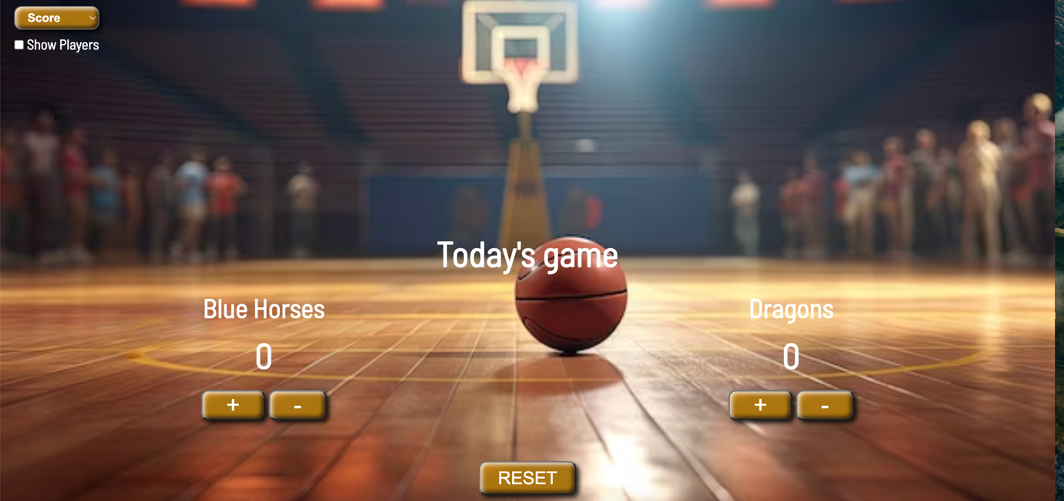

**Animation Project:**

This project creates a basic animation of a swarm of enemy sprites on an HTML canvas using JavaScript. It demonstrates the use of object-oriented programming principles, sprite-based animation, and frame-based updates to create dynamic movement and behavior for multiple objects.

Key Components :

-*HTML5 Canvas*: The project uses a canvas with a defined width and height as the drawing surface for all animations.

-*JavaScript:* The primary language used to create and manage the animations and behavior of enemy objects.

-*Enemy Class:* Defines a blueprint for creating individual enemy objects, including properties such as position, size, sprite frame, speed, and behavior.

-*Sprite-Based Animation:* The enemy sprites are derived from a single sprite sheet, with logic to manage the frame-by-frame animation.

-*Dynamic Behavior:* Enemies move with randomized behavior, including random movement and variable flap speeds, creating a more organic animation.

There are more animation projects available at GitHub:

Other projects are available at GitHub: <https://github.com/KaterinaSmi/JavaScript_Portfolio>