Ekaterina Smirnova

Software developer

[Адрес организации]

JavaScript Portfolio

1.Weather App.

Weather Today is a simple weather application built with HTML, CSS, and JavaScript. It allows users to search for the current weather in any city and displays relevant weather information, including temperature, humidity, wind speed, and weather conditions.

This is an App utilizing Open API.

Available at: <https://github.com/KaterinaSmi/JavaScript_Portfolio/tree/main/weather-app>

2.**Basketball counter app**. For school basketball matches, for players’ parents, and for those who stayed home on the day of the game but want to follow.

Readme available at GitHub: <https://github.com/KaterinaSmi/Basketball-counter/blob/main/README.md>

Main functionality: Increment and decrement buttons for both teams, table of players with possibility to add new lines, time and location.

The index page looks like:

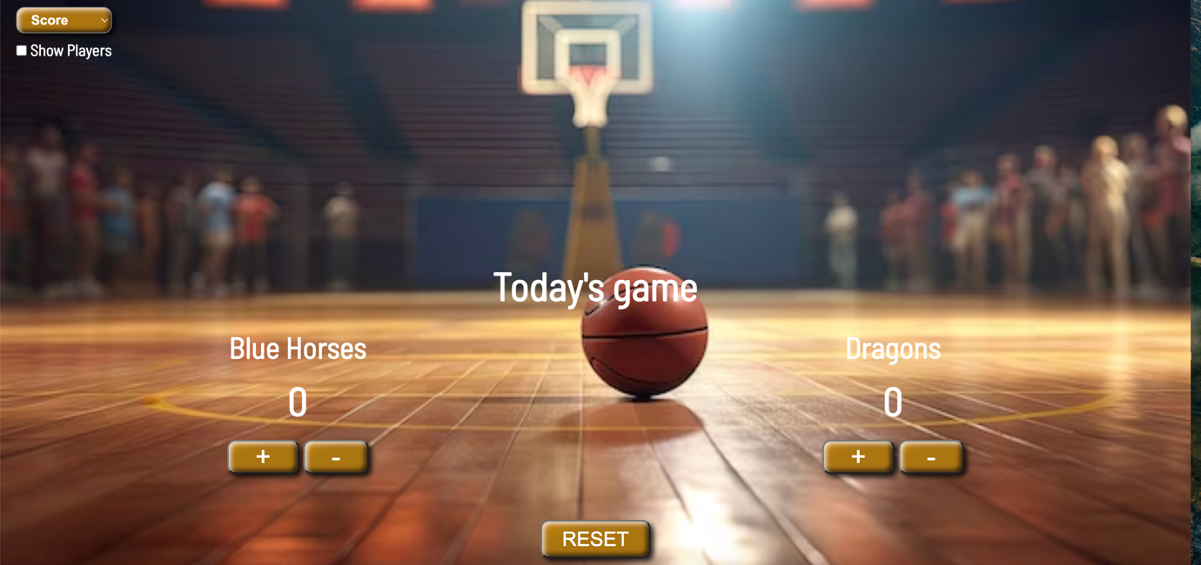

**Animation Project:**

This project creates a basic animation of a swarm of enemy sprites on an HTML canvas using JavaScript. It demonstrates the use of object-oriented programming principles, sprite-based animation, and frame-based updates to create dynamic movement and behavior for multiple objects.

Key Components :

-*HTML5 Canvas*: The project uses a canvas with a defined width and height as the drawing surface for all animations.

-*JavaScript:* The primary language used to create and manage the animations and behavior of enemy objects.

-*Enemy Class:* Defines a blueprint for creating individual enemy objects, including properties such as position, size, sprite frame, speed, and behavior.

-*Sprite-Based Animation:* The enemy sprites are derived from a single sprite sheet, with logic to manage the frame-by-frame animation.

-*Dynamic Behavior:* Enemies move with randomized behavior, including random movement and variable flap speeds, creating a more organic animation.

There are more animation projects available at GitHub:

Other projects are available at GitHub: <https://github.com/KaterinaSmi/JavaScript_Portfolio>