Overview
This project is part of the KMS+/04/LE_03–04 module and represents a complete online shop system built with Flask, Python, SQL/MySQL, HTML/CSS and Jinja2.
The goal is to provide a functional, user-friendly and visually consistent e-commerce application with:
- Product catalog (table view and card view)
- Filtering and searching
- Dynamic shopping cart
- Discount logic (company customers)
- Order creation
- Customer profile
- Reviews and average rating
- Responsive UI with a defined design system
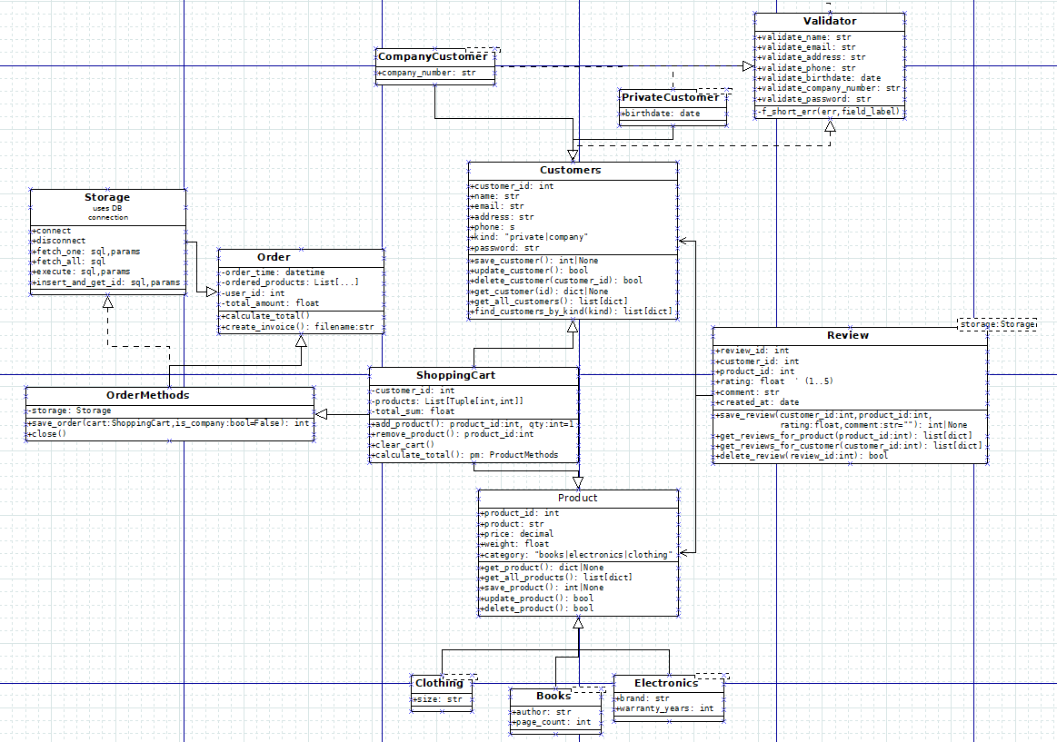

Key Features

Product Module
- Two display modes: Table View and Cards View
- Sorting (name, price, rating, category, total)
- Search field
- Filters:
  - Category
  - Brand (electronics)
  - Size (clothing)
  - Author (books)
- Dynamic quantity selector (+ / –)
- Add-to-cart button

Shopping Cart
- Dynamic updates
- Total price calculation
- Company customer discount (10%)
- Ability to update or remove items

Customer Management
- Registration (private or company customer)
- Login
- Profile page (update name, email, address, phone)
- Birthdate (private) or company number (company)
- Password validation
- Validation through a custom Validator + Rules system

Order System
- Save order header + items
- Order summary
- "My Orders" page showing:
  - Order number
  - Date
  - Subtotal
  - Discount (if applicable)
  - Total

Reviews
- A customer can leave a review only for purchased products.
- Average rating is calculated and displayed in the product list.

User Flow (UX)

Home Page

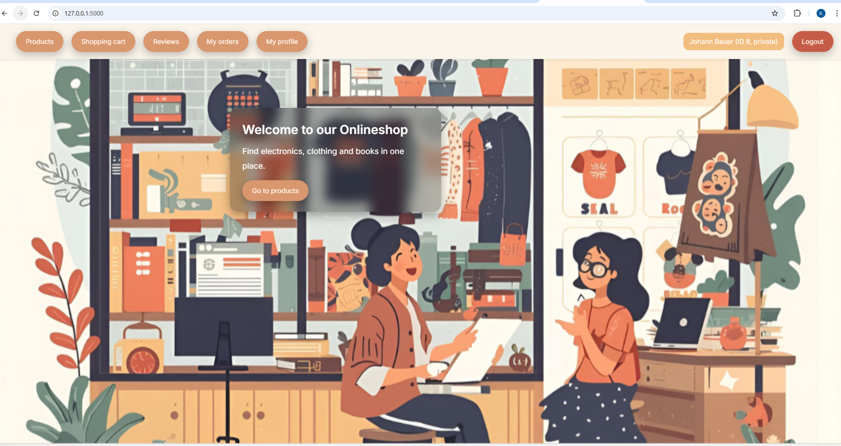
Glassmorphism hero card with:
- Welcome text
- Link to product list
- Background image

Product List (Table View)
- Sticky table header
- Color-coded icons
- Detailed row structure
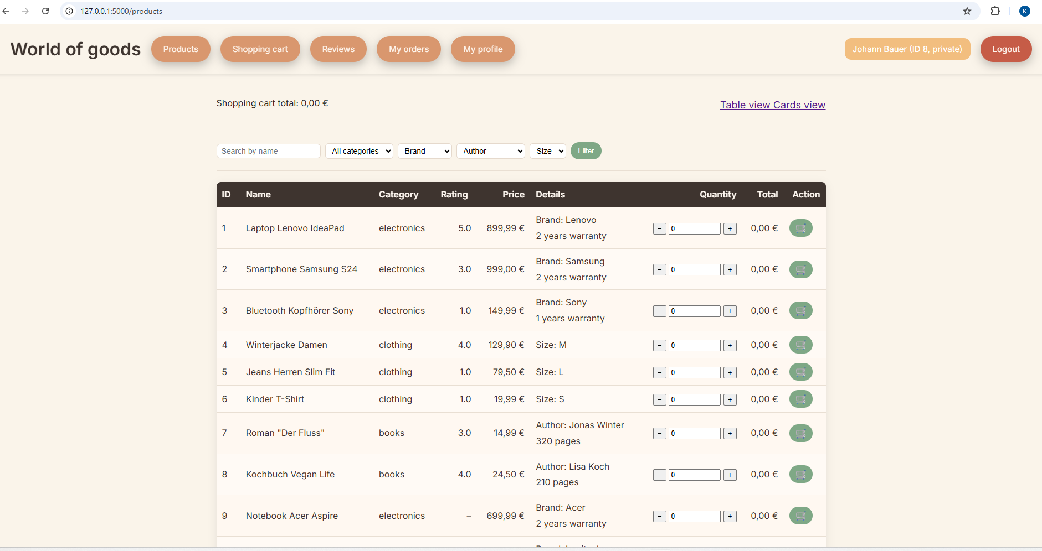

Product List (Cards View)
- Three-column grid
- Quick actions (quantity, add to cart)
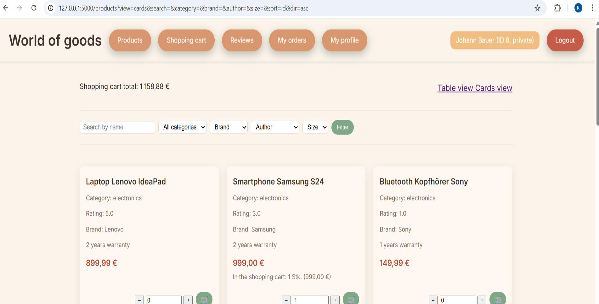

Shopping Cart
Shows all items with totals and discount.

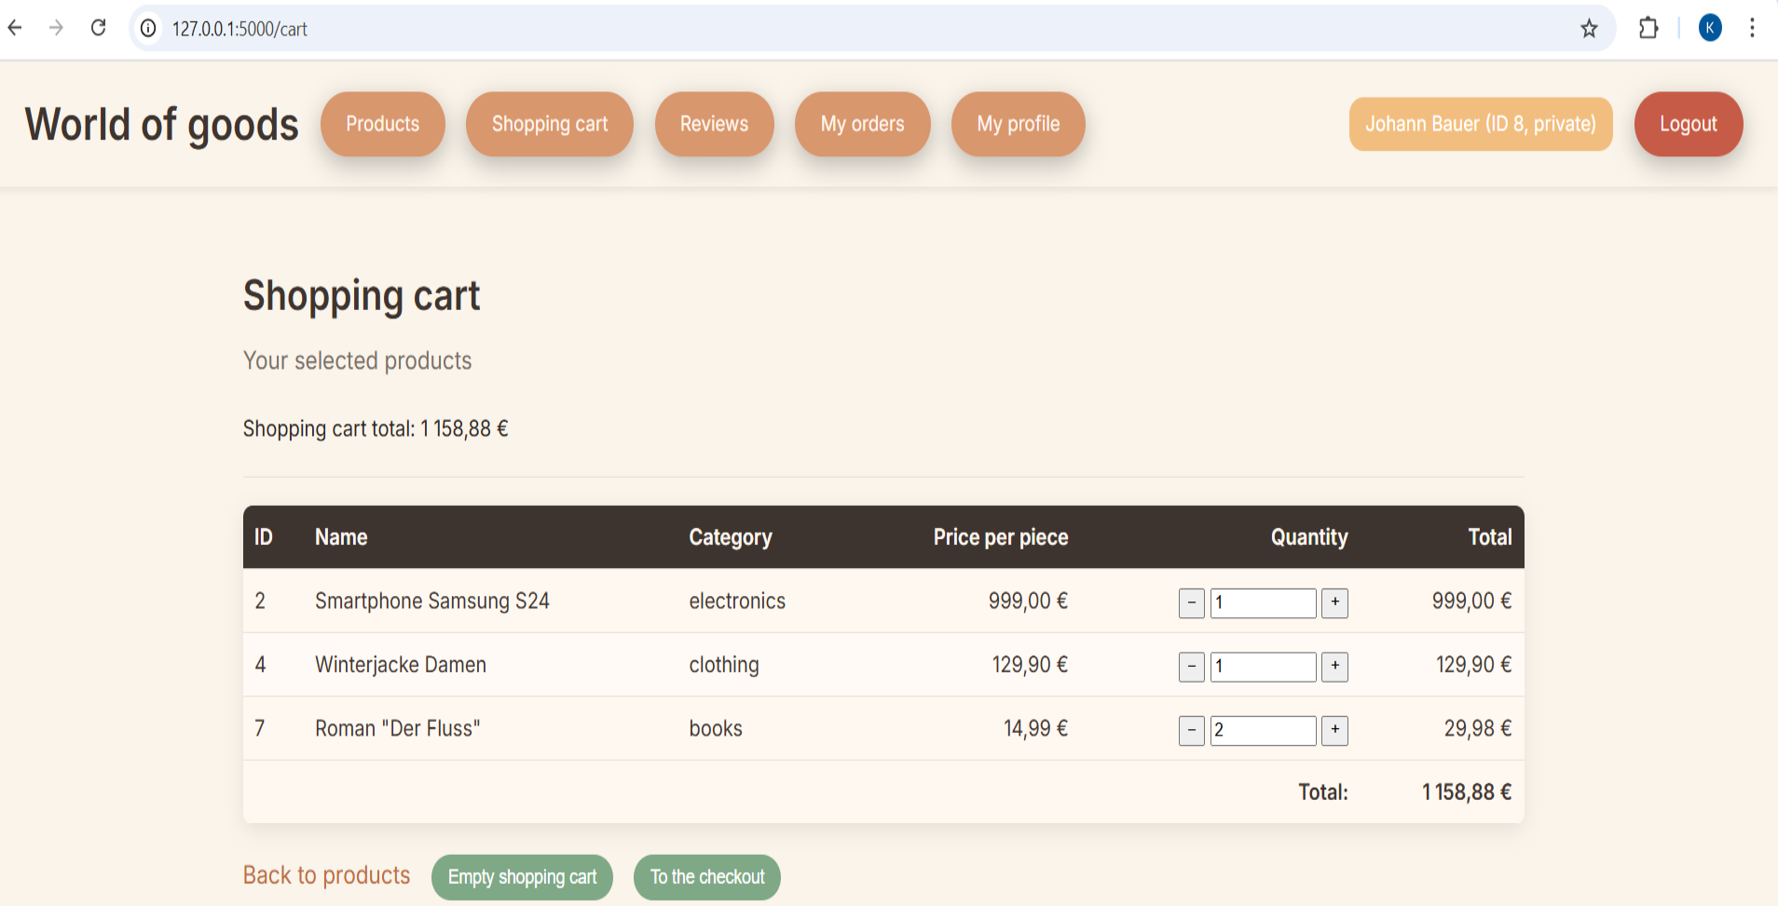

Profile Page
Editable fields + read-only fields depending on customer type.

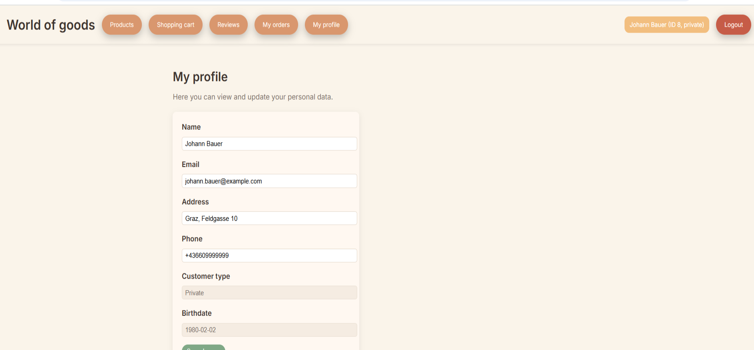

Checkout

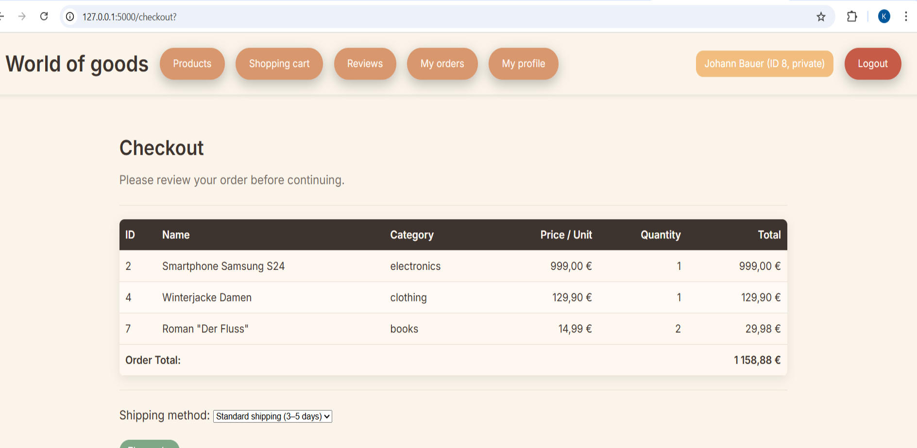

Order Success Page
Order summary, items table, totals.
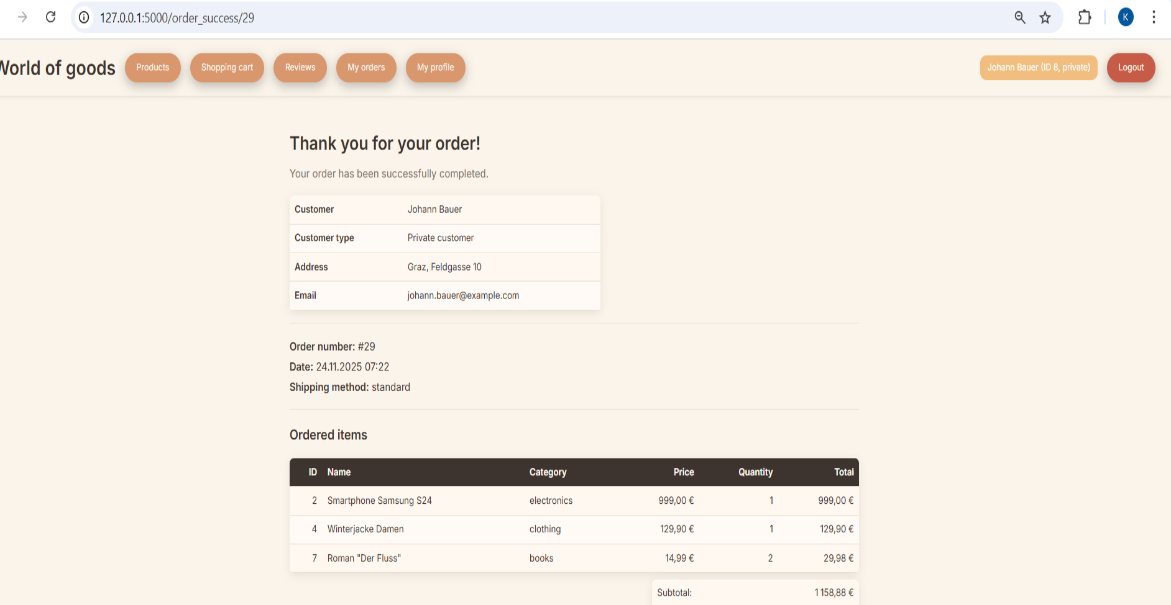

Order Success Page

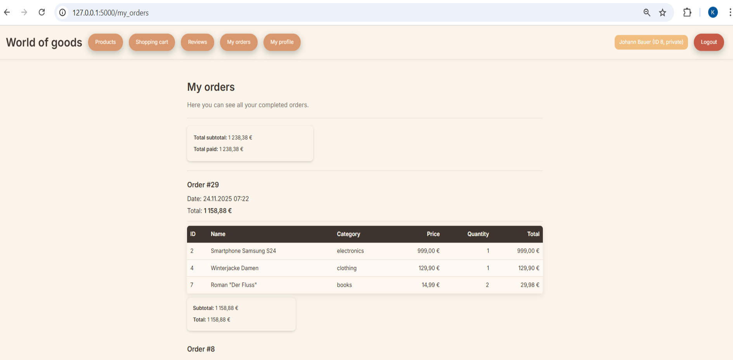

Reviews

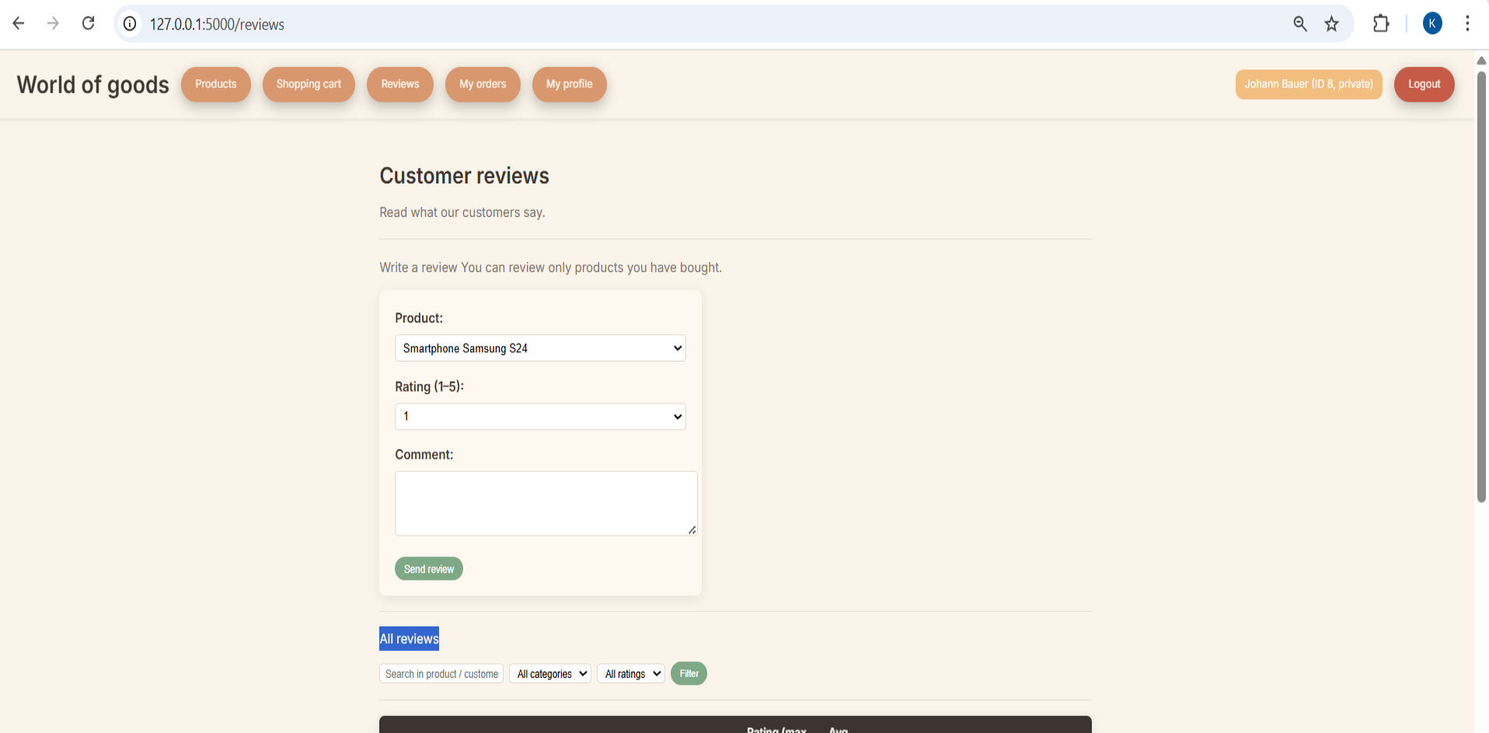

Design System (UI / CSS)
The project uses CSS variables for a consistent color palette.

Colors
Neutral and warm palette based on the main homepage background.
- Background main: #F7EBD4
- Cards: #FFFAF0
- Text main: #313409
- Link: #007BFF
- Accent buttons: warm coral/orange
- Primary action: blue
- Danger: red
- Table header: dark blue
- Price: wine red
Full list lives in:
/static/css/_colors.css

Components

Navigation Bar
- Sticky
- Left: logo, navigation links
- Right: user info badge and logout

Filter Bar
- Search
- Category select
- Sorting
- Size, brand, author

Tables
- Sticky header
- Zebra rows
- Hover highlight

Buttons
- Orange pills
- Primary blue
- Cart icon button

Forms
- Unified form card
- Validation messages
- Read-only fields for generated values

Flask Application Structure
project/
│
├── app.py
├── connection/
│ ├── db.py
│ └── storage.py
├── customers/
│ ├── validator.py
│ ├── rules.py
│ ├── customers.py
│ ├── private_customers.py
│ ├── company_customers.py
│ ├── customer_methods.py
├── products/
│ ├── product.py
│ ├── books.py
│ ├── electronics.py
│ ├── clothing.py
│ ├── product_methods.py
├── orders/
│ ├── order.py
│ ├── order_methods.py
│ ├── shopping_cart.py
├── reviews/
│ ├── review.py
│ ├── review_methods.py
├── static/
│ ├── css/ (design system + pages)
│ └── js/
│
└── templates/
├── base.html
├── home.html
├── products.html
├── cart.html
├── profile.html
├── my_orders.html
└── order_success.html

Database Schema (SQL)

Tables
- customers
- private_customer
- company_customer
- products
- orders
- order_items
- reviews

Views
- v_customers
- v_products
- v_orders
- v_order_items

Keys
- PKs: auto-increment integers
- FKs: strict
- ON DELETE RESTRICT for order relations

Validation System
Based on:
- Rules class (Pyadantic, regex, min/max, allowed values)
- Validator class (static methods)
- Used in customer registration, product creation, orders
Examples:
- validate_email()
- validate_password()
- validate_integer()
- validate_birthdate()
- validate_kind()

Order Logic

Steps:
- Validate cart
- Insert into orders
- Insert each item into order_items
- For company customers: apply 10% discount
- Commit transaction
Uses:
orders/order_methods.py

Testing

Manual testing includes:
- Registration (valid + invalid)
- Login
- Add to cart
- Change quantity
- All filters and sorting
- Company discount check
- Order placement
- Reviews permissions
- Sticky header behavior
- Return to correct scroll position after cart update

