**index.html – Front page**

image : images/Bakdam-sa-Temple-Grounds_med.jpg – Photographed by Kathleen Foreman

caption: Bakdam-sa Buddhist Temple, South Korea

Martial Arts after 40 and Beyond

Image: images/Title_Page_Banner_S3_.gif created in Fireworks by Kathleen Foreman

Your journey begins here…

**navigation.html** (not sure if I will use this in the website. I would need to work out how to map the buttons.

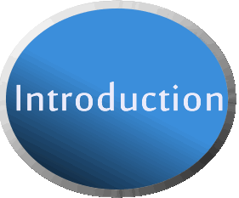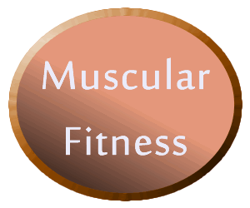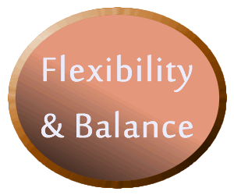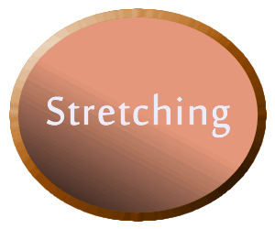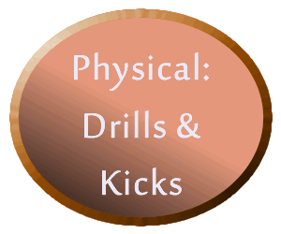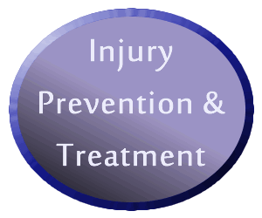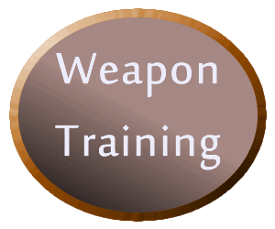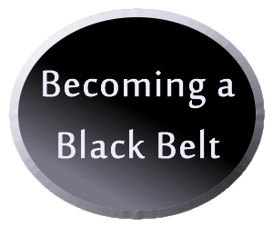

**Basic layout of all pages, except front page**

**Main content:**

**Images**:

images/BG_Main_lrg.jpg created in Fireworks by Kathleen Foreman

images/school-banner.jpg photographed by Kathleen Foreman,

images/bamboo_frame.gif see resources

images/button_prev.gif created in Fireworks by Kathleen Foreman

images/button_next.gif created in Fireworks by Kathleen Foreman

**Colors:**

Main Content area Links:

link: #820b0b; visited: #f2750e; hover: #46b73e; active: #6e1d84;

main content box: #FFFF99;

navigation links:

link: #C6B345; visited: yellow; hover: red; active: orange;

Top navigation background: green;

Side navigation; footer; figure & html background: #5A3832;

Side navigation border: ivory;

Footer text: #C6B345;

Video border: #4B3B19

**introduction.html**

sidebar image: images/korea-dojang-med.jpg photographed by Kathleen Foreman

caption: Korean DoJang

**Title: Introduction**

With the inclusion of Taekwondo sparring in the summer Olympics, martial arts has grown in popularity. For most, the perception is that it is a sport for youth. This is far from reality. Martial arts is much more than the sparring that popularized the sport and it is an activity that can be enjoyed by persons of all ages.

Martial arts is a great form of exercise. It encompasses flexibility, balance, cardio, endurance, physical skills, mental capacity and stress reduction. As we age, these attributes are very important in maintaining our health. So, too, it is important that we understand that our bodies cannot perform to the same level as the younger students in the class. Staying within the limits of our bodies allow for the participation in martial arts without the risk of injury.

Many adults are now pursuing martial arts as a form of exercise. Adult classes are tailored to the needs of this group dynamic. The stretching focuses on improving the flexibility needed. The physical skills are designed to challenge the individual without exceeding the physical limits. Endurance and cardio is achieved through drills and forms. Martial arts is a good way to reduce stress. Through the physical exercise and yelling we release the tension of the day.

It is more than just sparring. Join a class and experience all the martial arts has to offer.

Use the links to explore all that martial arts has to offer.

**aboutme.html**

sidebar image: images/about_me_image_med.jpg photographed by Tristan Foreman

caption: Training in South Korea

**Title: About Me:**

My name is Kathleen Foreman and I am a 3rd Dan in WTF Taekwondo. I have been training for 16 years. I’m 59 years old and began my Taekwondo journey when I was 43. I began training in Taekwondo with my older son when he was five years old and soon after my younger son was diagnosed with cystic fibrosis. I was searching for an activity that I could do with the older one to provide him with a special time with me. I did not want to watch him in a sport as a spectator, and at the time, bowling alleys were out of the question because patrons could smoke. A co-worker suggested Taekwondo, and we have been training together ever since. He is now 20 and also a 3rd Dan. The younger son joined us in 2003, when he was 4 ½ and is now a 2nd Dan. Training with my children, for me, enables us to have a strong bond. We have traveled to South Korea together to train in the imperial martial art called Sippahlki. This is a martial art that employs weapons such as swords, long stick and other long handled weapons.

As for beginning training at age 42, at first I could mostly compete with the younger students, but as age began to creep up, so did the injuries. I had to reconcile that my body could no longer perform at the same level it had in the past. That is not to say that I shy away from difficult techniques, it just means that I can’t get the same height or distance, or that I do not have the same power behind my kicks. But I am okay with that, because the main focus of my training is for fitness and health. I still enjoy competing at tournaments in poomsae and breaking, and I find that more adults have begun to compete as well. In addition to Taekwondo twice a week, we partake in a cardio-kickboxing class on Saturday mornings.

For me, Taekwondo is a fun activity and is always interesting. I continue to learn and the classes challenge me both physically and mentally. I found other activities to be either boring, or too hard on my joints. I continue to train and look forward to becoming a 4th Dan and master.

**dsclaimer.html**

**Title: Disclaimer**

**Disclaimer:**

As with any sport, check with your physician that you are physically fit to engage in an activity as rigorous was martial arts.

When starting out in martial arts for the first time it is important to remember to take it slow. You may see teenagers kicking and jumping high and be tempted to do the same. It is not a good idea to try to perform at their level. Begin slowly and build up to your desired level of fitness.

**blackbelt.html**

sidebar image: images/black_belts.jpg photographed by Peter Foreman

caption: Tristan & I achieving 3rd Dan, Sebastian achieving 2nd Dan

**Title:** **Becoming a Black Belt**

**Becoming a Black Belt**

I am often asked, “ How long does it take to get to Black Belt?” The answer to this is always the same. It depends on many different factors.

First you need to access “why” you are training in martial arts. For most adults engaging in martial arts the goal is to get exercise, increase flexibility, lose weight, for the social comradery or all of these. In this context, when you achieve black belt status, while it is rewarding, it is not the main goal.

Other factors will play a role in the time it takes to achieve this belt level.

* + How often can you attend classes - ideally you should train at least twice a week, but sometimes work, family or other factors take precedence.
  + How quickly you learn the techniques – each individual has their own pace.
  + Getting sidelined by injuries – it happens, be sure to take the time to recover fully before returning to class to prevent re-injury.
  + Changing schools – at times this may happen, in my experience, when I moved it took several years and schools before I found the right one for me. Each time I had to re-demonstrate my skills and learn each school’s unique style before I could advance.

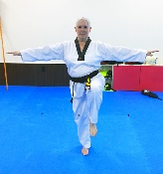**flexandbal.html**

sidebar image: images/Balance_med.jpg photographed by Master Byong Seok Kang

caption: Taekwondo Helps with Balance

**Muscular fitness**

**Title: Flexibility and Balance**

**Flexibility and Balance:**

Before stretching it is important to warm up your muscles through jogging, jumping jacks, jump rope, or a game of dodgeball or soccer. Warmed muscles are more resilient and pliable. Stretching is most important when participating in martial arts. As part of the aging process, our muscles and tendons become more rigid and it is accelerated by inactivity. The good news is that you can regain your flexibility through participation in a martial arts class. For adults the flexibility focus should be on the muscles surrounding the joints to prevent injury. Concentrate on hips, thighs, shoulders and back to support the rigors of martial arts. “When you stretch a muscle, the body’s natural reaction is to tighten and try to shorten.” It can take up to 20 seconds for the signals to reach the muscle, telling it relax and lengthen. Holding a stretch for 20 seconds is best to achieve results. You may find that stretching only during class is not enough to achieve the flexibility you desire. Stretching at home in between classes is a good idea.

Balance is an important aspect of Taekwondo. Maintaining balance during kicks, especially spinning kicks, is required for control. Drills to strengthen your muscles help with gaining control.

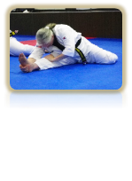**stretch.html**

Images: all photographed by Master Byong Seok Kang

navSidebar: images/holding_stretch_med.jpg

caption: Stretching improves flexibility

Below content: images/cross_body_med.jpg

These images use id=stretchCap to hide the details until you hover over the image

images/cross_leg_med.jpg

images/standing_hip_med.jpg

images/forward_hamstring_med.jpg

**Title: Stretching**

**Stretching:**

**Rules for stretching as per Sang H. Kim in his book “Martial Arts after 40”**

* + Never bounce during a stretch, bouncing causes tears
  + Keep you back straight and bend from your hips
  + Never bend your knees more than 90° during squats
  + Be patient, you cannot force it
  + Feel the burn, it you don’t feel the stretch, you’re not improving it
  + Don’t cheat, don’t bend your knees during the stretch
  + Work within you genetic limitations, meet your goals
  + Stretch all major muscle groups
  + Differentiate between stretching for flexibility and stretching for warm-up
  + Avoid exercises that cause joint pain or feel uncomfortable

With advanced age the risk of serious injury from a fall increases. Improving balance reduces the risk of a fall. Martial arts incorporates the need for balance, with forms and kicking. This is reinforced by keeping you center of balance low and your body upright while performing skills. It is also enhanced through the development of the muscles that support the body, such as the ankles.

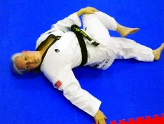**Hover over the images for stretch details.**

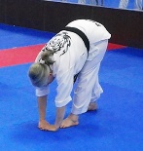

Forward Hamstring Stretch

Step forward, bending at the waist, reach for the floor in front of the forward leg to stretch you hamstring.

Cross Body Hip Stretch:

Lying on your back, pull your knee up and across your body to stretch your hip muscle.

Step forward, bending at the waist, reach for the floor in front of the forward leg to stretch you hamstring.

Bend front leg at 90°, extending the back leg, keeping your body upright to expand and stretch the front hip muscle.

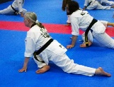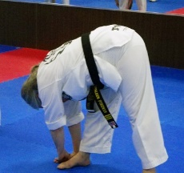

Bend front leg at 90°, extending the back leg, keeping your body upright to expand and stretch the front hip muscle.

Legs shoulder length apart, bending at the waist, twist and reach for the floor, stretching you hip muscle.

Cross Leg Hip Stretch

Side Hamstring Stretch

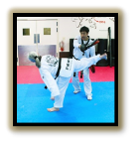**physical.html**

**Images:**

navSidebar: images/back_kick_med.jpg photographed by Master Byong Seok Kang

caption: Taekwondo Back Kick

Below content: images/1karatekatagif.gif – an animated gif –



**Title: Physical Skills**

**Physical Skills: drills, kicks**

It goes without saying that martial arts is a physical sport. There is reason that martial arts incorporates a belt system. Beginner belts learn basic skills and the focus is on technique. As you progress, the skills become more complex and use a greater range of motion. Using your full range of motion during kicks and punches increases not only muscle strength but flexibility as well. Drills in kicking and punching improve. The main focus should be on technique rather than height. Using proper technique will prevent injury, by eliminating incorrect use of muscles and joints. Proper techniques are gained through repetition and body memory. If you focus on performing kicks, punches and forms correctly each time, your body remembers the movement and results in accurate skills. Drills are designed to focus on this aspect and target specific goals within martial arts. Some of the aspects of martial arts targeted are agility, reaction times, coordination, speed, and endurance.

After a vigorous session, you may feel some muscle soreness. Take a break, and allow your muscles to recover, then return and continue. With time your stamina, strength and endurance will improve.

**endurance.html**

**Images:**

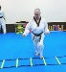navSidebar: images/endurance_med.jpg

 caption: Warming up with ladder drills

Below content: bb_sparring_med.jpg Caption: Sparring Gear On

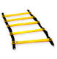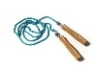 Agility_Ladder.jpg

Jump_Rope.jpg

**Title: Cardio and Endurance**

**Cardio and Physical Endurance**

We can improve our cardiovascular health by raising our heart rate for 25 minutes. In martial arts this is achieved in many ways. Most activities in a martial arts class will bring your heart rate up. The physical movement throughout the class in itself is beneficial. Ladder drills, running/jogging, kicking drills, and even performing forms with power and snap raise your heart rate. Some classes include sparring for those that wish to engage in it. This is a great way to build cardio-vascular endurance. The sparring rounds typically last 1-3 minutes, but include the use of your major muscles for kicking and moving. Since it isn’t for everyone, there are many other ways to build your endurance with martial arts. One way is speed kicking, such as kicking a target 100 times, as fast as you can. Endurance can be categorized by four types, and are incorporated into a martial arts class.

**Long or aerobic endurance** – the ability to perform at a moderate level for a long time,

* + • 20 minutes of sustained activity or 3-5 minute intervals requiring sufficient oxygen intake to prevent fatigue
  + • Examples: Running, ladder drills

**Short duration endurance** – the ability to perform at an intense level for a short time,

* + • Going full out for 30 second to 3 minute intervals for 10 minutes
  + • Examples: Sparring, target kicking at full power, non-stop combination kicking

**Muscular endurance** – the ability of your muscle to perform continuously,

* + • Repetitious muscle strengthening exercises
  + • Examples: Push-ups, sit-ups, squats, leg-lifts, bar work with repeated kicks

**Mental endurance** – the ability to concentrate for a prolonged time.

* + • Focused concentration
  + • Examples: Forms or patterns, quick thinking during sparring

**prevention.html**

**Title: A note on Injuries:**

**Injury Prevention and Treatment:**

**Injury Prevention:**

Sports injuries are a common concern for adults entering a martial arts program. While the potential for injury exists, the following are some helpful tips for avoiding them. One is to select a martial art that is suitable to your physical ability. Arts that include throwing, falling or high jumping, may not be appropriate for older bodies. Another factor to consider is the participant dynamic, a class with young children or teenagers with something to prove may not be the right environment. Search for an art that balances the goals you want to achieve.

**If you get injured:**

Most injuries in martial arts involve bruises, sprains, or a pulled muscle. It is important to note that as we age, it takes longer for our bodies to recover. For minor bruises and achy muscles, the RICE (Rest, Ice, compression & Elevation) method works well. It helps to relieve pain and swelling and promote healing and flexibility.

For more serious injuries, consult your doctor, and take a break and let yourself heal before returning. If you rush back you risk aggravating the injury, resulting in more time away.

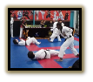**choosing.html**

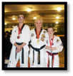**images:**

navSidebar: self_defense_med.jpg caption: Self Defense

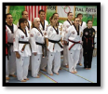 Below content: images/competition_med.jpg caption: Competition

images/Comradery_med.jpg caption: Comradery

**Title: Choosing a School**

**Choosing a martial art and school**

With all of the different martial arts styles available it can be overwhelming when searching for the style and school that meets your needs. Here are some tips to help you decide.

1. Decide what you want to get out of the training.

a. Self-defense

b. Fitness

c. Competition

d. Comradery

2. Look for a school that offers adult classes and/or family classes if you wish to train with your child(ren).

3. Trial a school, most schools offer a trial period before you commit. This is important. If you are not satisfied with the training, change schools. (I have trained under five grand masters. Not all schools are the same.)

4. Speak with the master about your goals, limitations and responsibilities outside of training. They will be able to help in meeting your needs.

**weapons.html**

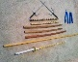**Images:**

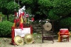 navSidebar: images/weapons_stash_med.jpg caption: My Weapons

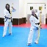 Below content: images/sippahlki_weapons_med.jpg caption: Sippahlki Weapons

images/jang_bang_duo_med.jpg caption: Jang-Bang Training

video/jang_bang_form.mp4 video

**Title:** **Weapons**

**Weapon Training**

Another way to enhance your martial arts experience without increasing the risk to adult joints is the incorporation of weapons into the training. Movements with weapons still provide physical activity but are easy on the body. Some weapons that are often included in martial arts classes include:

1. nunchaku. – single and double techniques, movements to music

2. Short stick, (Escrima or Dan Bong), techniques that include self-defense or demonstration

3. Long Stick (Bo Staff or Jang Bong), basic techniques, movements, self-defense, forms

4. Sword – (Gum – pronounced Goom) – basic techniques, forms, self-defense

5. Sai – basic techniques, forms, defensive moves

6. Cane – self-defense, forms (good to know when we reach the stage when we will need one)

**recommended.html**

**Images:**

Below content: images/books.gif

images/laptop_sm.gif

**Title: Recommended Reading**

**Recommended Reading:**

**Websites:**

[www.blackbeltwiki.com](http://www.blackbeltwiki.com) - covers many martial art styles, plus instruction on many related topics

[www.martialartsover40.com](http://www.martialartsover40.com) – articles related to adult training

[www.taekwondoanimals.com](http://www.taekwondoanimals.com) – a comprehensive site that provides information for all ages

[www.bluecottagetkd.com](http://www.bluecottagetkd.com) – a good resource for forms from multiple diciplines

[www.tkdtutor.com](http://www.tkdtutor.com) – contains a fairly comprehensive list of martial art styles throughout the world

**Books:**

“Martial Arts After 40” by Sang H. Kim

[“Sekwondo”](http://www.sekwondo.be/sekwondo-boek/) - By prof. Jan Lodder, MD, PhD. 3rd DAN WTF Taekwondo - Initiation for Novices Over the Age of Forty

Works cited

**research.html**

**Images:**

navSidebar: images/resources.gif

**Research:**

**Websites:**

[www.blackbeltwiki.com](http://www.blackbeltwiki.com) - covers many martial art styles, plus instruction on many related topics

[www.martialartsover40.com](http://www.martialartsover40.com) – articles related to adult training

[www.taekwondoanimals.com](http://www.taekwondoanimals.com) – a comprehensive site that provides information for all ages

[www.bluecottagetkd.com](http://www.bluecottagetkd.com) – a good resource for forms from multiple diciplines

[www.tkdtutor.com](http://www.tkdtutor.com) – contains a fairly comprehensive list of martial art styles throughout the world

**Books:**

**Kim, Sang H.. Martial Arts After 40. Connecticut. Turtle Press. 2000. Print.**

Lodder, Prof. Jan MD, PhD [“Sekwondo](http://www.sekwondo.be/sekwondo-boek/) -- Initiation for Novices Over the Age of Forty”. Texas, Strategic Book Publishing and Rights Co. 2012. Ptint.

**Images:**

<http://www.clipartbest.com/karate-clip-art-free>

Sidekick vector; bamboo border,

<http://www.clipartpanda.com/categories/karate-clip-art-free>

Side_Kick_Image – used for the previous & back buttons

Office.com clip art

SideKick button.wmf – used for bullets

Jump Rope – Slide 11; Books – Slide 17

http://www.craftyjenny.com/free-clip-art-download-laptop-computer.html - Slide 17

Photography - Foreman Family Photo Library

Baekdam-sa-Temple-Grounds – Slide 1; Bonsai Tree – Slide 2; Korea dojang – Slide 3, Woldo_By_Japan_Sea – Slide 4, About Me slide show, New-Dan-Levels – Slide 6, Sparring- Slide 11, Endurance – Slide 12, Slide 14 – Self-Defense, Competition & Comradary; Slide 15 – JangBang Duo, Sippahlki Weapons & Weapons Stash

Photography – Master Byong Seok Kang – Stretching Photos – Slide 7-10, Jang Bang Video

**Sound:**

*The JangBang video features the song DRAMATIC CINEMATIC INTRO : from Dramatic Cinematic Epic Music by Plastic3; available under a Creative Commons; https://www.jamendo.com/en/track/989827/dramatic-cinematic-intro Attribution-Noncommercial license.*

Background music features the song Pavel Fomitchov - Kama Sutra by Tunguska Electronic Music Society; ; available under a Creative Commons- Attribution-NonCommercial-ShareAlike