Attendance Monitoring Management System

| Katherine S. Villegas  Young Software Engineers’ Society  Candelaria, Quezon, Philippines  ksvillegas1@up.edu.ph |
| --- |

# ABSTRACT

Attendance, an important and compulsory tool in the process of learning, is included in the grading scheme of some instructors and professors in the University of the Philippines Los Baños. However the existing attendance monitoring methods being used are time consuming, tedious and occasionally unreliable. To solve this problem, this paper aims to meet the needs of the instructors and professors with regards to attendance monitoring by implementing a system that will handle and monitor the attendance of the students. The system will be using a Face Recognition feature that will aim to detect faces through a built in web camera to verify the attendance of the students. The system must successfully integrate the Face Detection for Attendance Monitoring module that captures, stores and detects faces of the students. Moreover, the system must hold a record of the attendance of students for viewing and monitoring.

# INTRODUCTION

Attendance is an important and compulsory tool in the process of learning. In the University of the Philippines Los Baños, attendance is included in the grading scheme of some instructors and professors. In fact, there is a UP Code on Attendance (Chapter 50, Art. 346) stating that if a student lost 20% of the hours schedules in one subject, he shall be dropped from that subject. But despite the importance of monitoring the attendance of students, the existing attendance monitoring methods are not good and reliable enough.

Furthermore, instructors and professors nowadays uses manual means of monitoring the attendance of students. Students’ attendance is normally taken by: using attendance sheets that are disseminated in class, requesting students to pass a piece of paper with their name, student number and section; having a seating arrangement and letting the Student Assistant to monitor the attendance; or by calling the students one-by-one. However, this methods are tedious, time consuming and unreliable

Thus, creating an automatic attendance monitoring system can ease the means of monitoring the attendance of students. The system that will be developed will make use of the Face Detection for Attendance Monitoring, a Special Problem done by a previous Computer Science (ICS) student of the Institute of Computer Science, that captures, stores and detects faces of students. The output data will be stored in a database and this will serve as the students’ attendance. The system will also hold a record of the attendance of the students for viewing and monitoring. This system can meet the needs of the instructors and professors of the Institute of Computer Science regarding the attendance monitoring in an easy and reliable way. Instructors, professors and student assistants will also be spared from the manual way of checking the attendance, which is a tedious task. ICS students can also benefit from this for they can study the system and find new and more effective ways in developing such systems.

# RElated Work

There are different studies that have been conducted which automatically monitors the attendance of students. Some of the available system uses face recognition to record the attendance of students. While some uses other components in recording the attendance.

One of the studies that tried to create a solution in the attendance monitoring is the research paper entitled An Attendance Monitoring System Using Biometrics Authentication. This system uses human fingerprint characteristics to issue the employees’ attendance. [8]

Another study uses ID card barcode readers to record the attendance of the students. The system’s implementation is divided into three parts which are the Client Program Implementation, Server Program Implementation and Online System Implementation. All parts are implemented in Microsoft Visual Studio 2003. The database system of attendance record has six schemas which includes the Events, Attendance, Students, Departments, Places and Users. [5]

In addition, a study uses a Radio Frequency Identification (RFID) system in the attendance monitoring problem. RFID technology uses electronic passive and active tags with suitable readers to facilitate the automatic wireless identification.[2]

One more study implemented an android mobile application on smartphones to automate the attendance monitoring system. This study reduces the need of pen and paper manual attendance tracking and additional biometric scanner device for attendance checking. The employees’ time and attendance tracking is determined by the GPS using smartphone. [9]

One of the studies that uses face recognition to record the attendance of students is the Integrated System for Monitoring and Recognizing students during Class Session. This student attendance system uses biometric authentication protocol and was made in the Al Zaytoonah University of Jordan. It uses face detection and face recognition to facilitate the checking of attendance in the classroom. In this system, classrooms’ camera captures students’ photo and directly process it to produce the attendance report of the instructors. [1]

Another similar system is the Smart Attendance using Real Time Face Recognition which was developed in the Sri Lanka Institute of Information Technology. This system monitors the attendance of employees. Haar cascade was used in the human face detection. While a simple Principal Component Analysis was used to recognize human faces. Natural Processing Language method was used in handling the request of employees to leave by approving or rejecting leaves and replies for all requests. [7]

Moreover, a system developed in Saintgits College of Engineering in India is consists of a high resolution digital camera to monitor the classroom or the office room. Cameras are embedded on a microcontroller which enables it to rotate in left and right directions. The images obtain by the camera are sent to a computer programmed system that compares the it with a set of reference images of the students. This system uses Principal Component Analysis and the Eigenfaces approach in face recognition. [3]

The mentioned systems are reliable and efficient, one the other hand installing and maintaining these systems are costly. However, a similar system was developed in the University of the Philippines Los Baños that automates the checking of attendance based on their location and seat plan by taking an image of the top-front position of the classroom. Nonetheless, the system relies only on the seat plan. If a person is located in a specific chair, the person will be marked as present whether or not that person is the real student assigned to it. [4]

This study will implement an attendance monitoring system that is not costly by using resources that are already available, specifically a laptop with a built-in web camera. This system will use facial recognition and detection to check the attendance of students. The system will also have a Graphical User Interface (GUI) for the users’ ease of use. And data will be saved on the database for viewing and monitoring of the students’ attendance status.

# Methodology

**Face Recognition and Detection**

Before the successful integration of the Face Detection for Attendance Monitoring, the implementation of the of the said application must be understood first. The face detector is a standalone application that uses OpenCV for the checking of attendance through image processing. The input images will be captured using the application, and will undergo on the process of automated checking and recording of attendance.

**Data Storage**

Images of students for comparison will be saved in a database. Students are separated according to their subject, this means that a schema will be composed of the students under a subject. Aside from the image of the students, other information such as name and student number will also be saved in the database.

For the attendance, when a face is recognized by the application. Data such as the name of the student, student number and timestamp will be saved in the database. Attendance of students will also be separated according to their subject, a schema will be composed of the attendance of students under a certain subject.

**System Flowchart**

Live images captured by the built-in web camera are processed thru Image Processing using the Face Detection for Attendance Monitoring. When a face is recognized after processing, data will be saved in a database. Data can now be used for the attendance management system.

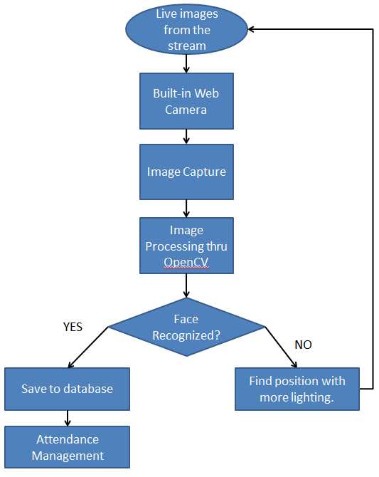

**Figure 2. Flowchart of the System**

**Attendance Monitoring**

The users which are the instructors or professors can view the attendance status of students. The system will also notify the user if student/s is/are near in having excessive absences.

# Evaluation

The Face Detection for Attendance Monitoring must be successfully integrated and implemented to the system. The system must be able to capture and store a face image. It must also match the detected faces in the images stored. However, facial detection will only be made possible with the assumption of the presence of proper lighting because of the device that will be used in detecting a students’ face, which is a build-in web camera of a laptop.

On the previous implementation of the Face Detection for Attendance Monitoring module, the output of the detected and recognized faces are stored in a XML file that contains their attendance record including the timestamp. For this implementation, data must be stored in a database. The data must also be retrieved properly for viewing and monitoring purposes.

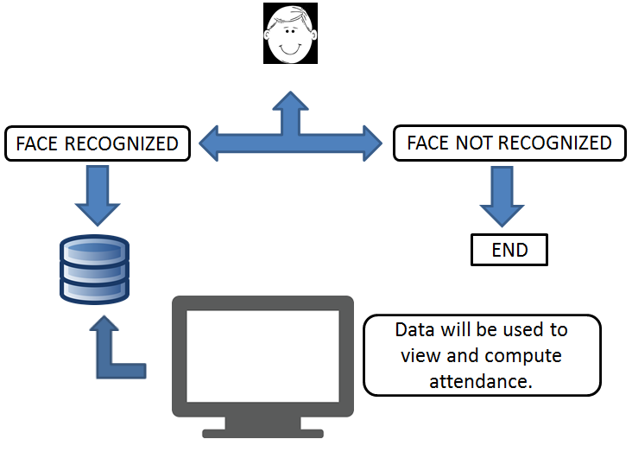

**Figure3. Experimental Design**

To assess this implementation, the system will be subject to be tested by at most two laboratory classes in the Institute of Computer Science, which is approximately 40 students assuming that a laboratory class includes 20 students.

# Timeline

Below is a table that contains the rough timeline of the activities/modules that comprises the Attendance Monitoring Management System.

|  |  |
| --- | --- |
| **DATE** | **ACTIVITY/MODULE** |
| January 25 – 29, 2016 | Getting the code/program used in the Face Detection for Attendance Monitoring |
| February 1-5, 2016 | Testing the Face Detection for Attendance Monitoring |
| Creating the Web Application for the Attendance Monitoring Management System | |
| February 8-19, 2015 | Sign Up, Log In, Log Out |
| February 15-26, 2015 | Adding Students to Subjects Module |
| February 29 – March 18, 2015 | Making the output of the Face Detection for Attendance Monitoring stored in a database |
| March 21 – April 1, 2015 | Computation for the attendance of students. |
| April 4 – 15, 2015 | Polishing of the System |

# REFERENCES

1. Alia, M.A., Tamimi, A.A., AL-Allaf. O.N.A. (2013). *Integrated System For Monitoring And Recognizong Students During Class Session.* The International Journal of Multimedia & Its Applications, Vol. 5, No. 6, (December 2013) pp. 45 – 52.
2. Arulogun, O.T., Olatunbosun, A., Fakolujo, O.A., Olaniyi, O.M. (2013). *RFID-Based Students Attendance Management System.* International Journal of Scientific & Engineering Research, Vol. 4, Issue 2, (February 2013) pp. 1-9.
3. Joseph, J. (2013).  *Automatic Attendance Management System Using Face Recognition.* International Journal of Science and Research, Vol. 11, No. 2, (November 2013) pp. 327 – 330.
4. Invierno, I.D.C. (2013).  *Location-based Classroom Attendance Monitoring System for ICS Lecture Halls.* Published Undergraduate Special Problem, University of the Philippines Los Baños, Laguna, Philippines.
5. Kizildag, M., Basar, E., Celikag, M., Atasoylu, E., Mousavi, S. (2007). *An Automated Attendance Monitoringand Registration System for EMU’s SPIKE Seminar Series.* Eastern Mediterranean University.
6. Rojas, R.C. (2015).  *Face Detection for Attendance Monitoring.* Published Undergraduate Special Problem, University of the Philippines Los Baños, Laguna, Philippines.
7. Roshan Tharanga, J.G., Samarakoon, S.M.S.C., Karunarathne, T.A.P., Liyanage, K.L.P.M, Gamage, M.P.A.W., Perera, D. (2013). *Smart Attendance Using Real Time Face Recognition.* SAITM Research Symposium on Engineering Advancements, pp. 41-44.
8. Rao, S., Prof. Satoa K.J. (2013). *An Attendance Monitoring System Using Biometrics Authentication.* International Journal Of Advanced Research in Computer Science and Software Engineering, Vol. 3, Issue 4 (April 2013) pp. 379-383.
9. Sultana, S., Enayet, A., Mouri, I.J. (2015). *A Smart, Location Based Time and Attendance Tracking System Using Android Application.* International Journal of Computer Science, Engineering and Information Technology, Vol. 5, No. 1(February 2015) pp. 1 -5