# Checking the application of blink reconstruct function to pupil size data

### Installation and import

Installation of packages. Import of python libraries and modules.

!pip install pyplr  
!pip install neurokit2  
import sys  
sys.path.append("../Pupillengröße/Skripte/")  
  
import pandas as pd  
import numpy as np  
import matplotlib.pyplot as plt  
import logging as log  
import checkdata  
import importlib  
from IPython.display import display  
def display_all(df):  
 from IPython.display import HTML, display  
 IPython.display(IPython.HTML(df.to_html()))

Requirement already satisfied: pyplr in /Users/Katharina/Desktop/Pupille/venv/lib/python3.10/site-packages (1.0.3)  
Requirement already satisfied: msgpack in /Users/Katharina/Desktop/Pupille/venv/lib/python3.10/site-packages (from pyplr) (1.0.5)  
Requirement already satisfied: requests in /Users/Katharina/Desktop/Pupille/venv/lib/python3.10/site-packages (from pyplr) (2.31.0)  
Requirement already satisfied: numexpr in /Users/Katharina/Desktop/Pupille/venv/lib/python3.10/site-packages (from pyplr) (2.8.4)  
Requirement already satisfied: scipy in /Users/Katharina/Desktop/Pupille/venv/lib/python3.10/site-packages (from pyplr) (1.11.1)  
Requirement already satisfied: pyzmq in /Users/Katharina/Desktop/Pupille/venv/lib/python3.10/site-packages (from pyplr) (25.1.0)  
Requirement already satisfied: matplotlib in /Users/Katharina/Desktop/Pupille/venv/lib/python3.10/site-packages (from pyplr) (3.7.2)  
Requirement already satisfied: numpy in /Users/Katharina/Desktop/Pupille/venv/lib/python3.10/site-packages (from pyplr) (1.25.1)  
Requirement already satisfied: seaborn in /Users/Katharina/Desktop/Pupille/venv/lib/python3.10/site-packages (from pyplr) (0.12.2)  
Requirement already satisfied: seabreeze in /Users/Katharina/Desktop/Pupille/venv/lib/python3.10/site-packages (from pyplr) (2.4.0)  
Requirement already satisfied: tables in /Users/Katharina/Desktop/Pupille/venv/lib/python3.10/site-packages (from pyplr) (3.8.0)  
Requirement already satisfied: pandas in /Users/Katharina/Desktop/Pupille/venv/lib/python3.10/site-packages (from pyplr) (2.0.3)  
Requirement already satisfied: pyparsing<3.1,>=2.3.1 in /Users/Katharina/Desktop/Pupille/venv/lib/python3.10/site-packages (from matplotlib->pyplr) (3.0.9)  
Requirement already satisfied: kiwisolver>=1.0.1 in /Users/Katharina/Desktop/Pupille/venv/lib/python3.10/site-packages (from matplotlib->pyplr) (1.4.4)  
Requirement already satisfied: fonttools>=4.22.0 in /Users/Katharina/Desktop/Pupille/venv/lib/python3.10/site-packages (from matplotlib->pyplr) (4.41.0)  
Requirement already satisfied: contourpy>=1.0.1 in /Users/Katharina/Desktop/Pupille/venv/lib/python3.10/site-packages (from matplotlib->pyplr) (1.1.0)  
Requirement already satisfied: pillow>=6.2.0 in /Users/Katharina/Desktop/Pupille/venv/lib/python3.10/site-packages (from matplotlib->pyplr) (10.0.0)  
Requirement already satisfied: cycler>=0.10 in /Users/Katharina/Desktop/Pupille/venv/lib/python3.10/site-packages (from matplotlib->pyplr) (0.11.0)  
Requirement already satisfied: python-dateutil>=2.7 in /Users/Katharina/Desktop/Pupille/venv/lib/python3.10/site-packages (from matplotlib->pyplr) (2.8.2)  
Requirement already satisfied: packaging>=20.0 in /Users/Katharina/Desktop/Pupille/venv/lib/python3.10/site-packages (from matplotlib->pyplr) (23.1)  
Requirement already satisfied: pytz>=2020.1 in /Users/Katharina/Desktop/Pupille/venv/lib/python3.10/site-packages (from pandas->pyplr) (2023.3)  
Requirement already satisfied: tzdata>=2022.1 in /Users/Katharina/Desktop/Pupille/venv/lib/python3.10/site-packages (from pandas->pyplr) (2023.3)  
Requirement already satisfied: charset-normalizer<4,>=2 in /Users/Katharina/Desktop/Pupille/venv/lib/python3.10/site-packages (from requests->pyplr) (3.2.0)  
Requirement already satisfied: urllib3<3,>=1.21.1 in /Users/Katharina/Desktop/Pupille/venv/lib/python3.10/site-packages (from requests->pyplr) (2.0.3)  
Requirement already satisfied: idna<4,>=2.5 in /Users/Katharina/Desktop/Pupille/venv/lib/python3.10/site-packages (from requests->pyplr) (3.4)  
Requirement already satisfied: certifi>=2017.4.17 in /Users/Katharina/Desktop/Pupille/venv/lib/python3.10/site-packages (from requests->pyplr) (2023.5.7)  
Requirement already satisfied: py-cpuinfo in /Users/Katharina/Desktop/Pupille/venv/lib/python3.10/site-packages (from tables->pyplr) (9.0.0)  
Requirement already satisfied: cython>=0.29.21 in /Users/Katharina/Desktop/Pupille/venv/lib/python3.10/site-packages (from tables->pyplr) (3.0.0)  
Requirement already satisfied: blosc2~=2.0.0 in /Users/Katharina/Desktop/Pupille/venv/lib/python3.10/site-packages (from tables->pyplr) (2.0.0)  
Requirement already satisfied: six>=1.5 in /Users/Katharina/Desktop/Pupille/venv/lib/python3.10/site-packages (from python-dateutil>=2.7->matplotlib->pyplr) (1.16.0)  
  
[notice] A new release of pip available: 22.3.1 -> 23.2.1  
[notice] To update, run: pip install --upgrade pip  
Requirement already satisfied: neurokit2 in /Users/Katharina/Desktop/Pupille/venv/lib/python3.10/site-packages (0.2.5)  
Requirement already satisfied: scipy in /Users/Katharina/Desktop/Pupille/venv/lib/python3.10/site-packages (from neurokit2) (1.11.1)  
Requirement already satisfied: pandas in /Users/Katharina/Desktop/Pupille/venv/lib/python3.10/site-packages (from neurokit2) (2.0.3)  
Requirement already satisfied: matplotlib in /Users/Katharina/Desktop/Pupille/venv/lib/python3.10/site-packages (from neurokit2) (3.7.2)  
Requirement already satisfied: numpy in /Users/Katharina/Desktop/Pupille/venv/lib/python3.10/site-packages (from neurokit2) (1.25.1)  
Requirement already satisfied: scikit-learn>=1.0.0 in /Users/Katharina/Desktop/Pupille/venv/lib/python3.10/site-packages (from neurokit2) (1.3.0)  
Requirement already satisfied: joblib>=1.1.1 in /Users/Katharina/Desktop/Pupille/venv/lib/python3.10/site-packages (from scikit-learn>=1.0.0->neurokit2) (1.3.1)  
Requirement already satisfied: threadpoolctl>=2.0.0 in /Users/Katharina/Desktop/Pupille/venv/lib/python3.10/site-packages (from scikit-learn>=1.0.0->neurokit2) (3.2.0)  
Requirement already satisfied: python-dateutil>=2.7 in /Users/Katharina/Desktop/Pupille/venv/lib/python3.10/site-packages (from matplotlib->neurokit2) (2.8.2)  
Requirement already satisfied: packaging>=20.0 in /Users/Katharina/Desktop/Pupille/venv/lib/python3.10/site-packages (from matplotlib->neurokit2) (23.1)  
Requirement already satisfied: contourpy>=1.0.1 in /Users/Katharina/Desktop/Pupille/venv/lib/python3.10/site-packages (from matplotlib->neurokit2) (1.1.0)  
Requirement already satisfied: fonttools>=4.22.0 in /Users/Katharina/Desktop/Pupille/venv/lib/python3.10/site-packages (from matplotlib->neurokit2) (4.41.0)  
Requirement already satisfied: cycler>=0.10 in /Users/Katharina/Desktop/Pupille/venv/lib/python3.10/site-packages (from matplotlib->neurokit2) (0.11.0)  
Requirement already satisfied: pyparsing<3.1,>=2.3.1 in /Users/Katharina/Desktop/Pupille/venv/lib/python3.10/site-packages (from matplotlib->neurokit2) (3.0.9)  
Requirement already satisfied: kiwisolver>=1.0.1 in /Users/Katharina/Desktop/Pupille/venv/lib/python3.10/site-packages (from matplotlib->neurokit2) (1.4.4)  
Requirement already satisfied: pillow>=6.2.0 in /Users/Katharina/Desktop/Pupille/venv/lib/python3.10/site-packages (from matplotlib->neurokit2) (10.0.0)  
Requirement already satisfied: tzdata>=2022.1 in /Users/Katharina/Desktop/Pupille/venv/lib/python3.10/site-packages (from pandas->neurokit2) (2023.3)  
Requirement already satisfied: pytz>=2020.1 in /Users/Katharina/Desktop/Pupille/venv/lib/python3.10/site-packages (from pandas->neurokit2) (2023.3)  
Requirement already satisfied: six>=1.5 in /Users/Katharina/Desktop/Pupille/venv/lib/python3.10/site-packages (from python-dateutil>=2.7->matplotlib->neurokit2) (1.16.0)  
  
[notice] A new release of pip available: 22.3.1 -> 23.2.1  
[notice] To update, run: pip install --upgrade pip

### Preparing:

Defining plot variables, subject_id and data_dir. Using the dataclass DataConfig of the checkdata module. The data for eyenum 0 and 1 is prepared seperatly and two new variables (eye0 and eye1) are created. The data is prepared with the function prepare of checkdata module to slice the data into separate frames on the basis of annotation_timestamps. The results are plotted by using the plot function of checkdata module. One line chart and three histograms are created. The variable eye0 is displayed.

# wenn ich checkpadata.py ändere, muß das Modul neu importiert werden. Das macht reload()  
importlib.reload(checkdata)  
plt.rcParams['figure.figsize'] = [20, 10]  
plt.rcParams['figure.dpi'] = 200   
subject_id="PJ15_1_PLR1"  
data_dir="/Users/Katharina/Desktop/Beispieldaten"  
#data_dir="../data/groesse/3.4Stimulation/"  
config=checkdata.DataConfig(window_duration=90)  
eye0=checkdata.prepare(data_dir,subject_id,0,config)  
eye1=checkdata.prepare(data_dir,subject_id,1,config)  
checkdata.plot(eye0[0],"auge 0 (0)")  
display(eye0[0])

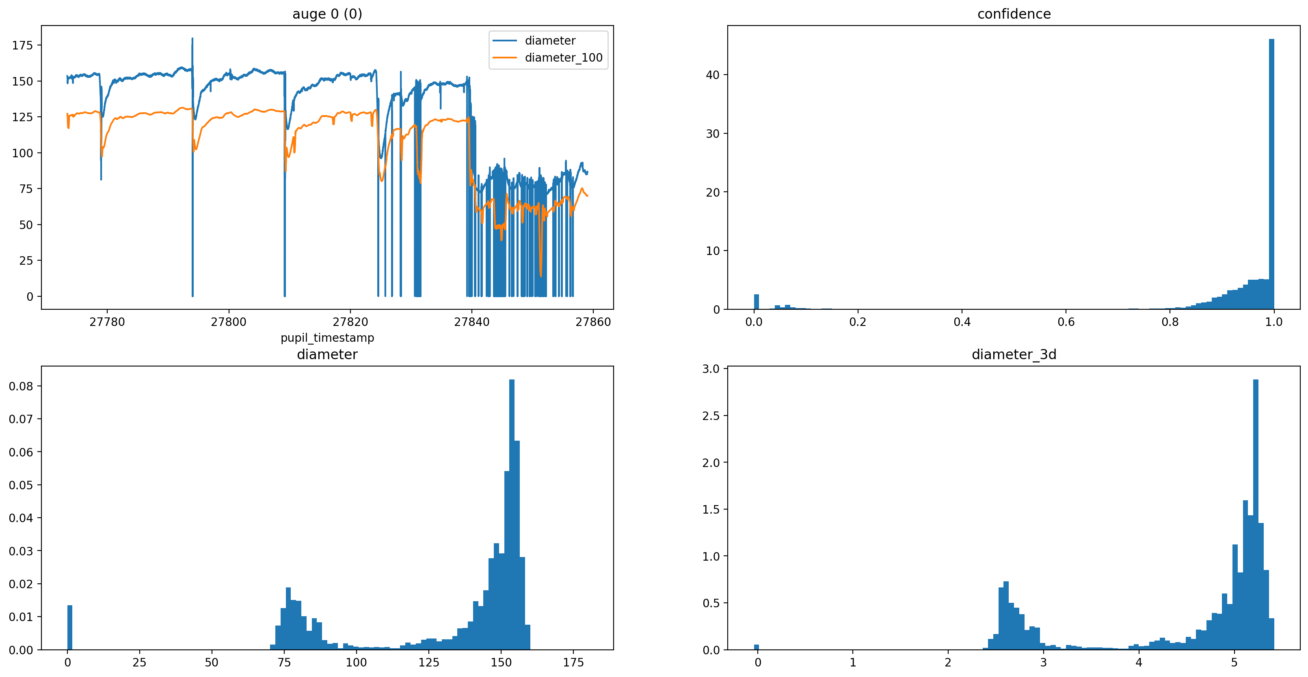

pupil_timestamp eye_id confidence diameter diameter_3d \  
10750 27773.394969 0 0.965048 153.545731 NaN   
10751 27773.394969 0 0.965048 153.522871 5.186446   
10754 27773.403036 0 0.950132 153.344421 NaN   
10755 27773.403036 0 0.950132 153.325403 5.179502   
10758 27773.410923 0 1.000000 152.720485 5.159230   
... ... ... ... ... ...   
51815 27858.998821 0 1.000000 86.531479 NaN   
51818 27859.006871 0 1.000000 86.725915 2.932043   
51819 27859.006871 0 1.000000 86.726234 NaN   
51822 27859.014928 0 0.924724 86.810715 NaN   
51823 27859.014928 0 0.924724 86.807513 2.934398   
  
 diameter_100 pupil_timestamp_based rowid timeslot   
10750 127.126738 0.003254 0 0   
10751 127.117531 0.003254 1 0   
10754 127.108182 0.011321 2 0   
10755 127.101383 0.011321 3 0   
10758 127.088824 0.019208 4 0   
... ... ... ... ...   
51815 70.054411 85.607106 20533 20   
51818 70.086564 85.615156 20534 20   
51819 70.102132 85.615156 20535 20   
51822 70.127477 85.623213 20536 20   
51823 70.143325 85.623213 20537 20   
  
[20538 rows x 9 columns]

## Use datamatrix from pydatamatrix.eu to detect and reconstruct blinks

### Installation and import

Installation of packages. Import of python libraries and modules.

!pip install fastnumbers  
!pip install datamatrix  
import datamatrix  
import datamatrix.series  
import datamatrix.operations

Requirement already satisfied: fastnumbers in /Users/Katharina/Desktop/Pupille/venv/lib/python3.10/site-packages (5.0.1)  
  
[notice] A new release of pip available: 22.3.1 -> 23.2.1  
[notice] To update, run: pip install --upgrade pip  
Requirement already satisfied: datamatrix in /Users/Katharina/Desktop/Pupille/venv/lib/python3.10/site-packages (1.0.4)  
Requirement already satisfied: psutil in /Users/Katharina/Desktop/Pupille/venv/lib/python3.10/site-packages (from datamatrix) (5.9.5)  
Requirement already satisfied: prettytable in /Users/Katharina/Desktop/Pupille/venv/lib/python3.10/site-packages (from datamatrix) (3.8.0)  
Requirement already satisfied: scipy in /Users/Katharina/Desktop/Pupille/venv/lib/python3.10/site-packages (from datamatrix) (1.11.1)  
Requirement already satisfied: openpyxl in /Users/Katharina/Desktop/Pupille/venv/lib/python3.10/site-packages (from datamatrix) (3.1.2)  
Requirement already satisfied: tomlkit in /Users/Katharina/Desktop/Pupille/venv/lib/python3.10/site-packages (from datamatrix) (0.11.8)  
Requirement already satisfied: json-tricks in /Users/Katharina/Desktop/Pupille/venv/lib/python3.10/site-packages (from datamatrix) (3.17.1)  
Requirement already satisfied: numpy in /Users/Katharina/Desktop/Pupille/venv/lib/python3.10/site-packages (from datamatrix) (1.25.1)  
Requirement already satisfied: et-xmlfile in /Users/Katharina/Desktop/Pupille/venv/lib/python3.10/site-packages (from openpyxl->datamatrix) (1.1.0)  
Requirement already satisfied: wcwidth in /Users/Katharina/Desktop/Pupille/venv/lib/python3.10/site-packages (from prettytable->datamatrix) (0.2.6)  
  
[notice] A new release of pip available: 22.3.1 -> 23.2.1  
[notice] To update, run: pip install --upgrade pip

The variable eye0 is converted into a data structure called a series using the datamatrix library. The data with the series structure is plotted.

dm_eye0_diameter=datamatrix.convert.from_pandas(eye0[0])['diameter']  
plt.plot(dm_eye0_diameter)

[<matplotlib.lines.Line2D at 0x7f8ed62a9c30>]

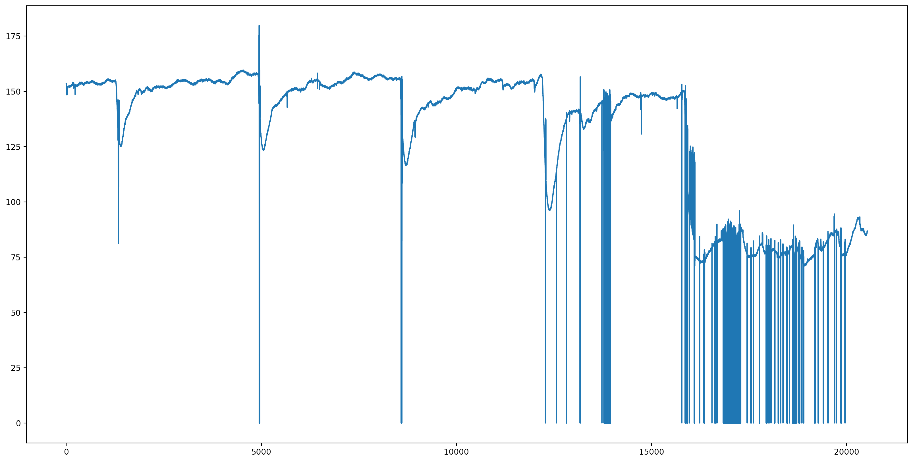

The blinkreconstruct function is then applied to the prepared data objectdm_eye0_diameter. The data after the application of the blinkreconstruct function is plotted. With the loop it is possible to check which parameter values fit best to the data and remove artefacts. The results are plotted.

dm_eye0_diameter_fixed=datamatrix.series.blinkreconstruct(dm_eye0_diameter, mode='advanced')  
plt.plot(dm_eye0_diameter_fixed)  
print(type(eye0))  
  
# Annahme: eye0 ist eine Liste von Objekten  
for item in eye0:  
 item['diameter_rec'] = checkdata.blinkreconstruct(item['diameter'], vt_start=10/800, vt_end=5/800, mode='advanced')  
  
for item in eye0:  
 diameter = item['diameter']  
 diameter_rec = item['diameter_rec']  
 pupil_timestamp = item['pupil_timestamp']  
  
 # Erstelle den Plot für diese Daten  
 plt.figure()  
 plt.plot(pupil_timestamp, diameter, label='Original Diameter')  
 plt.plot(pupil_timestamp, diameter_rec, label='Reconstructed Diameter')  
 plt.xlabel('Pupil Timestamp')  
 plt.ylabel('Diameter')  
 plt.title('Diameter vs. Pupil Timestamp')  
 plt.legend()  
 plt.show()

<class 'list'>

pandas.core.series.Series

pandas.core.series.Series

pandas.core.series.Series

pandas.core.series.Series

